12 Dec 2022

TO: HCNRA, Wallowa-Whitman National Forest
ATTN: Project Team Leader, Lucas Glick, lucas.glick@usda.gov
VIA: https://cara.fs2c.usda.gov/Public//CommentInput?Project=63111
CC: sadie.slamka@usda.gov

Subject: Double Creek Roadside + Salvage CE — scoping comments

Please accept the following scoping comments from Oregon Wild concerning the Double Creek Roadside + Salvage CE, https://www.fs.usda.gov/project/?project=63111. Oregon Wild represents 20,000 members and supporters who share our mission to protect and restore Oregon’s wildlands, wildlife, and water as an enduring legacy. Our goal is to protect areas that remain intact while striving to restore areas that have been degraded. This can be accomplished by moving over-represented ecosystem elements (such as logged and roaded areas) toward characteristics that are currently under-represented (such as roadless areas and complex old forest).

This proposal involves removing danger trees along 23 miles of the Hat Point Road, and area salvage of approximately 250 acres of fire-damaged trees.

We were relieved to hear that this would be the only post-fire logging on the District as a result of the 2022 fires. And we would be remiss not to note our appreciation that the agency did not immediately suppress every fire this past year. It was refreshing to see the agency use the opportunity not just to use fire, but also to educate the public about the benefit of fire. We hope we can see more of this – and not just in protected Wilderness going forward.

We appreciate staff taking the time to talk with us to better understand what is being proposed. We appreciate the candor regarding some of the motivations as well. This is a refreshing change from recent years. We hope we can continue to build on this into the future.

Oregon Wild accepts that high priority roads such as the Hat Point Road must be kept safe for workers and the public. But we want to minimize the loss of ecologically valuable large snags and down wood. We urge that danger tree removal focus on trees that are at imminent risk of falling and have a high probability of hitting well-travelled roads. Trees more than 100 feet from roads are unlikely to strike the road, because tree >100 ft from roads could fall many directions that will not strike the road. See “An Ecological Approach to Danger Trees” below.

The area salvage in section 31 and 32 is not necessary for safety and is contrary to the best available science regarding ecosystem management. The area salvage is proposed in an area that may be outside of the IRA boundary but it is nonetheless de facto roadless with obvious no roads or development separating the area from the IRA. The agency should recognize the fact that some areas (like this one) were arbitrarily excluded from the IRA boundaries and respect the compelling evidence that such areas should be managed for their ecological significance.

It is important to recognize the scientific context for a salvage project like this, science which highlights the critical ecological importance of both natural recovery of fire-affected forests and the disproportionate value of primary forests, including roadless areas. Conserving such area advance the twin goals of climate mitigation and biodiversity conservation:
Primary forests are defined as forests composed of native species in which there are
no clearly visible indications of human activities and ecological processes have not been
significantly disturbed. Multiple values are found at higher levels in intact forests of
a given type, including habitat for endangered species, water security, and accumulated
forest carbon stocks that keep carbon out of the atmosphere, and provide moderation of
air and surface temperature through evapotranspiration.
…
The complex early seral forest habitats that developed after high severity burns are important to a broad range of wildlife. Post-fire harvest and felling of live and dead trees can harm soil, integrity, hydrology, natural regeneration, slope stability, and wildlife habitat. Large standing dead, live yet possibly dying, and downed trees help forests recover and provide habitat for more than 150 vertebrates in the PNW.
In burned watersheds, post-fire logging worsens conditions that have resulted from a century of human activity and impedes the rate of recovery. In sum, post-fire treatments can cause a significant loss of ecosystem services.
…
Instead of regularly harvesting on all f the 70% of U.S> forest land designated as “timberlands” by the U.S. Forest Service, setting aside sufficient areas of Strategic Reserves would significantly increase the amount of carbon accumulated between now, 2050 and 2100, and reestablish greater ecosystem integrity, helping to slow climate change and restore biodiversity.
Law, Beverly E., William R. Moomaw, Tara W. Hudiburg, William H. Schlesinger, John D. Sterman, and George M. Woodwell. 2022. Creating Strategic Reserves to Protect Forest Carbon and Reduce Biodiversity Losses in the United States. Land Vol. 11, no. 5: 721. https://doi.org/10.3390/land11050721, https://www.mdpi.com/2073-445X/11/5/721/htm.

Given the importance of clean water, climate mitigation, and biodiversity, and the social and ecological costs associated with post-fire logging, we urge the Forest Service to find another way to pay for the removal of danger trees rather than hiding the cost of those treatments in the unaccounted (and overdrawn) budgets for climate stability, social costs of carbon dioxide emissions, as well as snag habitat and complex early seral habitat.

We understand industry was consulted prior to the development of this project. While it may have been difficult in this case, we would have liked to have had similar opportunities. In particular, due to an early winter, we – and other members of the public – were unable to visit the site. Had we been given the same opportunity as industry, we would have had a better understanding of this project and may have been able to provide more informed comments that could lead to a better project.

When the agency designs prescriptions for removal of dead trees that are not danger trees, as a general principle, the agency should approach silviculture the same as before the fire, i.e., remove small trees and retain large trees. This should not be a clearcut, large and old structure should be retained, and we encourage heterogeneity that includes clumps, dead-downed habitat, etc.

We appreciate being told that snag retention will be based upon wildlife needs, however we are aware that the agency lacks an agreed upon approach to conservation of snags and dead wood. The Trump Screens amendment essentially endorse an approach that can be summarized as “retain some snags for some wildlife.” This does not comply with the NFMA requirements for maintaining species viability. Snags are at a major deficit across the landscape, and a limiting factor for dozens of species of wildlife. Post fire logging reduces many of the benefits that fires provide, so, even if snag number are high in the area, there is no reason targets can’t be exceeded. Sufficient snags (especially large, resilient snags) should be retained at the unit level as well.

We understand that the commercial “salvage” will be packaged along with the roadside danger tree removal. We also understand that there is an incentive to maximize the commercial value of this project. However, we strongly encourage the agency to focus roadside hazard tree removal on trees that are legitimate hazards (upslope, leaning towards the road, within 100 feet of the road, etc.) rather than to extract financial value, and hide the ecological costs.

In numerous projects on this and other forests in the region, we have been disappointed to see enormous slash piles burned and turned into carbon dioxide rather than serving its ecological function as habitat or soil building. Rather than burning slash, we encourage it to be left on site or made available for firewood collection.

Firewood poaching is a serious problem on this district, and there is a concerning lack of law enforcement. Please consider the likelihood that “treated” stands will likely be even more enticing to firewood cutters, analyze the likely impacts based on similar units, and consider measures that can be taken to reduce the damage.

Given the importance of this landscape, please ensure that invasive species will be aggressively managed after logging is completed. Given the relatively small footprint of this project, that should be feasible.

We understand that the commercial activities in this project are meant to help offset costs of danger tree removal. While we understand this may be a “low value” sale, the ecological values here are quite high. We encourage the agency to consider other ways to pay for projects that are less ecologically damaging and less controversial to the broad public – who are co-equal stakeholders in the management of our public lands.

This landscape is incredibly important at the local and continental scale. It is truly unique. It is one of the most remote forested landscapes in the state. The road is well used, but bisects some of the largest unroaded landscapes in Oregon. Much of the area has already been designated by congress as Wilderness, Wild and Scenic Rivers, and National Recreation Areas. Many parts of it – including areas targeted by this logging have been proposed for Wilderness and even National Park status in the past. Logging along the road magnify the roads deleterious impacts.

The wide spot along the road that is NOT IRA, where area salvage is proposed, is nonetheless uninventoried roadless area. In the map below, the pale polygon is IRA. The darker polygon is uninventoried roadless area.
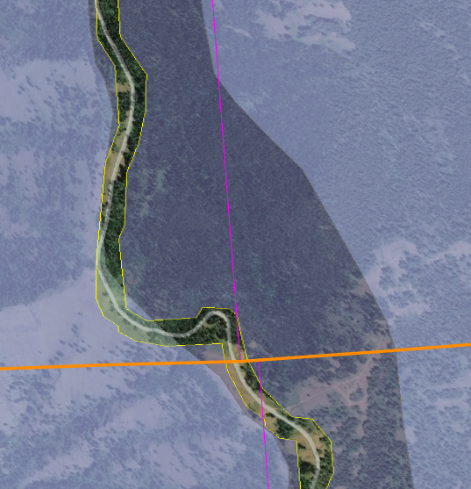
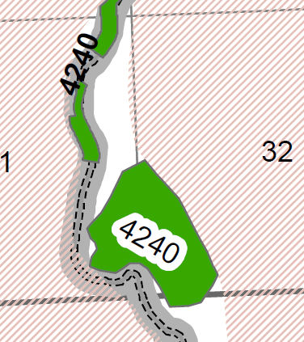

The landscape here is part of a region with the most intact assemblage of large wildlife in the state of Oregon, and it is adjacent to populations of extirpated species that should be allowed to return. Dense forests, dead wood habitat, and connectivity are important everywhere, but especially here in this continental connectivity corridor that is largely unforested and naturally fragmented. The FS should strive to retain valuable patches of forest like this.

We understand that the CE contemplates building up to 0.5 miles of road. That can mean 0 miles of road construction. Given the remote nature of this landscape, the damage roads cause, the lack of a Travel Management Plan, the backlog of road maintenance, and other factors, we strongly encourage the agency to design the project to include no new roads – temporary or otherwise.

If any roads or skid trails are built, they should be fully obliterated so as not to increase destructive off-road use after they are used for this project.

We understand there will be a challenge balancing public safety and recreational access to this project. Given that this project should be implemented relatively quickly, and its impacts will linger, to the extent that these, and ecological values, conflict, we encourage the agency to prioritize long-term ecological health by not building roads, bypasses, or other things that will remain.

Sometimes the motivation for eliminating hazards is based on a misunderstanding of legal liabilities. The NEPA analysis needs to acknowledge that the public assumes certain risk when recreating on public lands, so not every hazardous tree on every dead end spur road needs to be felled and removed. See ORS §§ 105.672(3), 105.682(1) and Brewer v. ODFW, 2 P.3d 418, 167 Or.App. 173. http://www.publications.ojd.state.or.us/A103245.htm.

ORS 105.682(1) provides:
Except as provided by subsection (2) of this section [pertaining to intentional injuries], and subject to the provisions of ORS 105.688 [limiting immunity to those who do not charge for use of the land or who charge no more than $20 per cord for woodcutting on the land], an owner of land is not liable in contract or tort for any personal injury, death or property damage that arises out of the use of the land for recreational purposes, woodcutting or the harvest of special forest products when the owner of land either directly or indirectly permits any person to use the land for recreational purposes, woodcutting or the harvest of special forest products. The limitation on liability provided by this section applies if the principal purpose for entry upon the land is for recreational purposes, woodcutting or the harvest of special forest products, and is not affected if the injury, death or damage occurs while the person entering land is engaging in activities other than the use of the land for recreational purposes, woodcutting or the harvest of special forest products.
ORS 105.676 provides:
The Legislative Assembly hereby declares it is the public policy of the State of Oregon to encourage owners of land to make their land available to the public for recreational purposes, for woodcutting and for the harvest of special forest products by limiting their liability toward persons entering thereon for such purposes...
"Land" is defined by ORS 105.672(3) as including "all real property, whether publicly or privately owned." "Owner" is defined by ORS 105.672(4) as "the possessor of any interest in any land, including but not limited to possession of a fee title. 'Owner' includes a tenant, lessee, occupant or other person in possession of the land."

Consider An Ecological Approach to Danger Trees
- The objective of public safety is laudable, but there are gradations of risk based on characteristics of the site and the tree and the type and amount of public exposure, so felling of hazard trees must be balanced against other important objectives such as wildlife habitat, carbon storage, water quality/stream shade, etc.
- After fire soils are damaged and fragile. Maintaining natural processes such as litterfall and dead wood retention and decay help protect and restore soil conditions. Clearing large areas along an extensive road system using heavy equipment can have significant negative cumulative impacts such as: soil degradation from heavy equipment operating off roads and biomass removal, water quality degradation from heavy equipment affecting ditches that convey water to streams; cumulative loss of habitat associated with snags, down wood, and diverse early seral vegetation; accelerated carbon emissions; increased fire hazard associated with fire ignition risks, and plantation fuel structure; habitat fragmentation and loss of habitat connectivity caused by increasing the width of non-habitat associated with roads; etc
- The agency should be more risk tolerant and retain more trees in sensitive areas, such as unroaded areas, riparian areas, and mature & old-growth stands and conservation areas.
- The agency can also be more risk tolerant because some agents of tree decay such as heart rot can coexist in living trees for hundreds of years. By Katherine Latham 2021. The Lost Generation of Ancient Trees. 8th September 2021. https://www.bbc.com/future/article/20210908-the-lost-generation-of-ancient-trees;
- To protect soil and water quality and vegetation diversity, heavy equipment should not be allowed off of roads.
- USFS Roads Policy requires the agency to use an open, public roads analysis process to balance competing interests involved in roads management including public safety and environmental values, and the policy urges the agency to focus maintenance work on the roads that get the most use, and emphasizes decommissioning of roads where environmental conservation should take priority, and “If necessary for environmental protection and due to lack of funding, travel on classified roads may need to be restricted or closed.” USFS Road Management Policy. https://www.fs.usda.gov/nfs/11558/www/nepa/115185_FSPLT3_5597368.pdf. The careful weighing of interests required to perform careful roads analysis means that it is not appropriate to categorically exclude danger tree removal projects from NEPA.
- The agency should consider alternative means of managing hazards from falling trees:
  - Minimize human activities near hazard trees (e.g., closing roads). This may not work where a hazard trees is adjacent to a high traffic road, but some little used roads can be closed. Analyze whether spurs or overgrown roads truly receive public use that justifies hazard tree removal;
  - Temporarily limit the use of roads that cannot be permanently closed until the risk of falling trees is naturally reduced;
  - Top trees, rather than kill them, if shortening them would reduce the chance they would reach the road if they fell;
  - Place signage warning people of post-fire hazards, particularly on roads that are infrequently used. This way people can evaluate the risks for themselves;
  - Often the hazard is not from the tree falling directly on people, but from cars colliding with trees that have previously fallen. This hazard can be mitigated with signage and speed limits, while allowing valuable wildlife trees to persist;
  - Prohibit cutting live, green trees, since all surviving trees are helping to rebuild the below-ground ecosystem, stabilize soils, and serve a valuable role as legacy structure and a recruitment pool for future large trees and snags;
  - Focus tree removal on imminent danger or hazard trees located within striking distance of high use areas, such as developed sites, parking lots, and paved roads. Wherever possible, use hazard trees for restoration of streams and placement in nearby stands that lack large wood;
  - Where they do not pose an immediate threat to safety, all trees presumed to be dying should be treated as live until they are dead, so as to not lose the ecological benefits of those trees that may survive;
  - Take measures to stabilize impacted slopes in areas where roadside logging is unavoidable; and
  - Analyze the cumulative impacts of all post-fire sales and roadside logging projects across agency jurisdictions.
- The agency should only fall trees that pose an imminent hazard to the public. There is little need to fell trees that lean away from the road. Even if a tree is directly on the edge of the road, a tree falling in a random direction has only a 50% chance of hitting the road, and the likelihood diminishes as the distance from the road increases. Trees more than 100 feet from the road have a low probability of falling on the road, even if they are taller than 100 feet. This is because of all the directions these trees could fall, only a small subset would reach the road. For instance, in the figure below, if a tree located at point (E) is close to a road (represented by line G-H) there is a much higher risk of it hitting the road compared to a tree at the location of point (C). The sum of the angles from the tree to the road (in the blue shaded areas) represent either broad or narrow risk of a tree falling and hitting the road depending on its distance from the road.

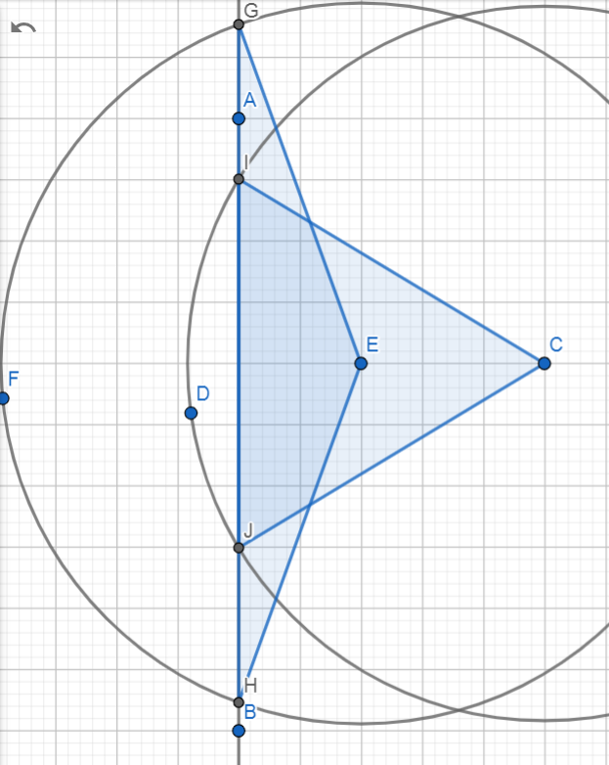
https://www.geogebra.org/geometry?lang=en
- There are several reasons that danger tree felling should be limited to 100 feet from roads. The chance of trees more than 100 feet from roads impacting the road are not very high because the tree would have to fall in precisely the right direction toward the road. And there is a much higher chance it will fall in numerous directions that do not threaten the road. In addition, many dead tree tops break off and fall close to the base of the tree, leaving a shorter snag with a more limited zone of hazard. Felling trees more than 100 feet from roads is unnecessarily risk averse, and unjustifiably sacrifices environmental values (such as snag habitat, dead wood habitat, and soil health).
- The agency should focus on roads that are heavily used by the public and workers. There is a trade-off between safety and habitat, and the agency should conserve defective trees and snag habitat in areas that receive little public use.
- The agency should fell trees as absolutely necessary, but wherever possible leave the trees on-site to provide down wood habitat. When tree removal is necessary use the wood to restore stream habitat or to add down wood to previously clearcut plantations where down wood habitat is severely lacking.
- We object to commercial sale of hazard trees, because there are economic conflicts of interest that could lead to ecologically important large trees being removed for the wrong reasons. And the need for large trees for restoration purposes far outstrips the supply.

The risk of a dead trees actually falling and hitting someone is extremely remote and must be put in perspective. For instance, the agency allows the public to use thousands of miles of roads where the risk of death or injury from collisions or other accidents is far far higher than the risk of being hit by a falling tree. The agency also allows boating and swimming in dangerous waterbodies, winter camping, mountain climbing, off-road vehicle use, and hunting with dangerous weapons. The agency also promotes dangerous occupations such as logging and firefighting, and piloting aircraft used for a variety of forest management activities. Furthermore, public use of public lands is skewed toward the summer months, while the extreme weather that tends to cause trees to fall is skewed toward the winter months. If the purpose of this project is to increase public safety please consider all the alternative ways that safety might be enhanced.

The hazards from trees falling is also mitigated by time. These are not high use roads. The chance that an employee or member of the public will be there when the tree falls is very low. To put things in perspective, there are almost 16 million seconds in a year. How many seconds are there vehicles on the road under these trees during the course of a year, and what fraction 16 million is that?

Allow Natural Processes to Flourish in Unroaded Areas
Unroaded/undeveloped areas are an important feature of the historic range of variability that needs to be restored. Such areas provide high quality water, soil, fish & wildlife habitat, carbon storage, recreation and scenic values, etc. The purpose and need should include restoration of unroaded/undeveloped areas (consistent with the natural range of variability) where natural processes can flourish.

Unroaded areas are rare on the landscape and they are one of the places where human influence has been limited and the ecological building blocks remain in place, so it is reasonably possible to achieve restoration of desired ecological conditions by relying on natural self-correcting mechanisms. Natural processes have operated successfully for millennia to achieve dynamic balance between forest growth and mortality. Within unroaded areas the agency should focus on eliminating unnatural stressors (such as livestock and weeds) while reintroducing natural processes such as fire. There may be an opportunity to manually pre-treat fuels before reintroducing fire, but building miles of new roads and removing significant habitat structures would not be appropriate.

In a 1997 letter to President Clinton, 136 scientists said:
There is a growing consensus among academic and agency scientists that existing roadless areas–irrespective of size–contribute substantially to maintaining biodiversity and ecological integrity on the national forests. The Eastside Forests Scientific Societies Panel, including representatives from the American Fisheries Society, American Ornithologists’ Union, Ecological Society of America, Society for Conservation Biology, and The Wildlife Society, recommended a prohibition on the construction of new roads and logging within existing (1) roadless regions larger than 1,000 acres, and (2) roadless regions smaller than 1,000 acres that are biologically significant…. Other scientists have also recommended protection of all roadless areas greater than 1,000 acres, at least until landscapes degraded by past management have recovered…. As you have acknowledged, a national policy prohibiting road building and other forms of development in roadless areas represents a major step towards balancing sustainable forest management with conserving environmental values on federal lands. In our view, a scientifically based policy for roadless areas on public lands should, at a minimum, protect from development all roadless areas larger than 1,000 acres and those smaller areas that have special ecological significance because of their contributions to regional landscapes.
Letter to President Clinton from 136 scientists (Dec. 10, 1997).
https://drive.google.com/file/d/0B4L_-RD-MJwrRzhFcm5QcFR0MHM/view?usp=sharing&resourcekey=0-2-sbGMN3bOUBQGGMDBQM1Q

To the list of special values found within unroaded areas must be added carbon storage. European policy leaders consider roadless areas effective for carbon storage and climate mitigation:
[T]he European Parliament has agreed to raise the issue of roadbuilding in intact forests at the UN Climate Change Conference to be held next month in Warsaw (Poland); it calls on parties to use the existence of roads in forest areas as an early negative performance indicator of REDD+ projects, and to prioritise the allocation of REDD+ funds towards road free forests.
Oct 24, 2013 Press release: EUROPEAN PARLIAMENT BACKS THE PROTECTION OF ROADFREE AREAS. http://kritonarsenis.gr/eng/actions/view/european-parliament-backs-the-protection. Federal land managers should recognize the tremendous carbon values in unroaded/unmanaged forests and avoid actions that would threaten these values. See also, William R. Moomaw, Susan A. Masino, and Edward K. Faison. 2019. Intact Forests in the United States: Proforestation Mitigates Climate Change and Serves the Greatest Good Front. For. Glob. Change, 11 June 2019 | https://doi.org/10.3389/ffgc.2019.00027; https://www.frontiersin.org/articles/10.3389/ffgc.2019.00027/full. See also, Kun, Z., DellaSala, D., Keith, H., Kormos, C., Mercer, B., Moomaw, W.R. and Wiezik, M. (2020), Recognising the importance of unmanaged forests to mitigate climate change. GCB Bioenergy. Accepted Author Manuscript. doi:10.1111/gcbb.12714 https://onlinelibrary.wiley.com/doi/pdfdirect/10.1111/gcbb.12714. (“The most effective means for keeping carbon out of the atmosphere to meet climate goals is to protect primary forests (Mackey et al. 2020) and continue growing secondary forests to accumulate additional carbon (proforestation) (Moomaw et al. 2019) while reducing emissions from all sources including bioenergy. … The importance of primary (unlogged) forests lies in the magnitude and longevity of their carbon stock. In order to reverse the decreasing forest carbon stocks in Europe (EEA, 2019), the largest forest carbon stores must be protected and additional forests must be allowed to continue accumulating carbon (proforestation).”).

“While primary forests of all extents have conservation value, areas of greater extent warrant particular attention where they persist, as they support more biodiversity, contain larger carbon stocks, provide more ecosystem services, encompass larger-scaled natural processes, and are more resilient to external stresses. The significance of large areas of primary forests has been highlighted by the global mapping of Intact Forest Landscapes (IFL) greater than 500 km2 in extent. While suitable for many purposes, other thresholds may be more suitable at regional and national levels that reflect local ecological factors.”
IUCN Policy Statement on Primary Forests, https://www.iucn.org/sites/dev/files/content/documents/iucn_pf-ifl_policy_2020_approved_version.pdf

There are tremendous co-benefits from conserving large blocks of unmanaged forests, such as climate mitigation and biodiversity conservation.
Based on the species–area relationship, regarded as one of ecology’s few universal laws, protection of [too] little habitat will condemn thousands of species to extinction if habitat outside them is converted, degraded or lost. It is this logic that underpins calls for ‘Nature Needs Half’ [26], together with an understanding that ecosystem processes and services of the scale needed to sustain the well-being of life on Earth require large wildlife populations and huge expanses of intact and restored habitat. ... Climate change adds a new dimension to the question of how much protected area coverage is needed to assure conservation of wild nature. Climate change is already reducing wildlife population sizes and forcing range shifts as conditions alter [28,29]. Protected areas counter such stresses by building up populations, and connectivity of populations and habitats is emerging as a key property in securing species persistence and resilience to rapid change [5]. Hence networked protected areas, especially where embedded within well-managed landor seascapes, provide crucial stepping stones to accommodate range shifts and, where no further movements are possible, refuges of last resort [5]. Analyses suggest that adequate levels of population viability and connectivity can be achieved only with marine protected area coverages of 30% or more [27]. ... [G]iven that many ecosystems are already degraded, ensuring continued provision of ecosystem services requires not only the precautionary protection of currently intact habitats, but also large-scale habitat restoration.
Providing greater space for recovery of intact, vibrant nature is not altruistic conservation, but is, we argue, an indispensable act of self- preservation, producing a cascade of benefits that will help maintain the habitability of the biosphere as the climate changes, thereby securing the well-being of generations to come.
Roberts CM, O’Leary BC, Hawkins JP. 2020 Climate change mitigation and nature conservation both require higher protected area targets. Phil. Trans. R. Soc. B 375: 20190121. http://dx.doi.org/10.1098/rstb.2019.0121. See also, Soto-Navarro C et al. 2020 Mapping co-benefits for carbon storage and biodiversity to inform conservation policy and action. Phil. Trans. R. Soc. B 375: 20190128. http://dx.doi.org/10.1098/rstb.2019.0128 showing the congruence of high carbon value and high biodiversity value in PNW forests.

Even when forests in roadless areas seem more uniform than desired, it is not always necessary to mechanically thin forests to increase diversity and complexity. Natural processes can do the job. Spies et al (2002) enumerate a variety of disturbance agents that can help diversify forest stands without logging.
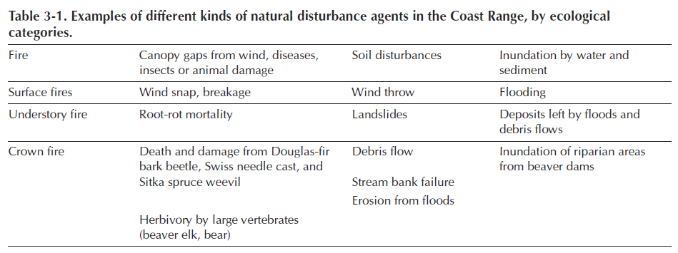
Thomas A. Spies, David E. Hibbs, Janet L. Ohmann, Gordon H. Reeves, Robert J. Pabst,
Frederick J. Swanson, Cathy Whitlock, Julia A. Jones, Beverly C. Wemple,
Laurie A. Parendes, and Barbara A. Schrader. 2002. The Ecological Basis of Forest Ecosystem Management in the Oregon Coast Range. http://www.fsl.orst.edu/rna/Documents/publications/Flynn%20Creek%20spies_etal_2002_ecological_basis.pdf in Hobbs, S. D. et al (2002). Forest and stream management in the Oregon coast range. Corvallis, Or: Oregon State University Press. https://osupress.oregonstate.edu/book/forest-and-stream-management-in-oregon-coast-range

One of the important but under-appreciated values of unroaded areas is the long-term creation and maintenance of dead wood habitat due to the fact that unmanaged areas are where natural processes are allowed to flourish. Unroaded areas are one of the few places where trees are allowed to fulfill their entire “lifecycle” (including their life-giving role as snags, dead wood, and soil builders) in the forest. Korol et al (2002) found that large snag habitat is below historic range of variability across the Interior Columbia Basin and they estimated that even if the agencies apply enlightened forest management on federal lands in the Interior Columbia Basin for the next 100 years, we will still reach only 75% of the historic large snag abundance, and most of the increase in large snags will occur in roadless and wilderness areas. Jerome J. Korol, Miles A. Hemstrom, Wendel J. Hann, and Rebecca A. Gravenmier. 2002. Snags and Down Wood in the Interior Columbia Basin Ecosystem Management Project. PNW-GTR-181. http://www.fs.fed.us/psw/publications/documents/gtr-181/049_Korol.pdf. Since wilderness and unmanaged areas are the only place that a healthy population of snags is likely to be recruited and maintained over the long term, they represent invaluable and irreplaceable mitigation for all the places where snags are in short supply due to logging, hazard tree removal, and other management efforts designed to control and capture mortality.

The map below shows the strong correlation between snag abundance and unmanaged forest lands such as wilderness and roadless areas.
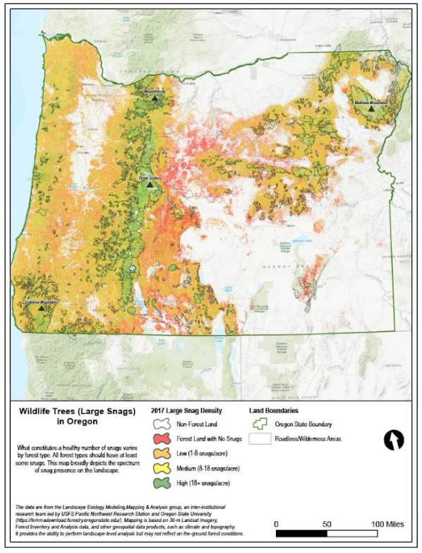

Wisdom et al (2008) found that snag abundance in the Pacific northwest forests is inversely related to past harvest and proximity to roads. Wisdom, M.J., and Bate, L.J. 2008. Snag density varies with intensity of timber harvest and human access. For. Ecol. Manage. 255: 2085–2093. doi:10.1016/j.foreco.2007.12.027. http://www.fs.fed.us/pnw/pubs/journals/pnw_2008_wisdom001.pdf (“Our highest snag density … occurred in unharvested stands that had no adjacent roads. … Stands with no history of timber harvest had 3 times the density of snags as stands selectively harvested, and 19 times the density as stands having undergone complete harvest. Stands not adjacent to roads had almost 3 times the density of snags as stands adjacent to roads.”)

Low-impact restoration activities, including but not limited to prescribed fire, mowing, non-commercial thinning, and weed removal may be appropriate in roadless/unroaded areas as long as they will be substantially unnoticeable to the casual observer and leave the area suitable for future wilderness designation. The NEPA document should describe the roadless/unroaded area, the undeveloped values present, and the need for, and impacts of, the proposed restoration activities.

Commercial logging prescriptions are typically designed to exert significant control over fire behavior and tree mortality, and similar prescriptions have been and are being applied across quite a large area of our federal forests. By limiting treatments to low-impact, non-commercial activities in undeveloped areas we are still treating them, and still getting benefits in terms of fire and "forest heath," but we are relaxing our control just a bit and letting natural processes play a bigger role in that subset of the landscape.

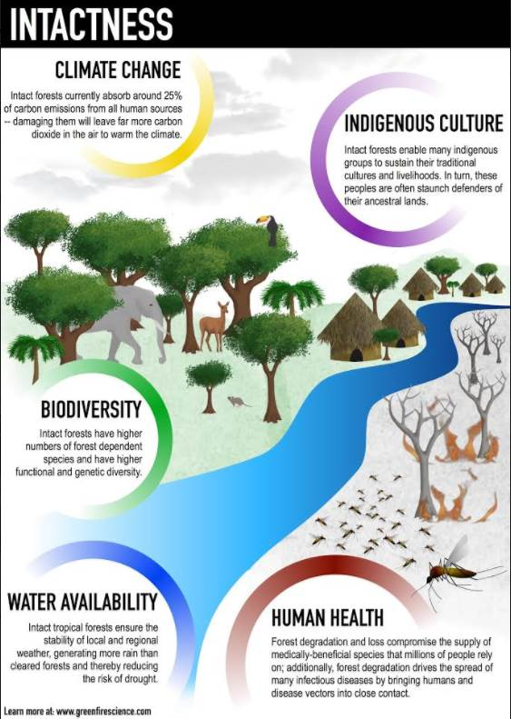
Watson et al 2018. The exceptional value of intact forest ecosystems. Nature Ecology & Evolution (2018) https://www.nature.com/articles/s41559-018-0490-x

Each substantive issue discussed in these comments should be (i) incorporated into the purpose and need for the project, (ii) used to develop NEPA alternatives that balance tradeoffs in different ways, (iii) carefully analyzed and documented as part of the effects analysis, and (iv) considered for mitigation.

Note: If any of these web links in this document are dead, they may be resurrected using the Wayback Machine at Archive.org. http://wayback.archive.org/web/

Sincerely,
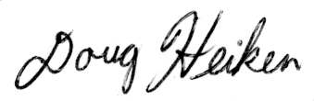
Doug Heiken
dh@oregonwild.org

