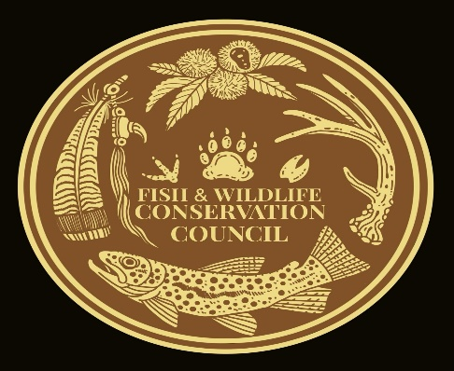
David Whitmire
Fish and Wildlife Conservation Council Chair
2700 Flat Creek Valley Road
Lake Toxaway, NC 28747
avery@citcom.net
828-553-0083

November 4, 2022

Pisgah National Forest Ranger Districts
USDA Forest Service
Attn: Nicholas Larson, Jen Barnhart, Dave Casey

Re: Grandfather, Appalachian, Pisgah Restoration Project (GAP Project) Comments

To Pisgah District Rangers:

On behalf of the Fish and Wildlife Conservation Council, thank you for this opportunity to comment on the GAP project for the Pisgah National Forest.

The Fish and Wildlife Conservation Council (FWCC) was formed in the early 1990’s to establish a voice for sportsmen and women across Western North Carolina (WNC) on wildlife and wildlife habitat issues on the public lands we live around. Most recently a large portion of our work is on the Nantahala / Pisgah National Forest Revision Plan that is it its final stages. While we are committed to the many faucets of needed work for wildlife habitat through -out WNC, our biggest asset is connecting the local sportsmen and women to their resource managers and vice versa.

We have followed the GAP project from the beginning. Our council often uses our Federal and State Resource managers as technical advisers and has been the case for the GAP project. We appreciate the time and hard work that has went into this project. We feel it is the right direction, at the right time as fire is an important tool for wildlife habitat. With that said the facts remain that our wildlife habitat has suffered greatly over the past thirty years with the lack of meeting goals from past plans and the general lack of capacity from resources managers to put quality habitat on the ground. While many aspects today lead us to believe that the future of habitat on this forest will be much improved on, overcoming thirty years of not meeting goals and those effects concern us. It is with those concerns that we summit these comments.
The project itself is a large landscape project. The capacity to develop and implement it will take a large portion of each the Pisgah Districts capacity, including using partners. The benefits of fire to make communities safer, forest healthier and wildlife habitat better is the focus. With the limited number of resources, we should focus on the most effective burns we can. FWCC would like to see an increase in the amount of young forest habitat created from the 500 acres listed, to closer to 1500 acres per year. 1. This fall in line with the new proposed forest plan in its Tier 2 objectives, which must be met if we are to see improved wildlife habitat. 2. With the deficit we now have on young forest habitat and the lack of Forest Service capacity, GAP will be a major focus. Without emphasizing young forest habitat during the Gap project duration, we feel the ability to create young forest will continue to be pushed to the back of the line. 3. We should stive to burn with the most effectiveness possible. Often young forest creation never reaches its full potential because the lack of fire during its succession. Regeneration based on age class and composition should be done as an integral part of GAP as to make burns the most efficient both in money and time to achieve the best outcomes. Simply burning to be burning has benefits but restoring these areas and burning should be the goals, especially for quality wildlife habitat. 4. We would like to see a priority or emphasis on the North Carolina Wildlife Resources Commisssion Wildlife Habitat Active Management area for regeneration within the GAP project.

Access remains a key ingredient to a successful GAP project. Roads and fire lines must be maintained to allow access for burning, fire breaks, restoration, and other needed work. FWCC recognizes the importance of these features and the important role they can play in wildlife habitat. 1. We would like to see daylighting of roads out to fifty foot each side of roads. This will create much needed native young growth habitat for many species. More modern equipment also allows for better maintenance of these linear openings than ever before. 2.When seeding roads and fire breaks, use wildlife beneficial seeds or mixtures that hold erosion and benefit wildlife. 3. Permanent Wildlife fields within the burning units should be daylighted to 100 ft from edge. Burning of the fields and surrounding edges will create a layer transition much desired for many species and making future burns most effective.

FWCC appreciates the Forest Service’s work to improve the pace and scale of activities that provide quality wildlife habitat. The polygons listed we support but realize they too may need to be flexible to be expanded. We also support flexibility in identifying needed restoration concerns as the project moves forward. As concerned citizens our comments are based on our vast knowledge of the past, present, and future boots on the ground experiences in this forest. We support this project and hope you will consider not only our request to go further for wildlife but also some of our partner’s request. We endorse both the North Carolina Wildlife Resources Commissions and the Ruffed Grouse Society & American Woodcock Societies comments concerning the Gap project.

Sincerely,
David Whitmire
FWCC Chair

