21 March 2022

TO: Barlow Ranger District
ATTN: Ashley Popham, NEPA Planner, ashley.popham@usda.gov
VIA: https://cara.fs2c.usda.gov/Public//CommentInput?Project=56470 [The legal notice says “A link to provide electronic comments is located on the project website under ‘Comment/Object on Project’”, but there is no webform provided to submit comments there.]

Subject: Grasshopper Project — comments

Please accept the following comments from Oregon Wild concerning the Grasshopper Project Draft EA, https://www.fs.usda.gov/project/?project=56470. Oregon Wild represents 20,000 members and supporters who share our mission to protect and restore Oregon’s wildlands, wildlife, and water as an enduring legacy. Our goal is to protect areas that remain intact while striving to restore areas that have been degraded. This can be accomplished by moving over-represented ecosystem elements (such as logged and roaded areas) toward characteristics that are currently under-represented (such as roadless areas and complex old forest).

I have a deep personal connection to this project area, having camped at Bonny Crossing many times.

The Proposed Action Alternative 1 involves:
- 1,777 acres of thinning and gaps up to 5 acres in stands under 80 years old
- 3503 acres of variable density thinning in native, multi-cohort, stands older than 80 years old
  - 272 acres of logging in inventoried roadless areas (10-14” dbh limit)
  - 487 acres of thinning young stands in the National Recreation Area
  - 494 acres of logging in LSR (mostly under 80 years)
  - 556 acres of logging in riparian reserves (including 463 acres in older stands)
    - no-cut buffers of 60 feet for perennial streams and 30 feet along intermittent streams
    - 40- 50% canopy cover retention in the treated portion of the riparian stands.
  - 4,785 acres of logging in matrix
  - 1,234 acres of logging will degrade spotted owl nesting, roosting, foraging habitat
  - 1,181 acres of logging will adversely affect spotted owl critical habitat (828 acres of CH will be downgraded)
- Fuel reduction and fuel breaks and prescribed burning
- ~ 17 miles of temporary road construction (none in IRAs)
- 1 mile of open road closed
- 0.4 miles road decommissioning
- Forest Plan exceptions allowing greater disturbance of vegetation and watersheds

The FS needs to take an ecological approach to forest management, and view forest succession and mortality as natural and desirable features of forest habitat development. Multi-cohort stands are desirable from the perspective of spotted owls and their prey. Mortality from competition and other causes helps thin the forest. Natural mortality is preferable to logging because it helps recruit dead wood that is important for development of high quality late successional habitat.

This is a large project with complex trade-offs on carbon and climate, spotted owl suitable habitat and critical habitat, recruitment of snags and dead wood.

We have serious concerns with the significant effects and trade-offs associated with variable density thinning of suitable owl habitat under Alternative 1, and it’s worth noting that those trade-offs are even greater if the FS chose the conduct Shelterwood regen harvest under Alt 2.
Table of Contents
Logging in Roadless Areas 3
Allow Natural Processes to Flourish in Unroaded Areas 5
Logging in northern spotted owl suitable habitat and critical habitat 9
Fuel Reduction Logging Will Have a Net Harmful Effect on Spotted Owl Habitat, Even if the Goal is to Protect Suitable Habitat from Wildfire. 15
Fire and Fuel Analysis 29
Focus on the younger stands, defer the older stands. 29
The Purpose and Need Should Address The Unmet Need for Carbon Storage 34
Carbon Emissions from Logging 35
Forest Degradation just as bad as Deforestation 39
Logging Does Not Increase Capacity for Growing Trees 43
Variable Density Thinning 48
Logging Effects on Snag Recruitment 56
Logging in Riparian Reserves. Logging Effects on Dead Wood Recruitment. 64
Weigh the trade-offs associated with logging in riparian reserves. 77
Density-dependent versus density-independent mechanisms 86
Logging in riparian reserves older than 80 years. 88
Lack of Site-Specific NEPA Analysis 89
Avoid unnecessary construction of temporary roads. Optimize treated and untreated. 92
New Information Requires Modification of Matrix Objectives. 95

Logging in Roadless Areas
The FS should refrain from commercial logging in roadless areas, especially the multi-cohort native stands. Natural unmanaged forests are rare on the landscape and provide disproportionate ecosystem services. Logging has significant adverse trade-offs on late successional habitat, carbon storage, and dead wood recruitment.

The FS should log lightly in the IRA and retain relatively more basal area and canopy cover. This will help mitigate adverse effects on wildlife, carbon, watershed etc, and also reduce the cost of future management by suppressing the growth of surface and ladder fuels.

The EA does not provide a clear rationale for logging in the IRA, especially an analysis that weighs and compares the alleged benefits of logging versus all the trade-offs on habitat, soil/water quality, carbon storage, fire hazard, etc.

The EA analysis does not reflect our scoping comments highlighting the disproportionate ecological values provided by unmanaged/unroaded areas, and the disproportionate impacts of logging those areas. For instance, one of the important but under-appreciated values of unroaded areas is the long-term creation and maintenance of dead wood habitat due to the fact that unmanaged areas are where natural processes are allowed to flourish. Unroaded areas are one of the few places where trees are allowed to fulfill their entire “lifecycle” (including their life-giving role as snags, dead wood, and soil builders) in the forest. Korol et al (2002) found that large snag habitat is below historic range of variability across the Interior Columbia Basin and they estimated that even if the agencies apply enlightened forest management on federal lands in the Interior Columbia Basin for the next 100 years, we will still reach only 75% of the historic large snag abundance, and most of the increase in large snags will occur in roadless and wilderness areas. Jerome J. Korol, Miles A. Hemstrom, Wendel J. Hann, and Rebecca A. Gravenmier. 2002. Snags and Down Wood in the Interior Columbia Basin Ecosystem Management Project. PNW-GTR-181. http://www.fs.fed.us/psw/publications/documents/gtr-181/049_Korol.pdf. Since wilderness and unmanaged areas are the only place that a healthy population of snags is likely to be recruited and maintained over the long term, they represent invaluable and irreplaceable mitigation for all the places where snags are in short supply due to logging, hazard tree removal, and other management efforts designed to control and capture mortality.

The EA failed to consider an alternative that would restore large blocks of unroaded habitat areas by closing roads adjacent to the unroaded areas, and treating the IRAs (or at least the multi-cohort native stands) via non-commercial thinning and prescribed fire.

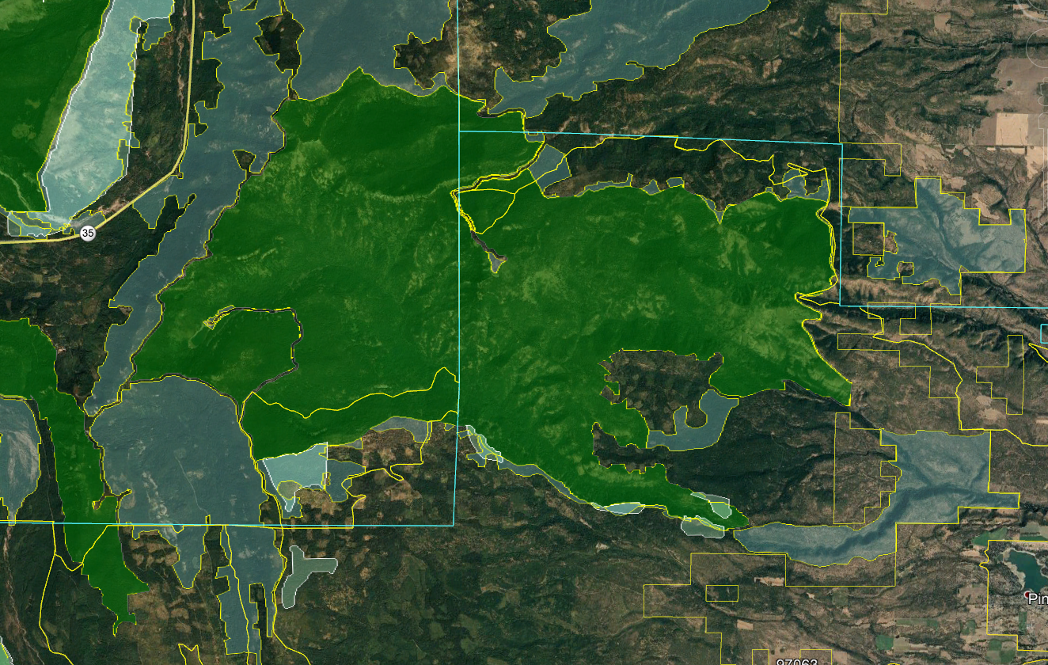

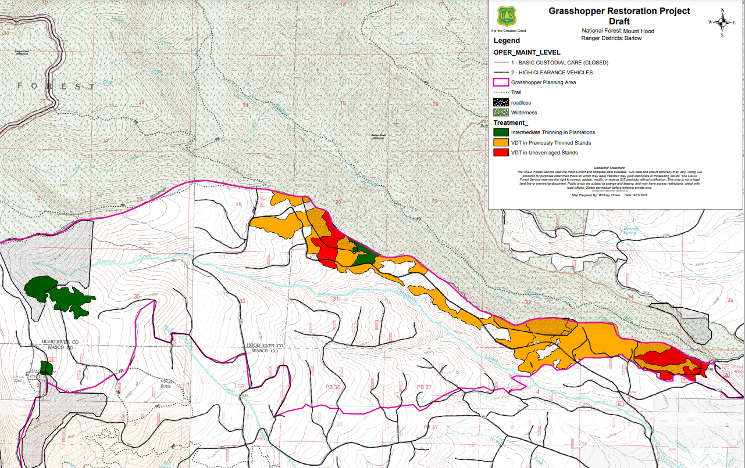

Allow Natural Processes to Flourish in Unroaded Areas
Unroaded/undeveloped areas are an important feature of the historic range of variability that needs to be restored. Such areas provide high quality water, soil, fish & wildlife habitat, carbon storage, recreation and scenic values, etc. The purpose and need should include restoration of unroaded/undeveloped areas (consistent with the natural range of variability) where natural processes can flourish.

Unroaded areas are rare on the landscape and they are one of the places where human influence has been limited and the ecological building blocks remain in place, so it is reasonably possible to achieve restoration of desired ecological conditions by relying on natural self-correcting mechanisms. Natural processes have operated successfully for millennia to achieve dynamic balance between forest growth and mortality. Within unroaded areas the agency should focus on eliminating unnatural stressors (such as livestock and weeds) while reintroducing natural processes such as fire. There may be an opportunity to manually pre-treat fuels before reintroducing fire, but building miles of new roads and removing significant habitat structures would not be appropriate.

Unroaded areas often have mature forests which are developing and diversifying naturally. “Mature Seral Stage - This stage typically occurs between ages 81 and 195. Stand diversity is gradually increasing in response to openings in the canopy created by wind-throw, disease, insects, and stand mortality” Eugene BLM, 1995. Mohawk/McGowan Watershed Analysis.

Even when forests in roadless areas seem more uniform than desired, it is not always necessary to mechanically thin forests to increase diversity and complexity. Natural processes can do the job. Spies et al (2002) enumerate a variety of disturbance agents that can help diversify forest stands withouit logging.
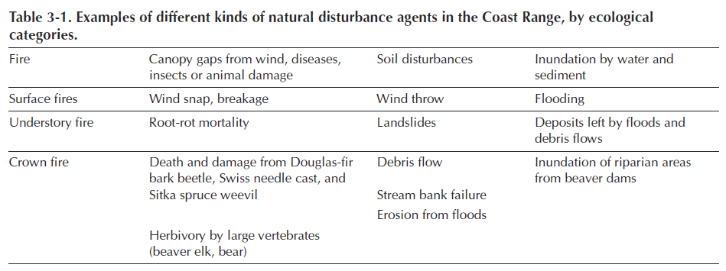
Thomas A. Spies, David E. Hibbs, Janet L. Ohmann, Gordon H. Reeves, Robert J. Pabst,
Frederick J. Swanson, Cathy Whitlock, Julia A. Jones, Beverly C. Wemple,
Laurie A.Parendes, and Barbara A. Schrader. 2002. The Ecological Basis of Forest Ecosystem Management in the Oregon Coast Range. http://www.fsl.orst.edu/rna/Documents/publications/Flynn%20Creek%20spies_etal_2002_ecological_basis.pdf in Hobbs, S. D. et al (2002). Forest and stream management in the Oregon coast range. Corvallis, Or: Oregon State University Press. https://osupress.oregonstate.edu/book/forest-and-stream-management-in-oregon-coast-range

One of the important but under-appreciated values of unroaded areas is the long-term creation and maintenance of dead wood habitat due to the fact that unmanaged areas are where natural processes are allowed to flourish. Unroaded areas are one of the few places where trees are allowed to fulfill their entire “lifecycle” (including their life-giving role as snags, dead wood, and soil builders) in the forest. Korol et al (2002) found that large snag habitat is below historic range of variability across the Interior Columbia Basin and they estimated that even if the agencies apply enlightened forest management on federal lands in the Interior Columbia Basin for the next 100 years, we will still reach only 75% of the historic large snag abundance, and most of the increase in large snags will occur in roadless and wilderness areas. Jerome J. Korol, Miles A. Hemstrom, Wendel J. Hann, and Rebecca A. Gravenmier. 2002. Snags and Down Wood in the Interior Columbia Basin Ecosystem Management Project. PNW-GTR-181. http://www.fs.fed.us/psw/publications/documents/gtr-181/049_Korol.pdf. Since wilderness and unmanaged areas are the only place that a healthy population of snags is likely to be recruited and maintained over the long term, they represent invaluable and irreplaceable mitigation for all the places where snags are in short supply due to logging, hazard tree removal, and other management efforts designed to control and capture mortality.

The map below shows the strong correlation between snag abundance and unmanaged forest lands such as wilderness and roadless areas.
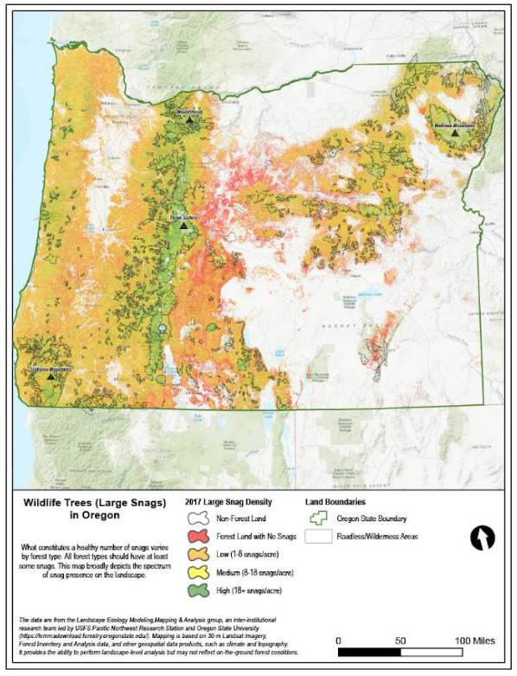

Wisdom et al (2008) found that snag abundance in the Pacific northwest forests is inversely related to past harvest and proximity to roads. Wisdom, M.J., and Bate, L.J. 2008. Snag density varies with intensity of timber harvest and human access. For. Ecol. Manage. 255: 2085–2093. doi:10.1016/j.foreco.2007.12.027. http://www.fs.fed.us/pnw/pubs/journals/pnw_2008_wisdom001.pdf (“Our highest snag density … occurred in unharvested stands that had no adjacent roads. … Stands with no history of timber harvest had 3 times the density of snags as stands selectively harvested, and 19 times the density as stands having undergone complete harvest. Stands not adjacent to roads had almost 3 times the density of snags as stands adjacent to roads.”)

Low-impact restoration activities, including but not limited to prescribed fire, mowing, non-commercial thinning, and weed removal may be appropriate in roadless/unroaded areas as long as they will be substantially unnoticeable to the casual observer and leave the area suitable for future wilderness designation. The NEPA document should describe the roadless/unroaded area, the undeveloped values present, and the need for, and impacts of, the proposed restoration activities.

Commercial logging prescriptions are typically designed to exert significant control over fire behavior and tree mortality, and similar prescriptions have been and are being applied across quite a large area of our federal forests. By limiting treatments to low-impact, non-commercial activities in undeveloped areas we are still treating them, and still getting benefits in terms of fire and "forest heath," but we are relaxing our control just a bit and letting natural processes play a bigger role in that subset of the landscape.

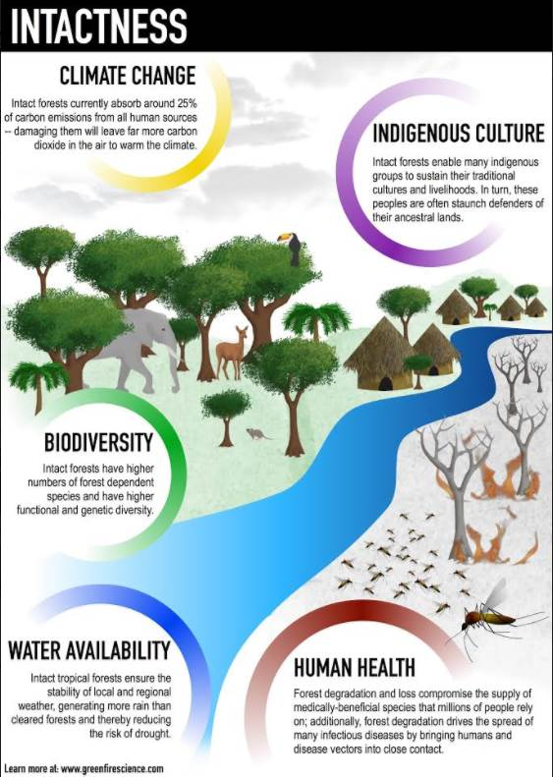
Watson et al 2018. The exceptional value of intact forest ecosystems. Nature Ecology & Evolution (2018) https://www.nature.com/articles/s41559-018-0490-x

Logging in northern spotted owl suitable habitat and critical habitat
Critical habitat is supposed to be managed to help recover spotted owls, not just to avoid jeopardy to the species.

Patches of high quality spotted owl habitat (RA32) should be excluded from commercial logging to help mitigate for all the suitable owl habitat that is occupied and defended by barred owls that was not considered in the 1994 FEIS. High quality habitat should be broadly defined. Conservation actions should be limited to non-commercial thinning and prescribed fire.

This project should be designed to avoid degrading/downgrading/removing suitable spotted owl habitat and critical habitat.

The Wildlife Report (p 17) claims that 1181 acres of spotted owl nesting/roosting critical habitat will be logged but habitat quality will somehow be maintained. This is unsupported by the evidence, including the important fact that commercial logging always causes a significant long-term reduction in dead wood habitat that is important for spotted owls and their prey.

The Wildlife Report (p 9) says “The Grasshopper planning are is in the middle of the range for spotted owl so the above studies may indicate a balance between and advantage for barred owls and an advantage for spotted owls.” This analysis fails to recognize a more significant effect of downgrading 1200 acres of suitable owl habitat, which is that when two species are competing for the same habitat, reducing the amount of suitable habitat increases the chances of co-existence and increase the chances of competitive exclusion.

A telemetry study showed that in fragmented landscapes barred owls have a survival advantage relative to spotted owls, but that survival advantage diminishes in landscapes with a higher proportion of older forest. In other words, conservation of mature & old-growth forest should be favored because spotted owls are able to compete nearly equally with barred owls in landscapes with a high proportion of old forest.
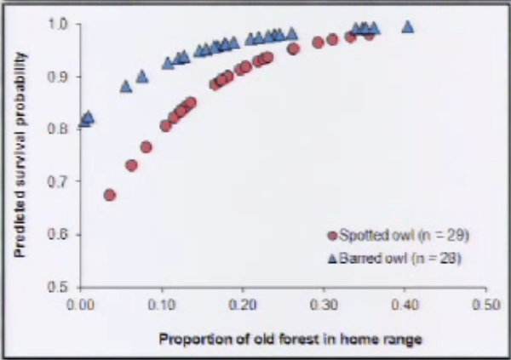
See Wiens, D. 2012. Presentation to The Wildlife Society. http://tws.sclivelearningcenter.com/index.aspx?PID=6893&SID=163551 (at 1:12).

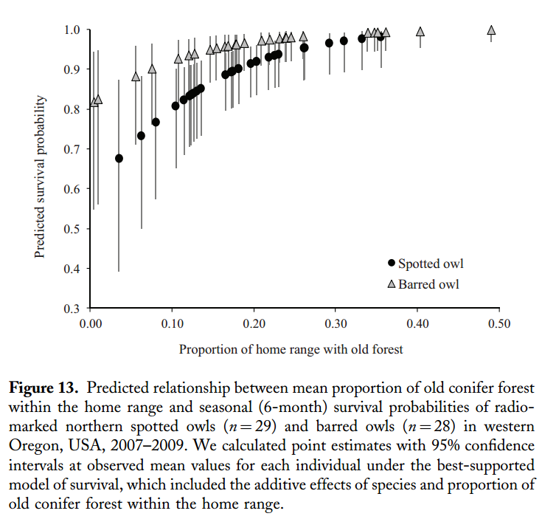
Wiens, J.D., Anthony, R.G., and E.D. Forsman. 2014: Competitive Interactions and Resource Partitioning Between Northern Spotted Owls and Barred Owls in Western Oregon. Wildlife Monographs 185:1–50; 2014; DOI: 10.1002/wmon.1009. https://ir.library.oregonstate.edu/xmlui/bitstream/handle/1957/48214/AnthonyRobertFisheriesWildlifeCompetitiveInteractions.pdf

David Wiens has conducted the most thorough research on the influence of barred owls on spotted owls and concluded -
Conservation Implications
- Results emphasize the importance of old conifer forest and moist streamside habitats to resource partitioning.
- Additional loss of older forest can further constrain both species to a common set of limiting resources, thereby increasing competitive pressure
Wiens, D.J. 2012. Dietary Overlap between Northern Spotted Owls and Barred Owls in Western Oregon, workshop What’s for Dinner: Spotted Owl Prey 2012 http://ecoshare.info/projects/central-cascade-adaptive-management-partnership/workshops/spotted-owl/; http://ecoshare.info/wp-content/uploads/2012/08/Barred-compared-to-spotted-Owl-diets.ppt

The final Recovery Plan for the Northern Spotted Owl has partially addressed the barred owl issue by adopting Recovery Action 32 which urges the FS and BLM to “Maintain substantially all of the older and more structurally complex multi-layered conifer forests on Federal lands outside of MOCAs…” based on the idea that “protecting these forests will not further exacerbate competitive interactions between spotted owls and barred owls as would occur if the amount of shared resources were decreased.” (FRP p 34). The revised critical habitat for the northern spotted owl was also expanded to “… increase the likelihood that spotted owls would be able to persist in areas where barred owls are also present. … [A]dditional critical habitat may allow for coexistence of the two species, potentially reducing competition (Dugger et al. 2011; Forsman et al. 2011).” FWS 2012. CHU draft EA, p 53, 62. http://www.fws.gov/oregonfwo/Species/Data/NorthernSpottedOwl/Documents/CH_DRAFTEnvAssmnt_6.1.12.pdf. In considering this recommendation the agencies must prepare NEPA analysis which considers the full potential of suitable habitat quantity and quality and its mediating influence on the interactions between spotted owls and barred owls. Maintaining a subset of suitable habitat as recommended by the recovery plan is one option, but the agencies must consider the full benefits of protecting all suitable habitat, not just a subset, and providing additional mitigation in matrix areas such as managing the matrix to enhance habitat for owl prey species. The recovery plan is not a NEPA document and FWS was not required to consider all reasonable alternatives. Action agencies like the FS and BLM on the other hand are required to fully consider alternatives. It would be wise to do so at a range-wide level, but until that is done, the agencies should not adversely modify any suitable habitat. Protection of additional suitable habitat in order to reduce competitive interactions between the two owls is now a recognized tool in the toolbox and represents significant new information about any proposal to modify suitable habitat regardless of how far the planning process may have proceeded.

A 2010 Draft report “Population Demography of Northern Spotted Owls” corroborates the need to protect more than just a subset of the highest quality spotted owl habitat as contemplated in the draft Recovery Action 32.
We also found a negative relationship between recruitment rates and the presence of Barred Owls and a positive relationship between recruitment and the amount of suitable owl habitat in the study areas. Recruitment was higher on federal lands where the amount of suitable owl habitat was generally highest. [p 96] …
While our observational results do not demonstrate cause-effect relationships, they provide support for the hypothesis that the invasion of the range of the Spotted Owl by Barred Owls is at least partly the cause for the continued decline of Spotted Owls on federal lands. Our results also suggest that Barred Owl encroachment into western forests may make it difficult to insure the continued persistence of Northern Spotted Owls (see also Olson et al. 2004). The fact that Barred Owls are increasing and becoming an escalating threat to the persistence of Spotted Owls does not diminish the importance of habitat conservation for Spotted Owls and their prey. In fact, the existence of a new and potential competitor like the Barred Owl makes the protection of habitat even more important, since any loss of habitat will likely increase competitive pressure and result in further reductions in Spotted Owl populations (Horn and MacArthur 1972, Olson et al. 2004, Carrete et al. 2005). [pp 97-98] …
Our results and those of others referenced above consistently identify loss of habitat and Barred Owls as important stressors on populations of Northern spotted Owls. In view of the continued decline of Spotted Owls in most study areas, it would be wise to preserve as much high quality habitat in late-successional forests for Spotted Owls as possible, distributed over as large an area as possible. This recommendation is comparable to one of the recovery goals in the final recovery plan for the Northern Spotted Owl (USDI Fish and Wildlife Service 2008), but we believe that a more inclusive definition of high quality habitat is needed than the rather vague definition provided in the 2008 recovery plan. Much of the habitat occupied by Northern Spotted Owls and their prey does not fit the classical definition of “old-growth” as defined by Franklin and Spies (1991), and a narrow definition of habitat based on the Franklin and Spies criteria would exclude many areas currently occupied by Northern Spotted Owls. [p 99]...
Eric D. Forsman, Robert G. Anthony, Katie M. Dugger, Elizabeth M. Glenn, Alan B. Franklin, Gary C. White, Carl J. Schwarz, Kenneth P. Burnham, David R. Anderson, James D. Nichols, James E. Hines, Joseph B. Lint, Raymond J. Davis, Steven H. Ackers, Lawrence S. Andrews, Brian L. Biswell, Peter C. Carlson, Lowell V. Diller, Scott A.Gremel, Dale R. Herter, J. Mark Higley, Robert B. Horn, Janice A. Reid, Jeremy Rockweit, Jim Schaberl, Thomas J. Snetsinger, and Stan G. Sovern. “Population Demography of Northern Spotted Owls.” DRAFT COPY 17 December 2010. This draft manuscript is in press at the University of California Press with a projected publication date of July 2011. It will be No. 40 in Studies In Avian Biology, which is published by the Cooper Ornithological Society. http://www.reo.gov/monitoring/reports/nso/FORSMANetal_draft_17_Dec_2010.pdf.
A well-known axiom of the species-area relationship from island biogeography holds that as habitat area increases, the number of cohabiting species also increases. See especially, Part III - Competition in a Spatial World in Tilman, D. and P. Karieva, Eds. 1997. Spatial Ecology: The Role of Space in Population Dynamics and Interspecific Interactions. Monographs in Population Biology, Princeton University Press. 368 pp.

A well-known axiom of the species-area relationship from island biogeography holds that as habitat area increases, the number of cohabiting species also increases. See especially, Part III - Competition in a Spatial World in Tilman, D. and P. Karieva, Eds. 1997. Spatial Ecology: The Role of Space in Population Dynamics and Interspecific Interactions. Monographs in Population Biology, Princeton University Press. 368 pp.

“The major causes of population and species extinction worldwide are habitat loss and interactions among species. … The most robust generalization that we can make about population extinction is that small populations face a particularly high risk of extinction. … [E]mpirical support for the extinction-proneness of small populations has been found practically wherever this issue has been examined. … The loss of habitat reduced population size …. Larger habitat patches have larger expected population sizes than smaller patches. Therefore, other things being equal, we could expect large habitat patches to have populations with a lower risk of extinction than populations in small patches. … More generally, the relationship between patch size and extinction risk provides a key rule of thumb for conservation: other things being equal it is better to conserve a large than a small patch of habitat or to preserve as much of a particular patch as possible. … [T]here are likely to be many complementary reasons why large patches have populations with low risk of extinction. ”
Oscar E. Gaggiotti and Ilkka Hanski. 2004. Chapter 14 - Mechanisms of Population Extinction. In Ecology, Genetics, and Evolution of Metapopulations. Elsevier. 2004. http://web.archive.org/web/20070612211945/http://www.eeb.cornell.edu/sdv2/Readings/Gaggiotti&Hanski.pdf

The effects of habitat availability on competing species was explored by expert wildlife population modelers who found —
The territorial occupancy model developed by Lande (1987), extended here to include two competing species, represents a useful tool for evaluating how equilibrium breeding numbers could be affected by changes in habitat availability, demographic parameters, dispersal behavior and interspecific competition … Its application shows that increases in the exclusive suitable habitat of each species is the best option to maintain viable populations of territorial competitors in a same area, given that it reduces competition for territories. Increases in habitat overlap by reducing the exclusive habitat available for one species strongly affected the outcome of competition, resulting in extinction of the species for which exclusive habitat had been eliminated.
Martina Carrete, Jose´ A. Sa´nchez-Zapata, Jose´ F. Calvo and Russell Lande. Demography and habitat availability in territorial occupancy of two competing species. OIKOS 108: 125-136, 2005 http://www.ebd.csic.es/carnivoros/personal/carrete/martina/recursos/13.%20carrete%20et%20al%20%282005%29%20oikos%20108-125.pdf.
From these ecological foundations, one can see that the barred owl, by invading, occupying suitable habitat and excluding spotted owls, has reduced the effective size of the reserves that were established in 1994, and thereby reduces the potential population of spotted owls. Extinction risk is increased by this loss of habitat and smaller population. If we provide more suitable habitat, the population potential increases, and the risk of extinction decreases. The most rational way to respond is to protect remaining suitable habitat, expand and restore the reserve system to provide more suitable habitat to increase the likelihood that the two owl species can co-exist.
This view is corroborated by owl biologist David Wiens who was interviewed on the Lehrer NewsHour. He said: “The more habitat you protect, the more you're going to alleviate the competitive pressure between the species. Rather than reducing it and increasing the competitive pressure between these two species, we need to provide as much habitat as possible for them.” DAVID WIENS. NewsHour interview. “Biologists Struggle to Save the Spotted Owl.” December 18, 2007. http://www.pbs.org/newshour/bb/science/july-dec07/owl_12-18.html. Robert Anthony agrees, “If you start cutting habitat for either bird, you just increase competitive pressure.” Welch, Craig. 2009. The Spotted Owl’s New Nemesis. Smithsonian Magazine. January 2009. http://www.smithsonianmag.com/science-nature/The-Spotted-Owls-New-Nemesis.html?c=y&page=2 And in the same article Eric Forsman added "You could shoot barred owls until you're blue in the face," he said. "But unless you're willing to do it forever, it's just not going to work."

The book "Signs of Life: How Complexity Pervades Biology" by Sole and Goodwin has an interesting discussion that immediately brings to mind the barred owl/spotted owl issue. Chapter 7 of the book describes work being done by a Japanese researcher named Kaneko who developed and explored a modeling concept called "coupled map lattices." The lesson from these models is that when habitat is abundant, competing species operate within the "coexistence regime" but when habitat becomes scarce the model switches to a new attractor and operates in the "exclusion regime.” This model strongly supports the idea that retaining more habitat increases the likelihood that spotted and barred owls can coexist, and if we eliminate reserves or continue to log suitable habitat in the matrix, then barred owl may competitively exclude and extirpate the spotted owls. Similar results are demonstrated in resource competition models described by Tilman, Lehman, and Thompson. 1997. Plant diversity and ecosystem productivity: theoretical considerations. Proceedings of the National Academy of Sciences. 94:1857-1861. http://www.cedarcreek.umn.edu/biblio/fulltext/t1694.pdf. See also, Tilman, D. and P. Karieva, Eds. 1997. Spatial Ecology: The Role of Space in Population Dynamics and Interspecific Interactions. Monographs in Population Biology, Princeton University Press. 368 pp. and Valenti D., Fiasconaro A., Spagnolo B. Pattern formation and spatial correlation induced by the noise in two competing species http://arxiv.org/PS_cache/cond-mat/pdf/0401/0401424v1.pdf.

Fuel Reduction Logging Will Have a Net Harmful Effect on Spotted Owl Habitat, Even if the Goal is to Protect Suitable Habitat from Wildfire.
The EA analysis of effects to spotted owls and their critical habitat only describes conclusions, but there is no real analysis describing the effects of logging on spotted owl life functions, and prey populations, and of particular relevant here, the relative risks to spotted owls from fire versus fuel reduction logging.

Spotted owls prefer to live in dense forests. So-called “fuel” is also important habitat for spotted owls and their prey. Any effort to reduce fuels also degrades habitat and the effect is long-lasting. This is a significant effects requiring consideration in an EIS.

Logging has complex effects on fire and fuels, with many tendencies to increase rather than decrease fire hazard. Logging opens the stand and makes the microclimate hotter, dryer, and windier drying fuels and increasing flame lengths. Logging produces a lot of slash and “activity fuels” that are not treated in a timely manner. And opening the canopy stimulates the growth of surface and ladder fuels. Roads are also associated with fire ignitions.

When logging intended to benefit habitat will also reduce the quality of habitat, the NEPA analysis must include some evaluation of ecological costs and benefits — e.g., the probability that logging will degrade habitat vs. the probability that fuel reduction treatments will interact favorably with fire and thus benefit habitat. This evaluation requires an estimate of the probability of future wildfire. To assume, as many analyses do, a 100% chance of future wildfire over-estimates the likelihood of treatments will interact with fire, thus over-estimating the ecological value of fuel treatments, and under-estimating the ecological effects of logging on habitat. See Heiken, D. 2010. Log it to save it? The search for an ecological rationale for fuel reduction logging in Spotted Owl habitat. Oregon Wild. v 1.0. May 2010. https://www.dropbox.com/s/pi15rap4nvwxhtt/Heiken_Log_it_to_save_it_v.1.0.pdf?dl=0.
There is a strong interest among the federal land management agencies to conduct widespread logging in suitable spotted owl habitat in order to reduce the effect of fire. The agencies view fuel reduction logging as beneficial to owl habitat because some modeling shows that fire behavior is moderated by fuel reduction, but proponents never seem to conduct a careful evaluation of the relative probability, and the relative harms, of logging versus wildfire. A careful analysis shows that logging to control fire and expecting to benefit spotted owl habitat is analogous to rolling a die and expecting to roll a six every time.

This is an example of the “base rate fallacy” or “neglecting priors” from Bayesian statistics. The probability of a forest stand NOT burning are far greater than the probability of a forest stand burning. Attempts to address a problem that is unlikely to occur, such as by thinning a forest that is unlikely to burn, runs a high risk that unintended negative effects will overwhelm beneficial effects. https://en.wikipedia.org/wiki/Base_rate_fallacy Tips for avoiding the pitfalls ignoring Bayesian thinking include:
- Remember prior/background probability of events/contingencies.
- Imagine your theory of the situation is wrong. How would the world look different? Consider the no action alternative.
- Update incrementally. New data points should lead to small changes in thinking not wholesale reversals
https://youtu.be/BrK7X_XlGB8

Strangely, the probabilistic aspects of this issue have been largely ignored in the owl science literature, but recently explored in the forest-carbon literature which recently showed that although thinning can modify fire behavior, logging to reduce fire effects is likely to remove more carbon by logging than will be saved by modifying fire. Mitchell, Harmon, O'Connell. 2009. Forest fuel reduction alters fire severity and long-term carbon storage in three Pacific Northwest ecosystems. Ecological Applications. 19(3), 2009, pp. 643–655 http://www.fs.fed.us/pnw/pubs/journals/pnw_2009_mitchell001.pdf. The reason for this seemingly counterintuitive outcome is a result of the “law of averages.” As explained by Cathcart et al 2009 —
The question is—if the implementation of fuels treatments within the Drews Creek watershed had the beneficial effect of reducing the likelihood of wildfire intensity and extent as simulated in this study, why is the expected carbon offset from fuels treatment so negative? The answer lies in the probabilistic nature of wildfire. Fuels treatment comes with a carbon loss from biomass removal and prescribed fire with a probability of 1. In contrast, the benefit of avoided wildfire emissions is probabilistic. The law of averages is heavily influenced that given a wildfire ignition somewhere within the watershed, the probability that a stand is not burned by the corresponding wildfire is 0.98 (1 minus the average overall conditional burn probability …

Thus, the expected benefit of avoided wildfire emissions is an average that includes the predominant scenario that no wildfire reaches the stand. And if the predominate scenario for each stand is that the fire never reaches it, there is no avoided CO2 emissions benefit to be had from treatment. So even though severe wildfire can be a significant CO2 emissions event, its chance of occurring and reaching a given stand relative to where the wildfire started is still very low, with or without fuel treatments on the landscape.
Jim Cathcart, Alan A. Ager, Andrew McMahan, Mark Finney, and Brian Watt 2009. Carbon Benefits from Fuel Treatments. USDA Forest Service Proceedings RMRS-P-61. 2010. http://www.fs.fed.us/rm/pubs/rmrs_p061/rmrs_p061_061_079.pdf.

Both carbon and spotted owl habitat tend to accumulate in relatively dense forests with intermediate or longer fire return intervals. Thus, we can likely read these studies and replace the word "carbon" with the word "spotted owl habitat" and the results will likely hold.
In an effort to advance the discussion and help the agencies conduct better risk assessments in the NEPA context we have prepared a white paper in an attempt to clarify the critical considerations in a probabilistic risk assessment that compares the risk of logging versus wildfire. Heiken, D. 2010. Log it to save it? The search for an ecological rationale for fuel reduction logging in Spotted Owl habitat. Oregon Wild. v 1.0. May 2010. https://www.dropbox.com/s/pi15rap4nvwxhtt/Heiken_Log_it_to_save_it_v.1.0.pdf?dl=0. This report is most relevant in SW Oregon but the proposed evaluative framework is applicable in the east Cascades, northern California, and elsewhere. This report focuses on studies that have so far focused on carbon and spotted owl habitat, but the analysis is relevant for any species or forest value that requires relatively dense forest cover, such as American marten, Pacific fisher, pileated woodpecker, northern goshawk, etc. See for instance, Aubry et al 2013. Meta-Analyses of Habitat Selection by Fishers at Resting Sites in the Paciﬁc Coastal Region. The Journal of Wildlife Management 77(5):965–974; 2013; DOI: 10.1002/jwmg.563. See also, Moriarty, K. M., Epps, C. W. and Zielinski, W. J. (2016), Forest thinning changes movement patterns and habitat use by Pacific marten. The Journal of Wildlife Management. doi: 10.1002/jwmg.1060. https://www.fs.fed.us/pnw/pubs/journals/pnw_2016_moriarty001.pdf. (Abstract: “martens avoided stands with simplified structure, and the altered patterns of movement we observed in those stands suggested that such treatments may negatively affect the ability of martens to forage without increased risk of predation. Fuel treatments that simplify stand structure negatively affected marten movements and habitat connectivity. Given these risks, and because treating fuels is less justified in high elevation forests, the risks can be minimized by applying treatments below the elevations where martens typically occur.”) And see, Katie M. Moriarty 2014. Ph.D. Dissertation. Habitat Use and Movement Behavior of Pacific Marten (Martes caurina) in Response to Forest Management Practices in Lassen National Forest, California. November 21, 2014. https://ir.library.oregonstate.edu/xmlui/bitstream/handle/1957/54574/141203_Moriarty_OSU_Dissertation_FINAL.pdf. And see: Kirkland, J. 2016. Science Findings #192. Striving for Balance: Maintaining Marten Habitat While Reducing Fuels. Dec 2016. https://www.fs.fed.us/pnw/sciencef/scifi192.pdf (“[R]esearchers fitted martens with GPS collars and tracked their behavior to learn how the animals responded in forest stands that differed in structural complexity-variability in tree size, depth and overlap of crowns, and distance and uniformity of spacing among trees. The martens traveled several miles a day in search of food, but they avoided open areas and thinned stands (forest areas where small-diameter trees and understory have been removed), most likely because they were more vulnerable to predators in those spaces. They thrived in forests with complex canopies and connected stands, which allowed them to move more freely in search of food with less risk of predation.”)

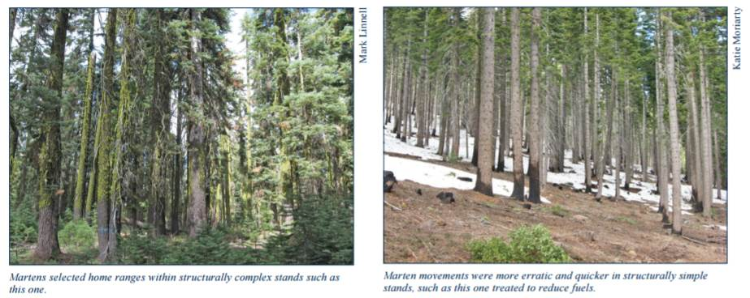
To justify such fuel reduction logging in suitable owl habitat on ecological grounds requires several findings: (1) that wildfire is highly likely to occur at the site of the treatment, (2) that if fire does occur it is likely to be a severe stand-replacing event, and (3) that spotted owls are more likely to be harmed and imperiled by wildfire than by logging at a scale necessary to reduce fire hazard. Available evidence does not support any of these findings, which raises serious questions about the need for and efficacy of logging to reduce fuels in western Oregon and other forests lacking frequent fire return intervals.
The probabilistic element of the risk equation demands careful consideration. Both logging and fire have meaningful consequences, so the issue really boils down to a comparative probabilistic risk assessment where risk is characterized by two quantities: (1) the magnitude (severity) of the possible adverse consequence(s), and (2) the likelihood (probability) of occurrence of each consequence.

Framework for Assessing the Risk of Wildfire vs Fuel Reduction Logging
 | Likelihood of event | Magnitude of harm | Net Benefit
Wildfire | LOW: Stand replacing wildfire is not common in western Oregon. Fire suppression policy prevails. The chance that any given acre of forest will experience wildfire is low. | LOW: The majority of wildfire effects are not stand replacing. Fire is a natural process to which native wildlife are adapted. There is still a deficit of natural fire processes on the landscape. | Fire is likely less harmful to habitat than fuel reduction logging.
Logging | HIGH: To be effective in controlling fire, logging must be very extensive, and sustained. Many more acres would need to be logged than would burn. | HIGH: Widespread logging will have significant impacts on canopy, microclimate, understory vegetation, down wood, and long-term effects on recruitment of large trees and snags. | Fuel reduction logging is likely more harmful to habitat than wildfire.

The white paper is organized around these risk evaluation parameters.

An insurance analogy might help. People buy fire insurance for their homes because they can pay a small amount in order to receive benefits in the improbable event of fire. Fuel reduction logging is like an insurance policy that hedges against the chance that fire might occur, but instead of paying with money we are paying with late successional habitat units (because logging late successional habitat to reduce fuels unavoidably degrades and removes habitat). We are also expecting benefits in habitat units. This means the agency can conduct an analysis to show whether the fire insurance payments are worth it from a habitat perspective. The agency can quantify whether logging results in a greater assurance of habitat maintenance, or not. When this analysis is conducted it is clear that fuel reduction logging is just not worth it, because, simply put, the price of insurance is far too high. Logging will degrade habitat across many acres that will never experience any benefits from modified wildfire. Fuel reduction logging is like paying 100 habitat units for insurance and receiving 10 habitat units of benefits.

In spite of what we often hear, federal forests are not at imminent risk of destruction by wildfire. Fire return intervals remain relatively long, due to both natural factors and active fire suppression policies. Wildfire severity also remains moderate. Most wildfires are NOT stand replacing. Most fires are in fact low and moderate severity.

The location, timing, and severity of future fire events cannot be predicted making it difficult to determine which forests will benefit from treatment - consequently fuel treatments must be extensive and many stands will be treated unnecessarily, thus incurring all the costs of fuel logging, but receiving none of the beneficial effects on fire behavior.

Furthermore, logging for purposes of fuel reduction has impacts on owl and prey habitat that remain under-appreciated, especially the reduction of complex woody structure, and the long-term reduction in recruitment of large snags and dead wood. Fuel reduction logging also has complex effects on fire hazard with potential to increase fire hazard, especially when fuel reduction efforts involve removal of canopy trees. Ganey et al (2017) said “Existing studies on the effects of fuels reduction treatments on spotted owls universally suggest negative effects from these treatments (Meiman et al. 2003, Seamans and Gutiérrez 2007, Stephens et al. 2014a, Tempel et al. 2014).” Ganey, J.L., H.Y. Wan, S.A. Cushman, and C.D. Vojta. 2017. Conflicting perspectives on spotted owls, wildfire, and forest restoration. Fire Ecology 13(3): 146–165. doi: 10.4996/ fireecology.130318020. http://fireecologyjournal.org/docs/Journal/pdf/Volume13/Issue03/ganey-318.pdf

BLM admits that “The treatment of a stand to improve its fire resiliency commonly reduces the immediate value of the stand for northern spotted owls.” BLM 2016. PRMP and FEIS for the Resource Management Plans in Western Oregon. Appendix W - Response to Comments, p 1985. http://www.blm.gov/or/plans/rmpswesternoregon/files/prmp/RMPWO_Vol_4_Appendix_W.pdf

It is important to recognize that forest wildlife evolved in ecosystems with fire so wildfire may not be adverse to wildlife. Bond (2016) reports changing evidence about the effects of fire on the three subspecies of spotted owls.
As spotted owls are associated with dense, late-successional forests, biologists typically assumed that fires that burned at high intensity were similar to clearcut logging and had a negative impact on long-term survival of the species. Many land managers now believe that high-severity fires pose the greatest natural risk to owl habitat (Davis et al., 2016). Fire, however, is a different type of disturbance than logging. Before data were collected from spotted owls in burned forests, it was not unreasonable to assume that high-severity fire might eliminate habitat because it reduces canopy cover, kills trees, and consumes coarse woody debris—all of which comprise important structure for owls and their prey—but current research is revealing that a surprising number of spotted owl sites continue to be occupied and reproductively successful after experiencing fires of all intensities and that populations are quite resilient to fire. Further, spotted owls utilize complex early seral forests for foraging, providing evidence that severely burned forests can benefit spotted owls depending upon its extent and configuration (Bond et al., 2009; Comfort et al., 2016). Spotted owls evolved in landscapes where severe fire was an important component historically (Baker, 2015) …
One reason why spotted owls remain in burned territories is that fire enhances habitat for some of their primary prey species. … Many small mammal species are more abundant in shrub- and herb-dominated habitats, vegetation typical of recently burned complex early seral forests.
…
Conclusions: An Emerging New Paradigm About Spotted Owls and Severe Wildfire
• Most spotted owl pairs generally survive and continue to reproduce in breeding sites that experienced severe fire across the range of the three owl subspecies.
• Lower-quality sites (often vacant and nonreproductive) have lower occupancy with increasing amounts of severe fire, whereas higher-quality sites (occupied and reproductive before fire) remain occupied at similar rates as long-unburned forests, regardless of amount of severe fire.
• Spotted owls nest and roost in forested stands with high canopy cover (unburned/low burned) even in burned landscapes.
• Spotted owls forage in severely burned stands.
• Home-range sizes are similar in burned and unburned landscapes.
• Postfire logging is correlated with site abandonment and reduces survival.
• Studies of spotted owls in burned forests not subjected to postfire logging are necessary in order to separate and understand the relative influence of each disturbance.

Contrary to current perceptions and recovery efforts for the spotted owl (USFWS, 2011, 2012), high-severity fire does not appear to be an immediate, dire threat to owl populations that requires massive landscape-level fuel-reduction treatments to mitigate fire effects (see, eg, Hanson et al., 2009). Empirical studies conducted from 1 to 15 years after fires demonstrate that most burned sites occupied by spotted owl pairs remain occupied and reproductive at the same rates as long-unburned sites, regardless of the amount of high-severity fire in core areas. Burned sites where owls are not detected immediately after fire are often recolonized later, demonstrating the folly of concluding those sites permanently “lost” to spotted owls.
…
Harvesting timber to lower risk of fire has adverse effects on spotted owls (eg, Tempel et al., 2014), whereas fire itself has both costs and benefits depending on many factors. It is important to critically weigh these costs and benefits, especially since spotted owls evolved in landscapes shaped by wildfires (Baker, 2015). Odion et al. (2014) simulated changes in northern spotted owl habitat over a 40-year period following fire and the type of thinning typically proposed by federal land managers. The simulation showed that thinning over large landscapes would remove 3.4–6.0 times more late-successional forest over time in the Klamath and dry Cascades than forest fires would, even given a future increase in the amount of high-severity fire.
Bond, M.L. 2016. The Heat Is On: Spotted Owls and Wildfire. Reference Module in Earth Systems and Environmental Scienceshttp://dx.doi.org/10.1016/B978-0-12-409548-9.10014-4. See also, Lynn N. Schofield, Stephanie A. Eyes, Rodney B. Siegel, Sarah L. Stock. 2020. Habitat selection by spotted owls after a megafire in Yosemite National Park. Forest Ecology and Management, Volume 478, 2020, 118511, ISSN 0378-1127,
https://doi.org/10.1016/j.foreco.2020.118511. (“We examined specific habitat characteristics associated with [California] spotted owl presence before and after the [Rim] fire to understand how fire-induced changes in habitat structure may influence spotted owl territory selection. Spotted owls persisted and nested within the fire perimeter throughout the four post-fire years of our study at rates similar to what we observed in areas of Yosemite that were unaffected by the fire. However, within the fire perimeter, spotted owls avoided areas characterized by >30% percent high severity fire. Prior to the fire, spotted owls selected for areas of high canopy cover relative to the rest of the landscape; after the fire, even though territory centers shifted substantially from pre-fire locations, pre-fire canopy cover remained a stronger predictor of spotted owl presence than post-fire canopy cover, or any other pre- or post-fire habitat variables we assessed.”).

Another study showed that suitable spotted owl habitat is relatively resilient to fire effects.
Pre-fire nesting/roosting habitat had lower probability of burning at moderate or high severity compared to other forest types under high burning conditions. Our results indicate that northern spotted owl habitat can buffer the negative effects of climate change by enhancing biodiversity and resistance to high-severity fires, which are predicted to increase in frequency and extent with climate change. Within this region, protecting large blocks of old forests could be an integral component of management plans that successfully maintain variability of forests in this mixed-ownership and mixed-severity fire regime landscape and enhance conservation of many species.
Lesmeister, D. B., S. G. Sovern, R. J. Davis, D. M. Bell, M. J. Gregory, and J. C. Vogeler. 2019. Mixed-severity wildfire and habitat of an old-forest obligate. Ecosphere 10(4):e02696. 10.1002/ecs2.2696. https://esajournals.onlinelibrary.wiley.com/doi/pdf/10.1002/ecs2.2696.

When all this evidence is put together, it becomes clear that "saving" the spotted owl by logging its habitat to reduce fuels often does not make any sense.

Similar conclusions were reached is several studies, reviews, and expert commentaries, such as:

Lehmkuhl et al. (2015) found -
3. Tradeoffs between fire resistance and NSO habitat quality are real. Our results demonstrate that balancing the goals of increasing fire resilience while maintaining habitat function, especially nesting and roosting, for the NSO in the same individual stand is a difficult, if not an impossible, task. Even lighter thinning treatments typically reduce canopy cover below 40 percent. The reality is that nesting and roosting NSO habitat is by definition very susceptible to high-severity fire; owl habitat value and fire risk are in direct conflict on any given acre. …
Lehmkuhl, John; Gaines, William; Peterson, Dave W.; Bailey, John; Youngblood, Andrew, tech. eds. 2015. Silviculture and monitoring guidelines for integrating restoration of dry mixed-conifer forest and spotted owl habitat management in the eastern Cascade Range. Gen. Tech. Rep. PNW-GTR-915. Portland, OR: U.S. Department of Agriculture, Forest Service, Pacific Northwest Research Station. 158 p. ​http://www.fs.fed.us/pnw/pubs/pnw_gtr915.pdf. The authors, however, made no meaningful attempt to resolve these trade-offs.

Odion et al. 2014, who looked at the relative effects of fire versus thinning and fire on spotted owl habitat in two regions of interest: the Klamath and dry Cascades --
Using empirical data, we calculated the future amount of spotted owl habitat that may be maintained with these rates of high-severity fire and ongoing forest regrowth rates with and without commercial thinning. Over 40 years, habitat loss would be far greater than with no thinning because, under a “best case” scenario, thinning reduced 3.4 and 6.0 times more dense, late-successional forest than it prevented from burning in high-severity fire in the Klamath and dry Cascades, respectively. Even if rates of fire increase substantially, the requirement that the long-term benefits of commercial thinning clearly outweigh adverse impacts is not attainable with commercial thinning in spotted owl habitat. It is also becoming increasingly recognized that exclusion of high-severity fire may not benefit spotted owls in areas where owls evolved with reoccurring fires in the landscape.
…
We found that the habitat recruitment rate exceeded the rate of severe fire by a factor of 4.5 in the Klamath and 10 in the dry Cascades, leading to a deterministic increase in dense forest habitat over time, assuming no other disturbance events. In contrast, previous published assessments of fire on spotted owls have not explicitly considered fire and forest regrowth rates (Wilson and Baker 1998, Lee and Irwin 2005, Roloff et al. 2005, 2012, Calkin et al. 2005, Hummel and Calkin 2005, Ager et al. 2007, Lehmkuhl et al. 2007). Not including the probability of high-severity fire, which is low, leads to highly inflated projections of the effects of thinning versus not thinning on high-severity fire (Rhodes and Baker 2008, Campbell et al. 2012).
Our calculations of thinning effects included rates of forest regrowth along with high-severity fire. The calculations illustrate how the requirement that the long-term benefits of thinning clearly outweigh adverse impacts (USFWS 2011) is not attainable as long as treatments have adverse impacts on spotted owl habitat. This is because the amount of dense, late-successional forest that might be prevented from burning severely would be a fraction of the area that would be thinned.
…
This would not be a concern if thinning effects were neutral, but the commercial thinning prescriptions being implemented call for forests with basal area reduced by nearly half to 13.5-27.5 m2/ha, which is mostly well below the minimum level known to function as nesting and roosting habitat (ca. 23 m2/ha) (Buchanan et al. 1995, 1998). … Even an immediate doubling of fire rates due to climate change or other factors would result in far less habitat affected by highseverity fire than thinning. In addition, much of the highseverity fire might occur regardless of thinning, especially if the efficacy of thinning in reducing high-severity fire is reduced as fire becomes more controlled by climate and weather (Cruz and Alexander 2010). Clearly, the strategy of trying to maintain more dense, late-successional forest habitat by reducing fire does not work if the method for reducing fire adversely affects far more of this forest habitat than would high-severity fire, and the high-severity fire might occur anyway because it is largely controlled by climate and weather.
…
While much of the concern about fire and thinning in dry forests of the Pacific Northwest has focused on spotted owls, it may also apply to other biota associated with dense, old forests, including species of conservation concern, such as Pacific fisher (Martes pennanti pacifica), which research indicates may benefit from mixed-severity fire (Hanson 2013), the Northern Goshawk (Accipiter gentilis), and, following fire, the Black-backed Woodpecker (Picoides arcticus), … Our findings highlight the need to be cautious about conclusions that thinning treatments are needed for species found in dense forest and that they will not have unintended consequences (e.g., Stephens et al.2012) until long-term, cumulative impacts are better understood. As we found with spotted owls, long-term and unintended consequences may be substantial for species that rely on dense, late-successional forests,
Dennis C. Odion, Chad T. Hanson, Dominick. A. DellaSala, William L. Baker, and Monica L. Bond. 2014. Effects of Fire and Commercial Thinning on Future Habitat of the Northern Spotted Owl. The Open Ecology Journal, 2014, 7, 37-51 37. http://benthamopen.com/toecolj/articles/V007/37TOECOLJ.pdf

The Wildlife Society (TWS) peer review of the 2010 Draft Recovery Plan for the Spotted Owl. The draft plan called for extensive logging to reduce fire hazard (“inaction is not an option”). TWS used state-and-transition model to evaluate the effects of opening dry forests to reduce fire hazard versus the effects of wildfire.
The results of running the model with 2/3rds of the landscape treated leads to open forest becoming predominant after a couple of decades, occupying 51 percent of the forested landscape, while mature, closed forest drops to 29 and 24 percent of the Klamath and dry Cascades forests, respectively (Appendix A, Figure 5, shows the Cascades). Treatments that maintain open forests in 2/3rds of the landscape put such a limit on the amount of closed forest that can occur, even if high severity fires were to be completely eliminated under this scenario, there would only be 35 percent of the landscape occupied by closed forests. In contrast, to the extensive treatment scenario, treating only 20 percent of the landscape reduces mature, closed canopy forest by about 11 percent (Appendix A, Figure 6).
One justification for the extensive treatment scenario promoted in the 2010 DRRP is that it is needed because of increased fire hypothesized to occur under climate change. By doubling the rate of high severity fire by 2050 with 2/3rds of the landscape treated, closed canopy forest is reduced to 25 percent in the Klamath compared to 60 percent without treatment and 23 percent in the dry Cascades compared to 54 percent without treatment.
Under what scenario might treatments that open forest canopies lead to more closed canopy spotted owl habitat? The direct cost to close forests with treatments that open them is simply equal to the proportion of the landscape that is treated. This reduction in closed canopy forest can only be offset over time if the ratio of forest regrowth to stand-replacing fire is below 1 (5-8 times more fire than today), and shifts to above 1 with the treatments (and most or all stand replacing fire in treated sites is eliminated, as modeled here). Another scenario that allows closed forests to increase would be if treating small areas eliminated essentially all future stand replacing fire, not only in treated areas, but across the entire landscape. This scenario obviously relies on substantially greater control over fire than is currently feasible, and it would increase impacts of fire exclusion if effective.
…
In sum, to recognize effects of fire and treatments on future amounts of closed forest habitat, it is necessary to explicitly and simultaneously consider the rates of fire, forest recruitment, and forest treatment over time, which has not yet been done by the Service.
…
The potential impacts of fuel treatments on spotted owls are not considered. … We also know little about the impacts of fire, yet this has been treated as a major threat, leading to proposing more fuel treatments. However, it is uncertain at this time which is a bigger threats, fires or treatments to reduce risk of fires. … If the plan intends to use the best available science to describe ongoing impacts to spotted owl habitat, information and literature about disturbances to reduce fuels should be included.
… there has been no formal accounting of how closed canopy forests can be maintained with the widespread treatments that are being proposed.
The Wildlife Society 2010. Peer Review of the Draft Revised Recovery Plan for Northern Spotted Owl. November 15, 2010. http://www.fws.gov/oregonfwo/Species/Data/NorthernSpottedOwl/Recovery/Library/Documents/TWSDraftRPReview.pdf.

This analysis is consistent with the findings of Raphael et al (2013) used a state-and-transition model to explore the effects of landscape fuel reduction logging on spotted owls and found:
Active fuel reduction activities in moderate habitat contributed to substantial short-term (simulation years 0 to 30) population declines under the larger area, higher intensity scenarios. … The combination of BDOW interactions and high-intensity, larger-area treatments contributed to the most substantial NSO population bottlenecks. The combined effects of aggressive fuel reduction treatment approaches and interactions with BDOWs have the potential to contribute to increased extinction risk for NSOs in both analysis areas. … It appears that management regimes that take out owl habitat through treatments (either current or potential future) do not reduce the amount of habitat that is lost to wildfire enough to make up for the habitats lost through treatments.
Principle Investigator: Dr. Martin G. Raphael. Project Title: Assessing the Compatibility of Fuel Treatments, Wildfire Risk, and Conservation of Northern Spotted Owl Habitats and Populations in the Eastern Cascades: A Multi-scale Analysis. JFSP 09-1-08-31 Final Report, Page 19. http://www.firescience.gov/projects/09-1-08-31/project/09-1-08-31_final_report.pdf. This study also highlights the fact that natural landscapes (under the influence of natural forces like climate, photosynthesis, and natural disturbance) have a lot of ecological inertia, and well-intentioned management interventions are unlikely to significantly change the trajectory.

In early 2012, FWS released their proposed rules for spotted owl critical habitat and an announcement of their intention to encourage widespread “active management” within suitable, critical habitat. Fed. Reg. March 8, 2012. http://www.gpo.gov/fdsys/pkg/FR-2012-03-08/pdf/2012-5042.pdf. This brought out critics in the scientific community who call for more rigorous analysis of the consequences before widespread adoption of logging as a means of habitat management.
[W]e are concerned that the decision to move forward with untested “active management” of federally owned forest lands at the landscape level prior to validation through the scientific peer-review process represents a potentially serious lapse in the application of the scientific process. This decision may conflict with the DOI’s scientific integrity policy as well as the mandates of several environmental laws …
…
The Department of the Interior’s Fish and Wildlife Service (FWS) considers active forest management as including those techniques that involve aggressive forest thinning and associated forest canopy reductions in dry forests and modified regeneration harvests in mature moist forests. Given that the primary driver of the spotted owl’s decline has been the destruction of old-growth forest habitat by logging, which will be the means used to achieve the anticipated forest thinning and regeneration harvests, we are especially concerned about the potential habitat impacts of adopting untested “active management” forestry technique. Accordingly, we request that the DOI prepare an Environmental Impact Statement (EIS) under NEPA to provide a rational, scientific approach for the testing of active management forestry in order to ensure that such techniques are validated through the peer-review process prior to their utilization at any commercial or landscape scale in the spotted owl’s critical habitat.
…
The Presidential Memorandum accompanying the proposed critical habitat designation also noted: “on the basis of extensive scientific analysis, areas identified as critical habitat should be subject to active management, including logging in order to produce the variety of stands of trees required for healthy forests. The proposal rejects the more conservative view among conservation biologists that land managers should take a ‘hands off’ approach to such forest habitat in order to promote this species’ health.” We are concerned that this memorandum overstates the quality and quantity of scientific research on the potential benefits of active forest management, especially in the Pacific Northwest on a federally threatened species. In particular, we are unaware of any substantial or significant scientific literature that demonstrates that active forest management enhances the recovery of spotted owls.
…
after a full scientific peer-review of the data collected, the FWS and DOI would be able to make a fully informed decision regarding short- and long-term management of critical habitat. We believe that such an approach is clearly warranted given that the spotted owl is a closed canopy dependent species and active management may degrade habitat for the owl and encourage further expansion of the barred owl. Notably, recent evidence has shown spotted owl extirpation rates related to barred owl invasions are highest for spotted owls with low levels of old growth habitat in nesting areas or high levels of forest fragmentation[fn]. Scaling up logging activities throughout the Pacific Northwest, particularly on BLM lands in western Oregon where “active management” is ostensibly going to be integral to pending resource management plan revisions, is therefore premature and not representative of the best available science.
Society for Conservation Biology, The Wildlife Society, American Ornithologists Union. 4-2-2012 letter to Secretary of Interior Salazar. http://www.eenews.net/assets/2012/04/02/document_gw_01.pdf [fn] citing Dugger, K.M., R.G. Anthony, and L.S. Andrews. 2012. Transit dynamics of invasive competition: barred owls, spotted owls, habitat, and the demons of competition present. Ecological Applications (2011) Volume: 21: 2459-2468.

Part of the problem is that modifying fire behavior requires fuel modification (and habitat modification) across large areas. Charnely et al 2015 said –
… large areas (thousands of acres) must be treated to change fire behavior and reduce its spread and intensity. Randomly-located fuels treatments begin to affect fire behavior when 20 to 30 percent of the landscape is treated (Finney et al. 2007). ... The entire landscape does not need to be treated to reduce wildfire risk, but a significant portion does.
​Charnley, S., Poe, M., Ager, A., Spies, T., Platt, E., Olsen, K.O. 2015. “A Burning Problem: Social Dynamics of Disaster Risk Reduction through Wildfire Mitigation.” Human Organization 74 (4): 329–40. doi:http://dx.doi.org/10.17730/0018-7259-74.4.329.​
http://www.fs.fed.us/pnw/pubs/journals/pnw_2015_charnley003.pdf Fuel treatments must be repeated as the fuels grow back, so this is not a one-time entry. Repeated landscape fuel treatments at this scale will have significant unavoidable effects on owl populations.

There are now webtools available that can help the agencies deal with uncertainty surrounding the efficacy of fuel reduction. For instance, this web-based spreadsheet (http://getguesstimate.com/) allows users to create models with confidence intervals around input variables. Then it runs thousands of Monte Carlo simulations to come up with estimates of model behavior. The agencies could use this to estimate the probability that fuel treatments would interact with fire and provide ecological benefits.

Even back in 1990 scientists were calling for research to determine if logging was compatible with owl conservation. That research has not been done. The Interagency Scientific Committee said “Allow silvicultural treatments that have been tested or demonstrated through experimentation to facilitate the development of suitable habitat, such as planting trees.” 1990 ISC Report, p 325.

Fire and Fuel Analysis
The EA provides a misleading picture of the effects of logging on fires behavior. There is only a small chance that fire will interact with treated stands before the fuels regrow. The NEPA analysis needs to make clear that the actual effects of the action and no action alternatives are almost indistinguishable.

The similarities of the action and no action alternatives also need to be considered when weighing the adverse trade-offs of logging. Is it worth it to emits thousands of tons of carbon, and degrade thousands of acres of spotted owl habitat, and hundreds of acres of riparian habitat, and degrade habitat for snag-associated wildlife for many decades to come, (and add the cumulative effects on perpetual maintenance treatments) when the benefits of fuel reduction are so small? The EA needs to do a better job of comparing the effects of logging and its trade-offs as weighted by their probabilities.

The EA Table 12 says “Surface winds and fuel moistures may increase” as a result of logging. Correction: Fuel moisture would decrease, not increase.

The Wildlife Report (p 5) says “Treatments that reduce the canopy cover to 40 percent will delay the attainment of late seral habitat compared to the no action alternative by as much as 75 to 100 years” Much of this long-term effect will occur in suitable and critical habitat for a Threatened species. This would occur on 1200 acres or more. This is a significant effect requiring an EIS. The FS should consider lighter thinning prescriptions that retains more canopy and better spotted owl habitat. This would also benefit snag habitat and the climate.

Focus on the younger stands, defer the older stands.
Our scoping comments provided a detailed rationale for conserving mature forests. This project does not appear to recognize the significant adverse trade-offs of logging older forests that are already providing late successional habitat and have all the building blocks to continue development of high quality late successional habitat. See our scoping comments and see Doug Heiken 2009. The Case for Protecting Both Old Growth and Mature Forests. Version 1.8 April 2009. https://www.dropbox.com/s/4s0825a7t6fq7zu/Mature%20Forests%2C%20Heiken%2C%20v%201.8.pdf?dl=0.

There might be some ecological benefits from lightly thinning understory trees in dry forests, but large-scale commercial logging in suitable northern spotted owl nesting, roosting, foraging habitat (in critical habitat no less) will cause significant effects and requires consideration in an EIS.

Recent research by Tappeiner, Poage, and others indicates that a substantial portion of a tree’s size and character at several hundred years of age can be explained by the tree’s rate of growth at age 50. This leads to a tentative conclusion that thinning stands younger than 50 years old should be a higher priority than thinning stands older than 50 years.

Recent modeling also “found it difficult to alter the development trajectories of well-established young stands that were first managed at age class 50 [years]” and concluded that earlier intervention would have promoted deeper crowns and lead to greater diameter class differentiation. Andrews, Perkins, Thrailkill, Poage, Tappeiner. 2005. Silvicultural Approaches to Develop Northern Spotted Owl Nesting Sites, Central Coast Ranges, Oregon. West. J. Appl. For. 20(1):13-27.

The 1992 draft recovery plan for the Northern Spotted Owl urged early intervention in young stands because they are more “plastic” before crowns become too small and management option diminish. See 1992 Final Draft recovery plan for the Northern Spotted Owl pp 487-489.

Trees that still have a lot more growing to do are far more likely to respond well to thinning because they can put a lot more growth into their still-developing crowns, whereas older trees that are not expected to grow much higher have much less responsive crowns so will not respond as well to thinning. J.C. Tappeiner II, W.H. Emmingham, and D.E. Hibbs. Silviculture of Oregon Coast Range Forests. Chapter 7 in Forest and Stream Management in the Oregon Coast Range. Edited by Stephen D. Hobbs, John P. Hayes, Rebecca L. Johnson, Gordon H. Reeves, Thomas A. Spies, John C. Tappeiner II, and Gail E. Wells, 2002.

Thinning the harvest units that are less than 50 years old will hopefully have minimal impact on the environment (especially soil, water, and wildlife) and thinning such young stands will likely have long-term ecological benefits in terms of accelerating late successional forest characteristics.

However, thinning the harvest units that are over 50 years old is more likely to have significant environmental impacts and the long-term benefits in terms of accelerating development of late-successional characteristics is uncertain at best. Recent science tells us that thinning in older stands is less likely to change the trajectory of the stands. The agency should refocus its efforts on younger stands where the results are likely to be on balance more beneficial.

There is scientific controversy over the question of whether and to what degree it is beneficial to thin older trees to accelerate late-successional characteristics. An EIS is needed to address this question.

Stimulating the development of a diverse understory is often used as a justification for thinning, but this may not be justified in stands older than about 40 years. A systematic review of 917 Forest Inventory and Analysis (FIA) plots in western Oregon (mostly on non-federal lands) found, “Contrary to expectations of canopy closure, mean canopy cover by age class rarely exceeded 85 percent, even in unthinned productive young conifer forests. Possibly as a result, effects of stand age on understory vegetation were minimal, except for low levels of forbs found in 20- to 40-year-old wet conifer stands. … Although heavily thinned stands had lower total cover, canopy structure did not differ dramatically between thinned and unthinned stands. Our findings suggest potential limitations of simple stand succession models that may not account for the range of forest types, site conditions, and developmental mechanisms found across western Oregon.” McIntosh, Anne C.S.; Gray, Andrew N.; Garman, Steven L. 2009. Canopy structure on forest lands in western Oregon: differences among forest types and stand ages. Gen. Tech. Rep. PNW-GTR-794. Portland, OR: U.S. Department of Agriculture, Forest Service, Pacific Northwest Research Station. 35 p. http://www.fs.fed.us/pnw/pubs/pnw_gtr794.pdf. This seems to indicate that the benefits of thinning may be best realized in dense stands younger than 40 years old. This study also showed that in wet conifer stands the mean Canopy Height Diversity Index and the mean Simpson’s Diversity Index of tree heights leveled off at about age 65. This study also looked at canopy conditions after three levels of thinning intensities (heavy, light, and none). “Mean cover of the lower canopy layer was nominal for all three thinning intensities. … There were no evident trends between understory cover and thinning history; both shrub and forb cover were fairly similar among the three thinning intensities. … The lack of a strong effect of crown closure on understory cover may be related to our finding that mean crown cover did not exceed 85 percent. … We expected greater cover of understory vegetation in thinned than in unthinned stands but did not detect significant differences in this analysis.”

Scientists have also presented findings that many young densely stocked stands may not develop into late-successional stands as projected in the Northwest Forest Plan. This is new information that must be addressed in a new EIS to consider the consequences of more thinning of young stands (or the lack thereof) on spotted owls and all the other species dependent upon late-successional habitat.

The NEPA analysis should have a good discussion (in light of recent research results) of the anticipated impacts and benefits of thinning on the different age classes of trees in the different harvest units. The NEPA analysis should include another alternative that considered deferring harvest of the older stands.

“Within stands … lacking in late-successional habitat, those stands that would respond to treatment by accelerated development into late-successional habitat. Younger stands are generally more responsive to treatment, and should be considered higher priority than older mid-successional stands, relative to this objective.” Shasta-Trinity Forest-wide LSR Assessment. 8-26-1999.

A study of the effects of thinning on tree stability and height/diameter ratios found:
The results suggest that plantation H/D values can be lowered and stability promoted through reduced planting densities or early thinning; however, later thinnings may not be effective in promoting stability, since they do not appear to lower H/D values. Higher initial planting densities shorten the time period during which thinning can be expected to effectively lower future H/D values. … [H]igh density stands have limited stand-height window during which thinning can be used to improve future stand stability substantially.
Wilson, J.S., and C.D. Oliver. 2000. Stability and Density Management in Douglas-fir Plantations, Can. J. For. Res. 30(6): 910-920 (2000).

See Muir, P.S., R.L. Mattingly, J.C. Tappeiner II, J.D. Bailey, W.E. Elliott, J.C. Hagar, J.C. Miller, E.B. Peterson, and E.E. Starkey. 2002. Managing for biodiversity in young Douglas-fir forests of western Oregon. U.S. Geological Survey, Biological Resources Division, Biological Science Report USGS/BRD/BSR–2002-0006. 76 pp. http://www.fsl.orst.edu/cfer/pdfs/mang_bio.pdf.

The Eugene BLM described the expected result of thinning a dense stand of 77 year old Douglas-fir—
Thinning … by itself, would not speed development of late-successional forest structure. Thinning would retain a relatively high overstory density and would result in only a modest increase in diameter growth of the retained trees. Additional thinning or other disturbance that would substantially lower overstory density would be needed before the stand would develop late-successional structure, such as multiple canopy layers, shade-tolerant conifer understory, or a wide range of tree diameters (Spies and Franklin 1991; see also BLM 2003, pp. 66-69, 171-174).
Eugene BLM. Bear Creek Timber Sale EA, April 2004. http://www.edo.or.blm.gov/planning/nepa/documents/BearCrkEA.pdf (link broken 7/31/2012).

The age at which a forest is thinned has a strong effect on aboveground C storage. Evidence from the few PCT studies that considered timing of thinning shows that total stem volume, which is a large component of the aboveground C (Harmon et al., 2004), is greater in stands thinned early as compared to stands thinned later (Varmola and Salminen, 2004). This is consistent with stand dynamics theory, which suggests that wood volume growth rates recover more quickly from early thinnings than from late thinnings (Oliver and Larson, 1996; Long et al., 2004; Varmola and Salminen, 2004).
Michael S. Schaedel, Andrew J. Larson, David L.R. Affleck, R. Travis Belote, John M. Goodburn, Deborah S. Page-Dumroese. 2017. Early forest thinning changes aboveground carbon distribution among pools, but not total amount. Forest Ecology and Management 389 (2017) 187–198. https://www.fs.fed.us/rm/pubs_journals/2017/rmrs_2017_schaedel_m001.pdf.

All logging, including thinning stands of any age, include some adverse impacts and trade-offs. Some impacts of logging are unavoidable, so there is no such thing as a logging operation that is 100% beneficial. Depending on how thinning is done thinning can have adverse impacts such as soil disturbance, habitat disturbance, carbon removal, spreading weeds, reduced recruitment of snags, road-related erosion and hydrologic impacts, moving fuels from the canopy to the ground, hotter-drier-windier microclimate that is favorable to greater flame lengths and rate of fire spread, etc. Some of these negative effects are fundamentally unavoidable, therefore all thinning has negative effects that must be compensated by beneficial effects such as reducing competition between trees so that some can grow larger faster, increased resistance drought stress and insects, increasing species diversity, possible fire hazard reduction, etc. It is generally accepted that when thinning very young stands, the benefits outweigh the adverse impacts and net benefits are likely. It is also widely understood that thinning older stands tends to have greater impacts on soil, water, weeds, carbon, dead wood recruitment so the impacts very often outweigh the benefits, resulting in net negative ecological outcome on the balance sheet. As we move from young forest to older forests, the net benefits turn into net negative impacts, but where is that line? The authors of the Northwest Forest Plan took all this into account and determined that 80 years is a useful place to draw the line between forests that are likely to benefit from silviculture and those that are likely to experience net negative consequences. There is no new science to change that conclusion. In fact, new information developed since 1994 shows that dead wood is probably more valuable than previously thought - being important for a wide variety of ecological functions, not least of which is providing complex habitat that supports prey species for spotted owl and a variety of other predators both east and west of the Cascades. As stands become mature at around 80 years of age, they begin accumulating snags and dead wood from natural mortality processes. Thinning “captures mortality” and removes it from the forest thus preventing those trees from ever becoming snags and dead wood and interrupting the critical process whereby mature forests accumulate dead wood. The loss of recruitment of dead wood habitat when logging older stands is a long-term impact and provides a very strong argument against logging in stands over 80 years old. For further information see 1993 SAT Report pp 146-152. AND February 1991 Questions and Answers on A Conservation Strategy for the Northern Spotted Owl (prepared in response to written questions from the Senate Energy and Natural Resources Committee to the Interagency Scientific Committee on the May 1990 ISC Report. AND Jerry Franklin, David Perry, Reed Noss, David Montgomery, Christopher Frissell. SIMPLIFIED FOREST MANAGEMENT TO ACHIEVE WATERSHED AND FOREST HEALTH: A CRITIQUE. National Wildlife Federation. https://web.archive.org/web/20061008082841/http://www.coastrange.org/documents/forestreport.pdf.

Robert Anthony reminded the regional executives in 2013 that:
The long-term benefits of thinning in young plantations to create forests with characteristics of late-successional forests (e.g. large diameter standing and down wood) may outweigh any short-term negative effects on owls or their prey. However, as the age of forests selected for thinning increases, the short-term negative effects of such activities will likely increase and the benefits decrease. The Northwest Forest Plan specified a maximum age of 80 years for forests that are slated for thinning. The reasons for this guideline were that (1) it was unclear if thinning could actually accelerate the rate at which naturally regenerated mature forests developed old forest conditions, and (2) spotted owls forage in mature forests, and thinning of these forests will likely reduce their quality as spotted owl habitat both in the short and long term.
Anthony, R.G. 2013. “Effects of Riparian Thinning on Marbled Murrelets and Northern Spotted Owls.” Part III of the Science Review Team for the identification and interpretation of the best available scientific information to determine effects of riparian forest management. 28 January 2013.

Another study that supports the emphasis on early intervention is Peter, David H.; Harrington, Constance A. 2010. Reconstructed old-growth forest stand structure and composition of two stands on the Olympic Peninsula, Washington state. Res. Pap. PNW-RP-583. Portland, OR: U.S. Department of Agriculture, Forest Service, Pacific Northwest Research Station. 22 p. http://www.fs.fed.us/pnw/pubs/pnw_rp583.pdf (“These sites appear to have multiple developmental pathways determined by events early in their stand histories that affect stand structure and composition for hundreds of years. This has implications for the possibilities of, and methodologies for, restoration of old-growth structure and function. But, naturally or through silvicultural manipulation, diversification in at least these plant associations is encouraged by lower early conifer density, patchy spacing of dominant trees, and prevention of immediate conifer occupancy of openings.”)

The Purpose and Need Should Address The Unmet Need for Carbon Storage

The agency typically says one of the purposes of this project is to provide a supply of wood products to the public. The agency should reconsider timber targets in light of the fact that the public needs carbon storage to reduce global climate change much more than they need wood products. The NEPA analysis also needs to account for the fact that managing forests for water quality, water quantity, quality of life, and carbon storage for a stable climate will contribute far more to community stability than propping up the timber boom-bust industry with subsidized logging.

The agency must recognize that wood products are already under-priced and over-supplied due to “externalities” (costs that are not included in the price of wood, so those costs are shifted from wood product producers and consumers to the general public who suffer the consequences of climate change without compensation from those who profit from logging related externalities). Ecosystem carbon storage on the other hand is under-supplied because there is not a functioning market for carbon storage and climate services. The agency is in a position to address these market imperfections by focusing on unmet demand for carbon storage instead of offering wood products that are already oversupplied.

Land protection, both public and private, provides substantial ecological benefits by avoiding conversion of natural systems to intensive, developed uses. These benefits include carbon sequestration, watershed functioning, soil conservation, and the preservation of diverse habitat types (e.g., Daily 1997, Brauman et al. 2007, Kumar 2012, Watson et al. 2014). Land protection also solves a key market failure: private markets tend to underprovide socially beneficial land uses such as natural forests, agricultural lands, or managed timberlands. The reason for this failure is that many of the benefits of these lands go to the public in general, not individual landowners. When private values and market transactions determine land uses, less land will be devoted to socially beneficial uses than if citizens could collectively determine use on the basis of social values (e.g., Angelsen 2010, Tietenberg and Lewis 2016).
Katharine R.E. Sims, Jonathan R. Thompson, Spencer R. Meyer, Christoph Nolte, Joshua S. Plisinski. 2019. Assessing the local economic impacts of land protection. Conservation Biology. 26 March 2019 https://doi.org/10.1111/cobi.13318, https://harvardforest.fas.harvard.edu/sites/default/files/Sims_et_al-2019-Conservation_Biology.pdf.

Maintaining and increasing carbon storage in ecosystems on public lands is also required to meet LRMP desired future conditions and standards & guidelines. Carbon emissions from logging and other land management activities exacerbate global climate change and drive ecosystem changes that diverge from desired future conditions, such as uncharacteristic drought, fire, insect outbreaks, vegetation and wildlife mortality, species range shifts, low summer stream flows, unfavorable stream temperatures, extreme precipitation and peak flows and erosion, uncertainty related to vegetation recovery post-disturbance, uncertainty about the ability to provide a predictable, sustainable supply of forest products, etc. The agency should identify a purpose and need that recognizes the necessity of avoiding carbon emissions from logging and optimizing carbon storage to fulfill the promises in the LRMP.

Carbon Emissions from Logging
The EA analysis repeats the same deeply flawed boilerplate that all Region 6 timber sale NEPA analysis suffer from. Oregon Wild’s 8-14-2019 scoping comments clearly describes several of these problems (and why the analysis is flowed) but the EA did not make any effort to correct these problems.

For instance, the EA essentially says this carbon emissions caused by logging under this project are no big deal in the grand scheme of things, but we explained in our scoping comments why the FS cannot dismiss the relatively small contribution of this project to the problem of global climate change because global climate change is caused by cumulative effects. Every activity could make the same excuse that they are just a small part of the problem and it would never get addressed.

In addition, the EA says that logging emissions caused by this project are “justified” because logging will reduce carbon emissions from fire and other disturbances. This is not supported by the best available science. Our scoping comments explained why in great detail:
Logging proponents often claim that logging will increase carbon storage controlling carbon emissions caused by natural processes such as fire and insect-induced mortality.

This is simply counter-factual. In most cases, managing forests in an effort to control natural processes that release carbon will only make things worse by releasing MORE carbon. This is mostly because no one can predict where fire or insects will occur, so the treatments must be applied to broad landscapes, yet the probability of fire or insects at any given location remains low, and only a small fraction of the treated areas will actually experience fire or insects. As a result, many acres will be treated "unnecessarily" and therefore the cumulative carbon emissions from logging to control fire and insects (plus the carbon emissions from fire and insects that occur in spite of control efforts) are greater than emissions from fire and insects alone. A careful analysis shows that logging to control fire and expecting to increase carbon storage is analogous to rolling a die and expecting to roll a six every time.

This is an example of the “base rate fallacy” or “neglecting priors” from Bayesian statistics. The probability of a forest stand NOT burning are far greater than the probability of a forest stand burning. Attempts to address a problem that is unlikely to occur, such as by thinning a forest that is unlikely to burn, runs a high risk that unintended negatives effects will overwhelm beneficial effects. https://en.wikipedia.org/wiki/Base_rate_fallacy

The 2018 US Forest Service Northwest Forest Plan Science Synthesis concluded that fuel reduction is unlikely to be an effective climate mitigation strategy.
Some studies from other regions in the Western United States (i.e., the Southwest and Sierra Nevada) suggest that thinning and fuel reduction can mitigate carbon loss from fire. Fuel reduction may reduce losses of carbon at stand levels compared with the consequences of high-severity wildfire burning in stands with high fuel loads (Finkral and Evans 2008; Hurteau and North 2009; Hurteau et al. 2008, 2011, 2016; North and Hurteau 2011; North et al. 2009, Stephens et al. 2009). However, because the probability of treated areas burning is generally low (Barnett et al. 2016), and most biomass is not consumed by fire, slight differences in losses resulting from combustion in fire compared with losses from fuel reduction are unlikely to make fuel reduction a viable mitigation strategy (Ager et al. 2010, Campbell et al. 2012, Kline et al. 2016, Mitchell et al. 2009, Restaino and Peterson 2013, Spies et al. 2017).
USDA 2018. Synthesis of Science to Inform Land Management Within the Northwest Forest Plan Area. General Technical Report. PNW-GTR-966 Vol. 1. June 2018. https://www.fs.fed.us/pnw/pubs/pnw_gtr966_vol1.pdf.

Law & Harmon (2011) conducted a literature review and concluded …
Thinning forests to reduce potential carbon losses due to wildfire is in direct conflict with carbon sequestration goals, and, if implemented, would result in a net emission of CO2 to the atmosphere because the amount of carbon removed to change fire behavior is often far larger than that saved by changing fire behavior, and more area has to be harvested than will ultimately burn over the period of effectiveness of the thinning treatment.
Law, B. & M.E. Harmon 2011. Forest sector carbon management, measurement and verification, and discussion of policy related to mitigation and adaptation of forests to climate change. Carbon Management 2011 2(1). https://content.sierraclub.org/ourwildamerica/sites/content.sierraclub.org.ourwildamerica/files/documents/Law%20and%20Harmon%202011.pdf.

Campbell and Agar (2013) conducted a sensitivity analysis and found robust results indicating that fuel reduction does not increase forest carbon storage.
… we attempt to remove some of the confusion surrounding this subject by performing a sensitivity analysis wherein long-term, landscape-wide carbon stocks are simulated under a wide range of treatment efficacy, treatment lifespan, fire impacts, forest recovery rates, forest decay rates, and the longevity of wood products. Our results indicate a surprising insensitivity of long-term carbon stocks to both management and biological variables. After 80 years, … a 1600% change in either treatment application rate or efficacy in arresting fire spread resulted in only a 10% change in total system carbon. This insensitivity of long-term carbon stocks is due in part by the infrequency of treatment/wildfire interaction and in part by the controls imposed by maximum forest biomass. None of the fuel treatment simulation scenarios resulted in increased system carbon.
Campbell, J, Agar, A (2013) Forest wildfire, fuel reduction treatments, and landscape carbon stocks: A sensitivity analysis. Journal of Environmental Management 121 (2013) 124-132 http://fes.forestry.oregonstate.edu/sites/fes.forestry.oregonstate.edu/files/PDFs/Campbell_2013_JEM.pdf
[… and much more …]

As explained below, the Forest Service’s standardized NEPA language regarding carbon and climate change fails to take a hard look that NEPA requires. The analysis makes several highly misleading statements about managing forests for carbon storage, climate resilience, and the effects on climate change. The analysis inappropriately mischaracterizes the role of individual logging projects in the cumulative problem of global GHG emissions. The analysis misstates the effects of logging related carbon emissions that are not related to “deforestation.” The analysis grossly misstates the climate effects of logging intended to reduce disturbance. The analysis misleadingly implies that logging benefits the climate by increasing forest productivity.

The NEPA analysis should consider the adverse climate consequences of GHG emissions caused directly and indirectly by logging. The Forest Service should not rely on the boilerplate NEPA language from the regional office which is flawed in many ways. Instead the Forest Service:
- Must recognize the cumulative nature of the GHG emissions and climate problems. It does not matter that this project is small in the global scheme because all emissions matter when the causation is global and cumulative;
- Cannot credibly assert that this project is harmless because it’s not causing deforestation. This is immaterial. All GHG emissions, regardless of the source or how it is labelled, are part of the problem and cause the same climate impacts.
- Cannot credibly assert that thinning for forest health justifies or mitigates emissions from logging. Logging does not increase the capacity for growing trees. To the contrary, logging harms soil and reduces site productivity. Storing carbon in wood products is not preferable to storing carbon in forests. Evidence shows that forests are a more secure way of storing carbon. If this forest is not logged, or if more green tree are retained in situ, the agency cannot conclude that natural mortality will be greater than logging mortality. In fact, it is quite easy to predict that logging causes significantly more mortality than natural processes.
- Must not compare carbon before and after logging. That is an improper framework for NEPA analysis. The proper NEPA framework is to compare the effects of different alternatives (over time), so the agency must describe the carbon emissions and carbon storage in the forest over time with logging and without logging.
- Logging to reduce fire effects does not result in a net increase in forest carbon storage. The agency cannot predict the location, timing, or severity of future wildfires, so most fuel treatments will cause carbon emissions without any offsetting benefits from modified fire behavior. Studies clearly show that the total carbon emissions from logging (plus unavoidable wildfire) are greater than carbon emissions from wildfire alone.
- Cannot credibly assert that carbon storage in wood products is a useful climate strategy. Logging kills trees, stops photosynthesis, and initiates decay and combustion, with the end result being a significant transfer of carbon from the forest to the atmosphere. In stark contrast, an unlogged forest continues to grow and transfer more carbon from the atmosphere to the forest. Carbon emissions caused by logging far exceed the small fraction of carbon transferred to wood products. Carbon accounting methods that attempt to account for substitution of wood for other high-carbon building materials are fraught with uncertainty and too often represent maximum potential substitution effects rather than lower realistic estimates.

Forest Degradation just as bad as Deforestation

The agency often says “This project does not fall within any of these main contributors of greenhouse gas emissions. … The main activity in this [forestry] sector associated with GHG emissions is deforestation, which is defined as removal of all trees, most notably the conversion of forest and grassland into agricultural land or developed landscapes (IPCC 2000).” The agency is again minimizing the effects of its activities and avoiding its dual responsibilities to produce accurate NEPA analysis and help store carbon in forests. All emissions are a problem. Categories do not really matter. The atmosphere sees each molecule of CO2 and other GHG equally. Climate authorities recognize “forest degradation” is just as bad as deforestation. In fact, the urgency to maintain and enhance biogenic terrestrial carbon stores has long been recognized and is reflected in the inclusion of the land sector in the report of the United Nations Framework Convention on Climate Change (UNFCCC). The official title of UN program related to reducing GHG emissions from land use includes the words deforestation AND “forest degradation” i.e., Reducing Emissions from Deforestation and Forest Degradation (REDD). This clearly refutes the agency’s assertion that forest management activities that fall short of deforestation are not among the categories of concern regarding global GHG emissions.

The Copenhagen Accord recognizes the need to avoid dangerous climate change and the role of forests in climate mitigation.
“…To achieve the ultimate objective of the Convention to stabilize greenhouse gas concentration in the atmosphere at a level that would prevent dangerous anthropogenic interference with the climate system, we shall, recognizing the scientific view that the increase in global temperature should be below 2 degrees Celsius … enhance our long-term cooperative action to combat climate change. We recognize the crucial role of reducing emission from deforestation and forest degradation and the need to enhance removals of greenhouse gas emission by forests and agree on the need to provide positive incentives to such actions”
http://www.climatesciencewatch.org/file-uploads/Copenhagen_Accord.pdf. This likely requires reducing atmospheric CO₂ concentrations below 350 ppm and avoiding logging that would increase atmospheric carbon emissions. Boucher, D., and K. Belletti-Gallon, 2015. Halfway There? What the Land Sector Can Contribute to Closing the Emissions Gap. Union of Concerned Scientists. http://www.ucsusa.org/sites/default/files/attach/2015/01/ucs-halfway-there-2015-full-report.pdf (“Enormous amounts of carbon are released into the atmosphere when forests are cleared. “Forest degradation” activities, such as selective logging, … are also significant emissions sources.”)

Forest degradation should be defined from a climate change perspective to include any human land-use activity that reduces the carbon stocks of a forested landscape relative to its carbon carrying capacity. The climate change imperative demands that we take a fresh look at our forest estate. The carbon impacts of all land uses, including commercial logging, must be brought explicitly into our calculations in terms of their direct and indirect effects on forest degradation.
Brendan G. Mackey, Heather Keith, Sandra L. Berry and David B. Lindenmayer. 2008. Green Carbon: The role of natural forests in carbon storage. Part 1. A green carbon account of Australia’s south-eastern Eucalypt forests, and policy implications. Australian National University. http://epress.anu.edu.au/green_carbon/pdf/whole_book.pdf.

The agency must account for all forest carbon loses, not just from deforestation, but also degradation. Sophie Yeo 2015. Blog - Forest degradation as bad for climate as deforestation, says report. 08 Apr 2015, http://www.carbonbrief.org/blog/2015/04/forest-degradation-as-bad-for-climate-as-deforestation,-says-report/

​A study by Erb et al (2017) shows that deforestation represents only about half of the cumulative carbon emissions from land use. Most of the other half is from forest degradation. ​
Scientists just presented a sweeping new estimate of how much humans have transformed the planet
By Chris Mooney, Washington Post
December 20 , 2017
https://www.washingtonpost.com/news/energy-environment/wp/2017/12/20/scientists-present-a-sweeping-new-estimate-of-how-much-humans-have-altered-the-planet/
...
Razing forests or plowing grasslands puts carbon in the atmosphere just like burning fossil fuels does.
Now, new research provides a surprisingly large estimate of just how consequential our treatment of land surfaces and vegetation has been for the planet and its atmosphere.
...
[T]he study also presented an even larger and perhaps more consequential number: 916 billion tons. That’s the amount of carbon, the research calculated, that could reside in the world’s vegetation — so not in the atmosphere — if humans somehow entirely ceased all uses of land and allowed it to return to its natural state. The inference is that current human use of land is responsible for roughly halving the potential storage of carbon by that land.
...
The study found that there are two far-less-recognized components of how humans have subtracted from Earth’s potential vegetation — and that in combination they are just as substantial as deforestation. Those are large-scale grazing and other uses of grasslands, as well as forest “management.” With the latter, many trees and other types of vegetation are subtracted from forests — often the larger and older trees due to logging — but the forests as a whole don’t disappear. They’re just highly thinned out.
“This effect is quite massive, more massive than we expected actually,” Erb said.
...
The research means that so-called degraded land — not fully deforested but not “natural” or whole, either — is a phenomenon to be reckoned with.
“It suggests that the amount of carbon released to the atmosphere from land use is approximately equal to the amount still retained,” said Tom Lovejoy, an ecologist at George Mason University who was not involved in the work. “That means the restoration agenda is even more important than previously thought and highlights the enormous amount of degraded land in the world.”
...
“Scenarios that limit global warming to 1.5 or 2 degrees [Celsius] require not only rapid cessation of greenhouse gas emissions but also removal of somewhere between about 100 and 300 billion tons of carbon from the atmosphere,” Phil Duffy, president of the Woods Hole Research Center, said in an email.
“This paper suggests that restoring vegetation around the world could in principle achieve that,” Duffy continued, noting that if all the potential vegetation were restored it would offset some 50 years of global carbon emissions. While “the full theoretical potential will never be realized in practice … this paper indicates that restoring vegetation could make an extremely important contribution to controlling global climate change.”
See Karl-Heinz Erb et al. 2017. Unexpectedly large impact of forest management and grazing on global vegetation biomass. Nature. Published online 20 Dec 2017. doi:10.1038/nature25138.
https://www.nature.com/articles/nature25138.epdf

Arneth et al (2017) showed that global vegetation models often make unrealistic assumptions about forests (such as that areas maintained in forest cover suffer no decline in carbon storage) and therefore underestimate both the carbon flux from logging as well as the carbon benefits of forest conservation.
… Dynamic global vegetation model simulations suggest that CO2 emissions from land-use change have been substantially underestimated because processes such as tree harvesting and land clearing from shifting cultivation have not been considered. As the overall terrestrial sink is constrained, a larger net flux as a result of land-use change implies that terrestrial uptake of CO2 is also larger, and that terrestrial ecosystems might have greater potential to sequester carbon in the future. Consequently, reforestation projects and efforts to avoid further deforestation could represent important mitigation pathways, with co-benefits for biodiversity. …
…
Wood Harvesting
Until recently, global DGVM studies that accounted for LULCC concentrated on the representation of conversion of natural lands to croplands and pastures, whereas areas under forest cover were represented as natural forest, and hence by each model’s dynamics of establishment, growth and mortality. Two-thirds to three-quarters of global forests have been affected by human use, which is mainly due to timber harvest; but forests are also a source of firewood or secondary products; or used for recreational purposes13. Between 1700 and 2000 an estimated 86 PgC has been removed globally from forests due to wood harvesting (WH)14. WH leads to reduced carbon density on average in managed forests15 and can ultimately result in degradation in the absence of sustainable management strategies. Furthermore, the harvesting of wood can reduce litter input, which lowers soil pools13. Bringing a natural forest under any harvesting regime probably will lead to net-CO2 emissions to the atmosphere — with a magnitude and time-dependency conditional on harvest intensity and frequency, regrowth and the fate and residence time of the wood products.

Impacts of land-management processes on the carbon cycle
The few published DGVM studies that account for the management of land more realistically16,19–21 consistently suggest a systematically larger FLULCC over the historical period compared to estimates that ignored these processes, with important implications for our understanding of the terrestrial carbon cycle and its role for historical (and future) climate change. …
…
Implications for the future land carbon mitigation potential
Our calculated increases in FLULCC, in absence of a clear understanding of the processes underlying FRL, notably strengthen the existing arguments to avoid further deforestation (and all ecosystem degradation) — an important aspect of climate change mitigation, with considerable co-benefits to biodiversity and a broad range of ecosystem service supply.
Arneth, A., Sitch, S., Pongratz, J. et al (2017) Historical carbon dioxide emissions caused by land-use changes are possibly larger than assumed. NATURE GEOSCIENCE | VOL 10 | FEBRUARY 2017. http://bstocker.net/wp-content/uploads/2016/09/arneth17natgeo.pdf.

When forest carbon accounting looks only at forest clearing, significant forgone carbon sequestration caused by forest degradation are overlooked. “[N]ew research shows that we should be taking much better care of our last great intact forests because doing so has remarkable climate benefits. ... A single episode of serious damage can lead to decades of ‘lost earnings’ in the carbon accounts.” Tom Evans, Sean Maxwell 2019. The Carbon Bomb - A new report shows that deforestation released a shocking 626 percent more CO2 between 2000 and 2013 than previously thought. Scientific American. November 8, 2019. https://blogs.scientificamerican.com/observations/the-carbon-bomb/ citing Sean L. Maxwell, Tom Evans, James E. M. Watson et al 2019. Degradation and forgone removals increase the carbon impact of intact forest loss by 626%. Science Advances 30 Oct 2019: Vol. 5, no. 10, eaax2546. DOI: 10.1126/sciadv.aax2546. https://advances.sciencemag.org/content/5/10/eaax2546. (“[W]e encourage national governments to better account for the full carbon impact of intact forest retention. For example, emission baselines that account for selective logging and other more cryptic degradation processes would reduce the disproportionate emphasis on recent forest clearance”).

Logging Does Not Increase Capacity for Growing Trees

The NEPA analysis suggests that logging will increase forest productivity, but there is no evidence that this is true. The agency often says “Projects like the proposed action that create forests or improve forest conditions and capacity to grow trees are positive factors in carbon sequestration.”
“I am unaware of a single study, or plausible mechanism, by which tree removal increases stand-level productivity (and by extension carbon stocks). For instance, the CFCP fairly cites Battles et al. (2015) as empirical evidence that thinned forests can “within a decade or two” regain the carbon lost due to the removal of smaller trees, but fails to acknowledge that the un-thinned control forests in this same study continued to grow over this period and, at all times, contained more carbon that the thinned ones. Even when one considers the protection thinning affords forests from carbon losses in high-severity fire, thinned forests contain less carbon over space and time than do fire suppressed ones (provided conditions afford timely post-fire regeneration). Such is well-established in several reviews of the subject, all of which are notable missing from the CFCP citations (Campbell et al., 2012; Restaino and Peterson 2013; Young, 2015; Kalies and Kent 2016 ).”
Campbell, J.L. 2017, Comments on the Jan 2017 draft California Forest Carbon Plan. http://www.fire.ca.gov/fcat/downloads/FCAT_PublicComment/Campbell_CFCP_Review_Final-2nd.pdf. The “capacity to grow trees” (i.e., net ecosystem productivity) on this landscape will actually be adversely affected by the proposed action to the extent the FS builds roads, compacts soil, removes biomass, etc.

Law et al (2013) showed that logging to address climate change does not increase forest productivity. Beverly E. Law, Tara W. Hudiburg & Sebastiaan Luyssaert (2013): Thinning effects on forest productivity: consequences of preserving old forests and mitigating impacts of fire and drought, Plant Ecology & Diversity, 6:1, 73-85 http://dx.doi.org/10.1080/17550874.2012.679013;
https://terraweb.forestry.oregonstate.edu/sites/terraweb/files/Law_PED13.pdf (“The regional analysis indicates that proposed climate change mitigation actions to reduce impacts in Pacific Northwest US forests that included a treatment of sparing mesic mature forests, clear-cutting mesic young forests (<50 years, reducing harvest cycle from 80 to 50 years, which is already being planned) and thinning all age classes of dry forests to minimise drought and fire impacts on carbon (<650 mm precipitation per year) resulted in a 29% decrease in NPP over the 20-year treatment period compared with NPP resulting from current practices. … The zero-order estimate of fire-induced loss in NPP (11%) was less than that of large-scale prevention of forest fires (12.5%) over the 20-year treatment period (Sparing/Sharing treatment for dry forest only) … This and other studies suggest that the net effect of thinning the drier forests would be reduced NPP compared with NPP after fires”).

In the context of carbon and climate change, the agency cannot define “improve forest conditions” in way that justifies logging that increases GHG emissions at the expense of maintaining forest carbon storage.

Also, this project will cause far more tree mortality by logging than would be avoided via natural mortality. See discussion in DeCicco J.M. 2013. Biofuel’s carbon balance: doubts, certainties and implications. Climatic Change (2013) 121:801–814. DOI 10.1007/s10584-013-0927-9 http://download.springer.com/static/pdf/522/art%253A10.1007%252Fs10584-013-0927-9.pdf?auth66=1398528430_ad123a71083ade45750f8bec9a091a43&ext=.pdf (“A first-order model shows that biofuels are beneficial only to the extent that their production effectively enhances net ecosystem production.”).

Where clear-cutting of long-established virgin forest is followed by the establishment of commercial plantation forests or agroforestry systems, it is doubtful that the C released to the atmosphere will ever be fully recovered within the ecosystem.
Matthews R.W. et al. (1996) WG3 Summary: Evaluating the role of forest management and forest products in the carbon cycle. In: Apps M.J., Price D.T. (eds) Forest Ecosystems, Forest Management and the Global Carbon Cycle. NATO ASI Series (Series I: Global Environmental Change), vol 40. Springer, Berlin, Heidelberg. http://www.sysecol2.ethz.ch/pdfs/Ma121-lq.pdf

William R. Moomaw, Susan A. Masino, and Edward K. Faison. 2019. Intact Forests in the United States: Proforestation Mitigates Climate Change and Serves the Greatest Good Front. For. Glob. Change, 11 June 2019 | https://doi.org/10.3389/ffgc.2019.00027; https://www.frontiersin.org/articles/10.3389/ffgc.2019.00027/full (“ABSTRACT: Climate change and loss of biodiversity are widely recognized as the foremost environmental challenges of our time. Forests annually sequester large quantities of atmospheric carbon dioxide (CO2), and store carbon above and below ground for long periods of time. Intact forests—largely free from human intervention except primarily for trails and hazard removals—are the most carbon-dense and biodiverse terrestrial ecosystems, with additional benefits to society and the economy. Internationally, focus has been on preventing loss of tropical forests, yet U.S. temperate and boreal forests remove sufficient atmospheric CO2 to reduce national annual net emissions by 11%. U.S. forests have the potential for much more rapid atmospheric CO2 removal rates and biological carbon sequestration by intact and/or older forests. The recent 1.5 Degree Warming Report by the Intergovernmental Panel on Climate Change identifies reforestationand afforestation as important strategies to increase negative emissions, but they face significant challenges: afforestation requires an enormous amount of additional land, and neither strategy can remove sufficient carbon by growing young trees during the critical next decade(s). In contrast, growing existing forests intact to their ecological potential—termed proforestation—is a more effective, immediate, and low-cost approach that could be mobilized across suitable forests of all types. Proforestation serves the greatest public good by maximizing co-benefits such as nature-based biological carbon sequestration and unparalleled ecosystem services such as biodiversity enhancement, water and air quality, flood and erosion control, public health benefits, low impact recreation, and scenic beauty. ... Proforestation produces natural forests as maximal carbon sinks of diverse species (while supporting and accruing additional benefits of intact forests) and can reduce significantly and immediately the amount of forest carbon lost to nonessential management. Because existing trees are already growing, storing carbon, and sequestering more carbon more rapidly than newly planted and young trees (Harmon et al., 1990; Stephenson et al., 2014; Law et al., 2018; Leverett and Moomaw, in preparation), proforestation is a near-term approach to sequestering additional atmospheric carbon: a significant increase in “negative emissions” is urgently needed to meet temperature limitation goals. The carbon significance of proforestation is demonstrated in multiple ways in larger trees and older forests. For example, a study of 48 undisturbed primary or mature secondary forest plots worldwide found, on average, that the largest 1% of trees [considering all stems ≥1 cm in diameter at breast height (DBH)] accounted for half of above ground living biomass (The largest 1% accounted for ∼30% of the biomass in U.S. forests due to larger average size and fewer stems compared to the tropics) (Lutz et al., 2018). Each year a single tree that is 100 cm in diameter adds the equivalent biomass of an entire 10–20 cm diameter tree, further underscoring the role of large trees (Stephenson et al., 2014). Intact forests also may sequester half or more of their carbon as organic soil carbon or in standing and fallen trees that eventually decay and add to soil carbon (Keith et al., 2009). Some older forests continue to sequester additional soil organic carbon (Zhou et al., 2006) and older forests bind soil organic matter more tightly than younger ones (Lacroix et al., 2016).”) See also, How to fight climate change? Save existing forests. Guest column by William R. Moomaw, Bob Leverett, Robert A. Jonas and Monica Jakuc Leverett. 7-24-2019. https://www.gazettenet.com/Guest-column-by-William-R-Moomaw-Bob-Leverett-Robert-A-Jonas-and-Monica-Jakuc-Leverett-27110056.

FEN MONTAIGNE 2019. Why Keeping Mature Forests Intact Is Key to the Climate Fight. Yale e360 OCTOBER 15, 2019. https://e360.yale.edu/features/why-keeping-mature-forests-intact-is-key-to-the-climate-fight (“... [P]reserving existing mature forests will have an even more profound effect on slowing global warming in the coming decades, since immature trees sequester far less CO2 than older ones. ... ‘The most effective thing that we can do is to allow trees that are already planted, that are already growing, to continue growing to reach their full ecological potential, to store carbon, and develop a forest that has its full complement of environmental services,’ said Moomaw. ... [I]n order to meet our climate goals, we have to have greater sequestration by natural systems now. So that entails protecting the carbon stocks that we already have in forests. ... We’ve seen a lot of interest lately in planting more trees. And planting trees is great and it makes us all feel good and it’s a wonderful thing to do ... but they will not make much of a difference in the next two or three decades because little trees just don’t store much carbon. Letting existing natural forests grow is essential to any climate goal we have.”)

As climate stress increases, maintaining forest productivity will require conserving fungal diversity, which in turn requires conserving the trees and dead wood that support fungal diversity. As explained by Peter et al (2013) –
New emerging techniques allow to study the functional diversity of mycorrhizal fungi under natural conditions in forests (Courty et al. 2010). One of the most important functions of these fungi is the enhanced nutrient uptake of forest trees. Therefore, the functional abilities of nutrient mobilisation from organic material were tested in several forest ecosystems and under diverse environmental conditions (Pritsch and Garbaye 2011). These studies show that species do have different functional abilities in enzymatic activities, e.g. for nitrogen acquisition by degrading proteins in the soil or in lignin degradation (see Figure 57, Hutter et al. in prep). Whereas some mycorrhizal species complement each other, some are redundant in these functions but are sometimes adapted to other soil conditions and might be complementary in additional functions such as water uptake (Buée et al. 2007, Jones et al. 2010, Rineau and Courty 2011). Therefore, on the one hand, high diversity in the mycorrhizal fungal community is of great importance for forest trees to optimally exploit soil resources through the different functional abilities of single species. On the other hand, a high diversity allows the mycorrhizal community to respond to changing environmental conditions and disturbances by modifying the community towards better-adapted species that maintain important ecosystem functions. ... With climate warming, it is expected that the severity and duration of drought will increase, and therefore the maintenance of intact mycorrhizal networks will become more critical to the stability of forest ecosystems (Simard and Austin 2010). ... Several factors, such as natural disturbances, forest management, and anthropogenic pollution, impact this diversity and structure, in most cases by changing the competitiveness and dominance of the species present. Under severe disturbances, species richness is impacted, lowering the potential resistance to additional stresses or even reducing ecological function. ... Although the effect of climate change factors and their interaction on mycorrhizal communities is complex and difficult to predict, it is likely that these communities will help stabilize forest ecosystems under the predicted climatic scenarios (Simard and Austin 2010). Management practices should therefore consider the functional importance of mycorrhizal fungi and their networks in the natural regeneration and resilience of forests.
Martina Peter, Marc Buée and Simon Egli 2013. Biodiversity of mycorrhizal fungi as a crucial player in forest ecosystem functioning. In Daniel Kraus and Frank Krumm (eds.) 2013. Integrative approaches as an opportunity for the conservation of forest biodiversity. European Forest Institute. 284 pp.
http://www.integrateplus.org/uploads/images/Mediacenter/integrate_book_2013.pdf.

A literature review by Tomao et al (2020) explains that the adverse effects of logging on fungi populations has at least three causes: (i) loss of ectomycorrhizal-hosts and the associated reduction in carbohydrate production and carbohydrate transfer from living trees to the fungal symbionts, (ii) reduction in quantity and diversity of dead wood substrate, and (iii) adverse modification of the microclimate, e.g., rapid wetting and drying, soil compaction, reduced water retention, reduced gas exchange, etc.
Highlights –
• We review the effect of forest management practices on fungal diversity.
• Fungal diversity is positively related with canopy cover, basal area and tree species diversity.
• Diversity of deadwood size and decomposition stage is positively related to richness of wood-inhabiting fungi.
• The higher is the forest management intensity the lower is the diversity of fungal species. ...
If no management practices are performed for a long time, stands may gradually evolve into so-called “old-growth forests”. In the absence of anthropogenic disturbances, forests may slowly recover the natural disturbance dynamics (forest fires and windstorms, parasite outbreaks, fungal decay, gap creation due to insects) and develop those stand structural features (large living trees, large amount of deadwood, canopy gaps of various size, coexistence of senescent, mature and initial stages) typical of primary forests (Burrascano et al., 2013). ... Old-growth forests are recognized as an important reserve of fungal diversity for several fungal functional guilds. Indeed, a very large number of ectomycorrhizal species can be hosted in old growth stands (Richard et al., 2004; Zhang et al., 2017).
Antonio Tomao, José Antonio Bonet, Carles Castaño, Sergiode-Miguel, 2020. How does forest management affect fungal diversity and community composition? Current knowledge and future perspectives for the conservation of forest fungi. Forest Ecology and Management, Volume 457, 1 February 2020, 117678, https://doi.org/10.1016/j.foreco.2019.117678.

Stenzel et al (2021) showed that thinning Ponderosa pine increased net primary productivity on a tree basis, but reduced carbon storage on a stand basis, even after accounting for carbon stored in wood products. The carbon deficit caused by thinning is expected to last for at least several decades. Stenzel, J. E., Berardi, D. B., Walsh, E. S., & Hudiburg, T. W. (2021). Restoration thinning in a drought-prone Idaho forest creates a persistent carbon deficit. Journal of Geophysical Research: Biogeosciences, 126, e2020JG005815. https://doi.org/10.1029/2020JG005815. (“… [R]esults suggested that thinned stand NEP would exceed control NEP in subsequent years following several years of canopy recovery due to increases in available mineral nitrogen and increased allocation of carbon to wood (and a resulting decrease in biomass turnover). However, a carbon deficit relative to control remained due to the removal of ∼40% of live ecosystem carbon as well as the subsequent release of ∼60% of removed biomass by 2050. Despite the continued storage of a portion of removed biomass in long-lived wood products, large immediate and short-term emissions were associated with slash combustion, on-site decomposition, and short-term product chain emissions (i.e., waste and paper), and do not represent avoided emissions through 2050.”). The climate does not benefit if a few trees increase productivity, it only benefits if more carbon remains stored and less greenhouse gas is emitted to the atmosphere. Logging does NOT accomplish this goal.

Variable Density Thinning

Thinning tends to homogenize stands by isolating individual stems. Natural forests tend to have more clumps of trees. This is what wildlife evolved with. The FS should focus on avoiding homogenizing stands, and emphasizing spatial variability and multiple scales, especially at fine scales.

Scientists recognize that "Historically, [dry forests] displayed much spatial heterogeneity, consisting of fine-scale, low contrast structural patchworks" and they recommend that projects like this —
"Restore characteristic levels of within-stand spatial heterogeneity - this refers to a non-uniform distribution of forest structural elements, such as trees, snags, and canopy density. Such spatial heterogeneity is characteristic of older forest stands and landscapes in both Moist and Dry Forest regions (Franklin et al. 2002; Franklin and Van Pelt 2004). The practitioner of ecological forestry will typically look to the heterogeneity inherent in stands and landscapes as a beginning point or guide in incorporating heterogeneity in treatments.
...
The need for spatial heterogeneity
Spatial heterogeneity is an essential element in restoring and sustaining Dry Forests and landscapes. Restoration activities need to build upon and enhance existing residual spatial heterogeneity. Ecological restoration will rarely involve extensive areas of uniform treatments. A complex pattern of open and dense forest, meadows, and glades should result with:
1) Small dense patches of seedlings and saplings. Johnson et al. (2008) proposed at least 10% of these “skips”;
2) Medium-sized dense patches (300+ acres in size) scattered over the landscape to help provide habitat for species such as the Northern Spotted Owl and its prey; and
3) Variability in landscape-level forest and non-forest patches.
...
Long-term management of Dry Forest sites in the Pacific Northwest can also be based on principles of ecological forestry. Initial silvicultural activities would be designed to restore ecological conditions that are both sustainable and provide for a full array of ecological values. These are sometimes referred to as “restoration” and include the following considerations:
...
3) silvicultural activity in harvest areas build upon and enhance the spatial heterogeneity (fine scale, low contrast structural mosaic) that is characteristic of the Dry Forest types, including provision for denser untreated patches;
John & Franklin. 2009. Restoration of Federal Forests in the Pacific Northwest: Strategies and Management Implications. http://fes.forestry.oregonstate.edu/sites/fes.forestry.oregonstate.edu/files/PDFs/RestorationOfFederalForestsInThePacificNorthwest.pdf

Refer to the following resources to inform your implementation of variable density thinning:
- Duncan S. Wilson, and Klaus J. Puettmann. Density management and biodiversity in young Douglas-fir forests: challenges of managing across scales. DRAFT submitted to Forest Ecology and Management. August 2006. (“Spatially variable treatments provide for variable canopy structure and understory vegetation and results from the LSMEs suggest incorporating these into thinning prescriptions may be beneficial where biodiversity is of concern. The need for spatially variable treatments is highlighted by the hierarchical habitat-selection framework of various wildlife species. This framework provides a basis for matching spatial variability in forest structure and vegetation to the spatial scales that wildlife species perceive and respond to. Silvicultural prescriptions that increase within-stand variability can provide important habitat features across multiple scales and enhance habitat quality beyond that provided by stand-level prescriptions. … [M]anaging for biodiversity necessarily includes activities on several disturbance and spatial scales, which may include variable-density thinning, creating gaps and unthinned patches of different sizes, and creating two-storied stands through natural regeneration or underplanting (Carey et al., 1999; Hayes and Hagar, 2002; Puettmann et al., 2004). … The added objective of increasing understory vegetation for wildlife habitat and other ecological functions likely will require more intensive density management in order to ensure adequate resources for understory development (McComb et al., 1993; Hayes et al., 1997). … Complex vertical canopy structures are of interest when managing for biodiversity because they have been associated with increased songbird diversity and use (Carey, 1996). … Windstorms and disease that kill trees are common in young stands (Lutz and Halpern, 2006) and may result in natural gaps of widely varying sizes (from single trees to entire stands). … [M]anaging for understory vegetation and diverse habitat features will require either multiple, or heavy thinnings. Alternatively, variable density thinnings with areas of extremely low density or gap creation may provide long term openings. … Managing large deciduous tree patches to minimize overtopping by conifers will be advantageous for developing large crowns, large durable snags, and heavy seed production. Many songbird and bat species nest or roost in deciduous trees, and retention of these in thinning operations can provide vital features in otherwise suitable habitat (Hayes and Hagar, 2002). … Young stands with high understory vegetation cover and diverse composition will benefit many wildlife species especially where this habitat is rare, such as in dense unthinned stands (Hayes and Hagar, 2002; Beggs, 2005). … Providing within-stand heterogeneity of understory vegetation can further increase the odds that suitable habitat will be available at the correct spatial scales for multiple species. … Understory deciduous trees and shrubs are especially important habitat, as they provide berries and seeds (Wender et al., 2004), small mammal cover (Martin and McComb, 2002), contribute to foliage height diversity, and are an important substrate for lichen growth. Abundance of arthropods, an important food source for most neotropical songbirds, has been linked to the deciduous shrub component (Schowalter, 1995; Muir et al., 2002). A diverse understory composition is also beneficial, as deciduous shrubs, grasses and forbs are generally more palatable than evergreen plants and thus serve as an important food source for small mammals and invertebrates (Muir et al., 2002). … Density management tends to homogenize shrub cover slightly when pre-treatment cover is relatively high. In contrast, thinning tends to increase shrub cover and greatly increase within-stand variability where shrub cover is absent before treatment (Harrington et al., 2005). High uniform shrub cover of a few species might reduce diversity of function, and treatments such as variable-density thinning or gap creation have been proposed to increase spatial variability in shrub cover and thus stand diversity. … In contrast to early thinning results, retrospective studies, which documented conditions 10–30 years postharvest, generally showed no effect or a strong increase in tall and short shrub cover. … The distinction between early and late responses to thinning also needs to consider trends in stand dynamics where stands develop higher shrub and herb cover as they move from the stem exclusion to the understory initiation and old-growth stages (Spies, 1991; Wender et al., 2004). … Herb cover generally responds either neutrally or slightly negatively to thinning … competition from rapidly increasing shrub cover may have confounded the impacts of overstory removal (Beggs, 2005). … Ten to thirty years after thinning, herb cover was higher in thinned than unthinned stands (Bailey et al., 1998; Thysell and Carey, 2001). Herb response to thinning, however, may be negatively correlated with the response of the competing shrub and tree layers (He and Barclay, 2000). … Unthinned patches have been proposed to promote diversity and better mimic natural stand development patterns, especially patterns of spatial diversity in overstory cover and species composition (Carey et al. 1999). … Small patches that were 36 and 50-m in diameter (0.1 and 0.2 ha, respectively) at the DMS study were compositionally similar to the thinned stand (200 tph residual density), whereas the interiors of 71-m diameter patches (0.4 ha) were compositionally similar to the unthinned stands (Wessell, 2006). Unthinned patches of any size supported several species not present in the thinned stands, suggesting the value of these patches to within-stand heterogeneity and potential for propagation into adjacent areas. … Thinning disturbs existing vegetation and frees up resources, compounding the risk that interfering species will expand and dominate understory vegetation. … Too much regeneration, however, especially of shade-tolerant species, can provide a “secondary stem exclusion” that results in nearly complete loss of shrub and herb cover (Alaback and Herman, 1988; Bailey and Tappeiner, 1998). Although none of the short-term results of the LSMEs documented this response … In areas where tall shrub cover is of special concern, harvesting activities may be designed to protect shrub patches. …
- Kevin W. Zobrist. 2005. A literature review of management practices to support increased biodiversity in intensively managed Douglas-fir plantations. Final Technical Report to the National Commission on Science for Sustainable Forestry (NCSSF). http://www.ruraltech.org/pubs/working/ncssf/tech_a/tech_report_a.pdf (“To meet the needs of a broad range of species, structural diversity is needed to provide a variety of habitat elements (Helgerson and Bottorff 2003, Muir et al. 2002). This requires complex three-dimensional canopy attributes and spatial relationships … Structural manipulations … should greatly shorten the time necessary for occupancy [by late-seral dependent species]. … Stem exclusion stage … supports few wildlife species. … the positive effects of thinning [is to] allow light to reach the forest floor. This provides better developed understories … Studies have found direct links between thinning and wildlife abundance … more winter birds … abundance of small mammals … Old forest conditions [are] most lacking on the landscape and difficult to replace … Instead of traditional, uniform thinning, irregular thinning with different densities, unthinned areas, and openings can greatly enhance structural diversity (Curtis et al. 1998, Helgerson and Bottorff 2003). This is also called variable density thinning, which treats alternating areas of usually around 0.25 to 0.5 acres leaving two or more different levels of residual density (Carey and Curtis 1996, Carey and Johnson 1995, Carey et al. 1999b, Carey and Wilson 2001). Variable density thinning is intended to mimic natural forest processes of suppression and mortality to create a structural mosaic and maintain wind stability (Carey et al. 1999b). … Another important way to increase stand-level structural diversity is to retain biological legacies … such as large, live trees, snags, and downed wood can better mimic natural disturbances and give plantations a structure more similar to natural stands (Franklin et al. 2002, Hansen et al. 1991). … The practices described above can be combined to create “biodiversity pathways” for forest management. Biodiversity pathways begin with legacy retention at the time of harvest, less intensive site preparation to conserve downed wood and other forest floor substrates, and planting at wider spacing. Successive variable density thinnings are done over longer rotations. These thinnings are heavier than traditional commercial thinnings and favor multiple species. The goal of biodiversity pathways is to minimize the dense stem-exclusion stage and accelerate the development of old forest structure and function to support increased biodiversity (Carey and Curtis 1996, Carey et al. 1996).”)
- Poage, Nathan, J. 2005, Variability in Older Forest Structure in Western Oregon. U.S. Geological Survey, Open-file Report 2005-1385, 28 p. http://fresc.usgs.gov/products/papers/1445_Poage.pdf (Vegetation patterns are highly variable within and between stands. Patch size and density generally decreased with increasing stand diameter class. Observed patterns and trends “are most likely reflection of the normal processes of tree mortality and snag production and decay within stands. As the trees in a patch increase in size, self-thinning reduces patch density and—by creating gaps within a patch—can divide the original patch into two smaller ones. Similarly, tree growth and mortality lead to fewer but larger snags in a patch. Decay also decreases the patch density of snags and can lead to the formation of gaps within patches of snags. The formation of gaps within patches appears somewhat random … ”
- SÁNDOR BARTHA et al. 2004. On the Importance of Fine-Scale Spatial Complexity in Vegetation Restoration Studies. International Journal of Ecology and Environmental Sciences 30: 101-116, 2004 http://www.zpok.hu/img_upload/cb39111eba7a31c9c0e48686fa8e3c87/IJEES2004.pdf (“Effective restoration should start from an understanding of the spontaneous processes of vegetation succession and utilize the natural “self-repair” mechanisms.... This context dependence of local vegetation dynamics is emphasized by the non-equilibrium ecological paradigm. This paradigm views the developing plant community as a complex dissipative system, which involve a methodology with explicit representation of spatiotemporal patterns. …. Descriptive and experimental evidences on natural succession (especially the accumulating data from long-term permanent plots and paleo-pollen spectra) revealed that succession is highly stochastic and the related mechanisms are far more complex than expected. … The variability of succession trajectories and the individualistic nature of local community dynamics can be understood by considering the effects from the spatiotemporal neighbourhoods at various scales. By temporal neighbourhood effects we mean the long lasting influence of initial conditions and the accumulating effects of specific events experienced during the site history … The neighbourhood relationships enfold along a hierarchy of scales. This means that history and spatial context are of vital at finer scales as well. Since restoration is the reassembly of community through human intervention (MacMahon and Hall 2001), understanding the community’s assembly rules is of considerable importance (Wilson 1999). Fine-scale contingencies are probably more significant in plant communities where individuals are sessile and interactions are local (Czárán and Bartha 1992). … [W]e propose a simple and quick method appropriate for monitoring the finescale structural complexity of developing vegetation, and well able to collect additional information relevant for manipulating both rates and directions of processes. … The under-estimated complexity of natural systems implies that we might restore over-simplified versions of target communities. … [W]e showed that ignoring the fine-scale, within-stand community patterns, complexity would be underestimated again, and the resulting limited knowledge might lead to wrong restoration decisions. … Our case studies illustrated that the number of realized species combinations (as a measure of fine-scale structural complexity) is a better indicator of the early stage of degradation and the optimum disturbance regimes, than the stand-scale aggregated averages…. We argue that non-equilibrium conditions require specific methodology which ables to represent the spatiotemporal variation and dependence at multiple scales.”)
- Franklin J.F.; Van Pelt R. 2004. Spatial Aspects of Structural Complexity in Old-Growth Forests. Journal of Forestry, Volume 102, Number 3, April/May 2004, pp. 22-28(7). (“We find a gradual evolution of (1) canopies from simple, top-loaded, single-layered canopies in young stands to the vertically continuous, bottom-loaded canopies in older forests; and (2) spatial heterogeneity from uniform young stands that are initially dominated by competitive processes to the fine-scale structural patchwork of old-growth forests. … Old temperate forests can be viewed as fine-scale structural mosaics that are developed and maintained as a consequence of chronic disturbances. Forests subject to stand replacement disturbances evolve through an even-aged cohort that is initially homogenized by competitive-based mortality before arriving at the developmental stage where chronic disturbances become the dominant influence on stand structure. … [T]he functional old-growth forest consists of a fine-scale structural mosaic in which all elements of the structural mosaic are needed to achieve a complete old-growth forest.”)
- Competitive mortality tends to homogenize. Chronic intermediate disturbances act on the homogeneous forest to create spatial heterogeneity.
- Non-competitive mortality (insects, disease, wind, low to mixed-severity fire) tends to be contagious, creates canopy gaps and decadence, and tends toward heterogeneity.
- Chronic low- to moderate-intensity disturbance maintains fine scale structural mosaic until an uncommon stand replacing event occurs.
- This fine scale mosaic is characteristic of old forests in both stand-replacing and gap-replacing disturbance regimes.
- Natural canopy gaps tend to be 1/4 to 1/2 acres, a scale that is smaller than those proposed for group selection, so group selection may not be consistent with HRV.
- Spatial patterns exist at multiple scales. [Perhaps ~1/f distribution of habitat patchiness. With many small and a few large patches, but most habitat represented in the large patches. Fractal edge dimensions. Contagious disturbance takes long path. See e.g. Gisiger, T. 2001. Scale invariance in biology: coincidence or footprint of universal mechanism? Bio. Rev. (2001) 76 pp 161-209. http://www3.sympatico.ca/thomas.gisiger/Gisiger_2001.pdf and Manrubia, S. C., Solé, R. V. (1997) On forest spatial dynamics with gap formation. Journal of Theoretical Biology 187, 159–164. Sole and Manrubia http://www.sciencedirect.com/science/article/pii/S0022519397904094.
- Epicormic branches are excellent habitat platforms for birds, mammals, and epiphytes.
- Older stands have higher leaf areas.
- All stand development process are simultaneously present within the stand, so new definition of forest "stand" may be need to account for the wide range of processes and conditions present concurrently within an otherwise "uniform" distinguishable stand.
- NOTE: Franklin and Van Pelt may have over-simplified the range of processes in operation within young stands. See: Lutz. J.A. 2005. The Contribution of Mortality to Early Coniferous Forest Development. MS Thesis. University of Washington. http://faculty.washington.edu/chalpern/Lutz_2005.pdf.This MS Thesis looked at long-term transect data from young forests in Western Oregon and found that non-competitive mortality and gap forming processes are very much in operation in young stands. A major conclusion of this study is the homogenizing influence of stand growth and competitive mortality in young stands is significantly counter-balanced by non-competitive mortality that tends toward heterogeneity and structural diversification. This means that if young stand management is to effectively mimic natural patterns and processes, that variable density treatments must be the rule, and the scale of the mosaic must be very fine scale. See also Lutz & Halpern 2006. Tree Mortality During Early Forest Development: A Long-Term Study Of Rates, Causes, And Consequences. Ecological Monographs, 76(2), 2006, pp. 257–275. http://cfr501.jamesalutz.com/Lutz_Halpern_Mortality_EM_2006.pdf
- Carey, Andrew B., Janet Kershner, Brian Biswell, and Laura Dominguez de Toledo. 1999. Ecological Scale and Forest Development: Squirrels, Dietary Fungi, and Vascular Plants in Managed and Unmanaged Forests. Wildlife Monographs, No 142, Supplement to the Journal of Wildlife Management, Vol. 63 No. 1, January 1999. http://www.fs.fed.us/pnw/pubs/journals/pnw_1999_carey003.pdf. (“[S]ilviculture can contribute to simplification or to diversification of the ecosystem.
...
It is our contention that aggradation and redistribution of biomass, living and dead, results in niche diversification, an expansion of the niche hyperspace of the ecosystem and the community it contains....It is this expansion that may result in emergent properties through symbiosis and synergy.... Thus we hypothesize that conservation of biodiversity could be achieved in managed forests through planned human-caused disturbances and gradual change that create a multidimensional space of particular dimensions; it is those dimensions we seek to describe here.
...
Crown-class differentiation accounted for more variance in our data set than any other factor. Similarly, Carey et al. (1991b) reported that dbh alone could separate age classes in their sample, and Spies and Franklin (19901) reported that most variance among age classes across the Pacific Northwest could be reduced to a single canonical variate related to the standard deviation of dbh and the density of large trees.
...
In our study, crown-class differentiation accounted for 25% of variance in vegetation structure, but proved to be a major dimension of the realized habitat of chipmunk abundance.
...
Crown-class differentiation is perhaps the factor of forest development most amenable to management: (1) species composition can be determined managerially at initiation of a new stand by legacy retention, planting, and precommercial thinning, (2) management of stem density and growth rates is well founded (Curtis and Carey 1996), and (3) spacing can be varied tree to tree or patch to patch within stands (Carey 1995, Carey et al. 1996a,b). Growth of large trees and time lead to disease, injury, decay, and death of trees and consequent expansion of multidimensional niche space. Decay processes seem less deterministic; management of decadence is more problematic.
...
Of all the habitat elements we measured, coarse woody debris proved to be the best predictor of the realized habitat space, activity; and carrying capacity of northern flying squirrels and carrying capacity for Townsend’s chipmunk.
...
If catastrophic disturbance sets the stage, it is small-scale disturbances in the canopy that determines the pace of the ecosystem development. Whitmore (1989) claimed that gaps drive the forest cycle in all forests; but the ecological process of tree death (Franklin et al. 1987) is particularly important in expansion of niche space.
...
... biodiversity is suppressed in competitive exclusion (which historically was rare in many landscapes; Tappeiner et al. 1997a) and there is expansion of niche space and increased biodiversity in understory-reinitiation and niche-diversification stands.
...
... Ecosystem dynamics... suggest active ecosystem management would be more effective than passive management (withdrawals or reserves) for conservation of biodiversity in second-growth forests.
...
Thinnings, active promotion of decadence, and legacy retention hold potential in managing forests for biodiversity, but spatial scale of management is important.
...
Thinning
In the Pacific northwest, the best opportunities for conservation of biodiversity through ecosystem management lie in the millions of hectares of second growth forest <50 years old. (DeBell et al 1997, Hayes et al 1997). Crown class differentiation, canopy stratification, understory development, and habitat breadth can be enhanced through thinning, but spatial patterning is important.... Traditional, light commercial thinning will not preclude or move a stand out of competitive exclusion and will not increase habitat breadth. Heavy thinning with even spacing can cause stands to become drier through increase wind and sunlight, could result in salal brushfields (simple structure with low habitat breadth), and if applied in a dense stand) could disrupt mycorrhizal links and increase probability of massive windthrow (Carey et al 1996b).
...
Variable-density thinning on a 0.1-0.5 ha scale that removes subordinate or codominant trees appears to have potential for increasing crown-class differentiation, canopy stratification, understory development, and habitat breadth.... [W]e suggest that maintaining relative densities of 0.5 and 0.35 in a ratio of 2:1 over the stand could result in accelerating the development of stand structure and heterogeneity characteristic of late-seral, natural forests. Hagar et al. (1996) recommended variable-density thinning with relative densities of 0.2 -0.7. Actual choice of relative densities should entail consideration of risk of windthrow, potential for creation of salal or salmonberry (Rubus spectabilis) brushfields, the silvics of the species being managed, and site conditions. Multiple thinnings would be necessary to (1) keep the disturbance intermediate to small scale, (2) avoid disrupting connectivity among tree crowns (3) prevent excessive drying of the forest floor, (4) avoid development of a sparse overstory with a dense salal brushfield underneath, and (5) keep the canopy from closing into a stage of competitive exclusion.
...
... Traditional commercial thinning with systematic spacing allowed quick (ca. 10 yr) canopy closure and return to competitive exclusion; biodiversity targets were not met.... In forests being restored for late-seral wildlife, biodiversity thinnings appeared to have substantial value in creating late-seral forest relatively quickly. In forest managed for economic values....
...
Managing for decadence
Managing decadence is the most challenging aspect of intentional ecosystem management. Our research shows that decadence is more than snags and logs; it is a process that is influential in multiple aspects of ecosystem development from providing cavities for wildlife, to creating gaps in the canopy, to altering forest floor microclimate and structure.”)
“To simulate this type of natural disturbance [openings created by beetles], logging in medium-aged mixed montane stands should aim to create gaps with retention of a part of the dead wood. Planting after logging should be delayed, to lengthen this important phase of sunlit conditions otherwise rarely found in a landscape of young and dense commercial forests.” Jorg Muller, Heinz Butler, Martin Goßner, Thomas Rettelbach, Peter Duelli, 2008. The European spruce bark beetle Ips typographus in a national park: from pest to keystone species. Biodivers Conserv (2008) 17:2979–3001.

Logging Effects on Snag Recruitment
The EA (p 62) says “Alternative 1 would have fewer snags and less down wood than taking no action, however there would be no meaningful impact at the watershed scale…” This is misleading because the FS does not fully describe the significant long-term reduction in snag recruitment caused by thousands of acres of logging. The watershed scale is not the only relevant scale at which snag shortages will be felt. What about the home range of snag associated wildlife species.

The following three graphs from the Cottage Grove District’s Holland Moonsalt EA clearly show the adverse effect of logging on large and small snags and down wood. This project involved more than 1,000 acres of commercial thinning of 40-50 year old stands retaining 40-90 trees per acre, plus 364 acres of unthinned “skips” within units (247 acres of that is riparian reserves), and 3 snags/acre created by girdling. Umpqua NF 2009. Holland Moonsalt Timber Sale Project EA. Cottage Grove Ranger District. May 2009. http://www.fs.fed.us/r6/umpqua/projects/projectdocs/holland-moonsalt-thin/00-ea.pdf (link broken 8/1/12) p 92
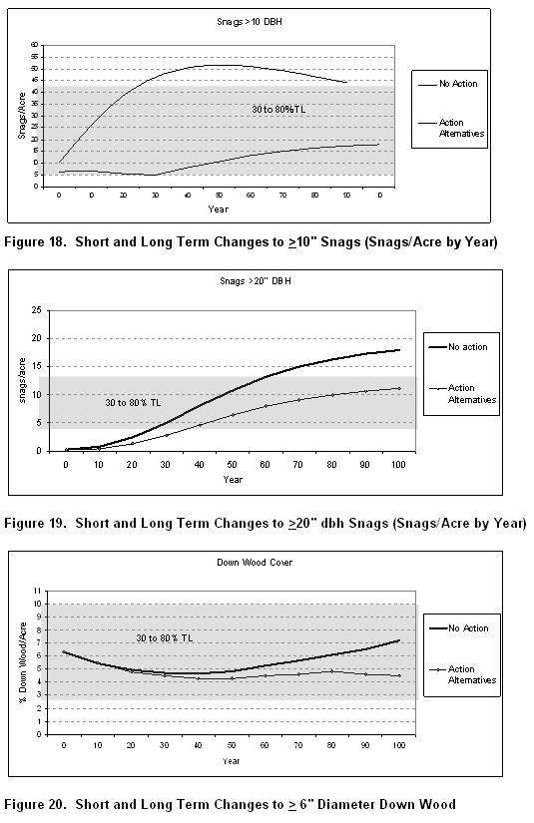

The EA (p 62) also says, after logging “… there would be sufficient quantities in units and across the landscape to provide for the needs of dependent species over time.” This is not supported by the evidence. The current Forest Service standards for snag retention are based on outdated science, and the FS has not followed NFMA/NEPA procedures to adopt new snag standards based on best available science. DecAID is not a new standard but it at least provides some information that can inform this decision. The EA lacks any meaningful input from DecAID, such as the projected tolerance levels for snag-associated wildlife after logging. LSRs and critical habitat should be managed for 80% tolerance levels, but logging is likely to reduce habitat to 30% tolerance levels, or less.

The EA fails to include any meaningful analysis of snag habitat found in the Wildlife Report, such as the fact that Alt 1 will result in snag recruitment levels far below the levels needed for wildlife.

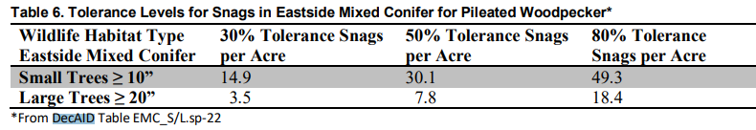

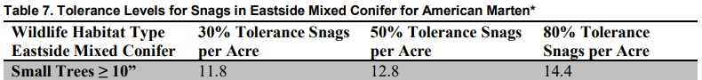

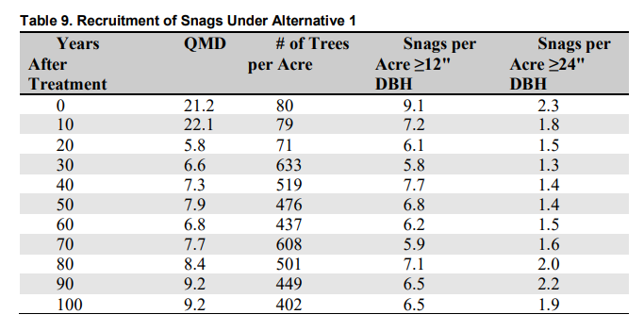

The Wildlife Report’s analysis of the Environmental Consequences Snags and Down Wood is misleading and incomplete because it fails to meaningfully compare the action and no action alternatives (a core purpose of NEPA), and it compares the “current” and “reference” conditions for various categories of dead wood habitat, but it fails to compare the “projected” snag levels in the decades after logging.

The Wildlife Report (p 61) admits that “Alternative 1 would delay the attainment of snags through natural processes because of the reduction in density of the stands. This effect changes the trajectory for snag development compared to the No Action Alternative and reduces the number of trees available to become snags.” But the analysis fails to take a hard look at the significance and persistence of the snag deficit caused by logging, and fails to take a hard look at effects to specific wildlife at the home range scale.

The Wildlife Report (p 61) says after logging “there would be sufficient quantities in units and across the landscape to provide for the needs of dependent species over time.” This assertion is not supported by any analysis. The FS does not even have standards to say how many snags is “enough” to meet the needs of wildlife. All we know is that the existing standards are outdated and scientifically discredited and likely provide for too few snags to meet the needs of wildlife.

The Forest Service cannot provide any assurance that its plans and projects will assure viable populations of native wildlife that depend on dead trees. The Forest Service does not know how many snags are necessary to support viable populations of cavity associated species. The Forest Service has provided no credible link between DecAID tolerance levels, potential population levels, and/or viable populations. The Forest Service has also failed to reliably quantify existing and projected habitat for snag associated species.

The Wildlife Report analysis of cumulative impacts (p 65) says
“The Grasshopper project activities are therefore likely to have little cumulative effect on snag and down wood habitat throughout the analysis area. The overall effect on snags and down wood for the watershed as a result of this project is that snags and down wood would be retained and would bring the watershed closer to the range of historic variability and would result in a situation where the needs of snag dependent species are being met across the landscape now and into the future.”
This is unsupported. (i) This conclusion is clearly at odds with the analysis in the Wildlife Report that shows that there is a current shortage of snag habitat in the project area (e.g., Figures 1 and 3), and logging is likely to make that shortage worse, not better (e.g., Tables 8 and 9), and after logging snag numbers will be suboptimal for snag-associated wildlife (e.g., Tables 6 and 7). (ii) The FS failed to recognize that with continuing need to enter these forests to meet timber targets and accomplish perceived fuel reduction needs, plus danger tree removal along roads and in work areas, plus tree felling as part of future fire-suppression efforts, there would likely be a foreseeable and persistent shortage of snag habitat in this project area. (iii) The FS has no basis for saying that the needs of wildlife are being met. The EA (p 55) makes an unsupported assertion that logging “would not contribute to a negative trend in viability” for management indicator species (MIS) pileated woodpecker and American marten, even though: We knows snags are currently in short supply. We know that current forest plan standards for snag habitat are outdated. We know wildlife need more snags, not fewer. And we know logging under this project will reduce, not increase snag numbers.

The Wildlife Report (p 15) says “Retain and restore key structural components, including large and old trees, large snags, and downed logs” is a “Special management considerations for primary constituent elements are from the Final Critical Habitat Rule (USFWS 2012, p. 71909-71910). … for ECN 7.” This requirement of the critical habitat rule is not being followed because logging will result in a long-term reduction in recruitment of snags and dead wood.

An unavoidable impact of all commercial logging is to “capture mortality” which reduces valuable snag habitat in the short-term (via hazard tree felling) and in the long-term (via delayed recruitment and reduced overall recruitment). For example, in a thinning project on the Siuslaw National Forest “modeling stand #502073 over a 100-year cycle [using ORGANON] predicts a total stand mortality of 202 trees (>10 inches dbh) for the unthinned stand, while mortality for the thinned stand was two trees. Therefore, thinning will reduce density-dependent mortality within the stand by 99%.” NOAA April 4, 2006 Magnuson Act consultation on Essential Fish Habitat and Response to Siuslaw NF Lobster Project BA. There is no reason to think that thinning in densely stocked forests elsewhere would be any different.

Dead wood in forests is thought to follow a U-shaped pattern over time “from the combined and lagged effects of legacy wood decay and the recruitment of new dead wood,” (Harmon 1986, Hudiburg 2009) resulting in abundant dead wood legacies from the previous stand in young forests, less dead wood in middle-aged stands as the legacies decay, and more again in older stands as natural mortality processes manifest. If the goal is to restore high quality old forest habitat, the agencies must respect this dynamic by recognizing that dead wood recruitment requires (1) “surplus” biomass and (2) it’s a process that takes time, so managers should ensure that middle-aged stands accumulate biomass and begin to recruit and accumulate snags and dead wood. The low of dead wood in middle aged stands is not universal or necessarily desirable, and since many young stands were deprived of the legacies they normally enjoy, it would be advisable to start accumulating snags and dead wood as soon as possible, not wait for mature stages.

The EA (p 61) says “Snags and down logs would be maintained according to Forest Plan Standards and Guidelines.” This is false assurance. The federal forest agencies now recognize that current methods and assumptions concerning snag habitat standards are outdated, and the old snag standards do not ensure enough snags to meet the intent of the standard, yet the agencies have not adjusted their management plans to account for this new information nor have they developed new standards that are consistent with the latest scientific information.

As explained on the DecAID website:
Why is DecAID needed?
National Forest LRMP standards and guidelines for management of snags and down wood in the Pacific Northwest were based on wildlife species models and tools that were developed in the 1970s and 1980s (Thomas et al. 1979, Neitro et al. 1985, Marcot 1992, Raphael 1983). New information about the ecology, dynamics, and management of decayed wood has been published since then, and the state of the knowledge continues to change. Rose et al. (2001) report that results of monitoring indicate that the biological potential models are a flawed technique (page 602). There has been an evolution from thinking of large woody material as habitat structures, to thinking of decaying wood as an integral part of complex ecosystems and ecological processes.

This paradigm shift has made the management of dead wood a much more complex task. We can no longer expect to go to our LRMPs or the biological potential model to get one number for the amount or size of snags and down wood that we can apply to all projects and to all acres. We are directed to use the best available science to manage ecosystems, and the best available science simply will not support business as usual for managing dead wood.
Region 6 - USDA Forest Service. A Guide to the Interpretation and Use of the DecAID Advisor. June, 2006. http://www.fs.fed.us/r6/nr/wildlife/decaid-guide/

A few of the problems with the old standards are:
- They failed to account for the fact that the number of snags needed for roosting, escape, and foraging can exceed the number of snags needed for nesting;
- They failed to recognize that the number of snags needed to support viable populations of secondary cavity users may exceed the needs of primary cavity excavators;
- The old standard failed to account for the size height of snags favored by some species;
- In applying the old standards the agencies often fail to account for rates of snag fall and recruitment;
- The old standards fail to recognize non-equilibrium conditions in our forests, i.e. some species rely on the natural large pulses of snags associated with large disturbances;
- The old standards fail to account for the differential use of space and population density of different species;
- The old standards ignore other important habitat features of dead wood, e.g. loose bark, hollow trees, broken tops, etc.

The Forest Service recognizes that
Forest Plan standards were based on a model that did not account for snags required for foraging (EA p. 68 and Appendix K p. 45). There is general consensus in the scientific and professional community that using the biological potential model (which was used in developing the Forest Plan standard) is flawed and does not provide adequate nesting, roosting, or foraging structure for cavity excavating birds …
North Fork John Day RD, Umatilla NF. 2011. Mirage Vegetation Management Project DN. http://a123.g.akamai.net/7/123/11558/abc123/forestservic.download.akamai.com/11558/www/nepa/53012_FSPLT2_055455.pdf.

Bull et al. (1997) states current direction for providing wildlife habitat on public forest lands does not reflect the new information available, which suggests that to fully meet the needs of wildlife, additional snags and habitat are required for foraging, denning, nesting, and roosting. Rose et al. (2001) suggests that calculation of numbers of snags required by woodpeckers based on assessing their “biological (population) potential” is a flawed technique (Rose et al. 2001) due to the fact that empirical studies are suggesting that snag numbers in areas used and selected by some wildlife species are far higher than those calculated by this technique. There is general consensus that the biological potential model does not provide adequate nesting, roosting, or foraging structure for cavity excavating birds (Bull et al. 1997, Johnson and O’Neil 2001). This suggests the current direction of managing for 100 percent population levels of primary excavators may not represent the most current knowledge of managing for cavity nesters.
North Fork John Day RD, Umatilla NF. 2011. Mirage Vegetation Management Project EA, Appendix K – Terrestrial Wildlife Specialist Report. p K-45. http://a123.g.akamai.net/7/123/11558/abc123/forestservic.download.akamai.com/11558/www/nepa/53012_FSPLT2_055426.pdf.

The authors of DecAID describe some of the limitations of the old methods of managing snag habitat.
Limitations of Existing Approaches for Assessing Wildlife-Dead Wood Relations.
Models of relationships between wildlife species and snags in the Pacific Northwest typically are based on calculating potential densities of bird species and expected number of snags used per pair. This approach was first used by Thomas et al. (1979). Marcot expanded this approach in Neitro et al. (1985) and in the Snag Recruitment Simulator (Marcot 1992) by using published estimates of bird population densities instead of calculating population densities from pair home range sizes. This approach has been criticized because the numbers of snags suggested by the models seem far lower than are now being observed in field studies (Lundquist and Mariani 1991, Bull et al. 1997). In addition, the models provided only deterministic point values of snag sizes or densities and of population response ("population potential") instead of probabilistic estimates that are more amenable to a risk analysis and risk management framework.
In addition, existing models have focused on terrestrial vertebrate species that are primary cavity excavators. Thomas et al. (1979) and Marcot (1992) assumed that secondary snag-using species would be fully provided for if needs of primary snag-excavating species were met. However, McComb et al. (1992) and Schreiber (1987) suggested that secondary cavity nesting birds may be even more sensitive to snag density than are primary cavity excavators.
Furthermore, existing models do not address relationships between wildlife and down wood, nor do they account for species that use different types of snags and partially dead trees, such as hollow live and dead trees used by bats (Ormsbee and McComb 1998, Vonhof and Gwilliam 2007), Vaux's swift (Chaetura vauxi) (Bull and Hohmann 1993), American marten (Martes americana) (Bull et al. 2005), and fisher (Martes pennanti) (Zielinski et al. 2004).
Bruce G. Marcot , Janet L. Ohmann, Kim L. Mellen-McLean, and Karen L. Waddell. Synthesis of Regional Wildlife and Vegetation Field Studies to Guide Management of Standing and Down Dead Trees. Forest Science 56(4) 2010. http://www.fs.fed.us/pnw/pubs/journals/pnw_2010_marcot002.pdf

The agencies need to prepare a EIS to consider a replacement methodology for maintaining species and other values associated with dead wood. This is especially critical because adequate dead wood is recognized as an essential feature of healthy forests and the Forest Service has identified lots of “management indicator species” associated with dead wood habitat.

Back in the early 1990s the Forest Service recognized the their forest plans were not adequate to maintain populations of spotted owls and they tried to develop plans to conserve spotted owl without following NEPA and NFMA procedures. The courts said they had to stop cutting owl habitat until they had complied with environmental laws. This is the same situation we find ourselves in today with dead-wood associated species. The agencies should stop harming dead wood habitat until they have a legal plan to conserve associated species over the long-term. Seattle Audubon Society v. Epsy, 998 F.2d 699, 704 (9th Cir. 1998) (an agency must re-examine its decision when the EIS "rests on stale scientific evidence and false assumptions").

There is evidence that retaining more than the minimum number of snags has significant benefits for cavity dependent species. Comparing two sites in Northern California, Blacks Mountain Experimental Forest (BMEF) with little past logging and lots of snags, and Goosenest Adaptive Management Area (GAMA) with lots of logging and fewer snags, the author’s found “… three times as many snags (6.38/acre vs. 2.04/acre, respectively) … The use of snags by cavity-nesting bird species was dramatically different between the sites. Thirty-one cavity-nesting pairs from 10 species were detected at BMEF, while only one pair each of two species were detected at GAMA…. This fifteenfold difference is much greater than any measure of snags or cavities reported. …”
We feel that forest managers may well be asking a misleading question. “Snags per acre” requirements implicitly assume an equilibrium condition and reflect only one ecological requirement for a given cavity-nesting species. … [C]onsideration of foraging habitat and other ecological requirements must be part of the “snags per acre” management considerations. This is an important, but somewhat daunting proposition, as potential cavity-nesting species are diverse, and each species likely has very different foraging ecologies, as well as other differences in habitat requirements. … [C]avity nesters at BMEF used larger snags on average … [T]he loss of large trees due to logging in eastside pine and other forests, over the past century has major implications for cavity-nesting birds. … [F]orest managers must have a sense of snag recruitment in relationship to snag fall, and the patterns and processes that underlie them, when addressing wildlife needs. … We view the understanding of these complexities to be of primary importance in forest management for wildlife.
Steve Zack, T. Luke George, and William F. Laudenslayer, Jr. 2002. Are There Snags in the System? Comparing Cavity Use among Nesting Birds in “Snag-rich” and “Snag-poor” Eastside Pine Forests. USDA Forest Service Gen. Tech. Rep. PSW-GTR-181. http://www.fs.fed.us/psw/publications/documents/gtr-181/017_Zack.pdf.

Logging in Riparian Reserves. Logging Effects on Dead Wood Recruitment.
Riparian reserves are a separate land allocation that are set aside for conservation, not logging. Riparian reserves should not be treated as part of the same logging units that are designed with a purpose and need includes producing wood products.

The FS should be sure to apply riparian reserves to the unmapped water features documented by citizen surveyors, such as Bark staff and volunteers.

The NEPA analysis needs to provide a site-specific rationale for logging in riparian reserves to meet ACS objective, AND describe how the benefits of advancing those ACS objective(s) clearly outweigh the cumulative trade-offs imposed on other ACS objectives, e.g., loss of wood recruitment.

The EA (p 22, Table 1) says Large Wood Frequency and Recruitment are Functioning at Risk and that logging would Enhance wood recruitment. This is unsupported. Logging will unquestionably capture mortality and reduce wood recruitment.

Grasshopper EA (p 23) says logging prescriptions will apply “no-cut buffers of 60 feet for perennial streams and 30 feet along intermittent streams and a 40- 50% canopy cover retention in the treated portion of the riparian stands.” This is not adequate to avoid retarding ACS objectives for dead wood and shade. Cutting trees within 1 site potential tree distance from streams will definitely reduce recruitments of wood to streams. (Keep in mind that small wood is functional in small streams). Cutting forests to 40-50% canopy cover within the shade-zone of streams will also deprive streams of the shade they need to stay cool and provide optimal habitat for fish.

Grasshopper EA (p 23) says
“Proposed silvicultural treatment outside protection buffers in Riparian Reserve would reduce the trees per acre and thus reduce the total number of trees available as potential down wood in the short term, however improved health and growing conditions for remaining trees would improve the overall quality of wood recruitment for the larger size classes, thus meeting large wood recruitment objectives more effectively in the long term … Both Alternatives 1 and 2 will result in a long-term beneficial effect to large wood frequency and recruitment and thus there would be a beneficial impact to Region 6 sensitive species and habitat.”
This is not supported by any analysis in the NEPA document and (as explained below) it contradicts every other credible analysis that has been done. Logging is a subtractive endeavor. You cannot get an additive result, i.e., more wood, by removing wood. See Heiken, D. 2012. Thinking about Dead Wood in Managed Landscapes. https://www.dropbox.com/s/5gofctjdglx5t3t/dead%20wood%20slides%202012.pdf?dl=0

The Grasshopper EA (p 12) says “Analyses concluded that thinning would result in a minor short-term reduction of available recruitment of downed woody material, and that there would be a long-term benefit as tree growth would be accelerated, ultimately providing more abundant recruitment in the larger size classes …” This is not supported by the best available science which consistently shows that commercial logging has a significant long-term adverse effect on wood recruitment. Accelerated growth on significantly fewer stems simply does not result in more abundant large snags. You simply cannot produce more snags by subtracting trees. Unlogged trees continue to grow. Some modelling shows a slight increase in some subcategory of very large trees as a result of thinning, but this increase is offset by a much more significant reduction in overall recruitment of large trees and functional wood. See Pollock, Michael M. and Timothy J. Beechie, 2014. Does Riparian Forest Restoration Thinning Enhance Biodiversity? The Ecological Importance of Large Wood. Journal of the American Water Resources Association (JAWRA) 50(3): 543-559. DOI: 10.1111/jawr.12206. http://oregon-stream-protection-coalition.com/wp-content/uploads/2014/07/Pollock-and-Beechie.-2014.-Riparian-thinning-and-biodiversity.pdf. Spies et al (2013) showed “Conventional [i.e., commercial] thinning can accelerate the development of very large diameter trees. In stands that are conventionally thinned, the appearance of very large diameter dead trees (greater than 40”) may be accelerated by 1 to 20 years relative to unthinned plantations, depending on thinning intensity and initial stand conditions. Trees of such sizes typically begin to appear 5 to 10 decades after thinning 30 to 40 year old stands.” Thomas Spies, Michael Pollock, Gordon Reeves, and Tim Beechie 2013. Effects of Riparian Thinning on Wood Recruitment: A Scientific Synthesis - Science Review Team Wood Recruitment Subgroup. Jan 28, 2013, p 36. http://www.mediate.com/DSConsulting/docs/FINAL%20wood%20recruitment%20document.pdf. However, the appearance of a few “very large” trees in the decades after thinning comes with the loss of a much larger volume of “large functional” trees that were exported from the site before they were allowed to grow and recruit to dead wood pool.

This graph from the Curran Junetta Thin EA shows that heavy thinning delays by more than 60 years the attainment of habitat objectives for large snags (i.e. mid-point of the gray band representing 30-80% tolerance level).

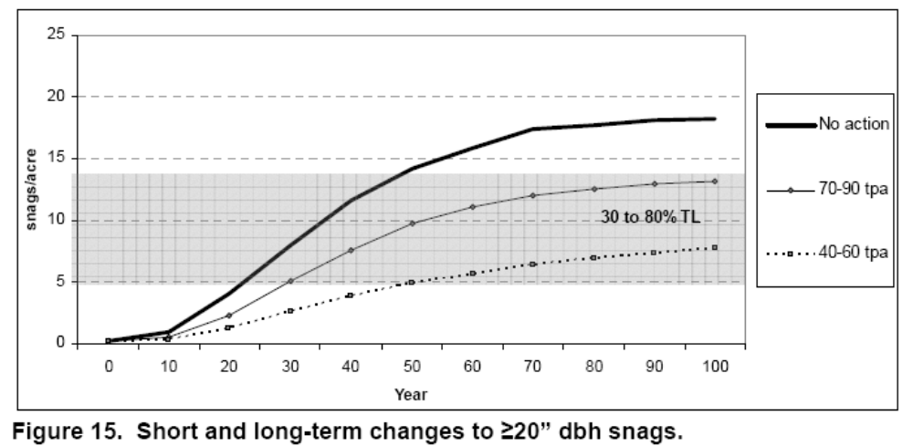
http://a123.g.akamai.net/7/123/11558/abc123/forestservic.download.akamai.com/11558/www/nepa/32805_FSPLT2_053506.pdf.

“Two common consequences of conventional thinning practices have been increased uniformity of forest structure and composition, and removal or delay in the development of dead wood as snags or down wood to meet decadence and habitat functions. … Over the past several decades our ecological understanding of decadence and its importance to habitat and biogeochemical processes has increased substantially, but translation of the fundamental knowledge into coherent goals is lagging.”
Paul D. Anderson 2013. Two Decades of Learning about Thinning in the Ecosystem Management Era. http://www.fs.fed.us/pnw/pubs/pnw_gtr880/pnw_gtr880_001.pdf in Density Management in the 21st Century: West Side Story PNW-GTR-880. http://www.treesearch.fs.fed.us/pubs/44695

New science brings into question the ecological value of commercial logging as a restoration tool in riparian reserves.
… our data suggest that mature, late-successional conifer dominated forests have well developed structural characteristics in terms of abundant large trees in the overstory, abundant large snags, and a well-developed understory of shade-tolerant trees. We modeled the growth of young conifer stands to assess whether a common restoration treatment [thinning to 150 trees per hectare] would accelerate development of structural characteristics typical of reference conditions. We found that left untreated, the stands followed a trajectory towards developing forest structure similar to the average reference condition. In contrast, the restoration treatment followed a developmental trajectory along the outside range of reference conditions.
Pollock, M. M., T. J. Beechie, and H. Imaki. 2012. Using reference conditions in ecosystem restoration: an example for riparian conifer forests in the Pacific Northwest. Ecosphere 3(11):98. http://dx.doi.org/10.1890/ES12-00175.1 The following figure from this study shows that all types of thinning cause stand development to miss the reference stand trajectory for dead wood.

The figure below, from Pollock et al (2012), shows that tree removal through thinning can lead to stand development trajectories that miss the reference condition for dead wood. We point this out to highlight one of the trade-offs involved in thinning, and to encourage careful thinking about mitigation. Leaving the cut trees in the woods is a good short-term mitigation, but the small trees do not last long enough to fill the temporal gap between now and when the stand begins recruiting more dead wood on its own. Leaving unthinned patches within treated stands is a good mid-to-long-term mitigation.
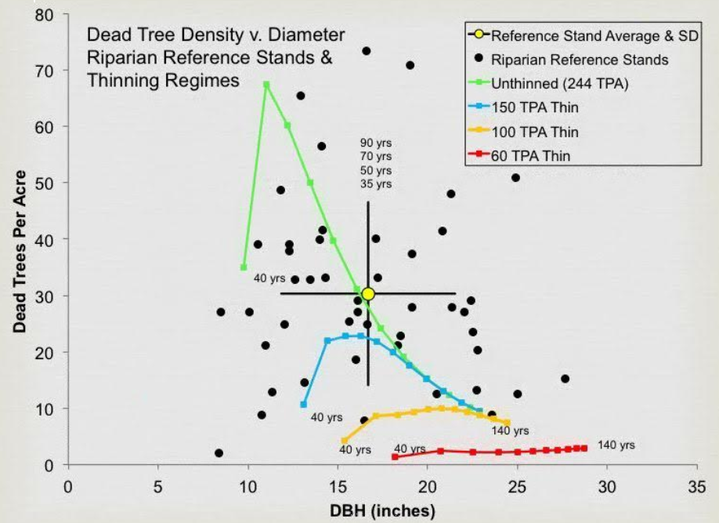
Pollock, M. M., T. J. Beechie, and H. Imaki. 2012. Using reference conditions in ecosystem restoration: an example for riparian conifer forests in the Pacific Northwest. Ecosphere 3(11):98. http://dx.doi.org/10.1890/ES12-00175.1

EA (p 23) says logging will result in less wood recruitment in the short-term, but high quality in the long term. “In the short term, in-stream large wood could be reduced within the treatment units but would result in higher quality wood recruitment over the long term.” This conclusion is not supported and fails to consider important factors such as the fact that small wood is functional in small streams. Small wood can serve as “high quality” habitat in many small streams that this project will log adjacent to. The NEPA analysis misses the mark by failing to take a hard look at the adverse effects of logging on recruitment of functional wood.

“The effect that wood has on [fish] habitat is related to the size of the piece of wood relative to the channel size and gradient.” East Alsea Landscape Management Project – EA Appendix H - Fish BE, 4-18-2011. The NEPA analysis should therefore disclose the effects of logging not only on absolute size of wood but on the size of wood relative to stream size and gradient. Dead wood of all sizes is important to streams and riparian function. In small streams, small wood can even perform the ecological and hydrological functions normally thought to require large wood. If the goal of logging is to create large trees faster, the NEPA analysis should document the size, gradient, and other characteristics of streams adjacent to each logging area and determine the size of wood that can serve key ecological and hydrological functions, then disclose the effects of logging relative to those relevant wood sizes.

The effects of logging in riparian reserves should be described in terms of the number of pieces and the volume of wood, not just the size wood. Scientists recommend wood volume as a more meaningful measure of wood’s value instream. “Total volume of wood through time was reported for all simulations, which is a more conservative measure of wood abundance than the number of pieces.” Mark A. Meleason, Stanley V. Gregory, And John P. Bolte. 2003. Implications Of Riparian Management Strategies On Wood In Streams Of The Pacific Northwest. Ecological Applications, 13(5), 2003, pp. 1212–1221. http://www.geo.oregonstate.edu/classes/geo582/week_5_1_wood_movement/Meleasonetalstrategies.pdf.

Dead wood is important to both aquatic and terrestrial purposes of the riparian reserves network, so the NEPA analysis cannot just focus on recruitment of wood to streams, but must also address the need to recruit optimal levels of snag and dead wood to meet the needs of terrestrial wildlife (primary cavity excavators, secondary cavity users, amphibians, mollusks, lichen, fungi, etc) which were intended to be benefited by riparian reserves. Wood loading in small streams helps them perform their many critical ecological functions. Meyer J.L. et al 2007. WHERE RIVERS ARE BORN: The Scientific Imperative for Defending Small Streams and Wetlands. Sierra Club and American Rivers. https://www.americanrivers.org/wp-content/uploads/2016/05/WhereRiversAreBorn_report.pdf

We are concerned that thinning captures mortality which reduces and delays recruitment of large wood needed to meet ACSO #8 among others. Thinning is often conducted in riparian areas based on the false assumption that thinning accelerates the recruitment of large trees and therefore large snags, but rigorous analysis using stand simulation software clearly shows that assumption to be false. Note ACSO #8 is based on the aquatic objective more clearly stated in the SAT Report as “Maintain or restore riparian vegetation to provide an amount and distribution of large woody debris characteristic of natural aquatic and riparian ecosystems.” 1993 SAT Report. Ch 5, p 456.

Thinning in stands of trees that are not yet of "pool forming" size may be beneficial, but after trees are of pool-forming size, thinning just captures and removes the mortality that should end up in the stream. (In simplistic terms, a pool-forming tree is one big enough to fall all the way across the stream, so it varies by stream size, but in general it only takes a small tree to form a pool in a small stream). See Roni, Philip, Timothy J. Beechie, Robert E. Bilby, Frank E. Leonetti, Michael M. Pollock, And George R. Pess. 2002. A Review of Stream Restoration Techniques and a Hierarchical Strategy for Prioritizing Restoration in Pacific Northwest Watersheds. North American Journal of Fisheries Management 22:1–20, 2002 American Fisheries Society 2002 http://www.crab.wa.gov/LibraryData/RESEARCH_and_REFERENCE_MATERIAL/Environmental/020923StreamRestoreTechPNW.pdf.

Looking at the total miles of streams, small streams dominate, therefore most logging takes place along small streams. BLM has admitted that small wood can be functional in small streams.
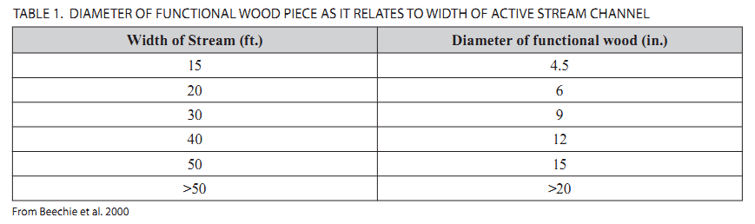
BLM 2014. Planning Criteria - Western Oregon RMP Revisions, p 49. http://www.blm.gov/or/plans/rmpswesternoregon/plandocs.php. It’s also worth noting that small streams are disproportionally ecologically important. “While small-stream habitats have only about 20% of the available salmon in the watershed, they provide 50% of bear consumption of salmon. ‘This tells us that populations of sockeye salmon that spawn in little streams are disproportionately important to bears,’ said study lead author Jonny Armstrong, an ecologist at Oregon State University. ‘Bears profit from these small streams because they offer salmon at unique times of the season. To capitalize on plentiful salmon runs, bears need them to be spread across time.’ Small streams typically have cold water, which leads to populations of salmon that spawn much earlier in the season when no other populations are available to predators such as bears.” Branam, C. 2019. Easy prey: The largest bears in the world use small streams to fatten up on salmon. December 19, 2019. https://today.oregonstate.edu/news/easy-prey-largest-bears-world-use-small-streams-fatten-salmon citing Jonathan B. Armstrong, Daniel E. Schindler, Curry J. Cunningham, William Deacy, Patrick Walsh. 2019. Watershed complexity increases the capacity for salmon–wildlife interactions in coastal ecosystems. Conservation Letters. Published: 20 November 2019 https://doi.org/10.1111/conl.12689 https://conbio.onlinelibrary.wiley.com/doi/pdfdirect/10.1111/conl.12689.

Also, when the objective of riparian thinning is to develop structures suitable for instream habitat structures, there is a trade-off between quality and quantity. “Quality” is represented by the size of woody pieces. Larger is generally better, and thinning typically increases the growth rate of retained trees. “Quantity” is represented by the number of stems or the total volume of wood available for recruitment to streams and riparian uplands. Unthinned stands tend to have much higher number of stems and total wood volume, and they tend to recruit dead wood sooner. To justify logging, the agencies too often focus on growing large wood faster without acknowledging the adverse effects on wood quantity and delayed recruitment. The focus on wood size fails to tell a complete story because:
(1) Pieces of wood much smaller than 20 or 24” diameter can be ecologically functional. Many streams in adjacent to thinning projects are small and lack the power to move much wood, so small trees are still functional;
(2) Average stand diameter does not reflect actual wood recruitment to riparian reserves. A stand of large vigorous trees is not experiencing the ecological processes (mortality) necessary to recruit wood to streams and riparian uplands;
(3) Average stand QMD does not account for the number of stems or the volume of wood available for recruitment toward ecological services. A few large stems do not serve the same ecological function as a large number of slightly smaller stems.

Even when looking at the size and number of pieces, there is no long-term benefit from thinning. “Thinning accelerated the development of large diameter trees by about 20 years such that there were more live trees > 18” dbh in the two decades following thinning, relative to the unthinned stand, but this advantage was short-lived. Three decades after thinning, there were more live trees > 18” dbh in the unthinned stand and five decades after thinning there were twice as many live trees >18” dbh in the unthinned stand relative to the thinned stand. A similar trajectory was observed for the live trees > 24” dbh.” Kim Kratz, Ph.D., Issue Paper for Western Oregon. NMFS, Oregon State Habitat Office. 7-23-2010. Appendix 1. page 38. https://www.blm.gov/or/districts/medford/forestrypilot/files/kswildetal-attach4.pdf. The most notable effect of thinning is to reduce recruitment of larger wood. Even during the brief period that the thinned stand had more large trees, those trees are unlikely to be recruited to the stream, because they are more vigorous as a result of thinning.

"Available research (et al., Beechie and Sibley 1997, Bilby and Ward 1989) indicates that trees as small as 5-6 inches in diameter can form pools in small streams. Thinning along small streams with wood deficits can significantly reduce recruitment of wood to streams (Beechie et al. 2000), and the risks of this happening appear to be significantly increased by the above management actions. [i.e. "thinning in riparian areas for all stream sizes"]
...
Alternatives 2 and 3 will substantially decrease the large wood contribution to fish bearing streams relative to the No-Action Alternative, and the decreases will be long-term. This is because thinning will remove wood large enough to form pools from the riparian zone (if the term large wood is defined by its ability to form pools rather than the arbitrary value of >20 inches diameter) (Beechie et al. 2000)."
NMFS, Comments on DEIS for the WOPR dated 01-11-2008. pp 8-9, 21. http://www.blm.gov/or/plans/wopr/files/NOAA_comments.pdf. See also Roni, Philip, Timothy J. Beechie, Robert E. Bilby, Frank E. Leonetti, Michael M. Pollock, And George R. Pess. 2002. A Review of Stream Restoration Techniques and a Hierarchical Strategy for Prioritizing Restoration in Pacific Northwest Watersheds. North American Journal of Fisheries Management 22:1–20, 2002 American Fisheries Society 2002 http://www.crab.wa.gov/LibraryData/RESEARCH_and_REFERENCE_MATERIAL/Environmental/020923StreamRestoreTechPNW.pdf. “Beechie et al. (2000) provided guidance for determining when thinning is appropriate and when it will result in a loss of near-term recruitment of LWD that may create fish habitat.” Beechie found that
“The models predict that thinning of the riparian forest does not increase recruitment of pool-forming LWD where the trees are already large enough to form pools in the adjacent channel and that thinning reduces the availability of adequately sized wood. Thinning increases LWD recruitment where trees are too small to form pools and, because of reduced competition, trees more rapidly attain pool-forming size”
To evaluate effects of various stand treatments on LWD recruitment, we modeled treatments and controls for a range of initial mean diameters and channel widths. We modeled Douglas-fir stands of four different initial quadratic mean diameters (initial DBHq = 12, 23, 38, and 51 cm). For each initial DBHq we applied control (unthinned) and treatment (thinned) scenarios to channels 5, 10, 15, 20, 25, and 30 m wide. We applied three different levels of thinning for each combination of channel width and initial DBHq (Table 2) and selected the treatment providing the most LWD over the next 100 years to compare with the unthinned scenario. Large woody debris recruitment for the thinning treatment was then compared with the unthinned control, and the result was recorded as negative (thinning produced less LWD than control), positive (thinning produced more LWD than control), or neutral. … We estimated the proportion of riparian forests having trees that are large enough to create pools, using three thresholds for pool-forming diameter of LWD (Dpf = 10, 30, and 38 cm) corresponding to channel widths of 4, 12, and 15 m. … When we compared thinned to unthinned scenarios for a range of initial stand diameters and channel widths in Douglas-fir stands, we found that thinning increases cumulative LWD abundance when the DBHq of the stand is about 10 cm less than the minimum pool-forming diameter for the adjacent channel (Figure 6). … The models predict that thinning of the riparian forest will not increase recruitment of pool-forming LWD on any channel less than 15 or 20 m wide. Because relatively small debris can form pools in these channels and the trees reach poolforming size rapidly, thinning simply reduces the availability of adequately sized wood. Thinning may increase LWD recruitment to large channels because thinning reduces competition among trees and increases growth rates.
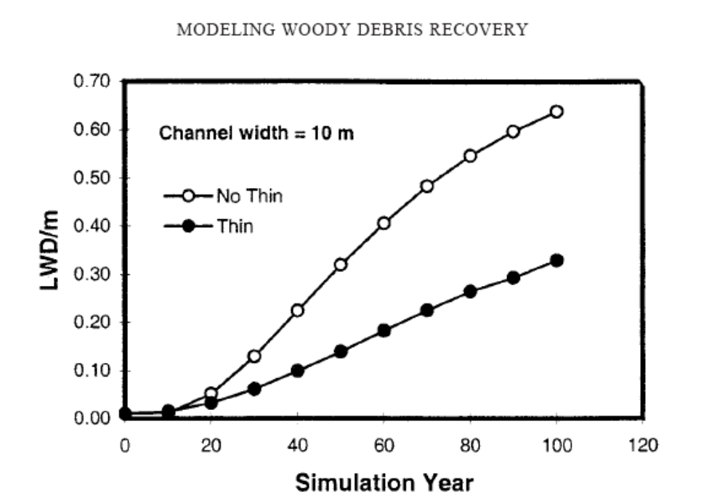
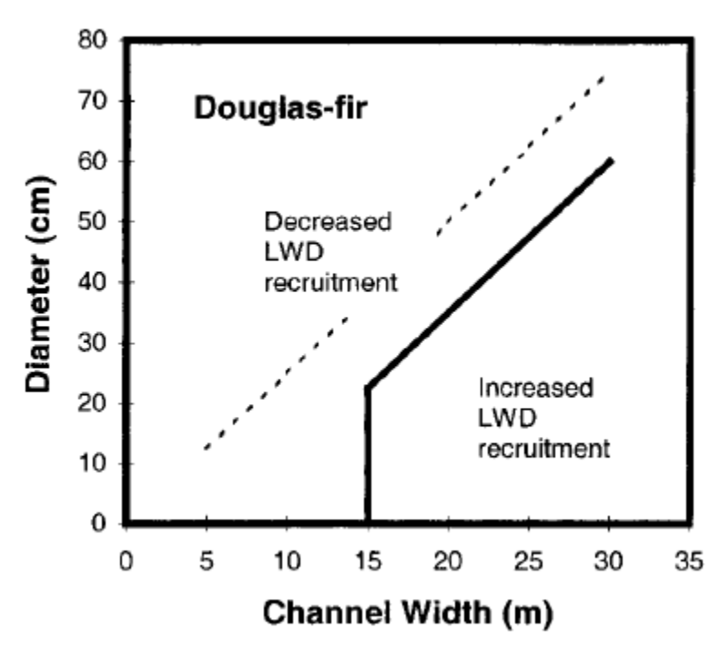
Beechie, T., G. Pess, P. Kennard, R. Bilby, and S. Bolton. 2000. Modeling Recovery Rates and Pathways for Woody Debris Recruitment in Northwestern Washington Streams. North American Journal of Fisheries Management. 20:436–452. ftp://frap.cdf.ca.gov/pub/incoming/TAC/ISOR%20references%201-139%20%20KIRSTEN/Beechie%20et%20al.%202000.pdf.
Don’t make the mistake of assuming that thinning is always consistent with the ACS because it helps grow large trees faster. First, thinning captures mortality and actually delays recruitment of large wood. Second, the agencies often misinterpret the Northwest Forest Plan ROD by confusing accelerated attainment of ACS objectives with ACS compliance. The NWFP ROD actually says that silviculture in riparian reserves is generally prohibited, and allowed only “if needed to attain” ACS objectives, not (as implied by the EA) if needed to “accelerate” ACS objectives. This is a common “group-think” misinterpretation of the ACS. The appropriate evaluation is to ask “will ACS objectives eventually be met without intervention?” If the answer is “yes,” then silviculture is technically not allowed. Confusion may stem from the fact that the ACS also has a “do not retard” standard, but this is separate from the “if needed” test, and is itself a criteria to limit active management, not an excuse to reject the no action alternative. The “do not retard” standard cannot be interpreted to require active management whenever and wherever it would accelerate attainment of ACS objectives. That would lead to all kinds of problems, such as cumulative impacts, unintended consequences, and sacrificing some aquatic objectives in the pursuit of others. Oregon Wild is not absolutely opposed to treatment of riparian reserves but we want to avoid the slippery slope of just assuming “it’s all good” without careful analysis and justification.
Under the NWFP: “The risk has been shifted under the Aquatic Conservation Strategy because each project must meet the maintenance and restoration criteria by maintaining or restoring the physical and biological processes required by riparian-dependent resources within a watershed.” 1994 FSEIS p 3&4 – 69. Clearly, this requires the FS to show there is a need for intervention.

The NEPA analysis must reflect accurate scientific analysis such as that presented by the NMFS:
A strategy of thinning to accelerate the development of a few healthy, large-diameter trees does not translate into more large wood in streams. … Overall, an unthinned stand will produce a higher number of both live and dead trees across a range of diameter classes and will produce far more dead wood over a much longer time frame relative to a heavily thinned stand. … The tradeoff of getting a few more large standing live trees sooner at the expense of a continuous supply of both large and small trees over the long term period always needs to be considered.
…
Numerous studies suggest that all organic matter, including the various sizes of wood, has functional value in streams (and riparian areas), and that these functions vary with size (Bilby and Likens 1980, Beechie and Sibley 1997, Gurnell et al. 2002). Of particular note is that large wood that cannot singly form pools will form pools in combination with other pieces of wood and other obstructions by forming “wood jams.” Wood jams are common feature of natural streams of all sizes, and contain a distribution of wood sizes that, in concert, can form a semipermeable structure that can retain sediment (such as that used for spawning), nutrients and organic material, as well as form pools upstream and downstream of the obstruction (Bilby and Likens 1980, Bilby 1981, Bilby and Ward 1991).
…
Reid and Hilton (1998) found that 30% of the trees falling into streams were triggered by trees falling from farther upslope. More research on this subject is needed, but it speaks to the indirect importance of trees in the outer portion of the riparian zone for wood delivery to streams.
…
Managing for large instream wood also results in the creation of large riparian wood and large snags, both of which are beneficial to numerous species other than salmonids, such as cavity nesting birds and certain amphibians.
…
[NMFS’s Northwest Fisheries Science Center’s quantitative analysis of the East Alsea Landscape Management Project, Pollock, M.M.] (Appendix 1) suggests that typical riparian thinning regimes will result in a mature forest with fewer large diameter trees, fewer large diameter snags, and fewer large diameter pieces of wood on the riparian forest floor and in streams, relative to natural conditions. This largely stems from excessive thinning. In regards to stream habitat, many of the negative impacts created by the existing riparian thinning proposals could be largely avoided with wider no-thin buffers (e.g., see Appendix 1) and removing far fewer trees during thinning operations.
…
The exclusive use of the 24-inch/50-ft wood indicator by the USFS and BLM does not satisfy the requirement in 50 CFR 402.14 that both the action agency and NMFS use the best available scientific and commercial data, or (2) the requirement in 50 CFR 402.02 that the action agencies and NMFS analyze all effects of the proposed action … which would mean consideration of a broader range of sizes of wood.
…
Recommendations
- The USFS and BLM should include all sizes of wood in describing environmental baseline conditions and in analyzing the effects of its proposed actions, not just pieces of wood that are greater than 24 inches in diameter and greater than 50 ft in length.
- The USFS and BLM should adjust their tree diameter targets based on stream size. Databased curves are available for both functional-sized and key pieces of wood (e.g., Fox and Bolton 2007).
- The USFS and BLM should leave more thinned trees on the ground in riparian areas, particularly close to streams, on floodplains, and on steep sideslopes where some trees are likely to slide down into streams, than are required to meet wildlife needs.
- In order to better portray environmental baseline conditions and to understand the likely effects of thinning proposals, the USFS and BLM should develop stand data separately for riparian and upland forests.
- In order to insure adequate recruitment of conifer wood to streams, the USFS and BLM should measure riparian buffers from the outer edge of streamside hardwood forests, where present.
- The USFS and BLM should work with NMFS to develop reliable methods of wood recruitment modeling and procedures that could be used routinely in ESA section 7 consultations to promote decisions based on data instead of concepts and generalizations from the scientific literature.
…
Kratz, K.W. 2010. Response to April 1, 2010, Request by the Interagency Coordinating Subgroup for Position Paper to Support the February 23, 2010 Elevation of Two Northwest Forest Plan Issues to the Regional Executives. NOAA/NMFS July 23, 2010.

From Appendix 1 of the NMFS Memo quoted above:
Thinning did accelerate the development of large diameter trees by about 20 years relative to the unthinned stand, but this benefit was short-lived because the higher number of trees in the unthinned stand allowed it to produce far more large diameter live and dead trees in the long run. A century after thinning, a 60 foot no cut buffer between a stream and the thinned forest provided 56% of the stream wood relative to an unthinned stand, while a 150 foot no cut buffer provided 91% of the stream wood relative to an unthinned stand. Our results suggest that the thinning regimes proposed by the Siuslaw National Forest will delay the development of key structural elements of forest and stream habitat by more than a century. The delay in stream habitat recovery can be minimized by creating a no cut buffer of 150 feet or more in width between streams and any forest thinning operations. Some of the delay in forest structure development caused by thinning might also be reduced by removing far fewer trees.
…
[Analysis based on a 37 year old Douglas-fir stand thinned to 55 TPA]

MORTALITY TREES — … Trees in the thinned stand increased diameter rapidly, and in 20 years following thinning, had a greater number of > 18” diameter trees relative to the unthinned stand. However, from 30-100 years after thinning, the unthinned stand had more > 18” dbh trees, and by year 135 had over 5 [dead]TPA, compared to just 0.6 [dead]TPA in the thinned stand. Neither stand produced many trees > 24” dbh by year 135. The thinned stand produced slightly more > 24” [dead]TPA for each decade following thinning through year 115 (e.g. 0.5 v. 0.4 > 24” [dead]TPA at year 115), but by year 135 the unthinned stand was producing more large trees (0.7 v. 0.5 > 24” [dead]TPA). Further, at year 135, the trend of the > 24” dbh [dead]TPA in the unthinned stand was increasing, while in the thinned stand the > 24” dbh class had leveled off, suggesting that beyond year 135 the unthinned stand would continue to produce a greater number of large dead trees. … Comparison of the thinned and unthinned mortality curves graphically illustrates that thinning greatly reduced riparian tree mortality and thus reduces the potential for snags, forest wood and instream wood. It is noteworthy that the proposed thinning reduces tree mortality during the period of stand development when tree mortality and thus snag and wood loading, is at its’ highest. For example, for an unthinned stand at age 135, about 50 years past peak mortality, will still be producing about 10 trees per acre per decade. In contrast, a thinned stand will have about 0.5 [dead]TPA for the same time period. … The 30 foot no cut buffer, which approximates what the Siuslaw National Forest proposed …, would provide less than 30% of the in stream wood relative to a 250 foot no cut buffer at year 135.
…
[T]he vast majority of stands likely grew at densities higher than 55 TPA, and there is no evidence that such low density conifer stands were found in riparian environments. For example, Poage and Tappeiner (2002) estimated growth rates from the stumps of 505 large diameter Douglas-fir on upland sites and concluded that at age 50, about 75% of them were growing at tree densities higher than 53 TPA Since riparian forests generally are more productive and have higher tree densities than upland forests (Pollock et al., in review), we expect that the occurrence of young, low density riparian stands would be even less than in upland environments.
…
Even if the uncut buffer is 150 feet wide and the thinning is confined to the outer 100 feet of the Riparian Reserve, a century after thinning, the recovery rate of instream wood will still be lowered by about 10%. This is a significant decrease for a program that is ostensibly designed to improve riparian function. We conclude that the thinning of riparian forests to the degree contemplated in the Siuslaw National Forest will delay creation of late successional forest structure by more than a century. … Thinning treatments may exist which will accelerate the
development of late successional forest structure in Riparian Reserves and that are consistent with the goals of the Northwest Forest Plan Aquatic Conservation Strategy, but they most assuredly will involve the removal of far fewer trees. … Future research should more comprehensively assess the conditions under which thinning accelerates or retards the development of key structural attributes of riparian forests.
Michael M. Pollock and co-authors to be determined. [in review 2010] Effects of Riparian Thinning on Development of Late-Successional Forest Structure in the Alsea Watershed, Oregon, USA. NOAA Fisheries, Northwest Fisheries Science Center, Seattle, Washington.

Weigh the trade-offs associated with logging in riparian reserves.

It’s already been made clear that logging is a subtractive endeavor that is adverse to recruitment of dead wood. So, the agency often claims that logging in riparian reserves is necessary to improve attributes other than large wood. However, these benefits are often minor and transitory, and do not outweigh the significant long-term adverse effect of logging on recruitment of dead wood. The agency must focus on the most significant contributions of vegetation toward ACS objectives and the most significant effects of logging on the ACS objectives.

If the agency intends to log in riparian reserves to increase some nebulous goal like “vegetation diversity and complexity,” then please explain why the biophysical indicators for the ACS objectives (set forth below) do not include any mention of vegetation diversity or complexity. See the Jazz Thinning Preliminary Analysis, 2011. http://bark-out.org/sites/default/files/bark-docs/Jazz_PA_0.pdf.
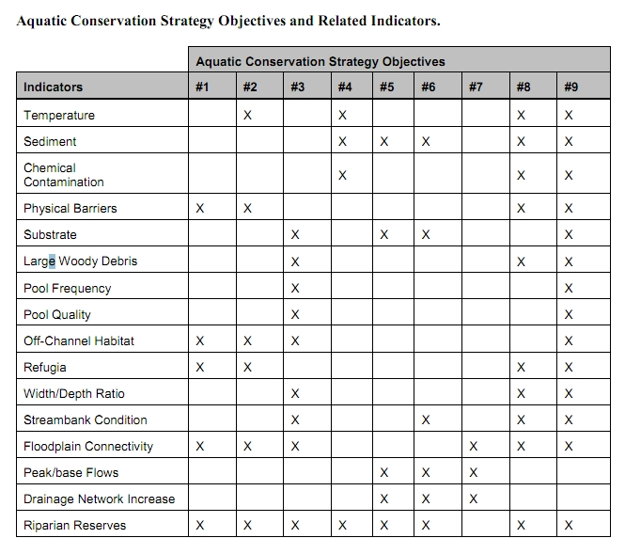
These ACS objectives and biohysical indicators are consistent throughout the Pacific Northwest and are not unique to the Mt Hood NF.

The Northwest Forest Plan and its supporting documentation make clear that the primary value of riparian vegetation is as a source of large wood and shade, not vegetation diversity and canopy layering, as often asserted by the agency to justify logging in riparian reserves. BLM admits “The primary function of Riparian Reserves is to provide shade and a source of large wood inputs to stream channels.” Medford BLM 2013. Pilot Thompson EA, p 3-76. http://www.blm.gov/or/districts/medford/plans/files/PT_EA_ForWeb.pdf

Stan Gregory notes the following trade-offs associated with logging riparian reserves to enhance early seral vegetation:
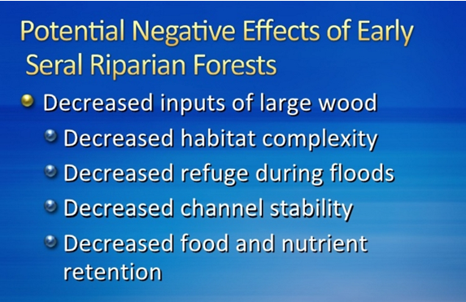
Gregory, Stan 2010. What About Riparian Systems: Who Benefits From an Early Seral Forest Condition. Workshop - Early Seral Forest - We know we need it -- How do we get it? Presentation sponsored by the Central Cascades Adaptive Management Partnership and NW Oregon Ecology Group http://ecoshare.info/2010/07/06/what-about-riparian-systems-who-benefits-from-an-early-seral-forest-condition-gregory/

The Northwest Forest Plan Aquatic Conservation Strategy Objectives (1994 ROD p B-11) enumerates specific purposes for “Maintain[ing] and restor[ing] the species composition and structural diversity of plant communities in riparian areas and wetlands” that is -
“to provide adequate summer and winter thermal regulation, nutrient filtering, appropriate rates of surface erosion, bank erosion, and channel migration and to supply amounts and distributions of coarse woody debris sufficient to sustain physical complexity and stability.”
All these values are provided as well or better by unthinned riparian stands.

The effects of logging on dead wood are significant and long term, adversely affecting a core function of the reserves, while the purported benefits to vegetation diversity are minor and transitory, and affect secondary purposes of the reserves.

Large Wood
Large quantities of downed trees are a functionally important component of many streams (Swanson et al. 1976; Sedell and Luchessa, 1982; Sedell and Froggat, 1984; Harmon et al. 1986; Bisson et al. 1987; Maser et al. 1988; Naiman et al. 1992). Large woody debris influences channel morphology by affecting longitudinal profile, pool formation, channel pattern and position, and channel geometry (Bisson et al. 1987). Downstream transport rates of sediment and organic matter are controlled in part by storage of this material behind large wood (Betscha 1979). Large wood affects the formation and distribution of habitat units, provides cover and complexity, and acts as a substrate for biological activity (Swanson et al. 1982; Bisson et al. 1987). Wood enters streams inhabited by fish either directly from the adjacent riparian zone from tributaries that may not be inhabited by fish, or hillslopes (Naiman et al. 1992).
Large wood in streams has been reduced due to a variety of past and present timber harvesting practices and associated activities. Many riparian management areas on federal lands are inadequate as long term sources of wood.
…
Riparian Ecosystem Components
…
Riparian vegetation regulates the exchange of nutrients and material from upland forests to streams (Swanson et al. 1982; Gregory et al. 1991). Fully functional riparian ecosystems have a suite of characteristics which are summarized below. Large conifers or a mixture of large conifers and hardwoods are found in riparian zones along all streams in the watershed, including those not inhabited by fish (Naiman et al. 1992). Riparian zone-stream interactions are a major determinant of large woody debris loading (House and Boehne 1987; Bisson et al. 1987; Sullivan et al. 1987). Stream temperatures and light levels that influence ecological processes are moderated by riparian vegetation (Agee 1988; Gregory et al. 1991). Streambanks are vegetated with shrubs and other low-growing woody vegetation. Root systems in streambanks of the active channel stabilize banks, allow development and maintenance of undercut banks, and protect banks during large storm flows (Sedell and Beschta 1991). Riparian vegetation contributes leaves, twigs, and other forms of fine litter that are an important component of the aquatic ecosystem food base (Vannote et al. 1980).
1993 FEMAT Report, pp V-13, V-25.

The effects of thinning on crown development are not very significant.

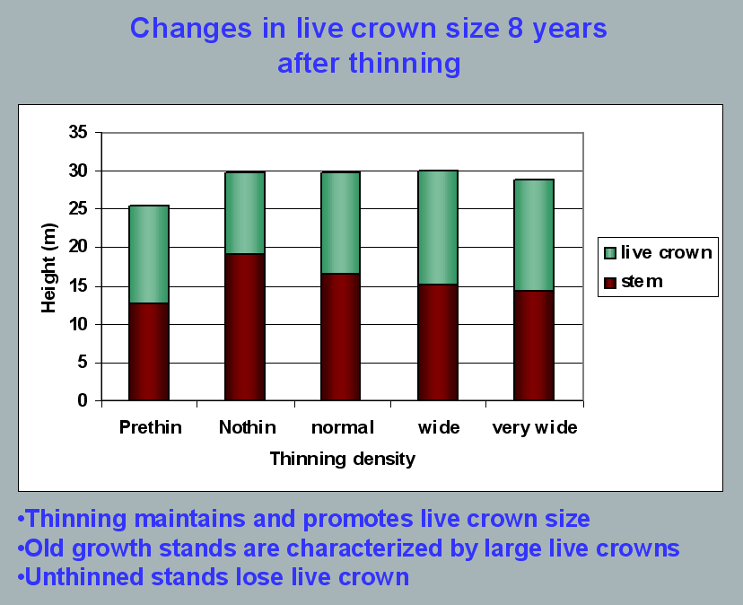
Aquatic/Riparian Ecosystem Dynamics and Associated Management Implications - Recent Findings. Powerpoint, 32.6M. This topic was presented at the Regional Interagency Executive Committee meeting on January 7, 2003. https://web.archive.org/web/20161221100307/http://www.reo.gov/library/presentations/Szaro_present_Aquatic_Rip_Final.ppt.

Stimulating the development of a diverse understory is often used as a justification for thinning, but this may not be justified in stands older than about 40 years. A systematic review of 917 Forest Inventory and Analysis (FIA) plots in western Oregon (mostly on non-federal lands) found,
Contrary to expectations of canopy closure, mean canopy cover by age class rarely exceeded 85 percent, even in unthinned productive young conifer forests. Possibly as a result, effects of stand age on understory vegetation were minimal, except for low levels of forbs found in 20- to 40-year-old wet conifer stands. … Although heavily thinned stands had lower total cover, canopy structure did not differ dramatically between thinned and unthinned stands. Our findings suggest potential limitations of simple stand succession models that may not account for the range of forest types, site conditions, and developmental mechanisms found across western Oregon.
McIntosh, Anne C.S.; Gray, Andrew N.; Garman, Steven L. 2009. Canopy structure on forest lands in western Oregon: differences among forest types and stand ages. Gen. Tech. Rep. PNW-GTR-794. Portland, OR: U.S. Department of Agriculture, Forest Service, Pacific Northwest Research Station. 35 p. http://www.fs.fed.us/pnw/pubs/pnw_gtr794.pdf. This seems to indicate that the benefits of thinning may be best realized in dense stands younger than 40 years old. This study also showed that in wet conifer stands the mean Canopy Height Diversity Index and the mean Simpson’s Diversity Index of tree heights leveled off at about age 65. This study also looked at canopy conditions after three levels of thinning intensities (heavy, light, and none). “Mean cover of the lower canopy layer was nominal for all three thinning intensities. … There were no evident trends between understory cover and thinning history; both shrub and forb cover were fairly similar among the three thinning intensities. … The lack of a strong effect of crown closure on understory cover may be related to our finding that mean crown cover did not exceed 85 percent. … We expected greater cover of understory vegetation in thinned than in unthinned stands but did not detect significant differences in this analysis.”

While one can generalize that vegetation diversity is more likely to flourish when conifer density is lower, there are data showing a wide range of conifer density can support a wide range of deciduous shrub cover. Thinning is not always necessary. The NEPA analysis should carefully document the site-specific “need” for thinning.
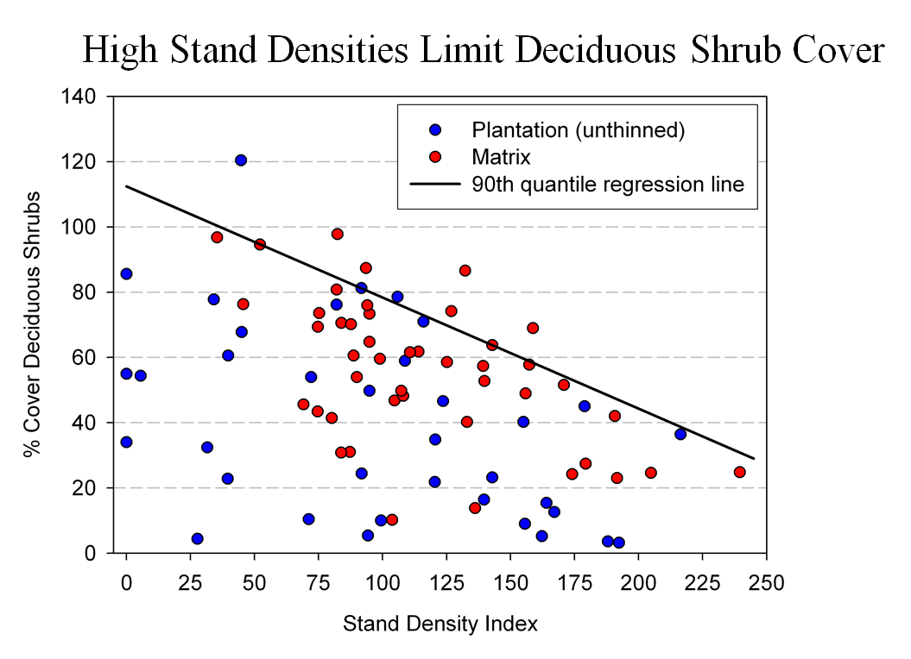
Spies, T. 2008. Powerpoint: Assumptions behind thinning young stands to create late successional riparian habitat. Presented at Riparian Thinning: Logic Paths for Silvicultural Prescriptions -- March 20, 2008. https://ecoshare.info/projects/central-cascade-adaptive-management-partnership/workshops/riparian-thinning-logic-paths/

It is also worth noting that where understories are well-stocked, midstory development can be enhanced by focusing on treating the understory itself rather than killing canopy trees.
[R]esults show that individual understory trees can be selectively favored for increased growth into the midstory by being released from competing saplings in the understory cohort. …Our results suggest that understory release treatments can be used to target individual saplings for increased growth, thereby recruiting a shade tolerant midstory cohort and accelerating the development of vertical foliar connectivity and a multi-layered stand structure. Abundance of non-coniferous understory vegetation is also augmented by this treatment. … [Note] The extent to which released understory trees collectively form a cohesive midstory canopy stratum is dependent on the density and horizontal arrangement of those released individuals. … . Inducing spatial variability within the midstory tree cohort would emulate the finescale disturbances of natural stands that create gaps and patches.
Taylor, Andrew 2016. : Understory Vegetation Dynamics and Midstory Development Following Understory Release Treatments in Northwest Oregon Thinned Douglas-fir Stands. OSU MS Professional Paper.

Anderson (2007) looked at the effects of thinning in young Douglas fir forests and found –
[T]hinning treatments … had little impact on the abundance, size, or diversity of understory vegetation. Disturbance resulted in short-term decreases in understory vegetation cover, particularly tall shrubs. However, within five years of treatment, understory vegetation abundance returned to approximate pretreatment condition. … The general lack of understory vegetation response to the thinning treatments was likely due to the inherent resistance and resilience of the plant communities to disturbance, as well as the low intensity of disturbance attributable to the treatments.
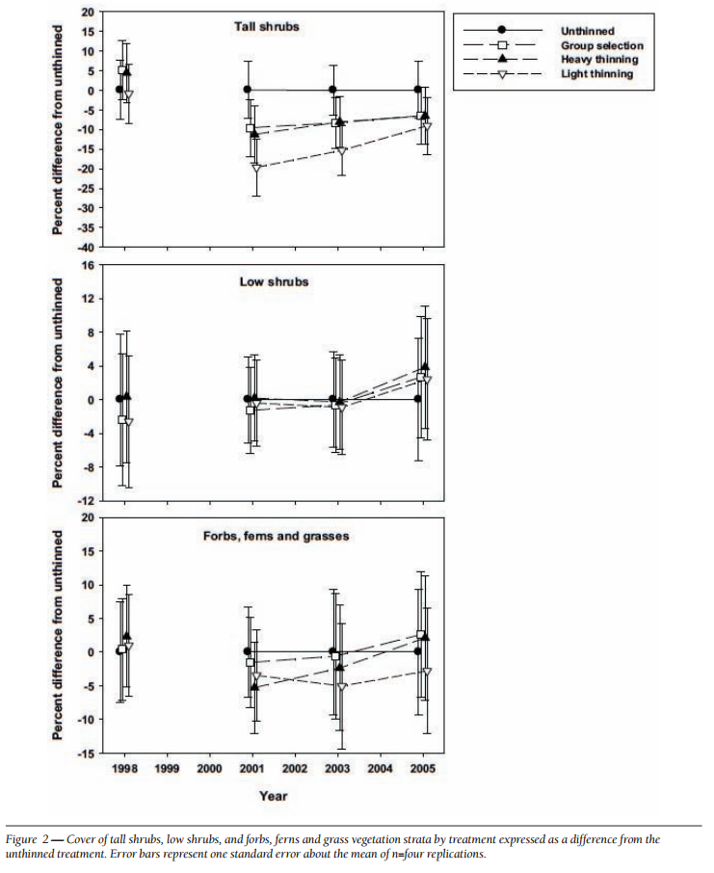
[Four years after thinning] tall shrub cover that was approximately four to nine percent less than the unthinned treatment … [C]over by low shrub species was unchanged by the harvest activity … Forbs, ferns, and grasses [experienced] little difference in cover between thinned and unthinned stands. … [F]ollowing treatment, the mean number of species declined somewhat, [then] return[ed] to pretreatment levels… [T]he evenness component of diversity did not differ among treatments or vary over time …. [T]here was little evidence of substantial alterations of understory shrub and herbaceous vegetation. This lack of strong understory vegetation response in terms of composition, abundance, or size is consistent with several studies of thinning in Douglas-fir. In a recent review of seven operational-scale silviculture experiments, Wilson and Puettmann (2007) report that percent cover by shrubs and percent cover by herbs, one to seven years following thinning showed little difference across a wide range of residual basal area.
Paul D. Anderson 2007. Understory Vegetation Responses to Initial Thinning of Douglas-fir Plantations Undergoing Conversion to Uneven-Age Management. Proceedings of the 2007 National Silviculture Workshop. http://www.fs.fed.us/pnw/publications/gtr733/PNW_GTR_733_4.pdf This paper was published in: Deal, R.L., tech. ed. 2008. Integrated restoration of forested ecosystems to achieve multi-resource benefits: proceedings of the 2007 national silviculture workshop. Gen. Tech. Rep. PNW-GTR-733. Portland, OR: U.S. Department of Agriculture, Forest Service, Pacific Northwest Research Station. 306 p.

[W]hile specific structural attributes of forest ecosystems have been correlated with certain species, it is uncertain how such species will respond to treatments designed to recreate these features. There is always the possibility that in our attempt to create a structural attribute we think is important, we eliminate another attribute that is equally important, but unrecognized. One example is that attempts to restore spotted owl habitat by heavily thinning to accelerate the development of large diameter nesting trees could actually delay spotted owl recovery by reducing production of the large down wood utilized by the species it preys upon (Forsman et al., 1984; Carey, 1995; North et al., 1999). Similarly, heavily thinning stands to accelerate the development of marbled murrelet nesting trees also create open stands with a dense understory that is ideal habitat for a number of corvid species that prey on marbled murrelet nest eggs (USFWS, 2010). Riparian thinning efforts to create long-term supplies of very large diameter instream wood that can initiate complex wood jam formation (e.g., key pieces) are also likely to reduce the supply of large diameter wood that will create pools (Beechie and Sibley, 1997; Beechie et al., 2000; Fox and Bolton, 2007). Thus, we suggest that any efforts to actively restore riparian forests for the benefit of certain species should be treated as scientific experiments and proceed cautiously, skeptically, and with robust pre- and post-treatment data collection efforts. Hypothesized effects of thinning on riparian forest structure and the use of that structure by targeted species should be tested against empirical data.
Pollock, Michael M. and Timothy J. Beechie, 2014. Does Riparian Forest Restoration Thinning Enhance Biodiversity? The Ecological Importance of Large Wood. Journal of the American Water Resources Association (JAWRA) 50(3): 543-559. DOI: 10.1111/jawr.12206. http://oregon-stream-protection-coalition.com/wp-content/uploads/2014/07/Pollock-and-Beechie.-2014.-Riparian-thinning-and-biodiversity.pdf.

Climate change highlights an additional trade-off related to logging riparian buffers. New science shows that more frequent drought makes upland habitats less suitable, so increasing numbers of upland birds flock to riparian corridors, which become more crowded, with negative effects on riparian-dependent species. The agency should do more to increase space for wildlife that need moist streamside habitat during droughts. Gabrielsen, Paul 2021. In dry years, rivers become birds’ crowded corridors. University of Utah @THEU.
https://attheu.utah.edu/uncategorized/in-dry-years-rivers-become-birds-crowded-corridors/ (“New research from the University of Utah and the Utah Division of Wildlife Resources (UDWR) finds that in dry years, birds funnel into the relative greenness of riparian (adjacent to river) environments. That increased diversity is accompanied by overcrowding that may cause increased competition for habitat and resources, the study finds, and an overall decrease in populations of birds who call the river home. … Neate-Clegg and his colleagues noticed that during particularly dry years they were finding more birds than usual in the mist nets near rivers. … The multi-year data showed that total bird captures and total species were higher in hotter and drier years, El Niño years, and less green years. The effect was strongest for non-riparian species, suggesting that in harsh conditions, birds from all over the landscape found their way to the rivers. “This suggests that the wider landscape is unable to support migrants and so they are forced to use greener areas,” Neate-Clegg says. But just as an influx of tourists can crowd out locals, the uptick in birds may have taken its toll on typically riparian species, especially those that breed on river banks…. In warmer years, population growth rates slowed for 47% of riparian bird species. The slowing, the researchers found, wasn’t due to more birds deaths, but rather to fewer new birds joining the population. There could be several reasons that bird breeding goes down in hotter years, but the authors suspect that more species in riparian habitats can mean more competition and fewer resources to go around. ‘This study shows how native bird populations utilize these habitats,’ Norvell says. ‘As droughts intensify, this becomes increasingly the refuge that everything’s relying on. And I don’t think humans are all that different in this case. We’re all increasingly relying on these very same areas.’ Neate-Clegg says that rivers provide connections for birds across the landscape, enabling them to transport nutrients or disperse seeds. A hotter, drier climate could affect those important functions that birds provide, called ‘ecosystem services.’”)

Density-dependent versus density-independent mechanisms
The agencies often emphasize that mortality is not a significant contributor to instream wood recruitment, implying that the effect of thinning on density dependent mortality may not be a big deal. However, the agencies also need to recognize that thinning in potential wood source areas significantly reduces the total amount of wood available for natural processes to act upon.

Since natural disturbance occurs in both thinned and unthinned stands, the proper comparison is not between density-dependent versus density-independent sources of dead wood, but rather the total recruitment of dead wood from all sources in thinned versus unthinned areas.

Also, thinning increases the spacing between trees which means that tree fall events tend to remain isolated rather than triggering small scale contagious tree-fall events that help introduce heterogeneity and recruit more dead wood. Each standing tree has potential energy that could do work on other trees, and stands with fewer trees are capable of doing less work in terms of self-thinning and small scale contagious disturbance. See JAMES A. LUTZ AND CHARLES B. HALPERN. 2006. TREE MORTALITY DURING EARLY FOREST DEVELOPMENT: A LONG-TERM STUDY OF RATES, CAUSES, AND CONSEQUENCES. Ecological Monographs, 76(2), 2006, pp. 257–275. This study showed that mortality from mechanical damage (“crushing disturbance”) from falling limbs and trees and snow loads can be a more significant factor than suppression mortality. In fact, mechanical damage produced four times more deadwood biomass than suppression mortality.

Thinning reduces the amount of trees and therefore reduces the amount of potential energy available to do ecological “work” including recruitment of more and larger wood than recruited by suppression mortality alone. Friesen (2009) said:
Lutz (2005) found in sampled unthinned young stands on the HJA that suppression mortality was observed in >80% of plots and was more than 2.5 times as common as mechanical damage (windthrow, stem snap, and crushing). However, biomass lost to mortality via mechanical damage was nearly four times that lost via suppression because mechanical damage killed larger stems.
Cheryl Friesen 2009. THINNING AND DEAD WOOD: “BEST AVAILABLE SCIENCE” December 15, 2009. http://ecoshare.info/projects/central-cascade-adaptive-management-partnership/synthesis-papers-tools/ See also, Brown, Martin J.; Kertis, Jane; Huff, Mark H. 2013. Natural tree regeneration and coarse woody debris dynamics after a forest fire in the western Cascade Range. Res. Pap. PNW-RP-592. Portland, OR: U.S. Department of Agriculture, Forest Service, Pacific Northwest Research Station. 50 p. (“Snag fall and fragmentation added so much wood to the ground—thousands of meters of log length per hectare—that it probably constitutes a significant ecological disturbance in itself, a kind of rain of logs.”)

Spies et al (2002) enumerate a variety of disturbance agents that can help diversify forest stands withouit logging. It is not always necessary to mechanically thin forests to increase diversity and complexity. Natural processes can do the job.
Thomas A. Spies, David E. Hibbs, Janet L. Ohmann, Gordon H. Reeves, Robert J. Pabst,
Frederick J. Swanson, Cathy Whitlock, Julia A. Jones, Beverly C. Wemple,
Laurie A.Parendes, and Barbara A. Schrader. 2002. The Ecological Basis of Forest Ecosystem Management in the Oregon Coast Range. http://www.fsl.orst.edu/rna/Documents/publications/Flynn%20Creek%20spies_etal_2002_ecological_basis.pdf in Hobbs, S. D. et al (2002). Forest and stream management in the Oregon coast range. Corvallis, Or: Oregon State University Press. https://osupress.oregonstate.edu/book/forest-and-stream-management-in-oregon-coast-range

Das et al (2016) found that mechanical damage plays a significant role in background mortality. Removing many tree stems through logging can therefore be expected to disrupt this natural successional process.
Mechanical factors were associated with 24% of dead trees and were dominated by broken stems (most commonly in intermediate and large trees) and trees that were crushed by other falling trees (most commonly in small and intermediate trees). Incidence of mechanical factors increased modestly from small to mid-size … [D]ead trees in old-growth forests of the Pacific Northwest had a substantially higher occurrence of mechanical mortality factors.
Adrian J. Das, Nathan L. Stephenson, and Kristin P. Davis 2016. Why do trees die? Characterizing the drivers of background tree mortality. Ecology, 97(10), 2016, pp. 2616–2627. See also, Das, A. J., J. J. Battles, P. J. van Mantgem, and N. L. Stephenson. 2008. Spatial elements of mortality risk in old-growth forests. Ecology 89:1744–1756.

Logging in riparian reserves older than 80 years.

The agency must carefully explain why they think it’s OK to thin stands over 80 years old in riparian reserves but not in LSRs when the goals are similar. Two of the main authors of the Northwest Forest Plan recently stated that “Riparian Reserves which have similar structural goals as the LSRs … A maximum thinning age of 80 years was used here.” Johnson & Franklin 2009. Restoration of Federal Forests in the Pacific Northwest: Strategies and Management Implications. http://fes.forestry.oregonstate.edu/sites/fes.forestry.oregonstate.edu/files/PDFs/RestorationOfFederalForestsInThePacificNorthwest.pdf (p 49).

FEMAT page IV-109 says that logging in riparian reserves stands older than 80 years is not appropriate. Such stands were presumed to remain unharvested as mitigation for Bryophytes and other species that prefer dense forest cover and abundant dead wood.
Mitigation for Bryophytes
Bryophytes should receive considerable protection under riparian prescriptions, especially those with full SAT riparian buffers. … Riparian stands older than 80 years should not be thinned or harvested.

“Findings: Thinning is most beneficial in dense young stands <80 years and less clear in older stands.” Chatel 2016. Riparian Management and ESA. Presentation at USFS Ecology Group meeting in Joseph, Oregon. 2016. http://ecoshare.info/whats-new/annual-reports/presentations-at-2016-annual-meeting-in-joseph-or/; http://ecoshare.info/uploads/annualMeeting2016/Riparian-Management-and-ESA-Chatel.pptx referencing Science Review Team, NW Oregon Riparian Reserve Tree Thinning Elevation.

In January 2013, the Science Review Team Wood Recruitment Subgroup reported their “Key Points” regarding the effects of commercial thinning on wood recruitment in riparian reserves:
Key Points
1. Thinning is most beneficial in dense young stands. Existing literature and stand development theory suggest that the greatest potential ecological benefits of thinning to accelerate the development of older forest structure (e.g. large trees, large dead trees, spatial structural and compositional heterogeneity, etc.) comes in dense uniform plantations less than 80 years and especially less than 50 years old. The benefits of thinning for older forest ecological objectives are less clear in stands over 80 years of age. Hence, our report focused primarily on plantations less than 50 years of age.
Thomas Spies, Michael Pollock, Gordon Reeves, and Tim Beechie 2013. Effects of Riparian Thinning on Wood Recruitment: A Scientific Synthesis - Science Review Team Wood Recruitment Subgroup. Jan 28, 2013, p 36. http://www.mediate.com/DSConsulting/docs/FINAL%20wood%20recruitment%20document.pdf

Lack of Site-Specific NEPA Analysis
The EA lacks any site-specific analysis of the long-term adverse effects of temporary road construction, including proximity to streams and other sensitive habitat types, soil types, slopes, fragmentation of affected habitat, etc. NEPA requires such analysis. The FS cannot defer that to a post-NEPA process that excludes the public and commits the FS to an action without NEPA analysis, public involvement, and site-specific comparison to the no action alternative.

In order to comply with NEPA requirements and cover both the programmatic and site-specific impacts of logging and road construction, the NEPA analysis must carefully document all the contingencies under which covered actions might occur —
- all the different soil types and topographies;
- all the different plant communities;
- impacts to habitat for all the different special status species;
- proximity to special resources;
- possible conflicts with site-specific recreation uses;
- compliance with RMP requirements for all the different land allocations;
- consideration of new information that may render the programmatic NEPA analysis obsolete;
- compatibility with the cumulative effects setting that exists in all the different watersheds, etc.
- site-specific trade-offs from road construction
The Grasshopper EA does not fulfill the requirements of NEPA.

NEPA requires that environmental analysis be specific enough to ensure informed decision-making and meaningful public participation.110 The Project EIS's omission of the actual location of proposed timber harvest and road construction within the Project Area falls short of that mandate. … The Project EIS at issue here … does not delineate harvest units, let alone identify planned activities within them and describe their impacts on localized cognizable values. Nor does the Project EIS allow the public to identify where specific harvest activities will occur in relation to various cognizable values on Prince of Wales Island.119 … [T]he EIS falls short of NEPA's directive to "contain[] a reasonably thorough discussion of the significant aspects of the probable environmental consequences" for each alternative.142 This approach, coupled with the lack of site-specific information in the Project EIS, detracts from a decisionmaker's or public participant's ability to conduct a meaningful comparison of the probable environmental impacts among the various alternatives. … The Project EIS identified a total acreage of potential timber harvest, but not the distribution of the specific acreage authorized by each alternative within these areas. This omission is meaningful given the duration and scale of the project.146 Despite "additional parameters that limit the ultimate selection of units and activities,"147 such as mitigation measures contained in the Activity Cards,148 the Project EIS's structure creates ambiguity about the actual location, concentration, and timing of timber harvest and road construction on Prince of Wales Island.149 By doing so, the Project EIS fails to provide a meaningful comparison of alternatives. By authorizing an integrated resource management plan but deferring siting decisions to the future with no additional NEPA review,150 the Project EIS violates NEPA. The Forest Service has not yet taken the requisite hard look at the environmental impact of site-specific timber sales on Prince of Wales over the next 15 years. The Forest Service's plan for condition-based analysis may very well streamline management of the Tongass and decrease the amount of falldown acreage associated with each timber sale;151 however, it does not comply with the procedural requirements of NEPA, which are binding on the agency.152 "NEPA favors 'coherent and comprehensive up-front environmental analysis to ensure . . . that the agency will not act on incomplete information, only to regret its decision after it is too late to correct."153
SE Alaska Conservation Council v. U.S. Forest Serv. (D. Alaska 2020). Case No. 1:19-cv-00006-SLG. March 11, 2020. https://earthjustice.org/sites/default/files/files/40-order-granting-msj_3-11-20.pdf.

As explained by the Center for Biological Diversity in their 3-24-2019 comments on the Lone Pine Project EA on the San Juan National Forest:
... NEPA’s “‘action-forcing’ procedures ... require the [Forest Service] to take a ‘hard look’ at environmental consequences” before the agency approves an action. “By so focusing agency attention, NEPA ensures that the agency will not act on incomplete information, only to regret its decision after it is too late to correct.” ...
NEPA’s review obligations are more stringent and detailed at the project level, or “implementation stage,” given the nature of “individual site specific projects.” “[G]eneral statements about possible effects and some risk do not constitute a hard look, absent a justification regarding why more definitive information could not be provided.”
Analyzing and disclosing site-specific impacts is critical because where (and when and how) activities occur on a landscape strongly determines that nature of the impact. As the Tenth Circuit Court of Appeals has explained, the actual “location of development greatly influences the likelihood and extent of habitat preservation. Disturbances on the same total surface area may produce wildly different impacts on plants and wildlife depending on the amount of contiguous habitat between them.” The Court used the example of “building a dirt road along the edge of an ecosystem” and “building a four-lane highway straight down the middle” to explain how those activities may have similar types of impacts, but the extent of those impacts – in particular on habitat disturbance – is different. Indeed, “location, not merely total surface disturbance, affects habitat fragmentation,” and therefore location data is critical to the site-specific analysis NEPA requires.

Avoid unnecessary construction of temporary roads. Optimize treated and untreated.

Roads have serious adverse effects on soil, water, wildlife, weeds, and carbon. There are already too many roads on our National Forests. More than the FS can afford to maintain. Road building is not part of the purpose and need for this “restoration” project. It is desirable to leave significant parts of this project area unlogged to mitigate for the adverse effects of logging on carbon storage, wildlife cover, and dead wood recruitment. It is therefore preferable to avoid the adverse effects of road building by focusing on areas that are accessible form existing roads. The Forest Service should consider an alternative that seeks an optimal mix of logged and unlogged areas, focusing on stands outside unroaded areas and accessible from existing roads.

Temporary roads still cause serious adverse impacts to soil, water and wildlife, and spread weeds. Decommissioning such roads is not entirely successful and the soil compaction effects can last for decades. The agency should consider avoiding building spurs by treating some areas non-commercially (e.g. thin lightly, create lots of snags, and leave the material on site).

We urge the agency to avoid road construction, including temporary road construction. The ecological costs of road construction almost always outweigh any benefits of the associated commercial logging activity. Since an optimal landscape restoration plan includes a mix of treated and untreated areas, the agency can easily avoid road construction by co-locating untreated areas and inaccessible areas.

Temporary roads have many of the same impacts as permanent roads, including complete vegetation removal, severe soil disturbance and compaction, severe modification of the flow of water and air through the soil, impairment of soil biological activity, wildlife habitat fragmentation (especially for microfauna), and wildlife cover loss. In spite of the fact that some roads may only be used by heavy equipment on a temporary basis, the biophysical effects of temporary roads can be long-lasting. The FS may even come back and use these temporary roads for future vegetation management or fire management. The temporal effects of temp roads can also be extended by legal or illegal use by off highway vehicles, woodcutters, hunters, mushroom collectors, etc.

The November 2000 National Forest Roadless Area Conservation FEIS p 3-30 says that temporary roads are not designed and constructed to the same standard as classified roads and therefore result in a “higher risk of environmental impacts.” The NEPA analysis must account for this increased risk of temporary roads compared to permanent roads.

The Roadless FEIS also says:
Temporary roads present most of the same risks posed by permanent roads, although some may be of shorter duration. Many of these roads are designed to lower standards than permanent roads, are typically not maintained to the same standards, and are associated with additional ground disturbance during their removal. Also, use of temporary roads in a watershed to support timber harvest or other activities often involves construction of multiple roads over time, providing a more continuous disturbance to the watershed than a single, well-designed, maintained, and use-regulated road. While temporary roads may be used temporarily, for periods ranging up to 10 years before decommissioning, their short- and long-term effects on aquatic species and habitats can be extensive. [The FEIS has similar disclosures citing extensive impacts to terrestrial species and habitats, and rare plant populations.]
Roadless Area Conservation FEIS — Specialist Report for Terrestrial and Aquatic Habitats and Species prepared by Seona Brown and Ron Archuleta, EIS Team Biologists http://web.archive.org/web/20040515020554/http://roadless.fs.fed.us/documents/feis/specrep/xbio_spec_rpt.pdf.

"Temporary roads are constructed with no engineering specifications since they are targeted to be used for a short time (ideally a single season), and then obliterated. This lack of construction design makes it particularly important to follow Project Design Criteria for avoiding potentially unstable slopes, even with potentially short time frame of use. That is because even temporary roads which are constructed with road cuts in steep, unstable terrain can trigger debris avalanches and slope failures by removing downslope support and interfering with surface and subsurface water flows that can weaken slopes."
USDA 2020. Stella Landscape Restoration Project Draft Environmental Impact Statement. Page III-30. Rogue River Siskiyou National Forest. https://www.fs.usda.gov/project/?project=53241.

For the semi-permanent roads that will be tilled, BLM’s own soils scientist has little faith in the restorative value of this technique. He says: “What I have seen so far have been nothing more than modified rock rippers and little lateral fracture of the soil occurs and the extent of de-compacting is very limited.” Coos Bay BLM, Big Creek Analysis file, section F, Soils Report. page 4.

The agency typically assumes that temporary roads will have little or no effect because they are temporary. The agency has shown no scientific evidence to support this assumption. In fact, scientific research has shown exactly the opposite. Effectiveness of Road Ripping in Restoring Infiltration Capacity of Forest Roads. Charles H. Luce, USDA Forest Service Intermountain Research Station, 1221 S. Main, Moscow, ID 83843. September 1996. Restoration Ecology, Vol. 5, No. 3. page 268.

Please consider George Wuerthner’s summary of the many problems with so-called temporary roads. George Wuerthner 2009. Temporary Roads Are Like Low Fat Ice Cream, NewWest. 3-17-09. http://www.newwest.net/topic/article/temporary_roads_are_like_low_fat_ice_cream/C564/L564/ (“The problem is that temporary roads have most of the same environmental impacts as regular roads.”). See also, Wuerthner’s April 2020 blog post showing the persistent impacts of temporary roads. http://www.thewildlifenews.com/2020/04/22/are-temporarily-roads-ecologically-invisible/.

Research results, published in Restoration Ecology, shows there is nothing temporary about temporary roads, and that ripping out a road is NOT equal to never building a road to begin with. The saturated hydraulic conductivity of a ripped road following three rainfall events was significantly greater than that of the road surface before ripping... most saturated hydraulic conductivities after the third rainfall event on a ripped road were in the range of 22 to 35 mm/hr for the belt series and 7 to 25 mm/hr for the granitics. These conductivities are modest compared to the saturated hydraulic conductivity of a lightly disturbed forest soil of 60 to 80 mm/hr.” id. Even this poor showing of restoring pre-road hydrologic effects worsened with repeated rainfall. “Hydraulic conductivity values for the ripped treatment on the granitic soil decreased about 50% with added rainfall (p(K1=K2)=0.0015). This corresponded to field observations of soil settlement and large clods of soil created by the fracture of the road surface dissolving under the rainfall... The saturated hydraulic conductivity of the ripped belt series soils also dropped from its initial value. Initially, and for much of the first event, the ripped plots on the belt series soil showed no runoff. During these periods, run-off from higher areas flowed to low areas and into macropores.... Erosion of fine sediment and small gravel eventually clogged these macropores... Anecdotal observations of roads ripped in earlier years revealed that after one winter, the surfaces were nearly as solid and dense as the original road surfaces.” Id. Even though ripped roads increase water infiltration over un-ripped roads, it does not restore the forest to a pre-road condition. “These increases do not represent ‘hydrologic recovery’ for the treated areas, however, and a risk of erosion and concentration of water into unstable areas still exists.” Luce, C.H., 1997. Effectiveness of Road Ripping in Restoring Infiltration Capacity of Forest Roads, Restoration Ecology; 5(3):265-270. http://library.eri.nau.edu/gsdl/collect/erilibra/import/Luce.1997.EffectivenessOfRoadRippingIn.pdf.

The Rogue River-Siskiyou National Forest’s Rustler EA (2010) says:
Temporary roads are also expected to have an irretrievable reduction in soil productivity since they are bladed (soil is mixed and displaced) and compacted. Even once rehabilitated, the soil profile is modified to a degree that may take many years to return to the productive state of the undisturbed forest soils adjacent to it.

To help weigh trade-offs, the agency should do an analysis that illuminates how many acres of accessed by each road segment so that we can distinguish between short segments of spur that allow access to large areas (large accomplishment of goals, with small cost/trade-off) and long spurs that access small areas (small accomplishment, large cost/trade-off). This can help inform the decision-maker’s balancing of the costs and benefits of logging and roading.

The 1994 NWFP ROD (p 68) says “Standards and guidelines for Alternative 9 require that new road construction be substantially limited. Any road construction associated with silvicultural treatments inside late-successional reserve would be subject to the overall ‘beneficial’ requirement for such activities. That is, if the value of a thinning was negated by the habitat lost through road construction to the thinning, the activity should not proceed.”

The Coos Bay BLM’s Brummit Creek Density Management EA (2005) includes a useful table showing the length of each road (new, renovated, improved), the unit acres that are accessed by each road, and the acres of unit per mile of road. This is a useful way to evaluate and prioritize road work relative the expected benefits of thinning.

New Information Requires Modification of Matrix Objectives.
This project is based on part on the need to produce timber to meet LRMP objectives. There is a trade-off between ecological objectives and timber objectives, and new information indicates that these trade-offs are becoming more acute. Before sacrificing older forests in order to produce timber, the agency needs to carefully consider new information developed since the Northwest Forest Plan was adopted in 1994. Several significant new developments indicate a need to increase emphasis on conservation and restoration of more mature & old-growth forests, and reduced emphasis on Matrix objectives such as timber production from logging of mature & old-growth forests. Unfortunately, the agencies have not taken steps to account for new information and has failed to adjust Matrix objectives accordingly.

A few of the most important new issues include:

Barred owls — The threatened spotted owl faces a significant new threat in the form of the barred owl which has recently invaded the range of the spotted owl, uses and similar habitat, and uses many of the same food sources. Hundreds of thousands of acres of suitable owl habitat that were assumed in the NW Forest Plan to be available for spotted owl nesting, roosting, and foraging are now occupied and defended by territorial barred owls to the exclusion of spotted owls. There is an urgent need to protect additional suitable owl habitat (and reduce the loss of existing habitat) in order to increase the likelihood that threatened spotted owls can coexist with newly invading barred owls instead of facing competitive exclusion. More habitat increases the chances that the two owls can co-exist. More discretion and more logging reduce the changes for co-existence and increase the chances for competitive exclusion/extirpation.

FWS has recommended protection of a subset of high quality owl habitat, but whether this subset of habitat is enough to ensure species recovery has never been tested and validated. The habitat modeling done as part of the spotted owl recovery planning process assume that the barred owl population would remain constant, but it is more realistic to expect that the barred owl population will continue to increase for some time. We are a long way from an effective rangewide barred owl control program, and if the program ever gets fully implemented, failure to maintain the program in perpetuity will likely lead to a rapidly resurgent population of barred owls. There are too many preconditions that undercut FWS’ modeling assumptions and the effectiveness of relying on a subset of suitable habitat. Spotted owls would be safer if all suitable habitat were protected.

The FS is using Recovery Action 32 to mitigate for the barred owl, but in reality all suitable habitat should be conserved. When the agency discovers that its plans are out of date and adopts new strategies, the agency must follow NEPA and NFMA procedures to amend its forest plan. ONRC and HCPC v. Forsgren, 252 F. Supp. 2d 1088 (D. Or. 2003) March 11, 2003. http://law.justia.com/cases/federal/district-courts/FSupp2/252/1088/2424683/ Here, RA 32 is a new strategy that the FS is using as a de facto plan amendment to justify logging suitable habitat. This is not allowed without following legal requirements.

Owl dispersal habitat – The matrix was intended to support spotted owl dispersal, and it was assumed that 40% canopy closure of trees 11” dbh would be enough, but new information indicates that spotted owl dispersal habitat should be managed for “at least 80%” canopy cover. Sovern et al (2015) found that
“Roost Site Selection. In contrast to the assumption that stands with relatively open canopies provide suitable dispersal habitat for spotted owls, our results suggest that dispersing juveniles selected stands for roosting that had relatively high canopy closure (x = 66 + 2%). … Two hypotheses could explain why dispersing owls selected closed-canopy stands. First, several researchers (Barrows 1981, Forsman et al. 1984, Weathers et al. 2001) have shown that temperature and precipitation appear to influence selection for roost trees and attributes within a roost tree, such as perch height and percent overhead cover. … Second, juvenile northern spotted owls may have selected for closed-canopy forest because their preferred prey were most abundant … Landscape Scale Selection. … [O]ur mean estimate of canopy closure from plots at roosts (66%), which was likely an underestimate of canopy cover, was considerably higher than the minimum values recommended by Thomas et al. (1990) [i.e. 50-11-40]. … Management Implications. … Based on our study, we recommend that managers should pursue a strategy that exceeds the canopy cover guidelines recommended by Thomas et al. (1990) when managing dispersal habitat for spotted owls. Based on our estimate of mean canopy closure (66%), and our estimate of mean canopy cover from overlaying a dot grid on the same areas (approx. 14% larger), we recommend that the target for canopy cover in stands managed for dispersing spotted owls should be at least 80%.”
Stan G. Sovern, Eric D. Forsman, Katie M. Dugger, Margaret Taylor. 2015. Roosting Habitat Use and Selection By Northern Spotted Owls During Natal Dispersal. The Journal of Wildlife Management 79(2):254–262; 2015; DOI: 10.1002/jwmg.834. https://osu-wams-blogs-uploads.s3.amazonaws.com/blogs.dir/2742/files/2016/09/Sovern-et-al.-2015.pdf.

Another owl dispersal concern is that in 2016 Oregon BLM adopted new RMPs that cut riparian reserves in half. Wide riparian reserves established by the Northwest Forest Plan were supposed to serve multiple purposes, including as spotted owl dispersal habitat, but the smaller riparian corridors do not fulfill that function, so the matrix needs to be modified to better meet spotted owl dispersal needs.

Carbon storage — Global climate change is a new and significant threat not only to imperiled species, but also whole forest ecosystems and human communities. To reduce the severity of global climate change requires, among other things, that the global carbon cycle be managed to store more carbon. Carbon-rich ecosystems like mature & old-growth forests of western Oregon present a tremendous opportunity to increase carbon storage and mitigate climate change.

Climate change is a new and significant reason to conserve forests and reduce logging. A science review will show that long-live d forests are a great place to store carbon, while wood products are relatively short-lived and not a good place to store carbon. Also, carbon can't be moved from the forest to durable wood products without causing significant GHG emissions. Alleged benefits of wood products substitution for steel and concrete are vastly over-estimated. All high biomass forests should be conserved, and many young forest should be allowed to grow.

Climate change — A warmer world with more seasonal extremes of wet and dry also creates uncertainty about our ability to sustain older forests, and about whether we can recreate functional old forests starting from young, planted stands. If climate change brings increasing frequency and severity of drought and natural disturbance, it may be harder to sustain existing older forests and harder to establish new forests and sustain them through long periods of forest succession required to reach habitat goals for imperiled species like spotted owls, marbled murrelet, and salmon. This highlights the old adage that “a bird in the hand is worth two in the bush.” We should retain all the older forests that we currently have (and carefully nurture likely recruitment forests). Climate uncertainty alone represents an increased risk for spotted owl recovery.

Undisturbed ecosystems and late successional forests are more resistant and resilient to climate change. György Kröel-Dulay et al (2015). Increased sensitivity to climate change in disturbed ecosystems. Nature Communications, 2015; 6: 6682. http://web.ics.purdue.edu/~jsdukes/Kr%C3%B6el-DulayEtAl_NC_2015.pdf. Climate change is a huge new stress on ecosystems that are already stressed. We can help ecosystems better withstand climate change by reducing anthropogenic stress caused by logging, roads, grazing, etc. Climate change is expected to amplify the hydrologic cycle. This calls for increased protection of whole watersheds and especially streams buffers (and reducing road/stream interactions). There may be a need for modest reductions in tree density, but only in limited areas. For wildlife that depend on dense forest conditions (i.e., most of our threatened & endangered species), logging to reduce stress or reduce fire hazard will only make things worse. Wildlife are more threatened by the combined effects of logging plus fire, than by fire alone. See Heiken, D. 2010. Log it to save it? The search for an ecological rationale for fuel reduction logging in Spotted Owl habitat. Oregon Wild. v 1.0. May 2010. https://www.dropbox.com/s/pi15rap4nvwxhtt/Heiken_Log_it_to_save_it_v.1.0.pdf?dl=0
Dead wood standards — Large accumulations of dead wood are essential for meeting objectives for fish & wildlife habitat, water quality, and carbon storage. Past and ongoing forest management has greatly reduced the prevalence of large snags and dead wood. Northwest Forest Plan standards for dead wood are based on an outdated “potential population” methodology which greatly underestimates the amount of snags and down logs needed to meet the needs of a variety of species associated with dead wood. Forests are a dynamic system where the population of all live trees represent the recruitment pool for all dead trees, so if more dead trees are needed over time, that means more live trees need to be retained for long-term recruitment. Before conducting activities like commercial logging (especially regen logging) that will result in long-term reduction in recruitment of snags and dead wood, the agencies should follow NEPA procedures to amend their management plans, consider alternatives, and adopt new standards that assure objectives are met over time and across the landscape.

Complex early seral forest - There is some concern that clearcuts on non-federal do not provide high quality habitat for wildlife that prefer complex early seral habitat with abundant legacies and diverse non-conifer vegetation. While this habitat may be under-represented, there are no listed species that depend on it because most of the species associated with ephemeral young forests tend to be mobile, generalist, and/or opportunistic. There are a wide variety of policy options for enhancing early seral that do not require that we sacrifice old forests. K. Norm Johnson, Debora L. Johnson. 2007. Policies to Encourage Diverse, Early Seral Forest in Oregon: What Might We Do? http://ecoshare.info/2010/10/04/k-norman-johnson-policies-to-encourage-diverse-early-seral-forest-in-oregon-what-might-we-do/ Climate change is expected to increase the prevalence of early seral forests. Regen logging produces lower quality early seral. We should instead stop salvage logging.

Fire Hazard – New information highlights the fact that regen logging increases fire hazard for many decades by causing the establishment of homogeneous young conifer stands with dense fuels close to the ground. See Harold S. J. Zald, Christopher J. Dunn. 2018. Severe fire weather and intensive forest management increase fire severity in a multi‐ownership landscape. Ecological Applications. Online Version of Record before inclusion in an issue. 26 April 2018. https://doi.org/10.1002/eap.1710. Also, https://phys.org/news/2018-04-high-wildfire-severity-young-plantation.html. This concern is highlighted by climate change which is extending the fire season. Roads also increase roadside ladder fuels and fire ignition risk. Conversely, another study shows that mature forests are more resilient to wildfire, which brings into question the long-held assumption that time-since-fire is an indicator of fuel build-upand increased fire hazard. Lesmeister, D. B., S. G. Sovern, R. J. Davis, D. M. Bell, M. J. Gregory, and J. C. Vogeler. 2019. Mixed-severity wildfire and habitat of an old-forest obligate. Ecosphere 10(4):e02696. 10.1002/ecs2.2696. https://esajournals.onlinelibrary.wiley.com/doi/pdf/10.1002/ecs2.2696

Hydrologic Effects – New information indicates that logging and roads have significant and long-lasting adverse effects on hydrology, including artificial peak flows in the years during storms, especially immediately after logging; as well as artificial low stream flows during summer, which lasts for several decades when dense young conifers establish after logging. Perry & Jones (2016) found “… Long‐term paired‐basin studies extending over six decades revealed that the conversion of mature and old‐growth conifer forests to plantations of native Douglas‐fir produced persistent summer streamflow deficits of 50% relative to reference basins, in plantations aged 25 to 45 years. This result challenges the widespread assumption of rapid “hydrologic recovery” following forest disturbance … “ Perry, T. D., and Jones, J. A. (2016) Summer streamflow deficits from regenerating Douglas-fir forest in the Pacific Northwest, USA. Ecohydrology, doi: 10.1002/eco.1790. http://onlinelibrary.wiley.com/doi/10.1002/eco.1790/full. Jones & Grant (1996) found “"This study demonstrated that road construction combined with patch clear-cutting ranging from 10 to 25% of basin area produced significant, long-term increases in peak discharges in small and large basins in the western Cascades.... In the western Cascades, clear-cutting and vegetation removal influence water balances by affecting evapotranspiration and possibly snow accumulation and melt, whereas road construction influences hillslope flow paths by converting subsurface flow to surface flow.” Jones, J.A., Grant G.E., "Peak flow response to clear-cutting and roads in small and large basins, western Cascades, Oregon," Water Resources Research, 32(4) 959-974, April 1996 https://www.wou.edu/las/physci/taylor/g473/refs/jones_grant_1996.pdf. The National Climate Assessment concludes that global climate change is expected to reduce the ability of watersheds and ecosystems to regulate water quality and water flow and buffer extreme events. http://nca2014.globalchange.gov/ Efforts toward watershed and riparian conservation should therefore be increased;
Pacific Fisher – In 2014, FWS proposed listing the Pacific fisher as "threatened" under the ESA. A final listing decision is due in Fall 2015. The imminent listing of the fisher requires the agencies to increase connectivity in the NWFP. The current network of reserves was designed more for spotted owls and is not ideal for fishers which have more difficulty in navigating between reserves. William J. Zielinski, et al., Using landscape suitability models to reconcile conservation planning for two key forest predators, Biological Conservation (2006), doi:10.1016/j.biocon.2006.07.003. http://www.sierraforestlegacy.org/Resources/Conservation/SierraNevadaWildlife/CaliforniaSpottedOwl/CASPO-Zielinski06.pdf The agencies need to increase conservation of habitats in the matrix that are suitable or potentially suitable for fisher. This includes mature & old-growth forests and riparian reserves.

The PNW economy has changed. At the NWFP tenth anniversary conference on April 13, 2004 in Portland, USFS PNW Regional Economist Richard Haynes said that the NW economy has “fundamentally changed” over the last ten years since the NWFP was approved. The changes include: growth and diversification of the overall economy so that the timber industry plays a much smaller role in the overall economy, structural changes in the timber industry both regionally and nationally so that few mills remain dependent upon federal old-growth log supply, and serious decline of the export market so the logs from private lands are now more available to domestic mills. This raises a significant issue about whether the NWFP should continue to log any more late-successional old-growth at all and take continued risks with population viability of late-successional old-growth dependent species. Changed economic circumstances represent significant new information and requires the agency to prepare an EIS to consider protecting all remaining mature and old-growth forests and shifting efforts toward restoration including thinning dense young plantations.

The economic and social benefits of logging are decreasing. As recently as 2001, there were 12 jobs generated per million board feet cut. In 2012, that ratio had declined to 6.5 jobs per million board feet logged. (Oregon Employment Department, July 17, 2014).
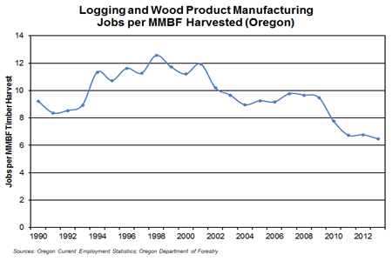

https://www.qualityinfo.org/-/jobs-per-board-feet-of-timber-harvests-in-oregon;

Since 2010, timber harvest and jobs have become decoupled. There is no reason to think that increased timber harvest will result in increased employment.

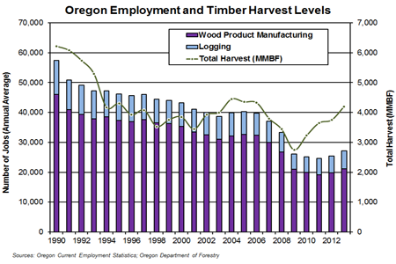
https://www.qualityinfo.org/-/jobs-per-board-feet-of-timber-harvests-in-oregon;

Producing timber from federal lands feeds an inherently volatile industry that perpetuates community instability. There is significant new information indicating that the timber industry is inherently volatile so proving timber from federal lands causes community instability rather than community stability. BLM’s 2015 Western Oregon Plan Revision DEIS (p 472) said:
Over the long-term (1969-2007), timber-based industries nationally exhibited low or negative growth rates with high volatility compared with the United States economy as a whole, indicating that these industries tend to be inherently volatile. Increases in timber industry activity in the planning area could bring additional exposure to greater economic instability.
http://www.blm.gov/or/plans/rmpswesternoregon/deis.php BLM’s DEIS acknowledges that the timber industry is far more volatile than other industries so boosting timber jobs does not necessarily translate to community stability. This new information requires a fundamental shift in thinking about the value of federal lands for timber production versus provision of public benefits that do contribute to community stability, such as: clean water, carbon storage and stabilizes the climate, biodiversity, diverse recreation opportunities, scenic values, etc.

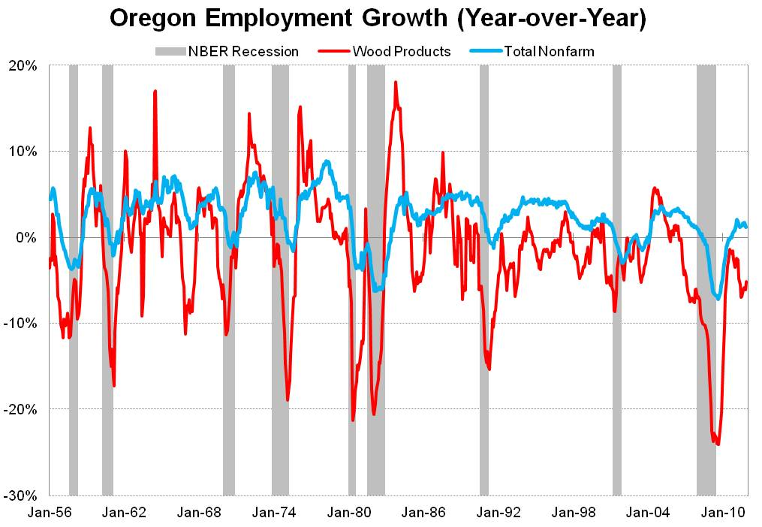

Lehner, J. 2012. Historical Look at Oregon’s Wood Product Industry. http://oregoneconomicanalysis.com/2012/01/23/historical-look-at-oregons-wood-product-industry/

Timber industry volatility would have its greatest effect in local communities that have the lowest levels of economic diversity, the greatest dependence on commodity production, and would therefore see the greatest fluctuations in jobs and income. The gain and loss of jobs caused by timber industry volatility would cause a variety of social problems related to job insecurity, depression, substance abuse, health care insecurity, domestic abuse, etc. which would in turn cause an increase in the demand for social services that are not adequately funded. If the Forest Service and BLM would emphasize development of less volatile economic sectors through provision of amenities instead of commodities, the social problems described above would be diminished and the demand for social services would be reduced.

All things being equal, a more diversified economy is a more stable economy. Oregon will always have a timber industry based on non-federal forest lands. The highest and best use of public forest lands, in terms of community stability, is to conserve the resources on those lands to provide a stable flow of ecosystem services such as clean water, carbon storage and recreation opportunities, that will help diversify the economy, and mitigate the economic instability caused by logging on non-federal lands.

“Sustained yield” is based on flawed science. Sustained yield logging in the matrix is premised on the concept of a “regulated forest.” As explained in the Days Creek – South Umpqua Harvest Plan EA “The key to achieving sustained yield is to establish a regulated forest with the proper distribution of stand age and size classes so that over time, approximately equal periodic harvests of the desired size and quality are produced. A ‘regulated forest’ consists of tree sizes in approximately equal parts and age classes that correspond to the size classes. To achieve the desired age class distribution, it is necessary that the harvest type resets the age class or seral stage, i.e. a regeneration harvest of selected stands is necessary, including regeneration harvest of intermediate-age classes. Over time, regeneration harvests can transform or convert an irregular forest structure to a regulated one (Hennes et al., 1971).” Unfortunately, this is only possible on paper. In the real world, none of this is possible, especially if the agency wishes to meet other important objectives such as water quality, climate stability, health populations of fish & wildlife, etc. See Jack Ward Thomas 1997. The Instability of Stability, http://web.archive.org/web/20001201174000/http://coopext.cahe.wsu.edu/~pnrec97/thomas2.htm (“The vision that I was taught in school of the "regulated forest" and the resultant predictable outputs of commodities has turned out to have been a dream. … By now it is becoming obvious that this dream was built on the pillars of the seemingly boundless virgin forest and an ethic of manifest destiny coupled with hubris of being able to predict the response of nature and humans. This was coupled with an inflated sense of understanding of forested ecosystems and of human control. Perhaps it is time to recognize that such stability is not attainable in any western region except for relatively short periods of years or decades. … It is increasingly apparent that ecological processes are not as well understood nor as predictable as had been assumed by natural resource managers steeped in Clementsian ecological theory of orderly and predictable succession of plant communities from bare ground to a mature, steady state. … In summary, the timber supply from federal lands is one drought, one insect and disease outbreak, one severe fire season, one election, one budget, one successful appeal, one loss in court, one listing of a threatened or endangered species, one new piece of pertinent scientific information, one change in technology, one shift in public opinion, one new law, one loss of a currently available technological tool, one change in market, one shift in interest rates, et al, away from "stability" at all times. And, these changes do not come one at a time, they come in bunches like banannas [sic] and the bunches are always changing. So, stability in timber supply from the public lands is simply a myth, a dream that was never founded in reality. It is time to stop pretending.”). See also: Donald Ludwig, Ray Hilborn, Carl Waters 1993. Uncertainty, Resource Exploitation, and Conservation: Lessons from History. Science, New Series, Vol. 260, No. 5104 (Apr. 2, 1993), pp. 17-36. http://www.waterboards.ca.gov/waterrights/water_issues/programs/bay_delta/deltaflow/docs/exhibits/swrcb/swrcb_ludwig1993.pdf

When we bring all these lines of evidence together one realizes that since the NWFP and the matrix land allocation was adopted there are many more reasons to protect forests and fewer reasons to log them. This needs to be considered in a new EIS. Since these significant new issues were not properly considered in the Northwest Forest Plan FEIS, the agency needs to address them in project level NEPA analyses. Since these significant new issues were not properly considered in the Northwest Forest Plan FEIS, the agency needs to address them here.

Preparation of new NEPA documents is a non-discretionary duty of all federal agencies. The CEQ regulations state that:
(c) Agencies:
(1) Shall prepare supplements to either draft or final environmental impact statements if:
… (ii) There are significant new circumstances or information relevant to environmental concerns and bearing on the proposed action or its impacts.
40 CFR 1502.9(c). This duty applies to both EISs and EAs. ISC v. Alexander (9th Circ. 2000).

"A federal agency has a continuing duty to gather and evaluate new information relevant to the environmental impact of its actions.... [W]hen new information comes to light the agency must consider it, evaluate it, and make a reasoned determination whether it is of significance as to require formal NEPA procedures." Warm Springs Dam Task Force v. Gribble, 621 F.2d 1017, 1023-24 (9th Cir. 1980). "[T]he decision whether to prepare a supplemental EIS is similar to the decision whether to prepare an EIS in the first instance: If there remains 'major Federal actio[n]' to occur, and if the new information is sufficient to show that the remaining action will 'affec[t] the quality of the human environment' in a significant manner or to a significant extent not already considered, a supplemental EIS must be prepared." Marsh v. ONRC, 490 U.S. 360, 374, 109 S. Ct. 1851, 1859 (1989). While BLM is making decision to implement the regen harvest and mature forest thinning aspects of its RMP, it must first prepare a new or supplemental EIS to consider all the new information that has arisen over the last two decades. Most of the new information indicates that forest conservation is even more important than previously realized and that logging is less important than previously realized.

Similarly, under both NMFA and FLPMA, the agencies must “… prepare and maintain on a continuing basis an inventory of all public lands and their resources and other values … This inventory shall be kept current so as to reflect changes in conditions and to identify new and emerging resource and other values …” 43 USC 1711 (similar at 16 USC 1603). The resulting inventory shall be used in creating land use plans which are living documents, not a static end result. “The Secretary shall … develop, maintain, and when appropriate, revise land use plans …” 43 USC 1712 (similar at 16 USC 1604). These provisions, combined with NEPA’s action-driven mandate for considering “new circumstances or information,” and the multiple-use mandate to utilize resources in the combination that “best meet the present and future needs of the American people” (43 USC 1702, 16 USC 1601) create a non-discretionary duty to keep programmatic plans up to date.

The fact that LRMPs and RMPs are all 20 years old (and well beyond the expected life-span of the plans) just adds to the evidence indicating the need for reconsideration of the emphasis on timber production, when conservation is what’s needed.

Each substantive issue discussed in these comments should be (i) incorporated into the purpose and need for the project, (ii) used to develop NEPA alternatives that balance tradeoffs in different ways, (iii) carefully analyzed and documented as part of the effects analysis, and (iv) considered for mitigation.

Note: If any of these web links in this document are dead, they may be resurrected using the Wayback Machine at Archive.org. http://wayback.archive.org/web/

Sincerely,
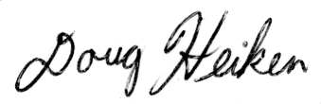
Doug Heiken
dh@oregonwild.org

Put another way, when threatened with extinction, “the best defense is a strong offense” that is, species are more likely to persist if they have a large, well-distributed population size and if we minimize all manageable threats. Dunham, Jason. 2008. Bull trout habitat requirements and factors most at risk from climate change. http://www.fs.fed.us/rm/boise/AWAE/projects/bull_trout/bt_Dunham.html
Rockström, J., W. Steffen, K. Noone, Å. Persson, F. S. Chapin, III, E. Lambin, T. M. Lenton, M. Scheffer, C. Folke, H. Schellnhuber, B. Nykvist, C. A. De Wit, T. Hughes, S. van der Leeuw, H. Rodhe, S. Sörlin, P. K. Snyder, R. Costanza, U. Svedin, M. Falkenmark, L. Karlberg, R. W. Corell, V. J. Fabry, J. Hansen, B. Walker, D. Liverman, K. Richardson, P. Crutzen, and J. Foley. 2009. Planetary boundaries:exploring the safe operating space for humanity. Ecology and Society 14(2): 32. [online] URL: http://www.ecologyandsociety.org/vol14/iss2/art32/. http://www.stockholmresilience.org/download/18.1fe8f33123572b59ab800012568/pb_longversion_170909.pdf. http://www.ecologyandsociety.org/vol14/iss2/art32/figure6.html.
Metcalf v. Daley, 214 F.3d 1135, 1141 (9th Cir. 2000) (quoting Robertson v. Methow Valley Citizens Council, 490 U.S. 332, 348 (1989)).
Marsh, 490 U.S. at 371 (citation omitted).
Ecology Ctr., Inc. v. United States Forest Serv., 192 F.3d 922, 923 n.2 (9th Cir. 1999); see also Friends of Yosemite Valley v. Norton, 348 F.3d 789, 800-01 (9th Cir. 2003); New Mexico ex rel Richardson v. Bureau of Land Management, 565 F.3d 683, 718-19 (10th Cir. 2009) (requiring site-specific NEPA analysis when no future NEPA process would occur); Colo. Envtl. Coal. v. Ofc. of Legacy Mgmt., 819 F. Supp. 2d 1193, 1209-10 (D. Colo. 2011) (requiring site-specific NEPA analysis even when future NEPA would occur because “environmental impacts were reasonably foreseeable”).
Or. Natural Res. Council Fund v. Brong, 492 F.3d 1120, 1134 (9th Cir. 2007) (citation omitted); see also Or. Natural Res. Council Fund v. Goodman, 505 F.3d 884, 892 (9th Cir. 2007) (holding the Forest Service’s failure to discuss the importance of maintaining a biological corridor violated NEPA, explaining that “[m]erely disclosing the existence of a biological corridor is inadequate” and that the agency must “meaningfully substantiate [its] finding”).
New Mexico ex rel Richardson, 565 F.3d at 706.
Id. at 707.
Id.

