21 March 2022

TO: Willamette NF, Middle Fork Ranger District
ATTN: Hilary Krieger
VIA: https://cara.ecosystem-management.org/Public/CommentInput?Project=61142
CC: hilary.krieger@usda.gov

Subject: Steeple Rock Rigdon Project — scoping comments

Please accept the following scoping comments from Oregon Wild and Cascadia Wildlands concerning the Steeple Rock Rigdon Project, https://www.fs.usda.gov/project/?project=61142. Oregon Wild represents 20,000 members and supporters who share our mission to protect and restore Oregon’s wildlands, wildlife, and water as an enduring legacy. Our goal is to protect areas that remain intact while striving to restore areas that have been degraded. This can be accomplished by moving over-represented ecosystem elements (such as logged and roaded areas) toward characteristics that are currently under-represented (such as roadless areas and complex old forest). Cascadia Wildlands is part of a movement to protect and restore wild ecosystems of the Cascadia Bioregion, including vast old-growth forests, rivers full of wild salmon, wolves howling in the backcountry, and vibrant communities sustained by the unique landscapes. Cascadia Wildlands’ contact information is: P.O. Box 10455, Eugene, OR 97440 | Eugene, OR 97401 | 541-434-1463 | info@cascwild.org.

This proposal, involves:
- Land allocations: Late Successional Reserve, riparian reserves, and matrix, (the scoping letter should have provided a map of this)
- variable density thinning across about 3,200 acres of 30 to 72-year old managed stands, with skips, gaps, and early seral creation
- Aquatic restoration activities (and some logging) on about 1,186 acres of Riparian Reserves such as tree tipping, fall and leave, floodplain augmentation, and instream restoration
- 277 acres of “fall and leave” would occur in young stands to benefit wildlife.
- Road work included in the proposed action would include road maintenance or reconstruction on approximately 100 miles of forest roads, with about 7.1 miles of decommissioning and about 30.6 miles of road closure.
- ~ 40 million board feet of timber
- Harvest systems for this project include roughly 26% helicopter logging, 56% skyline logging and 18% ground based yarding
- 30 acres of Meadow restoration
- Roadside fuels reduction on about 410 acres.
- 1450 acres of “burn blocks”

The scoping map shows several areas of “wildlife habitat treatment units” but the scoping letter does not make clear what that involves.

We are generally supportive of variable thinning in young managed stands that are accessible from existing roads, but it needs to be done thoughtfully and with meaningful consideration of, and mitigation of, the numerous trade-offs on dead wood habitat recruitment, carbon emissions/storage, spotted owl dispersal, spotted owl prey, etc.

The purpose and need for this project should be amended to include increasing carbon storage to mitigate global climate change, and avoiding actions that will substantially reduce the natural rate of carbon accumulation in these young, growing forests. This goal is necessary to address the climate emergency that is upon us, and this goal is harmonious with LSR and RR goals, including wildlife cover, dead wood habitat accumulation, diversity and abundance of spotted owl prey, aquatic and riparian habitat development, forest structure with high canopy that is resilient to fire, etc. The 1994 NWFP FEIS needs to be updated to matrix to require the matrix be managed for carbon storage. The FS should not tier to the 28 year old NEPA analysis supporting the matrix because it does not account for the urgent need to address global climate change and manage capable forests for carbon storage.

Wildlife evolved in a landscape dominated by large patches of unmanaged habitat, but decades of logging and road building have dramatically reduced wildlife access to such areas. The purpose and need should be amended to include restoration of large blocks of unmanaged habitat such as unroaded areas >1,000 acres. The map below shows two such areas on the east side of this project area located near Windfall Creek and Bear Bones Mountain. Appropriate restoration actions might include closing or decommissioning adjacent roads to enlarge these areas, and prescribed fire, or other actions that accurately mimic natural disturbance processes (i.e., snag creation and fall and leave without commercial removal of biomass), weed removal, non-commercial thinning, meadow restoration, etc.
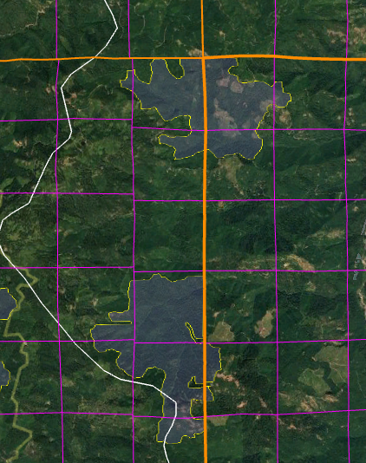

The Northwest Forest Plan does not recognize wood products as an appropriate goal within LSRs and riparian reserves. Wood products will undoubtedly be produced as a byproduct of restoration, but should not be part of the purpose and need. This will help ensure that trade-offs are resolved in favor of ecological objectives instead of timber sale viability and logging and layout efficiency. In addition, the matrix was established based on an EIS that did not consider the need for additional forest conservation to address climate change, and the barred owl, the community instability caused by the timber industry, and the continuing economic transition away from timber dependency.

Thinning should be done to achieve diversity and complexity of late successional habitat, particularly in LSR and riparian reserves. Thinning in reserves must avoid homogenizing these stands. This will require implementing a spatially variable thinning prescription with lots of skips and retained clumps of trees, as well as heavily thinned “gaps” (not mini-clearcuts) that mimic natural disturbance processes by retaining numerous live and dead trees within “gaps.” Thinning that primarily gives space to individual trees should not be favored in reserves. Natural forests grow in spatially variable clumps, not park-like stands.

Managing for complexity and diversity is appropriate in all land allocations, including matrix. Thinning in the matrix needs to account for accumulating gaps in the 1994 FEIS such as the competitive pressure of the barred owl, new science indicating that spotted owl dispersal requires higher canopy cover than normally provided in matrix logging projects, the effects of climate change (increasing uncertainty about conservation and restoration of late successional forests), continuing loss of spotted owl habitat on non-federal lands, and the accumulating science showing that thinning has long-term adverse effects on dead wood and spotted owl prey.

Thinning should focus on removing planted Douglas fir trees, and retaining all elements of existing diversity including minor species such as: pine, hemlock, cedar, yew, and hardwoods. Existing snags 16” dbh should be protected by keeping workers out of the danger zone.

Efforts should be made to protect ecologically valuable shrubs that provide cover and food for diverse wildlife, including diverse birds and spotted owl prey. This will require modifying logging prescriptions and fuel management prescriptions to avoid crushing and burning ecologically important shrubs that produce berries, nuts, pollen, nectar, seeds, insects and palatable forage. "Although usually classified as a shrub and not considered in discussions of forest composition or structure, A. circinatum [vine maple] dominated the angiosperm component, and although comprising only 0.9% of the basal area, it was the most abundant woody species in terms of stem count. This is important because A. circinatum makes a disproportionate contribution to biodiversity in this evergreen conifer forest, for example by providing food for folivore geometrid larvae that feed Neotropical migrant birds [26] and by providing substrate for epiphytic lichens and bryophytes [27]." Lutz JA, Larson AJ, Freund JA, Swanson ME, Bible KJ (2013) The Importance of Large-Diameter Trees to Forest Structural Heterogeneity. PLoS ONE 8(12): e82784. doi:10.1371/journal.pone.0082784. http://ctfs.arnarb.harvard.edu/Public/pdfs/LutzEtAl_PLoS2013.pdf

Thinning does not always accelerate development of late successional forests, in particular commercial thinning has an adverse effect on recruitment of snags and dead wood that are defining characteristics of late successional habitat. Thinning might produce the first large trees, but those trees would be vigorous and less likely to experience mortality, so developing large snags is not a direct and immediate result of growing large trees. Thinning also dramatically reduces the pool from which future mortality can be recruited so thinning actually retards development of some attributes of late successional forest and spotted owl habitat including snags and down wood. NEPA analyses often assert that "As a result of thinning, growth of retained live trees would be accelerated, so larger trees would be available sooner for recruitment as snags and CWD than without thinning." This is only half the story and it is very misleading. The agency is not being fully honest about the effects of logging unless statements like this are followed by a loud and clear acknowledgement that accelerating development of a few larger live trees (that might become snags if a few of them happen to die) comes at the cost of a significant reduction in the number of medium and large snags over time. From an ecological perspective, the net result of commercial logging is undeniably adverse to snag habitat. The agency cannot present logging as a benefit to snag habitat when it is really a cost that needs to be mitigated.

The graph below is from the Curran Junetta Thin EA (on the nearby Cottage Grove Ranger District). It shows that similar thinning prescriptions in similar stand types delays by more than 60 years the attainment of habitat objectives for large snags (i.e. mid-point of the gray band representing 30-80% tolerance level).

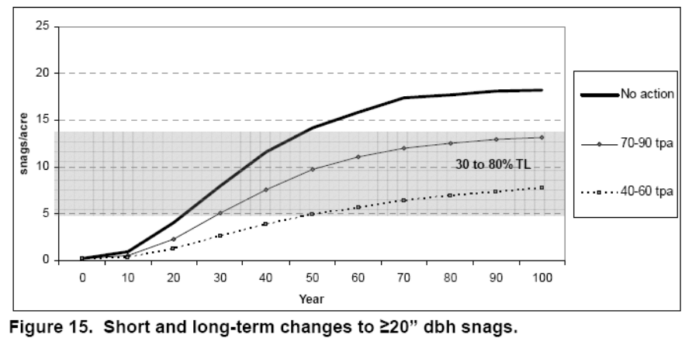

http://a123.g.akamai.net/7/123/11558/abc123/forestservic.download.akamai.com/11558/www/nepa/32805_FSPLT2_053506.pdf.

Thinning captures mortality and significantly reduces recruitment of snags and dead wood that are critically important habitat elements within LSR and riparian reserve land allocations. These adverse effects are significant and long-lasting. Artificial snag creation at the end of the project can help partially mitigate these effects, but snag creation has only short-term benefits. The artificially crated nags fall down within a decade or so, and then the thinned stand will suffer from a deficit of snags for decades because (i) there are far fewer stems in the stand available for recruitment; after thinning there is simply fewer trees for natural processes to act upon, (ii) after thinning the remaining trees are more vigorous and less likely to die and become snags., and (iii) the shortage of trees adversely affects natural mortality processes including fire, insects, and small contagious tree-fall events.

The adverse effects of captured mortality and reduced wood recruitment also apply in riparian reserves, which need abundant wood throughout their full width, not just instream. Thinning in riparian reserves should focus on stands less than 50 years old and should retain a generous no-cut buffer to ensure optimal wood recruitment.

“Early seral creation” should be done on a very limited scale outside of the reserves. First, logging does not mimic natural process very well. Logging removes valuable forest structure and biomass, and requires roads and significant disturbance of soils and understory vegetation. Second, natural processes such as wildfire are already creating large amounts of early seral habitat. Early seral creation should be limited to small (<3 acre) structure-rich gaps.

Roadside fuels reduction should be limited to removal of stems less than 7” dbh. The goals should be to reduce surface and ladder fuels while maintaining a relatively dense canopy cover to maintain a cool, moist microclimate, reduce wind speeds, and mostly importantly, help suppress the growth of surface and ladder fuels which reduces fire hazard and reduces future maintenance costs.

Prescribed fire or “burn blocks” should strive for a mosaic of burned conditions, not wall-to-wall blackened ground. Some of the post-thinning fuel work I have seen would tend to homogenize stand conditions by killing retained understory trees, and does not appear to be harmonious with LSR goals.

Road construction to reach thinning units should be reconsidered in light of the long-term adverse effects of roads, and the fact that meeting LSR goals requires large “skips” to mitigate for the effects of thinning and ensure that abundant dead wood recruitment occurs over time. The purpose and need and the NEPA analysis should strive to find the optimal mix of treated and untreated areas on the landscape to meet the full suite reserve objectives. Through this thoughtful intentional process, hopefully the adverse effects of road building can be avoided and the benefits of snag habitat recruitment can be gained. It’s a win-win.

If using techniques such as whole-tree yarding or yarding with tops attached to control fuels, the agency should top a portion of the trees and leave the greens in the forest in order to retain nutrients on site. Achat, Deleuze, et al 2015. Quantifying consequences of removing harvesting residues on forest soils and tree growth – A meta-analysis. Forest Ecology and Management Volume 348, 15 July 2015, Pages 124–141. http://www.sciencedirect.com/science/article/pii/S0378112715001814 (“Our study showed that, compared with conventional stem-only harvest, removing the stem plus the harvesting residues generally increases nutrient outputs thereby leading to reduced amounts of total and available nutrients in soils and soil acidification, particularly when foliage is harvested along with the branches. … Soil fertility losses were shown to have consequences for the subsequent forest ecosystem: tree growth was reduced by 3-7% in the short or medium term (up to 33 years after harvest) in the most intensive harvests (e.g. when branches are exported with foliage). Combining all the results showed that, overall, whole-tree harvesting has negative impacts on soil properties and trees that may have an impact on the functioning of forest ecosystems.”)

Where road building is necessary, ensure that the realized restoration benefits far outweigh the adverse impacts of the road. Carefully consider the effects of roads on connectivity, especially at road/stream crossings, across ridge tops, and midslope hydrological processes (such as large wood delivery routes). The NEPA analysis should rank new road segments according to their relative costs (e.g. length, slope position, soil type, ease of rehabilitation, weed risk, native vegetation impacts, etc.) and benefits (e.g. acres of restoration facilitated), then use that ranking to consider dropping the roads with the lowest ratio of benefits to costs. Avoid log hauling during the wet season. Once the relative acres accessed per mile of road is determined, take the analysis one step further and determine the “effective road density” of each segment. In other words, extrapolate as if that much road were required to reach each acre of the planning area, then compare the resulting road density to standards for big game, cumulative hydrological impact, etc? For example, if a new spur road accesses thinning opportunities at a rate of 200 acres of forest per mile of road, then divide 640 acres per section by 200 acres per mile to determine the effective road density of 3.2 mi/mi².

Descriptions of the effect of NOT thinning dense young stands (e.g., “skips” and the no action alternative) should incorporate the information presented in Lutz. J.A. 2005. The Contribution of Mortality to Early Coniferous Forest Development. MS Thesis. University of Washington. http://faculty.washington.edu/chalpern/Lutz_2005.pdf. This MS Thesis looked at long-term transect data from young forests in Western Oregon and found that non-competitive mortality and gap forming processes are very much in operation in dense young planted stands. This indicates that in young stands the homogenizing influence of stand growth and competitive mortality is significantly counter-balanced by non-competitive mortality that tends toward heterogeneity and structural diversification. This means that if young stand management is to effectively mimic natural patterns and processes, that variable density treatments must be the rule, and the scale of the mosaic must be very fine scale. Note: The study sites were located in the HJ Andrews Experimental Forest and were not naturally regenerated, so it is likely that in young stands that are naturally regenerating after disturbance such as fire, the heterogeneity and gap-forming processes would be even more pronounced. See also Lutz & Halpern 2006. Tree Mortality During Early Forest Development: A Long-Term Study Of Rates, Causes, And Consequences. Ecological Monographs, 76(2), 2006, pp. 257–275. http://cfr501.jamesalutz.com/Lutz_Halpern_Mortality_EM_2006.pdf and Franklin, J. F., T. A. Spies, R. Van Pelt, A. B. Carey, D. A. Thornburgh, D. R. Berg, D. B. Lindenmayer, M. E. Harmon, W. S. Keeton, D. S. Shaw, K. Bible, and J. Chen. 2002. Disturbances and structural development of natural forest ecosystems with silvicultural implications, using Douglas-fir as an example. Forest Ecology and Management 155:399-423. http://www.fs.fed.us/pnw/pubs/journals/pnw_2002_franklin001.pdf.

Focus the analysis on “trade-offs” related to logging. All logging, including thinning stands of any age, include some adverse impacts and trade-offs. Some impacts of logging are unavoidable, so there is no such thing as a logging operation that is 100% beneficial. Depending on how thinning is done, it can have adverse impacts such as soil disturbance; habitat disturbance; damage to the shrub layer; carbon removal; spreading weeds; reduced populations of prey for carnivorous species; reduced recruitment of snags; road-related impacts on soil, water, site productivity, and habitat; moving fuels from the canopy to the ground, hotter-drier-windier microclimate that is favorable to greater flame lengths and rate of fire spread, etc. Some of these negative effects are fundamentally unavoidable, therefore all thinning has negative effects that must be compensated by beneficial effects such as reducing competition between trees so that some can grow larger faster, increased resistance drought stress and insects, possible increasing species and structural diversity, possible fire hazard reduction, etc. It is generally accepted that when thinning very young stands, the benefits outweigh the adverse impacts and net benefits are likely. It is also widely understood that thinning older stands tends to have greater impacts on soil, water, weeds, carbon, dead wood recruitment so the impacts very often outweigh the benefits, resulting in net negative outcome on the balance sheet. Thus, as we move from young forest to older forests, the net benefits turn into net negative impacts. See Klaus J. Puettmann, Adrian Ares, and Erich Dodson. 2011. Over- and understory vegetation responses to thinning treatments: Can we accelerate late successional stand structures? Symposium: Density Management In The 21st Century: West Side Story. http://oregonstate.edu/conferences/event/densitymanagement2011/agenda.pdf (“growth of large trees was less responsive to thinning and low mortality rates for larger trees resulted in little recruitment of large snags or coarse woody debris (down wood). In general, thinning increased abundance and diversity of early-seral understory species, with little effect on late-seral species. On sites where shrub cover was already high harvesting initially reduced the cover, but shrubs recovered over time. Exotic species slightly increased in response to treatment …”); and Erich K. Dodson, Adrian Ares, and Klaus J. Puettmann. 2011. Thinning effects on tree mortality and snag recruitment. Symposium: Density Management In The 21st Century: West Side Story. http://oregonstate.edu/conferences/event/densitymanagement2011/agenda.pdf (“…thinning did little to accelerate the development of large snags and coarse downed wood that provide critical wildlife habitat…”) These are some of the trade-offs that must be disclosed and weighed in the NEPA document.

Weigh the trade-offs associated with logging in riparian reserves.

It’s already been made clear that logging is a subtractive endeavor that is adverse to recruitment of dead wood. So, the agency often claims that logging in riparian reserves is necessary to improve attributes other than large wood. However, these benefits are often minor and transitory, and do not outweigh the significant long-term adverse effect of logging on recruitment of dead wood. The agency must focus on the most significant contributions of vegetation toward ACS objectives and the most significant effects of logging on the ACS objectives.

If the agency intends to log in riparian reserves to increase some nebulous goal like “vegetation diversity and complexity,” then please explain why the biophysical indicators for the ACS objectives (set forth below) do not include any mention of vegetation diversity or complexity. See the Jazz Thinning Preliminary Analysis, 2011. http://bark-out.org/sites/default/files/bark-docs/Jazz_PA_0.pdf.
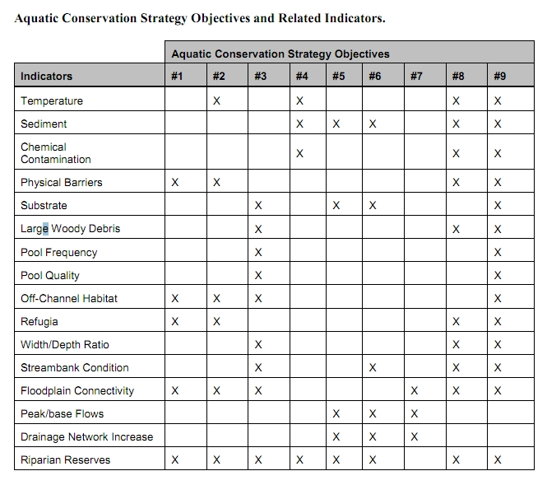
These ACS objectives and biohysical indicators are consistent throughout the Pacific Northwest and are not unique to the Mt Hood NF.

The Northwest Forest Plan and its supporting documentation make clear that the primary value of riparian vegetation is as a source of large wood and shade, not vegetation diversity and canopy layering, as often asserted by the agency to justify logging in riparian reserves. BLM admits “The primary function of Riparian Reserves is to provide shade and a source of large wood inputs to stream channels.” Medford BLM 2013. Pilot Thompson EA, p 3-76. http://www.blm.gov/or/districts/medford/plans/files/PT_EA_ForWeb.pdf

Stan Gregory notes the following trade-offs associated with logging riparian reserves to enhance early seral vegetation:
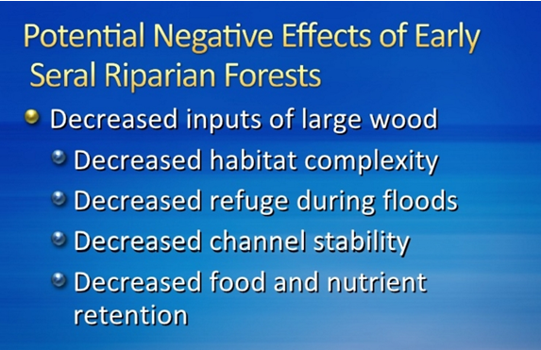
Gregory, Stan 2010. What About Riparian Systems: Who Benefits From an Early Seral Forest Condition. Workshop - Early Seral Forest - We know we need it -- How do we get it? Presentation sponsored by the Central Cascades Adaptive Management Partnership and NW Oregon Ecology Group http://ecoshare.info/2010/07/06/what-about-riparian-systems-who-benefits-from-an-early-seral-forest-condition-gregory/

The Northwest Forest Plan Aquatic Conservation Strategy Objectives (1994 ROD p B-11) enumerates specific purposes for “Maintain[ing] and restor[ing] the species composition and structural diversity of plant communities in riparian areas and wetlands” that is -
“to provide adequate summer and winter thermal regulation, nutrient filtering, appropriate rates of surface erosion, bank erosion, and channel migration and to supply amounts and distributions of coarse woody debris sufficient to sustain physical complexity and stability.”
All these values are provided as well or better by unthinned riparian stands.

The effects of logging on dead wood are significant and long term, adversely affecting a core function of the reserves, while the purported benefits to vegetation diversity are minor and transitory, and affect secondary purposes of the reserves.

Large Wood
Large quantities of downed trees are a functionally important component of many streams (Swanson et al. 1976; Sedell and Luchessa, 1982; Sedell and Froggat, 1984; Harmon et al. 1986; Bisson et al. 1987; Maser et al. 1988; Naiman et al. 1992). Large woody debris influences channel morphology by affecting longitudinal profile, pool formation, channel pattern and position, and channel geometry (Bisson et al. 1987). Downstream transport rates of sediment and organic matter are controlled in part by storage of this material behind large wood (Betscha 1979). Large wood affects the formation and distribution of habitat units, provides cover and complexity, and acts as a substrate for biological activity (Swanson et al. 1982; Bisson et al. 1987). Wood enters streams inhabited by fish either directly from the adjacent riparian zone from tributaries that may not be inhabited by fish, or hillslopes (Naiman et al. 1992).
Large wood in streams has been reduced due to a variety of past and present timber harvesting practices and associated activities. Many riparian management areas on federal lands are inadequate as long term sources of wood.
…
Riparian Ecosystem Components
…
Riparian vegetation regulates the exchange of nutrients and material from upland forests to streams (Swanson et al. 1982; Gregory et al. 1991). Fully functional riparian ecosystems have a suite of characteristics which are summarized below. Large conifers or a mixture of large conifers and hardwoods are found in riparian zones along all streams in the watershed, including those not inhabited by fish (Naiman et al. 1992). Riparian zone-stream interactions are a major determinant of large woody debris loading (House and Boehne 1987; Bisson et al. 1987; Sullivan et al. 1987). Stream temperatures and light levels that influence ecological processes are moderated by riparian vegetation (Agee 1988; Gregory et al. 1991). Streambanks are vegetated with shrubs and other low-growing woody vegetation. Root systems in streambanks of the active channel stabilize banks, allow development and maintenance of undercut banks, and protect banks during large storm flows (Sedell and Beschta 1991). Riparian vegetation contributes leaves, twigs, and other forms of fine litter that are an important component of the aquatic ecosystem food base (Vannote et al. 1980).
1993 FEMAT Report, pp V-13, V-25.

The effects of thinning on crown development are not very significant.

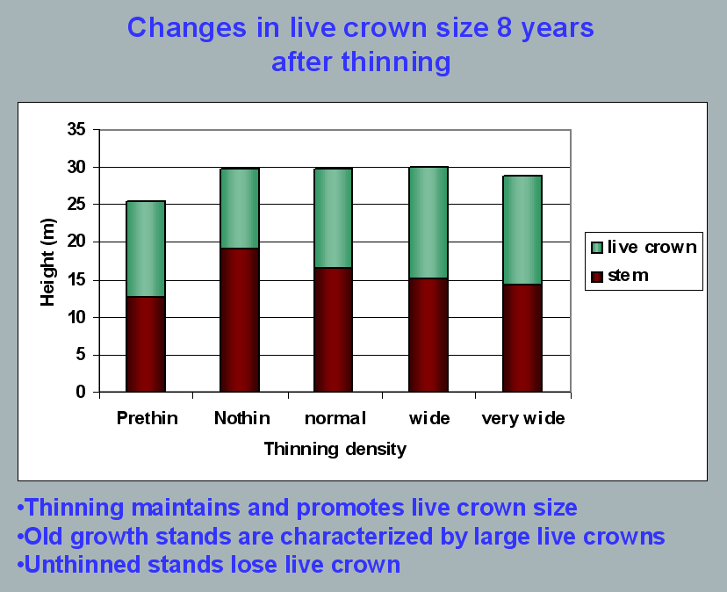
Aquatic/Riparian Ecosystem Dynamics and Associated Management Implications - Recent Findings. Powerpoint, 32.6M. This topic was presented at the Regional Interagency Executive Committee meeting on January 7, 2003. https://web.archive.org/web/20161221100307/http://www.reo.gov/library/presentations/Szaro_present_Aquatic_Rip_Final.ppt.

Stimulating the development of a diverse understory is often used as a justification for thinning, but this may not be justified in stands older than about 40 years. A systematic review of 917 Forest Inventory and Analysis (FIA) plots in western Oregon (mostly on non-federal lands) found,
Contrary to expectations of canopy closure, mean canopy cover by age class rarely exceeded 85 percent, even in unthinned productive young conifer forests. Possibly as a result, effects of stand age on understory vegetation were minimal, except for low levels of forbs found in 20- to 40-year-old wet conifer stands. … Although heavily thinned stands had lower total cover, canopy structure did not differ dramatically between thinned and unthinned stands. Our findings suggest potential limitations of simple stand succession models that may not account for the range of forest types, site conditions, and developmental mechanisms found across western Oregon.
McIntosh, Anne C.S.; Gray, Andrew N.; Garman, Steven L. 2009. Canopy structure on forest lands in western Oregon: differences among forest types and stand ages. Gen. Tech. Rep. PNW-GTR-794. Portland, OR: U.S. Department of Agriculture, Forest Service, Pacific Northwest Research Station. 35 p. http://www.fs.fed.us/pnw/pubs/pnw_gtr794.pdf. This seems to indicate that the benefits of thinning may be best realized in dense stands younger than 40 years old. This study also showed that in wet conifer stands the mean Canopy Height Diversity Index and the mean Simpson’s Diversity Index of tree heights leveled off at about age 65. This study also looked at canopy conditions after three levels of thinning intensities (heavy, light, and none). “Mean cover of the lower canopy layer was nominal for all three thinning intensities. … There were no evident trends between understory cover and thinning history; both shrub and forb cover were fairly similar among the three thinning intensities. … The lack of a strong effect of crown closure on understory cover may be related to our finding that mean crown cover did not exceed 85 percent. … We expected greater cover of understory vegetation in thinned than in unthinned stands but did not detect significant differences in this analysis.”

While one can generalize that vegetation diversity is more likely to flourish when conifer density is lower, there are data showing a wide range of conifer density can support a wide range of deciduous shrub cover. Thinning is not always necessary. The NEPA analysis should carefully document the site-specific “need” for thinning.
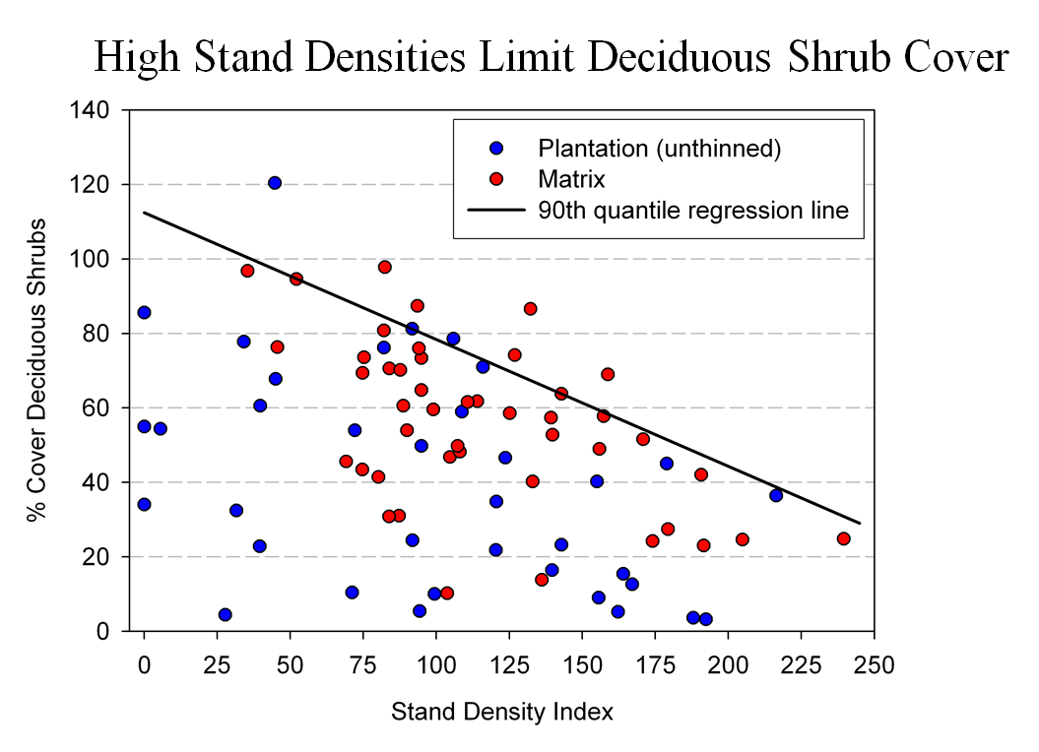
Spies, T. 2008. Powerpoint: Assumptions behind thinning young stands to create late successional riparian habitat. Presented at Riparian Thinning: Logic Paths for Silvicultural Prescriptions -- March 20, 2008. https://ecoshare.info/projects/central-cascade-adaptive-management-partnership/workshops/riparian-thinning-logic-paths/

It is also worth noting that where understories are well-stocked, midstory development can be enhanced by focusing on treating the understory itself rather than killing canopy trees.
[R]esults show that individual understory trees can be selectively favored for increased growth into the midstory by being released from competing saplings in the understory cohort. …Our results suggest that understory release treatments can be used to target individual saplings for increased growth, thereby recruiting a shade tolerant midstory cohort and accelerating the development of vertical foliar connectivity and a multi-layered stand structure. Abundance of non-coniferous understory vegetation is also augmented by this treatment. … [Note] The extent to which released understory trees collectively form a cohesive midstory canopy stratum is dependent on the density and horizontal arrangement of those released individuals. … . Inducing spatial variability within the midstory tree cohort would emulate the finescale disturbances of natural stands that create gaps and patches.
Taylor, Andrew 2016. : Understory Vegetation Dynamics and Midstory Development Following Understory Release Treatments in Northwest Oregon Thinned Douglas-fir Stands. OSU MS Professional Paper.

Anderson (2007) looked at the effects of thinning in young Douglas fir forests and found –
[T]hinning treatments … had little impact on the abundance, size, or diversity of understory vegetation. Disturbance resulted in short-term decreases in understory vegetation cover, particularly tall shrubs. However, within five years of treatment, understory vegetation abundance returned to approximate pretreatment condition. … The general lack of understory vegetation response to the thinning treatments was likely due to the inherent resistance and resilience of the plant communities to disturbance, as well as the low intensity of disturbance attributable to the treatments.
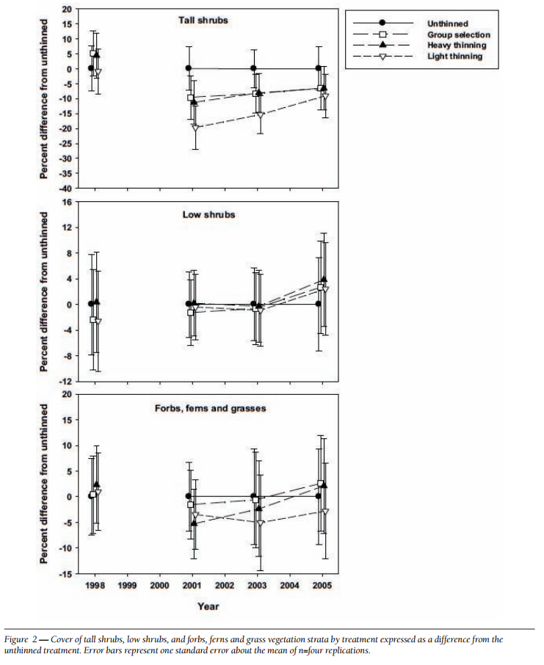
[Four years after thinning] tall shrub cover that was approximately four to nine percent less than the unthinned treatment … [C]over by low shrub species was unchanged by the harvest activity … Forbs, ferns, and grasses [experienced] little difference in cover between thinned and unthinned stands. … [F]ollowing treatment, the mean number of species declined somewhat, [then] return[ed] to pretreatment levels… [T]he evenness component of diversity did not differ among treatments or vary over time …. [T]here was little evidence of substantial alterations of understory shrub and herbaceous vegetation. This lack of strong understory vegetation response in terms of composition, abundance, or size is consistent with several studies of thinning in Douglas-fir. In a recent review of seven operational-scale silviculture experiments, Wilson and Puettmann (2007) report that percent cover by shrubs and percent cover by herbs, one to seven years following thinning showed little difference across a wide range of residual basal area.
Paul D. Anderson 2007. Understory Vegetation Responses to Initial Thinning of Douglas-fir Plantations Undergoing Conversion to Uneven-Age Management. Proceedings of the 2007 National Silviculture Workshop. http://www.fs.fed.us/pnw/publications/gtr733/PNW_GTR_733_4.pdf This paper was published in: Deal, R.L., tech. ed. 2008. Integrated restoration of forested ecosystems to achieve multi-resource benefits: proceedings of the 2007 national silviculture workshop. Gen. Tech. Rep. PNW-GTR-733. Portland, OR: U.S. Department of Agriculture, Forest Service, Pacific Northwest Research Station. 306 p.

[W]hile specific structural attributes of forest ecosystems have been correlated with certain species, it is uncertain how such species will respond to treatments designed to recreate these features. There is always the possibility that in our attempt to create a structural attribute we think is important, we eliminate another attribute that is equally important, but unrecognized. One example is that attempts to restore spotted owl habitat by heavily thinning to accelerate the development of large diameter nesting trees could actually delay spotted owl recovery by reducing production of the large down wood utilized by the species it preys upon (Forsman et al., 1984; Carey, 1995; North et al., 1999). Similarly, heavily thinning stands to accelerate the development of marbled murrelet nesting trees also create open stands with a dense understory that is ideal habitat for a number of corvid species that prey on marbled murrelet nest eggs (USFWS, 2010). Riparian thinning efforts to create long-term supplies of very large diameter instream wood that can initiate complex wood jam formation (e.g., key pieces) are also likely to reduce the supply of large diameter wood that will create pools (Beechie and Sibley, 1997; Beechie et al., 2000; Fox and Bolton, 2007). Thus, we suggest that any efforts to actively restore riparian forests for the benefit of certain species should be treated as scientific experiments and proceed cautiously, skeptically, and with robust pre- and post-treatment data collection efforts. Hypothesized effects of thinning on riparian forest structure and the use of that structure by targeted species should be tested against empirical data.
Pollock, Michael M. and Timothy J. Beechie, 2014. Does Riparian Forest Restoration Thinning Enhance Biodiversity? The Ecological Importance of Large Wood. Journal of the American Water Resources Association (JAWRA) 50(3): 543-559. DOI: 10.1111/jawr.12206. http://oregon-stream-protection-coalition.com/wp-content/uploads/2014/07/Pollock-and-Beechie.-2014.-Riparian-thinning-and-biodiversity.pdf.

Climate change highlights an additional trade-off related to logging riparian buffers. New science shows that more frequent drought makes upland habitats less suitable, so increasing numbers of upland birds flock to riparian corridors, which become more crowded, with negative effects on riparian-dependent species. The agency should do more to increase space for wildlife that need moist streamside habitat during droughts. Gabrielsen, Paul 2021. In dry years, rivers become birds’ crowded corridors. University of Utah @THEU.
https://attheu.utah.edu/uncategorized/in-dry-years-rivers-become-birds-crowded-corridors/ (“New research from the University of Utah and the Utah Division of Wildlife Resources (UDWR) finds that in dry years, birds funnel into the relative greenness of riparian (adjacent to river) environments. That increased diversity is accompanied by overcrowding that may cause increased competition for habitat and resources, the study finds, and an overall decrease in populations of birds who call the river home. … Neate-Clegg and his colleagues noticed that during particularly dry years they were finding more birds than usual in the mist nets near rivers. … The multi-year data showed that total bird captures and total species were higher in hotter and drier years, El Niño years, and less green years. The effect was strongest for non-riparian species, suggesting that in harsh conditions, birds from all over the landscape found their way to the rivers. “This suggests that the wider landscape is unable to support migrants and so they are forced to use greener areas,” Neate-Clegg says. But just as an influx of tourists can crowd out locals, the uptick in birds may have taken its toll on typically riparian species, especially those that breed on river banks…. In warmer years, population growth rates slowed for 47% of riparian bird species. The slowing, the researchers found, wasn’t due to more birds deaths, but rather to fewer new birds joining the population. There could be several reasons that bird breeding goes down in hotter years, but the authors suspect that more species in riparian habitats can mean more competition and fewer resources to go around. ‘This study shows how native bird populations utilize these habitats,’ Norvell says. ‘As droughts intensify, this becomes increasingly the refuge that everything’s relying on. And I don’t think humans are all that different in this case. We’re all increasingly relying on these very same areas.’ Neate-Clegg says that rivers provide connections for birds across the landscape, enabling them to transport nutrients or disperse seeds. A hotter, drier climate could affect those important functions that birds provide, called ‘ecosystem services.’”)

Each substantive issue discussed in these comments should be (i) incorporated into the purpose and need for the project, (ii) used to develop NEPA alternatives that balance tradeoffs in different ways, (iii) carefully analyzed and documented as part of the effects analysis, and (iv) considered for mitigation.

Note: If any of these web links in this document are dead, they may be resurrected using the Wayback Machine at Archive.org. http://wayback.archive.org/web/

Sincerely,

Doug Heiken
dh@oregonwild.org

Wiens, J.D., Anthony, R.G., and E.D. Forsman. 2014: Competitive Interactions and Resource Partitioning Between Northern Spotted Owls and Barred Owls in Western Oregon. Wildlife Monographs 185:1–50; 2014; DOI: 10.1002/wmon.1009. https://ir.library.oregonstate.edu/xmlui/bitstream/handle/1957/48214/AnthonyRobertFisheriesWildlifeCompetitiveInteractions.pdf; Julianna M. A. Jenkins, Damon B. Lesmeister, J. David Wiens, Jonathan T. Kane, Van R. Kane & Jake Verschuyl. 2019. Three-dimensional partitioning of resources by congeneric forest predators with recent sympatry. Scientific Reports 9, Article number: 6036 (2019) https://www.nature.com/articles/s41598-019-42426-0.pdf
Stan G. Sovern, Eric D. Forsman, Katie M. Dugger, Margaret Taylor. 2015. Roosting Habitat Use and Selection By Northern Spotted Owls During Natal Dispersal. The Journal of Wildlife Management 79(2):254–262; 2015; DOI: 10.1002/jwmg.834. https://osu-wams-blogs-uploads.s3.amazonaws.com/blogs.dir/2742/files/2016/09/Sovern-et-al.-2015.pdf
Paul D. Anderson 2013. Two Decades of Learning about Thinning in the Ecosystem Management Era. http://www.fs.fed.us/pnw/pubs/pnw_gtr880/pnw_gtr880_001.pdf in Density Management in the 21st Century: West Side Story PNW-GTR-880. http://www.treesearch.fs.fed.us/pubs/44695; Spies, T. A., and S. P. Cline. 1988. Coarse woody debris in forests and plantations of coastal Oregon. Pp. 5-23 in: C. Maser, R. F. Tarrant, J. M. Trappe, and J. F. Franklin, ed. From the forest to the sea: a story of fallen trees. Gen. Tech. Rpt. PNW- GTR-229. USDA Forest Service, Portland OR. http://www.fs.fed.us/pnw/pubs/229chpt1.pdf; Harmon, Mark 1999. Moving towards a New Paradigm for Woody Detritus Management. in Proceedings of the Symposium on the Ecology and Management of Dead Wood in Western Forests. PSW-GTR-181. http://www.fs.fed.us/psw/publications/documents/gtr-181/ https://www.fs.fed.us/psw/publications/documents/gtr-181/071_Harm.pdf;
Thomas Spies, Michael Pollock, Gordon Reeves, and Tim Beechie 2013. Effects of Riparian Thinning on Wood Recruitment: A Scientific Synthesis - Science Review Team Wood Recruitment Subgroup. Jan 28, 2013, p 36. http://www.mediate.com/DSConsulting/docs/FINAL%20wood%20recruitment%20document.pdf; Tom Manning, Joan Hagar, Brenda McComb 2012 spotted owl prey workshop. Flying Squirrel Response to Thinning in the Oregon Cascades. http://ecoshare.info/wp-content/uploads/2012/08/Commercial-thinning_flying-squirrels.ppt; http://ecoshare.info/projects/central-cascade-adaptive-management-partnership/workshops/spotted-owl/; Wilson, Todd M.; Forsman, Eric D. 2013. Thinning effects on spotted owl prey and other forest-dwelling small mammals. In: Anderson, Paul D.; Ronnenberg, Kathryn L., eds. Density management for the 21st Century: west side story. Gen. Tech. Rep. PNW-GTR-880. Portland, OR: U.S. Department of Agriculture, Forest Service, Pacific Northwest Research Station: 79–90. https://www.fs.fed.us/pnw/pubs/pnw_gtr880.pdf; Tom Manning, Joan C. Hagar, and Brenda C. McComb. 2011. Thinning of Young Douglas-fir Forests Decreases Density of Northern Flying Squirrels in the Oregon Cascades, [FORECO9370, revised Aug 2011] https://andrewsforest.oregonstate.edu/sites/default/files/lter/pubs/pdf/pub4783.pdf.

