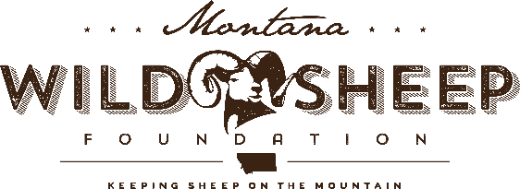

16 March 2022
Subject: Comment on Beaverhead-Deerlodge Outfitter and Guide Permits draft EA

We are specifically expressing our concern under “Table 1. New Activities under Consideration for Priority Outfitter and Guide Permits” in the Scoping letter and attachments dated 01/29/2022 found at: http://www.fs.usda.gov/nfs/11558/www/nepa/112370_FSPLT3_5229234.pdf

There is a new activity proposed for the Pioneer Landscape that would allow 120 service days llama use. This area also includes both native mountain goat habitat and bighorn sheep range.

In the Preliminary Wildlife Analysis in the Beaverhead-Deerlodge Outfitter and Guide Permits draft EA, the concern over pathogen transfer between llamas and bighorn sheep and mountain goats was addressed. Preliminary research does suggest caution regarding the issue of pathogen transfer. Also stated in the analysis, “Specific requirements are in place to reduce effects” for mountain goats, but that same language was not included with the section on bighorn sheep. We would like to see the same language included for bighorn as well. We would also like those requirements clearly spelled out in the draft EA.

Based on the above, we urge you to exclude core areas of mountain goat and bighorn sheep habitat (as identified by MTFWP) from areas of llama use under this new permit proposal. We would also urge yearly monitoring of use permitted llama activity baed on concerns above, including those expressed in the draft EA.

Thank you
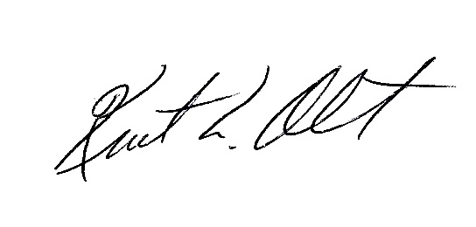
Kurt Alt
Conservation Director, Montana and International Programs
Wild Sheep Foundation and Montana Wild Sheep Foundation

