7 Feb 2022

TO: Siuslaw National Forest Supervisor’s Office
ATTN: Trevor Robinson
VIA: Sent via email (trevor.robinson@usda.gov, comments-pacificnorthwest-siuslaw@usda.gov) because the designated web portal is not working:
https://cara.ecosystem-management.org/Public//CommentInput?Project=59324
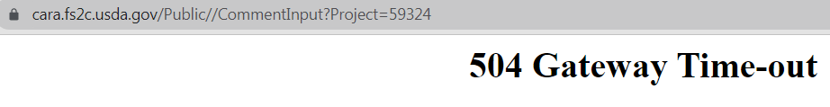
Subject: Franklin and Wasson Wild and Scenic Rivers Comprehensive River Management Plan EA — comments

Please accept the following comments from Oregon Wild concerning the Franklin and Wasson Wild and Scenic Rivers Comprehensive River Management Plan EA, https://www.fs.usda.gov/project/?project=59324. Oregon Wild represents 20,000 members and supporters who share our mission to protect and restore Oregon’s wildlands, wildlife, and water as an enduring legacy. Our goal is to protect areas that remain intact while striving to restore areas that have been degraded. This can be accomplished by moving over-represented ecosystem elements (such as logged and roaded areas) toward characteristics that are currently under-represented (such as roadless areas and complex old forest).

It just makes sense to include in the Wild and Scenic River boundary the area above Wasson Lake circled in red in the map below. This small area is the headwaters of a stream that flows into the Wild and Scenic River and is outside the wilderness, so it may be at risk from activities that might conflict with Wild and Scenic River goals.
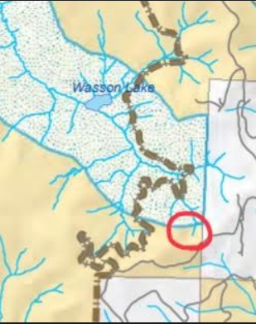

We strongly support the “Ecological systems outstandingly remarkable value” and we hope that the final comprehensive plan explicitly maintains a recognition that mature & old-growth forest vegetation as part of that ORV.

We are disappointed that the tributary stream labelled “31” in the scoping maps (clipped and pasted below) has been dropped from the WSR boundary, but since it’s inside the wilderness, we are not too worried about it.
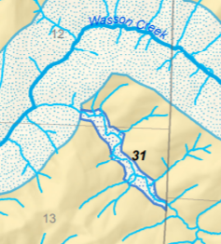

We incorporate by reference our scoping and pre-scoping letters and emails related to this proposal.

Each substantive issue discussed in these comments should be (i) incorporated into the purpose and need for the project, (ii) used to develop NEPA alternatives that balance tradeoffs in different ways, (iii) carefully analyzed and documented as part of the effects analysis, and (iv) considered for mitigation.

Sincerely,
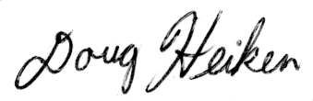
Doug Heiken
dh@oregonwild.org

