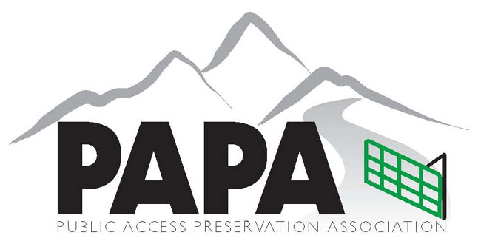
Public Access Preservation Association
PO Box 4220
Telluride, CO 81435
www.papatelluride.org

November 24, 2021

GMUG Forest Plan Revision Comments

Esteemed Revision Committee,

PAPA supports Alternative C with the addition of special considerations outlined below.

It is important to realize 55% of the GMUG forest has been closed to motorized recreation since the last revision 38 years ago, 55% off limits for OHV enjoyment. Therefore we do not support planning measures that continue to reduce motorized recreational enjoyment opportunities. We do support expansion of multi use systems.

Of main concern with Alternative C; the possibility of lost motorized opportunity in the future. Under this plan, many existing motorized roads and trails would now travel through land reclassified as Semi- Primitive Non-Motorized use land. In the event of any type of natural disturbance the path of travel can / could be closed without the possibility of re-route. We are not in favor of land being re-designated as semi-primitive where existing motorized opportunity is enjoyed. Please consider, details can be defined when appropriate.

Of main concern with Alternative C; historic motorized use routes. Recently many of these routes have been re-designated as non-motorized. These would now fall in the area of Semi-Primitive Non-Motorized. Therefore, never having the opportunity to be defended and re-opened as historic motorized routes. Please consider, details can be defined when appropriate.

Respectfully submitted,

John Dourlet Tom Thomas
President Vice President

