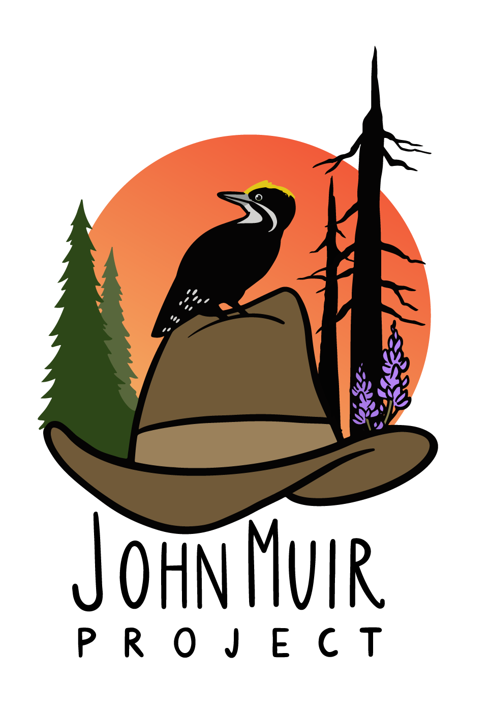

1015 15th St NW, Suite 600 PO Box 897
Washington, DC 20005 Big Bear City, CA 92314
Office: 202-657-7270 Telephone: 530-273-9290
_____________________________________________________________________________________

22 October 2021

Marc Stamer, District Ranger
Mountaintop Ranger District
San Bernardino National Forest

Dear Marc,

On behalf of the John Muir Project of Earth Island Institute, we are submitting these comments on the Environmental Assessment (EA) for the North Big Bear Project. We incorporate by reference herein, as part of these comments, our previous comments, including our scoping comments and reference list, and our two October 2021 email messages to you plus attached studies and maps. We also submit the following additional points:

1: Given the highly controversial nature of the project, and its unknown risks, regarding the effectiveness, or lack thereof, of this thinning/vegetation-management approach in wildlands far from the defensible space zone, an EIS must be prepared in light of potential serious impacts to public safety and nearby homes.

2: The EA’s Fuels Report relies upon a theoretical U.S. Forest Service model, with assumptions built into the model by the U.S. Forest Service, which means the outcomes are pre-determined. JMP submitted numerous scientific studies and other evidence indicating that the Forest Service’s modeling assumptions are incorrect, and thinning and associated vegetation management activities are either ineffective at protecting communities from wildland fire or are overtly counter-productive by often making fires spread faster and/or more intensely toward homes.

3: The EA’s Fuels Report is internally inconsistent. Pages 5 through 6 and Figure 2 on p. 6 state that the proposed activities would increase windspeeds through the forest during a fire, and would reduce the only category of fire behavior (flame lengths less than 4 feet) that would allow for direct attack of a wildfire by fire suppression crews, while high/very-high flame lengths would, in combination, remain approximately the same, and “moderate” flame lengths would substantially increase (p. 4 of the Fuels report states that, in “moderate” flame length areas, “Fires are too intense for direct attack…”). Elsewhere, the Fuels Report makes grand claims about substantially reduced fire intensity and severity, but those claims cannot be squared with pages 5 through 6, which indicate that, overall, fire intensity would increase if the project was implemented.

4: Figure 3 of the Fuels report is highly misleading. It pertains to pinyon-juniper stands in the “defense” zone, closest to homes, and reports theoretical model projections regarding flame lengths. However, since much of the proposed activities would involve clearcuts up to 1 acre in size, and in other areas nearly all trees would be removed (leaving only 17 per acre), the forest would be converted from forest into grassland and sage, which are vegetation types that intrinsically have much lower flame lengths (because the plants are much, much shorter than trees) BUT spread flame much faster—toward homes—based on the same group of fire modeling studies referenced in the Fuels report. This omission is serious, and presents a serious undisclosed risk and threat to nearby homes.

5: Nowhere do the Fuels report or EA disclose or analyze the extent to which the project would or could increase impacts to adjacent homes from increased winds (due to removal of the windbreak effect of the forest, after most or all trees are removed) and increased noise from nearby roads (due to removal of the noise shield effect of the forest).

6: The Emissions report includes estimates of CO2 emissions from equipment and also “open burning” through prescribed fire, but fails to include CO2 emissions from removal of trees. When trees are removed from forests, most of the carbon in them is emitted almost immediately due to incineration of branches/tops at biomass facilities and incineration of mill residues as “hog fuel” at lumber mills, or incineration of the trees as commercial firewood (Ingerson 2007, Harmon 2019). Thinning plus burning emits 3 times more carbon than wildfire alone (Campbell et al. 2012). These climate impacts are simply not disclosed in the Emissions report or EA.

7: The EA does not indicate any diameter limit on the size of trees that would be removed if the project was implemented; therefore, there is no analysis of the environmental impacts and wildlife habitat impacts of removing large, old-growth trees, including impacts to California spotted owl and bald eagle potential nest sites.

8: The EA states, in Table 2, that the planned logging in mixed-conifer and yellow pine forests would kill and remove an average of 63% of the forest basal area, plus an additional 10% tree mortality from subsequent prescribed burning, for a total cumulative mortality of about 73% on average before wildfire even occurred. Nowhere does the EA or Fuel report or any other report disclose the total cumulative effects on overall tree mortality from the proposed action, including tree cutting, prescribed fire, and then subsequent wildfire versus wildfire alone or some much less intensive action (e.g., prescribed fire alone with no thinning, or thinning only seedlings and saplings followed by prescribed fire). Moreover, the incredibly intensive killing and removal of trees described in Table 2 cannot be squared with the data presented in Figure 3—another major inconsistency which prevents the public from having any idea what the real impacts of the project would be.

9: The EA fails to analyze alternatives to the proposed action, and does not even include a comparative analysis of the no action alternative. This fails to meet even the minimum requirements of NEPA.

10: The EA and Wildlife BE do not adequately analyze the adverse impacts to resident bald eagles from the proposed logging and other intensive tree cutting that is proposed all around a known bald eagle nest location, nor is there any meaningful discussion or analysis of alternatives that would avoid these impacts, including alternative/s that would not put a new trail right through the eagle nest area, as well as avoid tree cutting or prescribed burning near the eagle nest area—a buffer distance that would completely avoid noise and mechanical disturbance impacts that can cause nest abandonment.

Sincerely,
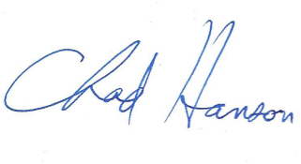
Chad Hanson, Ph.D., Ecologist
John Muir Project
P.O. Box 897
Big Bear City, CA 92314
530-273-9290
cthanson1@gmail.com

