Trout Unlimited El Dorado, PO Box 1605, Placerville, CA 95667
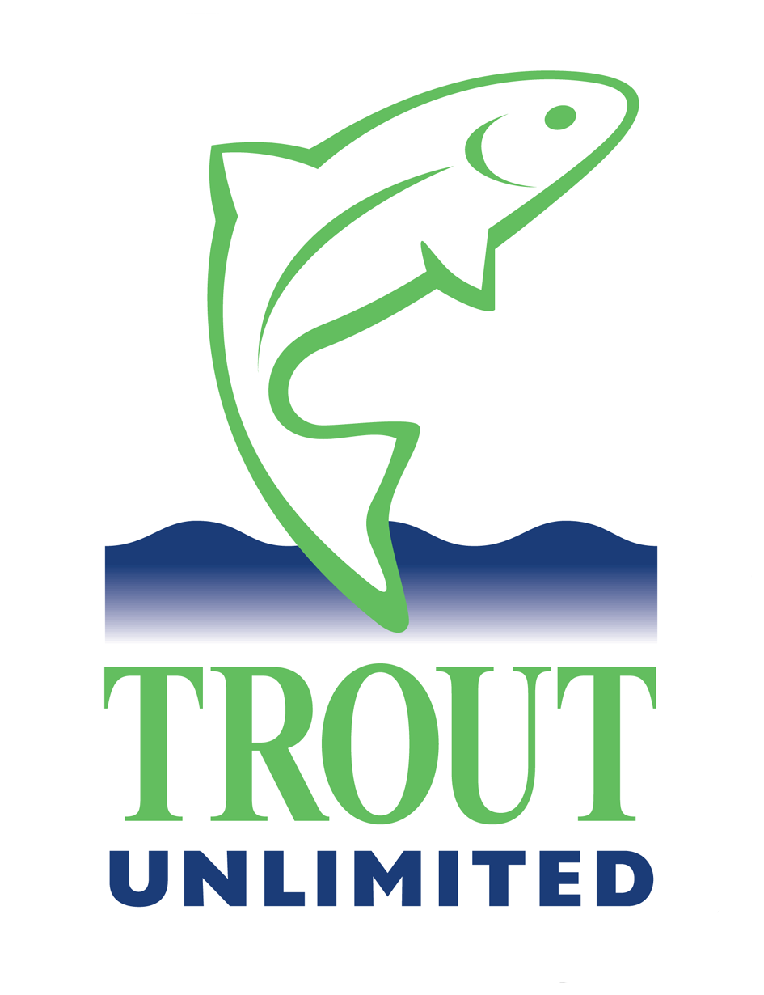

Exploratory Drilling In Long Valley
The El Dorado Chapter of Trout unlimited urges the denial of the proposed project by Kore Mining. This project will impact the recreational values of Mono County, create waste water and waste drill material, initiate a continuing demand for water and leave a marred landscape in the work area. Further, successful drilling results will lead to magnified demands and impacts. A continuing mining effort will create impossible demands for water and create unmanageable waste water and soils. The worst case end is a massive pit mine within 1000 feet of Hot Creek with a direct drainage path to the creek. And where would the waste go? Environmental effects of such a mine are extremely damaging. Similarities exist to the Pebble Mine in Alaska which has been in contention for over a decade.
Issues to be examined during scoping would include:
Damage to Forest System roads from heavy equipment use.
Enduring print of drill pads and access roads.
Demand for water to support drilling.
Creation and disposal of drilling waste products.
Traffic, noise and visibility of operations to Hot Creek and county users.
Guarantee of restoration of roads and drill pads.
Seasonal access and sensitivity to operations.
The potential risks of this project demand a full NEPA process even though the categorical exclusion process for the scoping may be appropriate because of the calendar.
Again, we urge the denial of the project. The scoping activity should define the risks associated with project continuation. The potential long term impacts should bring an immediate halt to the effort. Each step forward can only result in greater environmental degradation.
Trout Unlimited is a national conservation organization of 150,000 members. Over 10,000 members reside in California. Many of them enjoy and favor Hot Creek. Our El Dorado chapter has many members desiring to protect Hot Creek.
Hot Creek and its users are under direct assault and should be protected.
Justin Milami
President
Trout Unlimited El Dorado

