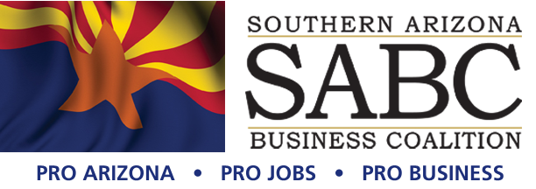

Coronado National Forest
Sierra Vista Ranger District
4070 South Avenida Saracino
Hereford, AZ 85615
C/o CELESTE KINSEY
District Ranger

Re: Sunnyside Exploration Drilling #55719

Dear Mr. Goshen:

"It's like déjà vu all over again." Since our last submittal on October 21, 2019 nothing has changed except the format of the comments for this submittal. With this being said, please find our letter of support for the Sunnyside proposed exploratory drilling project.
On behalf of the over 5000 employees directly and indirectly impacted by the mining
industry in Southern Arizona, thank you for your efforts with respect to the Sunnyside drilling project.

“Since 1950 the world’s population has grown from 2.5 billion to over 7.7 billion and the
need of copper has grown over 9 times the amount needed in 1950”, Dr. Brad Ross, Director of the Lowell Institute of Mining, University of Arizona. Where the US was an exporter of copper, we are now a net importer. We must allow for responsible development of new mining projects and make the US self-reliant on much need critical and other mineral resources that protect our national independence.

Economics
The mining industry has proven to be a significant economic engine in Santa Cruz county. History is a very good indicator that even in the early stages of exploration, companies such as Arizona Standard contribute to a better economic environment in the area.

Water
The proposed drilling plan has been constructed to minimize surface, noise, and traffic disturbance as much as possible, and truly has a very small footprint. Arizona Standard is planning on trucking in water that is sourced from municipal water systems, which are regularly tested for water quality to ensure that the resident populations are not exposed to drinking water that is below EPA standards.

Recreation
Under the proposal, access for recreation will not be impacted and in some cases, due to road improvements, will be expanded. This is at worst a net-zero impact to recreational purposes, and at best will enhance access for various recreational uses.

Ongoing Reclamation
Overall, with 30 or fewer drilling locations, and no more than two drilling rigs in use at one time, Arizona Standard has designed their plans around having the absolute smallest impact to the region with respect for the surrounding natural environment. Reclamation will be ongoing and continue to completion after drilling is ended, as well defined in the plan of operations.

Again, The Southern Arizona Business Coalition (SABC) in strong support of the Sunnyside proposed exploratory drilling program and request the Forest Service to provide a swift approval of the project in compliance with the law.

Thank you for your professional approach in address this very important process.

Sincerely,
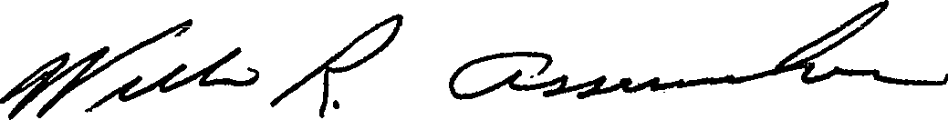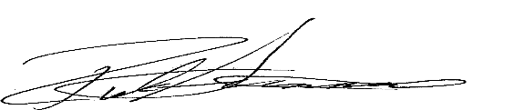
Bill Assenmacher, Co-Founder, SABC Rick Grinnell, Co-Founder, SABC

For further information please contact:
Rick Grinnell, VP
Southern Arizona Business Coalition
P.O. Box 26945
Tucson, AZ. 85726
520.247.3268 (c)
rick@soazbc.com
www.soazbc.com

