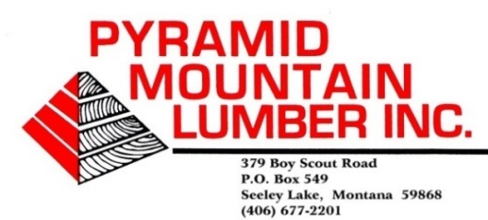

March 25, 2021

USDA-Bitterroot National Forest (BNF)
Seth Carbonari, Responsible Official
6735 West Fork Road
Darby, MT 59829

Re: Mud Creek Project comments

Dear Seth Carbonari:

Pyramid Mountain Lumber, Inc. in Seeley Lake submits the following comments on the Mud Creek project. We fully support this project.

We would like to see included in the Purpose and Need section of these projects, the need to support the local wood products infrastructure. Without that infrastructure, many of these projects would not be economical feasible. If that infrastructure is ever lost, it’s almost impossible to get back.

One of our overarching concerns is safety for the logging contractors. In the past, the Forest Service has included out-sloping roads into their Specified, and Reconstruction/Reconditioning road plans. This is used in conjunction with drain dips and other design features to keep the water from running down the road surfaces for long distances. This helps alleviate rutting, sediment runoff and road maintenance. An ongoing problem with dips and out-sloping roads, especially in frozen conditions is the safety and stability of tracked machines on these out-sloped roads. Several years ago, in Idaho, a tracked machine slid off an out-sloped road and resulted in a fatality. Just in the past month, a tracked line machine slid completely off an out-sloped road. Luckily no one was injured, but could easily have been. Tracked machines, including line machines, loaders, processors, and excavators have forty cleats on their tracks pointed downhill on these out-sloped roads that act as ice skates. Welding on grousers to these cleats do help dig into the ice and frozen road, but these are the only thing holding a 90-120,000-pound machine on an out-sloped road. When these tracked machines walk over a drain dip on frozen roads, only a few of these track cleats and grousers actually contact the road surface. Several machines have slid off the road walking over a frozen drain dip or out-sloped road. Also, many of these older roads were not build for 12’ wide machines. We’ve encountered older 10’ wide roads that have line units below the road. A 10’ wide road will not support a 12’ wide, 120,000-pound machine.

We ask you and the Forests’ road engineers to remember these items when designing road work and harvest units on these projects. There is not a tree out there that’s worth a person’s life.

Please contact me if you have any questions.

Sincerely,


Scott Kuehn
Resource Forester
(406) 546-9304,
Email: montanaforester@yahoo.com

