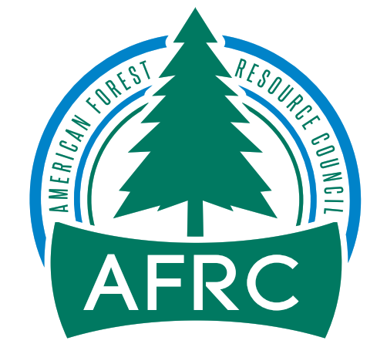

February 9, 2021

Jeffrey Rivera
Okanogan-Wenatchee National Forest
Wenatchee River Ranger District
c/o Paul Kelley
600 Sherbourne St.
Leavenworth, WA 98826

Dear Jeff:

On behalf of the American Forest Resource Council (AFRC) and its members, thank you for the opportunity to provide Draft EA comments on the Upper Wenatchee Pilot Project (UWPP).

AFRC is a regional trade association whose purpose is to advocate for sustained yield timber harvests on public timberlands throughout the West to enhance forest health and resistance to fire, insects, and disease. We do this by promoting active management to attain productive public forests, protect adjoining private forests, and assure community stability. We work to improve federal and state laws, regulations, policies, and decisions regarding access to and management of public forest lands and protection of all forest lands. Many of our members have their operations in communities within and adjacent to the Okanogan-Wenatchee National Forest and management on these lands ultimately dictates not only the viability of their businesses, but also the economic health of the communities themselves.

AFRC has been heavily engaged in the Project since its inception in 2017. AFRC participates in the North Central Washington Forest Health Collaborative (NCWFHC) which was instrumental in helping to solicit funding for the Project. AFRC has participated in two field trips to the Project area and provided scoping comments on March 18, 2019. AFRC also participated in the virtual open house meeting on January 20, 2021. Most recently AFRC participated in the NCWFHC quarterly meeting on February 3 during which a recap of the UWPP was presented.

The Upper Wenatchee Pilot Project area is 75,000 acres in size including 60,000 acres of National Forest lands and is located north of Leavenworth in Chelan County, Washington. The project area encompasses the Lower Chiwawa, Big Meadow, Lake Wenatchee, Beaver Creek-Wenatchee River sub-watersheds. The project is being designed to address how landscapes and watersheds have changed from historical conditions, as well as identifying activities that would make landscapes and watersheds more resilient to disturbances while considering climatic changes.

Below is a listing of the Purposes and Needs for the Project that have been identified.

Purpose:
- Address conditions that have departed from the historical range of variability to reduce the risk of wildfire and other disturbances to protect lives, communities, and ecological values.
- Promote better outcomes for a broad spectrum of ecological, social, and community resources and values in a manner that recognizes and responds to the important role of natural fire and helps mitigate risk in the wildland urban interface while providing for sustainable user access.
- Protect and restore watershed conditions that maintain uplands, late-successional habitat and large and old trees, riparian and instream habitat, and water quality and quantity for the benefit of communities and native fish and wildlife.
- Design and implement treatments to support the recovery of threatened, endangered, and sensitive species.
Need:
- Create and maintain successional pathways that provide the amount and spatial arrangement of forest conditions that increase resilience to natural disturbance and sustainability.
- Improve habitat conditions within Late-Successional Reserves while reducing risk to stand replacing fires.
- Maintain, enhance, or accelerate the development of large and old trees and increase proportion of old forest structure.
- Conserve the existing spotted owl and old forest habitat and identify and implement vegetation treatments to develop additional habitat in the most sustainable landscape location.
- Support biodiversity by restoring, enhancing, and/or maintaining unique habitats including aspen, white bark pine, meadows, and huckleberry fields.
- Reduce impacts from fire and return fire as a natural element of the landscape.
- Reduce risk of fire on National Forest System lands in the Wildland Urban Interface.

While AFRC supports the Purpose and Needs listed above we offer the following comments that we believe need to be considered in the Final EA to strengthen the document, address specific needs of AFRC’s membership, and to enable the responsible official to make a well-informed decision. Additionally, AFRC would like to compliment writers of the Draft EA document for making it very readable, laid out in logical sections, and containing good explanations of cause and effect for actions taken or not taken. Specifically, the Draft EA focuses the work on the Action Items as either Terrestrial treatments or Aquatic Restoration Actions. While we appreciate this approach, we believe there is some cross-over work which should be done that will affect both terrestrial and aquatic areas such as commercial treatments in the riparian areas that we will address in our comments.

- AFRC remains very disappointed that managing this landscape for timber production and maintaining our forest products infrastructure is not included in the Purpose and Need. AFRC has been very vocal to all Forest Service personnel since the inception of this project in 2017 that this 60,000-acre landscape has the potential to yield a considerable amount of sawlog volume which is greatly needed by the forest products industry. To ensure that the provision of raw materials was included in the Purpose and Need, we submitted comments during the pre-scoping process directly to the planning staff. We continue to view the lack of any consideration for economics or the need for this project to provide raw material in the Purpose and Need as a lack of understanding of our industrial infrastructure and to the community’s economic stability and how management on this project could benefit those. AFRC has voiced our concerns many times regarding the long-term sustainability of the timber supply on Forest Service land and how the current management paradigm is affecting this supply. Lands designated as Matrix are the only lands where our members can depend on a sustainable supply of timber products, as timber outputs on lands designated as reserves are merely a “byproduct,” Approximately 32 percent (23,814 acres) of the Project area is designated as Matrix, therefore, we would like the Wenatchee Ranger District to recognize the importance of this supply by including the provision of timber products into the UWPP’s purpose & need. It is important to AFRC that this provision is recognized by the Forest Service as a valued objective on Matrix land, and not simply a byproduct as it is on LSR land. AFRC believes that the Forest Service should take pride in the fact that they provide a crucial renewable resource to the public that they serve. We understand that every treatment proposed on this project will likely be designed to meet numerous objectives, but why can’t one of those objectives, particularly on lands designated as Matrix, be the provision of timber products? The chart below shows the Regional milling infrastructure that could use the products coming from the Okanogan-Wenatchee National Forest.

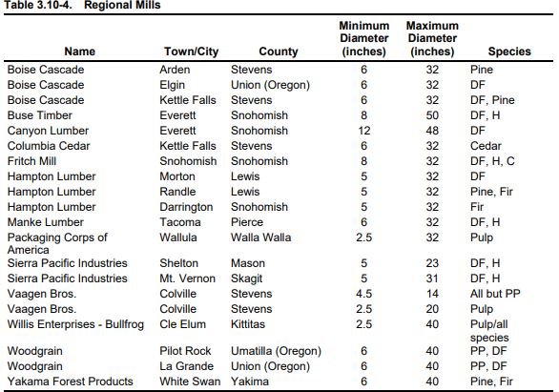

The National Forests in Washington are very important for providing the raw materials that sawmills within the State need to operate. The timber products provided by the Forest Service are crucial to the health of our membership. Without the raw material sold by the Forest Service these mills would be unable to produce the amount of wood products that the citizens of this country demand. Specifically, this Draft EA points out that Alternative 1 would support an estimated annual average of 14 direct (7 logging and 7 manufacturing) and 4 indirect jobs (18 jobs total). Without this material, our members would also be unable to run their mills at capacities that keep their employees working, which is crucial to the health of the communities that they operate in. These benefits can only be realized if the Forest Service sells their timber products through sales that are economically viable. This viability is tied to both the volume and type of timber products sold and the way these products are permitted to be delivered from the forest to the mills. There are many ways to design a timber sale that allows a purchaser the ability to deliver logs to their mill in an efficient manner while also adhering to the necessary practices that are designed to protect the environmental resources present on Forest Service forestland.

- AFRC supports Alternative 1 that has been developed for the Project. Please see Table 2.6-1 below:
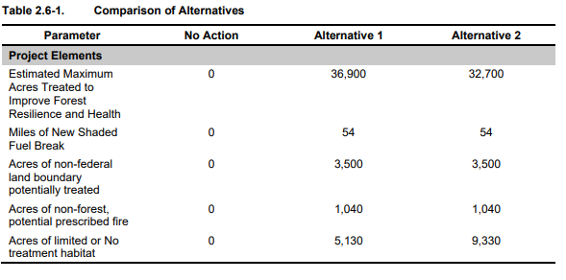
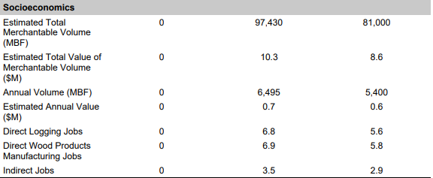

Alternative 1 will treat the most acres to improve forest health and resiliency which is a s key component of the Purpose and Need for the Project. Table 2.6-1 illustrates the large economic impact that harvesting as much as 97.4 mmbf could have. It should be noted that Alternative 1 will yield about $10.3 million in stumpage. Portions of these revenues will go into retained receipts or into K-V for other resource improvements. Members of the NCWFHC have specific restortaton projects they would like to have completed with the UWPP and stumpage revenues will helpt to fund many of these projects.

- AFRC supports the use of condition-based management for this Project. Condition-based management is defined as a system of management practices based on implementation of specific design elements from a broader proposed action, where the design elements vary according to a range of on-the-ground conditions to meet intended outcomes. Flexibility during implementation is allowed as part of condition-based management, recognizing that the environment is dynamic and changing as ecosystems respond to natural and human-caused events. In this approach, a suite of potential treatments types and intensities can be aligned, prior to implementation, with current conditions on the ground to move resources toward the desired conditions. AFRC believes that by using condition based NEPA it allows the planners and District personnel to address the most current forest health and resource needs at the time of implementation rather than years prior during the planning phase. As stated in the Draft EA “The best available science is considered in preparation of this EA; however, what constitutes best available science might vary over time and across scientific disciplines.” Since this Project could be active for 10-15 years, the best science should be used at the time of implementation and that is why the flexibility of condition-based management is needed.

- AFRC supports the District’s plan to manage in the Late Successional Reserve (LSR) parts of the Project area which covers 38 percent of the acreage. Part of the LSR will be managed to reduce the threat of wildfire while other parts of the LSR will be treated silviculturally to enhance or accelerate the development of large and old trees. Currently the area’s high risk of wildfire and the objective to develop spotted owl habitat in the most sustainable landscape locations will require active management.

If proposed actions within the LSR are not consistent with the NWFP, a project specific NWFP amendment would be required. Forest Plan amendments are intended to be an adaptive management tool to keep forest plans current, effective, and relevant between forest plan revisions. The proposed actions to address the issues identified above may require a project-specific amendment that would allow the project to meet habitat restoration and risk-reduction objectives. Specifically, a project-specific amendment would be required to amend the NWFP silviculture standard that prohibits harvest of trees in stands over 80 years old in LSRs (USDA Forest Service, 1994a: C-12). The amendment would allow treatment in stands that are over 80 years old to restore forests for wildlife species associated with old-forest open-canopy habitat conditions. No stand-age limitations apply for risk-reduction treatments. AFRC strongly supports the District requesting project specific amendments to get the goals of the Project implemented. AFRC encourages the District to harvest in stands over 80 years in age when appropriate to accomplish both fuels reduction and stand improvement. Relying on arbitrary tree age as a metric to inform management decisions is flawed. Stand conditions should be the primary factor that dictates treatments.

- The District has conducted surveys for spotted owls across the Project area for two years or more. The finding shows that where there were once 20 pairs of spotted owls, there are only two remaining non-nesting individuals left. Obviously, the status quo is not working for the spotted owl. The invasion of the barred owl, and loss of habitat to wildfire over the past three decades since the listing of the owl has led to this dire statistic. AFRC believes it will take active management in many of the LSR stands to bring them into a condition that favor the use by spotted owls. AFRC supports the goal listed in the Draft EA which states the District needs to “Reduce tree densities and shift forest stand structure, species composition, and landscape pattern to reduce insects and disease risks and damage to endemic levels.” Again, AFRC supports Alternative 1 which will conduct landscape treatments designed to move current conditions closer to reference conditions and thus increase landscape resilience to disturbances. Treatments would be more aggressive outside of high-quality habitat and Activity Centers and may remove nesting, roosting, and foraging (NRF) habitats to reduce the risk to other habitats. Habitat within the five highest priority activity centers (those that have had NSO activity in the past 15 years and contain the greatest amount of sustainable NRF) would be prioritized for retention.

- One critical need is to reduce the risk of fire in the Wildland Urban Interface within the Project area. Members of NCWFHC that live within the Project area have been emphatic about getting treatments implemented to reduce the risk and spread of wildfire onto their property. On the two tours to the Project area, we looked specifically at the areas that need treatment that abut the National Forests. AFRC believes the Forest needs to carry out heavy thinnings near property boundaries to reduce the risk of fire crossing those boundaries by creating barriers. These heavy thinnings should be carried out by spacing the leave trees far apart reducing the basal area down to 40 sq. ft. or less.

- AFRC strongly supports the use of 54 miles of shaded fuel breaks as discussed in the Draft EA. These shaded fuel breaks would be developed to slow fire movement, reduce the potential for crown fire initiation, protect habitats, and decrease the resistance of control on small and large fires. This would require the modification of forest structures to reduce surface and ladder fuels. Under both Action Alternatives, shaded fuel breaks would be developed to slow fire movement, reduce the potential for crown fire initiation, protect habitats, and decrease the resistance of control on small and large fires. This would require the modification of forest structures to reduce surface and ladder fuels. In general, the objective would be to raise the canopy base height and reduce canopy closure. Residual stand density would be dependent on the existing tree size class and distribution.

While the District is planning to vary the width of the fuel breaks between 100 to 300 feet, AFRC strongly supports a width of 300 ft. AFRC is pleased to see that 300-ft. wide fuel breaks will be planned around non-federal lands to further reduce risk and provide increased fire fighter safety, increased defensible space to nonfederal lands, and at-risk communities.

- There are many ways to design a timber sale that allows a purchaser the ability to deliver logs to their mill in an efficient manner while also adhering to the necessary practices that are designed to protect the environmental resources present on Forest Service forestland. The primary issues affecting the ability of our members to feasibly deliver logs to their mills are firm operating restrictions. As stated above, we understand that the Forest Service must take necessary precautions to protect their resources; however, we believe that in many cases there are conditions that exist on the ground that are not in step with many of the restrictions described in Forest Service EA’s and contracts (i.e. dry conditions during wet season, wet conditions during dry season).

We would like the Forest Service to shift their methods for protecting resources from that of firm prescriptive restrictions to one that focuses on descriptive end-results; in other words, describe what you would like the end result to be rather than prescribing how to get there. There are a variety of operators that work in the Okanogan-Wenatchee National Forest market area with a variety of skills and equipment. Developing an EA contract that firmly describes how any given unit shall be logged may inherently limit the abilities of certain operators. For example, restricting certain types of ground-based equipment rather than describing what condition the soils should be at the end of the contract period unnecessarily limits the ability of certain operators to complete a sale in an appropriate manner with the proper and cautious use of their equipment. To address this issue, we would like to see flexibility in the EA contract to allow a variety of equipment to the sale areas. We feel that there are several ways to properly harvest any piece of ground, and certain restrictive language can limit some potential operators. Though some of the proposal area may be planned for cable harvest, there may be opportunities to use certain ground equipment such as feller-bunchers and processors in the units to make cable yarding more efficient. AFRC supports the District’s plan allowing ground-based equipment on slopes up to 45%. Allowing the use of processors and feller-bunchers throughout these units can greatly increase its economic viability, and in some cases decrease disturbance by decreasing the amount of cable corridors, reduce damage to the residual stand and provide a more even distribution of woody debris following harvest. Tethered-assist equipment is also becoming a more viable and available option for felling and yarding on steep slopes. This equipment has shown to contribute little additional ground disturbance when compared to traditional cable systems. Please prepare your NEPA analysis documents in a manner that will facilitate this type of equipment.

Finally, AFRC would like the Forest to examine the days that operations and haul are shut down due to hunting seasons and other outdoor recreation. The logging community has a limited operating time at best, and further reductions such as these only makes surviving in the logging business that much more difficult.

- AFRC does not support the current Okanogan-Wenatchee National Forest Restoration Strategy. This Strategy developed in 2012 identifies a need to restore the sustainability and resiliency of forested ecosystems due to 1) increased susceptibility to uncharacteristically large and severe fires, 2) uncharacteristically severe insect outbreaks, and 3) declining habitat for late-successional and old forest associated species. The Restoration Strategy outlined a new planning approach based on principles of landscape-level restoration ecology with an emphasis on dry and mesic (moist) parts of the Forest. While this Strategy’s intent was effective management it has yielded unintended consequences such as the application of arbitrary diameter limits and other criteria that reduces the ability of the Forest to do needed restoration. AFRC believes this Strategy is just another overlay to the very restrictive NWFP, and the Restoration Strategy should be dropped.

- AFRC is concerned that neither Alternatives 1 or 2 adequately addresses the risk of insects and disease across the landscape. The chart below shows the acres at risk following treatments.
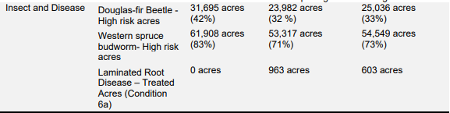

Currently, 31,695 acres are at high risk for Douglas-fir beetle and 61,908 acres are at high risk for wester spruce budworm. Modeling for this Project shows that treatments under the action alternative would decrease high-risk acres for both of these threats. Alternative 1 would reduce the high-risk acres for Douglas-fir beetle by about 7,700 acres and for western spruce budworm by about 8,600 acres. Similarly, but to a lesser extent, Alternative 2 would reduce the high-risk acres for Douglas-fir beetle by about 6,700 acres and for western spruce budworm by about 7,400 acres. While these reductions would help lessen the threat risk of insect and disease outbreaks, AFRC does not believe the Plan addresses these risks adequately.

- Approximately 14 percent (10,198 acres) of the Project area is designated as Riparian Reserves. Riparian Reserves include those portions of the watershed where riparian-dependent resources receive primary emphasis, and they overlay all other land allocations. AFRC commented in our scoping document that we would like to see active management in the riparian areas. We believe there is sound science behind treating in these areas, and we would like the Forest to consider that it has been well documented that thinning in riparian areas accelerates the stand’s trajectory to produce large conifer trees and has minimal effect on stream temperature with adequate buffers. Removal of suppressed trees has an insignificant short-term effect on down wood, and ultimately a positive effect on long-term creation of large down woody debris and large in stream wood, which is what provides the real benefit to wildlife and stream health. We encourage the Forest Service to focus their riparian reserve treatments on a variety of native habitats. We encourage the Wenatchee District to look for ways to incorporate treatments that meet those needs. Utilization of gap cuts to promote early seral habitat in the reserves, treatments to diversify all areas of the reserve, and prescriptions that account for the full range of objectives should be considered.

The tradeoffs that the Forest Service will likely be considering through the ensuing environmental analysis will be between achieving these forest health benefits and potentially having adverse impacts to streams. These impacts to streams typically include stream temperature, wood recruitment, and sedimentation associated with active management. We would like the Forest Service to review the literature cited below and incorporate its findings into your environmental analysis that will shape the level of management permitted to occur in riparian reserves.

Stream temperature
Janisch, Jack E, Wondzell, Steven M., Ehinger, William J. 2012. Headwater stream temperature: Interpreting response after logging, with and without riparian buffers, Washington, USA. Forest Ecology and Management, 270, 302-313.

Key points of the Janisch paper include:
- The amount of canopy cover retained in the riparian buffer was not a strong explanatory variable to stream temperature.
- Very small headwater streams may be fundamentally different than many larger streams because factors other than shade from the overstory tree canopy can have sufficient influence on stream temperature.

Anderson P.D., Larson D.J., Chan, S.S. 2007 Riparian Buffer and Density Management Influences on Microclimate of Young Headwater Forests of Western Oregon. Forest Science, 53(2):254-269.

Key points of the Anderson paper include:
- With no-harvest buffers of 15 meters (49 feet), maximum air temperature above stream centers was less than one-degree Celsius greater than for unthinned stands.

Riparian reserve gaps
Warren, Dana R., Keeton, William S., Bechtold, Heather A., Rosi-Marshall, Emma J. 2013. Comparing streambed light availability and canopy cover in streams with old-growth versus early-mature riparian forests in western Oregon. Aquatic Sciences 75:547-558.

Key points of the Warren paper include:
- Canopy gaps were particularly important in creating variable light within and between reaches.
- Reaches with complex old growth riparian forests had frequent canopy gaps which led to greater stream light availability compared to adjacent reaches with simpler second growth riparian forests.

Wood Recruitment
Burton, Julia I., Olson, Deanna H., and Puettmann, Klaus J. 2016. Effects of riparian buffer width on wood loading in headwater streams after repeated forest thinning. Forest Ecology and Management. 372 (2016) 247-257.

Key points of the Burton paper include:
- Wood volume in early stages of decay was higher in stream reaches with a narrow 6meter buffer than in stream reaches with larger 15- and 70meter buffers and in unthinned reference units.
- 82% of sourced wood in early stages of decay originated from within 15 meters of streams.

Sedimentation
Rashin, E., C. Clishe, A. Loch and J. Bell. 2006. Effectiveness of timber harvest practices for controlling sediment related water quality impacts. Journal of the American Water Resources Association. Paper No. 01162

Key points of the Rashin paper include:
- Vegetated buffers that are greater than 33 feet in width have been shown to be effective at trapping and storing sediment.

Collectively, we believe that this literature suggests that there exists a declining rate of returns for “protective” measures such as no-cut buffers beyond 30-40 feet. Resource values such as thermal regulation and coarse wood recruitment begin to diminish in scale as no-cut buffers become much larger. We believe that the benefits in forest health achieved through density management will greatly outweigh the potential minor tradeoffs in stream temperature and wood recruitment, based on this scientific literature. We urge the Forest Service to establish no-cut buffers along streams no larger than 40 feet and maximize forest health outcomes beyond this buffer.

The links to the studies mentioned above are listed below for reference.

Janisch paper on stream temps:
https://www.sciencedirect.com/science/article/abs/pii/S037811271100782

Dana Warren paper on light into the stream beds: https://www.researchgate.net/publication/311850456_Long-
term_effects_of_riparian_forest_harvest_on_light_in_Pacific_Northwest_USA_st reams

Julie Burton Paper on headwater widths and wood recruitment: https://www.semanticscholar.org/paper/Effects-of-riparian-buffer-width-onwoodloading-in-Burton-Olson/13c41421e2b6bf5eca847c4fb557235f3411127f

Edward Rashin article on Effectiveness of timber harvest practices for controlling sediment related water quality impacts:
https://onlinelibrary.wiley.com/doi/abs/10.1111/j.1752-1688.2006.tb05303.

- AFRC suggests the consideration of the use of DxP for any commercial thinnings. We believe that better results can be achieved in a much more efficient and cost-effective manner by utilization of basal area thinning. The use of DxP has been tried on some of the Projects on the Tonasket Ranger District with good results. While the Tonasket District is no longer part of the Okanogan-Wenatchee National Forest, AFRC believes those results should be considered.

- In addition to the lengthy analysis completed for managing in spotted owl habitat, AFRC believes the Forest has done a good job of identifying impacts to other species of concern including Canada Lynx, Grizzly Bear, wolverine, and others. In most cases the threat of wildfire to their habitat exacerbates the need for forest health treatments. Thus Alternative 1 is the best option for species maintenance and improvement.

- The Travel Analysis Plan has identified about 65 miles of roads for decommissioning, and about 14 miles of road to be closed (i.e., placed in storage in ML 1 status), for a total net reduction in open road of 78.5 miles. AFRC believes that a significant factor contributing to increased fire activity in the region is the decreasing road access to our federal lands. This factor is often overshadowed by both climate change and fuels accumulation when the topic of wildfire is discussed in public forums. However, we believe that a deteriorating road infrastructure has also significantly contributed to recent spikes in wildfires. This deterioration has been a result of both reduced funding for road maintenance and the federal agency’s subsequent direction to reduce their overall road networks to align with this reduced funding. The outcome is a forested landscape that is increasingly inaccessible to fire suppression agencies due to road decommissioning and/or road abandonment. This inaccessibility complicates and delays the ability of firefighters to attack nascent fires quickly and directly. On the other hand, an intact and well-maintained road system would facilitate a scenario where firefighters can rapidly access fires and initiate direct attack in a more safe and effective manner.

If the Forest Service proposes to decommission, abandon, or obliterate road segments from the UWPP area we would like to see the analysis consider potential adverse impacts to fire suppression efforts due to the reduced access caused by the reduction in the road network. We believe that this road network reduction would decrease access to wildland areas and hamper opportunities for firefighters to quickly respond and suppress fires. On the other hand, additional and improved roads will enable fire fighters quicker and safer access to suppress any fires that are ignited.

We would like the District to carefully consider the following three factors when making a decision to decommission any road in the project area:

    - Determination of any potential resource risk related to a road segment.
    - Determination of the access value provided by a road segment.
    - Determination of whether the resource risk outweighs the access value (for timber management and other resource needs).

We believe that only those road segments where resource risk outweighs access value should be considered for decommissioning. Further AFRC is concerned about the decommissioning of roads that access the Matrix lands. These are lands identified to produce timber and access is needed for managing and harvesting of those acres.

- The Forest also has a section of climate in the supporting documents. AFRC would like to encourage the Wenatchee District to consider several documents related to carbon sequestration and related forest management.

McCauley, Lisa A., Robles, Marcos D., Wooley, Travis, Marshall, Robert M., Kretchun, Alec, Gori, David F. 2019. Large‐scale forest restoration stabilizes carbon under climate change in Southwest United States. Ecological Applications, 0(0), 2019, e01979.

Key points of the McCauley paper include:
- Modeling scenarios showed early decreases in ecosystem carbon due to initial thinning/prescribed fire treatments, but total ecosystem carbon increased by 9– 18% when comparted to no harvest by the end of the simulation.
- This modeled scenario of increased carbon storage equated to the removal of carbon emissions from 55,000 to 110,000 passenger vehicles per year until the end of the century.
- Results demonstrated that large-scale forest restoration can increase the potential for carbon storage and stability and those benefits could increase as the pace of restoration accelerates.

We believe that this study supports the notion that timber harvest and fuels reduction practices collectively increase the overall carbon sequestration capability of any given acre of forest land and, in the long term, generate net benefits toward climate change mitigation.

Gray, A. N., T. R. Whittier, and M. E. Harmon. 2016. Carbon stocks and accumulation rates in Pacific
Northwest forests: role of stand age, plant community, and productivity. Ecosphere 7(1):e01224.10.1002/ecs2.1224

Key points of the Gray paper include:
- Although large trees accumulated C at a faster rate than small trees on an individual basis, their contribution to C accumulation rates was smaller on an area basis, and their importance relative to small trees declined in older stands compared to younger stands.
- Old-growth and large trees are important C stocks, but they play a minor role in additional C accumulation.

We believe that this study supports the notion that, if the role of forests in the fight against climate change is to reduce global greenhouse gasses through maximizing the sequestration of carbon from atmospheric CO2, then increasing the acreage of young, fast growing small trees is the most prudent management approach.

Links to the above mentioned studies can be found at:

Lisa McCauley article on large scale forest restoration stabilizes carbon: https://esajournals.onlinelibrary.wiley.com/doi/full/10.1002/eap.1979

Andrew Gray article on Carbon stocks and accumulation rates in Pacific Northwest forests: role of stand age, plant community, and productivity:
https://www.fs.usda.gov/treesearch/pubs/52237

Thank you for the opportunity to provide Draft EA comments on the Upper Wenatchee Pilot Project. We look forward to following the implementation of this project as it moves forward.

Sincerely,
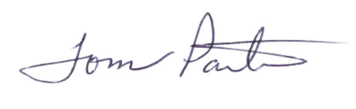

Tom Partin
AFRC Consultant
921 SW Cheltenham Street
Portland, Oregon 97239

