29 January 2021

TO: Elysia Retzlaff, Environmental Coordinator, Ochoco National Forest
VIA: https://cara.ecosystem-management.org/Public/CommentInput?Project=58081

Subject: Mill Creek Dry Forest Restoration Project — scoping comments

Please accept the following scoping comments from Oregon Wild concerning the Mill Creek Dry Forest Restoration Project, https://www.fs.usda.gov/project/?project=58081. Oregon Wild represents 20,000 members and supporters who share our mission to protect and restore Oregon’s wildlands, wildlife, and water as an enduring legacy. Our goal is to protect areas that remain intact while striving to restore areas that have been degraded. This can be accomplished by moving over-represented ecosystem elements (such as logged and roaded areas) toward characteristics that are currently under-represented (such as roadless areas and complex old forest).

The proposed action involves approximately 13,000 acres of commercial logging and fuel treatments, ad 43 miles of temporary road construction (6 miles new) :
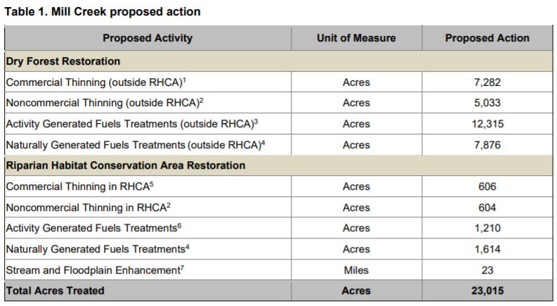
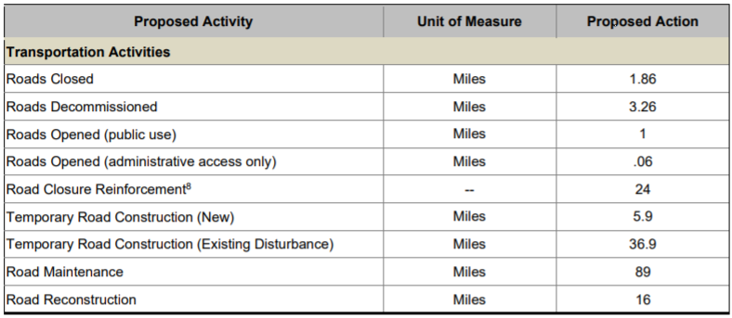

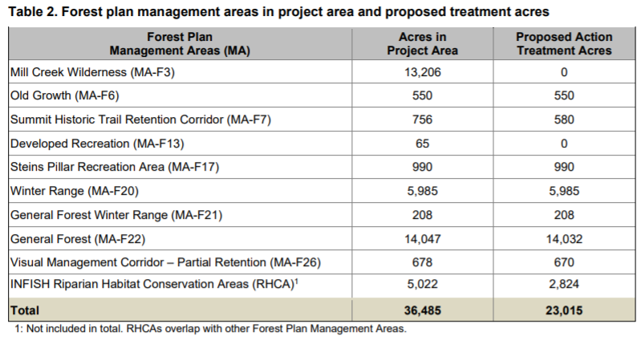
Purpose and need
The purpose and need should reflect restoration goals including:
- Restoring the natural range of variability for large blocks of unmanaged/unroaded habitat that wildlife evolved with. There is no compelling reason this goal should not be co-equal with other FS restoration objectives such as conserving large trees, reducing fuels, and shifting species composition. See Henjum, M.G., J.R. Karr, D.L. Bottom, D.A. Perry, J.C. Bednarz, S.G. Wright, S.A. Beckwitt and E. Beckwitt. 1994. Interim Protection for Late-Successional Forests, Fisheries, and Watersheds: National Forests East of the Cascade Crest, Oregon and Washington. A Report to the Congress and President of the United States. Eastside Forests Scientific Society Panel;
- Mitigating the climate crisis, by retaining and increasing carbon storage in large trees and the entire ecosystem. The bias toward commodity production at the expense of ecosystem carbon storage (and the land allocations that allow commercial logging) reflected in the LRMP need to be reconsidered in light of the climate crisis. “It is, therefore, the policy of [the Biden] Administration to listen to the science; to improve public health and protect our environment; to ensure access to clean air and water; … to reduce greenhouse gas emissions; to bolster resilience to the impacts of climate change;” Executive Order on Protecting Public Health and the Environment and Restoring Science to Tackle the Climate Crisis. JANUARY 20, 2021 https://www.whitehouse.gov/briefing-room/presidential-actions/2021/01/20/executive-order-protecting-public-health-and-environment-and-restoring-science-to-tackle-climate-crisis/;
- Mimicking natural disturbance processes by retaining abundant live and dead trees. Commercial logging removes too much biomass that would be retained after natural disturbance. Since logging does not mimic natural disturbance, the FS should strive to use non-commercial restoration tools other than logging and the NEPA analysis should identify and mitigate trade-offs associated with commercial logging;
- Retaining enough basal area to ensure long-term recruitment of abundant large trees and large snags and to give natural processes something to act upon. Commercial logging significantly reduces the total amount of wood available for natural processes to act upon. thinning increases the spacing between trees which means that tree fall events tend to remain isolated rather than triggering small scale contagious tree-fall events that help introduce heterogeneity and recruit more dead wood. Each standing tree has potential energy that could do work on other trees, and stands with fewer trees are capable of doing less work in terms of self-thinning and small scale contagious disturbance. See James A. Lutz And Charles B. Halpern. 2006. Tree Mortality During Early Forest Development: A Long-Term Study Of Rates, Causes, And Consequences. Ecological Monographs, 76(2), 2006, pp. 257–275. This study showed that mortality from mechanical damage (“crushing disturbance”) from falling limbs and trees and snow loads can be a more significant factor than suppression mortality. In fact, mechanical damage produced four times more deadwood biomass than suppression mortality. Thinning reduces the amount of trees and therefore reduces the amount of potential energy available to do ecological “work” including recruitment of more and larger wood than recruited by suppression mortality alone. Friesen (2009) said: “Lutz (2005) found in sampled unthinned young stands on the HJA that suppression mortality was observed in >80% of plots and was more than 2.5 times as common as mechanical damage (windthrow, stem snap, and crushing). However, biomass lost to mortality via mechanical damage was nearly four times that lost via suppression because mechanical damage killed larger stems.” Cheryl Friesen 2009. THINNING AND DEAD WOOD: “BEST AVAILABLE SCIENCE” December 15, 2009. http://ecoshare.info/projects/central-cascade-adaptive-management-partnership/synthesis-papers-tools/. See also, Brown, Martin J.; Kertis, Jane; Huff, Mark H. 2013. Natural tree regeneration and coarse woody debris dynamics after a forest fire in the western Cascade Range. Res. Pap. PNW-RP-592. Portland, OR: U.S. Department of Agriculture, Forest Service, Pacific Northwest Research Station. 50 p. (“Snag fall and fragmentation added so much wood to the ground—thousands of meters of log length per hectare—that it probably constitutes a significant ecological disturbance in itself, a kind of rain of logs.”) Das et al (2016) found that mechanical damage plays a significant role in background mortality. Removing many tree stems through logging can therefore be expected to disrupt this natural successional process. “Mechanical factors were associated with 24% of dead trees and were dominated by broken stems (most commonly in intermediate and large trees) and trees that were crushed by other falling trees (most commonly in small and intermediate trees). Incidence of mechanical factors increased modestly from small to mid-size … [D]ead trees in old-growth forests of the Pacific Northwest had a substantially higher occurrence of mechanical mortality factors.” Adrian J. Das, Nathan L. Stephenson, and Kristin P. Davis 2016. Why do trees die? Characterizing the drivers of background tree mortality. Ecology, 97(10), 2016, pp. 2616–2627. See also, Das, A. J., J. J. Battles, P. J. van Mantgem, and N. L. Stephenson. 2008. Spatial elements of mortality risk in old-growth forests. Ecology 89:1744–1756.

Screens Amendment – Large Tree Removal
The FS should not rely on the newly amended Eastside Screens purporting to allow removal of large trees. This plan amendment is scientifically unsupported and illegal. Wildlife populations evolved in a landscape with abundant large trees and large snags. Past management has caused a significant and persistent shortage of large and old trees and large snags on the eastside National Forests. The Screens amendment will allow removal of tens of thousands of large trees and exacerbate the shortage of large trees and large snags. The Forest Service can meet its objectives related to fuel reduction, species composition, and resilience by focusing on removal of small trees. The FS should realize the benefits of old tree conservation by exercising its discretion to retain old trees regardless of size. The FS should consider an alternative that retains all old trees regardless of size, and where appropriate kills (and retains as snags) white fir >21” dbh and younger than 120 years old when they are located within the dripline of legacy pine trees (>150 years old). This would help enhance the survival and resilience of legacy pine trees and enhance snag habitat.

The EA for the Large Tree Amendment is illegal because an EIS is necessary for a large-scale plan amendment likely to have significant effects on wildlife, carbon, and other resources; the EA failed to take a hard look at effects to wildlife, carbon and other resources; the EA failed to consider viable alternatives such as retaining old trees regardless of size and making snags from large young trees within the dripline of legacy trees; the EA mischaracterized the efficacy of the no action alternative which includes ample authority to remove small trees and meet goals related to fuel reduction, species composition, and resilience.

If the agency proposes to remove large trees in reliance on the Screens amendment, the FS must prepare an EIS and conduct a thorough NEPA analysis of the site-specific and cumulative effects of that amendment. The regional EA failed to conduct such an analysis. At a minimum, the analysis must describe the adverse effects of large tree removal on species of conservation concern, such as Pygmy nuthatch, White-headed woodpecker, Pileated woodpecker, Flammulated owl, Fisher, Goshawk, etc. See Linda Goodman's June 11, 2003 memo to eastside Forest Supervisors. Many additional species are also intended to benefit from the LOS restoration standards in the Eastside Screens, and DecAID provides a long list of key ecological functions of snags in Ppine/Doug fir forests. https://apps.fs.usda.gov/r6_decaid/legacy/decaid/queries/emcf-e-cscds-bmt/lrgr-trs/narrative.html#ECOLOGICAL%20FUNCTIONS%20AND%20PROCESSES%20OF%20DECAYED%20WOOD%20ELEMENTS. Any proposal to remove large trees must disclose whether and how the needs of these species will be met over time.

See attached comments on the Large Tree Amendment EA, and the Mildrexler et al (2020) publication regarding the carbon value of large tree conservation.

Protect old trees regardless of size.
Science indicates that slow-growing small old trees tend to be resilient and add to the diversity and resilience of forests. Black, Colber, and Pederson. 2008. Relationship between radial growth rates and lifespan within North American tree species. Ecoscience 15(3), 349-357 (2008). http://fate.nmfs.noaa.gov/documents/Publications/Black_et_al_2008_Ecoscience.pdf (See also Tobias Züst, Bindu Joseph, Kentaro K. Shimizu, Daniel J. Kliebenstein and Lindsay A. Turnbull, Using knockout mutants to reveal the growth costs of defensive traits, in: Proceedings of the Royal Society B, 2011, Jan. 26, doi:10.1098/rspb.2010.2475.

Franklin & Johnson (2013) explain why it is important to conserve small old trees:

Box 8: Removal of Small Old Ponderosa Pine Trees in Dry Forest Restoration Projects

Removal of small (<21" dbh), older (>150 yr) ponderosa pine trees is sometimes proposed as a part of Dry Forest restoration projects. These older trees are important ecological components of Dry Forests, despite their smaller size, which is why we recommend their retention along with larger old trees. Ponderosa pine >150 years include older mature pines (150 to 200 years) that are beginning to develop old-growth attributes and will become fully developed old-growth trees after about 200 years.

Small old trees fulfill many of the functions that larger old trees provide. These trees have:

1. A significant percentage of heartwood, which exhibits different patterns of decay than sapwood (in live trees, snags, and logs). Young ponderosa pine have relatively little and poorly developed heartwood. Snags from old trees persist for a longer time than snags from younger trees of comparable (or even larger) diameter, and
down wood (either bole or branches) decays differently than that of young trees.

2. Distinctive complex crowns and large branches that differ from those found on younger pines and that often have developed various defects (e.g., forks, brooms, and cavities) not present in younger ponderosa pine.

3. Greater value for wildlife than young trees of comparable or even larger diameter as a consequence of the preceding points – complex and distinctive crowns and significant heartwood content, which is reflected in quality wildlife habitat in both living and dead trees.

4. Bark that is thicker and fire resistant relative to the tree’s diameter, making the trees more resistant to fire than younger trees of comparable diameter. Since these smaller old trees exhibit many of the attributes of larger old trees, albeit it on a smaller scale, their retention is part of ecologically-focused restoration treatments.

When clusters of old ponderosa pine trees that include small old trees are encountered, silviculturists sometimes assume that significant competition must be taking place within these clusters, particularly if they observe mortality of individual trees. This inference of significant competition is unwarranted, however, and may reflect the silviculturist’s projection of the competitive processes of tightly spaced young trees. The old trees in these clusters have not only survived that period of youthful competition but almost certainly have established mutual relationships with each other, such as significant root grafting and shared mycorrhizal masses. Thus, these clusters of old trees are more likely to be mutually supportive than competitive.

Nevertheless, proposals for removal of removal of small older pine trees will arise and the following points should be considered:

1. An ecological justification for the removal of small (<21" dbh), old (>150 yr) ponderosa pine trees has not been established.

2. Proposals for removal of small old ponderosa pine trees would need to be based on economic necessity—that removal of some or all of these trees is necessary to create an economically viable or an economically more valuable restoration project.

3. If a project is calculated to be non-viable economically, we recommend consideration of the following adjustments prior to planning removal of small old ponderosa pine trees:
■ Adjustment of the boundaries of the project area so as to include additional areas that will generate larger volumes of wood during restoration;
■ Increase in the amount of wood marked for removal in trees <150 years even if this requires modification of target restored stand basal areas or trees/acre;
■ Elimination of restoration activities included as costs in the calculation of sale economics that are not essential to accomplishing the stand-level restoration goal; and,
■ Consider the potential for collaborators and partners to find funds.

4. If the restoration project remains non-viable after making the above adjustments, consider the alternative of whether or not to remove some small older ponderosa pine trees, including an assessment of how many such trees would have to be removed in order to achieve economic viability.

5. Calculation of economic viability should be based on the appraisal or other formal analysis that includes actual cruise or inventory data.

6. If a decision is made to proceed with cutting sufficient small older ponderosa pine trees to achieve viability, select only a sufficient number of such trees to achieve the economic break-even point.

7. The older trees selected for removal should come from the mature (150 to 200 year) age class; removal of fully developed (>200 year old) ponderosa pine should be avoided.

8. The decision process should be transparent, well documented to ensure that stakeholders and collaborative groups understand the basis for removing old trees.
Franklin, J.F., Johnson, K.N., et al 2013. Restoration of Dry Forests in Eastern Oregon – A Field Guide. The Nature Conservancy, Portland, OR. 202 pp. http://nature.ly/dryforests

See also, University of Montana. June 18, 2019. Cell structure linked to longevity of slow-growing Ponderosa Pines. https://www.sciencedaily.com/releases/2019/06/190618174358.htm (“Slow-growing ponderosa pines may have a better chance of surviving longer than fast-growing ones, especially as climate change increases the frequency and intensity of drought, according to new research from the University of Montana. ... [A] key difference between fast and slow growers resides in a microscopic valve-like structure between the cells that transport water in the wood, called the pit membrane. The unique shape of this valve in slow-growing trees provides greater safety against drought, but it slows down water transport, limiting growth rate.”). citing Beth Roskilly, Eric Keeling, Sharon Hood, Arnaud Giuggiola, Anna Sala. Conflicting functional effects of xylem pit structure relate to the growth-longevity trade-off in a conifer species. Proceedings of the National Academy of Sciences, 2019; 201900734 DOI: 10.1073/pnas.1900734116.

De la Mata et al (2017) studied the variable survival of Ponderosa pine during a mountain pine beetle (MPB) outbreak and found that slow growing trees had an advantage -
Growth rates have fitness consequences and selection is expected (23). Indeed, we found significant genetic responses to selection on growth rates, but importantly, these responses changed in direction and strength over time (Fig. 2A). Fast growth was positively selected before the outbreak, but negatively selected during the outbreak, clearly showing that intense herbivory shifted selection patterns. Fast growth in trees under competitive environments is critical for light acquisition and resource capture, and slow growth is selected against and underrepresented at mature stages (27). Consistently, selection for fast growth was strongest during early seedling establishment when density-dependent mortality in trees typically occurs (38) and when the proportion of seeds that attain maturity is usually very small (6). The MPB outbreak, however, caused significant selection differentials in the opposite direction (positive selection for slow-growing phenotypes), which triggered a negative genetic response after the outbreak (Fig. 2A). Our results are consistent with studies showing that fast early growth within tree species correlates with decreased longevity (29) and increased herbivory at maturity (30), and provide strong empirical evidence of the conflicting effects of growth rates on fitness during ontogeny.
…
Our results also have important management implications. Tree improvement programs supply seed resources for managed tree plantations, and for restoration purposes after natural and human-caused disturbances (e.g., fire, severe drought, and reclamation). These programs have traditionally focused on selection on growth-related traits (52), although efforts to breed for tree resistance against insects and pathogens are currently in place (53). Our results indicate that the traditional focus on fast-growth by tree breeding programs may reduce survival under intense, unpredictable stress (54).
Raul de la Mata, Sharon Hood, and Anna Sala 2017. Insect outbreak shifts the direction of selection from fast to slow growth rates in the long-lived conifer Pinus ponderosa. PNAS. www.pnas.org/cgi/doi/10.1073/pnas.1700032114.

Unroaded Areas
The Project area includes significant undeveloped/unroaded areas south and west of the Mill Creek Wilderness. See dark blue polygons in the map below. In order to protect and restore the ecological conditions that wildlife evolved with and to enhance back-country recreation, water quality, and carbon storage, the FS should avoid commercial logging, road building, and all their significant trade-offs in these unroaded areas. Unroaded areas have disproportionate ecosystem services and logging them will cause disproportionate adverse effects, so if logging is considered in these areas, the FS should prepare an EIS.

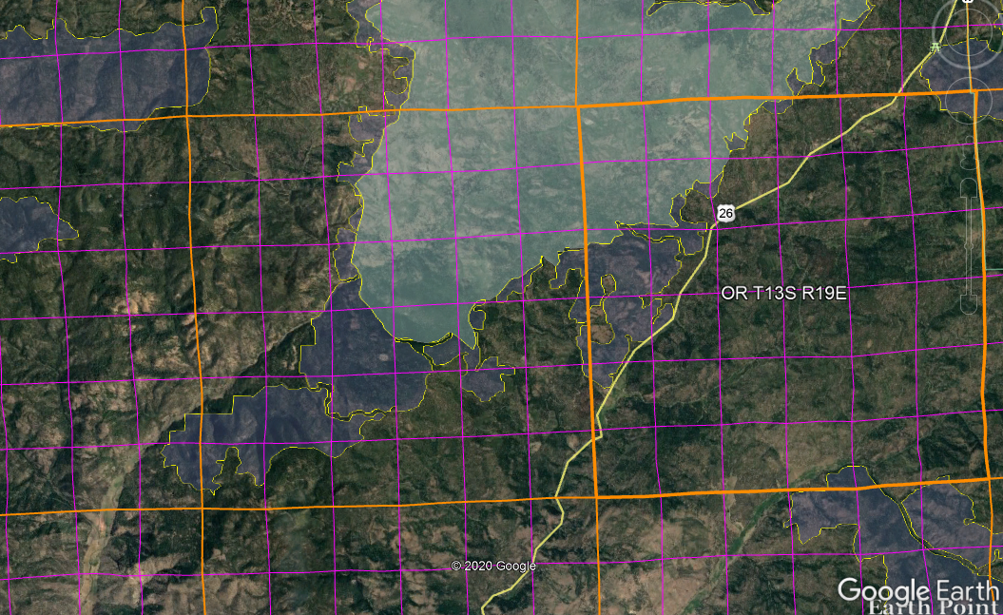

Unroaded areas tend to be less departed from the natural range of variability because natural processes are more intact, but if restoration actions are necessary to address the effects of fire suppression for instance, those goals can be met with non-commercial restoration methods that have fewer trade-offs, such as non-commercial thinning, prescribed fire, weed removal etc.

Allow Natural Processes to Flourish in Unroaded Areas
Unroaded/undeveloped areas are an important feature of the historic range of variability that needs to be restored. Such areas provide high quality water, soil, fish & wildlife habitat, carbon storage, recreation and scenic values, etc. The purpose and need should include restoration of unroaded/undeveloped areas (consistent with the natural range of variability) where natural processes can flourish.

Unroaded areas are rare on the landscape and they are one of the places where human influence has been limited and the ecological building blocks remain in place, so it is reasonably possible to achieve restoration of desired ecological conditions by relying on natural self-correcting mechanisms. Natural processes have operated successfully for millennia to achieve dynamic balance between forest growth and mortality. Within unroaded areas the agency should focus on eliminating unnatural stressors (such as livestock and weeds) while reintroducing natural processes such as fire. There may be an opportunity to manually pre-treat fuels before reintroducing fire, but building miles of new roads and removing significant habitat structures would not be appropriate.

Unroaded areas often have mature forests which are developing and diversifying naturally. “Mature Seral Stage - This stage typically occurs between ages 81 and 195. Stand diversity is gradually increasing in response to openings in the canopy created by wind-throw, disease, insects, and stand mortality” Eugene BLM, 1995. Mohawk/McGowan Watershed Analysis.

One of the important but under-appreciated values of unroaded areas is the long-term creation and maintenance of dead wood habitat due to the fact that unmanaged areas are where natural processes are allowed to flourish. Unroaded areas are one of the few places where trees are allowed to fulfill their entire “lifecycle” (including their life-giving role as snags, dead wood, and soil builders) in the forest. Korol et al (2002) found that large snag habitat is below historic range of variability across the Interior Columbia Basin and they estimated that even if the agencies apply enlightened forest management on federal lands in the Interior Columbia Basin for the next 100 years, we will still reach only 75% of the historic large snag abundance, and most of the increase in large snags will occur in roadless and wilderness areas. Jerome J. Korol, Miles A. Hemstrom, Wendel J. Hann, and Rebecca A. Gravenmier. 2002. Snags and Down Wood in the Interior Columbia Basin Ecosystem Management Project. PNW-GTR-181. http://www.fs.fed.us/psw/publications/documents/gtr-181/049_Korol.pdf. Since wilderness and unmanaged areas are the only place that a healthy population of snags is likely to be recruited and maintained over the long term, they represent invaluable and irreplaceable mitigation for all the places where snags are in short supply due to logging, hazard tree removal, and other management efforts designed to control and capture mortality.

Wisdom et al (2008) found that snag abundance in the Pacific northwest forests is inversely related to past harvest and proximity to roads. Wisdom, M.J., and Bate, L.J. 2008. Snag density varies with intensity of timber harvest and human access. For. Ecol. Manage. 255: 2085–2093. doi:10.1016/j.foreco.2007.12.027. http://www.fs.fed.us/pnw/pubs/journals/pnw_2008_wisdom001.pdf (“Our highest snag density … occurred in unharvested stands that had no adjacent roads. … Stands with no history of timber harvest had 3 times the density of snags as stands selectively harvested, and 19 times the density as stands having undergone complete harvest. Stands not adjacent to roads had almost 3 times the density of snags as stands adjacent to roads.”)

Low-impact restoration activities, including but not limited to prescribed fire, mowing, non-commercial thinning, and weed removal may be appropriate in roadless/unroaded areas as long as they will be substantially unnoticeable to the casual observer and leave the area suitable for future wilderness designation. The NEPA document should describe the roadless/unroaded area, the undeveloped values present, and the need for, and impacts of, the proposed restoration activities.

Commercial logging prescriptions are typically designed to exert significant control over fire behavior and tree mortality, and similar prescriptions have been and are being applied across quite a large area of our federal forests. By limiting treatments to low-impact, non-commercial activities in undeveloped areas we are still treating them, and still getting benefits in terms of fire and "forest heath," but we are relaxing our control just a bit and letting natural processes play a bigger role in that subset of the landscape.

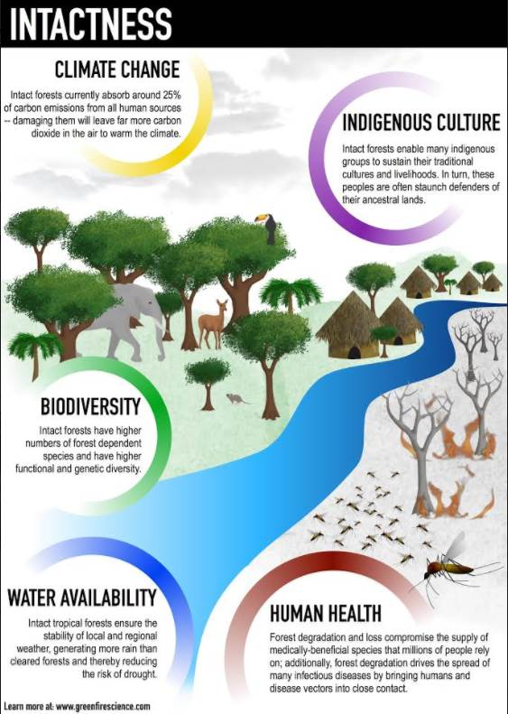
Watson et al 2018. The exceptional value of intact forest ecosystems. Nature Ecology & Evolution (2018) https://www.nature.com/articles/s41559-018-0490-x

Analysis of Potential Wilderness and Other Roadless Values Must be Distinct

It is important for the FS to clearly consider both wilderness values AND other unique values provided disproportionately by large unroaded/unmanaged areas.

An international group of scientists has identified a diverse array of important values provided by roadless areas, including:
ROADLESS AREAS - biodiversity conservation
- Preservation of native biodiversity
- Barrier against invasive species
- Preservation of genetic resources
- Maintenance of ecosystem connectivity and integrity
- Ensure habitat for viability of populations
- Provide migration corridors and stopovers

ROADLESS AREAS - ecosystem services
- Water regulation and supply
- Erosion control
- Air quality
- Climate regulation
- Disease control (e.g. Lyme disease)
- Pollination of crops
- High resilience to pest outbreak
- Recreation
- Education and scientific value

ROADLESS AREAS - climate change
- High resilience and buffering capacity
- Protection against catastrophic events (e.g. fires, landslides, floods)
- Carbon sequestration and decrease of greenhouse gases effects
- Support species adaptation
http://www.roadless.online/roadless-areas/ And conserving roadless areas is an efficient and economical way to meet many of these goals. http://www.roadless.online/wp-content/download/docs/Press%20Release%20Protecting%20Roadless%20Areas%20COP11%20CBD.pdf. Impacts to these values should be carefully evaluated before logging, road building, or using heavy equipment in roadless areas.

The FS often says that inventorying wilderness lands is a forest planning requirement, not a project planning requirement. This may be partially true but this only applies to the FS obligation to make wilderness recommendations during forest planning, it does not absolve the FS of their NEPA duties with respect to description of the affected environment and the disclosure of effects to unique environmental values. The agency has a clear responsibility to accurately described the character of the landscape as part of the “affected environment” section of the NEPA analysis. This includes the existence of unroaded areas >1,000 acres and the significant ecological values provided by such unroaded. areas. The agency also has a responsibility to accurately disclose the potentially significant environmental effects of building roads and logging in those unroaded areas.

Note: even though the FS does not have to make a wilderness recommendation during project planning, they do have to disclose the effects of logging on the wilderness character of the land. The wilderness character of the land is a discernable fact that is relevant to the NEPA analysis and the effects of logging on those wilderness values are an important consideration for the decision-maker.

Wilderness is just one among many reasons to protect unroaded areas. The FS needs to recognize that unroaded areas provide disproportionate public values such as clean water, biodiversity, carbon storage, resilience to climate change, recreation, and scenery. Watson et al (2018) –
summarize published evidence that intact forests support an exceptional confluence of globally significant environmental values relative to forests that have experienced those damaging human actions. We show that intact forests are indispensable not only for addressing rapid anthropogenic climate change, but also for confronting the planet’s biodiversity crisis, providing critical ecosystem services and supporting the maintenance of human health. We then show that the relative value of intact forests is likely to become magnified as already-degraded forests experience further intensified pressures (including anthropogenic climate change).
… [I]ntact forest protection can typically secure very high environmental values with often relatively low implementation and opportunity costs, which serves to reinforce the need for their direct inclusion in global environmental accords. …
… The increasing significance of intact forests
The differences in important environmental and social values of intact forests relative to degraded forests are likely to become magnified in the future due to two negative processes in degraded areas: progressive anthropogenic damage and reduced resilience to environmental change.
…
Retaining the integrity of intact forest ecosystems should be a central component of proactive global and national environmental strategies, alongside current efforts aimed at halting deforestation and promoting reforestation.
… An essential first step towards greater success is achieving widespread recognition that rapid loss of forest intactness represents a major threat to sustainable development and human well-being. Policymakers need to understand the challenge that the loss of forest intactness represents for achieving strategic goals outlined in key multilateral environmental agreements, including the Convention of Biological Diversity, the UNFCCC and the UN Sustainable Development Goals139,143, and this recognition needs to be translated into meaningful changes on the ground.
A fundamental constraint to progress is the fact that international definitions of forests have not differentiated among types of forest and, in most policy settings, they treat all forests, regardless of their condition, as equivalent1,144. As such, international policy processes seldom acknowledge the special qualities and benefits that flow from intact ecosystems as compared with those that are
degraded.
… There is evidence that the designation of ‘roadless areas’ in the USA, for example, has led to an effective expansion in the degree of ecoregional representation under protection and increases in the number of areas big enough to provide refugia for species needing large tracts relatively undisturbed by people.
…
Conclusion
There are still significant tracts of forest that are free from the damaging impacts of large-scale human activities. These intact forests typically provide more environmental and social values than forests that have been degraded by human activities. … The practical tools required to address this challenge are generally well understood and include well-located and managed protected areas, indigenous territories that exemplify sound stewardship regulatory controls and responsible behaviour by logging, mining, and agricultural companies and consumers, and targeted restoration. Currently these tools are insufficiently applied, and inadequately supported by governance, policy and financial arrangements designed to incentivize conservation. Losing the remaining intact forests would exacerbate climate change effects through huge carbon emissions and the decline of a crucial, under-appreciated carbon sink. It would also result in the extinction of many species, harm communities worldwide by disrupting regional weather and hydrology, and devastate the cultures of many indigenous communities. Increased awareness of the scale and urgency of this problem is a necessary pre-condition for more effective conservation efforts across a wide range of spatial scales.
Watson, Evans, Venter et al 2018. The exceptional value of intact forest ecosystems. Nature Ecology & Evolution (2018) https://www.nature.com/articles/s41559-018-0490-x

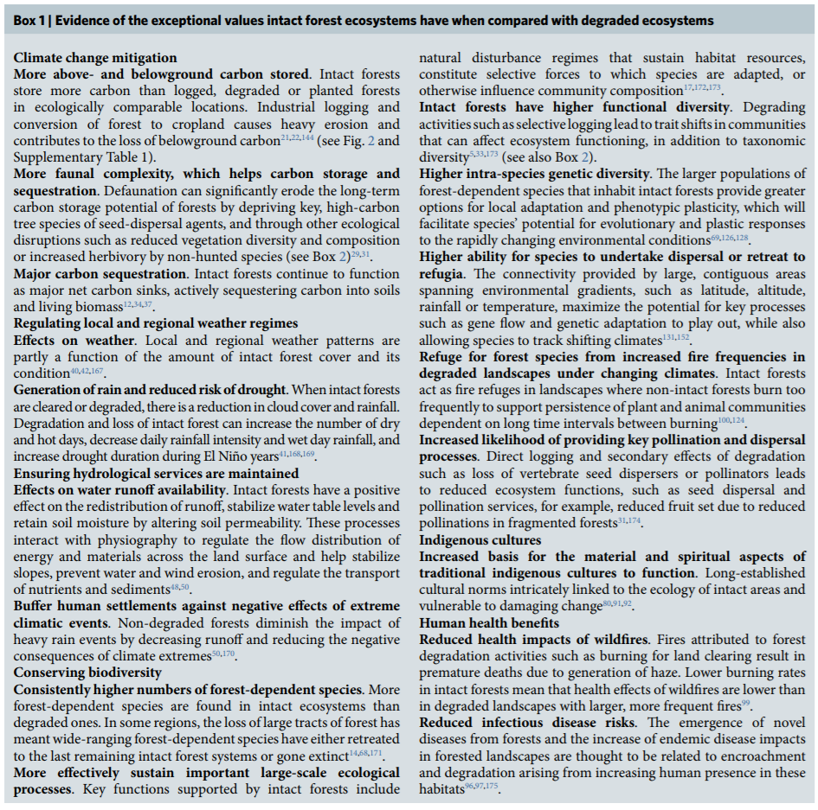
Watson et al (2018).

The NEPA analysis must not blur the distinction between the effect of logging on roaded areas and unroaded areas. The effects of logging unroaded areas are qualitatively different and more significant than logging areas previously affected by roads and logging. The NEPA analysis must clearly disclose the fact that water quality, habitat, scenic values, soil quality, and carbon storage are all better in unroaded areas than roaded areas, and logging will have disproportionately adverse effects on those values.

In a recent case the 9th Circuit held the NEPA analysis of wilderness values insufficient when the agency argued that wilderness issues was adequately addressed in the totality of other resource analyses.

"BLM provides a laundry list of other resource values that it did consider, ranging from animal habitat quality to visual resources. Although it does not argue that its analysis of these other resources was identical to an analysis of wilderness characteristics, it contends that the analysis had the "incidental benefit of capturing the [Southeast Oregon Plan's] effects on many 'wilderness characteristics.' " The BLM supposes, apparently, that members of the public and government decision-makers might be able to piece together a wilderness characteristics analysis from what the Bureau did say. The BLM is wrong in several regards.
First, the BLM never advanced such a position in the EIS itself. While interpretations that are "first articulated in a legal brief [are] not categorically 'unworthy of deference,' " the BLM's argument is simply a " 'post hoc rationalization advanced... to defend past agency action against attack.' "...
Moreover, the premises of the argument are wrong. Although the BLM suggests that "wilderness characteristics" is a nebulous term, capable of being addressed simply by generally examining resources having to do with nature, that is not so. As we have discussed at length, "wilderness characteristics" is a carefully-defined statutory concept, originating in the Wilderness Act, incorporated into the BLM's mandate by the FLPMA, and used by the BLM in its own Handbook...... Even had the BLM professed in the EIS to use such a consideration-by-proxy approach, it is far from clear that it would have provided adequate disclosure of any wilderness values potentially in the planning area. And, in any event, the BLM never purported to have developed such a proxy methodology, by which consideration of other resource types could be melded together to produce an analysis of wilderness characteristics.....
Finally, this appeal does not, as the BLM contends, concern an issue of agency methodology.... no question of methodology with regard to the treatment of wilderness values on non-WSA lands in the planning area is before us. Here, the BLM used no method to analyze or plan for the management of such values. We cannot defer to a void.
ONDA v. BLM (9th Circ. July 2008)
http://www.ca9.uscourts.gov/datastore/opinions/2008/07/14/0535931.pdf.

Be Inclusive in Identifying Roadless Boundaries

NEPA requires high quality information and analysis. 40 CFR 1500.1(b), and “full and fair discussion of significant environmental impacts,” 40 C.F.R. § 1502.1. Unfortunately, there are significant problems with the methods and results of the Forest Service’s prior efforts to inventory and map roadless areas, and one problem stands out – prior efforts have consistently underestimated the extent of unroaded areas on the National Forest.

Problems found on all National Forests
Our analysis of roadless area mapping available from the Forest Service revealed several problems that are present to some degree on all National Forests. The most prevalent problem was great variation in where Forest Service inventoried roadless area boundaries are drawn. In some places Forest Service roadless area boundaries come to the edge (or even cross) roads that bound the roadless areas. In other places the boundary is kept over a mile away from any bounding road. Most Forest Service roadless area boundaries were drawn in a very imprecise fashion, and often appear to wander across the landscape without any credible rationale for their location. Forest Service roadless areas were delineated without any precise and repeatable criteria and methodology. There is little consistency between roadless areas within a National Forest and even less consistency between forests. The only real consistency that we were able to find between all the National Forests in Washington State was that they all underestimated the acreage of roadless land in areas over 5000 acres in size.
Many unroaded, unlogged and completely wild areas have been excluded from Forest Service inventoried roadless areas for no apparent reason. It appears that the boundaries of Forest Service inventoried roadless areas were often drawn to minimize their size, particularly where substantial timber is involved. There is also no consistency regarding what is included and what is excluded from Forest Service roadless areas. In some cases Forest Service roadless areas (and some designated Wilderness Areas) include old roads, bulldozer trails, logged areas and other development. But in most cases even the slightest hint of old logging appears to be an excuse for excluding an area from a Forest Service roadless area.
Peter Morrison, Susan Snetsinger and George Wooten 1998. Unprotected Wild Lands In Washington State An Analysis of Their Current Status and Future under Current Management Direction, A report by The Pacific Biodiversity Institute, February 1998 http://www.okanogan1.com/research/roads/Roadless_Report_by_Morrison_et_al_2000.pdf

The Forest Service should follow its internal guidance (effective 1/30/2015) for “broad and inclusive” identification of potential wilderness, and public involvement in that process. The FS Planning Handbook says:
The primary function of the inventory step is to efficiently, effectively, and transparently identify all lands in the plan area that may have wilderness characteristics as defined in the Wilderness Act.

The inventory is intended to be reasonably broad and inclusive, based on the inventory criteria set out in this section and additional information provided to the Responsible Official through the required opportunities for public and government participation (sec. 70.61 of this Handbook). The intent is to identify lands that may be suitable, so that they can be evaluated and to allow for public input and feedback …
…
Include in the inventory areas that contain the following road improvement attributes if the areas also meet the other inventory criteria…
- Areas that contain forest roads maintained to level 1;
- Areas with any routes that are decommissioned, unauthorized or temporary, or forest roads that are identified for decommissioning in a previous decision document, or identified as likely unneeded in a travel management plan …
…
f. Areas with historical wagon routes, historical mining routes, or other settlement era transportation features considered part of the historical and cultural landscape of the area.
…
[The following developments should also be included in the inventory]
2. Vegetation treatments that are not substantially noticeable.
3. Timber harvest areas where logging and prior road construction are not substantially noticeable.
4. Permanently installed vertical structures, such as electronic installations that support television, radio, telephone, or cellular communications, provided their impacts, as well as their maintenance and access needs, are minimal.
5. Areas of mining activity where impacts are not substantially noticeable.
…
10. Lands adjacent to development or activities that impact opportunities for solitude. The fact that nonwilderness activities or uses can be seen or heard from within any portion of the area, must not, of itself, preclude inclusion in the inventory. It is appropriate to extend boundaries to the edges of development for purposes of inclusion in the inventory.
…
The Responsible Official shall ensure that the Interdisciplinary Team documents the evaluation … The intent is to ensure that the process for inventory and evaluation is transparent and accessible to the public for input and feedback.
…
Evaluate the degree to which the area has outstanding opportunities for solitude or for a primitive and unconfined type of recreation. The word “or” means that an area only has to possess one or the other. The area does not have to possess outstanding opportunities for both elements, nor does it need to have outstanding opportunities on every acre.
2012 Planning Rule Directives. FSH 1909.12- Chapter 70 – Wilderness. http://www.fs.usda.gov/detail/planningrule/home/?cid=stelprd3828310

The FS must avoid using the contrary policy of excluding 300 foot buffers along roads even when those areas otherwise qualify as potential wilderness.

The 300 foot buffers often used by Region 6 to determine the boundaries of “potential wilderness areas” are exceedingly large and unsupported by logic and evidence. The FS must remember that they are preparing an inventory of “potential” wilderness, so they should be inclusive. Congress has on many occasions established wilderness boundaries much closer than 300 feet from roads in many instances. The FS should not prejudge wilderness potential by excluding from its NEPA analysis areas that Congress might later decide to include in wilderness.

Habitat adjacent to roads may be somewhat modified by edge effects but it is still “roadless” right up to the edge of the road (e.g., soil and vegetation are essentially intact; wildlife movement is not encumbered; hydrology is generally functioning, the imprint of man is generally unnoticeable, etc). Tellingly, when constructing new roads, the FS never admits and discloses adverse effects extending 300 feet on either side of the road.

The 2007 FS Handbook also recommends “locat[ing] boundaries at prominent natural or semi-permanent human-made features to facilitate easy on-the-ground identification.” A road is a much more clearly identifiable boundary than an arbitrary line 300 feet away from the road.

To justify the wide, exclusionary buffers, the FS seems to rely on the fact that firewood cutting is allowed within 300 feet of roads; however, this does not justify eliminating huge swaths of otherwise roadless forests from the PWA analysis. Many roads are closed and not accessible to firewood cutters. Many open roads are not typically used for firewood access. Some areas adjacent to roads are too steep. There are conditions on firewood permits that limit the effects of firewood cutting. And most importantly, a few stumps visible within an unroaded area does not render the area ineligible for wilderness.

In its Sept 2012 appeal of the Umatilla NF’s South George Project, The Lands Council explained the problems with the purity doctrine that underpins the 300 foot buffer:
Moreover, the FEIS states at H-3 that a 300 ft. boundary was set on each side of forest roads, further eliminating potential wilderness lands (Map H-3), despite acknowledging that this criteria is inaccurate at H-3. This rigid application by the Forest Service has become known as the “purity doctrine,” in which any remote sign of past logging or road building will unequivocally preclude consideration of or recommendation for wilderness designation. There is, however, no foundation for such a rigid doctrine.

First, the FSH uses the permissive “may” when it states that “[a]reas may qualify for the inventory of potential wilderness even though they include the following types of areas or features: (9) Timber harvest areas where logging and prior road construction are not evident ….” Forest Service Handbook, 1909.12, 71.11(9). The Forest Service, however, failed to include any area that has been subject to logging as mapped in the District’s GIS harvest layer and systematically applied a 300 ft. buffer around all roads. Second, the Wilderness Act does not contain language that unequivocally requires no past management activities: “with the imprint of man’s work substantially unnoticeable” an “area of underdeveloped Federal Land” (as opposed to undeveloped). 16 U.S.C. § 1131(c). Third, numerous wilderness areas have been designated where past logging and other management activities are present. Finally, and perhaps most importantly, Congress has expressly asked the Forest Service to abandon the “purity doctrine.” In a Senate Report from the Committee on Energy and Natural Resources regarding the Endangered American Wilderness Act of 1977, the Committee stated: “Generally, the committee believes that the so-called ‘purity’ concept of wilderness long adhered to by the Forest Service, is unnecessarily restrictive and should be abandoned.” S. Rept. 95-490 on H.R. 3454. 95th Cong. 1st sess. October 11, 1977. As a result of the Forest Service’s rigid application of PWA criteria, 12,815 acres are not assessed under the Ninth Circuit’s requirement that roadless expanses are analyzed because of either “past timber harvest” or because “the boundary was set as 300 feet each side of the forest roads” (FEIS at 3-183 and Table 3-82).

Also, Congress rejected the argument that “outside sights and sounds” (such as those from adjacent roads) exclude an area from wilderness consideration. Senator Church quoted Senator Murray from the July 2, 1960 Congressional Record which noted that “wilderness character” is determined by looking at the very area under consideration, not by evaluating an adjacent area, even if some disturbances may emanate from that adjacent area. Church said, “Sights and sounds from outside the boundary do not invalidate a wilderness designation or make threshold exclusions necessary, as a matter of law”.

The Forest Service should strive to be more consistent with its prior policies dating back to 1960 relating to identification of roadless and potential wilderness areas. Application of a 300 foot buffer is an unprecedented and divergent policy that demands a compelling justification. Region 6 needs to justify why is chooses to apply a 300 foot buffer, when other regions use much smaller buffers that basically extend just to the edge of the road or the road prism. Region 1’s Roadless Area Inventory Protocol (11/20/96) applies a 50’ buffer from the centerline of roads. Region 4’s Protocol for Identifying and Evaluating Areas for Potential Wilderness (10/28/2004) recommends a 33 foot buffer from the centerline of roads. The FS must eliminate the large 300 foot buffers, and disclose how much logging is proposed in those areas.

New information on Snags.

Since logging will exacerbate the shortage of large snags, the NEPA analysis must take a hard look at new information on snags and the outdated snag standards in the LRMP. Dynamic ecosystems historically included large-scale mortality events both pulsed and continuous. Mortality and biomass accumulation are natural and desirable ecological processes that forest management has been working for decades to capture, suppress, and avoid. Large snags are severely under-represented in our forests and logging will capture, reduce and delay recruitment of future large snags. Korol et al (2002) estimated that even if we apply enlightened forest management on federal lands in the Interior Columbia Basin for the next 100 years, we will still reach only 75% of the historic large snag abundance, and most of the increase in large snags will occur in roadless and wilderness areas. Jerome J. Korol, Miles A. Hemstrom, Wendel J. Hann, and Rebecca A. Gravenmier. 2002. Snags and Down Wood in the Interior Columbia Basin Ecosystem Management Project. PNW-GTR-181. http://www.fs.fed.us/psw/publications/documents/gtr-181/049_Korol.pdf. Wisdom et al (2008) found that snag abundance in the Pacific northwest forests is inversely related to past harvest and proximity to roads. Wisdom, M.J., and Bate, L.J. 2008. Snag density varies with intensity of timber harvest and human access. For. Ecol. Manage. 255: 2085–2093. doi:10.1016/j.foreco.2007.12.027. http://www.fs.fed.us/pnw/pubs/journals/pnw_2008_wisdom001.pdf (“Our highest snag density … occurred in unharvested stands that had no adjacent roads. … Stands with no history of timber harvest had 3 times the density of snags as stands selectively harvested, and 19 times the density as stands having undergone complete harvest. Stands not adjacent to roads had almost 3 times the density of snags as stands adjacent to roads.”) Salem BLM’s Bottleneck LSR Enhancement Project EA (http://www.blm.gov/or/districts/salem/plans/files/sdo_080-07-16_eafonsi.pdf ) includes Table 9 which clearly shows that thinning will adversely affect mortality processes. Mortality would be 70 tpa without treatment, or 0.10 tpa with thinning, thus sacrificing 69.9 trees per acre averaging 20.3" dbh that would be recruited to the large snag and down wood pool over the next 30 years except that they will instead be cut and taken to the mill.

Snags have been severely depleted across the eastside and westside forests. The federal agencies need to compensate for the severe lack of snags on intensively managed forest lands, but unfortunately snags are lacking on federal lands as well. For snag depletion in westside forests, see Nonaka, E, Spies, TA, Wimberly, MC, and Ohmann, JL. 2007. Historical range of variability (HRV) in live and deadwood biomass: a simulation study in the Coast Range of Oregon, USA. Can. J. For. Res. 37:2349-2364. http://ddr.nal.usda.gov/bitstream/10113/9953/1/IND44013619.pdf , and Jerome J. Korol, Miles A. Hemstrom, Wendel J. Hann, and Rebecca A. Gravenmier. 2002. Snags and Down Wood in the Interior Columbia Basin Ecosystem Management Project. PNW-GTR-181. http://www.fs.fed.us/psw/publications/documents/gtr-181/049_Korol.pdf. For snag depletion in eastside forests, see the ICBEMP Scientific Analysis Group which found that “Across the [interior Columbia River] basin (all lands) large snags have declined more than 30 percent. This was most likely a reflection of the loss of late-seral forests, particularly in the dry and moist PVGs.” Miles A. Hemstrom, Wendel J. Hann, Rebecca A. Gravenmier, Jerome J. Korol. 2000. [SAG] Landscape Effects Analysis of the [ICBEMP] SDEIS Alternatives. USDA/USDI, draft March 2000.
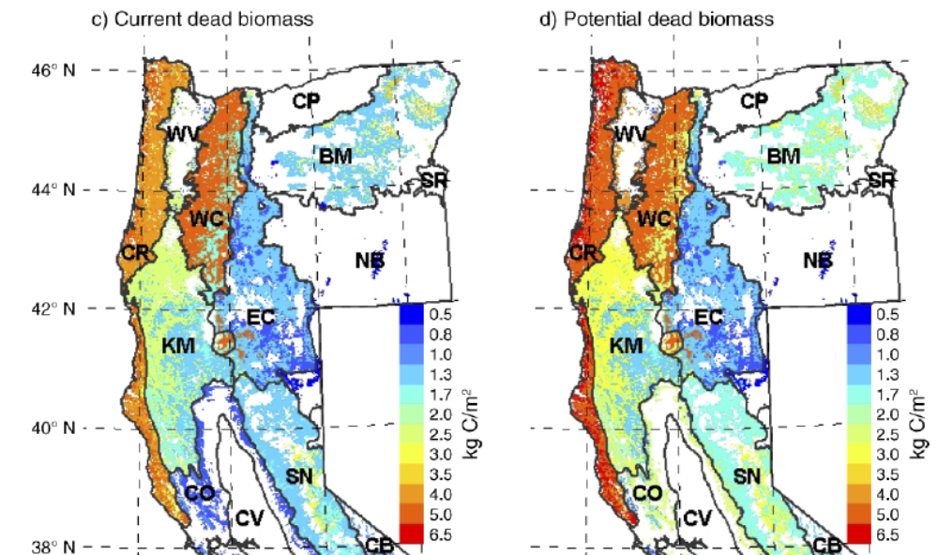
Tara Hudiburg, Beverly Law, David P. Turner, John Campbell, Dan Donato, And Maureen Duane 2009. Carbon dynamics of Oregon and Northern California forests and potential land-based carbon storage. Ecological Applications, 19(1), 2009, pp. 163–180
http://terraweb.forestry.oregonstate.edu/pubs2/Hudiburg2009EA.pdf.

The Eastside Screens interim wildlife standard recognizes that maintaining healthy wildlife populations requires abundant dead wood and that past practices have depleted the dead wood resource:
Snags, Green Tree Replacements and Down Logs:
INTENT STATEMENT – Most (if not all) wildlife species rely on moderate to high levels of snags and down logs for nesting, roosting, denning and feeding. Large down logs are a common and important component of most old and late structural forests. Past management practices have greatly reduced the number of large snags and down logs in managed stands.

The Screens call for application of the following MINIMUM standards with respect to snag habitat …
100% potential population levels of primary cavity excavators. This should be determined using the best available science on species requirements as applied through current snag models or other documented procedures.
Unfortunately, the Eastside Screens still rely on the discredited potential population method. The Forest Service has numbers for meeting 100% potential population levels and strives to meet targets that are known to be inadequate. Even if the agency aims for a target above 100% potential population levels, the agency is still using an invalid reference point that does not belong in the NEPA analysis. The best available science has not been incorporated into the standards. The agency lacks the “documented procedures” for meeting snag habitat requirements called for in the Eastside Screens.

The 9th Circuit recently reiterated that “species viability may be met by estimating and preserving habitat ‘only where both the Forest Service’s knowledge of what quality and quantity of habitat is necessary to support the species and the Forest Service’s method for measuring the existing amount of that habitat are reasonably reliable and accurate.’ Earth Island Inst. v. U.S. Forest Serv., 442 F.3d 1147, 1175-76 (9th Cir. 2006) (quoting Native Ecosystems Council v. U.S. Forest Serv., 428 F.3d 1233, 1250 (9th Cir. 2005))” ONRC v. Goodman (Mt Ashland case, 9th Circuit Sept 24, 2007) (emphasis added).
http://caselaw.findlaw.com/us-9th-circuit/1151013.html
and http://caselaw.findlaw.com/us-9th-circuit/1094367.html.

The Forest Service cannot provide any assurance that its plans and projects will assure viable populations of native wildlife that depend on dead trees. The Forest Service does not know how many snags are necessary to support viable populations of cavity associated species. The Forest Service has provided no credible link between DecAID tolerance levels, potential population levels, and/or viable populations. The Forest Service has also failed to reliably quantify existing and projected habitat for snag associated species.

An unavoidable impact of all commercial logging is to “capture mortality” which reduces valuable snag habitat in the short-term (via hazard tree felling) and in the long-term (via delayed recruitment and reduced overall recruitment). For example, in a thinning project on the Siuslaw National Forest “modeling stand #502073 over a 100-year cycle [using ORGANON] predicts a total stand mortality of 202 trees (>10 inches dbh) for the unthinned stand, while mortality for the thinned stand was two trees. Therefore, thinning will reduce density-dependent mortality within the stand by 99%.” There is no reason to think that thinning in densely stocked forests elsewhere would be any different.

Dead wood in forests is thought to follow a U-shaped pattern over time “from the combined and lagged effects of legacy wood decay and the recruitment of new dead wood,” (Harmon 1986, Hudiburg 2009) resulting in abundant dead wood legacies from the previous stand in young forests, less dead wood in middle-aged stands as the legacies decay, and more again in older stands as natural mortality processes manifest. If the goal is to restore high quality old forest habitat, the agencies must respect this dynamic by recognizing that dead wood recruitment requires (1) “surplus” biomass and (2) it’s a process that takes time, so managers should ensure that middle-aged stands accumulate biomass and begin to recruit and accumulate snags and dead wood. The low of dead wood in middle aged stands is not universal or necessarily desirable, and since many young stands were deprived of the legacies they normally enjoy, it would be advisable to start accumulating snags and dead wood as soon as possible, not wait for mature stages.

The federal forest agencies now recognize that current methods and assumptions concerning snag habitat standards are outdated, and the old snag standards do not ensure enough snags to meet the intent of the standard, yet the agencies have not adjusted their management plans to account for this new information nor have they developed new standards that are consistent with the latest scientific information.

As explained on the DecAID website:
Why is DecAID needed?
National Forest LRMP standards and guidelines for management of snags and down wood in the Pacific Northwest were based on wildlife species models and tools that were developed in the 1970s and 1980s (Thomas et al. 1979, Neitro et al. 1985, Marcot 1992, Raphael 1983). New information about the ecology, dynamics, and management of decayed wood has been published since then, and the state of the knowledge continues to change. Rose et al. (2001) report that results of monitoring indicate that the biological potential models are a flawed technique (page 602). There has been an evolution from thinking of large woody material as habitat structures, to thinking of decaying wood as an integral part of complex ecosystems and ecological processes.

This paradigm shift has made the management of dead wood a much more complex task. We can no longer expect to go to our LRMPs or the biological potential model to get one number for the amount or size of snags and down wood that we can apply to all projects and to all acres. We are directed to use the best available science to manage ecosystems, and the best available science simply will not support business as usual for managing dead wood.
Region 6 - USDA Forest Service. A Guide to the Interpretation and Use of the DecAID Advisor. June, 2006. http://www.fs.fed.us/r6/nr/wildlife/decaid-guide/

A few of the problems with the old standards are:
- They failed to account for the fact that the number of snags needed for roosting, escape, and foraging can exceed the number of snags needed for nesting;
- They failed to recognize that the number of snags needed to support viable populations of secondary cavity users may exceed the needs of primary cavity excavators;
- The old standard failed to account for the size height of snags favored by some species;
- In applying the old standards the agencies often fail to account for rates of snag fall and recruitment;
- The old standards fail to recognize non-equilibrium conditions in our forests, i.e. some species rely on the natural large pulses of snags associated with large disturbances;
- The old standards fail to account for the differential use of space and population density of different species;
- The old standards ignore other important habitat features of dead wood, e.g. loose bark, hollow trees, broken tops, etc.

The Forest Service recognizes that
Forest Plan standards were based on a model that did not account for snags required for foraging (EA p. 68 and Appendix K p. 45). There is general consensus in the scientific and professional community that using the biological potential model (which was used in developing the Forest Plan standard) is flawed and does not provide adequate nesting, roosting, or foraging structure for cavity excavating birds …
North Fork John Day RD, Umatilla NF. 2011. Mirage Vegetation Management Project DN. http://a123.g.akamai.net/7/123/11558/abc123/forestservic.download.akamai.com/11558/www/nepa/53012_FSPLT2_055455.pdf.

Bull et al. (1997) states current direction for providing wildlife habitat on public forest lands does not reflect the new information available, which suggests that to fully meet the needs of wildlife, additional snags and habitat are required for foraging, denning, nesting, and roosting. Rose et al. (2001) suggests that calculation of numbers of snags required by woodpeckers based on assessing their “biological (population) potential” is a flawed technique (Rose et al. 2001) due to the fact that empirical studies are suggesting that snag numbers in areas used and selected by some wildlife species are far higher than those calculated by this technique. There is general consensus that the biological potential model does not provide adequate nesting, roosting, or foraging structure for cavity excavating birds (Bull et al. 1997, Johnson and O’Neil 2001). This suggests the current direction of managing for 100 percent population levels of primary excavators may not represent the most current knowledge of managing for cavity nesters.
North Fork John Day RD, Umatilla NF. 2011. Mirage Vegetation Management Project EA, Appendix K – Terrestrial Wildlife Specialist Report. p K-45. http://a123.g.akamai.net/7/123/11558/abc123/forestservic.download.akamai.com/11558/www/nepa/53012_FSPLT2_055426.pdf.

The agencies need to prepare a EIS to consider a replacement methodology for maintaining species and other values associated with dead wood. This is especially critical because adequate dead wood is recognized as an essential feature of healthy forests and the Forest Service has identified lots of “management indicator species” associated with dead wood habitat.

Back in the early 1990s the Forest Service recognized the their forest plans were not adequate to maintain populations of spotted owls and they tried to develop plans to conserve spotted owl without following NEPA and NFMA procedures. The courts said they had to stop cutting owl habitat until they had complied with environmental laws. This is the same situation we find ourselves in today with dead-wood associated species. The agencies should stop harming dead wood habitat until they have a legal plan to conserve associated species over the long-term. Seattle Audubon Society v. Epsy, 998 F.2d 699, 704 (9th Cir. 1998) (an agency must re-examine its decision when the EIS "rests on stale scientific evidence and false assumptions").

Lessons Learned During the Last Fifteen Years
…
Several major lessons have been learned in the period 1979-1999 that have tested critical assumptions of these earlier management advisory models:
- Calculations of numbers of snags required by woodpeckers based on assessing their ‘biological potential’ (that is, summing numbers of snags used per pair, accounting for unused snags, and extrapolating snag numbers based on population density) is a flawed technique. Empirical studies are suggesting that snag numbers in areas used and selected by some wildlife species are far higher than those calculated by this technique.²²⁶
- Setting a goal of 40% of habitat capability for primary excavators, mainly woodpeckers,³⁶⁹ is likely to be insufficient for maintaining viable populations.
- Numbers and sizes (dbh) of snags used and selected by secondary cavity-nesters often exceed those of primary cavity excavators.
- Clumping of snags and down wood may be a natural pattern, and clumps may be selected by some species, so that providing only even distributions may be insufficient to meet all species needs.
- Other forms of decaying wood, including hollow trees, natural tree cavities, peeling bark, and dead parts of live trees, as well as fungi and mistletoe associated with wood decay, all provide resources for wildlife, and should be considered along with snags and down wood in management guidelines.
- The ecological roles played by wildlife associated with decaying wood extend well beyond those structures per se, and can be significant factors influencing community diversity and ecosystem processes.
Rose, C.L., Marcot, B.G., Mellen, T.K., Ohmann, J.L., Waddell, K.L., Lindely, D.L., and B. Schrieber. 2001. Decaying Wood in Pacific Northwest Forests: Concepts and Tools for Habitat Management, Chapter 24 in Wildlife-Habitat Relationships in Oregon and Washington (Johnson, D. H. and T. A. O'Neil. OSU Press. 2001) http://web.archive.org/web/20060708035905/http://www.nwhi.org/inc/data/GISdata/docs/chapter24.pdf

The potential population models are based on the number of trees needed for nesting cavity-excavator birds, however, “[t]he high value of large, thick-barked snags in severely burned forests has as much to do with feeding opportunities as it does with nesting opportunities they provide birds.” (Hutto. ConBio 20(4). 2006. http://web.archive.org/web/20060904175645/http://avianscience.dbs.umt.edu/documents/hutto_conbio_2006.pdf. The number of snags needed to support bird feeding, escape from predators, and other life functions, is different than, and likely higher than, the number of snags needed to support nesting, so the agencies’ existing “potential population” snag standards are arbitrary and capricious.

New science indicates that meeting the needs of cavity excavators requires retaining far more snags than managers realize.
… at-risk species, namely the black-backed and the white-headed woodpeckers, were nesting within burns that contained 86 to 96 percent of trees with unsuitably hard wood. This suggests that past studies that did not measure wood hardness counted many sites as available to cavity-excavating birds when actually they were unsuitable. “By not accounting for wood hardness, managers may be overestimating the amount of suitable habitat for cavity-excavating bird species, some of which are at risk,” Lorenz says.
In their study plots, the researchers did not find reliable visual cues to distinguish
between suitable and unsuitable trees. Snag decay class was a poor indicator of internal wood properties—and this was not the first study to demonstrate that fact, although it was the first study to do so in ornithology (past studies had been done by foresters and published in forestry journals).
“Currently, the best solution we can recommend is to provide large numbers of snags for the birds, which can be difficult without fire,” Lorenz says. According to the researchers’ calculations, if one of every 20 snags (approximately 4 percent) has suitable wood, and there are five to seven species of woodpeckers
nesting in a given patch, approximately 100 snags may be needed each year for nesting sites alone. This does not account for other nuances, like the fact that most species are territorial and will not tolerate close neighbors while nesting, or the fact that species like the black-backed woodpecker need more foraging
options. Overall, more snags are needed than other studies have previously recommended.
Vizcarra, Natasha 2017. Woodpecker Woes: The Right Tree Can Be Hard to Find. PNW Science Findings, Issue 199, August 2017. https://www.fs.fed.us/pnw/sciencef/scifi199.pdf. citing Lorenz, T.J.; Vierling, K.T.; Johnson, T.R.; Fischer, P.C. 2015. The role of wood hardness in limiting nest site selection in avian cavity excavators. Ecological Applications. 25: 1 016–1033. https://www.treesearch.fs.fed.us/pubs/49102.

The Purpose and Need should Address The Unmet Need for Carbon Storage

The agency typically says one of the purposes of this project is to provide a supply of wood products to the public. The agency should reconsider timber targets in light of the fact that the public needs carbon storage to reduce global climate change much more than they need wood products. The NEPA analysis also needs to account for the fact that managing forests for water quality, water quantity, quality of life, and carbon storage for a stable climate will contribute far more to community stability than propping up the timber boom-bust industry with subsidized logging.

The agency must recognize that wood products are already under-priced and over-supplied due to “externalities” (costs that are not included in the price of wood, so those costs are shifted from wood product producers and consumers to the general public who suffer the consequences of climate change without compensation from those who profit from logging related externalities). Ecosystem carbon storage on the other hand is under-supplied because there is not a functioning market for carbon storage and climate services. The agency is in a position to address these market imperfections by focusing on unmet demand for carbon storage instead of offering wood products that are already oversupplied.

Land protection, both public and private, provides substantial ecological benefits by avoiding conversion of natural systems to intensive, developed uses. These benefits include carbon sequestration, watershed functioning, soil conservation, and the preservation of diverse habitat types (e.g., Daily 1997, Brauman et al. 2007, Kumar 2012, Watson et al. 2014). Land protection also solves a key market failure: private markets tend to underprovide socially beneficial land uses such as natural forests, agricultural lands, or managed timberlands. The reason for this failure is that many of the benefits of these lands go to the public in general, not individual landowners. When private values and market transactions determine land uses, less land will be devoted to socially beneficial uses than if citizens could collectively determine use on the basis of social values (e.g., Angelsen 2010, Tietenberg and Lewis 2016).
Katharine R.E. Sims, Jonathan R. Thompson, Spencer R. Meyer, Christoph Nolte, Joshua S. Plisinski. 2019. Assessing the local economic impacts of land protection. Conservation Biology. 26 March 2019 https://doi.org/10.1111/cobi.13318, https://harvardforest.fas.harvard.edu/sites/default/files/Sims_et_al-2019-Conservation_Biology.pdf.

Do not rely on the flawed boilerplate climate analyses

As explained below, the Forest Service’s standardized NEPA language regarding carbon and climate change fails to take a hard look that NEPA requires. The analysis makes several highly misleading statements about forest carbon and climate change. The analysis inappropriately mischaracterizes the role of individual logging projects in the cumulative problem of global GHG emissions. The analysis misstates the effects of logging related carbon emissions that are not related to “deforestation.” The analysis grossly misstates the climate effects of logging intended to reduce disturbance. The analysis misleadingly implies that logging benefits the climate by increasing forest productivity.

The NEPA analysis should consider the adverse climate consequences of GHG emissions caused directly and indirectly by logging. The Forest Service should not rely on the boilerplate NEPA language from the regional office which is flawed in many ways. Instead the Forest Service:
- Must recognize the cumulative nature of the GHG emissions and climate problems. It does not matter that this project is small in the global scheme because all emissions matter when the causation is global and cumulative;
- Cannot credibly assert that this project is harmless because it’s not causing deforestation. This is immaterial. All GHG emissions, regardless of the source or how it is labelled, are part of the problem and cause the same climate impacts.
- Cannot credibly assert that thinning for forest health justifies or mitigates emissions from logging. Logging does not increase the capacity for growing trees. To the contrary, logging harms soil and reduces site productivity.
- Must not compare carbon before and after logging. That is an improper framework for NEPA analysis. The proper NEPA framework is to compare the effects of different alternatives (over time), so the agency must describe the carbon emissions and carbon storage in the forest over time with logging and without logging.
- Logging to reduce fire effects does not result in a net increase in forest carbon storage. The agency cannot predict the location, timing, or severity of future wildfires, so most fuel treatments will cause carbon emissions without any offsetting benefits from modified fire behavior. Studies clearly show that the total carbon emissions from logging (plus unavoidable wildfire) are greater than carbon emissions from wildfire alone.
- Cannot credibly assert that carbon storage in wood products is a useful climate strategy. Logging kills trees, stops photosynthesis, and initiates decay and combustion, with the end result being a significant transfer of carbon from the forest to the atmosphere. In stark contrast, an unlogged forest continues to grow and transfer more carbon from the atmosphere to the forest. Carbon emissions caused by logging far exceed the small fraction of carbon transferred to wood products. Carbon accounting methods that attempt to account for substitution of wood for other high-carbon building materials are fraught with uncertainty and too often represent maximum potential substitution effects rather than lower realistic estimates.

General recommendations for dry forest thinning/restoration
Please consider the following recommendations to improve the ecological benefits of restoring dry forests and to mitigate the adverse impacts.
  - Oregon Wild will do its best to maintain the torch that was carried for so long by the late Tim Lillebo who worked to protect and restore eastside forests for almost four decades. In Tim’s office, we found the following concise summary of his recommendations for thinning dry forests containing old growth trees.
Old Growth stand thinning
My recommendation for thinning in OG stands is the same prescription we used for the Glaze Project where we thinned OG stands.
Basically,
-retain all OG trees of all species
-retain historic mix of species
-retain all snags and down logs, with safety exceptions
-retain 15-20% in wildlife leave patches from 1/4 - 5 acres
-In small trees thin in variable density 60-80 sq ft basal area, retaining the largest trees that will become the next generation of old growth. Larger trees carry higher basal areas of 100-140+.
-thin leaving clumps of 2-10 trees with 3-4 clumps per acre
-doughnut thin around old growth trees, but if available retain 1-2 good sized trees in the doughnut to become replacement old growth
A more detailed description of Tim’s restoration concepts, vision, priorities, recommended prescriptions for eastside forests can be found in Oregon Wild’s “Practical Guide for Ecological Restoration of Eastern Oregon's Dry Forests,” http://www.oregonwild.org/sites/default/files/pdf-files/Eastside_Restoration_Handbook.pdf. In appropriate dry forest type please consider applying Tim’s recommendations, including lessons for successful restoration, and recommendations for minimizing unintended consequences.
  - Additional dry forest restoration concepts can be found here: Franklin, J.F., Johnson, K.N., et al 2013. Restoration of Dry Forests in Eastern Oregon – A Field Guide. The Nature Conservancy, Portland, OR. 202 pp. http://nature.ly/dryforests (We have not had a chance to carefully review all of the recommendations in this field guide, but it does appear to have some good ideas. We are concerned about the proposed allowance to remove some old trees to make restoration economically viable. There are no clear criteria to ensure that the ecological benefits exceed the ecological costs.)
  - Use an integrated multi-objective planning process. “An integrated planning process focuses on multiple-objective planning rather than single-objective planning from the beginning of the project. It favors a transparent and interactive process that offers opportunities for understanding ecosystem complexity, stakeholder positions, and clear articulation of decision trade-offs and benefits.” Jain, Theresa B.; Battaglia, Mike A.; Han, Han-Sup; Graham, Russell T.; Keyes, Christopher R.; Fried, Jeremy S.; Sandquist, Jonathan E. 2012. A comprehensive guide to fuel management practices for dry mixed conifer forests in the northwestern United States. USDA Forest Service Gen. Tech. Rep. RMRS-GTR-292. 2012 http://www.firescience.gov/projects/09-2-01-16/project/09-2-01-16_09-2-01-16_rmrs_gtr292web.pdf
  - When conducting commercial thinning projects take the opportunity to implement other critical aspects of watershed restoration especially reducing the impacts of the road system and livestock grazing and establishing the ecological processes that foster recovery of hydrologic systems and fire regimes. See FEMAT 1993. Appendix V-J: Guidelines for Restoration Projects (unnumbered pages between V-96 and VI-1). Bradbury, Nehlsen et al 1995. Handbook for Prioritizing Salmon & Watershed Restoration. http://pacificrivers.org/science-research/resources-publications/handbook-for-prioritizing-watershed-protection-and-restoration-to-aid-recovery-of-native-salmon.
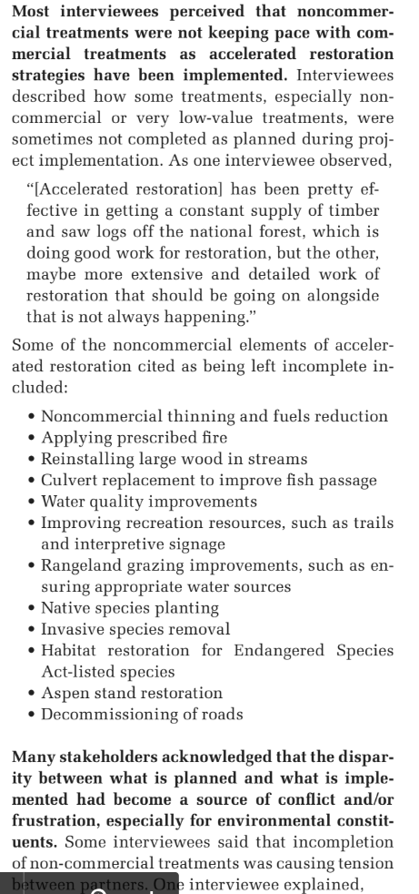
Anna Santo, Emily Jane Davis, Heidi Huber-Stearns, and Autumn Ellison 2018. Successes, Challenges, and Opportunities for Collaborative Accelerated Restoration in Oregon’s Blue Mountains. ECOSYSTEM WORKFORCE PROGRAM WORKING PAPER NUMBER 88, SUMMER 2018. http://ewp.uoregon.edu/
  - Don’t waste too much effort restoring forest structure when doing so will require continuous expenditure of money and effort to maintain. Use scarce resources efficiently by striving to restore ecological processes that can be self-sustaining. Recognize that insects and disease are natural ecological processes that actually help improve landscape diversity. Recognize that tree mortality recruits valuable habitat structures and makes resources available which increase the vigor of surviving trees, thus accomplishing many of the objectives of mechanical density reduction projects. Don't focus too much on tree health, but think instead about forest ecosystem health. Use natural processes where it makes sense to do so. Fettig et al 2013 review draft. The Ecology and Management of Moist Mixed-Conifer Forests in Eastern Oregon and Washington; a Synthesis of the Relevant Science and Implications for Future Management (“[R]estoration should aim to re-establish the self-organizing, self-maintaining, and adaptive capacities of ecosystems. This is done by restoring ecological patterns and processes. In doing so, we can address the goal of ‘healthier, more resistant, more resilient ecosystems, even if they are not exactly the same systems as before (USDA Forest Service).’ The application of ad hoc, narrowly focused ‘engineering’ solutions (e.g., managing forest structure and composition to recover a specific stable state) is expensive, logistically challenging, and often incapable of achieving restoration goals. Engineered solutions can still have limited roles for particular sites, but creating healthy and resilient landscapes requires a more dynamic and process-based perspective.”)
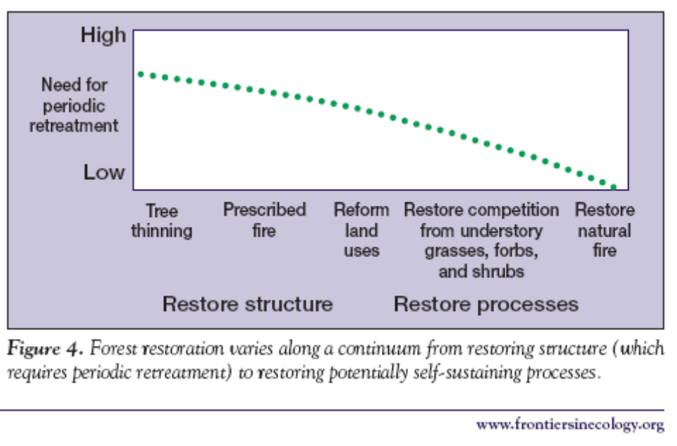
Reed F Noss, Jerry F Franklin, William L Baker, Tania Schoennagel, and Peter B Moyle. 2006. Managing fire-prone forests in the western United States. Front Ecol Environ 2006; 4(9): 481–487. http://spot.colorado.edu/~schoenna/images/Nossetal2006Frontiers.pdf. Crist, M.R., T.H. DeLuca, B. Wilmer, and G.H. Aplet. 2009 Restoration of Low-Elevation Dry Forests of the Northern Rocky Mountains: A Holistic Approach. Washington, D.C.: The Wilderness Society. http://fedgycc.org/documents/WldrnsSociety_Restoration-Low-Elev-Dry-Forests-Rocky-Mtns.pdf.
  - Use projects as an opportunity to conduct monitoring and research on the effects of thinning. There are many information gaps that need filling. Every project should generate useful information to inform future projects.
  - There are a lot of people calling for an increase in the “pace and scale” of restoration of eastside forests. The large size of recent projects raises concerns because the agency may run out of things to do. If the agency moves too fast, then the “restoration” task may be complete, but the agency will still have a timber target. If the agency proceeds at a more measured and sustainable pace, they can continue to harmonize restoration and timber goals for longer. This should be considered in the NEPA analysis.
  - Treated stands do not exist in isolation, so be sure to consider the effects of thinning on adjacent areas which may provide habitat for species of concern. Prepare a “risk map” based on proximity to different habitat types from high quality to non-habitat.
  - Only a small subset of needed restoration activities are “profitable,” so we can’t let logging economics determine restoration priorities. If we restore primarily those areas that have commercial-sized logs and fail to treat the thousands of acres of areas that need restoration but lack economic return, we will not be accomplishing real restoration which requires carefully and strategically choosing the subset of the landscape that can be treated to provide the greatest gain (both ecological and fire hazard reduction) for the least ecological “cost” in terms of soil, water, wildlife, carbon, and weeds. “Hoping to boost their economies and also restore these forests, local leaders are interested in the economic value of timber that might be available from thinning treatments on these lands. … [W]e found that on lands where active forestry is allowable, thinning of most densely stocked stands would not be economically viable.” Rainville, Robert; White, Rachel; Barbour, Jamie, tech. eds. 2008. Assessment of timber availability from forest restoration within the Blue Mountains of Oregon. Gen. Tech. Rep. PNW-GTR-752. Portland, OR: U.S. Department of Agriculture, Forest Service, Pacific Northwest Research Station. 65 p. http://www.fs.fed.us/pnw/pubs/pnw_gtr752.pdf. Allowing economics to drive these choices will result in greater ecological impacts and lower ecological gains. The NEPA analysis must honestly disclose what optimum restoration treatments would look like versus what is actually being proposed, so the public can see what’s being sacrificed.
  - Protect soil and water quality by avoiding ground-based logging and log hauling during the wet season.
  - Thinning should focus on areas accessible from existing roads. Building new roads will cause degradation that typically erases any alleged benefit of treatments. Inaccessible areas can be treated non-commercially or become part of the landscape mosaic that is untreated and serve important ecological values such as dense forest cover, carbon storage, and natural rates of snag recruitment.
  - Where road building is necessary, ensure that the realized restoration benefits far outweigh the adverse impacts of the road. Carefully consider the effects of roads on connectivity, especially at road/stream crossings, across ridge tops, and midslope hydrological processes (such as large wood delivery routes). The NEPA analysis should rank new road segments according to their relative costs (e.g. length, slope position, soil type, ease of rehabilitation, weed risk, native vegetation impacts, etc.) and benefits (e.g. acres of restoration facilitated), then use that ranking to consider dropping the roads with the lowest ratio of benefits to costs. Once the relative acres accessed per mile of road is determined, take the analysis one step further and determine the “effective road density” of each segment. In other words, extrapolate as if that much road were required to reach each acre of the planning area, then compare the resulting road density to RMP objectives for big game, fish conservation, cumulative hydrological impact, etc? For example, if a new spur road accesses thinning opportunities at a rate of 200 acres of forest per mile of road, then divide 640 acres per section by 200 acres per mile to determine the effective road density of 3.2 mi/mi².
  - Use the historic range of variability as a guide, but don’t just focus on seral stage. The NEPA description of historic “forest stand structure” is often generalized as stand initiation, stem exclusion, understory reinitiation, etc. These are not very good generalizations because after natural disturbance stand conditions would include abundant legacies that are created by natural disturbance and often persist for long periods after disturbance. However, these same terms are used to describe stand structures created by timber harvest that are NOT like natural stand structures, because logged stands lack the abundant legacy structures. The NEPA analysis should adjust the analytical methods to describe the historic abundance (and current shortage) of live and dead legacy structures. Restoring and maintaining legacies should be a major focus of restoration. Consider also the historic abundance of ecological attributes like large trees, large snags, the scale and distribution of patches of dense forest, low road density, roadless areas, etc., all of which have been severely reduced from historic norms. Also, consider the natural range of variability, which is the historic range of variability as modified by future climate change and fire suppression. James A. Harris, Richard J. Hobbs, Eric Higgs, and James Aronson. 2006. Ecological Restoration and Global Climate Change. Restoration Ecology Vol. 14, No. 2, pp. 170–176 JUNE 2006. http://www.globalrestorationnetwork.org/uploads/files/LiteratureAttachments/353_underlying-principles-of-restoration.pdf.
  - Develop restoration treatments appropriate to each forest type or plant association group (PAG). Dry Ponderosa pine forests that have significant ingrowth due to fire exclusion are good candidates for thinning. Mixed-conifer forest types often included some dense forest patches, so they should be retained at appropriate scales. Lodgepole pine and subalpine forests have stand replacing fire regimes and generally do not need to be thinned or regenerated.
  - Prioritize treating stands that are already degraded by past logging, and place less priority on treating previously unlogged forests. See Naficy, Cameron, Anna Sala, Eric G. Keeling, Jon Graham, and Thomas H. DeLuca. 2010. Interactive effects of historical logging and fire exclusion on ponderosa pine forest structure in the northern Rockies. Ecological Applications 20:1851-1864. http://rintintin.colorado.edu/~cana4848/papers/Naficy_et_al_2010_Ecol_App.pdf (“We document that fire-excluded ponderosa pine forests of the northern Rocky Mountains logged prior to 1960 have much higher average stand density, greater homogeneity of stand structure, more standing dead trees and increased abundance of fire-intolerant trees than paired fire-excluded, unlogged counterparts. Notably, the magnitude of the interactive effect of fire exclusion and historical logging substantially exceeds the effects of fire exclusion alone. These differences suggest that historically logged sites are more prone to severe wildfires and insect outbreaks than unlogged, fire-excluded forests and should be considered a high priority for fuels reduction treatments.”)
  - Recognize the value of untreated areas to provide benefits like dense forest cover, snags recruitment, soil/water quality, etc. Recognize that forests are naturally adaptive and natural processes will accomplish many of the benefits attributed to thinning. “Counter to many regional studies, our results indicated that treated and long-unaltered, untreated areas may be moving in a similar direction. Treated and untreated areas experienced declines in tree density, increases in the size of the average individual, and losses of surface fuels in most size classes. The number of large trees increased in untreated areas, but decreased in treated areas. Our results suggested that untreated areas may be naturally recovering from the large disturbances associated with resource extraction and development in the late 1800s, and that natural recovery processes, including self thinning, are taking hold. ... In a study of forest restoration need across eastern Washington and Oregon, over 25% of required restoration could be achieved through transition to later stages of forest stand development through successional processes as western landscapes recover from widespread historic degradation (Haugo et al., 2015).” Zachmann, L. J., D. W. Shaw, and B. G. Dickson. 2018. Prescribed fire and natural recovery produce similar long-term patterns of change in forest structure in the Lake Tahoe basin, California. Forest Ecology and Management 409:276–287. http://www.csp-inc.org/wp-content/uploads/2017/11/Zachmann_et_al_2017.pdf.
  - Some people describe dry forest thinning as "cutting trees that would likely not be there." But don't forget the biomass in those trees we are removing would likely have accumulated on other trees in the stand, (e.g., the idealized park like stand of low density very large trees) so thinning might get back to the right number of stems per acre but not the right amount of biomass per acre. Removing trees deprives the stand of live and dead biomass over the long term.
  - Prioritize treating dry forest types at low elevation and on south slopes. Treatments in forests with naturally mixed-severity fire regimes should be carefully scrutinized to ensure those areas (i) are in fact outside of the HRV, and (ii) treatment will not remove scarce habitat for focal species that depend on dense forests, and (iii) treatments are in fact needed and (iv) proposed treatments will be effective. Treatments in mixed severity fire regimes should be more patchy and leave behind more structure, more snags and large dead wood.
  - Removing large numbers of small trees and forest understory across large areas may not be consistent with historic forest conditions. New evidence indicates that small trees were more common in dry forests than previously recognized. Historically, more than 60% of trees in the Blue Mountains and eastern Cascades were “small” (<40 cm or <16” dbh). William L. Baker and Mark A. Williams. 2015. Bet-hedging dry-forest resilience to climate-change threats in the western USA based on historical forest structure. Front. Ecol. Evol., 13 January 2015 | doi: 10.3389/fevo.2014.00088. http://journal.frontiersin.org/Journal/10.3389/fevo.2014.00088/full
  - New evidence indicates that far more of the “dry” forests, rather than being typified low severity fire regimes, were in fact dominated by mixed severity fire regimes (including significant areas of stand replacing fire), so mixed severity fire is an important part of the historic range of variability that should be restored. The goal should not be a uniform low severity fire regime, but rather a wide mix of tree densities in patches of varying sizes. This objective can often be met by allowing natural fire regimes to operate, or by leaving significant areas untreated when planning fuel reduction projects. Hessburg, Paul. Evidence for the Extent of Mixed Severity Fires in Pre-Management Era Dry Forests of the Inland Northwest. Proceedings: Mixed Severity Fire Regimes: Ecology and Management. November 17–19, 2004. Spokane, Washington. http://web.archive.org/web/20100713232718/http://www.sustainablenorthwest.org/bmfp/hessburg__salter__james_paper_11.pdf; Baker, W.L., T.T. Veblen and R.L. Sherriff (2006). Fire, fuels, and restoration of ponderosa pine-Douglas-fir forests in the Rocky Mountains, USA. Journal of Biogeography. 2006. http://www.humboldt.edu/geography/documents/BakerEtAl_FireFuelsPipo_JBiog2007.pdf; Odion, D.C. et al 2014. Examining Historical and Current Mixed-Severity Fire Regimes in Ponderosa Pine and Mixed-Conifer Forests of Western North America. PLOS One. February 2014 | Volume 9 | Issue 2 http://www.californiachaparral.org/images/Odion_et_al_Historical_Current_Fire_Regimes_mixed_conifer_2014.pdf. (“We compiled landscape-scale evidence of historical fire severity patterns in the ponderosa pine and mixed-conifer forests from published literature sources and stand ages available from the Forest Inventory and Analysis program in the USA. The consensus from this evidence is that the traditional reference conditions of low-severity fire regimes are inaccurate for most forests of western North America. Instead, most forests appear to have been characterized by mixed-severity fire that included ecologically significant amounts of weather-driven, high-severity fire.”). William L. Baker 2017. Restoring and managing low-severity fire in dry-forest landscapes of the western USA. http://journals.plos.org/plosone/article?id=10.1371/journal.pone.0172288 (“Frequent fire (PMFI/FR < 25 years) was found across only about 14% of historical dry-forest area, with 86% having multidecadal rates of low-severity fire. Historical fuels (e.g., understory shrubs and small trees) could fully recover between multidecadal fires, allowing some denser forests and some ecosystem processes and wildlife habitat to be less limited by fire. Lower historical rates mean less restoration treatment is needed before beginning managed fire for resource benefits, where feasible.”)
  - “We have learned that forest thinning is rarely effective under extreme burning conditions, and the severity of fire in adjacent forests has little to do with whether a home burns," said Tania Schoennagel, who is affiliated with CU-Boulder's geography department. "Solely relying on public forest management to prevent homes burning by wildfire is simply barking up the wrong tree. We need more integrated solutions that cross the public-private land boundary to help us coexist with inevitable wildfire." CU Boulder Press Release, New global wildfire analysis indicates humans need to coexist and adapt. November 5, 2014. http://www.colorado.edu/news/releases/2014/11/05/new-global-wildfire-analysis-indicates-humans-need-coexist-and-adapt. And Coexist or perish, new wildfire analysis says (2014, November 5) retrieved 6 November 2014 http://phys.org/news/2014-11-coexist-perish-wildfire-analysis.html Fuel treatments in the WUI should be coupled with efforts to make communities fire resilient, not just to facilitate fire suppression. We urge the agency to bifurcate the landscape along the area defining the “structure ignition zone” within 100 feet of homes and built structures. Inside the structure ignition zone, vegetation treatments can focus on modifying fuels to protect infrastructure. Outside the structure ignition zone, treatments should focus on ecological restoration, where fuel hazard is but one consideration. Do not define the wildland urban interface too broadly, because fire hazard can be reduced by treating the area immediately adjacent to structures and this “structure ignition zone” is usually on non-federal lands. Fire is an important ecological process that needs to be restored on public lands, so the WUI fire problem should be framed as a structure-ignition problem and the solution for that generally lies with the private property owners. Joe H. Scott, Matthew P. Thompson, Julie W. Gilbertson-Day 2016. Examining alternative fuel management strategies and the relative contribution of National Forest System land to wildfire risk to adjacent homes – A pilot assessment on the Sierra National Forest, California, USA. Forest Ecology and Management 362 (2016) 29–37. http://www.fs.fed.us/rm/pubs_journals/2016/rmrs_2016_scott_j001.pdf (“A treatment scenario that focused on treating defensible space near homes was by far the most efficient at reducing WUI exposure, including exposure transmitted from USFS lands. … [T]he Defensible Space fuelscape was by far the most efficient at reducing home exposure. … In terms of feasible treatment scenarios, treating USFS land near where people live (Five-percent Solution) was not nearly as effective as treating the same amount of area where people live with a focus on land closest to the national forest (Defensible Space). … [T]he analysis suggests that mitigation of wildfire risk to homes through fuel treatment on some landscapes could be best accomplished by treating where the homes are, not on federal land further away. ”) Cohen 2008. The Wildland-Urban Interface Fire Problem – A Consequence Of The Fire Exclusion Paradigm. Forest History Today. Fall 2008. http://www.foresthistory.org/Publications/FHT/FHTFall2008/Cohen.pdf. Much more info here: http://www.fusee.org/community-fire-preparedness. See also, Gibbons P, van Bommel L, Gill AM, Cary GJ, Driscoll DA, et al. (2012) Land Management Practices Associated with House Loss in Wildfires. PLoS ONE 7(1): e29212. doi:10.1371/journal.pone.0029212. http://nature.berkeley.edu/moritzlab/docs/Gibbons_etal_2012_PLoS.pdf (“The typical response to destructive wildfires is to increase the total area of land that is fuel-reduced [10,13]. Our results instead indicate that a shift in emphasis from broad-scale fuel-reduction treatments to intensive fuel treatments close to houses will more effectively mitigate impacts from wildfires on houses. This result is consistent with observations that the density of airborne embers and amount of radiant heat (the principal causes of house loss during wildfires) are greatest closer to the fuel source. This suggests that the actions of private landholders, who manage fuel close to houses, are extremely important when reducing risks to houses posed by fuel.”). Alexandra D. Syphard, Teresa J. Brennan, and Jon E. Keeley. 2014. The role of defensible space for residential structure protection during wildfires. International Journal of Wildland Fire - http://dx.doi.org/10.1071/WF13158, https://d2k78bk4kdhbpr.cloudfront.net/media/publications/files/Syphard_defensibleSpace.pdf (“Structures were more likely to survive a fire with defensible space immediately adjacent to them. The most effective treatment distance varied between 5 and 20 m (16–58 ft) from the structure, but distances larger than 30 m (100 ft) did not provide additional protection, even for structures located on steep slopes. The most effective actions were reducing woody cover up to 40% immediately adjacent to structures and ensuring that vegetation does not overhang or touch the structure.”) The need for density reduction treatment in the immediate vicinity of homes complements WUI homeowners preferencs. See Factsheet: Forest Density Preferences of WUI Homebuyers. https://docs.wixstatic.com/ugd/5fc209_6f3c53750fb84fbfb6d86a40625f3d1f.pdf; and https://docs.wixstatic.com/ugd/5fc209_57cff23959e24668a1863dda2aa3b2b2.pdf (“In the more immediate forest surrounding WUI houses (100-meter (109-yard) radius level), WUI homebuyers have a preference for lower forest density. In the larger surrounding vicinity of WUI houses (500-meter (547-yard) radius level), higher forest density was preferred.”)
  - Prioritize treatment of the dense young stands that are most "plastic" and amenable to restoration. Another priority is to carefully plan and narrowly target treatments to protect specific groves of fire-resistant, old-growth trees that are threatened by ingrowth of small fuels, but don’t focus on rigid density reduction targets. Leave all medium and large trees that show old-growth characteristics.
  - Thin from below, retaining the largest trees, or use “free thinning” with a diameter cap so that some trees of all size classes are retained. Retain all large trees and most medium sized trees so they can recruit into the larger classes of trees and snags. In the face of uncertainty that is exacerbated by climate change, a bet-hedging strategy should retain trees of all sizes and stands of various densities. “Removal of most small trees to reduce wildfire risk may compromise the bet-hedging resilience, provided by small trees and diverse tree sizes and species, against a broad array of unpredictable future disturbances.” William L. Baker and Mark A. Williams. 2015. Bet-hedging dry-forest resilience to climate-change threats in the western USA based on historical forest structure. Front. Ecol. Evol., 13 January 2015 | doi: 10.3389/fevo.2014.00088. http://journal.frontiersin.org/Journal/10.3389/fevo.2014.00088/full
  - Identify and retain all trees with old-growth characteristics even if they are less than 21” dbh. Some refer to these small-old trees as "Tillebo trees" because the late Tim Lillebo was a big advocate for protection of old trees regardless of size. Old growth characteristics include thick bark, colored bark, flat top, asymmetric crown, broken top, forked top, relatively large branches, etc. These trees have important habitat value and human values regardless whether they are 21” dbh. Allow natural processes of succession and mortality to turn some of these medium and large trees into ecologically valuable snags and down wood. The agencies often use this technique to identify and retain old-growth juniper trees and the same can be used to protect old growth pine, larch, Douglas fir and other species. Van Pelt, R. 2008. Identifying Old Trees and Forests In Eastern Washington. Washington DNR. http://www.dnr.wa.gov/Publications/lm_hcp_east_old_growth_hires_part01.pdf. We are generally comfortable with the use of the Van Pelt guidelines to identify tree age, but as science improves, we urge the agency to use the best available information and err on the side of caution to ensure that trees older than 150 years (regardless of size) are not inadvertently cut. A recent study supports the retention of slow growing old trees because they are relatively more resilient. The study found that slower-growing older trees tend to channel their energy into structural support and defense compounds to “maximize durability while minimizing … damage”. Black, Colbert, & Pederson. 2008. Relationship between radial growth rates and lifespan within North American tree species. Ecoscience 15(3), 349-357 (2008). http://fate.nmfs.noaa.gov/documents/Publications/Black_et_al_2008_Ecoscience.pdf.. See also. Box 8 of Franklin, J.F., Johnson, K.N., et al 2013. Restoration of Dry Forests in Eastern Oregon – A Field Guide. The Nature Conservancy, Portland, OR. 202 pp. http://nature.ly/dryforests; and Tobias Züst, Bindu Joseph, Kentaro K. Shimizu, Daniel J. Kliebenstein and Lindsay A. Turnbull, Using knockout mutants to reveal the growth costs of defensive traits, in: Proceedings of the Royal Society B, 2011, Jan. 26, doi:10.1098/rspb.2010.2475. See also, University of Montana. June 18, 2019. Cell structure linked to longevity of slow-growing Ponderosa Pines. https://www.sciencedaily.com/releases/2019/06/190618174358.htm (“Slow-growing ponderosa pines may have a better chance of surviving longer than fast-growing ones, especially as climate change increases the frequency and intensity of drought, according to new research from the University of Montana. ... [A] key difference between fast and slow growers resides in a microscopic valve-like structure between the cells that transport water in the wood, called the pit membrane. The unique shape of this valve in slow-growing trees provides greater safety against drought, but it slows down water transport, limiting growth rate.”) citing Beth Roskilly, Eric Keeling, Sharon Hood, Arnaud Giuggiola, Anna Sala. Conflicting functional effects of xylem pit structure relate to the growth-longevity trade-off in a conifer species. Proceedings of the National Academy of Sciences, 2019; 201900734 DOI: 10.1073/pnas.1900734116.
  - Use diameter limits as a management tool because it provides a useful means to prevent economic values from trumping ecological values. The public supports the use of diameter limits because it provides a means to prevent economic values from trumping ecological values. It is often appropriate to use smaller diameter limits for fire tolerant species like Ponderosa pine and Douglas fir, while using somewhat larger limits for fire intolerant species like grand fir/white fir. The exceptional circumstances in which diameter limits allegedly don’t work, are more rare than the circumstances in which refusing to use diameter limits will lead to unintended consequences, including removal of ecologically valuable trees and lack of public trust.
  - While the agency embarks on an ambitious effort to reduce fuels and reduce forest density, the agency must also conserve habitat for diverse wildlife that depend on dense forest canopy cover, complex understories, and dead wood. Carbon storage and watershed values are also enhanced when forest cover is maintained. We urge the agency to carefully consider whether there is enough habitat provided for these species, including goshawk, marten, fisher, and pileated woodpecker. The current distribution of recognized and protected habitat areas may be inadequate, especially considering the need for redundancy to account for expected habitat loss from fire, logging, fuel reduction, and natural forest succession. The fact that big game cover requirements need to be amended to accommodate many projects like this raises concerns not just for big game, but for the wide variety of other species that depend on canopy cover, complex understory, and dead wood. Before conducting large-scale density reduction efforts or amending big game cover standards, the agency should carefully consider all the other wildlife that were intended to be sheltered by the "umbrella" of big game cover standards in the RMP. The cover and forage requirements of big game is another lens through which to think about optimizing the mix of treated and untreated stands, as well as the scale and extent of skips and heavily-thinned “gaps” within treated stands. The NEPA analysis should consider alternatives with different mixes of treated and untreated areas for this purpose. The agency should use a state-and-transition model to project future dense forest habitat recruitment under a reasonable set of assumptions about disturbance and succession.
  - Recognize that thinning affects fire hazard in complex ways, including some tendencies to make fire hazard worse. The agency must address the fact that thinning creates slash; moves fine fuels from the canopy to the ground (increasing their availability for combustion); thinning increases ignition risk (by increasing human access and human activities, including spark-generating machinery); thinning makes the forest hotter-drier-windier; and makes site resources available to stimulate the growth of future surface and ladder fuels. Amy E.M. Waltz, Peter Z. Fulé, W. Wallace Covington, and Margaret M. Moore. 2003. Diversity in Ponderosa Pine Forest Structure Following Ecological Restoration Treatments. Forest Science 49(6) 2003. http://www.globalrestorationnetwork.org/uploads/files/LiteratureAttachments/91_diversity-in-ponderosa-pine-forest-structure-following-ecological-restoration-treatments.pdf (Kaufmann M.R., G.H. Aplet, M. Babler, W.L. Baker, B. Bentz, M. Harrington, B.C. Hawkes, L. Stroh Huckaby, M.J. Jenkins, D.M. Kashian, R.E. Keane, D. Kulakowski, C. McHugh, J. Negron, J. Popp, W.H. Romme, T. Schoennagel, W. Shepperd, F.W. Smith, E. Kennedy Sutherland, D. Tinker, and T.T. Veblen. 2008. The status of our scientific understanding of lodgepole pine and mountain pine beetles – a focus on forest ecology and fire behavior. The Nature Conservancy, Arlington, VA. GFI technical report 2008-2. http://csfs.colostate.edu/pdfs/LPP_scientific-LS-www.pdf. A meta-analysi of the effects of partial cutting showed that understory growth was stimulated in all cases. D. Zhou, S. Q. Zhao, S. Liu, and J. Oeding. 2013. A meta-analysis on the impacts of partial cutting on forest structure and carbon storage. Biogeosciences, 10, 3691–3703, 2013. https://www.biogeosciences.net/10/3691/2013/bg-10-3691-2013.pdf. (“Understory C was stimulated significantly by partial cutting in all of the studies. This stimulation can be mostly attributed to an increase in the availability of light, water, and nutrients to the understory because of tree removal (Aussenac, 2000; Kleintjes et al., 2004; Deal, 2007)”). Fuel reduction must find the “sweet spot,” by removing enough of the small surface and ladder fuels while retaining enough of the medium and large trees to maintain canopy cover for purposes of microclimate, habitat, hydrology, suppression of ingrowth, etc. The agency should consider alternative canopy treatments that are small and patchy, instead of extensive and continuous. Selective pruning of lower branches should also be considered as a viable canopy treatment.
  - Not all ladder fuels are hazardous. Studies after the Biscuit fire showed that “Mid-story hardwoods dampened fire and reduced mortality of dominant conifers—consider leaving them when thinning. … Why did controls burn less intensely than thinned stands as predicted by fire models? Evidence to consider: … * Controls retained mid-story hardwoods (madrone, tanoak, chinkapin) and they did not act as fuel ladder as predicted, and rather appeared to dampen the fire (much lower char heights). * Still much to be learned about fire behavior.” Bernard Bormann 2009. From B&B to Biscuit: What We Have Learned from Recent Westside Dry Forest Fires, from Workshop: Restoring Westside Dry Forests - Planning and Analysis for Restoring Westside Cascade Dry Forest Ecosystems: A focus on Systems Dominated by Douglas-fir, Ponderosa Pine, Incense Cedar, and so on. May 28, 2009. http://ecoshare.info/projects/central-cascade-adaptive-management-partnership/workshops/restoring-westside-dry-forests/
  - Fire-regime condition-class may not be an accurate predictor of fire hazard, because it assumes incorrectly that time-since-fire is an accurate indicator of fire hazard. There is compelling evidence that time-since-fire has exactly the opposite of the assumed effect, that is, fires may burn more severely in early seral vegetation, and burn less severely in closed canopy forests. This may be related to the fact that closed canopy forests maintain a cool-moist microclimate that helps retain higher fuel moisture and more favorable fire behavior. Odion, D.C., E.J. Frost, J.R. Strittholt, H. Jiang, D.A. DellaSala and M.A. Moritz. 2004. Patterns of fire severity and forest conditions in the western Klamath Mountains, California. Conservation Biology 18(4): 927-936. http://nature.berkeley.edu/moritzlab/docs/Odion_etal_2004.pdf. Canopy cover also helps suppress the growth of ladder fuels. The practical significance of this is that thinning projects should retain more canopy variability across the stand, and need not focus on treatment of canopy fuels except to provide some well-distributed “escape hatches” for hot gases generated by surface fires. Credible models of post-thinning fire behavior, must account for both fuel structure and microclimate effects of thinning.
  - There is growing evidence that in order to be effective, mechanical treatments must be followed by prescribed fire. But the effects of such fires must also be carefully considered. Fuel treatments without regular follow-up treatments might be worse than doing nothing at all because thinning can be expected to stimulate the growth of future surface and ladder fuels. Crystal L. Raymond. 2004. The Effects of Fuel Treatments on Fire Severity in a Mixed-Evergreen Forest of Southwestern Oregon. MS Thesis. http://depts.washington.edu/nwfire/publication/Raymond_2004.pdf ; Jonathan R. Thompson, Thomas A. Spies 2009. Vegetation and weather explain variation in crown damage within a large mixed-severity wildfire. Forest Ecology and Management 258 (2009) 1684–1694. Therefore retain plenty of canopy cover to suppress the growth of those future fuels and as insurance against the very real possibility that follow-up fuel treatments may not be adequately funded and implemented.
  - Don’t thin to uniform spacing. Use variable density thinning techniques to establish a variety of microhabitats, break up fuel continuity, create discontinuities to disrupt the spread of other contagious disturbances such as disease, bugs, weeds, fire, etc. Retain patchy clumps of trees which is the natural pattern for many species.
  - Be creative in establishing diversity and complexity both within and between stands. “Patchy, gappy, and clumpy” is often use to describe the distribution of trees in dry forests. Use skips and gaps within units to help achieve diversity. Gaps should be small, while skips should be a little larger. Landings do not make good gaps because they are clearcut, highly compacted and disturbed, more likely subject to repeated disturbance, and directly associated with roads. Gaps should be located away from roads and should not be clearcut but rather should retain some residual structure in the form of live or dead trees. Methods of implementing spatial variability in restoration treatments are described by Churchill, D.J., M.C. Dalhgreen, A.J. Larson, and J.F. Franklin. 2013. The ICO approach to restoring spatial pattern in dry forests: Implementation guide. Version 1.0. Stewardship Forestry, Vashon, Washington, USA. http://www.cfc.umt.edu/ForestEcology/files/ICO_Manager_Guide.pdf and Derek J. Churchill, Andrew J. Larson, Matthew C. Dahlgreen, Jerry F. Franklin, Paul F. Hessburg, and James A. Lutz. 2013. Restoring forest resilience: From reference spatial patterns to silvicultural prescriptions and monitoring. Forest Ecology and Management 291 (2013) 442–457. http://www.fs.usda.gov/Internet/FSE_DOCUMENTS/stelprdb5428873.pdf
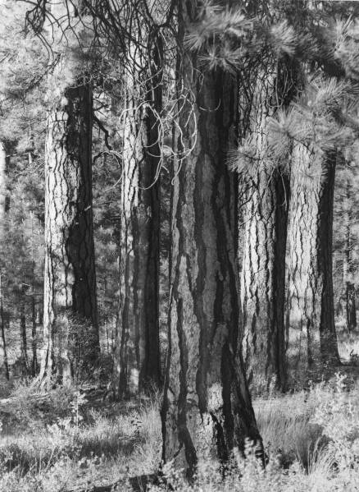
Figure 1. An example of naturally clumped large pines.
A historical reconstruction of forests in the Blue Mountains of Oregon, showed that more than 2/3 of plots had large clumps of between 10-30 trees and 50-90% of individual trees were within 6 meters of other trees (i.e., few were isolated individuals). Churchill, Derek J.; Carnwath, Gunnar C.; Larson, Andrew J.; Jeronimo, Sean A. 2017. Historical forest structure, composition, and spatial pattern in dry conifer forests of the western Blue Mountains, Oregon. Gen. Tech. Rep. PNWGTR-956. Portland, OR: U.S. Department of Agriculture, Forest Service, Pacific Northwest Research Station. 93 p. https://www.fs.fed.us/pnw/pubs/pnw_gtr956.pdf.
  - Thin heavy enough to stimulate development of some patches of understory vegetation, but don’t thin so heavy that future development of a uniform understory of ladder fuels becomes a more significant problem than the one being addressed by the current project. 15-20 years after thinning and prescribed fire, the Umpqua NF found “considerable development of less fire tolerant understory vegetation …. Continued stand development … will result in increased understory density and fuel laddering into the dominant fire tolerant overstory…” Umqua NF, Diamond Lake RD, Lemolo Pine Health Maintenance Burn Project, June 1, 2010 scoping notice.
  - The scale of patches in variable density thinning regimes is important. Ideally variability should be implemented at numerous scales ranging from small to large, including: the scale of tree fall events; pockets of variably contagious disturbance from insects, disease, and mixed-severity fire; soil-property heterogeneity; topographic discontinuities; the imprint of natural historical events; etc.
  - Retain and protect under-represented species of conifer and non-conifer trees and shrubs. Retain patches of dense young stands as wildlife cover and pools for recruitment of future forests.
  - View native insects and disease in an ecological context. They are part of the natural processes that diversify and enrich our forests. They are best viewed as solutions, rather than problems. In particular, mistletoe brooms and seeds (and the large trees that mistletoe often live on) provide many ecological benefits, and treatment efforts are typically ineffective. So mistletoe, insect, and disease treatments have many costs and few benefits.
  - Recognize that thinning captures mortality and that most stands (especially plantations) are already lacking critical values from dead wood due to the unnatural stand history of logging, planting, and disrupted natural processes. To inform the decision, please conduct a stand simulation model showing that long term snag recruitment (after logging) will still meet DecAID 50-80% tolerance levels.
  - We are concerned that the agencies’ stocking guides were created and intended to be used as a tool to avoid mortality which is clearly inconsistent with ecosystem management. (“To preclude serious tree mortality from mountain pine beetle, western dwarf mistletoe and perhaps western pine beetle, stand densities should be maintained below the upper limit of the management zone” Powell 1999, https://fs.usda.gov/Internet/FSE_DOCUMENTS/fsbdev7_016034.pdf) Healthy forests require dead trees, sometimes in abundance, in order to meet the needs of diverse wildlife and provide full suite of ecosystem functions. A comprehensive restoration approach requires focusing not just on live trees, but also on the full suite of ecological processes including density dependent mortality processes that create and recruit snags and dead trees as a valuable feature of eastside forests. We urge the agency not to manage for tree vigor and minimum stocking levels because it will not provide enough green trees for recruitment of snags through time. This is a critical issue given that the current standards for snag habitat are outdated and fail to provide adequate levels of snags and dead wood, and adequate levels of green trees needed to recruit those snags through time.
  - Retain abundant snags and course wood and green trees for future recruitment of snags and wood. Retention should be both distributed and in clumps so that thinning mimics natural disturbance. Retention of dead wood should generally be proportional to the intensity of the thinning, e.g., heavy thinning should leave behind more snags not less. Retain wildlife trees such as hollows, forked tops, broken tops, leaning trees, etc. Think not only about existing snags but more importantly about the processes the recruit snags, including: a large pool of green trees from which to recruit snags and the existence of competition and other mortality processes. Logging will significantly harm both of these snag recruitment factors. Recognize that thinning captures mortality. To inform the NEPA decision, please conduct a stand simulation model to fully disclose the adverse effects of logging on dead wood, especially long-term recruitment of large snags >20” dbh, and then mitigate for these adverse effects by identifying areas within treated stands and across the landscape that will remain permanently untreated so they can recruit adequate large snags and dead wood to meet DecAID 50-80% tolerance levels as soon as possible and over the long-term.
  - If using techniques such as whole-tree yarding or yarding with tops attached to control fuels, the agency should top a portion of the trees and leave the greens in the forest in order to retain nutrients on site. Achat, Deleuze, et al 2015. Quantifying consequences of removing harvesting residues on forest soils and tree growth – A meta-analysis. Forest Ecology and Management Volume 348, 15 July 2015, Pages 124–141. http://www.sciencedirect.com/science/article/pii/S0378112715001814 (“Our study showed that, compared with conventional stem-only harvest, removing the stem plus the harvesting residues generally increases nutrient outputs thereby leading to reduced amounts of total and available nutrients in soils and soil acidification, particularly when foliage is harvested along with the branches. … Soil fertility losses were shown to have consequences for the subsequent forest ecosystem: tree growth was reduced by 3-7% in the short or medium term (up to 33 years after harvest) in the most intensive harvests (e.g. when branches are exported with foliage). Combining all the results showed that, overall, whole-tree harvesting has negative impacts on soil properties and trees that may have an impact on the functioning of forest ecosystems.”)
  - Thinning creates activity fuels that can be treated (or not treated) in a variety of ways. Strive to treat fuels in ways that provide public benefits such as wildlife habitat (e.g., complex woody structure) and charcoal production (e.g., enhanced soil carbon storage), and reduce detrimental soil impacts from maching piling and hot burn piles. Deborah S. Page-Dumroese et al. 2017. Methods to Reduce Forest Residue Volume after Timber Harvesting and Produce Black Carbon. Scientifica. Volume 2017 (2017), Article ID 2745764, https://doi.org/10.1155/2017/2745764; https://www.hindawi.com/journals/scientifica/2017/2745764/
  - Avoid impacts to raptor nests and enhance habitat for diverse prey species. Train marking crews and cutting crews to look up and avoid cutting trees with nests of any sort and trees with defects.
  - Take proactive steps to avoid the spread of weeds. Avoid and minimize soil disturbance. Retain canopy cover and native ground cover to suppress weeds.
  - Buffer streams from the effects of heavy equipment and loss of bank trees and trees that shade streams. Mitigate for the loss of LWD input by retaining extra snags and wood in riparian areas. Recognize that thinning captures mortality that is not necessarily compensated by future growth.
  - Protect soils by avoiding road construction, minimizing ground-based logging, and avoiding numerous large burn piles. Mitigate the adverse soil impacts from burn piles by inoculating affected sites after burning (with living soil and native plant seeds, Julie E. Korb, Nancy C. Johnson, and W. W. Covington. 2004. Slash Pile Burning Effects on Soil Biotic and Chemical Properties and Plant Establishment: Recommendations for Amelioration. Restoration Ecology Vol. 12 No. 1, pp. 52-62 March 2004). Where road building is deemed necessary, ensure that the realized restoration benefits far outweigh the adverse impacts of the road, build the roads to the absolute minimum standard necessary to accomplish the job, and remove the road as soon as possible to avoid firewood theft, OHV trespass, and certainly before the next rainy season to avoid stormwater pollution. Do not allow log hauling during the wet season.
  - Adopt a purpose and need (and develop NEPA alternatives) that maintains and increases carbon storage in forest ecosystems. There is a carbon cost associated with thinning that must be disclosed and considered. As stands develop from young to mature to old, they continuously recruit carbon-rich material from the live tree pool to the dead wood pool. Some of that wood gets incorporated into the soil or falls in fire refugia where it can accumulate. Logging, even thinning, can dramatically affect the accumulation of carbon in the dead wood pool by capturing mortality, diverting it from the forest, and accelerating the transfer of carbon to the atmosphere. Carbon stays out of the atmosphere much longer if it remains in the forest as live and/or dead trees, instead of being converted to wood products and industrial and consumer waste.
  - If this project involves biomass utilization, the impacts need to be clearly disclosed. How will the biomass be moved from the remote corners of the treatment areas to the landings? Will there be extra passes made by heavy equipment? Will the landings be enlarged to make room for grinders, chip vans, and other equipment? Can the local forest roads accommodate chip vans? Will the roads be modified to make them passable by chip vans? What are the impacts of that? What are the direct, indirect, and cumulative impacts on soil, water, wildlife, and weeds?
  - Provide clear and detailed rationale that connects proposed actions to desired conditions. Test the rationale for actions and effects analysis against the scientific evidence, including the full range of evidence, reasonable opposing viewpoints, and the evidence presented in these comments. For each treatment unit, provide clear descriptions of silvicultural prescriptions and marking guides in the NEPA document.
  - Recognize that federal fuel reduction efforts likely have adverse unintended effects on human behavior and land use and fire hazard. “This project has explored the hypothesis that public fire suppression in fire-prone areas acts as a subsidy to landowners, incentivizing conversion of land to residential and commercial development. Landowners do not bear the full cost of their choice to build on land in fire-prone areas, since they do not pay for suppression, though they reap all of the benefits, potentially resulting in economically inefficient levels of development. … Results suggest that when federal suppression efforts intensify on public lands, private development accelerates nearby. The main paper produced by the funded research thus shows that public investment in reducing the damages from fire in the short run causes unintended long-run behavioral responses, which may increase future hazard exposure.” Sheila Olmstead (PI), Carolyn Kousky (co-PI), Roger Sedjo (co-PI) 2013. Final Report to the Joint Fire Science Program Wildland Fire Suppression and Land Development in the Wildland/Urban Interface. http://www.firescience.gov/projects/10-3-01-33/project/10-3-01-33_final_report.pdf. Rasker, R. 2016. Why do we keep putting people in the way of wildfire? The wrong carrots and sticks. LA Times Op-Ed. http://www.latimes.com/opinion/op-ed/la-oe-rasker-wildfire-preparation-incentives-20160901-snap-story.html. (“Wildfire presents a classic case of a moral hazard, which is what occurs when someone takes a risk knowing someone else will bear a great deal of the cost if things go wrong. Typically, the wildfire version plays out in the West like this: Local governments, eager to reap increased property taxes, willingly approve new home construction, even on or near the most flammable of lands. When fire comes, federal and state agencies send in crews and air tankers to defend private homes. Most of the cost is borne by taxpayers… [T]he hard and unpleasant reality is that we will never solve the wildfire problem unless local governments are forced to bear a higher proportion of the firefighting costs. Keeping more of the costs local would create a strong incentive for continually improving land-use planning and other wildfire preparation policies. It may also provide elected officials the political cover they need to require stricter fire-safe standards for existing as well as new developments because it would make land-use planning a fiscal necessity.”)
  - Acknowledge and consider the following potentially significant issues in the NEPA analysis:
- Removing commercial sized logs, and associated roads and slash disposal, often conflicts with other resource values such as soil, water, weeds, wildlife habitat, fire hazard, and carbon storage;
- Removal of commercial sized logs can make the stand hotter, drier, and windier, making fire hazard worse instead of better;
- Commercial logging tends to present significant risks of weed infestations because of soil disturbance and canopy reduction;
- Removal of commercial logs necessitates road related impacts on soil and water resources. Machine piling and pile burning tend to cause significant adverse impacts on soil and water, especially when combined with road impacts and other logging disturbances.
- “Capturing mortality” reduces future snag habitat that is already deficient. Increasing vigor via thinning delays recruitment of snag habitat that is already deficient;
- The unavoidable adverse impacts of logging and roads must be balanced against the rather uncertain benefits of fuel reduction. Fuel reduction has little or no beneficial effect on low severity fires (controlled by favorable weather conditions) or on high severity fires (controlled by unfavorable weather conditions). There is actually a very low probability that moderate intensity fire will affect any given stand during the relatively brief time period that fuel hazard is alleged to be reduced. Please disclose the realistic probability that desired outcomes will occur based on (1) whether fire is likely to occur when the fuel treatments are likely to be effective, and (2) if fire does occur, whether there will be a good match between (A) the actual forest type and fuel treatment type, and (B) the actual probability of favorable weather conditions and fire conditions for that forest type and treatment type. Depending on these variables, fuel treatments may have little influence on both low intensity fire and extreme high intensity fire, leaving only a small subset of well-matched fuel treatments and fires, and a low probability that the proposed treatments will have ecological benefit s that exceed ecological impacts.
- The effects of forest health thinning are very complex with many feedback loops. There is still a fair amount of scientific uncertainty about several critical factors relevant to a decision about fuel reduction, including: (A) uncertain rates of tree mortality and how many young trees need to be retained to ensure proper recruitment of future stands of old trees and large snags; (B) uncertainty about how much the canopy can be reduced without making the stand hotter, drier, and windier (and exacerbating fire hazard); (C) uncertainty whether logging has any significant beneficial effect on controlling insects and diseases like mistletoe.
- The agency must test the assumption that fire (and insect) risk reduction is compatible with ecological restoration objectives. This test must be spatial, probabilistic, and use reasonable assumptions about weather, fire frequency, fire suppression, and historic conditions in areas with variable-severity fire regimes. Sensitivity analysis should test the robustness of assumptions and conclusions. Example analyses can be found in the literature, e.g. Rutherford V. Platt, Thomas T. Veblen, and Rosemary L. Sherriff. 2006. Are Wildfire Mitigation and Restoration of Historic Forest Structure Compatible? A Spatial Modeling Assessment. Annals of the Association of American Geographers, 96(3), 2006, pp. 455–470. http://www.colorado.edu/geography/class_homepages/geog_4430_f10/Platt%20et%20al_Wildfire%20Mitigatnion_AnAAG_2006.PDF , and R. V. Platt, T. T. Veblen, and R. L. Sherriff. 2008. Spatial Model of Forest Management Strategies and Outcomes in the Wildland–Urban Interface Natural Hazards Review, Vol. 9, No. 4, November 1, 2008. DOI:10.1061/(ASCE)1527-6988(2008)9:4(199) http://public.gettysburg.edu/~rplatt/Platt%20et%20al._NatHazReview08.pdf (“The results point toward several ways to guide current management practices in the study area. First, prioritizing land at the lowest elevations leads to the selection of the most land where both wildfire mitigation and restoration of historical forest conditions are needed. When thinning is restricted to Forest Service land, less land is selected where both goals are needed under all parameter scenarios. This is because Forest Service land tends to be at higher elevations and comprises forest types that are within the HRV. … Prioritizing the stands with the highest canopy cover decreases the percentage of selected land where both outcomes are needed…. Many of the stands where restoration of historical forest conditions is needed are open canopy and located on south facing slopes and at lower elevations. In contrast, many closed canopy stands are often located at higher elevations and on north-facing slopes where restoration of historical forest conditions is not needed.”)
- Focus the analysis on “trade-offs” related to logging. All logging, including thinning, includes some adverse impacts and trade-offs. Some impacts of logging are unavoidable, so there is no such thing as a logging operation that is 100% beneficial. Depending on how thinning is done, it can have adverse impacts such as soil disturbance, habitat disturbance, carbon removal, spreading weeds, reduced recruitment of snags; road-related impacts on soil, water, site productivity, and habitat; moving fuels from the canopy to the ground, hotter-drier-windier microclimate that is favorable to greater flame lengths and rate of fire spread, etc. Some of these negative effects are fundamentally unavoidable, therefore all thinning has negative effects that must be compensated by beneficial effects such as reducing competition between trees so that some can grow larger faster, increased resistance drought stress and insects, possible increasing species and structural diversity, possible fire hazard reduction, etc. The NEPA analysis should elucidate and weigh these trade-offs and attempt to display net ecological effects.

Unresolved questions about forest restoration may require an EIS.

Forest restoration is still a work-in-progress and the agencies need to approach every project as an opportunity to learn and improve practices and ensure achievement of restoration objectives. It is important to recognize that logging has complex effects some of which might be considered restorative and some detrimental to ecological values, so all the effects (both beneficial and adverse) must be carefully described and weighed. Over-simplification of the complexities of forest restoration treatments can lead to unintended consequences. NEPA’s mandates for full-disclosure and informed-decision-making require that these unintended consequences be daylighted and avoided as much as possible.

“[F]uel-reduction activities may have undesirable environmental effects (e.g., the need for periodic treatments, introduction of weeds, soil disturbance, or maintenance of some roads).” Spies, Thomas A.; Hemstrom, Miles A.; Youngblood, Andrew; Hummel, Susan. 2006. Conserving old-growth forest diversity in disturbance-prone landscapes. Conservation Biology. 20(2): 351-362. http://www.fs.fed.us/pnw/pubs/journals/pnw_2006_spies001.pdf.

The NEPA analysis should address the following unresolved questions that seem to come up again and again, especially when considering so-called “dry” forests:
- Sharon Friedman questions several assumptions about historic range of variability and restoration of fire regimes:
(1) The idea that there is one past “historic fire regime” for millennia conceivably there were glaciers and warm periods, cool periods, and so on. Then there were humans* actively engaged, strangely absent from this narrative. Unless we know for sure that they were not burning forests.
(2) Then there is an idea that “ecosystems are adapted” . Adaptation is something that we usually consider to be a property of species. Exactly what is an “ecosystem” in this context, and how does it “adapt” since ” an ecosystem” is an idea about real physical things, and not a thing in itself?
(3) That you need to reenact the past for things to be OK ...
Sharon Friedman 4-30-2019 commenting on The Missing (PNW) Fires at The Smokey Wire blog. http://forestpolicypub.com/2019/04/30/the-missing-pnw-fires/#comment-453153
- Firescience.Gov reported the management implications of Martinson & Omi (2013): “Until residual activity fuels are disposed, they largely offset much of the hazard reduction benefit achieved from opening the canopy. While follow-up slash treatment may be generally intended, untreated slash seems to be encountered by large wildfires with surprising frequency.” Firescience.Gov News. Fuel Treatments and Fire Severity: A Meta-Analysis. Issue 58 | June 7, 2013. http://us2.campaign-archive1.com/?u=5f6de7b069a57255f980944b4&id=97915ceb5e&e=47edde4b58 citing Martinson, E.J.; Omi, P.N. 2013. Fuel treatments and fire severity: A meta-analysis. Res. Pap. RMRS-RP-103WWW. Fort Collins, CO: U.S. Department of Agriculture, Forest Service, Rocky Mountain Research Station. 35 pp https://www.firescience.gov/projects/08-2-1-09/project/08-2-1-09_RMRS-RP-103WWW.pdf. Martison & Omi (2013) make the point that treatments are only effective for a short-time (5-15 years) and will require periodic retreatment, essentially in perpetuity. This raises a serious conundrum. If the initial fuel treatment in a stand is funded by removal of “excess” small trees, follow-up treatments are either (a) unlikely to occur because there are no more excess trees to pay for them, or (b) if follow-up treatments are funded with more tree-removals, such treatments will be removing ever more ecologically valuable trees and undermining any ecological benefit of the initial treatment. From an ecological perspective, the "excess" trees were removed in the first treatment. After that, all the trees belong and need to be retained so they can grow large and old in order to rebuild the severely depleted population of old growth.
- There is a critical need to consider the trade-offs and cumulative effects of a fuel treatment program. Another important point that ties together several of the findings of Martinson & Omi (2013) (above):
- Treating fuels in individual stands is unlikely to be effective in altering landscape fire behavior because stand-scale treatments are unlikely to encounter fire during the relatively brief period that treatments is "effective;"
- In order to increase the probability that treatments will encounter fire and actually modify fire behavior, treatments must be implemented across the landscape;
- The cumulative effects of landscape-scale treatments (plus the REQUIRED follow-up treatments) comes with significant trade-offs in terms of water quality, wildlife habitat, carbon, roads, soil, weeds, cost, etc.
Any attempt to reduce fuels should address these cumulative effects and unresolved trade-offs.
- Removing the understory across large areas may not be consistent with historic forest conditions. New evidence indicates that small trees were more common in dry forests than previously recognized. Historically, more than 60% of trees in the Blue Mountains and eastern Cascades were “small” (<40 cm or <16” dbh). William L. Baker and Mark A. Williams. 2015. Bet-hedging dry-forest resilience to climate-change threats in the western USA based on historical forest structure. Front. Ecol. Evol., 13 January 2015 | doi: 10.3389/fevo.2014.00088. http://journal.frontiersin.org/Journal/10.3389/fevo.2014.00088/full
- How can we balance the need to thin overly dense forests in order to grow more big trees and the need to provide habitat for species that depend on dead wood and dense canopy cover? This is a particular concern in terms of species associated with dead wood and those associated with complex riparian areas. There is evidence that capturing mortality has adverse consequences for these species that have not been fully integrated into our management approaches. Some might argue that our forests are suffering more from a lack of management, but we would strenuously argue that our forests are still more threatened by too much of the wrong forms of management, past, present and future (roading, logging, grazing, mining, fire suppression) and there is still too little recognition of this.
- How can we balance the competing effects of canopy removal that both reduces fire hazard by reducing canopy bulk density and increases fire hazard by making the stand hotter, drier, and windier? Canopy reduction has competing effects on fuels and microclimate that need to be more carefully examined. Recognizing that “The fire environment is thus an integration of the effects of all of its components” (Countryman 1972) the agencies lack a comprehensive model that integrates the effects of logging on both fuel structure (rearranging fuels, moving the canopy to the ground) and microclimate (making the stand hotter, drier, windier). “The evaluation of biomass removal alternatives on fire potential is complex and many-faceted. … Treatments can alter many aspects of a stand and thus of fire potential. … In fact, fuels and fire potential change dynamically and continuously— and not always consistently. The relative success of treatments in reducing fire potential may change as stands and fuels develop. … In the long run, opening a stand and removing biomass alters stand dynamics and fuel dynamics. Effects on potential fire behavior may vary with time since treatment …” Reinhardt, Elizabeth D.; Holsinger, Lisa; Keane, Robert 2010. Effects of biomass removal treatments on stand-level fire characteristics in major forest types of the northern Rocky Mountains. Western Journal of Applied Forestry. 25(1): 34-41. http://www.fs.fed.us/rm/pubs_other/rmrs_2010_reinhardt_e001.pdf.
- How do we integrate and balance terrestrial and aquatic restoration objectives which can sometime be in conflict. Terrestrial restoration often involve manipulation of vegetation, while aquatic restoration more often benefits from minimal anthropogenic ground disturbance. Terrestrial restoration often requires road systems which are almost universally harmful to aquatic systems.
- Is fire-regime condition-class (FRCC) a sound basis for describing and prioritizing fuel treatments. FRCC is a widely used tool which assumes that “time since fire” is an accurate indicator of fire hazard, but there is conflicting evidence showing that closed canopy forests that develop in the absence of fire can help suppress the growth of surface and ladder fuels and maintain a cool, moist microclimate that helps reduce fire hazard. Dense canopy cover might actually help suppress fire rather than spread it. See Odion, D.C., E.J. Frost, J.R. Strittholt, H. Jiang, D.A. DellaSala and M.A. Moritz. 2004. Patterns of fire severity and forest conditions in the western Klamath Mountains, California. Conservation Biology 18(4): 927-936. http://nature.berkeley.edu/moritzlab/docs/Odion_etal_2004.pdf.
- How much dead wood habitat should we be leaving, and how do we ensure that enough is provided through time? The current forest plan standards for snag-associated wildlife (based on “biological potential”) are scientifically outdated and need to be updated. DecAID is a start, but it has its own limitations and DecAID has not been officially adopted as a management standard with appropriate tolerance levels clearly specified for each land allocation. See
- Franklin, J.F., Lindenmayer, D., MacMahon, J.A., McKee, A., Magnuson, J., Perry, D.A., Waide, R., and Foster, D. 2000. Threads of Continuity. Conservation Biology in Practice. [Malden, MA] Blackwell Science, Inc. 1(1) pp9-16. https://andrewsforest.oregonstate.edu/sites/default/files/lter/pubs/pdf/pub2815.pdf.
- William F. Laudenslayer, Jr., Patrick J. Shea, Bradley E. Valentine, C. Phillip Weatherspoon, and Thomas E. Lisle Technical Coordinators. Proceedings of the Symposium on the Ecology and Management of Dead Wood in Western Forests. PSW-GTR-181. http://www.fs.fed.us/psw/publications/documents/gtr-181/.
- Lofroth, Eric. 1998. The dead wood cycle. In: Conservation biology principles for forested landscapes. Edited by J. Voller and S. Harrison. UBC Press, Vancouver, B.C. pp. 185-214. 243 p. http://www.for.gov.bc.ca/hre/deadwood/DTrol.htm.
- Rose, C.L., Marcot, B.G., Mellen, T.K., Ohmann, J.L., Waddell, K.L., Lindely, D.L., and B. Schrieber. 2001. Decaying Wood in Pacific Northwest Forests: Concepts and Tools for Habitat Management, Chapter 24 in Wildlife-Habitat Relationships in Oregon and Washington (Johnson, D. H. and T. A. O'Neil. OSU Press. 2001) http://web.archive.org/web/20060708035905/http://www.nwhi.org/inc/data/GISdata/docs/chapter24.pdf.
- Stevens, Victoria. 1997. The ecological role of coarse woody debris: an overview of the ecological importance of CWD in B.C. forests. Res. Br., B.C. Min. For., Victoria, B.C. Work. Pap. 30/1997. http://www.for.gov.bc.ca/hfd/pubs/docs/Wp/Wp30.pdf.
- Hagar, Joan, 2007, Assessment and management of dead-wood habitat: USGS Administrative Report 2007-1054, pp. 1-32. http://pubs.usgs.gov/of/2007/1054/pdf/ofr20071054.pdf.
- Bruce G. Marcot 2017. Ecosystem Processes Related to Wood Decay. PNW Research Note 576. https://www.fs.fed.us/pnw/pubs/pnw_rn576.pdf
- Our understanding of mortality processes in eastside forests is still limited, so as we switch from human-dominated disturbance regimes back to more natural disturbance regimes, how many medium-sized trees do we need to retain in order to achieve desired levels of future old growth structure? The final recovery plan for the spotted owl recommends retention of large populations of medium-sized trees for recruitment as future large trees, both live and dead. See
- USFWS. 2008 Final Recovery Plan for the Northern Spotted Owl. http://www.fws.gov/pacific/ecoservices/endangered/recovery/NSORecoveryplanning.htm.
- K. Norm Johnson, Jerry Franklin, Debora Johnson. The Klamath Tribes’ Forest Management Plan. May 2008. http://www.klamathtribes.org/background/documents/Klamath_Plan_Final_May_2008.pdf.
- What are the full benefits of variability both within and between stands? Variability is not only good for habitat, but is also an under-appreciated way to moderate fire behavior.
- Kevin W. Zobrist. 2005. A literature review of management practices to support increased biodiversity in intensively managed Douglas-fir plantations. Final Technical Report to the National Commission on Science for Sustainable Forestry (NCSSF). http://www.ruraltech.org/pubs/working/ncssf/tech_a/tech_report_a.pdf.
- Poage, Nathan, J. 2005, Variability in Older Forest Structure in Western Oregon. U.S. Geological Survey, Open-file Report 2005-1385, 28 p.
- SÁNDOR BARTHA et al. 2004. On the Importance of Fine-Scale Spatial Complexity in Vegetation Restoration Studies. International Journal of Ecology and Environmental Sciences 30: 101-116, 2004
http://www.zpok.hu/img_upload/cb39111eba7a31c9c0e48686fa8e3c87/IJEES2004.pdf.
- Franklin J.F.; Van Pelt R. 2004. Spatial Aspects of Structural Complexity in Old-Growth Forests. Journal of Forestry, Volume 102, Number 3, April/May 2004, pp. 22-28(7).
- Lutz. J.A. 2005. The Contribution of Mortality to Early Coniferous Forest Development. MS Thesis. University of Washington. http://faculty.washington.edu/chalpern/Lutz_2005.pdf and See also Lutz & Halpern 2006. Tree Mortality During Early Forest Development: A Long-Term Study Of Rates, Causes, And Consequences. Ecological Monographs, 76(2), 2006, pp. 257–275. http://cfr501.jamesalutz.com/Lutz_Halpern_Mortality_EM_2006.pdf.
- Carey, Andrew B., Janet Kershner, Brian Biswell, and Laura Dominguez de Toledo. 1999. Ecological Scale and Forest Development: Squirrels, Dietary Fungi, and Vascular Plants in Managed and Unmanaged Forests. Wildlife Monographs, No 142, Supplement to the Journal of Wildlife Management, Vol. 63 No. 1, January 1999. http://www.fs.fed.us/pnw/pubs/journals/pnw_1999_carey003.pdf.
- Andrew B. Carey, Constance A. Harrington; Small mammals in young forests: implications for management for sustainability; Forest Ecology and Management (2001) 154(1-2): 289-309; http://www.fs.fed.us/pnw/pubs/journals/pnw_2001_carey003.pdf.
- Kevin Shear Mccann, The diversity–stability debate. Nature 405, 228 - 233 (11 May 2000). http://www.iterations.com/protected/dwnload_files/diversity_stability_debate.pdf.
- USFWS. 2008 Final Recovery Plan for the Northern Spotted Owl. http://www.fws.gov/pacific/ecoservices/endangered/recovery/NSORecoveryplanning.htm
- How can we balance the unavoidable adverse impacts of logging, roads, activity fuels, weeds, etc. versus the rather uncertain benefits of fuel reduction? Fuel reduction may have little or no beneficial effect on low severity fires (which are largely controlled by favorable weather conditions) or high severity fires (which are largely controlled by unfavorable weather conditions). What is the actual likelihood that favorable fire will occur any given stand during the relatively brief time period that fuel hazard is reduced by treatments? And, if fire does occur, will there be a good match between the actual forest type, the actual fuel treatment, and the actual weather conditions? See William L. Baker, Jonathan J. Rhodes. 2008. Fire Probability, Fuel Treatment Effectiveness and Ecological Tradeoffs in Western U.S. Public Forests. pp.1-7 (7). The Open Forest Science Journal, Volume 1. 2008. ftp://ftp2.fs.fed.us/incoming/r5/Science/Rhodes%20&%20Baker%20(2008).pdf.
- How effective will restoration treatments be in the long run unless we address the underlying causes of forest health problems, such as fire suppression, livestock grazing, roads, as well as top-down influences such as CO2 enrichment and climate change. For instance, “[s]hadetolerant trees show greater growth responses to CO2 than do shade-intolerant species because of more efficient use of light, water, and nutrients.” John Aber, Ronald P. Neilson, Steve Mcnulty, James M. Lenihan, Dominique Bachelet, And Raymond J. Drapek. 2001. Forest Processes and Global Environmental Change: Predicting the Effects of Individual and Multiple Stressors. BioScience vol 51, no. 9, pp735-751. http://www.usgcrp.gov/usgcrp/Library/nationalassessment/forests/bioone3.pdf This could account in part for the proliferation of shade tolerant ladder fuels in our forests.
- How do we determine the appropriate mix of park-like stands and denser stands? How do we merge limited snapshot views of historic conditions into an accurate picture of the full range of historic conditions? Could low density forest conditions be at least partially a lingering artifact of native American burning practices? Is the current densification of forests partly related to climate change and CO2 enrichment? What is the “future range of variability” in light of climate change? How do we manage eastside forests to be both resilient to disturbance and to store lots of carbon in order to help mitigate climate change? See William T. Sommers, Stanley G. Coloff, Susan G. Conard 2011. Synthesis of Knowledge: Fire History and Climate Change. JFSP Project 09-02-1-09 Fire History and Climate Change, Chapter 6. http://www.firescience.gov/JFSP_fire_history.cfm (“When researchers and managers talk about “historic” fire regimes, they are generally referring to fire regimes during the period before extensive European settlement. Because Native American populations were widespread in much of the western US for over 10,000 years, on a broad scale it is generally impossible to separate the effect that they had on vegetation and fire regimes from the effects of fire ignited by lightning and other sources.”) See also Baker, W.L., T.T. Veblen and R.L. Sherriff (2006). Fire, fuels, and restoration of ponderosa pine-Douglas-fir forests in the Rocky Mountains, USA. Journal of Biogeography. 2006.
- When commercial logging is used as a tool to accomplish restoration, how can we ensure that we don’t remove the very building blocks of forest health? There is evidence that commercial logging objectives can conflict with the attainment of objectives for both habitat and fire hazard. Are there other ways to pay for restoration that relies less on removing structure from the forest? See USDA PNW Research. Science Findings, Issue 85. http://www.fs.fed.us/pnw/sciencef/scifi85.pdf.
- What scales and pace of restoration is needed to maintain viable populations of native wildlife, or conversely, what do we have to do on federal lands to compensate for what is occurring on non-federal forest lands? What scales and pace of treatment can be tolerated across the landscape while still maintaining viable populations of native fish & wildlife?
- How to appropriately integrate management before, during, and after disturbance. Right now our efforts are very dis-integrated. We try to restore forests to be more fire adapted, while we continue to aggressively suppress fire and remove valuable structural legacies after fire. This makes no sense.
- The agency often claims that fuel reduction logging improves habitat for species dependent on old growth forests, such as pileated woodpeckers and goshawks. The claim is that by reducing fire hazard logging improves forest conditions over the long term, but recent research shows that fuel reduction logging has a significant cost in terms of reduced carbon storage. Even if logging reduces fire hazard there is less carbon stored in the logged forest than is stored in a burned forest. See Mitchell, Harmon, O'Connell. 2009. Forest fuel reduction alters fire severity and long-term carbon storage in three Pacific Northwest ecosystems. Ecological Applications. 19(3), 2009, pp. 643–655 http://www.fs.fed.us/pnw/pubs/journals/pnw_2009_mitchell001.pdf. Although thinning can affect fire, the agencies are likely to remove more carbon by logging than will be saved by avoiding fire. Forest carbon biomass is a rough proxy for wildlife habitat, soil quality, and other forest values, maybe even water quality. This brings into question the agency’s frequent claims that they are saving the forest by logging it. The agency especially must recognize that carbon biomass is a meaningful proxy for wildlife habitat, especially for species associated with structurally complex mature and old-growth forest, so the NEPA analysis needs to disclose the likely adverse consequences of logging in terms of loss of complex wood structure in these forests.
- Modern forestry does not account for the complex effects of both competition and cooperation among the trees in a stand. Forest science tends to assume that competition dominates, but in reality the trees in a stand often share resources and provides benefits to their neighbors. Logging interferes with natural forest community dynamics.
Wohlleben: We all learn in school that evolution advances by pitting each individual against every other in the struggle for survival. As a forester, I learned that trees are competitors that struggle against each other for light, for space. But we are now learning that individuals of a species are actually working together, they are cooperating with one another.
e360: How exactly do trees cooperate with one another?
Wohlleben: One thing is that mother trees suckle their children, they feed the young tree just enough sugars produced by its own photosynthesis to keep it from dying. Trees in a forest of the same species are connected by the roots, which grow together like a network. Their root tips have highly sensitive brain-like structures that can distinguish whether the root that it encounters in the soil is its own root, the root of another species, or the roots of its own species. If it encounters its own kind, I don’t know if scientists yet know how this happens, but we have measured with radioactive-marked sugar molecules that there is a flow from healthy trees to sick trees so that they will have an equal measure of food and energy available.
e360: How do the healthy trees that feed their sick companions benefit? Parts of the forest that grew naturally were 3 degrees C cooler than those managed by humans."
Wohlleben: If sick trees die, they fall, which open gaps in the canopy. The climate becomes hotter and drier and the environment becomes worse for the trees that remain. In the forest I manage, students from Aachen University did a study that shows that the parts of the forest that grew naturally were 3 degrees C cooler than those that are managed and disturbed by humans.
The world is trying to limit warming from climate change to 2 degrees, but undisturbed forests can do even better than that. Forests create their own microclimate. When we thin forests, the temperature rises, the humidity goes down, evaporation increases, and all the trees begin to suffer. So trees have a stake in supporting one another to keep all members of the community healthy.
Richard Schiffman, e360 INTERVIEW: Are Trees Sentient Beings? Certainly, Says German Forester. In his bestselling book, The Hidden Life of Trees, Peter Wohlleben argues that to save the world’s forests we must first recognize that trees are “wonderful beings” with innate adaptability, intelligence, and the capacity to communicate with — and heal — other trees. 16 NOV 2016. http://e360.yale.edu/feature/are_trees_sentient_peter_wohlleben/3055/. Similarly, Forests with more mature trees and more fungal connections may be more resilient than forests with fewer trees and fewer connections. Betkowski, B. 2020. Soil fungi act like a support network for trees, study shows – [University of Alberta] research is first to show that growth rate of adult trees is linked to fungal networks colonizing their roots. Folio Oct 22, 2020. https://www.folio.ca/soil-fungi-act-like-a-support-network-for-trees-study-shows/ citing Birch, JD, Simard, SW, Beiler, KJ, Karst, J. Beyond seedlings: Ectomycorrhizal fungal networks and growth of mature Pseudotsuga menziesii. J Ecol. 2020; 00: 1– 13. https://doi.org/10.1111/1365-2745.13507
These questions are not intended to doubt the need for restoration but rather to refine the focus of restoration and improve methods. The NEPA analysis should consider a full range of NEPA alternatives to illuminate and explore these unresolved issues.

This project presents a number of trade-offs that must be considered in an EIS, such as:
- Commercial logging and road construction versus unroaded/undeveloped values. Large unroaded/unmanaged areas provide disproportionate ecosystem services such as clean abundant water, high quality habitat, carbon storage / climate change mitigation, soil conservation, scenic values, quality of life, intact plant communities with fewer weeds, etc. Unroaded areas are rare and under-represented across the landscape and need to be restored, not further degraded. Building more roads and treating such a large fraction of the landscape move this landscape in the wrong direction;
- Commercial logging and road construction versus carbon storage. Climate change is a significant issue facing humanity. Our forests are an important part of the global carbon cycle. Logging will make climate change worse, while forest conservation will help store more carbon across the landscape and over time. This project is part of the cumulative global problem of carbon emissions. The global carbon cycle is globally distributed. There is no single place, or single activity that can fix the climate problem. All agencies must take steps to reduce GHG emissions. We can’t point the blame and solution elsewhere;
- Commercial logging and road construction versus long-term recruitment of snags and dead wood habitat. Snags and dead wood habitat are critically important to forest ecosystems. Dead wood serves a wide variety of ecosystem services, not just habitat. Snags and dead wood habitat has been significantly reduced and degraded by decades of forest management on public and private lands. Logging kills trees and exports the wood unavoidably reducing dead wood values. This is a particular concern when such a large fraction of the landscape will be treated. The RMP and Eastside Screens are based on outdated “potential population” methodology. New science indicates that wildlife need more snags and dead wood for a wider variety of life functions and more green trees are needed to serve as a recruitment pool for continuous snag recruitment through the life of the stand. The agency has not (but needs to prepare an EIS and plan amendment to) adopt new standards to replace the outdated standards. The agency should use DecAID as the best available science but should use this tool appropriately: prepare a stand simulation that project snag recruitment under the action and no action alternatives, not just rely on the reference stand conditions, but instead compares future snag conditions to the DecAID tolerance levels for individual species who’s viability depends on high snag abundance;
- Commercial logging and road construction versus habitat for wildlife that prefer complex forest and dense forest cover. Many wildlife, including goshawk, marten, pileated woodpecker, marten, three-toed woodpecker, black-backed woodpecker, and fish that need well-shaded streams and abundant dead wood, etc. Logging across such a large fraction of this landscape will remove and degrade habitat for these fish & wildlife. The NEPA analysis needs to carefully disclose and weigh these impacts and provide mitigation to ensure species viability;
- Commercial logging and road construction versus fire hazard. Logging has complex effects on fire and fuels with some effects tending to reduce hazard, and other effects tending to increase hazard. When forest “restoration” treatments involve significant reduction of canopy cover it can have complex effects on fire hazard with potential to increase fire hazard by making the stand hotter/drier/windier, generating more hazardous slash, stimulating the growth of future surface and ladder fuels, and additional roads increase human ignition risks. These trade-offs require an EIS.

Each substantive issue discussed in these comments should be (i) incorporated into the purpose and need for the project, (ii) used to develop NEPA alternatives that balance tradeoffs in different ways, (iii) carefully analyzed and documented as part of the effects analysis, and (iv) considered for mitigation.

Note: If any of these web links in this document are dead, they may be resurrected using the Wayback Machine at Archive.org. http://wayback.archive.org/web/

Sincerely,

Doug Heiken
dh@oregonwild.org

NOAA April 4, 2006 Magnuson Act consultation on Essential Fish Habitat and Response to Siuslaw NF Lobster Project BA.
The Deschutes National Forest used a sensible approach on the Lava Cast Project using a 21” diameter cap for lodgepole, 18” diameter cap for white fir, a 16” diameter cap for Ponderosa pine where the average diameter is the stand is below 12”, and 18” diameter cap for Ponderosa pine where the average diameter of the stand is larger than 12 inches. Lava Cast DN. Feb 2007.
Tom Spies made some useful observations in the Northwest Forest Plan Monitoring Synthesis Report: “Certainly, the growth of trees into larger diameter classes will increase as stand density declines (Tappeiner and others 1997). At some point, however, the effect of thinning on tree diameter growth levels off and, if thinning is too heavy, the density of large trees later in succession may be eventually be lower than what is observed in current old-growth stands. In some cases, opening the stand up too much can also create a dense layer of regeneration that could become a relatively homogenous and dominating stratum in the stand. Furthermore, if residual densities are too low, the production of dead trees may be reduced (Garman and others 2003). Thinning should allow for future mortality in the canopy trees.” http://web.archive.org/web/20070808101639/http://www.reo.gov/monitoring/10yr-report/documents/synthesis-reports/index.html
“[T]he data have not supported early expectations of ‘bonus’ volume from thinned stands compared with unthinned. … [T]hinnings that are late or heavy can actually decrease harvest volume considerably.” Talbert and Marshall. 2005. Plantation Productivity in the Douglas-fir Region Under Intensive Silvicultural Practices: Results From Research And Operations. Journal of Forestry. March 2005. pp 65-70. citing Curtis and Marshall. 1997. LOGS: A Pioneering Example of Silvicultural Research in Coastal Douglas-fir. Journal of Forestry 95(7):19-25.

