Attachment #12

These photos clearly show logging restores nothing but the purchaser’s financial bottom line

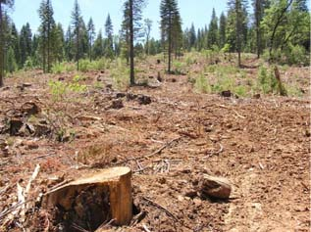

This is a clearcut with reserves unit. Only a fool would believe people who dislike how a clearcuts’ tragic effect on scenery would accept this.

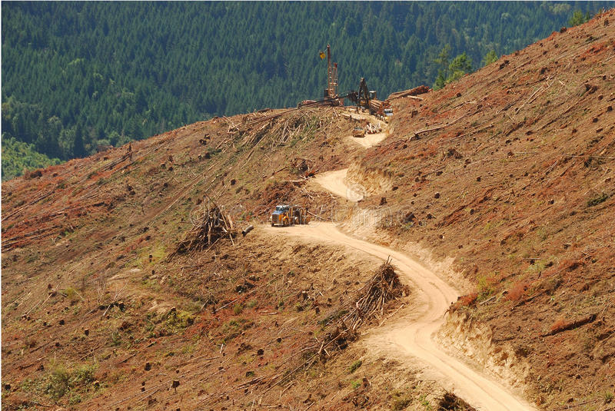

- 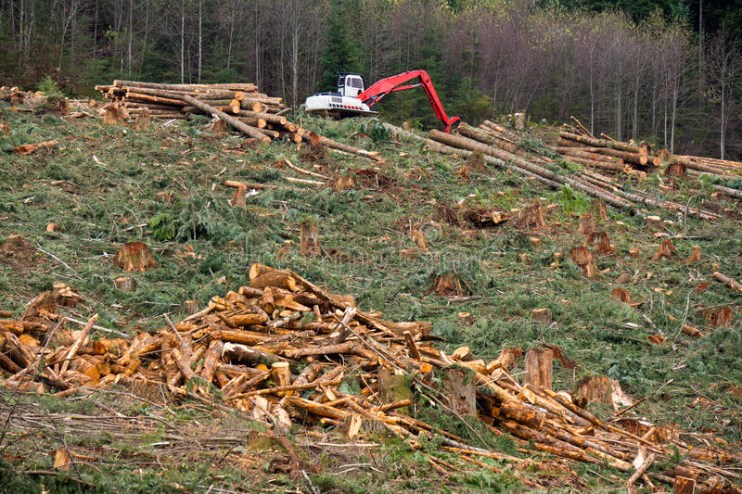
Clearcut logging in the Pacific

