22 Jan 2021

TO: David Warnack, Forest Supervisor, Willamette National Forest,
ATTN: Objections
VIA: https://cara.ecosystem-management.org/Public/CommentInput?Project=52868

Subject: Lowell Country Phase 3 - objection

Dear Forest Service:

In accordance with 36 CFR 218, Oregon Wild hereby objects to the project described below. Oregon Wild represents 20,000 members and supporters who share our mission to protect and restore Oregon’s wildlands, wildlife, and water as an enduring legacy.

DOCUMENT TITLE: Draft Decision Notice and Finding of No Significant Impact for the Lowell Country Project - Phase 3. https://www.fs.usda.gov/project/?project=52868

PROJECT DESCRIPTION: Phase 3 of the Lowell Country Project involves about 2,147 net acres of thinning (and 200 acres of “gaps) in stands under 80 years old, yielding 40 mmbf.
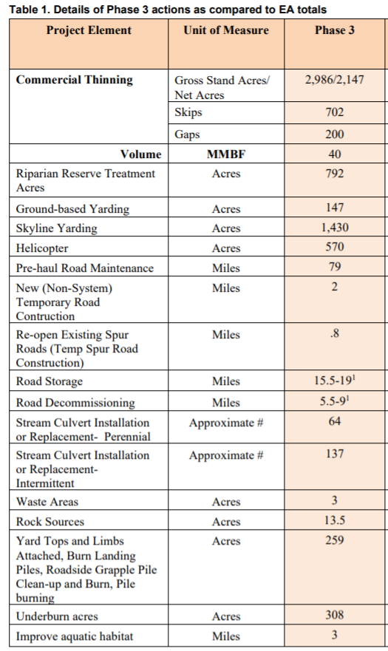

PROJECT LOCATION (Forest/District): Middle Fork Ranger District, Willamette National Forest, Lane County, Oregon

NAME AND TITLE OF RESPONSIBLE OFFICIAL: Molly Juillerat, District Ranger, Middle Fork Ranger District

LEAD OBJECTOR: Oregon Wild

REQUEST FOR MEETING TO DISCUSS RESOLUTION: Oregon Wild hereby requests a meeting to discuss potential resolution of the issues raised in this objection.

NARRATIVE DESCRIPTION OF THOSE ASPECTS OF THE PROPOSED DECISION ADDRESSED BY THE OBJECTION: Oregon Wild objects to removal of trees over 20” dbh from LSR and riparian reserves. We also object to the inadequate analysis of the effects of logging on carbon storage, climate change, snag recruitment, and the failure to prepare an EIS to take a hard look at the significant, long-term impacts of logging on snag recruitment, and carbon storage, especially the additional and cumulative effects of removing large trees.

SUGGESTED REMEDIES THAT WOULD RESOLVE THE OBJECTION:
Oregon Wild respectfully requests that the Forest Service withdraw the recommended project and —
- Issue a clear decision retains all non-hazardous trees 20” dbh or larger; or
- Prepare a new EIS to address the significant impacts and unresolved conflicts and fully complies with the requirements of NEPA and the CEQ regulations and addresses the specific concerns expressed below.

DESCRIBE HOW THE OBJECTIONS RELATE TO PRIOR COMMENTS:
Oregon Wild January 24, 2019 comments on the Lowell Country EA highlighted the important role of snags and dead wood in meeting LSR objectives, and the evidence that past and proposed logging will interfere with efforts to restore and maintain LSR objectives related to snags:
“Two common consequences of conventional thinning practices have been increased uniformity of forest structure and composition, and removal or delay in the development of dead wood as snags or down wood to meet decadence and habitat functions. … Over the past several decades our ecological understanding of decadence and its importance to habitat and biogeochemical processes has increased substantially, but translation of the fundamental knowledge into coherent goals is lagging.”
Paul D. Anderson 2013. Two Decades of Learning about Thinning in the Ecosystem Management Era. http://www.fs.fed.us/pnw/pubs/pnw_gtr880/pnw_gtr880_001.pdf in Density Management in the 21st Century: West Side Story PNW-GTR-880. http://www.treesearch.fs.fed.us/pubs/44695

“Many species in the Pacific Northwest evolved to use large snags and logs that were historically abundant in the landscape. If snags and logs are lost, biodiversity can be affected and potentially cause a loss of some function in the landscape such as control of forest insects.”
Mt Hood NF 2011. Huckleberry Thin EA. http://a123.g.akamai.net/7/123/11558/abc123/forestservic.download.akamai.com/11558/www/nepa/59590_FSPLT2_034896.pdf.

Many animals in Douglas fir forests are strongly associated with habitat features that are best developed in natural forest, such as large trees, snags, and downed logs. The diversity and density of cavity-nesting birds, for example, are positively correlated with the abundance of snags, especially tall and/or large-diameter snags (Nelson 1988, Zarnowitz and Manuwal 1985).
…
It is the cycle of structural development through plant growth, and the retention of structural complexity via legacy, that characterizes natural forests in the Coastal Northwest. Intensive wood production practices may alter this cycle both by truncating succession before large structures develop and by removing most existing structures during harvest. Planting and thinning may further promote uniformity in tree species, size, and spacing.
…
Studies in unmanaged forests teach us that natural disturbance maintains structural complexity within stands and that this complexity promotes plant and animal diversity.
…
Until it is clear that forests managed for wood production can be made suitable for native species, managers should consider retaining within managed forests representative tracts of all natural forest stages, not just old growth.
Hansen, A. J.; Spies, T. A.; Swanson, F. J.; Ohmann, T. L. 1991. Conserving biodiversity in managed forests - Lessons from natural forests. BioScience 41(6):382- 392. http://www.montana.edu/hansen/documents/downloadables/hansenetal1991.pdf.

“Dead wood in the form of snags and downed logs is generally common or abundant. Although a notable part of old-growth stands, such material is actually common in unmanaged stands in all successional stages in the Douglas-fir region.” Franklin & Spies 1983. CHARACTERISTICS OF OLD-GROWTH DOUGLAS-FIR FORESTS. Reprinted New Forests for a Changing World. Proceedings of the 1983 SAF National Convention http://andrewsforest.oregonstate.edu/pubs/pdf/pub120.pdf

Many natural young and mature stands have some of the attributes of old-growth stands that may not be present in young, managed stands. Perhaps the greatest difference between natural and managed stands is the lower number and volume of large snags and logs in managed plantations (Spies and Cline 1988). Many young natural forests less than 80 years old have high amounts of carry-over of woody debris...
Thomas A. Spies and Jerry F. Franklin 1991. The Structure of Natural Young, Mature, and Old-Growth Douglas-Fir Forests in Oregon and Washington in Leonard F. Ruggiero, Keith B. Aubry, Andrew B. Carey, and Mark H. Huff, technical editors 1991. Wildlife and Vegetation of Unmanaged Douglas-Fir Forests. General Technical Report PNW-GTR-285. http://www.fs.fed.us/pnw/pubs/gtr285/.
…
Consider the ecological costs and benefits of both thinned areas and unthinned areas. Thinned areas grow big trees (but fewer of them), while unthinned areas recruit more dead wood habitat structure in the short and long-term. In order to accomplish real ecological restoration in young stands we need to plan for and implement both thinned areas and unthinned areas.
Determining the appropriate scale of thinned and unthinned areas is a critical decision which requires clear objectives and quantitative analysis. One necessary component of such an analysis is to determine how many green trees are needed at what density in order to recruit sufficient snags over time (both short and long-term) to achieve 50-80% DecAID tolerance levels across the project area.
…
The agency often claims that logging in riparian reserves is necessary to improve attributes other than large wood. However, these benefits are often minor and transitory, and do not outweigh the significant long-term adverse effect of logging on recruitment of dead wood. The agency must focus on the most significant contributions of vegetation toward ACS objectives and the most significant effects of logging on the ACS objectives.
…
The Northwest Forest Plan and its supporting documentation make clear that the primary value of riparian vegetation is as a source of large wood and shade, not vegetation diversity and canopy layering, as often asserted by the agency to justify logging in riparian reserves.
…
The effects of logging on dead wood are significant and long term, adversely affecting a core function of the reserves, while the purported benefits to vegetation diversity are minor and transitory, and affect secondary purposes of the reserves.

Large Wood
Large quantities of downed trees are a functionally important component of many streams (Swanson et al. 1976; Sedell and Luchessa, 1982; Sedell and Froggat, 1984; Harmon et al. 1986; Bisson et al. 1987; Maser et al. 1988; Naiman et al. 1992). Large woody debris influences channel morphology by affecting longitudinal profile, pool formation, channel pattern and position, and channel geometry (Bisson et al. 1987). Downstream transport rates of sediment and organic matter are controlled in part by storage of this material behind large wood (Betscha 1979). Large wood affects the formation and distribution of habitat units, provides cover and complexity, and acts as a substrate for biological activity (Swanson et al. 1982; Bisson et al. 1987). Wood enters streams inhabited by fish either directly from the adjacent riparian zone from tributaries that may not be inhabited by fish, or hillslopes (Naiman et al. 1992).
Large wood in streams has been reduced due to a variety of past and present timber harvesting practices and associated activities. Many riparian management areas on federal lands are inadequate as long term sources of wood.
…
Riparian Ecosystem Components
…
Riparian vegetation regulates the exchange of nutrients and material from upland forests to streams (Swanson et al. 1982; Gregory et al. 1991). Fully functional riparian ecosystems have a suite of characteristics which are summarized below. Large conifers or a mixture of large conifers and hardwoods are found in riparian zones along all streams in the watershed, including those not inhabited by fish (Naiman et al. 1992). Riparian zone-stream interactions are a major determinant of large woody debris loading (House and Boehne 1987; Bisson et al. 1987; Sullivan et al. 1987). Stream temperatures and light levels that influence ecological processes are moderated by riparian vegetation (Agee 1988; Gregory et al. 1991). Streambanks are vegetated with shrubs and other low-growing woody vegetation. Root systems in streambanks of the active channel stabilize banks, allow development and maintenance of undercut banks, and protect banks during large storm flows (Sedell and Beschta 1991). Riparian vegetation contributes leaves, twigs, and other forms of fine litter that are an important component of the aquatic ecosystem food base (Vannote et al. 1980).
1993 FEMAT Report, pp V-13, V-25.

Oregon Wild submitted an objection to Lowell Country Phase 1 which noted:
This project will have significant long-term cumulative impacts on snag and dead wood habitat. Large scale logging will remove trees that can never be recruited as snags and dead wood which will have long-term adverse effects on recruitment of snags and dead wood. EA Figures 15, 16, and 17 shows that logging will cause a 3-4 decade delay in attainment of snag habitat representing DecAID 50% tolerance levels (and may prevent attainment of habitat representing 80% DecAID tolerance levels. This indicates NEPA significance.

This project area is located along the western edge of the Willamette NF in proximity to a lot of private industrial lands. Both public and private lands have been heavily logged leaving a severe shortage of snags and dead wood habitat on the landscape. This large-scale logging project will make a bad situation worse leading to potentially significant effects. This indicates NEPA significance.

Our EA comments and May 22, 2019 objection also raised a number of issues related to carbon emissions and climate impacts of logging that were not properly analyzed in the Lowell Country EA.

SPECIFIC ISSUES RELATED TO THE PROPOSED ACTION:

The Lowell Country Project will violate the Northwest Forest Plan standards & guidelines for reserves.

The 1994 Northwest Forest Plan ROD requires that reserves, both Late Successional Reserves and riparian reserves must be managed to enhance objectives related to natural old forests:
Late-Successional Reserves are to be managed to protect and enhance conditions of late-successional and old-growth forest ecosystems, which serve as habitat for late-successional and old-growth related species including the northern spotted owl. … The purpose of these silvicultural treatments [thinning in stands under 80 years old] is to benefit the creation and maintenance of late-successional forest conditions.
..
As a general rule, standards and guidelines for Riparian Reserves prohibit or regulate activities in Riparian Reserves that retard or prevent attainment of the Aquatic Conservation Strategy objectives. … TM-1. Prohibit timber harvest, including fuelwood cutting, in Riparian Reserves, except as described below. … Apply silvicultural practices for Riparian Reserves to control stocking, reestablish and manage stands, and acquire desired vegetation characteristics needed to attain Aquatic Conservation Strategy objectives.”

It is undisputed that logging the stand in the Lowell Country Project will removing large trees depriving the stands of large snags and dead wood needed to meet reserve objectives.

Removing trees larger than 20” dbh in LSR and riparian reserves makes no sense given that the EA (p 105) says “For snags with a minimum diameter of 20 inches, the portion of the landscape lacking snags is almost three times the area estimated for reference conditions, while the portion of the landscape with 0-2 snags/acre is more than 1.5 times reference conditions. The portions of the landscape with ≥10 large snags/acre are less than half reference conditions (8% vs. 18%, Figure 13).”

Even if, to a forester’s eye, there are “too many” trees larger than 20” dbh, from an ecologist’s perspective, retaining all large trees will lead to reserve objectives better than removing them. If large trees are relatively abundant, they may compete or be exposed to various natural processes and someday lead to competitive or non-competitive mortality, thus recruiting large snags that are in short support supply.

Logging Phase 3 of the Lowell Country Project will make a bad situation worse for snag habitat that is essential for meeting reserve objectives. There is an existing shortage of snags, and logging will retard recruitment and recovery of snag habitat. The EA (p 106) says “It is well-known from previous environment analysis of thinning projects that unthinned areas in the plantations (called skips) have the potential to contribute greater amounts of future deadwood than the areas that are commercially harvested.” Removing trees larger than 20” dbh would be particularly harmful because large snags are particularly important for meeting reserve objectives.

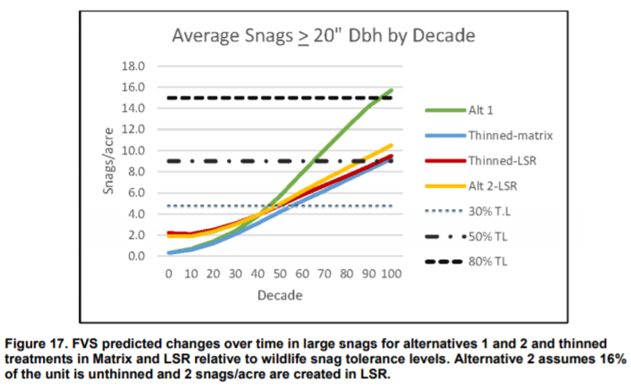

The DN says “the EA stated that “due to the high productivity of this area and fast growing trees, there may be some stands where cutting trees exceeding 20” dbh would be warranted to achieve the desired effects on stand structure and species diversity for LSR objectives” (EA pg. 58).” This is arbitrary and capricious because the analysis fails to show that retaining large trees will better meet LSR objectives for snag habitat that are not being met currently due to past logging and modified disturbance regimes.

EA (page 57) says “Due to the high productivity of this area and fast growing trees, there may be some stands where cutting trees exceeding 20” dbh would be warranted to achieve the desired effects on stand structure and species diversity for LSR objectives. The diameter distribution and growth of these stands may be such that, in order for thinning to be effective in accelerating the development of large living diameter trees and a multiple canopy layer, more than an incidental cutting and removal of >20 dbh trees may need to occur.” The FS failed to provide any compelling rationale to put reserve objectives related to live tree diameter and canopy layering above reserve objectives for snag and dead wood habitat. This is arbitrary and capricious. The fact that removing large trees just happens to increase economic recovery raises concerns that the FS has a conflict of interest. This is of grave concern to allow economic recovery to interfere with ecological goals in reserves.

The EA failed to consider an alternative in which all large trees (>20” dbh) are retained to optimize attainment of reserve objectives and harmonize goals related to large trees, large snags, and canopy layering.

The Lowell Country EA and Phase 3 DN fail to take a hard look at the effects of logging on carbon storage and climate change.

President Biden issued an executive order requiring the Forest Service to review and reconsider actions like the Lowell Country Logging Project that emit greenhouse gases:
.. the Federal Government must be guided by the best science and be protected by processes that ensure the integrity of Federal decision-making. It is, therefore, the policy of my Administration to listen to the science; to improve public health and protect our environment; to ensure access to clean air and water; to limit exposure to dangerous chemicals and pesticides; to hold polluters accountable, including those who disproportionately harm communities of color and low-income communities; to reduce greenhouse gas emissions; to bolster resilience to the impacts of climate change; to restore and expand our national treasures and monuments; and to prioritize both environmental justice and the creation of the well-paying union jobs necessary to deliver on these goals.
To that end, this order directs all executive departments and agencies (agencies) to immediately review and, as appropriate and consistent with applicable law, take action to address the promulgation of Federal regulations and other actions during the last 4 years that conflict with these important national objectives, and to immediately commence work to confront the climate crisis.
Executive Order on Protecting Public Health and the Environment and Restoring Science to Tackle the Climate Crisis. JANUARY 20, 2021 https://www.whitehouse.gov/briefing-room/presidential-actions/2021/01/20/executive-order-protecting-public-health-and-environment-and-restoring-science-to-tackle-climate-crisis/ (emphasis added).

The Lowell Country Project does emit greenhouse gases by killing trees, stopping photosynthesis, initialing and accelerating decay and combustion, and the NEPA analysis of that issue is quite flawed. We incorporate by reference the attached objection issues raised in our objection to Phase 1 of the Lowell Country Project. Those objections were raised on the same record as Phase 3 and the FS has not made any changes to the analysis to remedy the numerous flaws in the NEPA analysis related to carbon and climate change.

In particular, the EA analysis of carbon and climate has the following major flaws:
- The analysis tries to minimize the contribution of this project’s emissions to the global problem of climate change, which is misleading in the context of a problem caused by global cumulative emissions.
- The analysis tries to cast this logging project as aligned with recommended actions ot enhance resilience and mitigating emissions, which is highly misleading because moist forest types like those here are generally not recommended for resilience treatments, and risk reduction treatments emit more carbon than they save from disturbance so logging does not help “mitigate” emissions it exacerbates emissions.
- The EA says “any initial carbon emissions from this proposed action will be balanced and possibly eliminated as the stand recovers and regenerates.” This is highly misleading because it uses an inappropriate framework comparing carbon stores “before and after” logging instead of comparing alternatives “with and without” (as required by NEPA). Even if carbon grows back, it does not pay back the full “carbon debt” compared to the carbon in an unlogged forest.
- The EA tries to suggest that carbon emissions from sustainable logging are not as significant as carbon emissions from “deforestation” or and conversion. This is incorrect. The atmosphere sees every molecule of CO2 exactly the same. All carbon emissions contribute to the global climate crisis.
- The EA suggests that thinning will increase forest productivity and increase forest growth and enhance carbon uptake. There is simply no evidence to support this. There is no bonus volume form thinning. In fact, logging impacts soil and likely reduces site productivity.
- The EA suggests that logging for wood products is a climate solution. This is incorrect. Only a small fraction of the carbon in the logged forest is converted to wood products. Most of the wood carbon in a logged forest in put on an accelerated path to the atmosphere (e.g., kill vegetation, initiating decay, slash burns, etc). Wood products decay at about the same rate as dead wood in the forest.

Note: If any of these web links in this document are dead, they may be resurrected using the Wayback Machine at Archive.org. http://wayback.archive.org/web/

Sincerely,
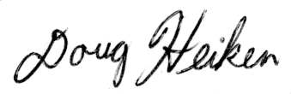
Doug Heiken
dh@oregonwild.org

