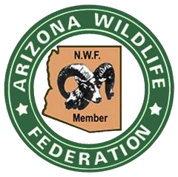

January 11, 2021

Emily Reynolds NEPA Planner
Coronado National Forest
300 W. Congress Street,
Tucson, AZ 85701.

ATTN: Meadow Valley Public Access Project/Letter of Support

Dear Ms. Reynolds:

The Arizona Wildlife Federation (AWF), a 501(c) 3 non-profit corporation, was founded in 1923 to take politics out of Arizona’s Game and Fish Management and to promote the management of Arizona's wildlife and natural resources based on the principles of sound science and best governance. The AWF got its start as the Arizona Game Protection Association and celebrated 97 years of Arizona wildlife conservation activity in 2020. Today, AWF continues our dedication to educating, inspiring, and assisting individuals and organizations to value, conserve, enhance, manage, and protect wildlife and wildlife habitat. We are statewide association of people interested in the present and future well-being of Arizona’s wildlife, wildlife habitat and natural systems.

Since our inception the AWF has been a proponent for providing permanent public access routes to public lands for recreational uses such as dispersed hunting, fishing, hiking, and camping. We have reviewed the proposed new roadways to remedy the locked gate on private lands in the Meadow Valley area of the San Rafael Valley and strongly support the efforts of the Coronado Forest to construct these 3.74 miles of alternate access roads. This action will provide for the desired perpetual legal public and administrative access to the Meadow Valley zone of the San Rafael Valley.

Sincerely,

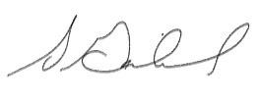
Scott Garlid
Executive Director, Arizona Wildlife Federation

