FLAMES IN OUR FORESTS: COLORADO’S UNPRECEDENTED WILDFIRE SEASON
Forest & Climate
Post date: 02 Nov, 2020
By Adam McCurdy, ACES Forest & Climate Program Director
COVID-19 and elections have dominated 2020 headlines, but wildfires haven’t been far behind. Across the Western US, the 2020 wildfire season has been devastating and unprecedented–and Colorado is no exception.

The Largest Wildfires in Colorado’s History
Over the course of this summer and fall, the record for the largest wildfire in Colorado history has been broken twice. Before 2020 the largest fire in Colorado was the 2002 Hayman fire, that record was broken on August 27th by the Pine Gulch fire, which burned 139,007 acres north of Grand Junction. The record didn’t last long, and on October 14th the Cameron Peak fire west of Fort Collins surpassed 158,000 acres to become the largest fire recorded in Colorado. At the time of writing, the Cameron Peak fire has burned 208,913 and is 67% contained.
As the Cameron Peak fire was setting records, the East Troublesome Fire was ignited. After burning for just over two weeks the East Troublesome Fire is 193,774 acres and 37% contained. While it has yet to surpass the Cameron Peak fire as the largest recorded fire in Colorado, East Troublesome has distinguished itself with unprecedented fire behavior for Colorado. On October 21st the fire burned 140,000 acres in 24 hours, a record in Colorado, and on the morning of October 22nd, the fire crossed the Continental Divide jumping over 1.5 miles of barren rocky terrain.
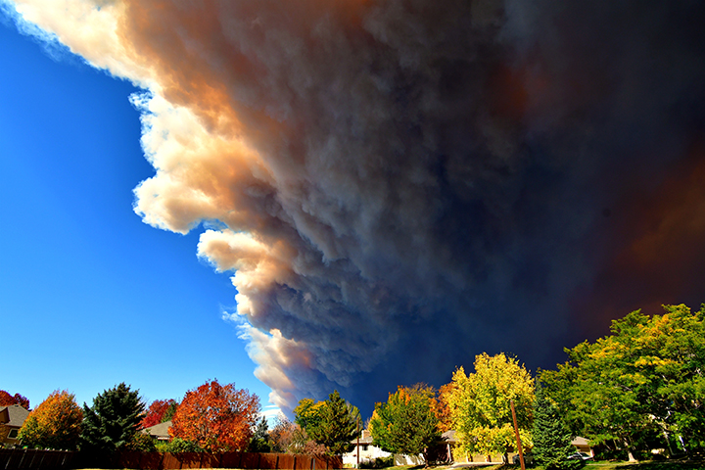
Photo: Chad Claeyssen. Smoke from the Cameron Peak Fire in Northern Colorado rolling over west Loveland.
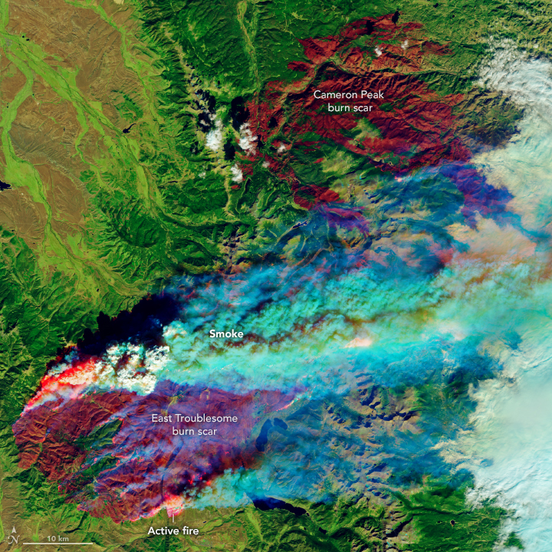
Image: Burn scars of the Cameron Peak and East Troublesome fires.

Ingredients for a Wildfire
Dr. Jennifer Balch, a professor and wildfire researcher at University of Colorado Boulder nicely summarizes the ingredients for a wildfire as a warm climate, fuels (primarily trees and grasses), and ignitions. If wildfires are changing, it has to be caused by a change to one of these three components. Like most things in the natural world, it’s not simple. In fact, it’s a good rule of thumb to ignore anyone who points to a single factor for increased fire activity and more extreme fire behavior. In this case, it is indisputably all three.

Ingredient #1: Warmer Climate
This piece has been especially important for the fires burning in Colorado this year. In most years Colorado has a very predictable fire season dictated by precipitation trends. In a typical year snow accumulates at high elevations in Colorado from early October through mid-April. From April-June the snowpack melts saturating soils, recharging aquifers, swelling rivers, and filling reservoirs. From a fire perspective, this is important. June is the driest month of the summer in Colorado–and for many areas in the mountains it’s the driest month of the entire year. Without the runoff from the winter snowpack, the relatively low precipitation in June means high fire danger, which we see in low snow years. By July the North American Monsoon has started and much of Colorado is getting frequent afternoon precipitation. In September and October temperatures drop and the high country typically gets its first snow. In terms of wildfire risk, Colorado’s typical precipitation pattern means that the highest risk is typically late June and early July, once the snow has melted but before the monsoons have started. By October the fire season is typically brought to a close with cold temperatures and high elevation snow.
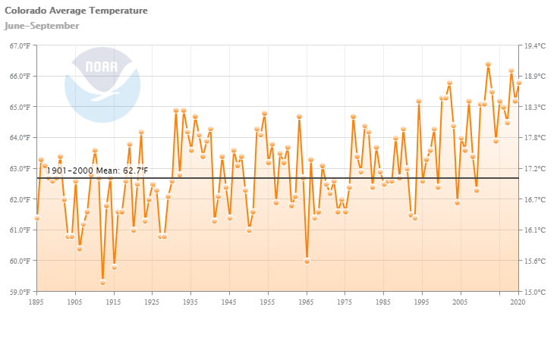
Now let's take a look at what happened this year. On April 1st snowpack for much of the state was close to 100% of the median (a little higher in the north and lower in the south). This is where things start to deviate pretty dramatically from a typical year. Usually, we expect 100% snowpack to translate to roughly 100% runoff but this year we only had 52% of normal runoff. Our exceptionally warm and dry spring meant that a lot of the snow went directly into the air, a process called sublimation, instead of melting and running off. Then the monsoon never happened–this June-September was the ninth-lowest precipitation since 1895. Combine this with the third warmest June-September on record and you end up with much drier fuels. The final piece of the puzzle has been an exceptionally warm October (at the time of writing, climate data for October hasn’t been released). A month that is typically characterized by cold temps and snow in the high county is hot, dry, and windy, a perfect recipe for wildfires.

Ingredient #2: Fuels
Of the three ingredients of wildfire, fuels are the most complicated and hard to understand. While changes in fuels have played a role in the recent increase in wildfires, it is only a piece of the puzzle, along with climate change and more ignitions. Climate deniers and timber companies often cite poor forest management as the sole reason for the increase in wildfires. Some readers may even remember a certain climate-denying president suggesting that California needs to rake their forest to prevent wildfires. As is usually the case, the truth is often far more complicated than the political sound bites. First a brief history lesson.
Humans have been altering fuels on the landscape in western North America since their arrival 15,000 years ago. Indigenous peoples initially used fire for cooking, warmth, and security, and inevitably some of these fires would have spread to the larger forests. More recently indigenous peoples purposefully set fires to manage forests, a practice referred to as prescribed fire or cultural burns. As European colonists moved west they removed native peoples from their lands and moved from periodic cultural burns to a policy of strict fire suppression. This allowed for fuels to build up, setting the stage for larger and more catastrophic wildfires in some areas.
Fire suppression has primarily had an impact in dry forests, like ponderosa pine. These forests evolved to frequent low severity fires that cleared out the understory while leaving more mature trees. In some forests these low severity fires would happen every ten years, so 100 years of fire suppression has left us with ten times the natural fuel load. Think about your typical campfire ten times larger.
Wet forests, like the spruce-fir forests found locally at high elevations, on the other hand, haven’t been dramatically impacted by fire suppression. These forests typically go hundreds of years without a fire. Ecologists refer to them as being climate-limited, there's always enough fuel to burn but the climate is almost always too cold and wet to support a fire. Larger and more frequent fires in these forests are primarily driven by climate change, and no amount of management can change that.
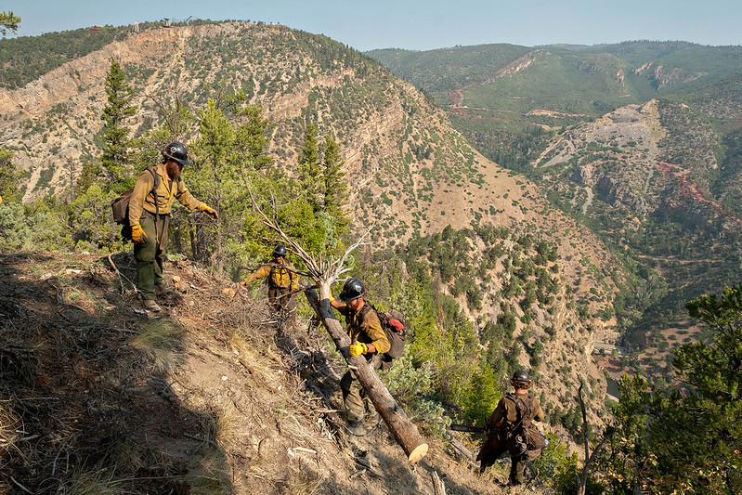
Photo: Joe Bradshaw. The "Ruby Mountain Hotshots" begin constructing fireline from the Boy Scout Trail up a ridge to tie into the line they put the day before down from the communication towers down toward the I-70 as part of the effort to contain the Grizzly Creek Fire, August 21, 2020.

Ingredient #3: Ignitions
There two ways wildfires are typically ignited: lightning and people. As with the other two ingredients of wildfire, humans are altering the sources of ignitions to make wildfires more common.
In Colorado the vast majority of our lightning strikes occur during the summer monsoons (between the end of June and the start of September). While lighting strikes certainly can occur outside of this period, it’s less common. It would be nice to think that lightning is something beyond the ability of humans to mess with–but of course, it’s not. Climate change is predicted to increase the number of lightning strikes in the contiguous US by 50% over this century. While this is concerning, any increase in lighting strikes probably hasn’t greatly contributed to the current increase in wildfires. That honor goes to human sparks.
The number of people using and living near fire-prone western forests has increased drastically over the past two decades. Between 1992 and 2015 the number of homes near wildlands increased by 42%. More people means more campfires, cigarettes, fireworks, and even gender-reveal parties – in other words, more sparks. Between 1992 and 2012 humans started 84% of wildfires in the US and on average tripled the length of the “lightning fire season”. More recently, both the Cameron Peak fire and the East Troublesome Creek fire are suspected to be human-caused.

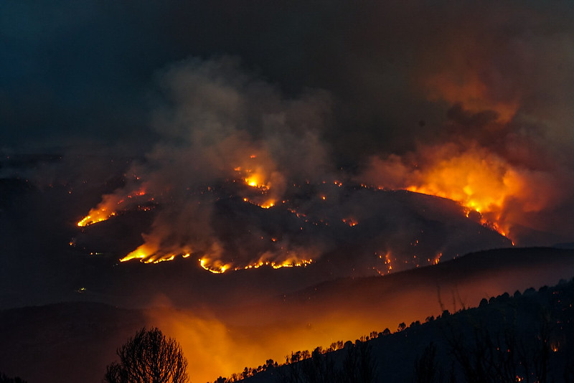
Photo: Joe Bradshaw, NIFC BLM, USFS Rocky Mountains, August 15, 2020.

Putting the Pieces Together
October isn’t fire season in Colorado, historically it’s a cold month without much lighting. But that’s changing. Human-caused climate change has created a hotter and drier Colorado, one study estimated that human-caused climate change doubled the area burned by wildfires from 1984-2015. And with plenty of people on the landscape, there’s no shortage of potential sparks.
We’re not in a good place with wildfire, but fortunately we have the tools, knowledge, and capacity to improve our situation. First and foremost, as a global society we need to eliminate carbon emissions and limit the continued impacts of climate change. If emissions aren’t reduced and climate change continues unabated nothing will be able to limit the spread of deadly megafires. More immediately we need to increase prescribed fires where appropriate. We need to educate our residents and visitors on how to minimize the risk of starting a wildfire. While the problem is complex, the solutions aren’t.

Adam McCurdy
ACES Forest & Climate Program Director

