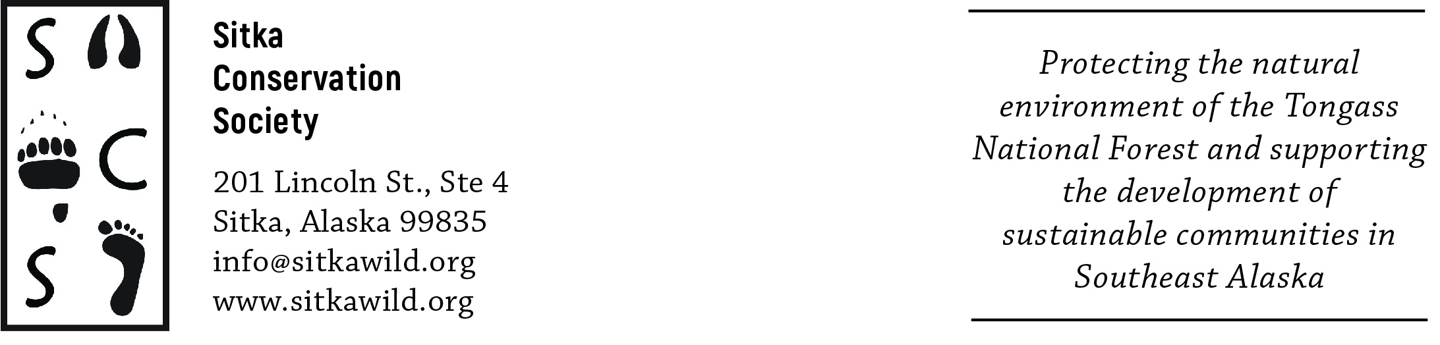

October 14, 2020
Thorne Bay Ranger District
Attn: Twin Mountain II Timber Sale
PO Box 19001
1312 Federal Way Thorne Bay,
Alaska 99919

These Twin Mountain II Timber Sale scoping comments are written by the Sitka Conservation Society and represent the Board of Directors of the Society and our membership of over 1000 people who use, depend on, and care about the integrity of the Tongass National Forest. These targeted comments are meant to articulate our concerns with the timber sale as proposed and what it indicates for the management direction on the Tongass, and raise broader issues related to the management of cultural use wood in the Tongass National Forest.

The stated purpose and need of this project is to “manage the timber resource for production of sawtimber and other wood products and to meet multiple resource objectives.” This commitment to manage the timber resource for other wood products and multiple resource objectives includes managing for a supply of wood to provide material for Alaska Native cultural uses and the Pacific Northwest Coast art. Two specific forest resources of high heritage value that are commonly used in Native art and craft forms are the species of Thuja plicata, western red-cedar, and Cupressus nootkatensis, Alaskan yellow-cedar. Cultural and heritage uses of these forest resources require clear, fine-grained red- and yellow-cedar that is generally over 450 years of age.

Tribes in the region have repeatedly expressed concern about the future availability of the redcedar resource for totem poles, carving, and weaving. As part of the Twin Mountain II Timber Sale EIS, the Forest Service should consult with local Tribal governments in Kasaan, Klawock, Hydaburg, and Craig about their current and future needs for redcedar trees for cultural and heritage use, and set these trees aside prior to sale. The Forest Service should also contact local weavers or put out a notice if any red cedar trees are slated to be cut down, so that weavers may harvest the bark for use pre-sale. One of the standards of the Tongass Land Management Plan is to “aim to locate and protect areas that contain specific forest resources of heritage value used for Native art and craft forms” (USDA 2016). Has the agency assessed the 3000 acres that are proposed to be harvested as part of the Twin Mountain II Sale to identify specific stands of red and yellow cedar, and are they taking actions to protect these areas?

The agency has identified one of the primary issues for this EIS as “designing an economical timber sale(s) that meets market demand.” How is demand being assessed, and does this market demand include the demand for Alaska Native art products that are created using wood resources from the Tongass? Market demand for timber needs to be analyzed in a more holistic manner that incorporates an economic assessment of the local demand in Southeast Alaska for cultural use wood and wood products that are the raw materials used by carvers and artists working in Pacific Northwest art traditions. This local demand for cultural use should then be specifically calculated into the TTRA mandate to “meet market demand for Tongass timber”. Please take into account and incorporate the requests for analysis of the local tribes, into the EIS for the Twin Mountain II sale.

The more general stated purpose of this sale is to “implement the 2016 Forest Plan direction to move the project area toward the desired future conditions described in that plan”. However, the Notice of Intent states that there will be no young growth timber made available for harvest. The 2016 Forest Plan was created to implement the Tongass Transition and provide a path for the timber industry to move from primarily old growth harvest to primarily young growth harvest in the space of 15 years. Almost 5 years has passed since the plan was enacted, and our transition should thus be well on its way. We are concerned about how this sale carries out the objectives of the Tongass Transition, and how it is responsive to the increasingly diminishing supply of old growth that we have left on the forest. Does this sale indicate to timber operators that there is a finite supply of old growth, and that this sale represents some of the last remaining stands on the Tongass? Or, does it imply that old growth timber harvest can continue to happen unimpeded and that mills do not need to start searching for new markets and machinery reconfiguration to start processing youth growth? Is the timber in these sales economically viable or will it be heavily subsidized through taxpayer-funded roads? What is the percentage of each acre of clearcut that actually contains financially operable timber, and how much timber is left on the ground as slash that is non-economically viable for sale?

The agency should not allow the export of local Tongass wood to Asian or contiguous US markets. This sale should go towards 100% domestic, value-added use in-region and encourage the responsible development of our local manufacturing capacity and creation of jobs. An integrated land management policy that stops or slows the export of round logs would help send a message to industry and the world that we want manufacturing in the state. As part of the NEPA process for this sale, the agency should also conduct a comprehensive inventory of all old growth left in the sale area, and on Prince of Wales and the surrounding islands more broadly, so that the public and the agency can fully comprehend how much of this rare resource is left, and the importance of the need for in-region, value-added manufacturing of this unique type of wood.

SCS is concerned with what this proposed sale signifies for the Tongass Transition, local use of timber, and local economies. We believe that the agency should make adjustments and stipulations to the sale that would create more direct benefits for in-region economic development. Increasing the amount of old growth forest that is on the chopping block will not result in future prosperity for the region’s mills or residents.

Sincerely,
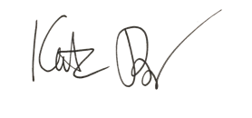
Katie Riley
Policy Director
Sitka Conservation Society

