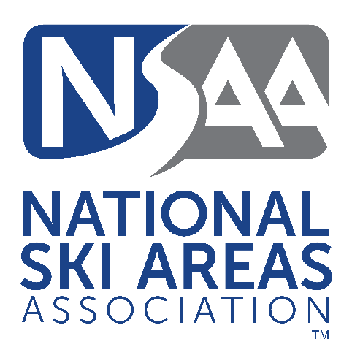

August 24, 2020

Sean Wetterberg
National Winter Sports Program Manager
125 South State Street, Suite 7105
Salt Lake City, UT 84138

Re: NSAA Comments on USFS Interim Directives on the Use and Storage of Explosive Materials on NFS lands Authorized Under Special Use Permits

Dear Mr. Wetterberg:
The National Ski Areas Association (NSAA) submits the following comments in response to the agency’s Issuance of Interim Directives and Notice of Availability for Public Comment on the Use and Storage of Explosives Materials on National Forest System Lands, published in the Federal Register on June 23, 2020. NSAA is the trade association for ski area owners and operators nationwide. NSAA represents 320 alpine resorts, accounting for over 90% of the skier/snowboarder visits in the United States. We submit these comments on behalf of our member areas that operate on National Forest System Lands and have explosives programs.

Background

Ski areas are a crucial component of the recreational activities offered on National Forests, and the ski industry’s partnership with the US Forest Service helps facilitate the public’s use, enjoyment, and appreciation of National Forests. Ski areas use various types of explosives in their operations for avalanche hazard mitigation purposes and maintain magazines for storage of explosive materials. Eight ski areas use military artillery and store military munitions for avalanche hazard mitigation purposes. NSAA and its Explosives Committee have a cooperative and positive working relationship with the Forest Service, the Bureau of Alcohol, Tobacco and Firearms (ATF) and the U.S. Army in the explosives arena. For ski area operations, safety and security in the use and storage of explosives is a top priority.

The ski industry has used explosives for avalanche control work since the 1950s, and our safety record is exemplary. We are committed to providing training for resort employees on the use of explosives for avalanche control work. NSAA issued “Guidelines on Explosives Use in Avalanche Control” in the early 1990s and has updated the guidelines as needed over time. These guidelines were informed by various federal and state regulations, references from the Institute of Makers of Explosives (IME), the International Society of Explosives Engineers (ISEE), and the U.S. Forest Service and represent observations of the best-known practices of avalanche mitigation activity over the past 60 years at U.S. ski areas. Additionally, NSAA adopted an Avalanche Blasting Resource Guide in 2003 to assist resorts in training employees on the use of explosives as a tool in the mitigation of avalanches, and updates that Resource Guide periodically as well.

Comments

NSAA supports the new directives from the agency as they streamline government regulation, clarify roles and responsibilities among government agencies, and add limited and reasonable requirements with respect to record keeping and security of magazines. More detailed comments are provided below.

Streamlining Regulation and Clarifying Roles & Responsibilities

Ski area explosives programs are regulated by a number of federal and state agencies, including ATF, OSHA, the U.S. Forest Service, the Department of Transportation, the Department of Homeland Security, the US Army (for those with military artillery programs), and state agencies. Given this myriad of regulations that we face as permittees and users of explosives, we strongly support better coordination of roles among government agencies and reduction of redundant regulations, both of which this rule helps accomplish. ATF is required to conduct inspections of permittees at least every three years by statute, and the new directives take that into account it no longer requiring separate USFS inspections of ski area magazines. As the new directives provide, the Forest Service can rely on ATF inspections and inspection records instead, which reduces the burden on permittees and streamlines government functions. The updated directives are likewise helpful in clarifying the role and jurisdiction of the Forest Service, the ATF, the Department of the Army, and states over explosives use and storage on National Forest System lands.

Record keeping and Magazine Security Changes
The directives add requirements on ski area operators to: share ATF inspection reports with the Forest Service; document seven-day magazine checks or inspections; replace locks and keys periodically at least every ten years; and document lock and key replacements in a log. These new requirements, which are cross referenced in an operating plan template, are reasonable and workable and are supported by NSAA and its Explosives Committee.
USFS Personnel Training
Finally, the directives provide for training of permit administrators to ensure that they can effectively monitor and verify the requirements of a permittee’s operating plan. To the extent possible, coordination of training among USFS personnel and ski industry personnel at existing industry meetings or webinars would be welcome and ideal. Having the same understanding of requirements and expectations will ensure compliance, increase safety, reduce surprises, and strengthen our partnership all the more.

* * *

We appreciate your consideration of these comments.

Best regards,

Geraldine Link

Director of Public Policy

