
PO Box 11648 | Eugene OR 97440 | 541-344-0675 | fax 541-343-0996
dh@oregonwild.org | http://www.oregonwild.org/

16 July 2020

TO: Mt Hood NF, Objections Reviewing Officer
VIA: objections-pnw-mthood@usda.gov

Subject: 36 CFR 218 objection of the Waucoma Huckleberry Enhancement Project

Dear Forest Service:

In accordance with 36 CFR 218, Oregon Wild hereby objects to the project described below.

DOCUMENT TITLE: Draft Decision Notice and Finding of No Significant Impact (and EA) for the Waucoma Huckleberry Enhancement Project

PROJECT DESCRIPTION: The proposed action includes:
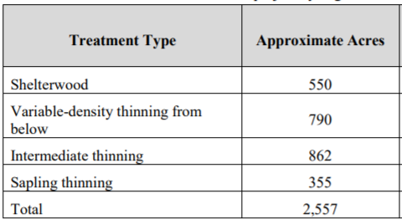

PROJECT LOCATION (Forest/District): Hood River Ranger District Mt. Hood National Forest, Hood River County, Oregon

NAME AND TITLE OF RESPONSIBLE OFFICIAL: Kameron Sam, District Ranger, Barlow and Hood River Ranger Districts

LEAD OBJECTOR: Oregon Wild

REQUEST FOR MEETING TO DISCUSS RESOLUTION: Oregon Wild hereby requests a virtual meeting to discuss potential resolution of the issues raised in this objection.

NARRATIVE DESCRIPTION OF THOSE ASPECTS OF THE PROPOSED DECISION ADDRESSED BY THE OBJECTION:
Our primary concerns with this project are:
- The FS failed to take a hard look at whether there is a real need to log to enhance huckleberries. This purpose and need will be accomplished by natural disturbance driven by global climate change. The analysis fails to highlight that no action meets the purpose and need,
- The FS failed to take a hard look at the adverse effect of logging on the disproportionate ecosystem services provided by unroaded areas,
- The FS failed to take a hard look at the adverse effect of logging on carbon emissions/storage and climate change,
- The FS failed to take a hard look at the adverse effect of logging on spotted owls and adverse competitive interactions with barred owls,
- The FS failed to take a hard look at the trade-offs and adverse effect of logging on mature and old growth forest habitat,
- The FS failed to take a hard look at the adverse effect of regen logging which has potentially significant effects on wildlife, carbon, fire hazard, water quality/quantity, recreation and scenic values, etc.,
- The FS failed to take a hard look at the adverse effect of logging on recruitment of snags and dead wood habitat, and failed to consider the adverse effects of logging in light of new information that the LRMP snag standards are scientifically discredited and it is understood that wildlife need more snags for a wider variety of life functions than previously recognized,
- The FS failed to take a hard look at the adverse effect of logging riparian reserves, including steep and unstable slopes such as units 136 and 138 that should be designated as riparian reserves,
- The FS failed to take a hard look at the site-specific effects of temporary road construction, because road locations were not even disclosed,
- The FS failed to prepare an EIS to address significant effects on the environment, including: logging in unroaded areas, carbon emissions/storage and climate change, spotted owls and adverse competitive interactions with barred owls, mature and old growth forest habitat, recruitment of snags and dead wood habitat, logging steep and unstable slopes that should be designated as riparian reserves, etc.,
- The final EA and draft DN fail to respond to public comment,
- The FS failed to develop mitigation alternatives to address the trade-offs described above and in public comments,

SUGGESTED REMEDIES THAT WOULD RESOLVE THE OBJECTION:
As stated in our comments, Oregon Wild does not object to thinning dense, young, non-riparian stands that are accessible from existing roads.

Oregon Wild respectfully requests that the Forest Service withdraw the recommended project and —
- Issue a clear decision that avoids logging and road building in roadless and unroaded areas, and protects mature and old-growth trees and stands, and protects important habitat features for native species of terrestrial and aquatic flora and fauna; or
- Prepare an EIS to address the significant impacts and unresolved conflicts and fully complies with the requirements of NEPA and the CEQ regulations and addresses the specific concerns expressed below.

Our concerns would be greatly reduced if the FS would drop logging on Mt Defiance, in the unroaded areas, and units 136 and 138.

DESCRIBE HOW THE OBJECTIONS RELATE TO PRIOR COMMENTS:
The issues raised in this objection were raised by Oregon Wild throughout the NEPA process.

SPECIFIC ISSUES RELATED TO THE PROPOSED ACTION:
Contents
COVID-19 4
The FS failed to take a hard look at whether there is a real need to log to enhance huckleberries. This purpose and need will be accomplished by natural disturbance driven by global climate change. The analysis fails to highlight that no action meets the purpose and need. 5
The FONSI is flawed. 5
The FS failed to take a hard look at the trade-offs and adverse effect of logging on mature and old growth forests. The FS Failed to Weigh Trade-offs. 6
The FS failed to take a hard look at the significant adverse effect of logging on the disproportionate ecosystem services provided by unroaded areas 9
The FS Failed to Consider New information on the Significant and Disproportionate Ecological Value of Unlogged Unroaded Areas >1,000 acres 10
The FS failed to take a hard look at the adverse effect of logging on recruitment of snags and dead wood habitat, and failed to consider the adverse effects of logging in light of new information that the LRMP snag standards are scientifically discredited and it is understood that wildlife need more snags for a wider variety of life functions than previously recognized 14
The FS failed to take a hard look at the adverse effect of logging on spotted owls and adverse competitive interactions with barred owls 19
The FS failed to take a hard look at the adverse effect of regen logging which has potentially significant effects on wildlife, carbon, fire hazard, water quality/quantity, recreation and scenic values, etc., 22
Shelterwood regen and Heavy Thinning will increase fire hazard and make forests less resilient to disturbance and climate change 22
The FS failed to take a hard look at the adverse effect of logging on mature and old growth forest habitat. Regen harvest reduces populations of small mammals. 24
Regen does not mimic natural disturbance 24
Regen harvest to create early seral forest is not needed 25
Climate change may increase early seral. 31
The FS failed to take a hard look at the adverse effect of logging riparian reserves, including steep and unstable slopes such as units 136 and 138 that should be designated as riparian reserves. Logging in Riparian Reserves to Meet ACS Objectives Not Scientifically Supported. 35
The Analysis Failed to Disclose Logging Riparian Reserves Will Harm Terrestrial Wildlife 41
The FS failed to take a hard look at the significant adverse effect of logging on carbon emissions/storage and climate change 43
The analysis makes several inaccurate and misleading statement about the carbon consequences of logging 45
The Analysis Failed to Recognize that Wood Products a Source of Carbon Emissions, Not a Sink, and the Carbon Value of Wood Products is Often Over-estimated. 47
The FS Failed to Respond to Public Comments 60
The Analysis Failed to Consider All Reasonable Alternatives. 61

COVID-19
The agency should refrain from releasing any NEPA documents for public comment or decisions for administrative review during the COVID-19 pandemic. The public is being asked to stay at home and cannot adequately access project areas that are being considered for ground disturbing activities. This hinders the public’s ability provide informed comment, which undermines a core purpose of NEPA. We are also concerned that the agency specialists who are working on NEPA effects analysis may not be able to do high quality work given that they also may not have ready access to the sites under consideration. The agency has plenty of work under contract, and does not need to slip more destructive projects under the radar during this crisis. Doing so would be a breach of the public trust.

See April 3, 2020 Memo from USFS Deputy Chief Chris French to Regional Foresters recommending delay of new comments periods and especially new objection periods for EAs and EIS, in light of:
Several factors can make public engagement exceptionally challenging in this situation. These include but are not limited to:
- Inability, legally or otherwise, to hold public meetings or field trips;
- Lack of access to virtual technology for interested parties and stakeholders;
- Lack of Personal Protective Equipment for Forest Service employees to manage public interactions/comments;
- Closures of facilities where hardcopy documents are typically made available;
- Physical distancing recommendations resulting in lack of access to postal facilities and Forest Service mailrooms;
- Reductions or closures in tribal, state, county, or local government operations or services
- Reductions in capacity within stakeholder organizations;
- Reductions in Forest Service capacity due to self-quarantines, sick leave, or a redirection of resources to support government wide COVID-19 responses;
- State, county, reservation, or city-wide stay-at-home orders;
- A nation focused on economic hardship, loss of employment and wealth, risk to themselves, family and friends, and the strains placed on society generally.

The FS failed to take a hard look at whether there is a real need to log to enhance huckleberries. This purpose and need will be accomplished by natural disturbance driven by global climate change. The analysis fails to highlight that no action meets the purpose and need.
No Action + Climate change + Wildfire = Huckleberry Enhancement + Diversity of Age Classes Across the Landscape
The EA considered prescribed fire to be an infeasible tool for huckleberry enhancement, but that is not the only kind of fire on the landscape. The analysis of the no action alternative should reflect the fact wildfire is expected in virtually all conifer forests and would someday burn and result in huckleberry enhancement. Which raises the questions, why here? why now? Doesn’t the forest burn somewhere in the Oregon Cascades every year? Maybe huckleberries could be collected there. And then another fire would occur and huckleberries could be collected there. Kind of a shifting mosaic of fire and huckleberry. I think that’s how things worked historically, and fire is expected to become more prevalent as a consequence of global climate change, so the no action alternative may in fact meet the purpose and need for huckleberry enhancement.

Fire is also a better tool to increase age-class diversity across the landscape. It results in a more natural mosaic of fire severity, legacy retention/carryover, patch scale, and forest pattern.

The analysis of the action alternatives must recognize that logging is a poor analog for wildfire. Logging to enhance huckleberries is like gardening the forest. It is not properly conceived ecosystem management. Logging requires roads. Logging removes biomass and causes a long-term loss of dead wood habitat. Logging depletes forest carbon stores and accelerates the transfer of carbon to the atmosphere.

The FS can best harmonize objectives by focusing efforts to produce timber and enhance huckleberries by thinning young plantations, and leaving fire-origin forests alone. Natural stands are self-organizing systems that are already meeting objectives and have all the building blocks for successional development to desired future conditions.

The FONSI is flawed.

The draft DN says that the effects are not significant because this project affects such a small fraction of the Mt Hood NF.
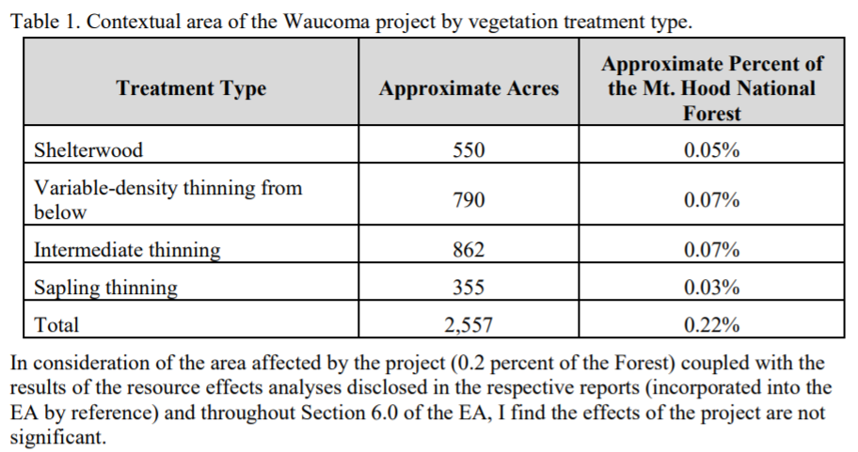
This is an incomplete and misleading approach to determining NEPA significance. This fails to recognize that the site-specific effects of logging and roads can be significant (such as the effects on unroaded areas, steep slopes, mature and old growth forest habitat), AND more importantly it fails to recognize that the cumulative effects of the Waucoma Project combined with the effects of all the other past, present and foreseeable logging and road projects on the Mt Hood NF may have significant effects. We think significant effects are likely especially with respect to mature and old growth forest habitat that is relied upon by threatened species such as the northern spotted owl, exacerbated by the fact that the FS cannot tier to any programmatic analysis of the effects of the barred owl invasion, and we know that reducing and degrading suitable owl habitat reduces the likelihood that spotted owls and barred owls can co-exist. Logging across the Mt Hood NF also has cumulative effects on carbon emissions/storage and climate stability, and recruitment of snag habitat. Again, two issues where the FS cannot tier to any programmatic analysis that addresses significant new information that logging will contribute to significant cumulative effects. See IPCC Reports and Rose, C.L., Marcot, B.G., Mellen, T.K., Ohmann, J.L., Waddell, K.L., Lindely, D.L., and B. Schrieber. 2001. Decaying Wood in Pacific Northwest Forests: Concepts and Tools for Habitat Management, Chapter 24 in Wildlife-Habitat Relationships in Oregon and Washington (Johnson, D. H. and T. A. O’Neil. OSU Press. 2001) http://web.archive.org/web/20060708035905/http://www.nwhi.org/inc/data/GISdata/docs/chapter24.pdf.

The FS failed to take a hard look at the trade-offs and adverse effect of logging on mature and old growth forests. The FS Failed to Weigh Trade-offs.

The analysis says “the analysis shows that the proposal is a prudent action to achieve Forest Plan goals and to enhance huckleberry production.” But nowhere in the analysis do we find a careful weighing of the multiple trade-offs (e.g., carbon, habitat) involved in this proposal to log native forests to enhance huckleberries and produce timber.

Logging mature forests has more significant trade-offs compared to thinning dense young plantations, but the EA failed to disclose and consider those trade-offs. This requires projects like this to be considered in an EIS. See Doug Heiken 2009. The Case for Protecting Both Old Growth and Mature Forests. Version 1.8 April 2009. https://www.dropbox.com/s/4s0825a7t6fq7zu/Mature%20Forests%2C%20Heiken%2C%20v%201.8.pdf?dl=0.

Land management inevitably involves trade-offs among competing uses of the public lands. Alternatives should be developed to resolve trade-offs in different ways.

The agency must avoid portraying the effects of the proposed action in uniformly positive terms, while describing the effects of no action in uniformly negative terms.

When the agency uses commercial logging to meet restoration goals, the NEPA analysis needs to clearly disclose to what extent optimal restoration outcomes are being sacrificed in order to “make units pencil out,” ensure “operational feasibility,” and/or produce timber volume. It is often the case that optimal restoration calls for retention of more trees, especially commercial-sized trees, that serve a variety of ecosystem services. Retaining optimal levels of medium and large trees –
- Provides habitat for wildlife that depend on (i) relatively dense forests and/or (ii) abundant snags and dead wood;
- Stores carbon that helps moderate global climate change;
- Enhances recreational/scenic values;
- Suppresses the growth of weeds and hazardous ladder fuels and reduces future maintenance costs associated with removing non-commercial in-growth; and
- Provides cool/moist microclimate buffering that benefits wildlife, recreation, and moderates fire hazard;
Removing trees to meet timber objectives sacrifices all these values. The agency needs to carefully disclose the extent to which these public values are sacrificed in order to achieve timber volume objectives. Clearly disclosing such trade-offs helps the public provide informed comment, and helps achieve the informed decision-making requirements of NEPA. It also furthers the requirements of NEPA related to:
- “... To determine the scope of environmental impact statements, agencies shall consider ... 3 types of alternatives, .... They include: ... (b) Alternatives, which include: (1) No action alternative. (2) Other reasonable courses of actions. (3) Mitigation measures (not in the proposed action).” 40 CFR §1508.25.
- “Federal agencies shall to the fullest extent possible: ... (e) Use the NEPA process to identify and assess the reasonable alternatives to proposed actions that will avoid or minimize adverse effects of these actions upon the quality of the human environment. (f) Use all practicable means, consistent with the requirements of the Act and other essential considerations of national policy, to restore and enhance the quality of the human environment and avoid or minimize any possible adverse effects of their actions upon the quality of the human environment.” 40 CFR §1500.2.
- “Study, develop, and describe appropriate alternatives to recommended courses of action in any proposal which involves unresolved conflicts concerning alternative uses of available resources.” 40 CFR §§1501.2(c), 1507.2(d), 42 USC § 4332(2)(E).
- “The discussion [of environmental consequences] will include the environmental impacts of the alternatives including the proposed action, any adverse environmental effects which cannot be avoided should the proposal be implemented, the relationship between short-term uses of man’s environment and the maintenance and enhancement of long-term productivity, and any irreversible or irretrievable commitments of resources which would be involved in the proposal should it be implemented”40 CFR §1502.16, 42 USC § 4332(2)(C). https://www.energy.gov/sites/prod/files/NEPA-40CFR1500_1508.pdf

NEPA requires disclosure of the trade-offs among competing uses.
Project-level planning and implementation pursues management activities in accordance with forest plans to enhance flows of particular ecosystem services—to improve a specific fish or wildlife population, for example, or reduce the likelihood that natural disturbance (e.g., wildfire) might adversely affect flows of ecosystem services. However, many ecosystem services and the associated landscape conditions from which they derive are interrelated in either conflicting or synergistic ways such that changes in one service necessarily involve changes in another service. In some cases, increased flows of one service may only be possible by accepting decreased flows of another service. Evaluating and communicating expected management outcomes necessarily must account for these interrelationships and the tradeoffs—the exchange of one level of service for another—made necessary when implementing a project that will affect multiple ecosystem service flows.
Conceptually, tradeoffs among ecosystem services are best illustrated by using the economic concept of “production possibility frontiers” (e.g., Bowes and Krutilla 1989: 49, Stevens and Montgomery 2002). Production possibility frontiers show the combinations and levels of ecosystem services that can be produced on a landscape given that landscape’s capacity to produce those services (e.g., its size and biophysical features) and management inputs (e.g., labor) and capital improvements (e.g., roads, trails, culverts).
…
Understanding the production possibilities for a given landscape enables managers to identify and weigh the possible output combinations that might be expected on a given landscape, and may make it more feasible to avoid unnecessary tradeoffs.
…
Another important step in evaluating forest management tradeoffs is characterizing how valued ecosystem services are likely to change in response to management activities under consideration. … Ideally, analysis of the likely outcomes of landscape management would be based on credible scientific information linking expected changes in ecosystem services to specific changes in landscape conditions and processes resulting from proposed plans and projects. The quantity and quality of scientific information available for evaluating management effects in this way can differ depending on how well particular ecosystem processes are understood and how well they can be described by ecologists and biophysical scientists as changes in ecosystem services.
… [M]any economists refer to a need for ecological production functions (e.g., Polasky 2008) that link the production of a given ecosystem service in space and time to landscape conditions and processes necessary to its production. …
Whether dealing with empirical data and models or qualitative data and narratives, evaluating and communicating expected management outcomes calls for managers to (1) identify key landscape conditions that affect the quantity and quality of valued ecosystem services; (2) characterize key relations between those landscape conditions and the levels of ecosystem services produced; and (3) describe the degree of uncertainty in the data and models used to predict management outcomes. This process includes describing the spatial and temporal aspects of expected outcomes.
Kline, Jeffrey D.; Mazzotta, Marisa J. 2012. Evaluating trade-offs among ecosystem services in the management of public lands. Gen. Tech. Rep. PNW-GTR-865. Portland, R: U.S. Department of Agriculture, Forest Service, Pacific Northwest Research Station. 48 p. http://www.fs.fed.us/pnw/pubs/pnw_gtr865.pdf.

The FS failed to take a hard look at the significant adverse effect of logging on the disproportionate ecosystem services provided by unroaded areas

There are several unroaded areas in the project area seen on the map below, especially around Mt Defiance and east of Rainy Lake. The boundaries of unroaded areas should be defined by the actual extent of existing roads and past clearcutting, not the flawed, underinclusive IRA boundary.

The EA fails to conduct any analysis of effects to unroaded areas because the EA erroneously think that roadless areas are only valued as potential wilderness. This is incorrect. Such areas provide disproportionate ecosystem services including clean water, hydrologic stability, soil conservation, slope stability, habitat for a wide variety of wildlife (source habitat, refugia, connectivity, and centers of dispersal), carbon storage, recreation and scenic values. The FS should protect the full extent of the de facto unroaded area.

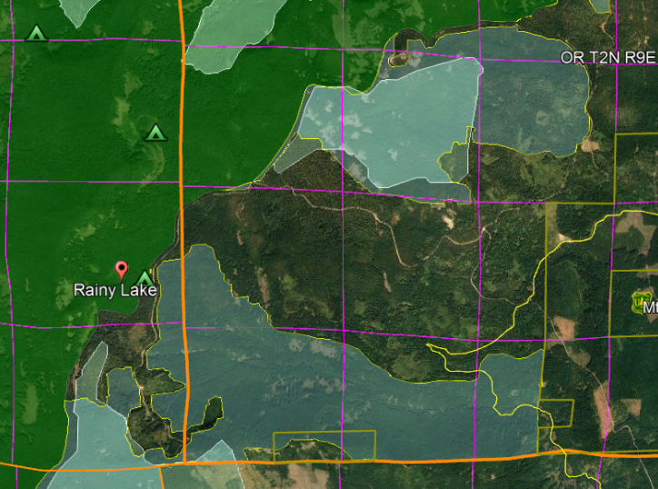

The FS Failed to Consider New information on the Significant and Disproportionate Ecological Value of Unlogged Unroaded Areas >1,000 acres
The agency cannot limit its analysis of roadless areas to inventoried areas >5,000 acres, because smaller roadless areas that were not inventoried are ecologically relevant and potentially significant. The NEPA analysis must reflect the growing scientific evidence (cited below) indicating the significant value of roadless areas smaller than 5,000 acres and larger than 1,000 acres. Recent scientific literature emphasizes the importance of unroaded areas greater than 1,000 acres as strongholds for the production of fish and other aquatic and terrestrial species, as well as sources of high quality water. Commercial logging and/or road building within large unroaded areas threatens these significant ecological values.

First, it is important to recognize that about 30% of inventoried roadless areas (IRA) nationwide are smaller than 5,000 acres. It is therefore likely that the diverse and significant values of IRAs can be found within many other unroaded areas between 1,000 and 5,000 acres that were simply not inventoried. NEPA requires that these values be recognized and the effects of logging and roads be carefully disclosed and considered. Martin, DeVelice, Brown. 2001. Landscape Analysis and Biodiversity Specialist Report. Forest Service Roadless Area Conservation FEIS. November 2000. http://www.fs.usda.gov/Internet/FSE_DOCUMENTS/fsm8_035781.pdf
Small areas are important for conserving biodiversity of species with small home ranges, species with special habitat needs, or for providing linkages between larger areas. … Of the more than 2,800 named inventoried roadless areas, about 70% of these areas are larger than 5,000 acres (USDA Forest Service 2000a).

Large unroaded areas are important simply due to the fact that they better represent the historic condition that species evolved with but they are now rare on the landscape due to human activities that have degraded and fragmented the majority of the landscape. The Northwest Forest Plan LSOG Effectiveness Monitoring Plan says that “perhaps 80 percent or more [of the historic late-successional old-growth forest] would probably have occurred as relatively large (greater than 1,000 acres) areas of connected forest.” Miles Hemstrom, Thomas Spies, Craig Palmer, Ross Kiester, John Teply, Phil McDonald, and Ralph Warbington; Late-Successional and Old-Growth Forest Effectiveness Monitoring Plan for the Northwest Forest Plan, USFS General Technical Report PNW-GTR-438; December 1998; http://www.fs.fed.us/pnw/pubs/gtr_438.pdf. Currently, these 1,000 acre and larger patches are rare on the landscape.

Boakes et al (2009) explained why it is important to retain large unroaded areas.
Abstract: Habitat clearance remains the major cause of biodiversity loss, with consequences for ecosystem services and for people. In response to this, many global conservation schemes direct funds to regions with high rates of recent habitat destruction, though some also emphasize the conservation of remaining large tracts of intact habitat. If the pattern of habitat clearance is highly contagious, the latter approach will help prevent destructive processes gaining a foothold in areas of contiguous intact habitat. Here, we test the strength of spatial contagion in the pattern of habitat clearance. Using a global dataset of land-cover change at 50x50 km resolution, we discover that intact habitat areas in grid cells are refractory to clearance only when all neighbouring cells are also intact. The likelihood of loss increases dramatically as soon as habitat is cleared in just one neighbouring cell, and remains high thereafter. This effect is consistent for forests and grassland, across biogeographic realms and over centuries, constituting a coherent global pattern. Our results show that landscapes become vulnerable to wholesale clearance as soon as threatening processes begin to penetrate, so actions to prevent any incursions into large, intact blocks of natural habitat are key to their long-term persistence.
Elizabeth H. Boakes, Georgina M. Mace, Philip J. K. McGowan and Richard A. Fuller 2009. Extreme contagion in global habitat clearance. Proceedings of the Royal Society B: Biological Sciences. November 25, 2009. doi: 10.1098/rspb.2009.1771

World Wildlife Fund and the Conservation Biology Institute summarized the important attributes of small roadless areas (1,000-5,000 acres).
Small roadless areas share many of attributes in common with larger ones, including:
• Essential habitat for species key to the recovery of forests following disturbance such as herbaceous plants, lichens, and mycorrhizal fungi
• Habitat refugia for threatened species and those with restricted distributions (endemics)
• Aquatic strongholds for salmonids
• Undisturbed habitats for mollusks and amphibians
• Remaining pockets of old-growth forests
• Overwintering habitat for resident birds and ungulates
• Dispersal “stepping stones” for wildlife movement across fragmented landscapes
WWF CBI 200x. Importance of Roadless Areas in Biodiversity Conservation: A Scientific Perspective - Executive Summary.
http://magicalliance.org/download/ecological-importance-of-roadless-areas.pdf

In a 1997 letter to President Clinton, 136 scientists said:
There is a growing consensus among academic and agency scientists that existing roadless areas–irrespective of size–contribute substantially to maintaining biodiversity and ecological integrity on the national forests. The Eastside Forests Scientific Societies Panel, including representatives from the American Fisheries Society, American Ornithologists’ Union, Ecological Society of America, Society for Conservation Biology, and The Wildlife Society, recommended a prohibition on the construction of new roads and logging within existing (1) roadless regions larger than 1,000 acres, and (2) roadless regions smaller than 1,000 acres that are biologically significant…. Other scientists have also recommended protection of all roadless areas greater than 1,000 acres, at least until landscapes degraded by past management have recovered…. As you have acknowledged, a national policy prohibiting road building and other forms of development in roadless areas represents a major step towards balancing sustainable forest management with conserving environmental values on federal lands. In our view, a scientifically based policy for roadless areas on public lands should, at a minimum, protect from development all roadless areas larger than 1,000 acres and those smaller areas that have special ecological significance because of their contributions to regional landscapes.
Letter to President Clinton from 136 scientists (Dec. 10, 1997).
https://docs.google.com/open?id=0B4L_-RD-MJwrRzhFcm5QcFR0MHM

To the list of special values found within unroaded areas must be added carbon storage. European policy leaders consider roadless areas effective for carbon storage and climate mitigation:
[T]he European Parliament has agreed to raise the issue of roadbuilding in intact forests at the UN Climate Change Conference to be held next month in Warsaw (Poland); it calls on parties to use the existence of roads in forest areas as an early negative performance indicator of REDD+ projects, and to prioritise the allocation of REDD+ funds towards road free forests.
Oct 24, 2013 Press release: EUROPEAN PARLIAMENT BACKS THE PROTECTION OF ROADFREE AREAS. http://kritonarsenis.gr/eng/actions/view/european-parliament-backs-the-protection. Federal land managers should recognize the tremendous carbon values in unroaded/unmanaged forests and avoid actions that would threaten these values. See also, William R. Moomaw, Susan A. Masino, and Edward K. Faison. 2019. Intact Forests in the United States: Proforestation Mitigates Climate Change and Serves the Greatest Good Front. For. Glob. Change, 11 June 2019 | https://doi.org/10.3389/ffgc.2019.00027; https://www.frontiersin.org/articles/10.3389/ffgc.2019.00027/full. See also, Kun, Z., DellaSala, D., Keith, H., Kormos, C., Mercer, B., Moomaw, W.R. and Wiezik, M. (2020), Recognising the importance of unmanaged forests to mitigate climate change. GCB Bioenergy. Accepted Author Manuscript. doi:10.1111/gcbb.12714 https://onlinelibrary.wiley.com/doi/pdfdirect/10.1111/gcbb.12714. (“The most effective means for keeping carbon out of the atmosphere to meet climate goals is to protect primary forests (Mackey et al. 2020) and continue growing secondary forests to accumulate additional carbon (proforestation) (Moomaw et al. 2019) while reducing emissions from all sources including bioenergy. … The importance of primary (unlogged) forests lies in the magnitude and longevity of their carbon stock. In order to reverse the decreasing forest carbon stocks in Europe (EEA, 2019), the largest forest carbon stores must be protected and additional forests must be allowed to continue accumulating carbon (proforestation).”).

There are tremendous co-benefits from conserving large blocks of unmanaged forests, such as climate mitigation and biodiversity conservation.
Based on the species–area relationship, regarded as one of ecology’s few universal laws, protection of [too] little habitat will condemn thousands of species to extinction if habitat outside them is converted, degraded or lost. It is this logic that underpins calls for‘Nature Needs Half’ [26], together with an understanding that ecosystem processes and services of the scale needed to sustain the well-being of life on Earth require large wildlife populations and huge expanses of intact and restored habitat. ... Climate change adds a new dimension to the question of how much protected area coverage is needed to assure conservation of wild nature. Climate change is already reducing wildlife population sizes and forcing range shifts as conditions alter [28,29]. Protected areas counter such stresses by building up populations, and connectivity of populations and habitats is emerging as a key property in securing species persistence and resilience to rapid change [5]. Hence networked protected areas, especially where embedded within well-managed landor seascapes, provide crucial stepping stones to accommodate range shifts and, where no further movements are possible, refuges of last resort [5]. Analyses suggest that adequate levels of population viability and connectivity can be achieved only with marine protected area coverages of 30% or more [27]. ... [G]iven that many ecosystems are already degraded, ensuring continued provision of ecosystem services requires not only the precautionary protection of currently intact habitats, but also large-scale habitat restoration.
Providing greater space for recovery of intact, vibrant nature is not altruistic conservation, but is, we argue, an indispensable act of self- preservation, roducing a cascade of benefits that will help maintain the habitability of the biosphere as the climate changes, thereby securing the well-being of generations to come.
Roberts CM, O’Leary BC, Hawkins JP. 2020 Climate change mitigation and nature conservation both require higher protected area targets. Phil. Trans. R. Soc. B 375: 20190121. http://dx.doi.org/10.1098/rstb.2019.0121. See also, Soto-Navarro C et al. 2020 Mapping co-benefits for carbon storage and biodiversity to inform conservation policy and action. Phil. Trans. R. Soc. B 375: 20190128. http://dx.doi.org/10.1098/rstb.2019.0128 showing the congruence of high carbon value and high biodiversity value in PNW forests.

The FS failed to take a hard look at the adverse effect of logging on recruitment of snags and dead wood habitat, and failed to consider the adverse effects of logging in light of new information that the LRMP snag standards are scientifically discredited and it is understood that wildlife need more snags for a wider variety of life functions than previously recognized
Tables 2 and 3 of the Wildlife Report (pp 30-31) show that the proposed action will result in a significant shortage of medium and large snags lasting for many decades after logging. The FS has no basis to say that this level of snags is sufficient for wildlife. The analysis does not compare the projected snags levels to the needs of wildlife, such as the tolerance levels in DecAID. However even if it did there is no connection between DecAID and any standards that define sufficient snag habitat, but there is science raising concerns that we are not leaving enough snags after logging. This issue requires an EIS especially given the fact that regen has very significant effects on snag habitat by retaining too few green trees to ensure recruitment of snags over time.

Shelterwood harvest will result in a snag gap. One of the most significant and lasting effects of stand replacing disturbance such as fire, wind, or regeneration logging is to bring the process of snag recruitment to a virtual standstill for many decades. This results in a “snag gap” that has serious adverse consequences for habitat and many other ecological processes. Modelling by Harris (2000) suggests that 12 or more green trees need to be retained during regen harvest for every snag we want to recruit at any given time during the rotation. Harris, R.B. 2000. Estimating large snag recruitment needs in regeneration timber harvests. Western Journal of Applied Forestry. 15: 140-146.
http://www.cas.umt.edu/facultydatabase/FILES_Faculty/1152/Harris%202000%20LargeSnagRecruitment%20Western%20J.%20Appl.%20For.pdf.

The analysis says “the proposed action would result in a sufficient quantity over time to meet the needs of dependent species.” This is unsupported by any analysis. The FS has not adopted (through NEPA and NFMA procedures) scientifically credible standards to define what quantity of snags and dead wood is “sufficient” to meet the needs of wildlife (and other ecosystem services associated with dead wood. The current forest plan standards for dead wood are scientifically discredited. New science says that the old standards do not retain enough snags and dead wood (or green trees for future recruitment) to meet the needs of wildlife associated with dead wood. See Rose, C.L., Marcot, B.G., Mellen, T.K., Ohmann, J.L., Waddell, K.L., Lindely, D.L., and B. Schrieber. 2001. Decaying Wood in Pacific Northwest Forests: Concepts and Tools for Habitat Management, Chapter 24 in Wildlife-Habitat Relationships in Oregon and Washington (Johnson, D. H. and T. A. O’Neil. OSU Press. 2001) http://web.archive.org/web/20060708035905/http://www.nwhi.org/inc/data/GISdata/docs/chapter24.pdf. As explained on the DecAID website:
Why is DecAID needed?
National Forest LRMP standards and guidelines for management of snags and down wood in the Pacific Northwest were based on wildlife species models and tools that were developed in the 1970s and 1980s (Thomas et al. 1979, Neitro et al. 1985, Marcot 1992, Raphael 1983). New information about the ecology, dynamics, and management of decayed wood has been published since then, and the state of the knowledge continues to change. Rose et al. (2001) report that results of monitoring indicate that the biological potential models are a flawed technique (page 602). There has been an evolution from thinking of large woody material as habitat structures, to thinking of decaying wood as an integral part of complex ecosystems and ecological processes.

This paradigm shift has made the management of dead wood a much more complex task. We can no longer expect to go to our LRMPs or the biological potential model to get one number for the amount or size of snags and down wood that we can apply to all projects and to all acres. We are directed to use the best available science to manage ecosystems, and the best available science simply will not support business as usual for managing dead wood.
Region 6 - USDA Forest Service. A Guide to the Interpretation and Use of the DecAID Advisor. June, 2006. http://www.fs.fed.us/r6/nr/wildlife/decaid-guide/. The authors of DecAID describe some of the limitations of the old methods of managing snag habitat.

Limitations of Existing Approaches for Assessing Wildlife-Dead Wood Relations.
Models of relationships between wildlife species and snags in the Pacific Northwest typically are based on calculating potential densities of bird species and expected number of snags used per pair. This approach was first used by Thomas et al. (1979). Marcot expanded this approach in Neitro et al. (1985) and in the Snag Recruitment Simulator (Marcot 1992) by using published estimates of bird population densities instead of calculating population densities from pair home range sizes. This approach has been criticized because the numbers of snags suggested by the models seem far lower than are now being observed in field studies (Lundquist and Mariani 1991, Bull et al. 1997). In addition, the models provided only deterministic point values of snag sizes or densities and of population response ("population potential") instead of probabilistic estimates that are more amenable to a risk analysis and risk management framework.
In addition, existing models have focused on terrestrial vertebrate species that are primary cavity excavators. Thomas et al. (1979) and Marcot (1992) assumed that secondary snag-using species would be fully provided for if needs of primary snag-excavating species were met. However, McComb et al. (1992) and Schreiber (1987) suggested that secondary cavity nesting birds may be even more sensitive to snag density than are primary cavity excavators.
Furthermore, existing models do not address relationships between wildlife and down wood, nor do they account for species that use different types of snags and partially dead trees, such as hollow live and dead trees used by bats (Ormsbee and McComb 1998, Vonhof and Gwilliam 2007), Vaux's swift (Chaetura vauxi) (Bull and Hohmann 1993), American marten (Martes americana) (Bull et al. 2005), and fisher (Martes pennanti) (Zielinski et al. 2004).
Bruce G. Marcot , Janet L. Ohmann, Kim L. Mellen-McLean, and Karen L. Waddell. Synthesis of Regional Wildlife and Vegetation Field Studies to Guide Management of Standing and Down Dead Trees. Forest Science 56(4) 2010. http://www.fs.fed.us/pnw/pubs/journals/pnw_2010_marcot002.pdf

The Forest Service needs to prepare a EIS to consider a replacement methodology for maintaining species and other values associated with dead wood. This is especially critical because adequate dead wood is recognized as an essential feature of healthy forests and the Forest Service has identified lots of “management indicator species” associated with dead wood habitat.

Logging mature and old forest may cause significant effects by making a bad situation worse for snags and dead wood habitat. A century of human influence punctuated by several decades of aggressive and irresponsible clearcutting and development have pushed forest ecosystems far outside the natural range of variability. Numerous species in our forests and streams qualify for listing under the Endangered Species Act or have recognized concerns for persistence. To be consistent with the Northwest Forest Plan and to help recover at-risk species, all future management actions must be designed to move forest and stream ecosystems towards the middle of the range of variability, and must NOT push ecosystems further toward the extremes. All regen harvest, salvage harvest, and road building will move forests in the wrong direction further toward the extremes. Thinning young plantations to create complexity and diversity and encourage decadence would move forest ecosystems in the right direction.

Recent research covering the Oregon Coast Range (but likely applicable to all conifer forests in Western Oregon) shows, “The majority of the landscape historically contained 500-700 Mg/ha of live wood and 50-200 Mg/ha of dead wood. The current dead wood condition is outside HRV. Stands with very low dead wood are currently dominant but rarely occurred historically.” Nonaka, Etsuko, Spies, Thomas, Wimberly, Michael, Ohmann, Janet. 2004. Historical range of variability in biomass dynamics and stand disturbance history: A simulation approach. http://abstracts.co.allenpress.com/pweb/esa2004/document/35104.
NONAKA, ETSUKO AND THOMAS A. SPIES. 2005. HISTORICAL RANGE OF VARIABILITY IN LANDSCAPE STRUCTURE: A SIMULATION STUDY IN OREGON, USA Ecological Applications, 15(5), 2005, pp. 1727–1746.
http://www.fs.fed.us/pnw/pubs/journals/uncaptured/pnw_2005_nonaka001.pdf.
http://www.fsl.orst.edu/clams/download/pubs/2005EA_nonaka_spies.pdf.
The following tables show Abundance of forest types with various combinations of live and dead wood relative to historic mean values derived from multiple 1,000 year simulations. Based on Table 3.4 in Nonaka, E, Spies, TA, Wimberly, MC, and Ohmann, JL. 2007. Historical range of variability (HRV) in live and deadwood biomass: a simulation study in the Coast Range of Oregon, USA. Can. J. For. Res. 37:2349-2364. http://naldc.nal.usda.gov/download/9953/PDF.

live wood biomass | very high |  | mature and old-growth forests with abundant live biomass and some dead wood are significantly below the historic mean
live wood biomass | high
live wood biomass | moderate high |  |  |  | unsalvaged disturbances with abundant dead wood are well below the historic mean
live wood biomass | moderate | clearcuts and post-fire salvage result in young forests with little dead wood. This type was rare historically but now significantly above the historic mean
live wood biomass | low
live wood biomass | very low
live wood biomass |  | very low | low | moderate | moderate high | high | very high
 | dead wood biomass

Here is the same chart showing magnitude of the departure from historic mean. Each + or - represents a deviation from the mean of 1% of the landscape).

live wood biomass | very high |  | - - - | - - - - - - - - - - - - - - - - - - - - - - - - - - - -
live wood biomass | high |  | - - - - - - - - - - - - - - - - - - - - - - - - - - - | - - -
live wood biomass | moderate high | + | - - - - - | - | - - - | -
live wood biomass | moderate | +++++ ++++ | ++ | + | - | -
live wood biomass | low | +++++ ++++ +++++ +++++ | +++ +++ | ++ | - | -
live wood biomass | very low | +++++ +++++ +++++ +++++ +++++ | +++++ +++++ | +++ | - - | - - | - -
live wood biomass |  | very low | low | moderate | moderate high | high | very high
 | dead wood biomass

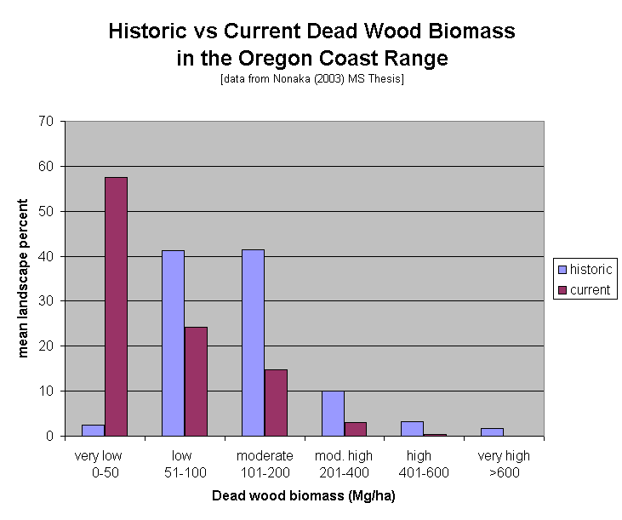

The FS failed to take a hard look at the adverse effect of logging on spotted owls and adverse competitive interactions with barred owls
The analysis of barred owl competition with spotted owls ignores the elephant in the room. Logging suitable habitat, or forests that could soon grow into suitable habitat reduces the availability of habitat for the two owl to co-exist within and increases the chances of adverse competitive interactions and competitive exclusion.

A well-known axiom of the species-area relationship from island biogeography holds that as habitat area increases, the number of cohabiting species also increases. See especially, Part III - Competition in a Spatial World in Tilman, D. and P. Karieva, Eds. 1997. Spatial Ecology: The Role of Space in Population Dynamics and Interspecific Interactions. Monographs in Population Biology, Princeton University Press. 368 pp.

“The major causes of population and species extinction worldwide are habitat loss and interactions among species. … The most robust generalization that we can make about population extinction is that small populations face a particularly high risk of extinction. … [E]mpirical support for the extinction-proneness of small populations has been found practically wherever this issue has been examined. … The loss of habitat reduced population size …. Larger habitat patches have larger expected population sizes than smaller patches. Therefore, other things being equal, we could expect large habitat patches to have populations with a lower risk of extinction than populations in small patches. … More generally, the relationship between patch size and extinction risk provides a key rule of thumb for conservation: other things being equal it is better to conserve a large than a small patch of habitat or to preserve as much of a particular patch as possible. … [T]here are likely to be many complementary reasons why large patches have populations with low risk of extinction. ”
Oscar E. Gaggiotti and Ilkka Hanski. 2004. Chapter 14 - Mechanisms of Population Extinction. In Ecology, Genetics, and Evolution of Metapopulations. Elsevier. 2004. http://web.archive.org/web/20070612211945/http://www.eeb.cornell.edu/sdv2/Readings/Gaggiotti&Hanski.pdf
A telemetry study showed that in fragmented landscapes barred owls have a survival advantage relative to spotted owls, but that survival advantage diminishes in landscapes with a higher proportion of older forest. In other words, conservation of mature & old-growth forest should be favored because spotted owls are able to compete nearly equally with barred owls in landscapes with a high proportion of old forest.
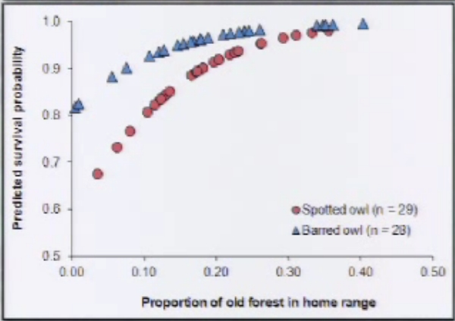
See Wiens, D. 2012. Presentation to The Wildlife Society. http://tws.sclivelearningcenter.com/index.aspx?PID=6893&SID=163551 (at 1:12).

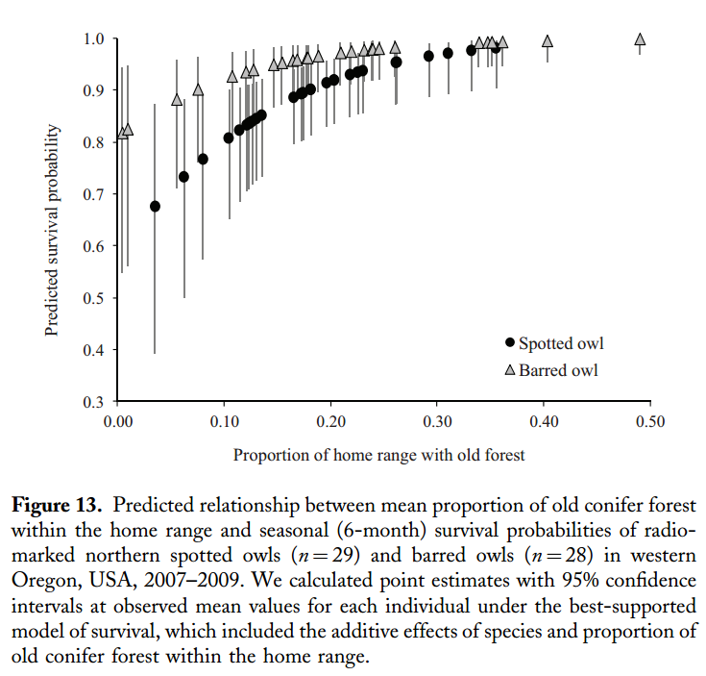
Wiens, J.D., Anthony, R.G., and E.D. Forsman. 2014: Competitive Interactions and Resource Partitioning Between Northern Spotted Owls and Barred Owls in Western Oregon. Wildlife Monographs 185:1–50; 2014; DOI: 10.1002/wmon.1009. https://ir.library.oregonstate.edu/xmlui/bitstream/handle/1957/48214/AnthonyRobertFisheriesWildlifeCompetitiveInteractions.pdf

David Wiens has conducted the most thorough research on the influence of barred owls on spotted owls and concluded -
Conservation Implications
• Results emphasize the importance of old conifer forest and moist streamside habitats to resource partitioning.
• Additional loss of older forest can further constrain both species to a common set of limiting resources, thereby increasing competitive pressure
Wiens, D.J. 2012. Dietary Overlap between Northern Spotted Owls and Barred Owls in Western Oregon, workshop What’s for Dinner: Spotted Owl Prey 2012 http://ecoshare.info/projects/central-cascade-adaptive-management-partnership/workshops/spotted-owl/; http://ecoshare.info/wp-content/uploads/2012/08/Barred-compared-to-spotted-Owl-diets.ppt

Yackulic et al (2019) show that continued emphasis on habitat restoration can help mitigate uncertainty about barred owl removal efforts which remain untested. Yackulic, Charles, et al. 2019. The past and future roles of competition and habitat in the range-wide occupancy dynamics of Northern Spotted Owls. Ecological Applications, 2019 DOI: 10.1002/eap.1861. https://esajournals.onlinelibrary.wiley.com/doi/pdf/10.1002/eap.1861. (“ ... maintaining or improving habitat condition could be an important factor in promoting persistence of NSO populations over longer time spans and could allow managers to be less reliant on BO removals in the future ... habitat recovery could eventually lessen the need for intensive management actions such as Barred Owl removal. If, on the other hand, managers allow habitat conditions to decline they may have to rely more on BO removal ...”) Stated another way, the agencies can reduce uncertainty about the long-term funding and long-term effectiveness of barred owl removal by emphasizing recovery of high quality suitable nesting, roosting, foraging habitat for northern spotted owls.

The FS failed to take a hard look at the adverse effect of regen logging which has potentially significant effects on wildlife, carbon, fire hazard, water quality/quantity, recreation and scenic values, etc.,

Shelterwood regen and Heavy Thinning will increase fire hazard and make forests less resilient to disturbance and climate change
The purpose and need for this project to enhance huckleberries, conflicts with the purpose to improve resilience. The analysis did not adequately weigh these effects. Shelterwood/regen logging and replanting conifers will stimulate growth of a new cohort of young trees that will grow and create continuous dense fuels close to the ground that have long flame lengths, carry fire, and serve as dangerous ladder fuels. Intermediate thinning to 30% canopy closure presents many of the same concerns to a slightly lesser degree.

The 2000 National Forest Roadless Area Conservation FEIS (p 3-92 -93) noted the fire hazard associated with regen logging:
[E]arly successional vegetative growth often forms into dense thickets that create a highly flammable situation. New tree growth, whether from natural regeneration or planted nursery stock, produces needles and twigs that become the fine fuel that contributes to wildland fire spread. … Post-harvest fuel conditions commonly found in some managed forests prompt many scientists to conclude that harvested forests have a higher propensity for large, severe wildland fires than forests that have not been harvested. A recent report by the National Research Council (2000) speaks to the issue of post-harvest fuel management in Pacific Northwest forests.
“Logging has been proposed as a possible surrogate for fire in reducing fuel accumulation with the added benefit of economic return (Agee 1993), but logging and clearcutting do not necessarily reduce flammable fuels…rapid regeneration of early-successional shrubs and trees can create highly flammable fuel conditions within a few years of cutting. Without adequate treatment of small woody residues, logging may exacerbate fire risk rather than lower it (Agee 1993)…”
USDA FS 2000. National Forest Roadless FEIS. https://web.archive.org/web/20160315152803/http://www.fs.usda.gov/roaddocument/roadless/2001roadlessrule/finalruledocuments

In the 1970s, Judge Burns recognized that regen harvest increases fire hazard. This was a class action case brought on behalf of Portland residents seeking to protect the Bull Run municipal watershed on the Mt Hood NF by enforcing a unique anti-trespassing law, but the judge’s findings with respect to the hazards associated with regen harvest and roads are instructive.

Logging cannot be said to reduce the risk of fire: it cannot affect the incidence of lightning and it raises rather than lowers the risk of man-caused fires. …

Logging may, however, have an effect on fire hazard.... What is important here is to decide whether the largescale, commercialized, sustained-yield logging program presently carried on by the Forest Service in fact reduces the hazard of fire. The uncomplicated truth is that slash from logging is not removed, the present program annually increases rather than decreases the fuel load, and does so in the types of fuel that are most dangerous as precursors to a crown fire. … Slash from old growth forests 'nearly always results in an extreme rate of spread and resistance to control. The potential for disastrous fires is high in the latter case unless the slash is disposed of immediately.' …
Unfortunately, 'logging residue is not being abated--it is accumulating.' …Even the slash-burned acres may have high ground fuel levels because slash burning does not remove all the fuel. The sustained-yield commercial logging program conducted in Bull Run adds to rather than decreases the fuel levels: to say that large-scale commercial logging increases, rather than diminishes, protection of the forest from fires is to say that black is white.
… [T]he road system which has been constructed since 1958 has not been the system which would have been built if intended primarily for fire fighting and control purposes. The road system largely represents roads to timber--not roads to fires. … The roads were primarily for logging, and only incidentally for fires.
Under the Forest Service's theory, to protect the water and the forest, it has to build roads to fight fires; it has to sell timber--lots of it--to get the roads built. Ergo, large-scale timber sales protect the forest. This may or may not be good logic, given the pitfalls of the federal budget process. But my duty is not to evaluate the logic, but rather to evaluate the law. Good logic or not, I hold this theory is not good law, in light of s 1862.
…[R]oads are not themselves particularly useful in fighting the catastrophic or crown fire. Only nature will suppress such a fire.
Miller v. Mallery, 410 F.Supp. 1283, 1294-1296 (D. Or 1976).

The FS failed to take a hard look at the adverse effect of logging on mature and old growth forest habitat. Regen harvest reduces populations of small mammals.

The analysis does not adequately disclose the adverse consequences of logging, especially shelterwood harvest on spotted owl prey. Small mammals are important prey for spotted owls and other focal predator species. Canopy removal and reduced stand complexity caused by regen harvest are adverse to small mammals such as red-backed voles, flying squirrels, and red tree voles.
“Clearcuts are drier than intact stands (Tappeiner et al., 2007), thus many conifer clearcuts may be too dry for red-backed voles (D.E. Pearson, personal communication), which are known for their high moisture requirements (Getz, 1962). … Red-backed voles strongly prefer structurally complex micro-habitats (Pearson, 1994).”
Rafał Zwolak 2009. A meta-analysis of the effects of wildﬁre, clearcutting, and partial harvest on the abundance of North American small mammals. Forest Ecology and Management 258 (2009) 539–545. http://stkctr.biol.sc.edu/Reprints/Reprints_4/Zwolak_2009.pdf

The analysis assumes that dispersal habitat is unlikely to provide foraging opportunities, but the analysis fails to recognize that owl dispersal habitat will be much more valuable to spotted owls if it does provide foraging opportunities.

Regen does not mimic natural disturbance

The NEPA analysis needs to consider the potentially significant cumulative effects on ecosystems and hydrologic systems from widespread logging in the project area and surrounding watersheds.

Foresters like to think that regen logging mimics natural processes like fire, but this is far from the case, because logging removes so much more biomass than fire. Fire leaves abundant legacies that offer some late successional habitat value, even in the young stands that dominate in the decades after fire. This is not the case with regen logging which removes much more biomass and disproportionally removes the large legacy components. This causes a much more abrupt spatial and temporal transition/fragmentation between young and old forests. Logging also causes much more significant soil disturbance, especially compaction and displacement, from roads, landings, skidding and yarding logs, and unusually hot slash fires. This spreads weeds, harms the below-ground ecosystem, degrades site productivity, and causes erosion. Regen combined with replanting and roads also causes very atypical hydrologic disruption, including artificial peak flows immediately after the first several storms following logging, and artificial low flows during summer for several decades following establishment of dense tree plantations.

Regen logging does not mimic natural disturbance because it removes the vast majority of the habitat structure, such as snags and large down wood, that early seral wildlife depend on. Eighty five percent of vertebrates tied to edges and early seral forest in the western Cascades need dead wood. C. Friesen 2010. Early Seral Forests – A Conservation Conundrum. http://www.ecoshare.info/uploads/ccamp/Early-Seral-Forest-Friesen.ppt; http://ecoshare.info/projects/central-cascade-adaptive-management-partnership/synthesis-papers-tools/

“Key attributes” of high quality early seral habitat include “exceptionally high quantities of large dead wood,” a condition that is not provided by commercial timber harvest that exports the vast majority of wood from the site. “[P]rompt reforestation and few legacies is unlikely to approximate the role of naturally generated early-seral conditions” M.E. Swanson Mark E. Swanson, Nichole M. Studevant, John L. Campbell, Daniel C. Donato. 2014. Biological associates of early-seral pre-forest in the Pacific Northwest. Forest Ecology and Management 324 (2014) 160–171. http://www.sierraforestlegacy.org/Resources/Conservation/Biodiversity/BD-Swanson-etal-EarlySeral2014.pdf.

Regen harvest to create early seral forest is not needed

Logging proponents say that regen harvest of mature forest is needed to enhance early seral forest which is in short supply, but this assertion is not well supported.
The amount of early-successional forest on the landscape within the range of the northern spotted owl is probably greater now than at any time in the past. ... Any species that find optimum habitat in burned forests must have had the dispersal and reproductive capabilities to find and reproduce in these dispersed and infrequent patches of habitat. In general, species associated with early-successional conditions are good dispersers, have high reproductive rates, and are able to persist in small patches of habitat that result from small-scale disturbance (Hunter 1990, Smith 1966)....

Compared to their historic populations, species associated with these early-successional conditions have increased in abundance. For example, Raphael et al. (1988) estimated that populations of 11 species of birds have probably tripled over historic numbers, and another 4 species have more than doubled. Raphael et al. (1988) and Raphael (1988) compared the estimated abundance of amphibians, reptiles, birds, and mammals from historic times to their present abundance and concluded that the early-successional associates that have increased over time were associated with more open, drier conditions; were widely distributed (larger total geographic ranges than species associated with late-successional conditions); and, had wider ecological tolerances (i.e., they occupy a greater variety of habitat types). As noted by Harris (1984), birds associated with early-successional forest are more often migrants whereas late-successional associates are generally permanent residents. These studies also show that whereas some species associated with early-successional conditions reach their maximum abundance in early-successional forest, none of the species were restricted to that successional stage.
...
The creation of early-successional conditions as a result of logging has produced a different pattern on the landscape than the pattern that likely would have resulted solely from natural disturbance. Patches of early-successional forest are now more evenly distributed across the landscape, and sizes of patches are smaller. This pattern may have resulted in a more widespread distribution of early-successional species than in the past.
…
[T]here is currently additional acreage of early-successional forest intermixed in a fragmented pattern within all of the Late-Successional Reserves and Riparian Reserves on federal lands within the range of the northern spotted owl. As well, natural disturbances will continue to create early-successional conditions. The federal forest lands occur within a broader landscape of nonfederal lands where additional early-successional forest will be created through logging and other management activity. These lands will contribute to the maintenance of early-successional forest over time.
1994 NWFP FSEIS, pp 3&4-203 – 204.
Also, there is no shortage of early seral forest. In fact, there’s already too much early seral in the Oregon Coast Range. Janet Ohmann. Trends in Early Seral Forest at the Stand and Landscape Scale. http://www.slideshare.net/ecoshare/janet-l-ohmann-trends-in-early-seral-forest-at-the-stand-and-landscape-scale. (Slides 12, 29 show there is “no shortage of early seral” in Coastal Oregon, and early seral “exceeds the HRV” [historic range of variability].)

BLM’s analysis for the 2015 RMP Revisions DEIS (Vol 1, pp 182-183) indicates that the “current condition” shows no shortage of “early seral forest” across 1.3 million acres of dry Douglas fir forests. (“Currently, the Douglas-fir/dry vegetation type has a slight overabundance of early seral and a substantial overabundance of mid-seral closed forest”) The biggest shortage is late seral forest types. The agencies’ main focus should remain transitioning over-abundant mid-seral stands to help mitigate the persistent deficit of late-seral stands.
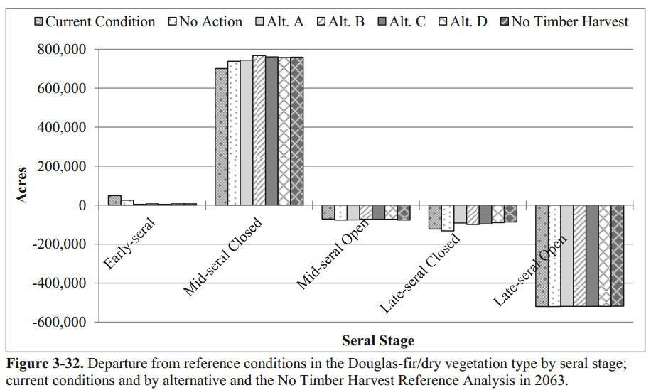
http://www.blm.gov/or/plans/rmpswesternoregon/files/draft/RMP_EIS_Volume1_pg_173-235.pdf

There are many ways of enhancing early-seral habitat without sacrificing mature forests, for instance, we could:
- Modify the way we fight fire and how we react after fire, e.g., leave areas to recover naturally after fire instead of salvage logging and replanting which more closely resembled industrial clearcutting;
- Modify practices on non-federal lands to encourage greater retention of live and dead trees during harvest, tolerate slower conifer re-establishment and greater diverse of native vegetation, e.g., discourage herbicide spraying to control competing native vegetation;
- Embed structure-rich “gaps” (e.g. patches of very heavy thinning) in our young stand thinning projects. See Miller, Randall. 2014. Practitioners Approach to Early Seral Habitats on Lands Managed Primarily for Older Forest, or There is More to Healthy Forests than Conifer Trees. Siuslaw NF. http://www.slideshare.net/ecoshare/09-practitionersapproachtoearlyseralhabitatsonlandsmanagedprimarilyforolderforestorthereismoretohealthyforeststhanconifertreesmiller; Cheryl Friesen and Norm Michaels 2010. Effects of Incorporating Gaps into Commercial Thinning Prescriptions: Best Available Science, 3-30-2010, Central Cascades Adaptive Management Partnership (CCAMP). http://ecoshare.info/projects/central-cascade-adaptive-management-partnership/synthesis-papers-tools/
- Extend the early seral character of existing very young stands that are starting to become dominated by conifers.

As an example, the Salem BLM’s 2013 decision on the Molalla Late-Successional Reserve Habitat Enhancement Project thins 2000 acres of young plantations (less than 40 y.o.) to variable canopy of 80-120 tpa. The goal is to set stand on a trajectory to develop multiple canopy layers and increase stand diversity. Within treated stands, BLM will create 1-5 acre patches with density reduced to 20 tpa, with the goal to develop of high-quality early seral habitat in near term while enhancing late successional diversity over the long-term.

Phalan et al (2019) looked at the effects of reduced harvest after adoption of the Northwest Forest Plan on birds associated with early seral forests and found that “Between 1984 and 2012, the early-seral ecosystem area declined on federal land by 18% ... Counter to our expectations, declines in diverse early-seral ecosystems on federal land came to an end, likely because of large wildfires ... Increases in areas of large, high-severity wildfires appear to have compensated for any decline in early-seral ecosystems created through harvest.” Benjamin T. Phalan, Joseph M. Northrup, Zhiqiang Yang, Robert L. Deal, Josée S. Rousseau, Thomas A. Spies, and Matthew G. Betts 2019. Impacts of the Northwest Forest Plan on forest composition and bird populations. PNAS 2019. https://www.pnas.org/content/pnas/early/2019/01/29/1813072116.full.pdf

Here is a map showing fire perimeters in eastern and western Oregon over the last two decades. There is presumably a significant amount of early seral habitat associated with these fires.

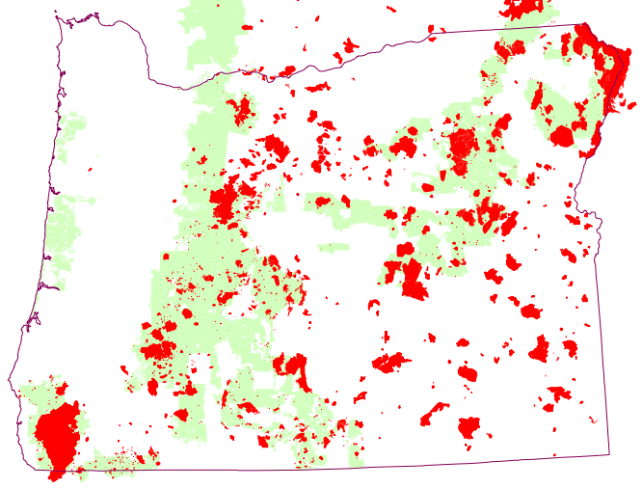
? http://www.mtbs.gov/compositfire/mosaic/bin-release/burnedarea.html

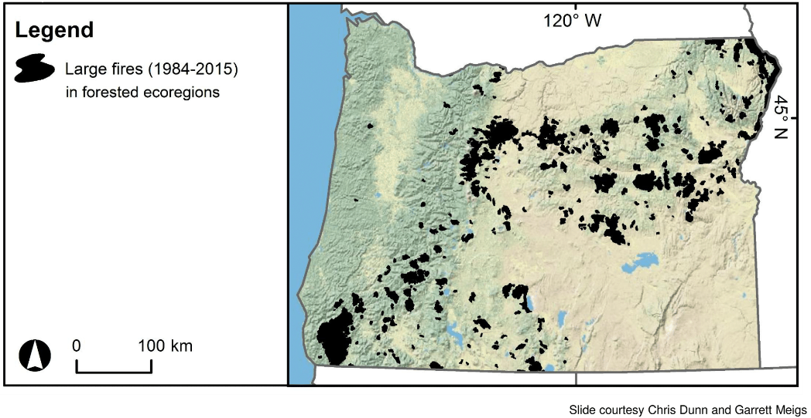

Oregon Wild’s scoping 2011 comments on the Coos Bay Wagon Road and Roseburg BLM Secretarial Pilot Projects shed further light on this issue:
Complex early seral forest
One of the primary restoration objectives we keep hearing for these projects is the need to restore complex early seral forest. This may well be an important goal. However, this goal needs to be validated and if valid, alternative means of meeting the goal must be explored. With a little thought and creativity one can see that many ways to increase rare early seral habitat without sacrificing rare mature & old-growth forests.

Validation of the early seral habitat objective requires, among other things, asking if the current and projected amount of early seral habitat might be adequate to meet the needs of the opportunistic and generalist species that tend to occur in those areas. Only the interior valleys (and a few ridgetops) of western Oregon likely had persistent early seral conditions, while most of the federal forest landscape had transient early seral conditions associated with disturbances. Early seral wildlife species likely evolved to take advantage of early seral conditions when and where it could be found in the shifting mosaic of seral conditions.

Natural disturbance processes continue to operate across the landscape, including fire, wind, ice storms, landslides, floods, volcanoes, native insects, native disease, etc. Each of these helps create various sized patches of early seral forests every year. Many predict that climate change will increase the frequency of these natural events, suggesting that any shortage of early seral conditions might just take care of itself. "Ecologically, increased distribution and frequency of disturbances may result in increased distribution and dominance of early successional ecosystems dominated by fire adapted species..." Lemieux, Christopher J., Daniel J. Scott, Rob G. Davis and Paul A. Gray. 2008. Changing Climate, Challenging Choices: Ontario Parks and Climate Change Adaptation. University of Waterloo, Department of Geography: Waterloo, Ontario http://web.archive.org/web/20101023221023/http://www.fes.uwaterloo.ca/geography/faculty/danielscott/PDFFiles/NRCAN-Report-FINAL.pdf [fn/ Conversely, it may become harder to maintain existing late-seral ecosystems and species, so existing late-successional old-growth forests should be retained in order to avoid making the shortage of late seral forest worse.]

There is widespread recognition that early seral forest is produced in abundance on non-federal lands (through industrial clearcutting). Current industrial forest practices does not produce high quality or long-lasting early seral forest. It is also true, but not widely recognized that the absolute abundance of early seral forest on non-federal lands might partially mitigate for its lack of quality.

Early seral vegetation also exists along many streams, rock outcrops, meadows, as well as roadsides, landings, and other disturbed sites throughout the forest. An honest assessment of the early seral shortage must account for the quantity, quality and functionality of all these early seral forest elements.

If there is indeed a shortage of complex early seral forest, we must evaluate a full range of alternative ways of increasing either the quantity and/or quality of such features. Alternatives that have been suggested include:

(a) Reform forest practices on non-federal lands to retain more legacy structures and allow a longer period of conifer establishment and more vegetation diversity after harvest, as suggested by Norm and Debora Johnson in 2007 —
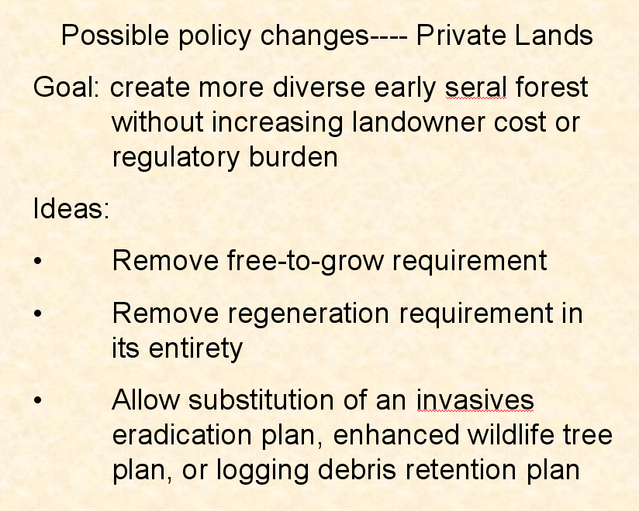
K. Norm Johnson, Debora L. Johnson. 2007. Policies to Encourage Diverse, Early Seral Forest in Oregon: What Might We Do? http://www.reo.gov/ecoshare/ccamp/good_forest_opening/powerpoints/Early%20seral%20talkrevfinal.ppt

(b) Rely on natural processes such as fire, wind, insects, etc. Since the public has been misinformed that natural forest mortality processes are undesirable, this approach would work best if we increase public tolerance for natural processes. This approach may also require reform of fire suppression policies and post-fire salvage logging and replanting, as suggested by Norm Johnson, Jerry Franklin, and others in 2007 Early Seral Forest Symposium. http://www.reo.gov/ecoshare/ccamp/Good_Forest_Opening.shtml.

(c) Aggressive pre-commercial thinning in existing very young stands or failed plantations to extend the early seral stage, as suggested in the Chalk Parker Project on the Middle Fork District of the Willamette NF;

(d) Create patches of heavily-thinned, structure-rich “gaps” in variable density thinning projects in dense planted stands <80 years old, as suggested by numerous projects around the region.

All these alternative methods would allow meaningful restoration of early seral forest conditions without unnecessarily sacrificing mature forests.
Oregon Wild 2011. Scoping Comments on the Wagon Road and Roseburg BLM Secretarial Pilots. http://www.oregonwild.org/oregon_forests/forest-management/in-your-forests/files-for-eyes-on-the-agencies/Wagon_Road_and_Roseburg_Pilots_scoping_6-29-2011_BLM.pdf

Climate change may increase early seral.

Efforts to artificially enhance early seral should recognize that climate change might take care of this for us, and in fact might make it much harder to hang on to the mature forests we have. "Ecologically, increased distribution and frequency of disturbances may result in increased distribution and dominance of early successional ecosystems dominated by fire adapted species..." Lemieux, Christopher J., Daniel J. Scott, Rob G. Davis and Paul A. Gray. 2008. Changing Climate, Challenging Choices: Ontario Parks and Climate Change Adaptation. University of Waterloo, Department of Geography: Waterloo, Ontario http://web.archive.org/web/20101023221023/http://www.fes.uwaterloo.ca/geography/faculty/danielscott/PDFFiles/NRCAN-Report-FINAL.pdf. Conversely, it may become harder to maintain existing late-seral ecosystems and species, so existing late-successional old-growth forests should be retained in order to avoid making the LSOG shortage worse.

Waring & Coops (2015) explained that we can expect more fire as a result of climate change.
Wildland fires can be expected to establish new landscape patterns over time, while correcting the “fire deficit” created following a century of fire exclusion (Marlon et al. 2012; North et al. 2015). The patterns are not expected to attain stability, however, because projected temperature increases, derived from 11 climate models, are expected to result in an increase in total cloud-to-ground lightning flashes of 12 % ± 5 % per degree Celsius of global warming, equivalent to a 50 % increase over the rest of this century for the contiguous United States (Romps et al. 2014).
Richard H. Waring, Nicholas C. Coops. 2015. Predicting large wildfires across western North America by modeling seasonal variation in soil water balance. Climatic Change. March 2016, Volume 135, Issue 2, pp 325–339. http://link.springer.com/article/10.1007/s10584-015-1569-x. See also, Jennifer R. Marlon, Patrick J. Bartlein, Daniel G. Gavin, Colin J. Long, R. Scott Anderson, Christy E. Briles, Kendrick J. Brown, Daniele Colombaroli, Douglas J. Hallett, Mitchell J. Power, Elizabeth A. Scharf, and Megan K. Walsh. Long-term perspective on wildfires in the western USA. PNAS, February 14, 2012 DOI: 10.1073/pnas.1112839109. http://www.pnas.org/content/109/9/E535.full.pdf (“Biomass burning in the western United States has remained in dynamic equilibrium with climate at least since 500 CE to the 1800s CE. Burning generally increased when temperatures and drought area increased, and decreased when temperatures and drought declined. … Against the backdrop of climatic and ecological processes, human activities had a marked impact on biomass burning after the late 1800s. … The data do suggest however that even modest increases in temperature and drought (relative to those being projected for the 21st century) are able to perturb the level of biomass burning as much as large-scale industrialized human impacts on fire. … Since the mid 1800s, the trend in fire activity has strongly diverged from the trend predicted by climate alone and current levels of fire activity are clearly out of equilibrium with contemporary climate conditions. The divergence in fire and climate since the mid 1800s CE has created a fire deficit in the West that is jointly attributable to human activities and climate change … Although the current rate of biomass burning is not unusual (even allowing for post-1980 CE increases in burning such as in ref. 3), it is clearly out of equilibrium with the current climate. Our long-term perspective shows that the magnitude of the 20th century fire decline, while large, was matched by “natural” fire reduction during cold, moist intervals in the past (e.g., LIA). Current fire exclusion and suppression however, is taking place under conditions that are warmer and drier than those that occurred during the MCA, which calls into question their long-term efficacy.”)

Human-induced climate change promotes the conditions on which wildfires depend, enhancing their likelihood and challenging suppression efforts. Human-induced warming has already led to a global increase in the frequency and severity of fire weather, increasing the risks of wildfire. ... Fire weather refers to periods with a high likelihood of fire due to a combination of high temperatures, low humidity, low rainfall and often high winds. Rising global temperatures and more frequent heatwaves and associated droughts increase the likelihood of wildfire by promoting hot and dry conditions which are conducive to fire weather. ... Western US and Canada. Models suggest that the impacts of anthropogenic climate change on fire weather extremes and fire season length emerged in the 2010s (Abatzoglou et al., 2019; Williams et al., 2019; Abatzoglou & Williams, 2016). Yoon et al. (2015) similarly predicted the occurrence of extreme fire risk would exceed natural variability in California by 2020. ... Paleo records also support increased wildfires during warmer periods. Sedimentary charcoal records and other indicators of fire activity have been used to extend records of fire throughout the Holocene period (the past 12,000 years) and beyond, enabling assessment of long-term interactions between climate and biomass burnt (Marlon et al., 2013, 2016). Other model–data comparisons reveal robust correspondence between fire and climate during the Holocene in most regions ...
Matthew W. Jones, Adam Smith, Richard Betts, Josep G. Canadell, I. Colin Prentice, and Corinne Le Quéré 2020. Climate Change Increases the Risk of Wildfires. Rapid Response Review using ScienceBrief.org. Published 14 January 2020. https://tyndall.ac.uk/sites/default/files/wildfires_briefing_note.pdf, https://sciencebrief.org/briefs/wildfires.

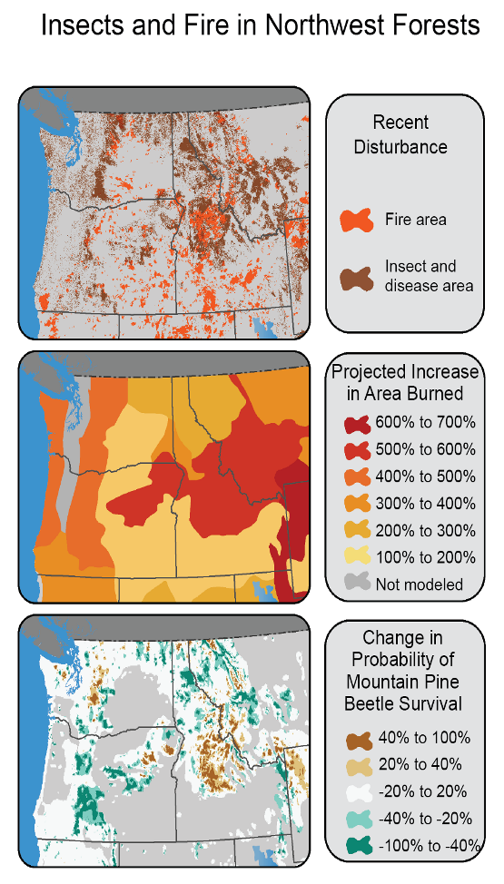
2014 National Climate Assessment. http://nca2014.globalchange.gov/

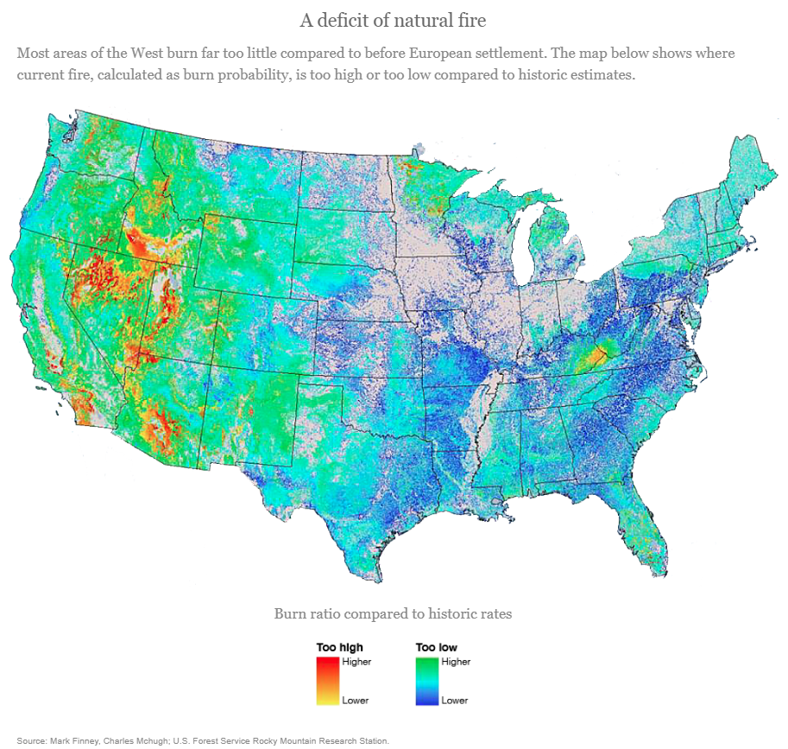

Tony Schick 2018. Can 'Moneyball' Fix How The West Manages Wildfire? OPB/EarthFix July 16, 2018 https://www.opb.org/news/article/fire-wildfire-west-management-science-data-risk-moneyball/

Tepley AJ, Thompson JR, Epstein HE, Anderson-Teixeira KJ. Vulnerability to forest loss through altered postfire recovery dynamics in a warming climate in the Klamath Mountains. Glob Change Biol. 2017; 00: 1–16. https://doi.org/10.1111/gcb.13704. (“In the context of ongoing climatic warming, certain landscapes could be near a tipping point where relatively small changes to their fire regimes or their postfire forest recovery dynamics could bring about extensive forest loss, with associated effects on biodiversity and carbon-cycle feedbacks to climate change. Such concerns are particularly valid in the Klamath Region of northern California and southwestern Oregon, where severe fire initially converts montane conifer forests to systems dominated by broadleaf trees and shrubs. Conifers eventually overtop the competing vegetation, but until they do, these systems could be perpetuated by a cycle of reburning.”)

“‘We see climate change affecting the system from two directions,’ says Thompson. ‘First, it is slowing conifer growth, keeping them low to the ground and more vulnerable to future fires for a longer period of time. Second, climate change is making fire more frequent. This phenomenon, which researchers call the 'interval squeeze,' threatens to transform this and other arid, fire-prone forests worldwide.’ ” Harvard Forest. 2017. Study: Wildfire in a Warming Climate Could Relegate Some Forests to Shrubland. Thursday, April 27, 2017. http://harvardforest.fas.harvard.edu/news/study-wildfire-warming-climate-could-relegate-forests-shrubland.

The FS failed to take a hard look at the adverse effect of logging riparian reserves, including steep and unstable slopes such as units 136 and 138 that should be designated as riparian reserves. Logging in Riparian Reserves to Meet ACS Objectives Not Scientifically Supported.

Units 136 and 138 are steep slopes and unstable (or potentially unstable) that should be designated as riparian reserves and protected from logging. 1994 NWFP ROD, p 9.

We are not entirely opposed to restoration actions in riparian reserves possibly even including thinning dense young stands, but the FS has latched onto questionable rationales for logging in riparian reserves that do not hold up to scrutiny. The FS needs to carefully weigh the scope and magnitude of all alleged benefits, against all adverse trade-offs, and limit restoration activities to those with clear net benefits. The EA did not do that.

The analysis says logging 129 acres of riparian reserves (down to 50% canopy and only 30-60 foot no cut buffer) would be for purposes including “improving future quality of downed wood and in-stream large wood.” The analysis did not address trade-offs including loss of wood quantity, and less reliable input of wood compared to the no action alternative. The EA did not disclose that unthinned trees continue to grow and that thinning has rather modest effects on tree size. The EA did not address the fact that multiple pieces of small wood can make up for any lack in size. The EA did not address the fact that most of the affected streams are small and smaller wood I still functional in smaller streams. The EA is contradictory saying that small wood decays faster, yet somehow also accumulates to cause a fire hazard, which is it?

The analysis seems to justify logging in riparian reserves based on reduce the risk of fire and other disturbance. This needs to be better explained in light of the standards & guidelines which admonish the FS to recognize the role of fire in ecosystems and minimize disturbance of vegetation: “FM-1. Design fuel treatment and fire suppression strategies, practices, and activities to meet Aquatic Conservation Strategy objectives, and to minimize disturbance of riparian ground
cover and vegetation. Strategies should recognize the role of fire in ecosystem function…”

The analysis says “In small streams, relatively small diameter pieces of woody debris can contribute to pool formation (Beechie and Sibley 1997)”. Why is this disclosed in the description of the proposed action (logging) instead of in the analysis of no action?

The analysis says “There would be no effect on large wood recruitment to the EFHR due to protection 23 buffers meeting or exceeding the height of site potential trees.” But this is confusing because the EFHR acronym is not defined, and the proposed action allows logging as close as 30 feet form streams.

The EA says “The Forest Plan has a standard of 106 pieces of suitable large wood per mile of stream (FW-095). To be counted towards this standard in eastside streams, large wood needs to be least 35 feet long with 80 percent at least 12 inches in mean diameter, and at least 20 percent over 20 inches in mean diameter.” The EA failed to compare the effects of alternatives to this standard over time. This is a significant oversight given that the EA admits that instream wood is deficient in the project area. Most of the trees to be removed are already over 12 inches in diameter, so logging riparian reserves as close as 30-60 feet form stream will directly and immediately retard attainment of plan objectives. And in the future more tress in riparian reserves will attain 20” dbh under no action than if these stands are logged. The FS has a duty to analyze effects relative to substantive legal standards. See Judge King's October 2003 Decision in ONRC Action v. U.S. Forest Service, CV. 03-613-KI (“The underlying EAs for the timber sales at issue did not properly frame the Forest Service’s survey and manage duties, they did not analyze a range of alternatives based upon these duties, they did not evaluate completed surveys, they did not demonstrate that the Forest Service had all of the proper information before it before allowing logging, and they did not provide for public influence over the decisions. For all of these reasons, the underlying EAs are legally deficient.” Emphasis added.) http://web.archive.org/web/20041105214752/http://www.onrc.org/press/ONRCv.USFS.pdf
And also Judge Hogan’s ruling in Klamath Siskiyou Wildlands Center v. Boody (D. Or. #03-3124-CO. May 18, 2004) where he held “plaintiffs have raised a serious question as to whether BLM violated NEPA in failing to disclose sufficient information in the EA to confirm compliance with … the RMP.” (Order at page 18).

The analysis says “in-stream large wood could be reduced within the treatment units but will result in higher quality wood recruitment over the long term.” This admits that ACS objectives for wood recruitment will be adversely affected and it implies that those adverse effects will be outweighed by enhanced quality of wood recruitment, resulting in net benefits to ACS objectives. This conclusion is unstated in the analysis and is not supported by the available evidence which shows that any gain in the size of trees in thinned stands is outweighed by the quantitative loss of functional wood recruitment.

When the analysis says of the no action alternative “there would be an increase in the amount of down wood, but this wood would generally be smaller in diameter and thus would decay faster both in and out of stream channels.” It does not disclose the number of trees available for recruitment varies greatly between the proposed action and no action alternatives, while the size of trees varies only a little between alternatives. In short, the quantitative reduction of wood recruitment due to logging in riparian reserves is significant and long-lasting, while the increase in tree size attributed to logging is modest and vastly outweighed by the loss of wood quantity. These details are important yet remain undisclosed.

The analysis says logging in riparian reserves is “consistent with the Aquatic Conservation Strategy Objectives because it would lead to improved conditions in the long term.” This is not supported. Abundant wood recruitment is important to meeting aquatic and terrestrial wildlife objectives in the riparian reserves land allocation, but logging causes a significant long-term loss of wood recruitment because the population of green trees is reduced and may not be enough trees available for recruitment throughout the full width of the reserves over the long-tem.

The figure below, from Pollock et al (2012), shows that tree removal through thinning can lead to stand development trajectories that miss the reference condition for dead wood. We point this out to highlight one of the trade-offs involved in thinning, and to encourage careful thinking about mitigation. Leaving the cut trees in the woods is a good short-term mitigation, but the small trees do not last long enough to fill the temporal gap between now and when the stand begins recruiting more dead wood on its own. Leaving unthinned patches within treated stands is a good mid-to-long-term mitigation.
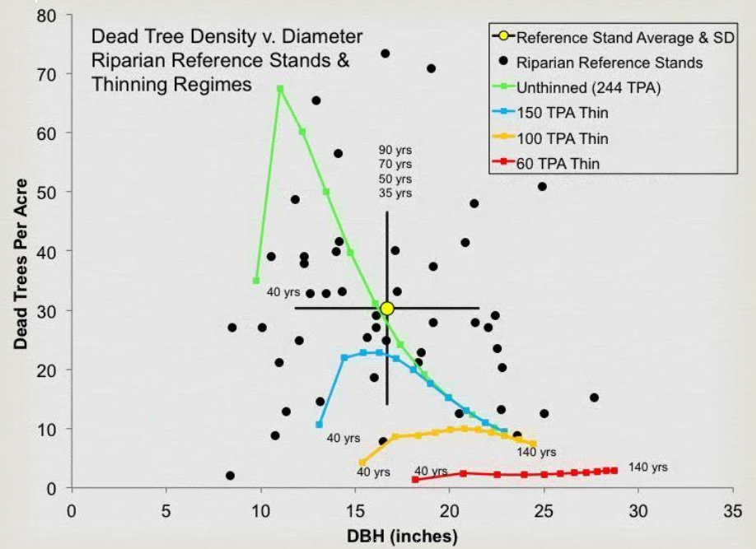
Pollock, M. M., T. J. Beechie, and H. Imaki. 2012. Using reference conditions in ecosystem restoration: an example for riparian conifer forests in the Pacific Northwest. Ecosphere 3(11):98. http://dx.doi.org/10.1890/ES12-00175.1

In January 2013, the Science Review Team Wood Recruitment Subgroup reported their “Key Points” regarding the effects of commercial thinning on wood recruitment in riparian reserves:

… In general, there is very little published science about the effects of thinning on dead wood recruitment and virtually none on thinning effects on wood recruitment in riparian zones. We conducted some limited simulation modeling to illustrate some of the relationships between thinning and dead wood recruitment. The simulations (and comparison of models) were not comprehensive or a rigorous analysis of thinning effects and should be viewed as preliminary. Below we provide 15 key points from our efforts:

Key Points

1. Thinning is most beneficial in dense young stands. Existing literature and stand development theory suggest that the greatest potential ecological benefits of thinning to accelerate the development of older forest structure (e.g. large trees, large dead trees, spatial structural and compositional heterogeneity, etc.) comes in dense uniform plantations less than 80 years and especially less than 50 years old. The benefits of thinning for older forest ecological objectives are less clear in stands over 80 years of age. Hence, our report focused primarily on plantations less than 50 years of age.

2. Results may not be applicable to all stand conditions. For this synthesis, many of our conclusions were based on modeling the effects of thinning 30 to 40 year old Douglas-fir plantation stands that range in density from 200 to 270 trees per acre (tpa). We consider such stands moderately dense, as young plantation stand densities range from less than 100 to greater than 450 tpa. In terms of dead wood production, higher density stands are likely to see more benefits from thinning, and lower density stands less benefits. [Portions of this project are probably less dense and less in need of thinning, compared to the very dense, very young stands addressed in this report.]

3. Accurate assessments of thinning effects requires site-specific information. The effects of thinning regimes on dead wood creation and recruitment (relative to no-thinning) will depend on many factors including initial stand conditions, particularly stand density, and thinning prescription—it is difficult to generalize about the effects of thinning on dead wood without specifying the particulars of the management regime and stand conditions. [The NEPA analysis needs to provide a site-specific, quantitative analysis to show that silviculture is needed to meet ACS objectives in these riparian reserves.]

4. Conventional [i.e., commercial] thinning generally produces fewer large dead trees. Thinning with removal of trees (conventional thinning) will generally produce fewer large dead trees across a range of sizes over the several decades following thinning and the life-time of the stand relative to equivalent stands that are not thinned. Generally, recruitment of dead wood to streams would likewise be reduced in conventionally thinned stands relative to unthinned stands. [This result is highly relevant to the proposed logging to meet ACS objectives.]

5. Conventional [i.e., commercial] thinning can accelerate the development of very large diameter trees. In stands that are conventionally thinned, the appearance of very large diameter dead trees (greater than 40”) may be accelerated by 1 to 20 years relative to unthinned plantations, depending on thinning intensity and initial stand conditions. Trees of such sizes typically begin to appear 5 to 10 decades after thinning 30 to 40 year old stands. [Note: The appearance of a few “very large” trees in the decades after thinning comes with the loss of a much larger volume of “large functional” trees that were exported from the site before they were allowed to grow and recruit to the stream. Any small gains in very large trees, comes at the expense of large numbers of large trees, so net benefits to ACS objectives are highly unlikely.]

6. Nonconventional [i.e., non-commercial] thinning can substantially accelerate dead wood production. Stands thinned with prescriptions that leave some or all of the dead wood may more rapidly produce both large diameter dead trees in the short-term and very large diameter dead trees (especially greater than 40”) in the long-term, relative to unthinned stands. Instream wood placement gets wood into streams much sooner than by natural recruitment, and can offset negative effects of thinning on dead wood production.

7. Assessments of thinning effects may vary depending on the forest growth model. The previous statements are supported by three stand simulation models (FVS, ORGANON, and ZELIG). However, the magnitude and timing of effects of thinning on dead wood recruitment and stand growth varied among models.

8. Dead wood in streams comes from multiple sources. Dead wood in streams is primarily recruited through near-stream inputs (e.g. tree mortality and bank erosion) and landslides and debris flows. All types of recruitment are important and the relative importance varies with site and stream characteristics.

9. 95% of near-stream wood inputs come from within 82 to 148 feet of a stream. The distance of near-stream inputs to streams varies with forest conditions and geomorphology. Empirical studies indicate that 95% of total instream wood (from near-stream sources) comes from distances of 82 to 148 feet. Shorter distances occur in young, shorter stands and longer distances occur in older and taller stands. [Don't forget: riparian reserves were established to serve both aquatic and terrestrial objectives, and many terrestrial wildlife depend on abundant snags and dead wood.]

10. Thinning can increase the amount of pool-forming wood under certain conditions. Thinning can increase the amount of pool-forming wood only when the thinned trees are smaller in diameter than the average diameter of pool-forming wood (which varies with stream size). [Smaller wood is functional in smaller streams, which means that thinning any commercial-sized trees near small streams is unlikely to advance ACS objectives.]

11. The function of instream wood varies with size and location. Large instream wood can serve as stable “key” pieces that create instream obstructions and form wood jams by racking up numerous smaller pieces of wood that are mobile during high flows. Such wood jams typically consist of a wide range of piece sizes and provide multiple ecological functions that vary with stream size and gradient.

12. Effects of thinning on instream wood needs to be placed in a watershed context. Assessing the relative effect of riparian thinning on instream wood loads at a site and over the long term requires an estimation of the likely wood recruitment that will occur from the opposite bank, from upstream transport, and the rate of decay and downstream transport of wood from the site.

13. The ecological effects of thinning needs to be placed in a watershed context. Watershed-scale perspectives are needed to restore streams and riparian vegetation. The ecological effects of thinning on instream habitat will vary depending upon location in the stream network. Riparian management practices can be varied to match the ecological functions of streams.

14. Variation in thinning is essential (i.e. don’t do the same thing everywhere). Variation in thinning prescriptions will produce more variable forest and wood recruitment conditions, which may more closely mimic natural forest conditions. Using a variety of treatments is also consistent with the tenets of adaptive management in situations where the outcomes of treatments are uncertain.

15. Healthy, diverse forests contain many dead trees. Numerous terrestrial forest species require large dead or dying trees as essential habitat. Some directly, others indirectly; to support the food web within which they exist. Abundant large snags and large down wood on the forest floor are common features of natural forests and essential for the maintenance of biological diversity.
Thomas Spies, Michael Pollock, Gordon Reeves, and Tim Beechie 2013. Effects of Riparian Thinning on Wood Recruitment: A Scientific Synthesis - Science Review Team Wood Recruitment Subgroup. Jan 28, 2013, p 36. http://www.mediate.com/DSConsulting/docs/FINAL%20wood%20recruitment%20document.pdf

The statement in #5 that "thinning can accelerate development of very large diameter trees" should be kept in proper perspective:
- The alleged gain in very large trees is very minor, compared to not logging;
- The alleged gain in very large trees is overwhelmed by the significant loss of functional wood in smaller size classes (including “large” wood), and even “medium “ and “small” wood that serves vital functions in small streams that are typical in most projects; and
- The alleged gain in very large trees is in the distant future and more speculative; while the loss of smaller functional wood is in the near-term and more certain. Predicting future mortality in thinned stands is difficult. If the trees do not die and fall down there is no benefit in terms of down wood.

The apparent dissonance between the fact that thinning reduces wood recruitment (#4), but also has the potential to increase production of the very large trees (#5) might be resolved by looking to the right mix of different treatments as suggested in #14 – with some riparian reaches left unthinned to provide for recruitment of large amounts of wood in a range of sizes, some areas thinned non-commercially, and some riparian patches thinned to produce those very large trees. Also, the statement in #10 that thinning can increase pool-forming wood depending on stream size, needs more explanation. Most riparian thinning occurs near small streams where small wood can be pool-forming.

Thinning to produce very large wood in the distant future at the expense of more abundant wood recruited over time is not advised. The SAT Report, upon which the ACS is founded, was clear that continuous input of wood is important. “Riparian zones along larger channels need protection to limit bank erosion due to trampling, grazing, and compaction, to ensure an adequate and continuous supply of large wood to channels …” 1993 SAT Report. Ch 5, p 455. Commercial removal of pool forming wood creates a gap in the wood recruitment process and is inconsistent with the goal of continuous wood recruitment.

The Analysis Failed to Disclose Logging Riparian Reserves Will Harm Terrestrial Wildlife
There is a fisheries report and a wildlife report but neither of these reports disclose the value of riparian reserves to terrestrial wildlife and the effects of logging, especially degraded microclimate and loss of dead wood values.

The analysis says “The proposed action includes some thinning in the dry upland portion of the riparian reserves and no-harvest protection buffers along the streams. Some commenters suggest that no treatment … would maximize trees dying on their own and falling into the stream.” This does not accurately describe the issue with logging in riparian reserves. The ecological value of dead wood recruitment in riparian reserves is not limited to wood recruited to the stream. Riparian reserves are intended to support the needs of a wide variety of wildlife, including many terrestrial wildlife that spend time in riparian reserves and will benefit from abundant dead wood habitat throughout the full extent of the riparian reserves, not just instream.

The authors of the NWFP Aquatic Conservation Strategy (ACS) recognized that logging outside stream buffers already depletes the amount of dead wood that could potentially fall into the riparian reserves, and they extended the reserves beyond a single-site-potential tree distance in order to buffer-the-buffer and ensure that upland areas of riparian reserves would maintain near natural levels of dead wood accumulation. The analysis does not seem to recognize this, and proposes to log riparian reserves in opposition to the purposes and intent of the Aquatic Conservation Strategy.

The Northwest Forest Plan ACS explicitly recognized the problem of reduced wood recruitment in narrow riparian buffers adjacent to logged sites. Simply put, logging adjacent to riparian reserves removes a source of wood recruitment within riparian reserves. The 1993 FEMAT Report, an appendix to the EIS supporting the NWFP explained:
Large wood on the ground is an important habitat component in riparian areas. Maintaining the integrity of the vegetation is particularly important for riparian-dependent organisms including amphibians, arthropods, mammals, birds, and bats (see appendix V-E for greater detail).
…
Riparian Processes as a Function of Distance from Stream Channels
…
Large wood delivery to riparian areas. Large downed logs are recruited into riparian areas from the riparian forests and from upslope forests. Similar to large wood delivery from riparian areas into streams, the effectiveness of upland forests to deliver large wood to the riparian area is naturally expected to decline at distances greater than approximately one tree height from the stand edge (Thomas et al.., 1993). Timber harvest adjacent to the riparian area creates an edge that eliminates one source of large wood. Thus, long-term levels of large wood may diminish in the riparian zone.
1993 FEMAT Report, pp V-25 - V-26.

Riparian reserves are intended to protect numerous species that do not live in the stream, rather, they live in the stream-side forest extending hundreds of feet from the stream, but they still require a relatively cool-moist microclimate, complex forest structure, and abundant wood, and these species will be adversely affected by logging adjacent to narrower riparian reserves. This is part of the reason the NWFP adopted a buffer-on-the-buffer, that is, an outer buffer of shade and cover to maintain suitable microclimate conditions for wildlife that live in the inner buffer.

The EIS supporting the NWFP states:
Riparian areas are widely considered to be important wildlife habitat. Cool air temperatures due to the presence of cool and turbulent surface waters, typically dense vegetative canopy cover, and their location in the lowest portions of watersheds combine to maintain a distinct microclimate along stream channels and in the adjacent riparian area. Maintaining the integrity of the vegetation in these areas is particularly important for riparian-dependent species of amphibians, arthropods, mammals, birds, and bats. Many species of amphibians, birds, and mammals use late-successional and old-growth riparian areas, including associated streams, ponds and wetlands, for reproducing, foraging, roosting, and as travel corridors (Table 3&4-11). The many wildlife species, along with lichens, mosses, vascular plants and mollusks, listed in Table 3&4-11 depend on diverse and complex riparian and aquatic habitats.
…
The principal factor influencing the outcomes for amphibians related to the width of Riparian Reserves.79 [1994 FSEIS pp 3&4 - 61, 3&4 - 81]
The NWFP recognized that forest openings adjacent to a riparian buffer would create “edge effects” that change the microclimate in the buffer and reduce the recruitment of wood to the buffer. The NWFP addressed this problem by adopting a buffer-on-the-buffer so that at least the inner portion of the riparian reserves would have near-natural microclimate and wood recruitment processes.
…
Many riparian species rely on unimpeded successional processes that accumulate abundant dead wood near streams, but not necessarily in streams. Logging within and adjacent to riparian reserves will capture mortality, truncate wood recruitment processes, and deprive wildlife of the abundant dead wood they need. Likewise, reducing stream buffers and allowing clearcut edges directly abutting inner riparian buffers will eliminate one source of down wood that would otherwise fall into the buffer. Protecting an outer buffer-on-the-buffer helps maintain natural levels of wood recruitment at least within the inner buffer, though the outer buffer itself would still suffer from depleted dead wood levels due to edge effects.
Heiken, D. 2013. Riparian Reserves Provide Both Aquatic & Terrestrial Benefits - A Critical Review of Reeves, Pickard & Johnson (2013). https://www.dropbox.com/s/yc13jrg0ya93yht/Heiken%202013.%20Review%20of%20Reeves%20et%20al%20Riparian%20Proposal.pdf?dl=0. The analysis in the EA does not fully and accurately disclose the original purposes of riparian reserves nor does it clearly and accurately disclose the effects of commercial tree removal within and adjacent to reserves.

The FS failed to take a hard look at the significant adverse effect of logging on carbon emissions/storage and climate change
The analysis says “it is not likely that a detailed carbon analysis would lead to changes to the proposed action or to the creation of other alternatives that achieve the purpose and need.” We will never know unless the analysis is conducted and disclosed to the public and the decision-maker as required by law.

The analysis says “The project area contains lands identified in the Forest Plan and the Northwest Forest Plan that are allocated for sustainable timber production.” This allocation was made before the urgent need for increased carbon storage came to the forefront. One of the purposes of this project is provide a supply of wood products to the public. The agency should reconsider timber targets and related land allocations in light of the fact that the public needs carbon storage to reduce global climate change much more than they need wood products. The NEPA analysis also needs to account for the fact that managing forests for water quality, water quantity, quality of life, and carbon storage for a stable climate will contribute far more to community stability than propping up the timber boom-bust industry with subsidized logging.

The agency must recognize that wood products are already under-priced and over-supplied due to “externalities” (costs that are not included in the price of wood, so those costs are shifted from wood product producers and consumers to the general public who suffer the consequences of climate change without compensation from those who profit from logging related externalities). Ecosystem carbon storage on the other hand is under-supplied because there is not a functioning market for carbon storage and climate services. The agency is in a position to address these market imperfections by focusing on unmet demand for carbon storage instead of offering wood products that are already oversupplied.

Land protection, both public and private, provides substantial ecological benefits by avoiding conversion of natural systems to intensive, developed uses. These benefits include carbon sequestration, watershed functioning, soil conservation, and the preservation of diverse habitat types (e.g., Daily 1997, Brauman et al. 2007, Kumar 2012, Watson et al. 2014). Land protection also solves a key market failure: private markets tend to underprovide socially beneficial land uses such as natural forests, agricultural lands, or managed timberlands. The reason for this failure is that many of the benefits of these lands go to the public in general, not individual landowners. When private values and market transactions determine land uses, less land will be devoted to socially beneficial uses than if citizens could collectively determine use on the basis of social values (e.g., Angelsen 2010, Tietenberg and Lewis 2016).
Katharine R.E. Sims, Jonathan R. Thompson, Spencer R. Meyer, Christoph Nolte, Joshua S. Plisinski. 2019. Assessing the local economic impacts of land protection. Conservation Biology. 26 March 2019 https://doi.org/10.1111/cobi.13318,
https://harvardforest.fas.harvard.edu/sites/default/files/Sims_et_al-2019-Conservation_Biology.pdf.

The analysis says “The elevation of on-site carbon sequestration above all other values is not appropriate for the project area. The science that was cited by some commenters as well as other literature on the subject was considered.” There is no evidence in the record that the FS considered the full range of viewpoints on carbon and climate information. It seems more clear that the FS continues to rely on flawed and misleading information in the carbon template from the Regional office. The NEPA analysis should consider the adverse climate consequences of GHG emissions caused directly and indirectly by logging. The Forest Service should not rely on the boilerplate NEPA language from the regional office which is flawed in many ways. Instead the Forest Service:
- Must recognize the cumulative nature of the GHG emissions and climate problems. It does not matter that this project is small in the global scheme because all emissions matter when the causation is global and cumulative;
- Cannot credibly assert that this project is harmless because it’s not causing deforestation. This is immaterial. All GHG emissions, regardless of the source or how it is labelled, are part of the problem and cause the same climate impacts.
- Cannot credibly assert that thinning for forest health justifies or mitigates emissions from logging. Logging does not increase the capacity for growing trees. To the contrary, logging harms soil and reduces site productivity.
- Must not compare carbon before and after logging. That is an improper framework for NEPA analysis. The proper NEPA framework is to compare the effects of different alternatives (over time), so the agency must describe the carbon emissions and carbon storage in the forest over time with logging and without logging.
- Logging to reduce fire effects does not result in a net increase in forest carbon storage. The agency cannot predict the location, timing, or severity of future wildfires, so most fuel treatments will cause carbon emissions without any offsetting benefits from modified fire behavior. Studies clearly show that the total carbon emissions from logging (plus unavoidable wildfire) are greater than carbon emissions from wildfire alone.
- Cannot credibly assert that carbon storage in wood products is a useful climate strategy. Logging kills trees, stops photosynthesis, and initiates decay and combustion, with the end result being a significant transfer of carbon from the forest to the atmosphere. In stark contrast, an unlogged forest continues to grow and transfer more carbon from the atmosphere to the forest. Carbon emissions caused by logging far exceed the small fraction of carbon transferred to wood products. Carbon accounting methods that attempt to account for substitution of wood for other high-carbon building materials are fraught with uncertainty and too often represent maximum potential substitution effects rather than lower realistic estimates.

The analysis makes several inaccurate and misleading statement about the carbon consequences of logging

The Carbon Report says (our responsive comments are in red):

For this proposal, the following actions have the potential to affect carbon emissions or sequestration:
• Thinning and other treatments to enhance the health of the residual stand would result in trees that are better able to withstand stresses such as dry summer conditions (Millar 2007) (Spittlehouse 2003). Carbon sequestration and emissions are determine by the balance between forest growth and mortality. The analysis fails to account for mortality and emission caused by logging which will vastly exceed mortality and emissions from natural processes during the next several decades. To store carbon over the long-term trees need to survive not only the stress of climate change but also the chainsaws unleashed by the FS timber sale program. Careful studies show that the carbon emitted by thinning vastly exceeds the carbon saved by reducing fire effects (and carbon released by other stresses is likely to be less than carbon released due to fire). Law, B. & M.E. Harmon 2011. Forest sector carbon management, measurement and verification, and discussion of policy related to mitigation and adaptation of forests to climate change. Carbon Management 2011 2(1). https://content.sierraclub.org/ourwildamerica/sites/content.sierraclub.org.ourwildamerica/files/documents/Law%20and%20Harmon%202011.pdf. The EA did not address this. The analysis fails to compare action and no action alternatives.
• Variable-density thinning with skips and gaps and the retention of minor species would result in stands that are resilient and better able to respond to whatever changes come in the future (Millar 2007). This is related to the proposition above. The FS seems to be saying that carbon sequestration and emissions is affected more by species diversity than by logging. This is not supported. It may be true that all-things-being-equal a diverse forest is more resilient in the face of climate change than a homogeneous forest. But that does not answer the question whether the carbon emissions from logging are erased and exceed by carbon gains from improved tree survival due to forest diversity. The weight of evidence shows that logging emits a lot of carbon and these emissions are not made up by improved tree survival due to forest diversity. The analysis fails to compare action and no action alternatives.
• Fossil fuel is used by equipment such as saws, tractors, skyline yarders, helicopters and log trucks. It is possible for some of this equipment to use biofuels, and it is likely to be used where it is available and price competitive. Helicopters would use more fuel than other yarding options. The analysis does not adjust the alleged benefits of biofuel according to the low likelihood that they will in fact be used. The FS does not disclose that biofuels may be worse for the climate than fossil fuels. Biofuels have a lower energy content and require more carbon emissions per unit of energy extracted from the fuels. John S. Gunn, David J. Ganz, and William S. Keeton 2012. Biogenic vs. geologic carbon emissions and forest biomass energy production. GCB Bioenergy (2012) 4, 239–242, doi: 10.1111/j.1757-1707.2011.01127.x http://www.manomet.org/sites/default/files/publications_and_tools/BiogenicGeologic%20August%202011.pdf. The analysis fails to compare action and no action alternatives.
• Some debris and other wood from tree tops and braches would be burned, releasing carbon into the atmosphere. Some debris would be piled at landings and other locations. Some wood may be removed as firewood for burning in residences. Some debris at landings would not be burned but would be used to block roads. In some units, tree tops and branches of cut trees would be left on the ground to decay. The analysis does not make clear that all vegetation killed by the logging operation including the boles of trees have stopped photosynthesis and started to decay and have been put on an accelerated path to the atmosphere. The analysis also fails to account for “forgone sequestration” that is, the loss opportunity to continue accumulating carbon on the living trees that are killed by logging. The analysis fails to compare action and no action alternatives.
• Woody debris retained on the ground increases soil carbon sequestration (Millar 2007). The project would retain some existing debris and logs on the ground and would add more in the form of logging slash such as branches and tree tops. Related to the previous points, the analysis fails to account for the fact that “woody debris” is formerly living trees that could be accumulating storing more carbon, instead they have been killed and put on an accelerated path to the atmosphere. The analysis fails to compare action and no action alternatives.
• Utilizing trees to create long-lived wood products sequesters carbon (IPCC 2007) (FAO 2007) (Stavins 2005) (Upton 2007). Some have shown that using wood to build houses has a more favorable carbon balance when compared to other building materials such as steel, concrete or plastic (Wilson 2006). The Analysis fails to recognize that steel and cement may be energy intensive but energy is fungible and can be produced renewably, so these alternative building materials can theoretically be decarbonized, whereas wood is made of carbon and is an integral part of the global carbon cycle. It can never be decarbonized. See more below.

The Analysis Failed to Recognize that Wood Products a Source of Carbon Emissions, Not a Sink, and the Carbon Value of Wood Products is Often Over-estimated.
Forest Service NEPA analyses often state “Utilizing trees to create long-lived wood products sequesters carbon (IPCC 2007) (FAO 2007) (Stavins 2005) (Upton 2007). Some have shown that using wood to build houses has a more favorable carbon balance when compared to other building materials such as steel, concrete or plastic (Wilson 2006).” This is inaccurate and misleading.

From a climate perspective, wood products represent net carbon emissions, NOT net carbon sequestration, because only a small fraction of the carbon in a logged forest ends up in wood products. Logging to create wood products causes the majority of forest carbon to be transferred to the atmosphere, not to wood products. Science clearly shows that carbon is more safely stored in forests, not in wood products.

Some argue that wood products are a good place to store carbon. This is a counter-productive climate strategy, because –

Only a small fraction of carbon from logged forests ends up in long-term storage in wood products, most is transferred to the atmosphere. Of all the carbon that is killed and/or exposed to accelerated decay in a logging operation only a small fraction ends up as durable goods and buildings -- most ends up as slash, sawdust, waste/trim, hog fuel, and non-durable goods like paper. Some say that converting forest to wood products "delays" emissions, but in fact logging accelerates emissions because they are the result of a process that kills trees that would continue to actively sequester carbon if not logged, and logging involves tremendous waste in the logging process, milling process, construction/manufacturing process.
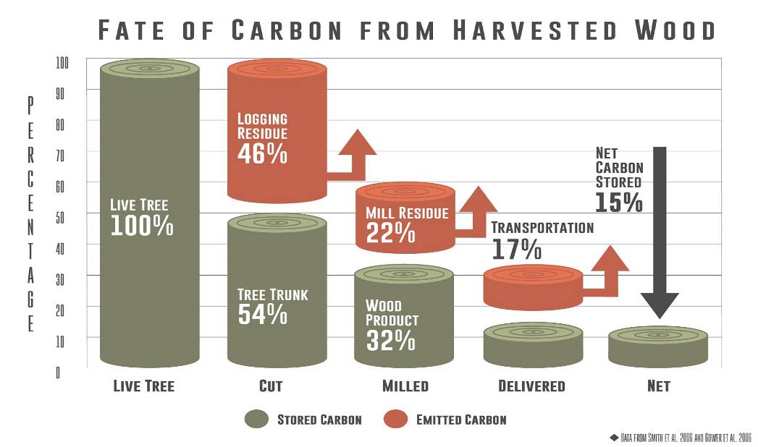

Carbon remains stored much longer in forests than in wood products. Much of the wood products which can reasonably be considered "durable" are in fact less durable than leaving the carbon stored safely inside a mature tree that might live to be hundreds of years old. Most of our wood products are disposable. It turns out that well-conserved forests on average store carbon more securely than our “throw-away” culture and economy does. Law, B. & M.E. Harmon 2011. Forest sector carbon management, measurement and verification, and discussion of policy related to mitigation and adaptation of forests to climate change. Carbon Management 2011 2(1). https://content.sierraclub.org/ourwildamerica/sites/content.sierraclub.org.ourwildamerica/files/documents/Law%20and%20Harmon%202011.pdf (“To the extent that management can direct carbon into longer lived pools, it can increase the stores of carbon in the forest sector. Harvest of carbon is one proposed strategy to increase carbon stores. However, harvesting carbon will increase the losses from the forest itself and to increase the overall forest sector carbon store, the lifespan of wood products carbon (including manufacturing losses) would have to exceed that of the forest. Under current practices this is unlikely to be the case. A substantial fraction (25–65%) of harvested carbon is lost to the atmosphere during manufacturing and construction depending on the product type and manufacturing method. The average lifespan of wood buildings is 80 years in the USA, which is determined as the time at which half the wood is no longer in use and either decomposes, burns or, to a lesser extent, is recycled. However, many forest trees have the potential to live hundreds of years (e.g. 800 years in the Pacific northwest USA). Mortality rates of trees are generally low, averaging less than 2% of live mass per year in mature and old forests; for example, in Oregon, mortality rates average 0.35–1.25% in forests that are older than 200 years in the Coast Range and Blue Mountains, respectively [8]. Moreover, the average longevity of dead wood and soil carbon is comparable to that of live trees. When the loss of carbon associated with wood products manufacturing is factored in, it is highly unlikely that harvesting carbon and placing it into wood products will increase carbon stores in the overall forest sector. This explains why in all analyses conducted to date, wood products stores never form the majority of total forest sector stores.”)

Reliance on wood products prevents forests from reaching their potential for carbon storage. Shanks (2008) said “There are also losses of carbon that occur during the creation of forest products. These losses to decay and wood products make carbon sequestration slower when harvesting is allowed. The young timberlands that replace older harvested lands grow quickly, but hold less in total carbon stores than their older counterparts; the net sequestration from forest products adds to total carbon stores, but does not come close to the vast amounts of carbon stored in non-harvested older timberlands. This finding differs from other papers that have shown that the highest carbon mitigation can be reached when high productivity lands are used exclusively for wood products creation (Marland and Marland, 1992). The wood products considered in these studies were either long lasting or used for fuel purposes. Allowing harvested timber to be allocated to all types of wood products increases carbon emissions and results in no harvest regimes sequestering more carbon.” Alyssa V. Shanks. 2008. Carbon Flux Patterns on U.S. Public Timberlands Under Alternative Timber Harvest Policies. MS Thesis. March 2008. http://ir.library.oregonstate.edu/dspace/bitstream/1957/8326/1/A_Shanks_Thesis_04%2002%2008_final.pdf.

“[W]ood product usage is reducing the potential annual sink by an average of 21%, suggesting forest carbon storage can become more effective in climate mitigation through reduction in harvest, longer rotations, or more efficient wood product usage. ... Allowing forests to reach their biological potential for growth and sequestration, maintaining large trees (Lutz et al 2018), ... will remove additional CO2 from the atmosphere. Global vegetation stores of carbon are 50% of their potential including western forests because of harvest activities (Erb et al 2017). Clearly, western forests could do more to address climate change through carbon sequestration if allowed to grow longer.” Tara W Hudiburg, Beverly E Law, William R Moomaw, Mark E Harmon and Jeffrey E Stenzel 2019. Meeting GHG reduction targets requires accounting for all forest sector emissions. 23 August 2019. Environmental Research Letters, Volume 14, Number 9. https://iopscience.iop.org/article/10.1088/1748-9326/ab28bb/pdf.

The amount of carbon missing from our forests vastly greater than the amount of carbon that can be accounted for in wood products storage. BLM’s Western Oregon Plan Revision FEIS shows that decades of converting old growth forests to plantations has reduced current forest carbon stores on BLM lands in western Oregon by 149 million tons, while some of that wood was converted into wood products, only 11 million tons of that carbon remains stored in wood products today, so logging our public forests to make wood products results in approximately 13 times more carbon emissions than carbon storage. This is pieced together from WOPR FEIS Figures 3-17 (p 3-221) and Figure 3-18 (p 3-224). Further logging of mature forests will exacerbate this outcome. See also, Tara W Hudiburg, Beverly E Law, William R Moomaw, Mark E Harmon and Jeffrey E Stenzel 2019. Meeting GHG reduction targets requires accounting for all forest sector emissions. Environmental Research Letters, Volume 14, Number 9. https://iopscience.iop.org/article/10.1088/1748-9326/ab28bb/pdf (“… over 100 years of wood product usage is reducing the potential annual sink by an average of 21%, suggesting forest carbon storage can become more effective in climate mitigation through reduction in harvest, longer rotations, or more efficient wood product usage. Of the ∼10,700 million metric tonnes of carbon dioxide equivalents removed from west coast forests since 1900, 81% of it has been returned to the atmosphere or deposited in landfills.”)

A lot of wood products are “stored” in landfills where they emit methane which has a global warming effect much greater than CO2. Ingerson, A. 2009 Wood Products and Carbon Storage: Can Increased Production Help Solve the Climate Crisis? Washington, D.C.: The Wilderness Society. http://web.archive.org/web/20100601080813/http://wilderness.org/files/Wood-Products-and-Carbon-Storage.pdf. (“Key Points - 1. When wood is removed from the forest, most of it is lost during processing. The amount lost varies tremendously by region, tree species and size, and local infrastructure. 2. The majority of long-term off-site wood carbon storage occurs in landfills, where decomposing wood gives off significant amounts of methane, a gas with high global warming potential. 3. In addition to wood processing losses, fossil fuels are required to turn raw logs into finished products and ship them from forest to mill to construction site to landfill. 4. Once wood losses and fossil emissions are accounted for, the process of harvesting wood and turning it into products may release more greenhouse gases than the emissions saved by storing carbon in products and landfills. … 9. Properly managed, wood can be a renewable source of building materials and fuels, but solving the climate crisis will require reducing the use of all materials and energy.”)

Living trees, even if they are “suppressed” store and accumulate carbon better than dead wood products. Even a suppressed tree stores carbon better than a dead tree after it is logged, limbed, bucked, debarked, milled, planed, processed, trimmed, manufactured, used, and then discarded. Recent evidence shows that slower-growing older trees tend to channel their energy into structural support and defense compounds to “maximize durability while minimizing … damage”. Colbert & Pederson. 2008. Relationship between radial growth rates and lifespan within North American tree species. Ecoscience 15(3), 349-357 (2008). http://fate.nmfs.noaa.gov/documents/Publications/Black_et_al_2008_Ecoscience.pdf. See also, University of Montana. June 18, 2019. Cell structure linked to longevity of slow-growing Ponderosa Pines. https://www.sciencedaily.com/releases/2019/06/190618174358.htm (“Slow-growing ponderosa pines may have a better chance of surviving longer than fast-growing ones, especially as climate change increases the frequency and intensity of drought, according to new research from the University of Montana. ... [A] key difference between fast and slow growers resides in a microscopic valve-like structure between the cells that transport water in the wood, called the pit membrane. The unique shape of this valve in slow-growing trees provides greater safety against drought, but it slows down water transport, limiting growth rate.”) citing Beth Roskilly, Eric Keeling, Sharon Hood, Arnaud Giuggiola, Anna Sala. Conflicting functional effects of xylem pit structure relate to the growth-longevity trade-off in a conifer species. Proceedings of the National Academy of Sciences, 2019; 201900734 DOI: 10.1073/pnas.1900734116.

The “substitution” value of wood products is vastly over-estimated. The timber industry vastly over-states the alleged climate benefit of storing carbon in wood products or using wood as a substitute for alternative building materials. While wood may be preferable to other materials in some applications and there is a grain of truth in the substitution analysis, the timber industry’s efforts to show a “substitution” benefit from short-rotation forestry is severely flawed. Most of the analyses that tout this effect are produced and advocated by the timber industry with unreasonable assumptions that don’t stand up to scrutiny. Note that the mission of the CORRIM group is to promote the use of wood products, not to develop sound forest policy or climate policy. The substitution argument is an example of the timber industry carefully choosing assumptions to guarantee a certain result and then stopping the analysis short of a complete picture of the issue.

The timber industry must not be allowed to continue business-as-usual and call it “climate friendly” because logging mature & old-growth forests on public lands and short-rotation clear-cutting on private lands are NOT climate friendly. Many in the timber industry like to promote logging as a solution to climate change because (they say) building with wood helps off-set construction using alternative materials such as steel and cement that may release more CO₂ during their manufacture. (See e.g., CORRIM analysis, http://www.corrim.org/reports/2005/swst/140.pdf , http://www.masonbruce.com/wfe/2004Program/1B1_Bruce_Lippke.pdf) Others appropriately promote protection of mature and old-growth forests as more reliable ways to store carbon in forests and long-rotation forestry as the most appropriate way to obtain wood products. It’s absurd to conclude that we can continue to destroy our forests to save the climate. Life on earth, especially forests, are the bilge pump that keeps our climate boat afloat.

Substitution of wood for more fossil carbon intensive building materials has been projected to result in major climate mitigation benefits often exceeding those of the forests themselves. A reexamination of the fundamental assumptions underlying these projections indicates long-term mitigation benefits related to product substitution may have been overestimated 2- to 100-fold. This suggests that while product substitution has limited climate mitigation benefits, to be effective the value and duration of the fossil carbon displacement, the longevity of buildings, and the nature of the forest supplying building materials must be considered. ... Conversion of older, high carbon stores forests to short rotation plantations would over the long term likely lead to more carbon being added to the atmosphere despite some of the harvested carbon being stored and production substitution occurring.
Mark E Harmon 2019. Have product substitution carbon benefits been overestimated? A sensitivity analysis of key assumptions. Environ. Res. Lett. in press https://doi.org/10.1088/1748-9326/ab1e95.

The benefits of wood product substitution are vastly over-stated:

1) Wood, concrete and steel are not the only building materials. The analysis must consider a wider range of alternatives, including reducing demand for building materials. Or, what if we converted annual plants such as grasses into long-term storage in buildings? Here's an idea: Take a portion of the land devoted to growing subsidized livestock feed and instead grow annual or semi-annual fiber crops that are made into wood substitutes. Unlike wood from trees that could better protect the climate if allowed to grow and store carbon hundreds of years, these alternative fiber products will store carbon far longer than the annual lifecycle of the fiber crops. We can grant legitimate carbon credits to promote their use. Then we can let forests grow and help save the climate.
2) Buildings made of steel and concrete have longer useful lifespans than wood and might outperform wood, over the long term. A credible analysis of substitution must account for factors such as the time it takes to reabsorb the carbon after forests are logged, differences in the useful lifespan of different building materials (steel and cement typically last longer), the improving carbon efficiency of the energy input used to make alternative building materials, the possibility of demand-side policies such as recycling and “demand reduction.”

3) Making cement does not require fossil fuels. It can be made with electricity which is becoming increasingly renewable. Ellis et al 2019. Toward electrochemical synthesis of cement—An electrolyzer-based process for decarbonating CaCO3 while producing useful gas streams. PNAS September 16, 2019 https://doi.org/10.1073/pnas.1821673116. https://www.pnas.org/content/pnas/early/2019/09/10/1821673116.full.pdf. In effect, the carbon footprint of steel and concrete shrink as the energy sector becomes decarbonized via expansion of wind and solar. Mooney 2016. Wind power is going to get a lot cheaper as wind turbines get even more enormous. The Washington Post, Sept 12, 2016. https://www.washingtonpost.com/news/energy-environment/wp/2016/09/12/wind-power-is-going-to-get-a-lot-cheaper-as-wind-turbines-get-enormous/. Justin Gillis. NYT, October 16, 2019. The Steel Mill That Helped Build the American West Goes Green - Wind and solar power will replace coal at a Colorado furnace. https://www.nytimes.com/2019/10/16/opinion/solar-colorado-steel-mill.html?smtyp=cur&smid=tw-nytimesscience.

4) Substitution is speculative because the alleged benefits are in the distant future, and it takes more than a century to off-set the carbon emissions (carbon debt) caused by logging forests. Only a small fraction of the carbon in a logged forest ends up in long-term storage in wood products. Most of the carbon in a logged forest is subject to an accelerated transferred to the atmosphere where it causes warming and ocea acidification. For every ton of carbon stored in wood products, there are several times more carbon from the forest prematurely transferred to the atmosphere. Since the alleged carbon benefits from substitution are typically realized in the distant future and must be discounted. The CORRIM study appears to assume a 0% discount rate which is inconsistent with rational decision making because it effectively places no value on the carbon stored in forests in the short-term under a no-harvest scenario compared to a harvest scenario. Near-term carbon storage is critically important while the economy transitions to low carbon methods, yet it will take over a century for substitution to off-set the initial carbon deficit associated with logging mature forests.
Under well-established principles of discounting, it is clear that the net present value of current carbon storage in existing mature forests exceeds the net present value of distant future benefits of substitution. This graph shows why the near term matters (most of the warming happens within 20 years and then slowly continues to increase):
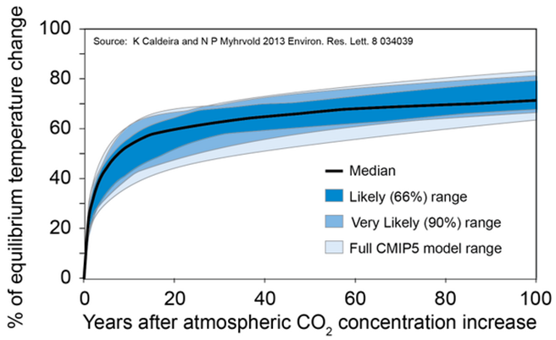
Related: the IPCC made a policy decision to place more value on the near-term because the majority of warming happens within 10-20 years after emissions. If it is true that we need to be more concerned about the near-term, then we can also say that forests are more valuable as places to store carbon and wood products are less valuable. This is because every effort to transfer carbon from the forest into wood products results in a net near-term pulse of carbon to the atmosphere, and this carbon "debt" is not repayed until the distant future when the replacement forest grows (not to the poin that it stores the same amount of carbon as before harvest) but rather to a point that recaptures all the carbon PLUS mitigates for the climate impacts caused during the "carbon debt" payback period. See Katsumasa Tanaka & Brian C. O’Neill. 2018. The Paris Agreement zero-emissions goal is not always consistent with the 1.5 °C and 2 °C temperature targets. Nature Climate Change (2018) doi:10.1038/s41558-018-0097-x. https://www.nature.com/articles/s41558-018-0097-x#Abs1, and see Brack, Duncan 2017. Woody Biomass for Power and Heat: Impacts on the Global Climate. Chatham House. https://www.chathamhouse.org/sites/files/chathamhouse/publications/research/2017-02-23-woody-biomass-global-climate-brack-embargoed.pdf.

5) “If wood buildings are replaced by wood buildings, substitution is not occurring, and because wood is preferred for construction of single-family housing in North America, some of our substitution values are overestimated (Sathre and O’Connor 2010). Wood
products store carbon temporarily, and a larger wood product pool increases decomposition emissions over time (figure 3).” Tara W Hudiburg, Beverly E Law, William R Moomaw, Mark E Harmon and Jeffrey E Stenzel 2019. Meeting GHG reduction targets requires accounting for all forest sector emissions. Environmental Research Letters, Volume 14, Number 9. https://iopscience.iop.org/article/10.1088/1748-9326/ab28bb/pdf.

6) Many analyses of substitution fail to account for the carbon debt associated with logging. They do this by starting with "bare ground" instead of an existing forest, which biases the analysis by crediting wood products with growing the forest in the first place instead of debiting wood products for dramatically reducing the carbon stored in an existing forest.
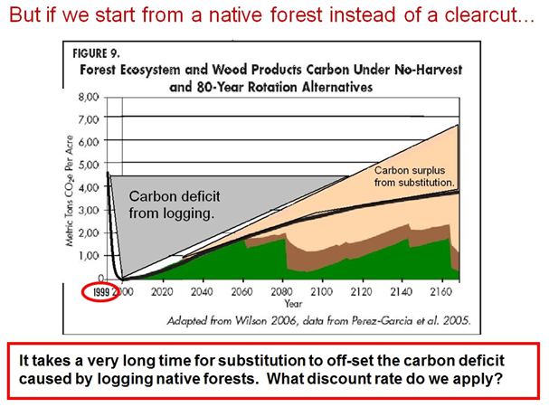
7) Substitution offers no guarantees that fossil fuels will stay in the ground. Fossil fuel use associated with the manufacture of steel and concrete will not be permanently avoided, but just delayed. The longest it could be delayed will be the earlier of:
- The point in time when the rising price of fossil fuels is undercut by the declining price of renewable energy.
- The point in time when we stop using fossil fuels for making steel and cement.
- The point in time when the fossil fuels that would have been used to make steel and cement are extracted and used for some alternative activity.
8) The CORRIM analysis fails to recognize that the production techniques used to make steel and concrete are continually improving leading to increased energy efficiency. For instance, steel recycling rates are always increasing, the addition of fly ash during the manufacture of concrete reduces its carbon footprint. Cement producers recently agreed to a voluntary 25% reduction in carbon emissions. http://www.reuters.com/article/GCA-GreenBusiness/idUSTRE54J5L420090520; http://www.wbcsdcement.org/pdf/agenda.pdf; There are several ways that emissions from cement and steel can be reduced, e.g., Reduce use; Clinker substitution; Carbon capture & storage; Alternative 'novel' cement https://www.carbonbrief.org/qa-why-cement-emissions-matter-for-climate-change (“Progress so far has come in three main areas. First, more efficient cement kilns have made production less energy-intensive. This can improve further ... [R]educing the proportion of Portland clinker in cement has also cut emissions. “High-blend” cements can reduce emissions per kilogram by up to four times, .... Geopolymer-based cements, for example, have been a focus of research since the 1970s. These do not use calcium carbonate as a key ingredient, harden at room temperature and release only water. Zeobond and banahUK are among firms producing these, with both claiming around 80-90% reduction in emissions compared to Portland cement. There are also several firms developing “carbon-cured” cements, which absorb CO2, rather than water, as they harden. If this CO2 absorption can be made higher than CO2 released during their production, cements could potentially be used as a carbon sink. US firm Solidia, for example, claims its concrete emits up to 70% less CO2 than Portland cement, including this sequestering step. The firm is now in a partnership with major cement producer LafargeHolcim. ... Other firms are using completely different materials to make cement. North Carolina-based startup Biomason, for example, uses bacteria to grow cement bricks which it says are both similarly strong to traditional masonry and carbon-sequestering.”). The energy grid that powers the steel mills and concrete plants are always becoming less carbon intensive. For instqance, here in Oregon, only about 32% of electricity is from coal:
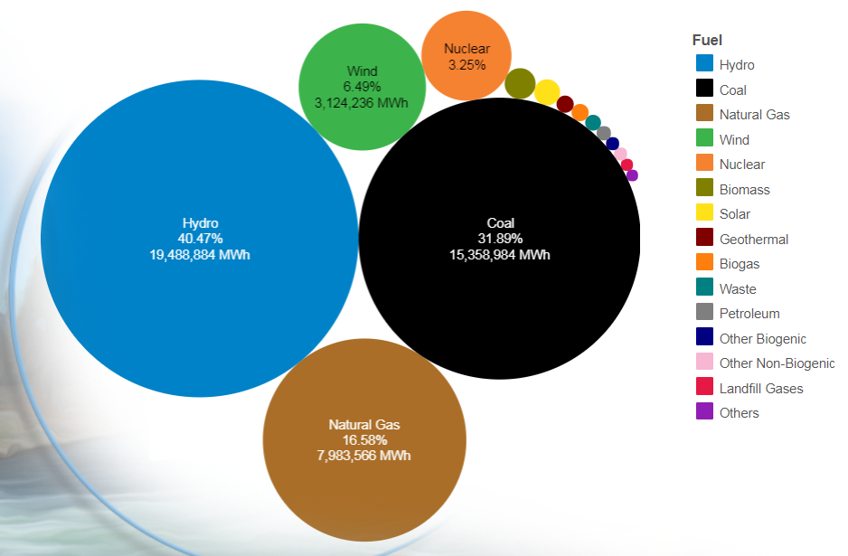
http://www.oregon.gov/energy/energy-oregon/Pages/Electricity-Mix-in-Oregon.aspx.

See also, Johanna Lehne and Felix Preston. 2018. Making Concrete Change - Innovation in Low-carbon Cement and Concrete. Chatham House Report. https://www.chathamhouse.org/sites/default/files/publications/2018-06-13-making-concrete-change-cement-lehne-preston-final.pdf; Maddie Stone 2019. CONCRETE JUNGLE - Cement has a carbon problem. Here are some concrete solutions. Grist Nov 20, 2019. https://grist.org/article/cement-has-a-carbon-problem-here-are-some-concrete-solutions/; Oberhaus, D. 2019. A Solar 'Breakthrough' Won't Solve Cement's Carbon Problem - A Bill Gates–backed startup called Heliogen uses concentrated solar power to produce cement. Wired 11-22-2019. https://www.wired.com/story/a-solar-breakthrough-wont-solve-cements-carbon-problem/

People must give fair treatment to the merits of the competing ideas by disclosing the flaws and caveats associated with the substitution argument.

Law et al (2018) said:
Increased long-term storage in buildings and via product substitution has been suggested as a potential climate mitigation option. Pacific temperate forests can store carbon for many hundreds of years, which is much longer than is expected for buildings that are generally assumed to outlive their usefulness or be replaced within several decades (7). By 2035, about 75% of buildings in the United States will be replaced or renovated, based on new construction, demolition, and renovation trends (31, 32). Recent analysis suggests substitution benefits of using wood versus more fossil fuel-intensive materials have been overestimated by at least an order of magnitude (33). Our LCA accounts for losses in product substitution stores (PSSs) associated with building life span, and thus are considerably lower than when no losses are assumed (4, 34). While product substitution reduces the overall forest sector emissions, it cannot offset the losses incurred by frequent harvest and losses associated with product transportation, manufacturing, use, disposal, and decay. Methods for calculating substitution benefits should be improved in other regional assessments.
Beverly E. Law, Tara W. Hudiburg, Logan T. Berner, Jeffrey J. Kent, Polly C. Buotte, Mark E. Harmon. 2018. Land use strategies to mitigate climate change in carbon dense temperate forests. Proceedings of the National Academy of Sciences Mar 2018, 201720064; DOI: 10.1073/pnas.1720064115
https://web.archive.org/web/20180727130028/http://www.pnas.org/content/pnas/115/14/3663.full.pdf.

Shafer et al (2011) state:
An alternative to increasing carbon stores within the forest is to harvest wood and store some of this carbon within wood products (Perez-Garcia et al., 2005). Under current manufacturing, use, and disposal practices this alternative is unlikely to increase the overall carbon store of the forest sector, which includes the forest and wood products derived from the forest (Harmon et al., 2009). Manufacturing, use, and disposal of harvested wood all entail significant carbon losses that are either as large as or larger than those in the forest itself (Krankina and Harmon, 2007). Wood products carbon offsets associated with biofuels and substitution of wood for more energy intensive building materials, such as steel and concrete, can theoretically increase the carbon “stores” of wood products beyond that stored in the forest itself (Perez-Garcia et al., 2005; Lippke et al. 2010). However, several issues need to be recognized regarding these offsets. First, most analyses have presented theoretical maximum product substitution offsets and ignored the effects of additionality (i.e., degree to which practices differ from business as usual or statutory requirements), permanence and replacement of existing wood products, and enduser preferences for building materials. If these factors are included, then substitution effects are substantially lower than the theoretical maximum and unlikely to surpass carbon stores in forests for many centuries if at all. Second, depending on the starting condition of the forest, both product substitution and forest-related biofuels can create carbon debts that delay carbon benefits. For example, biofuels harvested from existing forests could offset fossil fuel releases of carbon, but recent studies have indicated that carbon debts associated with the energy used during biofuel harvests, decreased carbon stores in forests, and differences in carbon to energy ratios could persist for decades to centuries, implying a significant temporal lag in net carbon uptake (Fargione et al., 2008; Searchinger et al., 2009). Third, being offsets, the effectiveness of both biofuel and product substitution will vary with the duration of the offset; the longer the delay in releasing fossil fuel carbon, the more effective offsets become: An offset with a 1 year delay would have little impact on atmospheric CO2 concentrations, whereas an offset of hundreds of years would have a much greater impact. Unfortunately, the duration of offsets is not well understood at this point, but it is unlikely to be infinite as tacitly assumed in many current analyses. Finally, while offsets are often counted as carbon stores, they are difficult to directly inventory because they are not physically in an identifiable location, whereas carbon stored in forests can be more directly inventoried and quantified.
Sarah L. Shafer, Mark E. Harmon, Ronald P. Neilson, Rupert Seidl, Brad St. Clair, Andrew Yost 2011. Oregon Climate Assessment Report (OCAR) http://occri.net/ocar Chapter 5. The Potential Effects of Climate Change on Oregon’s Vegetation. http://occri.net/wp-content/uploads/2011/04/chapter5ocar.pdf.

If the agency wishes to rely on substitution to justify carbon emissions from logging, they cannot assume the project will result in the theoretical maximum substitution benefits. They must instead consider and analyze the real world substitution effects based on several key factors. Fain et al (2018) explain--
[S]ubstitution is a key variable in determining cumulative carbon benefits over time. Franklin et al. discuss 6 key factors in determining the magnitude of substitution effects through time: (1) the amount of product-in-use created from the harvest, (2) the displacement factor, (3) percent of the harvest that will substitute for non-wood products like concrete or steel, (4) the cumulative nature of the substitution effects, (5) the length of time the substitution effect accumulates, and (6) the effect on the average lifespan of buildings if wood is substituted for fossil fuel intensive materials. ... The displacement factor ... varies depending on the building system and the embedded GHG emissions factor within displaced materials. ... [E]ngineering studies found the average displacement factor value to be 2.1, ... [T]his number is a global reference average and likely not accurate for any given place and time. Uniquely local and dynamic biological and socio-economic factors such as, silvicultural systems, tree species, form and age of trees, amount of wood degrade, mortality rates, market demand, economics of transporting to processing facilities, and supply quota agreements, greatly influence commercial wood products and thus any attempts to quantify substitution rates and life cycles. ... [A]s technology, wood use, and energy sources evolve into the future, so will the displacement factor associated with substitution, most likely declining.
Fain, S.J.; Kittler, B.; Chowyuk, A. Managing Moist Forests of the Pacific Northwest United States for Climate Positive Outcomes. Forests 2018; 9(10):618. https://www.mdpi.com/1999-4907/9/10/618 citing Franklin, J.; Johnson, N.; Johnson, D. Ecological Forest Management; Waveland Press: Long Grove, IL, USA, 2018.

… benefits attributed to product substitution are commonly overestimated. Substituting wood for aluminum and steel can displace fossil fuel emissions, but the displacement period needs to be part of the accounting. Displacement occurs until the building is replaced, and then the substitution can be renewed by a new building or it can be lost by using a material with a higher energy cost. In addition, it is often assumed that product substitution will reduce the demand for fossil fuel. However, due to human behavior and current economic systems that ignore adverse externalities, reducing resource consumption through substitution or improvements in efficiency rarely reduce fossil fuel use (York, 2012). Therefore, benefits may be substantially lower and the payback period much longer and smaller for the carbon debt from intensified management and avoided fossil fuel combustion than commonly assumed (Haberl et al., 2013).
Law, B.E., Waring, R.H. 2015. Review and synthesis - Carbon implications of current and future effects of drought, fire and management on Pacific Northwest forests. Forest Ecology and Management 355 (2015) 4–14. http://people.forestry.oregonstate.edu/richard-waring/sites/people.forestry.oregonstate.edu.richard-waring/files/publications/Law%20and%20Waring%202015.pdf
​Law & Harmon conducted a literature review and concluded …
Most LCA [life cycle analysis] studies rely heavily on wood product substitution for GHG benefits, and these have been grossly overestimated, with many ambiguous assertions that gloss over forest carbon dynamics; for example:
· Biofuel emissions are assumed to be zero because they are balanced by net growth, yet this would depend on the state of the preceding forest system – they could be positive, neutral or negative;
· Old forests are assumed to always be carbon sources, while young forests are always assumed to be carbon sinks, contrary to forest carbon dynamics findings;
· Dead wood and soil carbon stores are either not included or assumed to be constant;
· In one LCA, dead wood is not present in older forests, contrary to findings in the extensive ecological literature;
· The wood product pool is assumed to be an increasing carbon stock over time.
…
Substitution of more energy-intensive building materials with a less energy intensive one can, in theory, result in a fossil fuel offset; for example, when wood replaces a construction material with higher emissions (e.g., concrete or steel), the fossil CO2 emission avoided by choosing wood is credited as an offset. Thus, harvest of forest carbon and placement into buildings can impact the overall carbon balance of the forest sector [33,42]. However, several additional factors need to be considered. First, changes in the carbon stores of the forest ecosystem have to be considered relative to a base case that includes a lower level of harvests. As noted above, decreasing the interval between harvests, or increasing harvest intensity will lower the carbon store in the forest [9–11,31]; the question is whether stores in forest products combined with substitution offsets surpass losses from shorter rotations. Since the forest has a maximum carrying capacity, just the growth in carbon stores and offsets would seem to eventually exceed old forest carbon, although it could take centuries to happen, even using the most generous substitution effects. With more realistic substitution effects, it may never happen. In some cases, the amount of live and dead biomass in unharvested forests was grossly underestimated leading to an overestimation of the relative benefits of substitution. Second, in substitution effects calculations, it is often tacitly assumed that wood that is removed from forests and used in long-term wood products, specifically buildings, continues to accumulate infinitely over time. While building carbon stores have increased in many areas (e.g., the USA), this is largely because more forest area is being harvested and not because the harvest-related stores per harvest area are increasing. The trend that is being used as evidence of increasing building stores is based on the fact that because a greater area has been harvested, the total store has increased. This is not the same thing as the increase associated with a particular area of forest. A fixed per area basis is how substitution effects have largely been evaluated in the past, so arguing on an expanding area basis is inappropriate. The reason that wood products saturate is that housing and other wood products have a finite lifespan and are eventually replaced [43]. Although there can be some reuse of wood, essentially assuming an infinite lifespan or 100% reuse of wood products is completely unrealistic. Carbon is always lost as wood products are used or disposed of, which means release of CO2 to the atmosphere. Since long-term storage in forest products saturates over time (i.e., eventually does not increase), the effect of substituting wood for fossil fuel energy is also likely to saturate. Third, in most cases, the substitution offset was calculated based on the assumption that each time a house is to be built, the preference is for nonwood materials. This results in an estimate of the maximum substitution effect possible, but does not account for actual preferences for building materials. Granted, preferences vary by region and over time, but without accounting for these one cannot possibly estimate realistic substitution benefits. Fourth, current substitution accounting appears to violate a key principle of carbon offsets, namely permanence. In fact the ever-increasing substitution offset presented in these analyses appears to depend on impermanence of wooden buildings. Fifth, most, if not all, current analyses of substitution effects ignore the effects of additionality and whether wooden buildings are initially present. Given that many forests have already been harvested to produce wood products, replacing wooden buildings with more wooden buildings results in no additional substitution effect. Finally, these studies assume that it is a permanent benefit to GHG removal from the atmosphere. That is, they assume there is a continual increase in the carbon credit, and maintenance of a sustainable productive forest dedicated to providing substitutes for nonwood fuels and materials [44].
These caveats all suggest that while there is likely to be some building material substitution effect that is valid, it is far lower than generally estimated and as subject to saturation as other forest-related carbon pools. In summary, the substitution effect appears to have been grossly overestimated. Substitution is an offset, not a store. Offsets depend on the use of appropriate accounting rules. Until rules such as permanence, additionality and leakage are followed, the values being presented in many analyses are not credible.
…
Life cycle analysis (including substitution, proposed considerations)
…
· Substitution of more energy intensive building materials with less energy intensive ones can in theory result in a fossil fuel offset, but important considerations suggest that the substitution effect is substantially lower than estimated, and is subject to saturation.
Beverly Elizabeth Law & Mark E Harmon 2011. Forest sector carbon management, measurement and verification, and discussion of policy related to mitigation and adaptation of forests to climate change. Carbon Management 2011 2(1). https://content.sierraclub.org/ourwildamerica/sites/content.sierraclub.org.ourwildamerica/files/documents/Law%20and%20Harmon%202011.pdf.

The FS Failed to Respond to Public Comments

The draft DN says “Main issues of concern identified from the comment periods are listed and addressed in section 4.0, “Other Alternatives Considered and Not Developed.”” But we find no meaningful response at all to our extensive comments about the effects of proposed logging and roads in that section of the draft DN or any other.

We found a document on the website, which is referenced nowhere in the final EA or draft DN, which purports to address public comments. https://www.fs.usda.gov/nfs/11558/www/nepa/109664_FSPLT3_5299541.pdf. However, this document fails to address most of Oregon Wild comments on the preliminary EA, and since this document is not addressed in the analysis, there is no evidence that comments are properly reflected in the analysis.

The Forest Service’s notice-comment-objection regulations state unambiguously “Consideration of comments. (1) The responsible official shall consider all written comments submitted in compliance with paragraph (a) of this section.” 36 CFR 218.25 (b). The rules define “Specific written comments” as –
Written comments are those submitted to the responsible official or designee during a designated opportunity for public participation (§218.5(a)) provided for a proposed project. Written comments can include submission of transcriptions or other notes from oral statements or presentation. For the purposes of this rule, specific written comments should be within the scope of the proposed action, have a direct relationship to the proposed action, and must include supporting reasons for the responsible official to consider.”
36 CFR 218.2.
In order to assure compliance with the requirements to “consider” comments, it is only logical that the Forest Service must document in writing its fulfillment of the requirement. Without a record of the consideration of comments, administrative and judicial review of these requirements would be impossible, rendering these requirements meaningless.

In addition, NEPA has a separate requirement that federal agencies must respond to comments on NEPA documents. “An agency preparing a final environmental impact statement shall assess and consider comments both individually and collectively, and shall respond by one or more of the means listed below, stating its response in the final statement. …” 40 CFR 1503.4(a).
This section is addressed to EISs, but the CEQ regs are in fact applicable to EAs as well. “These regulations, unlike the predecessor guidelines, are not confined to sec. 102(2)(C) (environmental impact statements).” 40 CFR 1500.3.
In City of Davis v. Coleman, 521 F.2d 661 (9th Cit., 1975) the court said that in a statute requiring the social and environmental effects of projects be considered — “considered means to investigate and analyze; ‘consideration’ encompasses an affirmative duty to investigate and compile data, and a further duty to incorporate that data into a detailed reasoned analysis…”
Finally, independent of NEPA, the APA also requires agencies to adequately respond to all significant public comment as a “fundamental tenet of administrative law” NRDC v. EPA, 859 F.2d 156, 188 (D.C. Cir. 1988); see also ACLU v. FCC, 823 F.2d 1554, 1581 (D.C. Cir. 1987); Sierra Club v. EPA, 353 F.3d 976, 986 (D.C. Cir. 2004); Am. Iron & Steel Inst. V. EPA, 115 F.3d 979, 1005 (D.C. Cir. 1997). This principle ensures that agencies consider all material points raised by the public. NRDC, 859 F.2d at 188. Failure to respond to public comment can be grounds for invalidation of a decision as arbitrary and capricious. Id. A comment is “significant” when “if true, [it] raise[s] points relevant to the agency’s decision and which, if adopted, would require a change in an agency’s proposed rule.” Home Box Office Inc. v. FCC, 567 F.2d 9, 35, n.58 (D.C. Cir. 1977). The comment must “step over a threshold requirement of materiality” by explaining why the agency’s error is relevant and not “merely stat[ing] that a particular mistake was made.” Portland Cement Ass’n v. Ruckelshaus, 486 F2d 375, 394 (D.C.Cir. 1973).

The Analysis Failed to Consider All Reasonable Alternatives.

Public comments asked the FS to consider reasonable alternatives, such as meeting the purpose and need to enhance huckleberries by relying on natural disturbance processes that are expected to accelerate with global climate change, and meeting the need for timber volume by thinning dense young planted stands. The FS failed to consider these alternatives.

NEPA mandates that an agency “shall to the fullest extent possible: use the NEPA process to identify and assess the reasonable alternatives to proposed actions that will avoid or minimize adverse effects of these action upon the quality of the human environment.” 40 C.F.R. § 1500.2(e). NEPA also requires the USFS to “study, develop, and describe appropriate alternatives to the recommended courses of action in any proposal which involves unresolved conflicts concerning alternative uses of available resources as provided by section 102(2)(E) of 40 C.F.R. § 1501.2 (c).” Id.

Environmental analysis documents must “[r]igorously explore and objectively evaluate all reasonable alternatives” to the project. 40 C.F.R. § 1502.14(a). The Council on Environmental Quality (CEQ), which promulgated the regulations implementing NEPA, characterizes the discussion of alternatives as “the heart of the environmental impact statement.” 40 C.F.R. § 1502.14. A decisionmaker must explore alternatives in sufficient enough detail to “sharply defin[e] the issues and provid[e] a clear basis for choice among options by the decisionmaker and the public.” Id. § 1502.14. All reasonable alternatives must receive a “rigorous exploration and objective evaluation... , particularly those that might enhance environmental quality or avoid some or all of the adverse environmental effects.” Id. § 1500.8(a)(4). The analysis of the alternatives must be “sufficiently detailed to reveal the agency’s comparative evaluation of the environmental benefits, costs and risks of the proposed action and each reasonable alternative.” Id.

If the NEPA document considers only a restricted range of alternatives this would violate the very purpose of NEPA’s alternative analysis requirement, which is to foster informed decision-making and full public involvement. 42 U.S.C. §§ 4331, 4332(2)(E); 40 C.F.R. § 1508.9(b). See also Robertson v. Methow Valley Citizen’s Council, 490 U.S. 332, 349 (1989). The Ninth Circuit stated in California v. Block that “[a]s with the standard employed to evaluate the detail that NEPA requires in discussing a decision’s environmental consequences, the touchstone for our inquiry is whether an EIS’s selection and discussion of alternatives fosters informed decision-making and informed public participation.” California v. Block, 690 F.2d 753, 767 (9th Cir. 1982).

The purpose of the multiple alternative analysis requirement is to insist that no major federal project be undertaken without intense consideration of other more ecologically sound courses of action, including shelving the entire project, or of accomplishing the same result by entirely different means. Environmental Defense Fund v. Corps of Engineers, 492 F.2d 1123, 1135 (5th Cir. 1974); Methow Valley Citizens Council v. Regional Forester, 833 F.2d 810 (9th Cir. 1987), rev’d on other grounds, 490 U.S. 332 (1989) (agency must consider alternative sites for a project). The Ninth Circuit has concluded that “the existence of a viable but unexamined alternative renders an environmental impact statement inadequate.” Alaska Wilderness Recreation & Tourism v. Morrison, 67 F.3d 723, 729 (9th Cir.1995).

Other courts have stated that in order to comply with NEPA, “the discussion of alternatives ‘must go beyond mere assertions’ and provide sufficient data and reasoning to enable a reader to evaluate the analysis and conclusions and to comment on the EIS.” Citizens Against Toxic Sprays v. Bergland, 428 F. Supp. 908, 933 (D. Or. 1977). A detailed and careful analysis of the relative merits and demerits of the proposed action and possible alternatives is of such importance in the NEPA scheme that it has been described as the “linchpin” of the environmental analysis. For this reason, the discussion of alternatives must be undertaken in good faith; it is not to be employed to justify a decision already reached. Id.

"An alternative may not be disregarded merely because it does not offer a complete solution to the problem." Citizens Against Toxic Sprays v. Bergland, 428 F. Supp. 908. 933 (D. Or. 1977). As one court explained, "[o]bviously, any genuine alternative to a proposed action will not fully accomplish all of the goals of the original proposal. One of the reasons that Congress has required agencies to set out and evaluate alternative actions is to give perspective on the environmental costs, and the social necessity, of going ahead with the original proposal." Town of Matthews v. United States Dept of Transp., 527 F. Supp. 1055, 1058 (W.D.N.C. 1981).

The agency often says that removing medium and large trees is often necessary to ensure a viable timber sale even though the same medium and large trees need to be retained for late successional forest habitat characteristics, dead wood recruitment, to suppress the growth of ladder fuels, and to maintain a cool-moist microclimate that helps mitigate fire hazard. These conflicts were brought to light in PNW Science Findings. http://www.fs.fed.us/pnw/sciencef/scifi85.pdf (“requiring landscape treatments to earn a profit negatively impacted both habitat and fire objectives”). When economic objectives conflict with ecological objectives and fire hazard objectives, the agency is obligated to consider NEPA alternatives such as reallocating funds within the agency’s existing budget or asking Congress for additional appropriations to allow the agency to better balance competing objectives. See Center of Biological Diversity v. Rey, (9th Circ, May 14, 2008) http://web.archive.org/web/20081018102407/http://www.ca9.uscourts.gov/ca9/newopinions.nsf/BBADBE769F43A66D88257449005521AE/$file/0716892.pdf

"The existence of a viable but unexamined alternative renders an EA inadequate." Western Watersheds v. Abbey, 719 F.3d. at 1050. North Idaho Cmty. Action Network, 545 F.3d at 1153 (both EA and EIS must consider all reasonable alternatives, but EIS must provide more detail and analysis of those alternatives). When the agency clearly has independent knowledge of specific issues or concerns, "there is no need for a commenter to point them out specifically in order to preserve its ability to challenge a proposed action." Id. at 765; 'Ilio'ulaokalani Coal. v. Rumsfeld, 464 F.3d 1083, 1093 (9th Cir. 2006); see Friends of the Clearwater v. Dombeck, 222 F.3d 552, 559 (9th Cir. 2000) ("Compliance with NEPA is a primary duty of every federal agency; fulfillment of this vital responsibility should not depend on the vigilance and limited resources of environmental plaintiffs").

It is not enough to consider just one action alternative as BLM often does. The CEQ regulations specifically require that Environmental Assessments shall follow the alternatives language in NEPA.

40 CFR § 1508.9
"Environmental Assessment":
…
(b) Shall include brief discussions of the need for the proposal, of alternatives as required by sec. 102(2)(E), of the environmental impacts of the proposed action and alternatives …”

The “alternatives provision” of 42 U.S.C. § 4332(2)(E) applies whether an agency is preparing an EIS or an EA and requires the agency to give full and meaningful consideration to all reasonable alternatives. Native Ecosystems Council v. U.S. Forest Service, 428 F.3d 1233, 1245 (9th Cir. 2005); see Bob Marshall Alliance v. Hodel, 852 F.2d 1223, 1229 (9th Cir. 1988) (The alternatives requirement is triggered where unresolved conflicts as to the proper use of resources exist, whether or not an EIS is required). Te-Moak Tribe v. Interior, 608 F.3d 592, 601-602 (9th Cir. 2010) (“Agencies are required to consider alternatives in both EISs and EAs and must give full and meaningful consideration to all reasonable alternatives.”)

Consideration of Alternatives

"[O]ne important ingredient of an EIS is the discussion of steps that can be taken to mitigate adverse environmental consequences" of a proposed action. Robertson, 490 U.S. at 351. As one aspect of evaluating a proposed course of action under NEPA, the agency has a duty "to study all alternatives that appear reasonable and appropriate for study... , as well as significant alternatives suggested by other agencies or the public during the comment period." Roosevelt Campobello Int'l Park Comm'n v. United States EPA, 684 F.2d 1041, 1047 (1st Cir. 1982) (quotations omitted); Valley Citizens for a Safe Env't v. Aldridge, 886 F.2d 458, 462 (1st Cir. 1989); City of Carmel-By-The-Sea v. U.S. Dept. of Transp., 95 F.3d 892, 903 (9th Cir. 1996).

As stated in the Council on Environmental Quality ("CEQ") regulations implementing NEPA, the consideration of alternatives is "the heart of the environmental impact statement." 40 C.F.R. § 1502.14. These implementing regulations are entitled to substantial deference. Robertson, 490 U.S. at 355 (citing Andrus v. Sierra Club, 442 U.S. 347, 358 (1979)). The regulations require that the EIS "[r]igorously explore and objectively evaluate all reasonable alternatives, and for alternatives which were eliminated from detailed study, briefly discuss the reasons for their having been eliminated." 40 C.F.R. § 1502.14(a). It is "absolutely essential to the NEPA process that the decisionmaker be provided with a detailed and careful analysis of the relative environmental merits and demerits of the proposed action and possible alternatives, a requirement that we have characterized as 'the linchpin of the entire impact statement.'" NRDC v. Callaway, 524 F.2d 79, 92 (2d Cir. 1975) (citation omitted); see Silva v. Lynn, 482 F.2d at 1285; All Indian Pueblo Council v. United States, 975 F.2d 1437, 1444 (10th Cir. 1992) (holding that a thorough discussion of the alternatives is "imperative"). "The 'existence of a viable but unexamined alternative renders an environmental impact statement inadequate.'" Resources Ltd. v. Robertson, 35 F.3d 1300, 1307 (9th Cir. 1993) (quoting Idaho Conservation League v. Mumma, 956 F.2d 1508, 1519 (9th Cir. 1992)); see Grazing Fields Farm v. Goldschmidt, 626 F.2d 1068, 1072 (1st Cir. 1980) (Even the existence of supportive studies and memoranda contained in the administrative record but not incorporated in the EIS cannot "bring into compliance with NEPA an EIS that by itself is inadequate."). Because of the importance of NEPA's procedural and informational aspects, if the agency fails to properly circulate the required issues for review by interested parties, then the EIS is insufficient even if the agency's actual decision was informed and well-reasoned. Grazing Fields Farm, 626 F.2d at 1072; see Massachusetts v. Watt, 716 F.2d 946, 951 (1st Cir. 1983).
https://web.archive.org/web/20060905111357/http://classweb.gmu.edu/jkozlows/nepants.htm.

Sincerely,

Doug Heiken

