July 15, 2020

William Avey
Forest Supervisor
Helena-Lewis & Clark NF
2880 Skyway Drive
Helena, MT. 59602

I am writing to submit our objection to the Helena-Lewis and Clark National Forest Land Management Plan. We want the HLC NF to continue contributing to the forest products industry and we support active management of the forest resources. The following are areas of concern to Sun Mountain Lumber:

None of the alternatives produces the Sustained Yield Limit. The HLC combined forest SYL is shown as 57.57 mmbf. The projected timber sale program with an unconstrained budget achieves 43.2 mmbf in decade 1 and 43.7 mmbf in decade 2. The plan should include information regarding the required budget and an alternative to reach the SYL.

Alternative F does not include enough annual acres of harvest to address the insect and disease problems on the Forest. Timber harvest is a primary method of treating forest health problems. The number of acres affected by the pine beetle, Western spruce bud worm and the Douglas-fir bark beetle require more area be treated to increase forest health. This should be in addition to the stands of dead lodgepole pine that continue to require harvest to capture economic value and reduce hazardous fuels.

The Final plan should include all possible acres for management. The IRA’s can contribute needed timber volume and require management to restore forest health. Alternative F shows 87% of total lands as not suited for timber production. All remaining acres should be maintained for potential harvest.

Thank you for considering this objection. Sun Mountain Lumber requests to be included in any resolution meeting that may occur.

Respectfully,
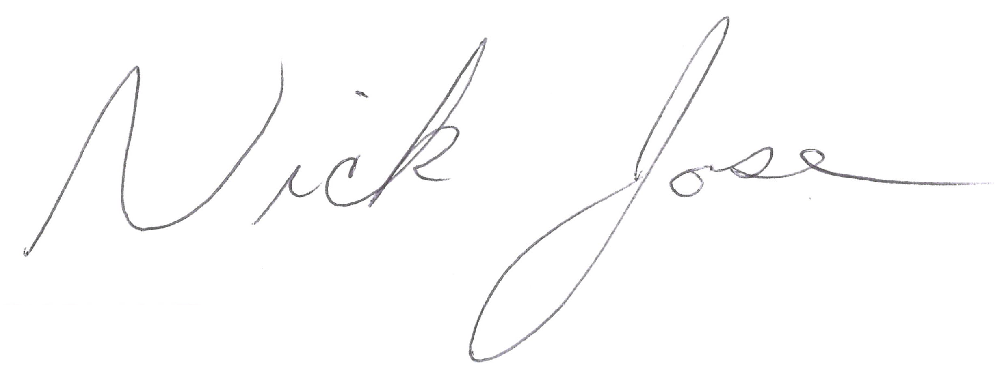

Nick Jose
Resource Manager
Cell 406-560-0374
Off 406-846-1600
Nick.jose@sunmtnlumber.com

