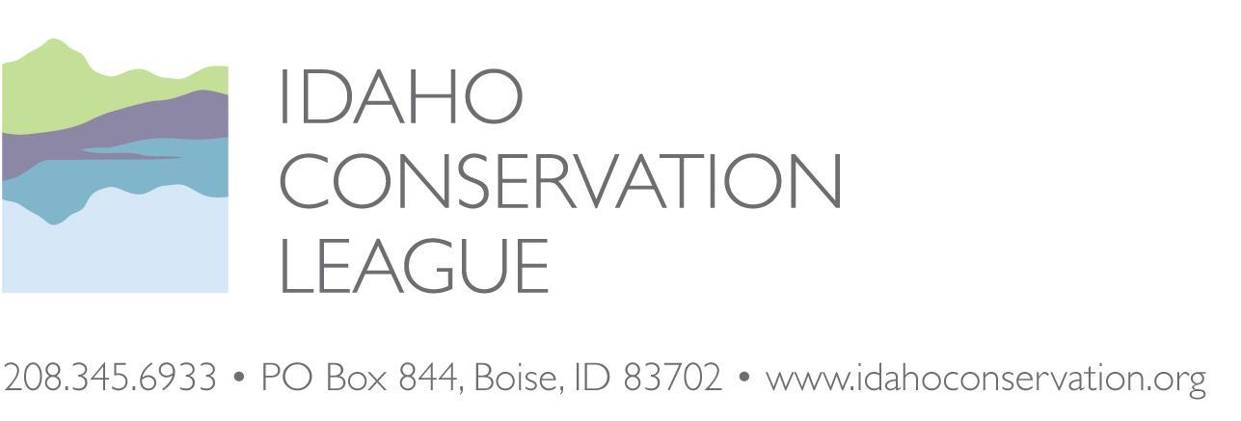

BEFORE THE REGIONAL FORESTER, INTERMOUNTAIN REGION, USDA FOREST SERVICE

BEFORE THE REGIONAL FORESTER, INTERMOUNTAIN REGION, USDA FOREST SERVICE

Idaho Conservation League
Objector
v.
Anthony Botello
Responsible Official

Objection to the Big Creek Hazardous Fuels Reduction Environmental Assessment and Draft Decision Notice, Krassel Ranger District, Payette National Forest

IDAHO CONSERVATION LEAGUE: John Robison, Lead Objector, Public Lands Director, P.O. Box 844, Boise, ID, 83701. Phone: (208) 345-6942 ext. 13, jrobison@idahoconservation.org

Certification of Filing
This objection was timely filed by electronic transmission to objections-intermtn-regional-office@fs.fed.us and submitted online ATTN: Objection Deciding Officer.
DATED this 18th day of May 2020.

Sincerely,
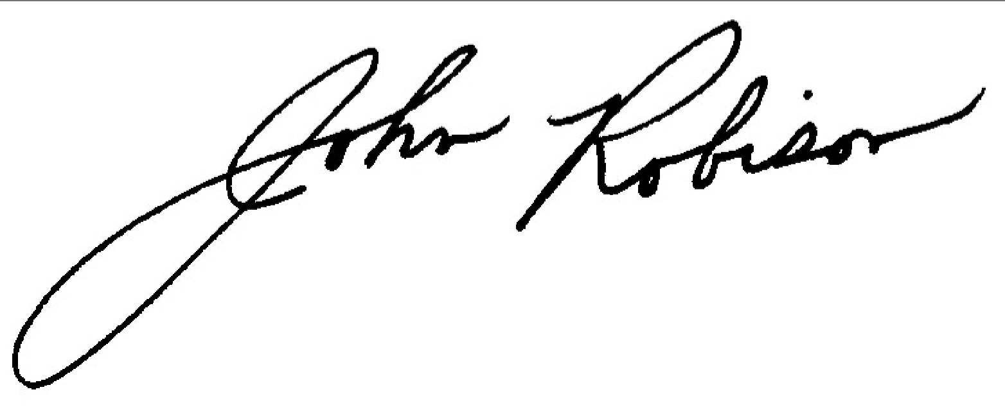
John Robison
Public Lands Director, Idaho Conservation League, Lead Objector
jrobison@idahoconservation.org
(208) 345-6942 x 13

Objector’s Notice, Statement of Reasons & Suggested Remedies
Objector’s Notice, Statement of Reasons

Notice of Objection
Pursuant to 36 CFR 218 Subpart B and § 218.5(a), the Idaho Conservation League objects to the Big Creek Hazardous Fuels Objection Project, proposed by Krassel District Ranger Anthony Botello on the Payette National Forest (PNF). This is in part a supportive objection and an opportunity to refine the project to minimize negative environmental impacts from project implementation. We intend to use the objection process as a means to strengthen the project record, participate in any objection resolution discussions with other objectors, address any remaining issues of uncertainty, and update the adaptive management approach to better guide project implementation as needed.

Connection between prior specific comments
The Idaho Conservation League has been engaged in discussions and deliberations on this project since it was initially scoped. We submitted comments on a similar project when it was proposed in 2004 and submitted scoping comments in September of 2018 and comments on the Draft EA on January 6, 2020. In our comments we discussed the issues listed in our objection.

Statement of Reasons
ICL is largely supportive of this project. We want to see the project successfully implemented in a timely manner and in such a way that projected benefits are realized and any negative effects are successfully avoided, minimized, and mitigated.

However, there are several places where it is unclear if the project is following Forest Plan standards or has a plan to communicate monitoring reports and progress with members of the public. We intend to use the objection process as a means to strengthen the project record, participate in any objection resolution discussions with other objectors, address any remaining issues of uncertainty, and update the adaptive management approach to better guide project implementation as needed. In the event these issues can be addressed during the objection resolution process, ICL would be willing to withdraw this objection in full.

Should other objectors raise additional concerns or bring additional information to the Forest Service’s attention, we hope to use the objection process to review this information and offer our perspective on any needed project modifications.

Issues and Suggested Remedies

- The Forest Service has not yet indicated the location of temporary roads which are an issue of significant concern because it appears that portions of the road would be in the riparian conservation area ("RCA") and the Big Creek Fringe Inventoried Roadless Area. We note that this area is within MPC 3.2 which states, "[r]oad construction or reconstruction may only occur where needed ... [t]o address immediate response situations where, if action is not taken, unacceptable impacts to hydrologic, aquatic, riparian or terrestrial resources, or health and safety, would result."

As a remedy, the Forest Service should indicate the temporary road locations on a map. We note that the Forest Service has been able to estimate approximate temporary locations for other projects with the caveat that final locations may change. We also request that the Forest Service begin discussions in earnest with the private property owner that could preclude the need for the ford and some temporary road construction. In the event that access across private property is not allowed, the Forest Service should limit treatments to non-commercial activities in that unit that do not require temporary road construction or a ford.

- The Forest Service plans on constructing 23 permanent fords in the Smith Creek drainage and 2 temporary fords or stream crossings:

Stream crossings and fords increase sediment to streams, create pulses of turbidity that can be detrimental to aquatic life and habitat and can impact the geomorphology of the stream channel over time. EA p. 40.

20 Crossings have the potential to impact fish via increased sediment delivery due to their proximity (<600’ from fish bearing stream) to disturbance. EA p 52.

Use of temporary crossings (fords) present the potential for adverse effects to fish. Approximately 5 temporary crossings (fords), including 3 within occupied CH, will be installed where equipment is needed to cross fish bearing streams. Installation and utilization of fords has the potential to adversely affect fish via physical contact e.g., crushing (injuring or killing) individual fish. EA. p. 54.

We understand that water quality is expected to improve over time as fords open to ATVs are armored and sediment production is reduced and are supportive of these goals:

We believe these OHV trails are currently having localized effects to water quality, turbidity and aquatic habitat every time an OHV travels through them. EA p. 40.

and

Indirect beneficial effects to water quality as fords would be constructed to Agency standard, hence reducing overall impacts to water quality over time. Project design features and regular maintenance expected to keep water quality effects at current levels or slightly improve. EA p. 40.

We also believe that indirectly the improvement of the fords in the Smith Creek drainage will reduce the impacts that are occurring from the frequent summer OHV use in the area. The fords will be more resilient to OHV use and, consequently, improve water quality over time. EA p. 40.

The Forest Service describes a number of design features for width, using logs, and minimizing ground disturbance:

We believe implementation of WAT-32 (limits the travel width of the ford), WAT-33 (protection of fords that cross intermittent fords), WAT-34 (protection of stream banks at ford crossing), and WAT-35 (minimization of ground disturbance) as well as BMP Road-7 (Stream Crossings) will not produce significant effects at stream crossings and fords as it relates to the Big Creek project. EA p. 52.

Turbidity will be minimized by implementing PDFs and BMPs including erosion control, and by utilizing bypass diversions to dewater the channel, and sumps and settling ponds where necessary. Spikes in turbidity could have temporary adverse effect on fish behavior such as feeding. These temporary effects would be negligible due to very limited use, and mitigation measures. The turbidity indicator would be maintained. EA p. 52.

In addition to these design features, the Forest Service states that one of the reasons for minimal impacts are the “relatively low number of fords”:

Summary of Effects to Endangered Species Act (ESA) Listed Fish, Critical Habitat (CH), and Management Indicator Species (MIS) There is potential for temporary to short-term negative effects to ESA listed fish and critical habitat with construction and utilization of fords, increased usage of roads (log haul) and potential increased sediment delivery to fish streams. However, the temporary to short-term negative effects are determined to be negligible due to the relatively small scale of the project (increase in log haul), relatively low number of fords and actual expected crossings, and application of PDF, BMP and mitigation measures. EA p. 54.

The term, “relatively low number of fords” is a subjective term as it is unclear what the Forest Service is comparing the number of fords to. The map indicating the fords shows what appears to be a large number of fords (23) in a relatively small subwatershed that supports listed fish species.

We are concerned about the cumulative effects of constructing all these fords at the same time or in the same short time frame. Aside from the mention of water work windows, there are no specific design features relative to phasing, timing or staging stream crossing construction so that downstream effects of constructing all fords are within acceptable limits.

As a remedy, the Forest Service should describe in more detail how the fords will be constructed and sequenced so that water quality will be protected. One potential solution is to construct no more than 3 stream crossings in a particular time window and allow sedimentation to settle before constructing additional crossings in the same drainage. We recognize that it may be logistically difficult to have all the stream crossings constructed at the same time but in the absence of any clarification, the public must assume that those simultaneous impacts may occur. We note that a phased and carefully monitored stream crossing implementation plan would be more consistent with the Forest Plan BMPs and standards for stream crossings:

SWST01 Management actions shall be designed in a manner that maintains or restores water quality to fully support beneficial uses and native and desired non-native fish species and their habitat….

BMP for Stream Crossings: Avoid, minimize, or mitigate adverse effects to soil, water quality, and riparian resources when constructing, reconstructing, or maintaining temporary and permanent water-body crossings.

As another remedy, monitoring reports and progress on stream crossing construction should be added to the implementation site. Clarification on what fords will be closed for construction, armored and then open to the public will also be of interest to the recreation community.

As a last remedy on this particular issue, the Forest Service and NOAA Fisheries and USFWS should complete consultation before the Decision Notice is finalized and the project proceeds as they may have additional insights into how to avoid, minimize and minimize impacts that should be incorporated into the final Decision Notice.

- We appreciate the fact that the Forest Service is planning on coordinating with private property owners on fuel reduction efforts. We would like to see a commitment by the Forest Service for additional outreach, education and enforcement efforts in the Big Creek area for educating recreationists about preventing human-caused wildfires such as putting out campfires. This effort is particularly appropriate given the remote nature of this area.

The Forest Service should also continue to work with the private property owners in the Big Creek, Edwardsburg, or Yellow Pine areas to advertise opportunities for local firewood and post and pole use, which would not necessitate hauling log trucks back to Cascade or McCall. We could support making trees from the shaded fuel breaks available for local use as long as riparian, legacy tree and wildlife protections could be secured.

- The Forest Service is planning on coordinating with private property owners on smoke management efforts from prescribed burns. We suggest reaching out to the local community members to gage their interest in a multiparty monitoring program as defined in Section 102(g) of the HFRA:
Section 102(g)(5) of the HFRA instructs the USDA Forest Service and DOI BLM to establish a collaborative multiparty monitoring, evaluation, and accountability process when significant interest is expressed in such an approach. The process will be used to assess the positive or negative ecological and social effects of authorized fuel-reduction projects, as well as those undertaken under Section 404 (applied silvicultural assessments) of the HFRA.
This outreach would also be consistent with the 10-year strategy and implementation guide:

This updated Implementation Plan focuses anew on the collaborative framework essential for success, and as to the Strategy’s four goals, sets forth desired outcomes, performance measures, and responsibilities for tasks identified. The goals are interrelated and mutually reinforcing: restoring fire-adapted ecosystems and reducing hazardous fuels will reduce risks to communities and provide economic benefits, as well as improve fire prevention and suppression. This updated Implementation Plan emphasizes: • Information sharing and monitoring of accomplishments and forest conditions to improve transparency, • A long-term commitment to maintaining the essential resources for implementation, • Landscape-level vision for restoration of fire adapted ecosystems, • The importance of using fire as a management tool, and • Continuing to improve collaboration consistent with the vision of the 10-Year Strategy and this Implementation Plan.
https://www.forestsandrangelands.gov/documents/resources/plan/10-yearstrategyfinal_dec2006.pdf

Such a program would also be consistent with the Forest Plan and could be incorporated into the implementation website:

ASOB05: When developing and implementing fire use projects, inform the public about potential smoke impacts to health and safety

ASGU04: Annually and/or seasonally communicate with the public regarding planned amounts of prescribed burning and potential smoke impacts.

- The Decision Notice and FONSI states that the project was developed collaboratively. There are several formal collaborative efforts underway on the Payette National Forest that are addressing other issues. These collaboratives represent a diverse set of stakeholders and seek to operate via consensus. The Forest Service mentioned that it gave a presentation to one of these collaborative groups but should clarify that it did not receive formal, consensus recommendations from an established Collaborative group.

As a remedy, the Forest Service should clarify that it is using the following definition of collaborative and that the agency was not seeking consensus:

(f) Public Collaboration.--In order to encourage meaningful public
participation during preparation of authorized hazardous fuel reduction
projects, the Secretary shall facilitate collaboration among State and
local governments and Indian tribes, and participation of interested
persons, during the preparation of each authorized fuel reduction
project in a manner consistent with the Implementation Plan.
https://www.govinfo.gov/content/pkg/PLAW-108publ148/html/PLAW-108publ148.htm

As a final remedy, we recommend that the Forest Service develop an implementation page for all project activities as was done for the Big Creek Restoration and Access Management Plan. This implementation plan would include the Prescribed Burn Plans mentioned on page 13 and could include meeting notes from subsequent outreach efforts with Big Creek residents and private property owners, along with a progress report of project activities. This action would allow for members of the public to plan activities around prescribed fire to the extent practicable. This implementation plan should also address the issue of dust generated by truck traffic. The implementation page should include a monitoring program of dust generated from truck traffic and an effectiveness review of mitigation measures. This implementation page could also keep track of maintenance work as proposed in the EA on p. 27.

