The photos below show post-harvest conditions of
logged areas of national forests. Incredibly, the sale
names included the word “restoration.” Ask yourself
what resources are restored in and downstream from
the timber sale units shown below. Ask yourself if
the cutover land is healthier than the adjacent uncut
forest? Now ask yourself why you feel good about
yourself knowing you helped plan this plunder.

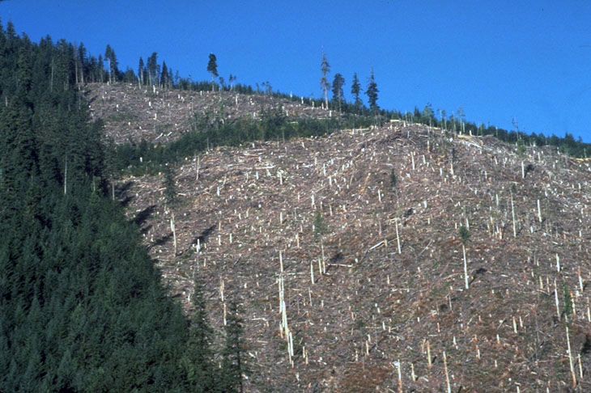
Photo #1…Bulldog Restoration Project

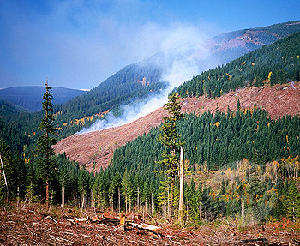
Photo #2…Clear Creek Restoration Project

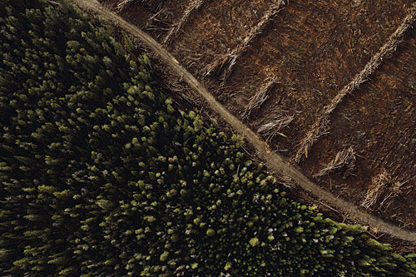
Photo #3…Crane Mountain Restoration Project

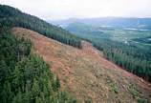
Photo #4…Sedgelaw Restoration Project

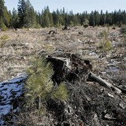
Photo #5…Bald Bear Restoration Project

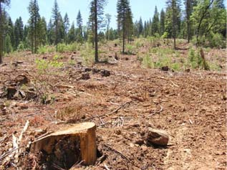
Photo #6…Heckler Restoration Project

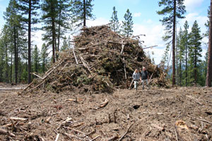
Photo #7...Lava Cast Restoration Project

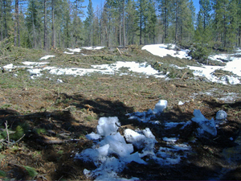

Photo #8...Upton Heights Restoration Project

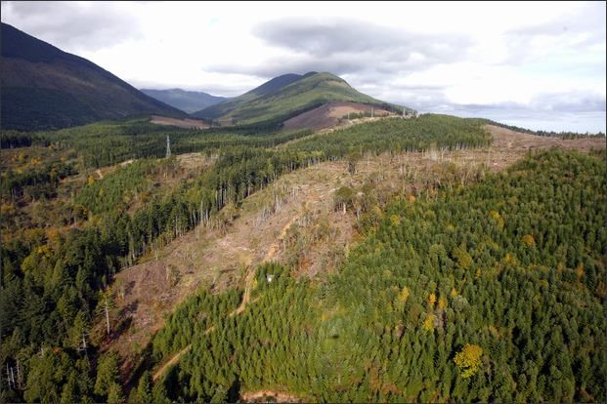
Photo #9...Elk River Restoration Project

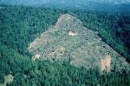

Photo #10…Crenshaw Restoration Project (note the landslide)

