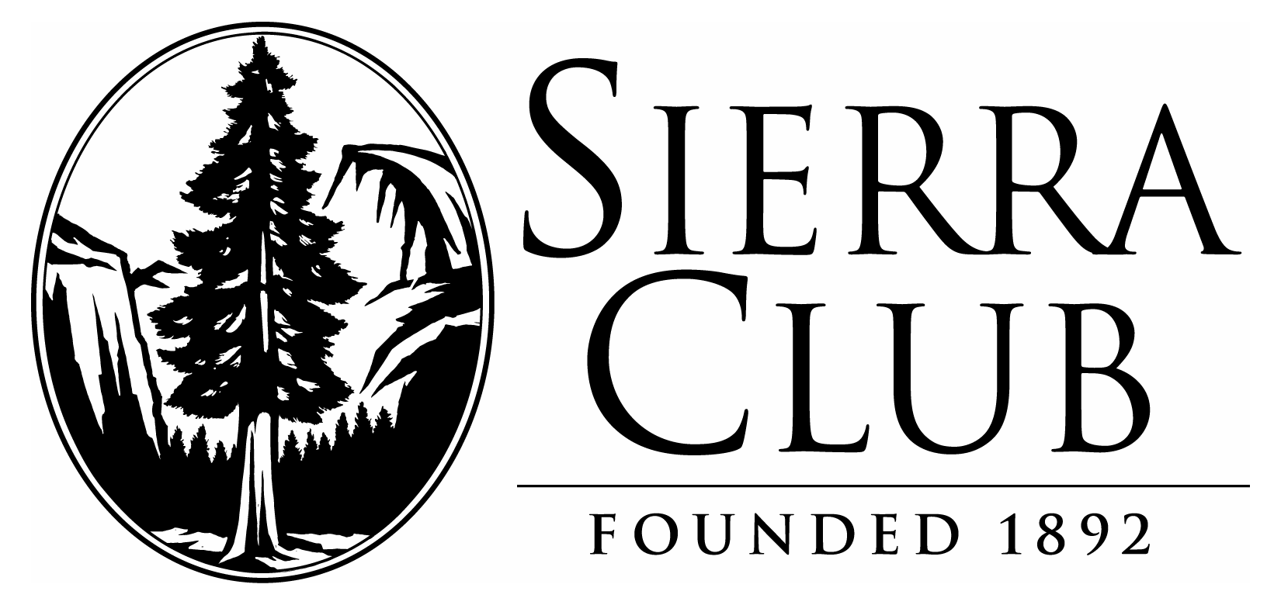
Washington State Chapter
180 Nickerson St, Ste 202
Seattle, WA 98109
Phone: (206) 378-0114
Fax: (206) 378-0034
www.cascade.sierraclub.org

April 12, 2020

Okanogan-Wenatchee National Forest
Cle Elum Ranger District
Attn: Michelle Capp
803 West 2nd Street
Cle Elum, WA 98922

Submitted to:
https://cara.ecosystem-management.org/Public//CommentInput?Project=57415

Subject: Gold Creek Valley Restoration Project, Scoping Comments

District Ranger Capp:

The Sierra Club has reviewed the scoping information for the Gold Creek Valley Restoration Project. The Sierra Club has a long history of involvement in the lands in and around Snoqualmie Pass, working to protect and restore the land and waters of this remarkable ecosystem. We are interested and supportive of the efforts to improve the habitat for Bull Trout in the Gold Creek/Keechelus Lake ecosystem, and would like to share our thoughts and concerns regarding the proposed restoration work that is currently being designed.

Hydrology and Design Details:
In general, we support the intent of the restoration designs presented in the scoping documents. It is assumed that any of these design options would fulfill the intended purpose of increasing the flow rate of ground and surface water back into the natural hydrologic cycle of Gold Creek, but we are interested to learn the specific costs and benefits of each of the proposed designs. In particular, the following issues should be addressed in the next stages of project review:

Are there differences in time frames to completion and anticipated increase of flow rates between these proposals? For example, the “Creek Integration Concept” anticipates that “Over time…the channel progressively fills the ponds”. Is this time frame of recovery therefore longer than the time frame of the other two proposals, which presumably will be implemented more directly through short-term construction? Is the dewatering of the creek anticipated to be remedied equally between all proposals? Besides the obvious physical differences in the three different layouts, what are the hydrological impacts of the different designs? What are the trade-offs? What will be the impacts to the bull trout population during the construction phase of the restoration process? And will there be any other fish or wildlife species impacted by this process?

We would like more information regarding the process used to fill the current Gold Creek Pond in the preliminary design concepts. This will likely require a large amount of fill material. Where will the fill be sourced from, and what time of material will it be? Will the ponds be drained and will the fill be compacted? If the fill material is too porous and/or the material remains too loosely deposited, it may not have the desired effect on the groundwater table.

Also, we are interested in learning more about the impacts of the construction process on the roads leading to and traveling past the remediation site. This project will require that large equipment be transported to and from the site, and that many dump trucks will travel along the access roads. To what level will the existing access roads be developed? Will there be relocation or widening of the existing route? Will Forest Service Road 114 be upgraded to a haul road? This would be a significant impact on the forest habitat of this area by clearing trees and further fragmenting the forest. This will degrade the connectivity with the recently constructed wildlife crossing structures on I-90. It could also change the long term public use of this valley. How will these roads be mitigated and/or downsized once the project is completed?

As a design comment, we would also note that maintaining viewscapes upvalley to the Alpine Lakes Wilderness Area is a high priority for our members as well as the general public, particularly those who may have limited mobility or have small children. View spots and picnic areas should maintain the types of views currently accessible from Gold Creek Pond, and the trails accessing the picnic areas and views should be designed with very clear ADA specifications. These paths should be designed to require minimum maintenance to provide long-term accessibility.

Downstream Improvements
We are also curious about the downstream improvements that can be done to improve habitat for the Bull Trout within this ecosystem.

Downstream from the project site there is a parcel of private land that currently provides excellent habitat on both banks along 2,500’ of Gold Creek, including adjacent to Gold Creek Pond. This is critical habitat that is currently flowing year round. That 77 acre property could be subdivided and developed, and was platted for a major condominium development. Any of this development would bring additional impacts to the stream through clearing of the forest, runoff and public access and use of the stream and riparian zone. Avoiding this is a key objective of the Bull Trout Action Plan, so the conservation of this property should be a part of the project.

We would also support the implementation of the actions outlined in the Yakima Bull Trout Action Plan to improve the success of the Keechelus/Gold Creek Bull Trout population. This would include, but not be limited to, the prohibition of vehicle access to the lakebed and Gold Creek, and addressing reservoir bed passage issues in Gold Creek. The plan also calls for fish passage at Keechelus Dam and a new bridge over Gold Creek at FS 4832. These are important projects. How will they be implemented?

We appreciate the opportunity to comment on this project during the scoping phase. Please keep us on the mailing list and informed of future developments.

Sincerely,

Nete Olsen
National Forest Committee

