Irresponsible Drivers and Recreational Vehicle Use
In your environmental assessment, please include the impact of motorized vehicles on the health of the forest and on all the wildlife, including the wild horses. Not only are people tearing up the Forest Service roads with their vehicles, but they’re literally tearing up the forest floor and terrorizing the wildlife. On numerous occasions, I have observed off-road vehicles driving throughout the forest, with no regard for the damage caused to the forest. This does fall within the scope of this project, as it impacts the overall health of the forest and impacts areas where wild horses roam for forage and water, as well as interferes with their breeding and foaling.

Woman who drove into the forest on her ATV to get closer to the wild horses:
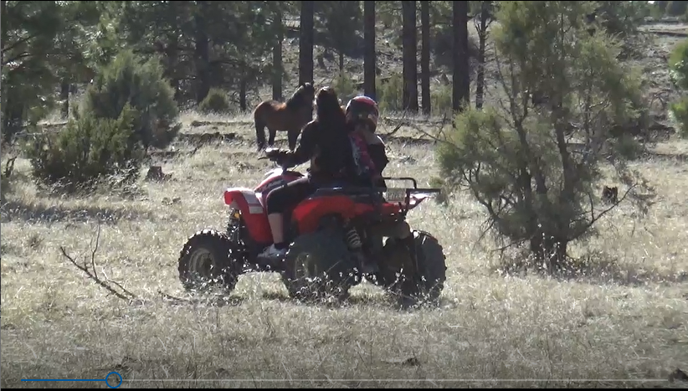

Someone hit and knocked down this sign with their vehicle:
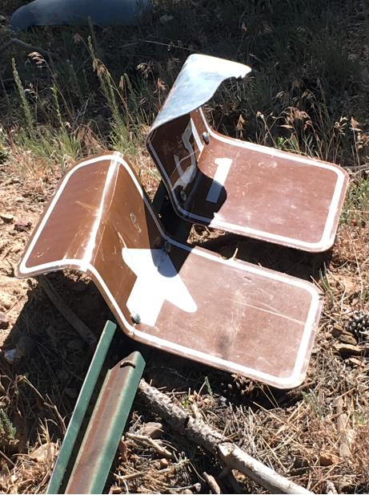

Just a couple of the numerous examples I have of vehicles driving off road and damaging the forest floor. There are numerous areas like this throughout the forest:


