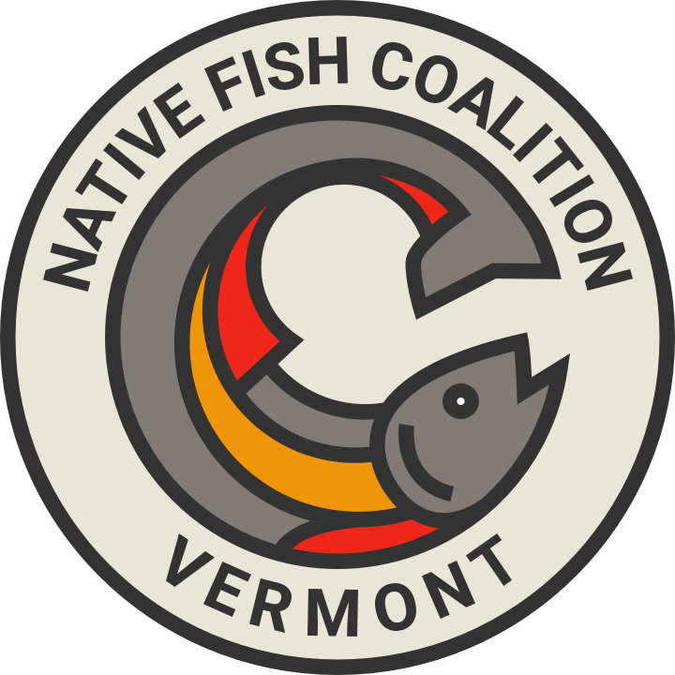
March 13, 2020

USDA Forest Service
c/o Jay Strand, Project Team Leader
99 Ranger Road
Rochester, VT 05767

RE: Somerset Integrated Resource Project

Dear Mr. Strand:

Native Fish Coalition (NFC) has reviewed in detail the Environmental Assessment issued by the U.S. Forest Service (USFS) Feb. 14, 2020 as part of the Somerset Integrated Resource Project (IRP).

NFC appreciates the endorsement by USFS of many actions benefiting wild native brook trout, namely riparian zone protection, large wood additions to upland streams and monitoring trout populations before and after habitat work.

NFC does object to one USFS action, however. In public comments No. 73, 95, NFC recommended a public informational sign program to highlight wild native trout at suitable locations, e.g. trailheads near streams. Although USFS endorses a collaborative sign project, it recommends excluding it from the formal plan. Instead, it suggests an informal process with the Vermont Department of Fish and Wildlife (VF&W).

For reference, the USFS said in its Feb. 2020 assessment: “The Forest Service welcomes the opportunity for developing and placing interpretive signs. This should be done in coordination with Vermont Agency of Natural Resources – Fish and Wildlife Department staff to ensure the message is consistent with current fishery management objectives.” (PC 31400-15)

NFC welcomes participation by VF&W. However, a sign program to benefit the public should not be contingent on a single party. Further, the NFC believes USFS fisheries staff has expertise to discern where wild native trout populations exist and where signs are appropriate.

In summary, NFC urges USFS to include the interpretive sign project in the Somerset plan. This assures a higher degree of success for a project that gives USFS and other partners credit for protecting and highlighting a valued resource — wild native trout —in the federal forest.

Sincerely,

Chris Owen
Secretary, Native Fish Coalition - Vermont Chapter
CC: Native Fish Coalition, Vermont Board
Native Fish Coalition, National Board

