THRIVING ECOLOGICAL BALANCE

I require the EA/EIS to provide to the public scientifically supportable and defensible research, reports and methods the USFS used to obtain the data for the following:
*Forage production
*Carrying capacity
*Acres allocated per Animal Unit Month
*Current and historical grazing allocations for livestock
*Temporary or extended grazing permits issued in the last 10 years
*Total available water sources in the area
*How many water sources have been fenced and why
*Miles of fencing in the area and purpose of this fencing
*Total big game populations in the area, including how the USFS plans to manage for if those species are not currently at their maximum population targets and most important:
*How the USFS distinguishes wild horse use from other rangeland users.

The NEPA law requires that all relevant scientific information be provided to the American public and that that information be taken a “hard look” at by the decision makers. The National Environmental Policy Act (NEPA) requires that to ensure that environmental assessment statements reflect a careful consideration of the available science, and that areas of disagreement or uncertainty are flagged rather than being swept under the carpet.

I require the upcoming EA/EIS to include scientifically supportable, credible and defensible USFS annual population increases stated in the public scoping notice and the USFS annual herd statistic reports for the past fifteen years. This scientific data would include but not be limited to both aerial and on the ground investigation and reports and photos and video.

I require evidence that the USFS have engaged in current range assessments adequate to allow the USFS to conclude that ONLY by lowering the current wild horse AML and/or removing any proposed number of wild Horses from the Heber herd would achieve that optimum number and return and maintain the range to its natural ecological balance.

While documentation is not the end of the NEPA process, it is important that a reasonably good job of communicating the purpose and need of the project; the values used to develop and compare alternatives; the results of [accurate] analysis for direct, indirect impacts, and cumulative impacts; and mitigation as required by relevant regulation. It provides [accurate] evidence to the public and participating agencies [showing] a commitment to, and satisfaction of the NEPA requirements. Environmental documentation must communicate clearly [and accurately] the results of project analysis and the subsequent decisions. http://www.environment.fhwa.dot.gov/projdev/qaimpact.asp

I require the EA/EIS to give a detailed explanation of any inequitable allocation of resources in this Territory to livestock grazing and the agency’s response to the fact that wild horse removals can cost-effectively be avoided by accommodating the current wild horse population levels through modest or complete downward adjustments to livestock grazing pursuant to 43 CFR 4710.5, which states, "If necessary to provide habitat for wild horses or burros, to implement herd management actions, or to protect wild horses or burros, to implement herd management actions, or to protect wild horses or burros from disease, harassment or injury, the authorized officer may close appropriate areas of the public lands to grazing use by all or a particular kind of livestock....Closure may be temporary or permanent." The cost to tax-paying Americans of grazing domestic livestock on public lands is heavily researched with the following results:
“The Government Accountability Office (GAO) has reported the federal government spends at least $144 million each year managing private livestock grazing on federal public lands, but collects only $21 million in grazing fees—for a net loss of at least $123 million per year”.
http://www.taxpayer.net/user_uploads/file/factsheet_Grazing_Fiscal_Costs(3).pdf

Costs of HWHT managment plan
I require that the EA include the entire costs of the Heber Wild Horse Territory management plan proposal. This requires the itemization of costs or at least estimates for the horse captures, disposal costs, sterilization, geldings, costs of holding the horses, etc that will be passed on to the tax payers such as myself. These costs should also include the $ 131,670 cost of the collaboration by Southwest Decision Resources and the $7,725 reward paid to ASU for their part in the collaboration as well as other costs and fees for the collaboration.

$ 131,670
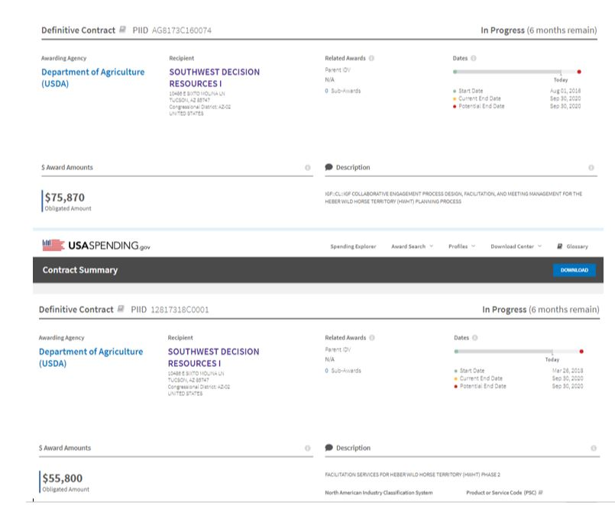

Award Amounts
This other was awarded to Arizona State University for $7,725.

Total Award Amount:$7,725
Award Details
Description HEBER WILD HORSE TER Period of Performance 04/26/2017 - 09/30/2019 (2 years, 5 months) Primary Place of Performance AZ
Congressional District: AZ-90 Other TypeOTHER FINANCIAL ASSISTANCE CFDA Program10.699 - PARTNERSHIP AGREEMENTS CFDA Program Description To increase participation by partners in all authorized Forest Service programs and activities.
ng.gov

USAspending.gov

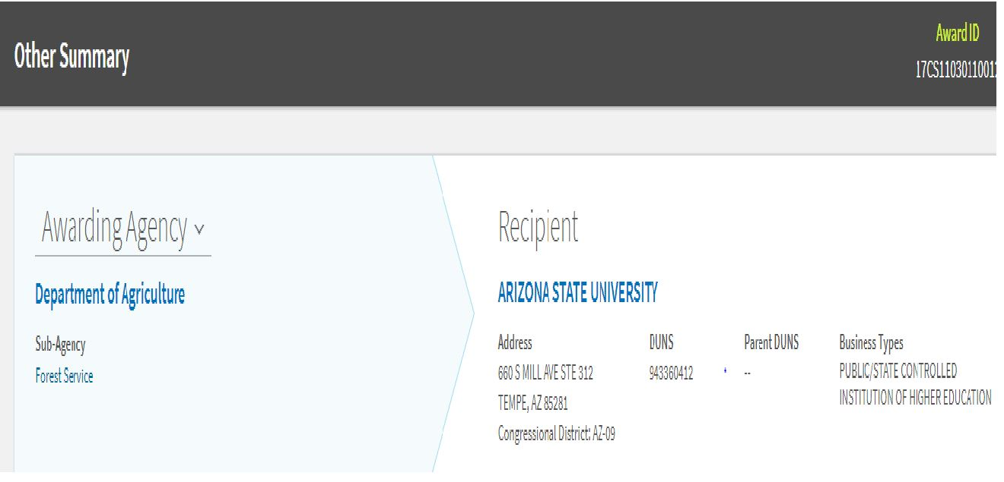

THE National academy of science (NAS) research report

The 2013 NAS report states, “Management of free-ranging horses and burros is not based on rigorous population-monitoring procedures.”

The U.S. Forest Service has not established the true population numbers of wild horses in the Sitgreaves National Forest. Overpopulation has not been proven. History shows the designation of the Heber Wild Horse Territory the way it was designated in 1974 was never drawn out in accordance with the Wild Free-Roaming Horses and Burros Act. In order to conclude that an over-population exists and make recommendations for artificial management considerations such as captures and removals and fertility control, there must be an accurate population count and proof of over population in the natural, original range of the Heber wild horse herd. There must be population tracking and range monitoring for at least 15 years in order to be able to determine if or how fast the population is growing.

As the district court explained in Dahl v. Clark, the test as to appropriate wild horse population levels is whether such levels will achieve and maintain a thriving, ecological balance on the public lands. Nowhere in the law or regulations is the USFS required to maintain any specific numbers of animals or to maintain populations in the numbers of animals existing at any particular time.

The only law that requires the USFS to maintain populations is the 1971 Congressional law. The law must be followed and the law states, “that wild free-roaming wild horses [and burros] are to be considered in the area where presently found, as an integral part of the natural ecosystem of the public lands”. Thus, an AML established purely for USFS administrative reasons because it was the level of the wild horse and/or burro use at a particular point in time or imagined to be an advantageous population for the USFS cannot be justified under statute.

Considering usage of only one species does not provide the scientific data to determine an appropriate population of any species in that area.
Therefore, I require hard data that shows water and forage consumption of every grazing species in the forest both domestic and wild.

Do not try to tell the public and me that the subject of the appropriate management level set by the USFS for this herd is “outside the scope” because nothing could be further from the truth – as a matter of fact, it is the major scope of the issue. The NEPA law requires that all relevant scientific information be provided to the American public and that that information be taken a “hard look” at by the decision makers. The National Environmental Policy Act (NEPA) requires that to ensure that environmental assessment statements reflect a careful consideration of the available science, and that areas of disagreement or uncertainty are flagged rather than being swept under the carpet.

A good hard look must also be taken at the recreational use in the forest. The forest floor is being torn up by people in off road vehicles that fail to adhere to the rules/laws stating that vehicles must stay on the FS roads. What used to be beautiful hill sides are now scarred by off road vehicles. This not only ruins the flora but also threatens the wildlife including wild horses. People have been found camping in areas where they are not supposed to be camping such as next to waterholes which impacts on the wild horses and other wildlife who depend on drinking from the waterholes. Hunters and people who target practice shoot in illegal areas, too close to the highway and across FS roads.

In addition to the concerns expressed above, the EA/EIS for this project must address and analyze the following impacts and concerns:

- A full disclosure of whether any member of the USFS planning and management team for this project has any personal or financial interest (including any interest in any grazing allotment) in the proposed plan. It is imperative that the USFS ensure that there are no conflicts of interest and that it has established high scientific standards before spending hundreds of thousands of taxpayer dollars on this proposal. (see regulatory captured agency)

“Regulatory Capture” is a form of political corruption that occurs when a regulatory agency, created to act in the public interest, instead advances the commercial or special concerns of interest groups that dominate the industry or sector it is charged with regulating. Regulatory capture is a form of government failure; it creates an opening for firms to behave in ways injurious to the public. The agencies are called "captured agencies".

Government agencies tend to elevate social, cultural, and political concerns over the natural environment. Congress designed NEPA to achieve environmentally positive results through a compulsory procedural mechanism, NEPA simply prohibits uninformed, not unwise, agency decisions (Nowlin & Henry, 2008). The EA/EIS process is required to weigh the benefits versus the financial and wild horse costs of the project.

Although I personally oppose any and all USFS interference and harassment with the Heber wild horses the public has the responsibility to review and make recommendations before any capture suggestion or any decision is made by the USFS and it is my request as well as the responsibility of the USFS to supply the public with adequate and accurate information, scientific research and realistic options. This is the main purpose of this letter and without the USFS willingness to supply complete, accurate and non-politically driven information and to review all scientific and logical information provided to the agency; any proposed EA/EIS or decision will be illegal.

As required by NEPA to bring federal action in line with Congress' goals and to foster environmentally informed decision-making by federal agencies, NEPA “establishes ‘action-forcing’ procedures that require agencies to take a ‘hard look’ at environmental consequences.” Metcalf v. Daley, 214 F.3d 1135, 1141 (9th Cir.2000) (quoting Robertson v. Methow Valley Citizens Council, 490 U.S. 332, 348, 109 S.Ct. 1835, 104 L.Ed.2d 351 (1989)). Therefore, I hereby require that the requested highly relevant and scientifically supported information be included in the USFS “hard look”. Additionally, these scientific research and reports that I require must become a part of the administrative record for this scoping and the upcoming HWHT Plan and also must be provided to the public and the decision makers.

