The Forest Service states “Unmanaged horses increase in population rapidly"

Prior to the federal court cases of 2005-2007 the Forest Service had been contracting with citizens to capture and remove free-roaming horses from the Sitgreaves. Those captures and removals were in violation of the WFRHBA due to lack of a Heber Wild Horse Territory management plan. In 2005 the Forest Service announced it was going to remove “approximately 300 horses that are currently grazing a portion of the Rodeo/Chediski burned area near Heber.” The Forest Service was taken to court and a Temporary Restraining Order was issued that prevented the FS from carrying out their plans to remove horses. In 2007 the Court ordered that no free-roaming horses could be removed from the entire Sitgreaves until there was a written Heber Wild Horse Territory management strategy. So the Heber herd has not been under any Forest Service “management” since 2005.

The following News Release refers to the free-roaming horses as “stray, domestic” however, those designations were without investigation and therefore arbitrary and not proven to be factual. The Forest Service has an obligation to manage and protect the free-roaming horses on the Sitgreaves.

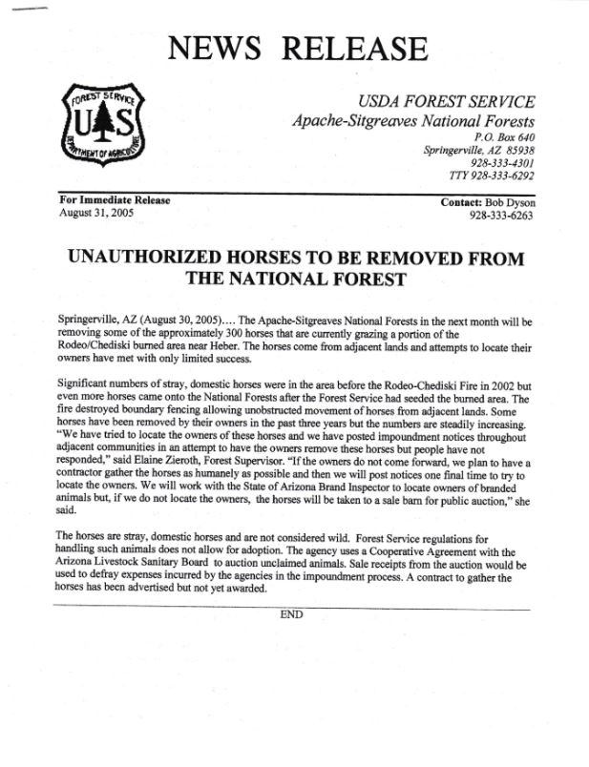

A Wild Horse Territory Management Plan proposal is not an opinion piece that one would expect to see in a newspaper. If you are going to state something as fact, you need to be able to support it with facts. Therefore, I am requiring that the upcoming EA provide proof that the Heber herd has rapidly increased in population during the past 15 years while they were unmanaged. Proof such as all the official wild horse censuses taken from 2005-2020 that would include data from the censuses such as dates, raw data, notes, photos, flight or ground patterns during the censuses, horse counts, locations of horses seen, etc.

