In Violation of the Wild Free-Roaming Horses and Burros Act of 1971

Horses from the Heber herd have been removed and killed in violation of the WFRHBA. This happened not only with the blessings of the Forest Service but it was the Forest Service that contracted with the public lands ranchers to capture and remove wild horses that were under Federal protection through the Wild Free-Roaming Horses and Burros Act! The horses were then sent to auction and sold without limitation.

Through a FOIA request we have knowledge that during the 1980s and 1990s the Forest Service had written agreements with citizens/ranchers to remove free-roaming horses from the Sitgreaves National Forest. Some of the agreements specify removing horses from cattle pastures on the Heber Wild Horse Territory. Without a HWHT management plan in compliance with NEPA the removals were illegal under the WFRHBA. That lack of a management plan is one of the things that prevented the Forest Service from contracting to have free-roaming horses removed in 2005.

While the Draft Proposed Action Plan for the Heber Wild Horse Territory claims there were no wild horses left on the HWHT after the mid 1990s it fails to mention the Forest Service routinely had contracted with ranchers/citizens to capture and remove free-roaming horses from the Sitgreaves National Forest including areas on the HWHT.

Information received through a Freedom of Information Act (FOIA) request revealed that in the 1980s and 1990s the Forest Service had made written agreements with private citizens/public lands ranchers, to capture and remove free-roaming horses from the Sitgreaves National Forest. Information from the FOIA request reply shows captured horses were sent to the Sun Valley Livestock Auction. Some of the agreements were for the captures of horses on cattle pastures which overlay the Heber Wild Horse Territory. Without a management plan in place and without proof of whether the horses were wild or domestic, those captures and removals were in violation of the Wild Free-Roaming Horses and Burros Act of 1971.

I am requiring full disclosure to the public as to all actions taken by the Forest Service to
capture, remove, destroy, any horses that were in the Sitgreaves National Forest after the Wild
Free-Roaming Horses and Burros Act went into effect in 1971.

Here are two of the numerous agreements I received through my FOIA request in which I asked for the following information: for any written or oral or email agreements or discussions and the names and title of any and all US Forest Service employees, that were made between the Forest Service and the permittees, including names of permittees and grazing allotment name and number, that would allow for horses to have been removed from the Black Mesa and Lakeside Ranger Districts from 1971 through the time the information is provided to me. Also for any records during that same time frame stating how many horses were removed in such roundups and the names of the participants in the roundups and from what grazing allotments or areas of the forest and the results (such as number captured and dates of capture) of those unclaimed, unbranded horses captured and the ultimate status of those horses (sold at auction etc.)

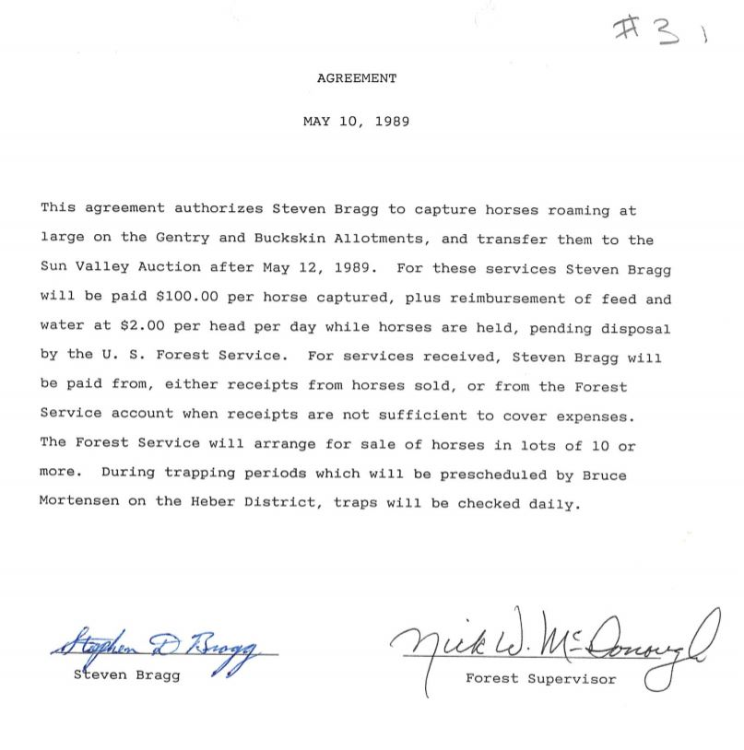

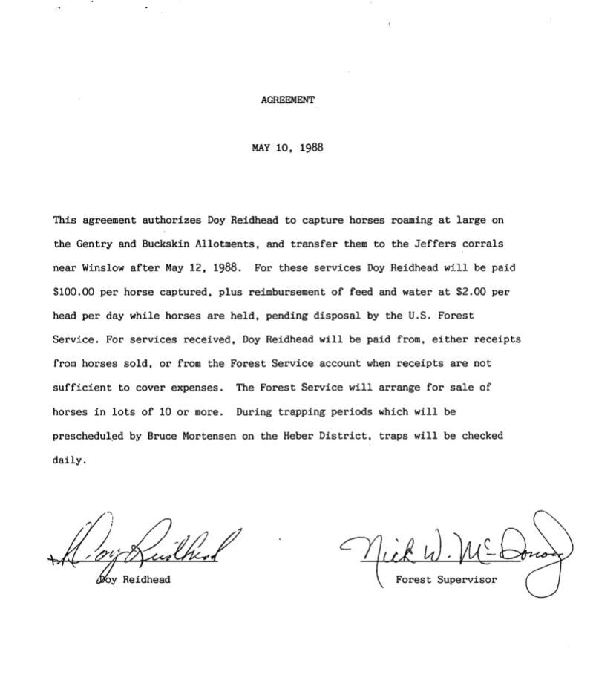
I require the USFS consider and provide to the public, the actions, results and impacts including
repeated removals and “distribution” of the horses that have previously been captured over the past forty-nine years [since 1971]. BLM equine genetics expert, Dr. Gus Cothran, has expressed concern regarding the genetic viability of both wild horse and wild burro herd populations under the management of the BLM. The Forest Service is under the guidance of the BLM so the same concerns would apply. Across the West, wild horse herds have been decimated and continued capture and removal and any chemical or surgical procedures the USFS authorizes and induces causes a high risk of the genetic viability of wild horse herds. Given the repeated and illegal reduction of the wild horse population, the USFS must analyze the direct, indirect, and cumulative impacts of and proposed reduction of the Heber wild horse herd, in their care and under their congressionally required protection.

Under the WFHBA "wild free-roaming horses and burros" means all unbranded and unclaimed horses and burros on public lands of the United States; Unless proven domestic property, the horses that were captured in the Sitgreaves belonged to every American and as such, every American is entitled to know what happened to OUR horses.

The NEPA law requires that all relevant scientific information be provided to the American public. Scientific information would include keeping record of the horses and their range. But in place of scientific record keeping, it appears horses were being removed continously. Therefore, I am requiring the following to be included in the EA so that the public can see the lack of adherence of the WFRHBA and how no science was used.

I am requiring the following to be included in the upcoming EA: Information regarding any and all the agreements/arrangements made including written and oral accounts, by the Forest Service for their rangers or between the Forest Service and citizens/ranchers, for the roundups, captures, removals, herding into the White Mountain Apache Reservation, and killings of free-roaming horses on the Sitgreaves:

All the names, titles, of the decision makers,
The Forest Service agreement writers and signers,
All written and verbal contracts,
Every agreement,
Every payment made,
Every amount received,
Every horse that was captured and removed,
Every horse that was shot or killed in any manner,
Location from where they were removed,
How long they were held,
Where they were held,
Where they were taken for “disposal”
Including dates on all information.

Also, any and all information of any of the pre-listed activities that were carried out by citizens/ranchers without the written or verbal agreements/contracts having been made with the Forest Service.

Do not tell me this is "outside the scope" because the foundation was laid when the Draft
Proposed Action Plan for the Heber Wild Horse Territory specifically introduced horse population counts. There was no mention of the fact that the Forest Service was instrumental in having horses removed in previous years. Population numbers that the Forest Service were not able to prove in Federal Court were included in the Draft Proposed Action. Nothing is
“outside the scope” if it affects the public lands and the NEPA law requires that all relevant scientific information be provided to the American public. The horse population was artificially
manipulated due to the fact that the Forest Service contracted, in violation of the Wild Free-
Roaming Horses and Burros Act to have horses removed without a Heber Wild Horse Territory
management plan.

