Impact of Fences After the Designation of the Heber Wild Horse Territory

Fences are prevent the wild horses from roaming throughout their currently designated territory.
On page 9 of the Draft Proposed Action for the Heber Wild Horse Territory Management Plan it is stated that the fences “may be restricting the horses to the southern and eastern portions of the analysis area with most horse use occurring outside the designated territory.” Well of course that is true! The fences are even preventing the horses from moving throughout the entire territory itself. They also prevent many horses from accessing the territory.

The aerial census map on page 10 of the Draft Proposed Action for the Heber Wild Horse Territory Management Plan shows there are no horses in nearly half of the designated territory. The fences are preventing the horses from free-roaming throughout their historical, migratory land. The Sitgreaves forest is heavily fenced making the principle use that of livestock instead of wild horses as the law requires under CFR title 36:
(14)Wild-horse and burro range means an area of National Forest System specifically so designated by the Chief, Forest Service, from wild horse and burro territory, for the purpose of sustaining an existing herd or herds of wild free-roaming horses and burros, provided the range does not exceed known territorial limits and is devoted principally, but not necessarily exclusively, to the welfare of the wild horses and burros, in keeping with the multiple-use management concept for the National Forest System.

Not only do those inner livestock pasture fences prevent natural migration and intermingling for strong herd genetics, they also pose a risk to the health of all the wildlife in the forest including the wild horses.

This Heber wild horse mare was freed but she ultimately died a short time later due to her internal injuries. Her foal then died because she was too young to be without her mother.

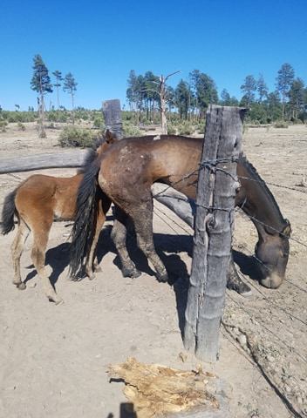

A photo of a cow elk who also died due to getting tangled in a fence when trying to leap over it. These are not isolated incidents.

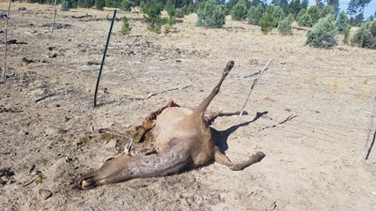

Then there are the heaps of discarded barbed wire fencing that are found throughout the forest that also pose a danger to wild horses, other wildlife, and humans.

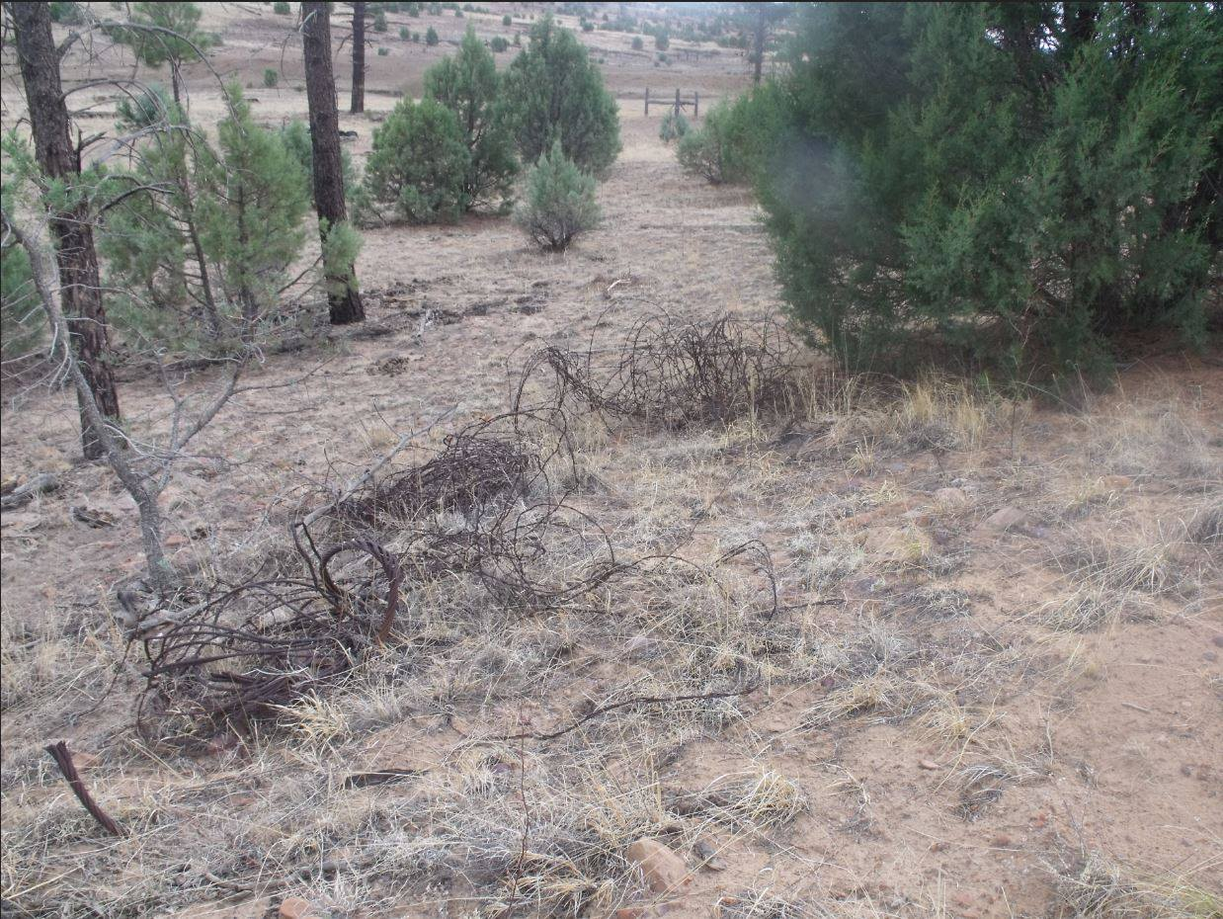

And in some cases rolls of never used barbed wire left out in the forest to become rusty snares for wild horses and other wildlife and humans. It’s disgusting. The Sitgreaves is a mess!
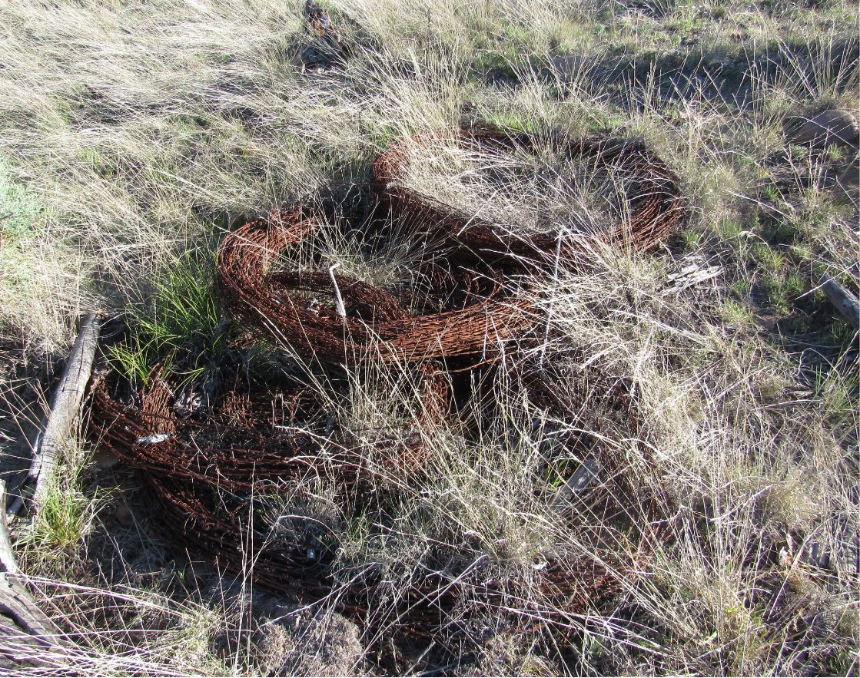

I require a “good hard look” to be taken and addressed in the upcoming EA regarding the fences and how they impact and impede the natural movement of the wild horses and the health risk they pose to all of the wildlife in the forest as well as the wild horses.

The Heber Wild Horse Territory management plan should include everything to better the forest for wild horses, other wildlife, human use, etc. But after reading through the plan it is evident that the main focus is how to eliminate wild horses.

