Heber Wild Horse Territory Comment

As an American tax-paying citizen, long time resident of Arizona, environmental researcher, visitor/camper/recreationist of the Sitgreaves National Forest, I require that the United States Forest Service (USFS) consider my scoping comment very seriously and include it in the administrative record for the Heber Wild Horse Territory Management Plan proposal.

“I became aware that political pressure has become a factor in the carrying out of some of the policies and aims of the Forest Service. This tendency is, in my opinion, one of the most regrettable things that could happen to a Service that has been so clean and clear of anything like political pollution in the past, and I earnestly hope that this tendency will be abolished before it strangles the real life out of a truly great and good Government”

EARLY DAYS IN THE FOREST SERVICE
by Albert E. Cole
Senior Ranger Deerlodge (Retired 1935)
P.O. Box 67 Deer Lodge, Montana
May 26, 1944
Volume 1 Compiled and Edited by Jessie Thompson circa 1944 U.S. DEPARTMENT OF AGRICULTURE FOREST SERVICE
Northern Region Missoula, Montana
https://foresthistory.org/wp-content/uploads/2017/02/EARLY-DAYS-IN-THE-FOREST-SERVICE-vol1.pdf

The USFS is required by the National Environmental Policy Act ("NEPA"), 42 U.S.C. §§ 4321, et seq., to prepare Environmental Assessments or EAs or, if indicated, Environmental Impact Statements (EIS) for any proposed changes to public lands that may have a significant environmental impact. The law directs the agency to identify environmental concerns, consider alternatives including no action at all and take a "hard look" at the issues and minimize significant environmental impact. A significant environmental impact includes actions that are likely to be highly controversial or have uncertain effects on the quality of our lives and that affect cultural and historical resources. 40 C.F.R. §1508.27(b). These evaluations as well as land use plans are full of words but have little substance when it comes to stating why wild horses must be removed from their homes. It is often what is NOT in these documents that is most telling. For these reasons, I require the following information be included in the Draft Proposed Action for the Heber Wild Horse Territory Management Plan.

The Wild and Free-Roaming Horses and Burros Act of 1971 (WFRHBA) is an Act of Congress signed into law. Consider the following un-amended language of the 1971 law and what it means: “It is the policy of Congress that wild free-roaming horses and burros shall be protected from capture, branding, harassment, or death.” This is the law of the people of the United States and the upcoming Heber Wild Horse Territory proposed plan must follow this law – it cannot include capture and it cannot include branding and must not include any kind of harassment and especially not death – all are illegal per the Congress of the United States of America. USFS and BLM policies are plans and statements that have been made by the agencies and associates and are only self-monitoring regulations and often do not follow the congressional law. Any and all policies established must be within the outline of the umbrella of the law that it is required to follow. A policy plan is nothing more than a strategy and is illegal if it does not follow the law of the United States of America.

At this time I wish to bring to the attention of the USFS management that any employee of the Department of Agriculture that has made false statements is subject to the following Title 18 violations which include fines and prison terms. Please keep this in your mind as you write and review the upcoming Environmental Impact Statement (EIS) / Environmental Assessment (EA).

The impact of ignoring or bypassing the edict of the law destroys the trust and the integrity of the United States Government to abide by a law that was passed by Congress and can only be abolished by an act of Congress.

Title 18 (18 U.S.C. § 1001). Making false statements (18 U.S.C. § 1001) is the common name for the United States federal crime laid out in Section 1001 of Title 18 of the United States Code, which generally prohibits knowingly and willfully making false or fraudulent statements, or concealing information, in "any matter within the jurisdiction" of the federal government of the United States, even by mere denial 18 U.S. Code § 1519 - Destruction, alteration, or falsification of records in Federal investigations Current through Pub. L. 114-38. (See Public Laws for the current Congress.) US Code Per the US Department of Justice, the purpose of Section 1001 is "to protect the authorized functions of governmental departments and agencies from the perversion which might result from" concealment of material facts and from false material representations.

Sitgreaves Forest History

The Draft Proposed Action for the Heber Wild Horse Territory Management Plan states:
“the history of the area horse herd(s) suggest that there are two periods of occupation. The first period dates between the 1930s to c. 1990, followed by a second period that dates from c. 1990 to the present.”

However, historical documents prove wild horses were in the Sitgreaves way before the 1930s. In fact, even the Forest Service’s own historical accounts back up the fact that there were wild horses in the Sitgreaves prior to the 1930s.

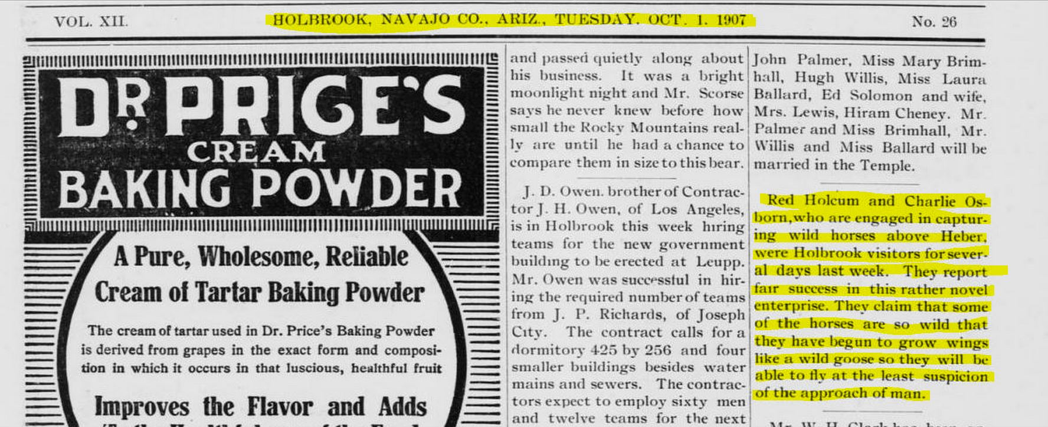

The following are excerpts from a historical court case regarding wild horses proving there were indeed wild horses in the Sitgreaves prior to the 1930s.

The Early Days:
A Sourcebook of Southwestern Region History — Book 2
USFS
http://npshistory.com/publications/usfs/region/3/early-days/2/sec3.htm?fbclid=IwAR0kIGDGcagv9ieNy8zVyr35adpUb1ycaDDXw8iVtNQMngib0aDr91YXioo
G-Trespass
Wild Horses No. 20-G-3 Albuquerque, New Mexico
April 22, 1931
Memorandum for Forest Officers:

The decision rendered by Judge Jacobs in the Federal Court at Phoenix on April 9 in the case of the United States vs. C. D. McCauley, County Attorney, and L. D. Divelbess, Sheriff, of Navajo County, Arizona, have been given wide publicity in the newspapers of the Southwest and no doubt all of you have read of the case in the papers. However, the decision in this case is of so much importance to the Forest Service in carrying out its policy of ridding the range of wild horses that I am attaching hereto for your information, mimeographed copies of the decree and injunction which are self-explanatory and it is hoped that all of you will familiarize yourselves with the circumstances of the case, as shown in these papers.

This case was taken to the Federal Court as a result of criminal proceedings against Ranger D. E. Slosser instituted in the State Court by County Attorney McCauley and Sheriff Divelbess for the purpose of preventing Forest officers from carrying out closing order procedure on the Sitgreaves National Forest.

From the information in the decree and injunction, it is evident that in carrying out closing order procedure, the courts will insist that ample notice of the plans for disposing of the wild horses, including the period fixed by the Forest Supervisor for disposing of them, be given to the interested stockmen; also, that before shooting horses, Forest officers use reasonable diligence in determining whether the horses are wild or gentle. It is realized that where wild and gentle horses are mixed on the same range it is rather difficult to distinguish the gentle horses from the wild ones, consequently a gentle horse may be killed accidentally, in which case the Service would be criticized, but if reasonable diligence is used to determine whether the horse is wild or gentle and notice of the time set for shooting the wild horses is given to the local stockmen, it is felt that the closing order procedure will be supported by the Federal courts and by public sentiment.

IN THE DISTRICT COURT OF THE UNITED STATES
IN AND FOR THE DISTRICT OF ARIZONA

UNITED STATES OF AMERICA
FINDINGS OF FACT
Excerpt:
Predicated upon the foregoing stipulated facts the Court makes and finds the following findings of fact:
1. That the Closing Order of the Secretary of Agriculture made on the 7th day of November, 1929, as hereinbefore set forth was in fact regularly made, issued and published according to law, and that the same by supplemental order by the Secretary of Agriculture has been duly extended in effect to and including June 30, 1931.
2. That said Closing Order is a legal and valid order in so far as it applies to wild horses of unknown ownership.
3. That C.D. McCauley is the duly elected, qualified and acting County Attorney of Navajo County, State of Arizona, and that as such official and in his capacity as such officer he would, if not restrained by order of this Court, attempt to and would prosecute any Forest officer who wilfully, unlawfully and maliciously killed, wounded or maimed any branded horse of known ownership on the Sitgreaves National Forest, Navajo County, whether running at large or not, and that L.D. Divelbess is the duly elected, acting and qualified Sheriff of Navajo County, Arizona and unless restrained would arrest said Forest officers.

“The Complainant, through its officers, is authorized to dispose of, by shooting if necessary, any wild horse of unknown ownership, as herein defined, whether branded or not, found in trespass on the National Forest running at large on the forest after said range has been closed by the Secretary of Agriculture to the grazing of wild horses of unknown ownership as herein defined and reasonable notice has been given thereof.”
http://npshistory.com/publications/usfs/region/3/early-days/2/sec3.htm?fbclid=IwAR3Ov19z9sfMsJ8vQ6XtTvXPVAcLcdm9UmPwZibAf5HNTNegHPPSOVklB_o

Again from historical accounts by the U.S. Forest Service
Chapter 11 - Grazing: Controlling Use to Maintain
Productivity

“Until the 1930’s, there were no fences on the national forests, and this made it difficult to make a trespass case stick. Fencing only began in Arizona in the 1930’s with the advent of the Civilian Conservation Corps.”
https://www.fs.usda.gov/Internet/FSE_DOCUMENTS/fsbdev3_021163.pdf

There were no fences in the Sitgreaves until the 1930s. This is significant because it shows the wild horses were able to roam freely throughout the forest up until the fences were installed. Wild horses were not confined to specific areas and accounts show them to have been dispersed throughout the Sitgreaves. The ancestors of what is known today as the Heber wild horse herd were truly free-roaming. Today the Forest Service and the public lands ranchers try desperately to convince people there were no wild horses left on the Heber Wild Horse Territory by the middle of the 1990s. They claim that in 1974 there were only seven horses on the Territory when the first census was taken. However, the Federal Court recognized in its Order in 2005 that the Defendants (the U.S. Forest Service) failed to support how they arrived at their figures. So the numbers stated by the Forest Service are a moot point. Yet the Forest Service still puts those same, unprovable numbers out there as if they are based in fact.

The Heber Wild Horse Territory

THE WILD FREE-ROAMING HORSES AND BURROS ACT OF 1971
(PUBLIC LAW 92-195)
§1332. Definitions
As used in this Act-
(b) "wild free-roaming horses and burros" means all unbranded and unclaimed horses
and burros on public lands of the United States;
(c) "range" means the amount of land necessary to sustain an existing herd or herds of
wild free-roaming horses and burros, which does not exceed their known territorial
limits, and which is devoted principally but not necessarily exclusively to their
welfare in keeping with the multiple-use management concept for the public lands;
https://www.blm.gov/or/regulations/files/whbact_1971.pdf

The Heber Wild Horse Territory (HWHT) boundaries were clearly not drawn up in accordance with the Wild Free-Roaming Horses and Burros Act (WFRHBA) of 1971. The WFRHBA states that horses and burros “are to be considered in the area where presently found, as an integral part of the natural system of the public lands.” Per the WFRHBA the “range” or known territorial limits are also to be included when designating wild horse territories. The entire wild horse population along with their known range was not taken into consideration when the Heber Wild Horse Territory was originally designated in 1974. In fact, the appearance is that the HWHT map was drawn up and then there was a census (by some unknown party) of horses in this arbitrary area. The Sitgreaves consisted of 749,084 acres at that time. It is highly unlikely that there were no other wild horses in the Sitgreaves at the time the Wild Free-Roaming Horses and Burros Act became law and in fact, a Forest Service document proves there were indeed other horses on the Heber Grazing Allotment at the time the “census” said there were only seven.

The Draft Proposed Action for the Heber Wild Horse Territory Management Plan states: “When the territory was established in 1974, a letter from the forest supervisor to the regional forester indicated the territorial use of the area and included the first census (seven horses)."
However, a document received from a FOIA request proves there were more than seven unclaimed, unbranded horses in the forest in 1974. To pick out just seven and ignore the other horses directly contradicts the mandate of the 1971 law to establish areas "where horses currently are" and to protect those horses. According to the document the other horses were on the Heber grazing allotment. Line 11 of the document below states the horses were “rounded up and sold at public auction". It states the horses were “White Mountain Apache trespass” however, that was never proven. Being on public lands of the United States and not claimed by the White Mountain Apaches or anyone else, the horses were wild by definition of the WFHBA and should have been protected as such and included in the census along with the area they were found and their natural range. To remove them would have been in violation of the Act.

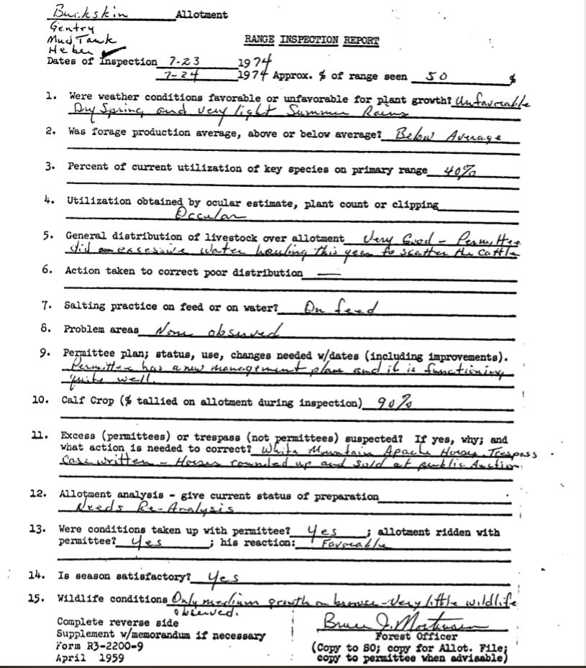

The WFRHBA is the law of the people of the United States. That law states: “that wild free-roaming horses and burros shall be protected from capture, branding, harassment, or death; and to accomplish this they are to be considered in the area where presently found, as an integral part of the natural system of the public lands.” USFS policies are plans and statements that have been made by the agencies and associates and are only self-monitoring regulations that are obligated to follow Congressional law.

The reply to a Freedom of Information Act (FOIA) offers no answers as to why that particular
19,700 acre portion of the Sitgreaves became the official Territory.

THE WILD FREE-ROAMING HORSES AND BURROS ACT OF 1971
(PUBLIC LAW 92-195)
§1331. Congressional findings and declaration of policy Congress finds and declares that wild free-roaming horses and burros are living symbols of the historic and pioneer spirit of the West; that they contribute to the diversity of life forms within the Nation and enrich the lives of the American people; and that these horses and burros are fast disappearing from the American scene. It is the policy of Congress that wild free-roaming horses and burros shall be protected from capture, branding, harassment, or death; and to accomplish this they are to be considered in the area where presently found, as an integral part of the natural system of the public lands.
“they are to be considered in the area where presently found”

The following excerpt is from the Forest Service website:
2. What prompted establishing a Wild Horse Territory on the Apache-Sitgreaves National Forests?
After the passage of the Wild Free-Roaming Horses and Burros Act of 1971, the Forest for wild horses. The census completed in 1974 found seven wild unclaimed horses on the Forest. A Wild Horse Territory was established for the horses in their location near the town of Heber, Arizona, and was named the Heber Wild Horse Territory. Over the next 20 the herd size remained very small. The last census of the Territory taken in 1993 found two mares.
https://www.fs.usda.gov/detail/asnf/landmanagement/resourcemanagement/?cid=fseprd534233

“The census completed in 1974 found seven wild unclaimed horses on the Forest.”
As I have shown, per Forest Service document, that was NOT the case.

The Forest Service and several members of the local community acknowledge the horses have always roamed between the "territory" and the Reservation, the courts ruled the horses are one-in-the-same, yet the Forest Service neglected to include the migratory land between the "territory" and the reservation in the territory historically used in 1971 and prior years in the lines drawn for the Heber Wild Horse Territory. This directly contradicts the mandate of the 1971 law to establish areas "where horses currently are."

From the WFRHBA:

(c) "range" means the amount of land necessary to sustain an existing herd or herds of
wild free-roaming horses and burros, which does not exceed their known territorial
limits, and which is devoted principally but not necessarily exclusively to their
welfare in keeping with the multiple-use management concept for the public lands;

The HWHT as it was originally drawn does not include all areas of the forest where free-roaming horses were known to have been. It also does not include their migratory lands or extend up to their territorial limits. Nor does it take into consideration how the grazing allotment pasture fences prevent the normal migration of horses. To have not taken into account all factors including where horses were currently living in the Sitgreaves National Forest and their territorial limits was an action not based upon consideration of relevant factors and so is arbitrary and capricious and not in accordance with the Wild and Free-Roaming Horses and Burros Act which was passed into law in 1971.
I require a close hard look at the historical accounts of where free-roaming horses were known to have been prior to the drawing of the current HWHT map.

In order for the HWHT to have been mapped out correctly and in compliance with the WFRHBA, the territorial limits, ALL free-roaming, unclaimed, unbranded horses in the Sitgreaves would have had to have been accounted for as well as the range and territorial limits of the horses.

“The census completed in 1974“

"The NEPA law requires that all relevant scientific information be provided to the American public and that that information be taken a “hard look” at by the decision makers. The National Environmental Policy Act (NEPA) requires that to ensure that environmental assessment statements reflect a careful consideration of the available science, and that areas of disagreement or uncertainty are flagged rather than being swept under the carpet.

An area of disagreement and uncertainty...“The census completed in 1974 found seven wild unclaimed horses on the Forest."
Therefore I require that all the following data for the census that was “completed” in 1974, be provided to the public and decision makers within the upcoming EA regarding the boundary of the Heber Wild Horse Territory including all original circa 1971 when the ACT was passed by Congress and also any subsequent review of the Territory lands.
The 1971-1974 census data required includes, but not limited to the following:
maps
field notes
meeting notes
names of decision makers
names of surveyors
all names and agencies they were employed by and titles of census participants
photos
dates that the census was conducted
mode of transportation used for taking the census
all (1) preliminary and (2) summary reports regarding the census

All data that was used to determine the territorial limits of the herd must be provided in the EA. This must not include just the current boundary or the eventual/final decision but the reasoning and process of the original and subsequent boundary decisions ... etc.
I require a detailed explanation of the reasons and not just a response of “outside the scope”. Nothing is “outside the scope” if it affects the public lands and the NEPA law requires that all relevant scientific information be provided to the American public.

Thank you for reviewing my comment on this Draft Proposed Action for the Heber Wild Horse Territory Management Plan. I do require that you take my comment into account and include it in the administrative record.

Sincerely,
Michele Anderson

