The photos below show post-harvest conditions of
logged areas of national forests. Incredibly, the sale
names included the word “restoration.” Ask yourself
what resources are restored by the timber sale units
shown below. Do you really believe the cutover
land is healthier than the adjacent uncut forest?
Isn’t it time to come to grips with what you are doing?
Does it make you proud to assault the Americans who
enjoy recreating on their national forests to generate
corporate profit?

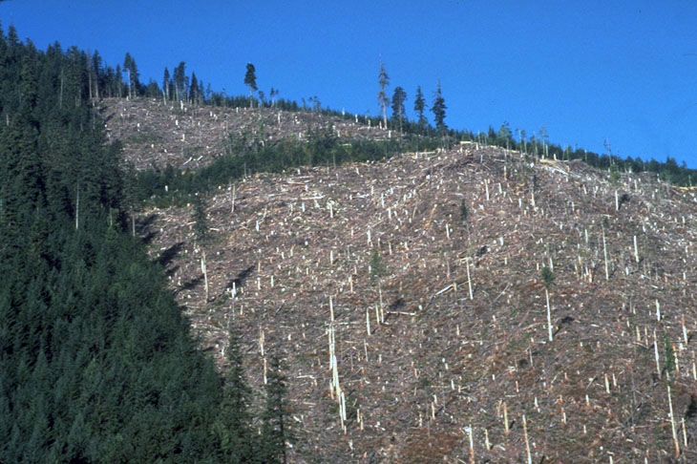
Photo #1…Bulldog Restoration Project

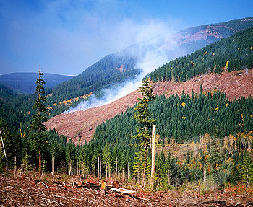
Photo #2…Clear Creek Restoration Project

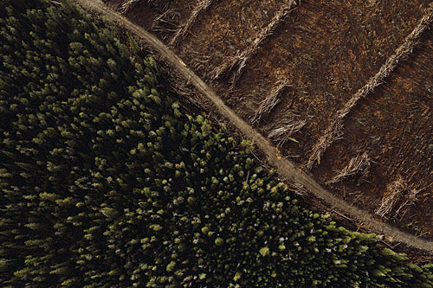
Photo #3…Crane Mountain Restoration Project

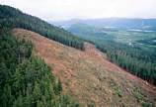
Photo #4…Sedgelaw Restoration Project

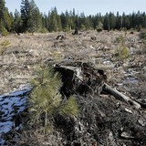
Photo #5…Bald Bear Restoration Project

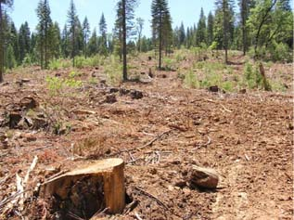
Photo #6…Heckler Restoration Project

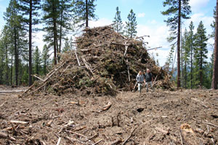
Photo #7...Lava Cast Restoration Project

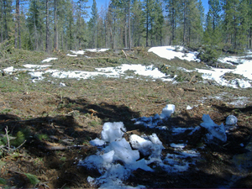

Photo #8...Upton Heights Restoration Project

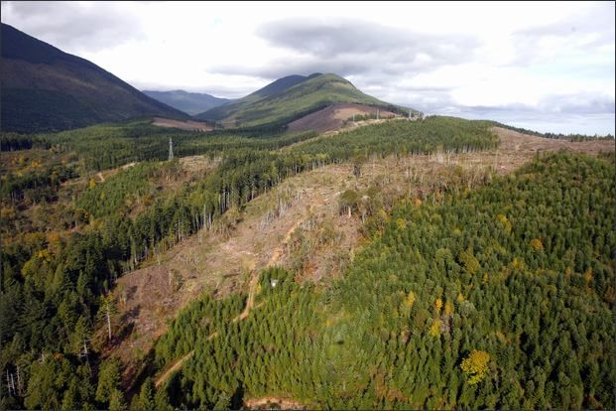
Photo #9...Elk River Restoration Project

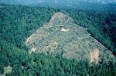

Photo #10…Crenshaw Restoration Project (note the landslide)

