December 24, 2018

VIA EMAIL: objections-alaska-regional-office@fs.fed.us

Dave Schmid
Regional Forester
USDA Forest Service, Alaska Region
709 W. 9th Street
Juneau, AK 99802-1628

Dear Dave,

The purpose of this letter is to file the Alaska Forest Association's (AFA) notice of Objections to the Tongass National Forest's proposed Prince of Wales Landscape Level Analysis (POW-LLA) Final EIS and Record of Decision (ROD). The AFA (111 Stedman Street, Suite 200, Ketchikan, AK 99901; (907) 225-6114) is one of the oldest trade associations in the State of Alaska and represents more than 100 members sharing an interest in Tongass National Forest lands and the Southeast Alaska timber industry. As stated in the AFA’s June 8, 2018 comments on the POW-LLA Draft Environmental Impact Statement (DEIS), a copy of which accompanies these Objections, the non-profit AFA currently benefits Southeast Alaska by managing a pension program, a group health insurance program, and a scholarship program, along with sponsoring the Sustainable Forestry Initiative program for Alaska. The AFA is committed to the restoration, promotion and maintenance of a healthy, viable forest products industry that contributes to the economic and ecological health in Alaska’s forests and communities. Towards that end, I offer the following Objections on behalf of the AFA.

Unnecessary Timber Harvest Constraints

Page 18 of the draft ROD states “I have determined that there will be no created openings in excess of 100 acres with the harvest of the Selected Alternative units”. We object to this constraint, which was not discussed in the DEIS. The draft ROD already acknowledges that the National Forest Management Act (NFMA) provides authorization to create openings over 100 acres in size. I have reviewed the maps provided on the POW-LLA website, and within the POW-LLA project area there are many instances where it would make economic and environmental sense to have harvest openings that are greater than 100-acres. A general prohibition on openings over 100 acres would reduce the volume available to the timber industry, it would isolate small patches of timber that would very likely blow down, it would limit the agency’s ability to design efficient logging systems and it would increase both harvesting costs and road amortization rates for certain small stands of timber. None of these impacts were assessed or disclosed in the DEIS. We request that you use the NFMA clearcut size authority in instances where it makes sense for economics, for preventing environmental harm and for safety.

Page 1 of the ROD states “No commercial harvest of old-growth stands in the area “North of the 20 Road” or within VCU 5280 as described in Alternative 5 of the FEIS”. This includes nearly 20,000 acres of timberland in an area that has a history of extensive blowdown. To the extent you are including timber salvage within the meaning of commercial harvest, we object to this constraint. Salvaging blown down timber is one of the primary reasons that this area has been heavily harvested in the past, particularly near Sumner Straits and Red Bay. We encourage you to retain the option to perform timber salvage operations in this area, and we note that the FEIS already points out that clearcuts result in increased deer browse and other benefits such that timber salvage in this area would actually benefit subsistence users for the next 25-years or so.

Demand for Timber

The annual demand goal for the Tongass listed on page 3-107 of the FEIS is 58 million board feet (mmbf). We have never agreed with the Forest Service procedure for estimating demand because it relies on past timber harvesting and manufacturing but ignores that the past harvest level is solely a result of a severely constrained timber supply. We even sent a critique of the procedure (attached) to the agency in 2007, but never received a reply. One of our industry goals is to restore full manufacturing integration so that our industry can support more year-around jobs and utilize all of the sawlogs and pulp logs that are harvested on the national forest. The investments needed to make this happen will require a much larger economy of scale as well as an assured long-term supply of timber.

Our last mid-size sawmill has been surviving at a harvest level of about 25 mmbf per year and that includes purchasing logs from other timber operators in the region as those logs are available. That single-shift operation could be doubled if sufficient timber supply were available. Further, Sealaska Corporation has told us that they would like an opportunity to purchase about 20 mmbf of timber annually from the national forest. The current demand for timber sales is not being met, and the opportunity to purchase timber from non-national forest lands is currently in decline. In contrast, on page 3-361, the POW-LLA FEIS assumes that non-federal timberland owners will provide 5,807 acres of timber harvest per year from the POW-LLA project area. I contacted each of the three non-federal landowners who plan timber harvest operations (something the USFS could and should have done), and they estimate their combined annual timber harvesting at a rate of about 3,800 acres of old-growth per year plus an additional 200 acres of young-growth. Consequently, the non-federal timber supply is overstated by about 1,800 acres per year. Under the Forest Service “residual demand” theory, the 1,800 acre error overstates the non-federal timber supply by about 40 mmbf. We object to the inaccurate and erroneous timber demand assertions on which the draft ROD is based. We request that you revise your FY 2018 annual goal upwards to at least 100 mmbf.

Page 3-107 of the FEIS includes the following statement “Across the Tongass National Forest there has been a lack of timber volume available for the Forest Service to offer. This is due to the fact that much of the volume available to offer that has gone through environmental analysis, and has a decision (NEPA), may not be offered at this time because these projects were created during better market conditions and are anticipated to appraise negative” (highlight added). We object to this statement false statement and request you remove this false rhetoric from the documents.
Data from the USFS appraisal shop was used to create the graph below. It is very apparent that the only significant decline in Southeast Alaska timber markets was immediately after the 1994 all-time high pulp market and after the 1997 closure of the last pulp mill. That mill closure resulted in reducing the value of all utility logs in the region (15% to 30% of the total forest) from about $200/mbf to basically zero. Sawlog markets have been trending upwards since 1997 (coincidentally, dissolving pulp markets have also continued to rise since 1997). The dismal timber sale economics and the constant failure to meet timber targets and implement timber sale projects since 1997 is due almost entirely to the wildlife conservation strategy and other standards and guidelines that were adopted in the 1997 TLMP.

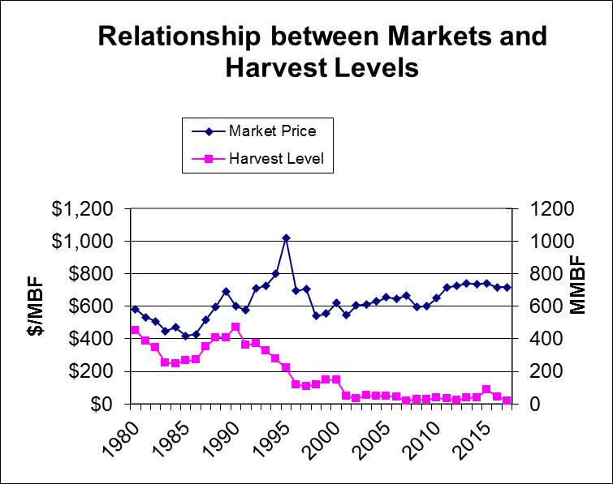

Page 2-28 of the document states “For each old-growth large sale greater than 10 MMBF, an amount equal to 25 percent of that sale volume must be identified from the remaining potential old-growth timber stands and placed in a pool for small sales offerings”. This self-imposed limit on the agency’s management discretion is excessive. While we recognize that economics and a reliable timber supply are critical for small operators as well as for larger operators, 25% of a 20 mmbf timber sale would amount to 5 mmbf which is more old-growth than the small/micro mills have ever used. The current 5-year schedule lists two timber offering from this project that are larger than 20 mmbf. This poorly thought out provision would result in creating a significant backlog of small/micro sales volume at a time when there is a severe shortage of timber for larger operators, none of which has more than a single year of timber currently available. The Forest Service 2008 land plan had a goal of restoring a fully-integrated manufacturing industry. That is a good goal and it doesn’t preclude small and micro-mills. Our region needs more year around jobs than can be sustained by a cottage industry alone. Consequently we object to this provision unless it is capped at a three-year supply similar to the agency’s goal of providing three years of timber under contract.

Young-Growth Timber Sale Economics

We object to the false assertions regarding young-growth timber sale economics in the draft ROD and accompanying environmental documents. Page 3 of the draft ROD states “An average of 3 MMBF annually of young-growth may be offered during the first 7 years of implementation…” and page 122 of the FEIS states “This alternative gives industry the most time under current practices to develop markets for the project area’s extensive young-growth which should become commercial during the late 2030s.” The export markets for young-growth timber are already well established even though Alaska’s share of the market is only about 1%. However, we cannot maintain a multimillion dollar spread of equipment for harvesting young growth with only 3 mmbf of harvest per year. A single, young-growth timber harvest operation will require a steady, consistent supply of roughly 11 to 15 mmbf annually. The draft ROD and accompanying environmental documents fail to disclose this information.

Page 122 of the FEIS also states “Alternative 2 would still provide enough young-growth volume for potential larger offerings that may prove an incentive for industry to invest in young-growth business other than export”. This statement is false and should be removed from the documents. There are also well established markets for products manufactured from young growth, but we cannot compete in those markets while we are at a competitive disadvantage to other manufacturers. For example:

- The current size of our young growth trees is too small to manufacture the high value products we produce from the old-growth trees;
- Southeast Alaska is 800-miles from the nearest market for young-growth lumber, veneer and wood fiber products;
- Our current young-growth volume is too small to supply even one modern, small-log sawmill; and
- The maximum term of the Forest Service timber sales is too short to amortize the investment needed to construct a small-log sawmill.
Realistically, our young-growth timber will not begin reaching maturity (the culmination of mean annual increment as mandated in NFMA) for another 30-years or so. Harvesting the young-growth at an earlier date will greatly reduce the total volume per acre from those stands and will limit the potential products that could be manufactured from the young-growth. As we have repeatedly explained, it would require an annual harvest of more than 200 mmbf of these small, young-growth trees to supply a single, competitive small-log sawmill. A fully integrated manufacturing industry will require even more. Early harvesting of the young-growth in Southeast Alaska can provide timber harvest jobs, but not manufacturing jobs.

Because of these four competitive disadvantages, a facility manufacturing low-value construction products cannot compete with similar enterprises in the Puget Sound region. Continuing to supply old-growth timber until sufficient acres of young-growth timber are available, and those young growth acres have matured, is necessary to sustain our industry. The draft ROD and supporting environmental documents create the misimpression that the POW-LLA project will foster a young-growth manufacturing industry. These misleading assertions must be corrected so that the public and the decision maker have an accurate understanding of the effects of the project.

Page 3-344 of the 2016 TLMP EIS states “Based on collective experience of timber managers on the Tongass and discussions with industry representatives, it was decided that in order for a young timber stand to have a chance of being economic, the majority of trees harvested need to produce two logs (underlining added). Production of one log per tree not only increases logging costs relative to revenues substantially, but also creates a large amount of slash left behind, which can have negative effects on wildlife, scenery, economics and recreation”. Instead, the POW-LLA project adopts a standard in which at least half of the volume in young-growth stands come from trees that are large enough to yield two 34-foot logs (page 28 of the POW-LLA FEIS). The difference is dramatic; an average 65-year old stand probably includes around two-hundred trees per acre so under the standard included in the 2016 TLMP FEIS, at least one-hundred of those trees must yield two 34-foot logs. However, under the POW-LLA proposed standard, only about ten 2-log trees per acre would be required. This would result in an enormous reduction in the profitability of young-growth harvesting. We request you utilize the 2016 TLMP standard in order to help insure that the young-growth timber sales are economically viable.

Old-Growth Timber Sale Economics

We are also concerned about the economic viability of the POW-LLA project. While the draft ROD and FEIS indicates there may be 423 mmbf of old-growth timber available to harvest, this assumption seems to be based on a falldown percentage of 50% (FEIS, P 3-106). However, in 2008, TetraTech (the Forest Service contractor for the 2008 TLMP) calculated that 72% of the 2008 TLMP suitable and available old-growth timber was financially deficit and thus could not be implemented. The agency’s record of implementation success since 2008 seems to validate the TetraTech falldown analysis, and there have been no changes in the TLMP guidelines since 2008 that would reduce the falldown percentage. Consequently, the FEIS very likely overstates the volume of timber that might be successfully implemented and available to the industry. Such misleading information violates NEPA and undermines the agency’s analysis of timber sale economics.

Additionally, a rough appraisal of the old-growth volume in the POW-LLA project based on the costs and values listed in the FEIS indicate that the project as a whole is deficit. The FEIS includes some detail by individual Timber Analysis Area (TAA), and incorporating that detail into the appraisal reveals that six of the thirteen TAAs appear to be very deficit, with the remaining seven TAAs appearing to appraise with less than a full profit and risk margin. Consequently, it is very unlikely that will provide anywhere near the 214 mmbf of timber harvest estimated on page 2 of the ROD. Also, we couldn’t find an estimate of the amount of helicopter logging required to harvest the timber in this project, but we are concerned that the only company still performing helicopter logging in Alaska has decided to sell all of its equipment and camp facilities and will likely not be available to perform helicopter logging in the future. This appears to be another sad outcome of the long-term decline in timber sales in the region. Our best estimate is that it will require at least a two-year supply of helicopter logging at 15 mmbf per year in order to entice another helicopter company to mobilize to Southeast Alaska.

The logging cost estimates on pages 3-113 to 3-115 seem low. For instance table 17 estimates that a helicopter partial-cut prescription will cost $362 to $395 per mbf, but local loggers report their helicopter costs are in excess of $500 per mbf. If these estimates do not include profit and risk for the loggers then that should be disclosed. In addition, table 17 also indicates that young growth cable logging will cost about half as much as old growth cable logging. That doesn’t seem reasonable.

In 2008 the Undersecretary of Agriculture requested that the Forest Service perform several economic analyses of the Suitable and Available timber in the 2008 TLMP. The Chief of the Forest Service agreed to do those analyses and to identify potential modifications to the TLMP to address timber sale economics, but those analyses were never performed. In 2016, we again requested that the agency perform an economic analysis of the Suitable and Available timber in TLMP and again, that analysis was never performed. Most of these economic shortcomings in TLMP are a result of the wildlife conservation strategy and other standards and guidelines incorporated in the 1997 TLMP, yet the agency has steadfastly refused to attempt any meaningful corrective actions. As a result, our industry has been in decline for over 20-years, and our installed sawmill manufacturing capacity has declined from over 500 mmbf to 114 mmbf (as reported in the 2018 Tongass Demand Briefing Paper). Once again, we request that the Forest Service perform a detailed analysis of the economics of harvesting and manufacturing timber in Southeast Alaska and propose changes to TLMP to correct any shortcomings.

Page 3-308 asserts that this project (656 mmbf of harvest) will support 2,657 jobs and $145 million in economic benefit. Actually with over $500 per mbf of harvest and manufacturing costs, a 656 mmbf harvest would provide more than $300 million in direct economic benefit. The direct jobs level appears overstated though. 656 mmbf over 15 years is only some 44 mmbf per year. Prior to 1990 when we were harvesting over 400 mmbf per year we sustained over 4,000 jobs annually according to the Forest Service 2002 706a report. We ask that you reexamine these economic assumptions and disclose accurate information to the public and the decision maker.

Invalid or exaggerated estimates of environmental impacts

Page 8 of the draft ROD limits timber harvest within 5-miles of a subsistence community. But page 15 acknowledges that all of the forested lands in the national forest are used for subsistence, and page 10 of the draft ROD acknowledges that deer populations increase for 25-years after timber harvest. Thus, the 5-mile limitation for subsistence reasons makes little sense.

Page 9 of the draft ROD alleges that 30 watersheds have been degraded by past logging. This allegation is unfounded, and we request that you correct this erroneous and misleading assertion. All of the areas previously harvested are reforested, and the trees are growing well, fish and wildlife populations remain high and the rate of sedimentation in the heavily logged watersheds appears to be roughly the same as in pristine areas. The small amount of sediment that does enter streams when we are hauling on rock roads does not interfere with salmon, but instead is normally held in suspension until the stream empties into the ocean. The coarser sediment seen in streams like the Harris River are normal sedimentation that has been ongoing for thousands of years. That has nothing to do with timber harvest or other development. These salmon escapement records from the ADF&G suggest that the two most heavily logged watersheds on Prince of Wales have not been degraded.
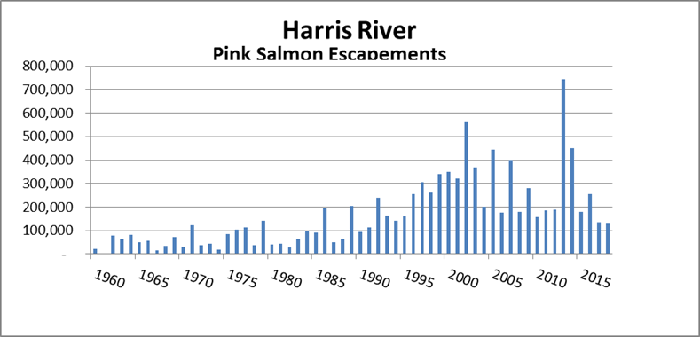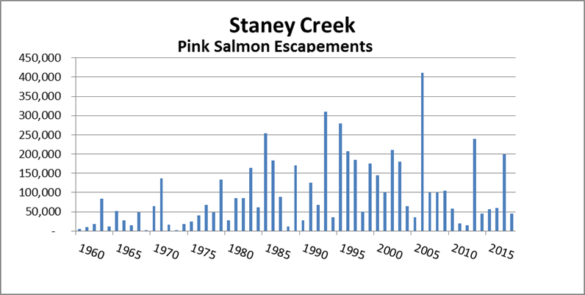

Page 3-140 of the document indicates a number of areas where the 2016 Forest Plan prohibits the harvest of old-growth in the Trout Unlimited 77 watersheds and the Nature Conservancy conservation areas. The impacts of these two, massive environmental group proposals was not analyzed in the Forest Plan. A subsequent analysis by the Forest Service indicates the total area affected totals some 3.77 million acres of which about 1.5 million acres is commercial timberland. There is no analysis of the social economic impacts of these massive set-asides and there is not even a map or listing of the areas affected. Neither is there any disclosure or analysis of the merits of these withdrawals either in the Forest Plan or this document. We request that you disclose a map and perform a thorough analysis of both the merits and the impacts of these withdrawals for the POW project area.

Page viii of the FEIS assumes maximum environmental impacts and uses 50% Productive old-growth (POG) as a maximum harvest threshold for each Wildlife Analysis Area (WAA). Using 50% POG as a threshold is excessive given that 15 to 30% is a more commonly accepted old-growth threshold. Further, the threshold should be measured at the Forest level or the biogeographic province level, not the small, WAA level. Measuring wildlife risk on smaller and smaller areas overstates the scope of the potential harm from harvesting and results in curtailing the timber supply in violation of the timber demand requirements of the Tongass Timber Reform Act and the more general multiple-use management requirements of the National Forest Management Act.

Page 3-91 of the FEIS acknowledges deer browse increases for 25 years after timber harvest but asserts that stem exclusion lasts to age 150 (far beyond CMAI). I doubt that that is true, but it is also irrelevant since the timberlands are scheduled to be harvested again at age 100. Consequently the so-called “stem exclusion” stage lasts only about 75 years, and as long as we continue to harvest timber, we will always have new clearcuts with a super-abundance of browse plus winter habitat from the edge-effect. The draft ROD and accompanying environmental documents overlook this reality, an oversight that should be rectified.

We commented on the DEIS that the edge-effect provides abundant winter deer browse and this is likely a big part of why the deer populations remain high in the previously logged areas despite the “deer model” prediction of an eventual severe winter mortality event (it hasn’t happened even one time in the last 65-years). The POW-LLA NEPA documents should include the edge-effect benefits; here they are again:

The Forest Service has long noted that the edge-effect adjacent to clearcut areas allows some species to increase in abundance. Many people have noted that the edges of clear cuts provide both enhanced deer browse and protection from winter snows. Wildlife biologists have estimated that this edge effect varies from about 100 to 660 feet and generally extends greater than 300 feet into the adjacent timber. A little geometry indicates that a 60 acre clearcut would establish a 300-foot edge-effect consisting of about 45 acres with enhanced quality deer winter range. This edge-effect habitat is more than adequate to sustain deer through the deep-snow winter months, and deer often utilize these areas in the winter. This is particularly true if the harvesting is at lower elevations where the timber grows more quickly and, by the way, where it is less costly to harvest timber. Consequently, the best way to increase deer habitat and sustain a local timber manufacturing industry is to increase clearcut logging.

Page 3-99 of the FEIS asserts that six of the WAAs will suffer a “change in abundance and distribution of deer…as deer hunter efficiency and success decrease in areas that transition into stem exclusion”. However, that assertion disregards the empirical evidence to the contrary – the deer populations in these six areas appear stable long after the assumed “stem-exclusion” age of 25 years:

  - WAA 1214 (Polk Inlet vicinity) was primarily harvested between 1986 and 1992. More than 5,000 acres harvested 26 to 32 years ago and still the hunter success in that WAA remains high.

  - WAA 1315 (Thorne Bay vicinity) was primarily harvested between 1961 and 1988. More than 30,000 acres were harvested 30 to 57 years ago and yet hunter success remains very high year-after-year; long after the “stem-exclusion” that the FEIS asserts begins after 25 years.

  - WAA 1317 (Hollis-12 Mile vicinity, was harvested primarily between 1959 and 1972, more than 6,000 acres of harvested 46 to 59 years ago and yet hunter success remains very high year-after-year.

  - WAA 1318 (Craig-Klawock-Big Salt), primarily between 1980 and 1995, probably some 40,000 acres of mostly private land was harvested 23 to 38 years ago and yet hunter success in the area remains very high year-after-year.

  - WAA 1420 (Ratz Harbor- Eagle Creek vicinity), 3,000+ acres were harvested primarily between 1959 and 1971, more than 3,000 acres harvested 47 to 59 years ago and yet hunter success remains very high year-after-year.

  - WAA 1422 (Staney-Naukati vicinity), more than 8,000 acres were harvested primarily between 1971 and 1987, more than 8,000 acres harvested 31 to 47 years ago and yet hunter success remains very high year-after-year.

Page 3-98 states “Hunter success rates may be lower in WAAs 1214, 1315, 1317, 1318, and 1420 due to the estimated deer harvest exceeding 10 percent of the estimated DHC (see Table 11).” The State ADF&G sent me the actual harvest records for 2011 through 2017 for 36 WAAs on Prince of Wales. Those records indicate that deer harvest success in the six referenced WAAs is within 3% of the deer harvest success for the remaining WAAs. In other words, there is no significant difference in actual hunter success in these six areas over the last seven years. Instead of basing the analysis on actual hunter success records, the presumption on page 3-98 appears to be based on a model that indicates Deer Harvest Capability is lower in the six referenced areas. We have requested additional information about this presumption.

Meanwhile, we object to the agency’s erroneous and exaggerated assertions of environmental impacts and urge you to reconsider the hypothetical stem-exclusion impacts which are not supported by empirical evidence.

Page 3-171 asserts the need for elevation corridors. This alleged need for elevation corridors is absurd; it takes only an hour or two for a person to walk from the top to the base of most of these Prince of Wales Mountains. Deer and wolves can walk down in less than half that amount of time, even when there is snow. Besides, the deer move off of the mountain tops long before the snows get deep enough to inhibit travel.

Page 3-177 asserts that mortality in heavily logged watersheds is high in severe winters, but there is no data provided to support this. In my 40+ years of traveling around Southeast Alaska’s forests, the winter deer mortality is about the same in both harvested and pristine areas. There may be more human predation in developed areas, but that is best managed through the State game regulations, not by restricting timber harvest.

Page 3-270 asserts that stem-exclusion lasts 150 to 200 years, which seems to conflict with the assertion on page 3-91. Both assertions ignore the empirical evidence in Southeast Alaska – for instance the evidence of high deer populations in the six most heavily logged watersheds mentioned in item above. The assertion also ignores that the harvest areas are normally scheduled to be harvested again every 100-years, so the 150 to 200-year remarks are irrelevant; the document should instead acknowledge that the stem-exclusion issues will go away after the timber reaches CMAI and is re-harvested. Once the areas are harvested again, those stands will again provide more deer browse, etc. than an old-growth forest.

The chart on page 3-230 includes an estimated 50% wolf mortality from illegal wolf harvest. There is no support provided for this estimate and even if true, the wolf harvest limit in the game regulations could be set low enough to compensate. There is no need to lower road density, which would increase harvest cost and further lower the potential harvest volume.

Page 3-318 asserts there are 11,357 acres of landslides. That is only 0.6% of the 1.8 million acres of national forest in the project area. Page 3-319 goes on to assert 1,762 acres are logging related landslides. That represents only 0.1% of the project area. If that is the total impact since 1954 then that represents only a de minimus 28 acres per year. The document should also mention that logging roads often intercept most of the debris from both the logging related and the natural landslides and therefore benefit the environment.

We urge you to consider the following comments regarding the allegations made by the State ADF&G regarding the DEIS; otherwise people less familiar with the issues might get a biased view of potential environmental impacts:

- Hundreds of miles of fish habitat are currently blocked by fish passage structures which do not provide efficient fish passage. Replacing or removing all deficient stream crossing structures blocking fish passage should be a priority.

  - Actually the Forest Service documents indicate that only 18 miles of the 3,474 miles of salmon streams in the project area are behind red-pipes.

  - In addition, it is important to note that most of these red-pipe fish culverts were properly installed pursuant to fish-passage standards that were later revised. Most of the red-pipes that did not pass fish at all were replaced long ago. The majority of remaining red-pipes enable fish passage, but do not meet the current standard. The Forest Service has an ongoing program to remove or upgrade these remaining culverts over time.

- To maintain and enhance deer habitat, we support minimizing old-growth harvest and maximizing the proportion of young-growth in the total timber harvest.

  - Actually, deer populations typically increase after logging and ADF&G deer hunting records for this project area indicate that deer-hunter success in logged areas is double or triple the deer-hunter success in non-logged areas. This level of deer harvest has been sustained for many decades and there is no evidence of decline. This indicates that timber harvest does not harm deer habitat and actually enhances deer-hunter success.

- We support excluding any type of development activity within a 0.5 mile-radius of known dens but emphasize that this distance should be considered the minimum necessary.

  - The Forest Service reports that wolves frequently abandon old dens and establish new ones, often in areas closer to recently logged areas where deer populations are greater. Establishing “perpetual” 500-acre wolf-den reserves is an unnecessary constraint that will worsen our timber supply situation with no benefit to wolves.

- Considering that significant additional old-growth harvest is anticipated on non-federal lands in the POW LLA area and that the full cumulative effects of that old growth harvest on wildlife populations and wildlife users will not be realized for several more decades, ADF&G encourages a more conservative approach.

  - The POW-LLA analysis includes an analysis of the impact of activities on non-federal lands in the project area. The harvest levels in Southeast Alaska are already so low that our last surviving mid-size sawmill is in jeopardy. Encouraging a “more conservative approach” is not helpful.

- ADF&G believes that the POW LLA should be just that, an analysis of the resources on Prince of Wales and surrounding islands, and not an implementation project. This broad landscape assessment should be a non-decision making part of a step-by-step process which could result in individual Forest Plan implementation projects are required under NEPA.

  - This suggestion to do additional NEPA analysis is unnecessary and would result in a significant delay at a time when the timber supply available to the industry is at a critically low level and would add significant additional expense to the cost of completing this NEPA document.

Sincerely,
Owen Graham
Executive Director
Alaska Forest Association
111 Stedman Suite 200
Ketchikan, AK 99901

Phone: 907-225-6114
Email: owengraham39@gmail.com

