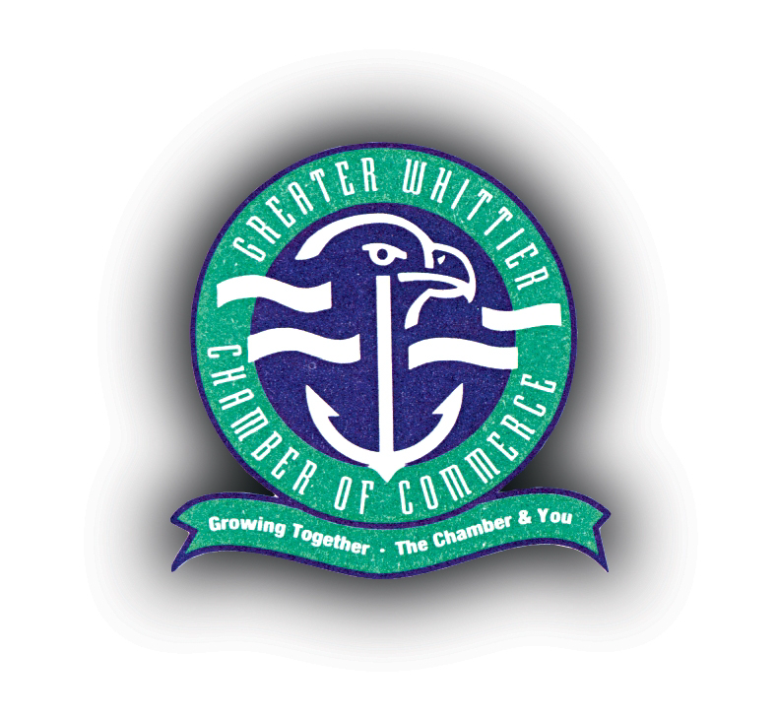

February 18, 2016

To Whom It May Concern,

The Greater Whittier Chamber of Commerce is writing on behalf of its business members to ask the US Forest Service to maintain the Nellie Juan- College Fjord Wilderness Study Area intact as proposed by ANILCA.

WHERE AS, the experience of wilderness and the WSA is the foundation of many of our member’s business.

WHERE AS, the message to the world that they may experience wilderness in Prince William Sound is vital to marketing to our member businesses.

WHERE AS, western Prince William Sound is experiencing increased pressure from campers, private boaters, fishing and hunting since the road opened in 2000, we need the designated wilderness management policies to help protect, enforce and educate users.

WHERE AS, some of the areas recommended to be removed from the WSA are still recovering from EVOS and need further protection.

WHERE AS, mining and logging, are not consistent with the current uses of the area including recreation, tourism, commercial and recreational fishing, which are vital to the economy of Prince William Sound communities.

NOW, THEREFORE BE IT RESOLVED, the Greater Whittier Chamber of commerce hereby requests that all lands dedicated by ANILCA to the Nellie Juan-College Fjord Wilderness Study Area be maintained.

Kelly Bender
President
Greater Whittier Chamber of Commerce

