25 Sept 2019

TO: David Halemeier, Detroit District, Willamette NF
VIA: https://cara.ecosystem-management.org/Public/Commentlnput?Project=53556

Subject: Dry Beard Draft EA — comments

Please accept the following comments from Oregon Wild and Cascadia Wildlands concerning the Dry Beard Draft EA, https://www.fs.usda.gov/project/?project=53556. Oregon Wild represents 20,000 members and supporters who share our mission to protect and restore Oregon’s wildlands, wildlife, and water as an enduring legacy. Our goal is to protect areas that remain intact while striving to restore areas that have been degraded. This can be accomplished by moving over-represented ecosystem elements (such as logged and roaded areas) toward characteristics that are currently under-represented (such as roadless areas and complex old forest). Cascadia Wildlands is part of a movement to protect and restore wild ecosystems of the Cascadia Bioregion, including vast old-growth forests, rivers full of wild salmon, wolves howling in the backcountry, and vibrant communities sustained by the unique landscapes. Cascadia Wildlands contact information is P.O. Box 10455, Eugene, OR 97440 | Eugene, OR 97401 | 541-434-1463 | info@cascwild.org.

The proposed action alternative involves logging approximately 1,079 acres of stands 35-78 years old to produce 24 mmbf. 430 acres of thinning would be in riparian reserves. Thinning treatments would incorporate gap creation of 1-3 acres in size on approximately 27 acres and/or dominant tree release (DTRs) on approximately 21 acres. One thinning unit includes 3 acres of thinning with a prescription designed to improve sugar pine habitat by reducing stocking, underburning and planting rust resistant sugar pine. The remainder of the unit would also be commercially thinned, but with a different prescription. Some thinning treatments would also incorporate some untreated areas, or skips on 260 acres (about 20% of the treatment acres)Post-harvest fuels treatments include underburning and pile and bum treatments. The project proposes 2.6 miles of road decommissioning and 1.8 miles of road storage. The project also proposes replacement or repair of the Idanha Bridge, which leads into the project area.

We would like to thank the Forest Service for focusing this project on the kinds of stands (over-represented, young, planted?) and the mostly the kinds of treatments (variable thinning) that are most in need of restoration and that raise fewer concerns in terms of wildlife conflicts. We are providing some critical comments in the spirit of “continual improvement” (what we’ve done before is not the end-all and be-all; maybe we can do even better) and “we still have a lot to learn about restoration” (forests develop slowly over many decades and centuries; restoration of young forests is still an emerging science; we don’t know exactly how our treatments will unfold in the years ahead; and we should be humble because still have a lot to learn).

Alternatives
NEPA requires consideration of all reasonable alternatives, which is intended to allow the public and the decision-maker to compare the effects of different approaches to forest management. We are disappointed that the Forest Service is violating the letter and spirit of NEPA by only considering one action alternative.

Oregon Wild scoping comments suggested that the NEPA analysis should consider an alternative so that the effects can be compared with business as usual thinning.
We urge the Forest Service to consider (and adopt) an alternative based on the following recommendations:
- Mimic natural disturbance by retaining live and dead trees structure in the gaps;
- Do not plant conifers in gaps. Let gaps persist as complex early seral habitat. There is ample seed sources in the adjacent areas, so they will eventually fill in with conifers.
- Thin variably. Retain clumps of trees as is common in old growth forests. Avoid thinning methods that clears space around every tree;
- Recognize the trade-offs involved with thinning in riparian reserves. Thinning removes valuable structure with long-term effects on both aquatic and terrestrial wildlife. These effects likely violate the Aquatic Conservation Strategy. Retain 50 foot no-cut stream buffers in stands less than 50 years old, and 100 foot no-cut buffers in stands older than 50 years. Remember, riparian reserves are not to be used to meet timber objectives;
- Focus on areas accessible from existing roads. Avoid new road construction.
- Make climate change mitigation part of the purpose and need. Minimize carbon emissions by focusing on the youngest stands and retaining relatively high basal area.
- Retaining higher basal area will also help mitigate adverse effects of thinning on snag habitat, small mammals that are important prey for spotted owls (e.g., flying squirrels and red tree vole);
Oregon Wild, July 13, 2018 scoping comments (pp 1-2). An alternative based on these recommendations is quite reasonable because it will meet the purpose and need and will mitigate many of the significant trade-offs associated with commercial logging, e.g., snag recruitment and dead wood habitat in both uplands and riparian reserves, carbon storage for climate change mitigation, persistence of early seral habitat, soil and water degradation caused by logging roads, etc.

Riparian Reserves
The EA failed to conduct an adequate analysis of the trade-offs associated with commercial logging in riparian reserves, including depleted wood recruitment that is supposed to be conserved throughout the full extent of the riparian reserves to meet the needs of both aquatic and terrestrial species.

Appendix G provides a rationale for logging in each riparian reserves but fails to disclose all the trade-offs associated with logging so the alleged benefits can be weighed against the unavoidable adverse effects of tree removal, e.g. wood depletion, soil displacement, damaging the under-story, etc.

The figure below, from Pollock et al (2012), shows that tree removal through thinning can lead to stand development trajectories that miss the reference condition for dead wood. We point this out to highlight one of the trade-offs involved in thinning, and to encourage careful thinking about mitigation. Leaving the cut trees in the woods is a good short-term mitigation, but the small trees do not last long enough to fill the temporal gap between now and when the stand begins recruiting more dead wood on its own. Leaving unthinned patches within treated stands is a good mid-to-long-term mitigation.
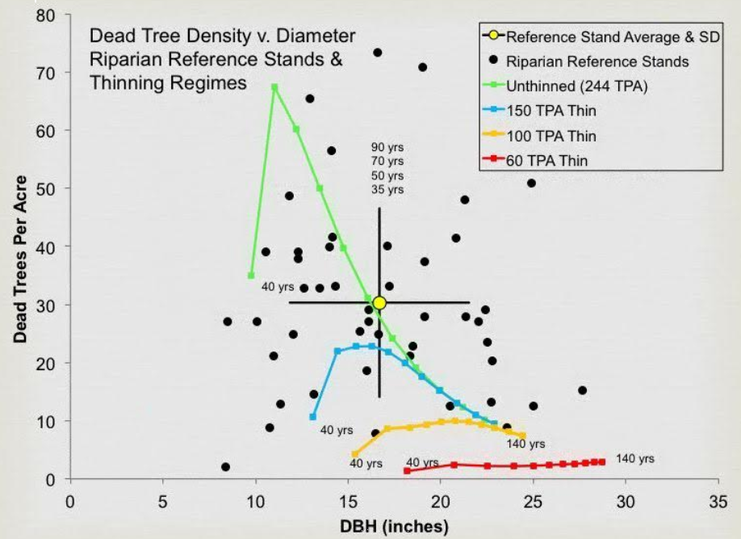
Pollock, M. M., T. J. Beechie, and H. Imaki. 2012. Using reference conditions in ecosystem restoration: an example for riparian conifer forests in the Pacific Northwest. Ecosphere 3(11):98. http://dx.doi.org/10.1890/ES12-00175.1

The EA relies on riparian reserves as mitigation for adverse effects on spotted owl prey, saying “Retention of no-treatment areas (skips and Riparian buffers) would help mitigate short-term effects to flying squirrels by providing travel corridors from adjacent late seral habitats and across the landscape” (EA p 58). However, this analysis fails to account for the fact that thinning is proposed across a large fraction of the riparian reserves, so the mitigation that riparian reserves could and should provide is severely compromised by extensive logging of intended mitigation sites.

A large section of Oregon Wild scoping comments (at pp 13-20) describes trade-offs associated with logging in riparian reserves and asked for careful analysis of these trade-offs. The EA did not do that.

Wet Season Hauling
The EA says “The haul routes would be brought up to a standard that allows for wet season haul.” The Forest Service and the EA put far too much faith in BMPs that do not adequately ensure that wet season hauling would avoid impacts to streams. See examples from the Hehe LSR Thin Project.

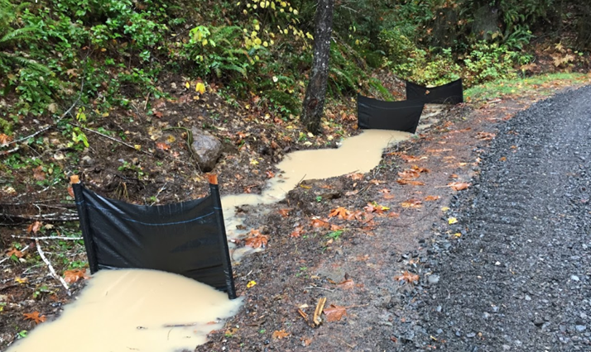
Sediment bypassing efforts to control it. BMPs are not 100% effective. Log hauling during dry weather minimizes such risks.

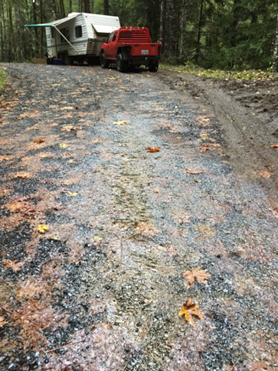
Fuel spill mobilized by rain. Mistakes happen. Wet weather makes them worse.

Here is a link to a video showing more sediment bypassing controls:
https://photos.google.com/share/AF1QipMrmOpv4TgRdWdWu1df5YC4-lESBEfRLShlN-Aj8QWJhGNqk5NUIv8v8K-YzeSBgg/photo/AF1QipOihedu-_gG-87yegW54vTJINS3OZ4l-S1-I-IK?key=bWR2WjJqV2dvWHZDRTlHSndxWWZMcktYMzdtMHdB

Authorizing wet season log hauling is a gift to the timber industry at the expense of the public interest. It should not be authorized.

Snags and Dead Wood
The EA failed to conduct an adequate analysis of the trade-offs associated with commercial logging and its effects on short-term and long-term recruitment of snags and down wood.

Appendix F describes the existing and desired conditions relative to DecAID tolerance levels but critically fails to compare those data points to the quantity of snags and dead wood expected to be recruited over time after so many trees are removed from the forest.

Using data from stand exams modeled through FVS-FFE (West Cascades variant) the Umpqua NF found that the actual effect of thinning is to capture mortality and delay recruitment of large wood for up to 60 years. Other NEPA analyses should emulate the honest disclosure of thinning impacts on snag habitat found in the Cottage Grove District’s Curran Junetta Thin EA:

There is currently an excess of forested land in this area without snags (roughly 5 times higher than what DecAID recommends) and a deficiency in areas with high snag densities (roughly 12% of what DecAID recommends). Management prescriptions should allow for these extremes because they are ecologically important (White et al. 2002, Mellen et al. 2005). Common natural disturbances that produce areas with high levels of dead wood include wildfire, insects and disease, and wind (blow down) events.
…
The action alternatives cause a decrease in stand levels of snags and down wood caused by incidental falling of snags for logging or safety reasons, and consumption of down wood during the fuels reduction treatments. Thinning would then reduce the amount of suppression mortality within the thinned portions of stands, indirectly affecting future recruitment of CWD. Existing snags and logs would be protected to the extent practical and safe. However, it is probable that the action alternatives would lower levels of these structures (to approximately one to two snags per acre) through mechanical disturbance from tree falling and harvesting. … To mitigate for effect on large snags, the action alternatives would include the inoculation of two trees per acre on 857 acres and five snags per acre on 379 acres (within CHU OR-20) with locally collected native heart rot fungus. Inoculated trees begin to develop heart rot within five years as they continue to grow (Duncan, 1999), eventually producing larger trees with cavities and future snags that remain standing longer than if girdled. Inoculation is a management tool being used to offset the reduction of suppression mortality caused by thinning and to maintain a component of decadence within these managed stands. Additional snag mitigation would occur within CHU OR-20; six snags per acre would be created by fire during fuels reduction activities. In unit seven, mitigation would occur by girdling trees (>15 inch dbh or largest trees available) to achieve six snags per acre within the thinned portions of the unit.
…
Large snag (≥20” DBH) densities within the stands are currently below the levels advised for in DecAID (4.7 snags/acre – 30% tolerance level). Under the no action alternative this level of snags would not be achieved for another two decades (Figure 15). The action alternatives would delay reaching this level by an additional 10 to 30 years (10 years for units thinned to 70 to 90 trees per acre, 30 years for units thinned to 40 to 60 trees per acre).
…
Cumulative impacts
Substantial adverse impacts to levels of CWD at both the stand and landscape-scale have resulted from past clearcut timber harvesting, road building, roadside salvage and fire exclusion. The Layng Creek inventory showed an overabundance of land area with no snags, and a deficit of land area with high snag densities (caused by fire exclusion). It would take several decades to restore snag and log conditions to within the ranges advised for in DecAID at these two extreme ends of the range of CWD.
USDA Forest Service. 2007. Curran Junetta Thin EA. Cottage Grove Ranger District, Umpqua National Forest. June 2007. http://a123.g.akamai.net/7/123/11558/abc123/forestservic.download.akamai.com/11558/www/nepa/32805_FSPLT2_053506.pdf.

This graph from the Curran Junetta Thin EA shows that heavy thinning delays by more than 60 years the attainment of habitat objectives for large snags (i.e. mid-point of the gray band representing 30-80% tolerance level).

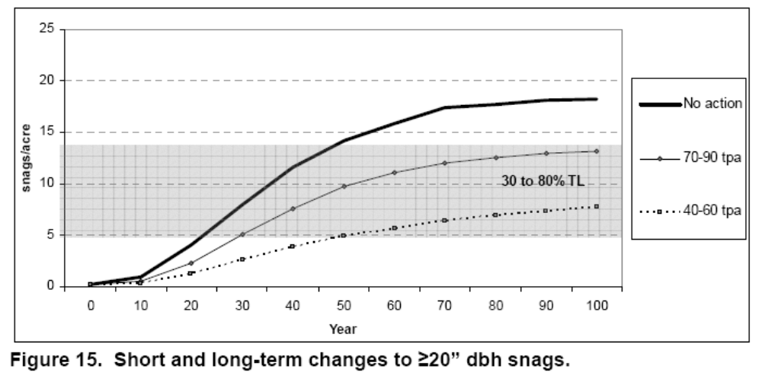
http://a123.g.akamai.net/7/123/11558/abc123/forestservic.download.akamai.com/11558/www/nepa/32805_FSPLT2_053506.pdf.
The EA (p 58) relies on ineffective and inadequate mitigation. The EA admits that “Thinning reduces the abundance of large live trees and large snags, important habitat for flying squirrels” but that “Design elements require that snags and coarse woody debris be retained in all units.” This analysis fails to account for the fact that existing snags and down wood are ephemeral, and that maintaining biologically optimal levels of snags and down wood requires a constant input of mortality from the pool of green trees, and that thinning depletes that recruitment pool, so mitigation requires maintaining more green trees, but the EA (and Appendix F) did not even quantify and disclose the adverse effects of logging on recruitment of snags and dead wood habitat over time. Such an analysis would reveal the short-comings of relying on weak mitigation such as retention of existing snags and down wood.

Spotted Owl Prey
Another important trade-off caused by commercial thinning is adverse impacts on prey species relied upon by spotted owls and other meso-predators. The prey species adversely affected include: red tree voles, flying squirrels, red-backed voles, among others. The EA analysis of effects on prey species is contradictory and inaccurate.

The EA (p 58) says. “Thinning treatments would reduce inter-tree competition, accelerating the development of large live trees, which eventually turn into large snags. Over the long term, thinning young stands should therefore cause an improvement in the habitat of northern flying squirrels.” This is not accurate. Thinning reduces the population of green trees available for recruitment as snags. This effect far outweighs any minor increase in the growth rate of the few trees that remain after thinning. See Figure 15 from Curran-Junetta EA above. This result is not unique. It is consistent across all analyses that have carefully looked at the issue. The EA also admits that “Thinning reduces the abundance of large live trees and large snags, important habitat for flying squirrels (Manning et al. 2012).”

The Purpose and Need should Address The Unmet Need for Carbon Storage

One of the purposes of this project is “Contribute to a predictable, sustainable supply of timber and other forest products to maintain the stability of local and regional economies” (EA p 7). The agency should reconsider the purpose and need for timber targets in light of the fact that the public needs carbon storage to reduce global climate change much more than they need wood products. And the Forest Service needs to account for the fact that managing forests for water quality and quantity, quality of life, and carbon storage for a stable climate will contribute far more to community stability than propping up the boom-bust timber industry with subsidized logging.

The agency must recognize that wood products are already under-priced and over-supplied due to “externalities” (costs that are not included in the price of wood, so they are shifted from wood product producers and consumers to the general public who suffer the consequences of climate change without compensation from those who profit from logging related GHG emissions). Ecosystem carbon storage on the other hand is under-supplied because there is not a functioning market for carbon storage and climate services. The FS is in a position to address these market imperfections by focusing on unmet demand for carbon storage instead of offering wood products that are already oversupplied.

Land protection, both public and private, provides substantial ecological benefits by avoiding conversion of natural systems to intensive, developed uses. These benefits include carbon sequestration, watershed functioning, soil conservation, and the preservation of diverse habitat types (e.g., Daily 1997, Brauman et al. 2007, Kumar 2012, Watson et al. 2014). Land protection also solves a key market failure: private markets tend to underprovide socially beneficial land uses such as natural forests, agricultural lands, or managed timberlands. The reason for this failure is that many of the benefits of these lands go to the public in general, not individual landowners. When private values and market transactions determine land uses, less land will be devoted to socially beneficial uses than if citizens could collectively determine use on the basis of social values (e.g., Angelsen 2010, Tietenberg and Lewis 2016).
Katharine R.E. Sims, Jonathan R. Thompson, Spencer R. Meyer, Christoph Nolte, Joshua S. Plisinski. 2019. Assessing the local economic impacts of land protection. Conservation Biology. 26 March 2019 https://doi.org/10.1111/cobi.13318,
https://harvardforest.fas.harvard.edu/sites/default/files/Sims_et_al-2019-Conservation_Biology.pdf.

Do not rely on the flawed boilerplate climate analyses

As explained below, the Forest Service’s boilerplate NEPA analysis regarding carbon and climate fails to take a hard look that NEPA requires. The analysis makes several highly misleading statements about forest carbon and climate change. The analysis inappropriately mischaracterizes the role of individual logging projects in the cumulative problem of global GHG emissions. The analysis misstates the effects of logging related carbon emissions that are not related to “deforestation.” The analysis grossly misstates the climate effects of logging intended to reduce disturbance. The analysis misleadingly implies that logging benefits the climate by increasing forest productivity.

The NEPA analysis should consider the adverse climate consequences of GHG emissions caused directly and indirectly by logging. The Forest Service should not rely on the boilerplate NEPA language from the regional office which is flawed in many ways. Instead the Forest Service:
- Must recognize the cumulative nature of the GHG emissions and climate problems. It does not matter that this project is small in the global scheme because all emissions matter when the causation is global and cumulative;
- Cannot credibly assert that this project is harmless because it’s not causing deforestation. This is immaterial. All GHG emissions, regardless of the source or how it is labelled, are part of the problem and cause the same climate impacts.
- Cannot credibly assert that thinning for forest health justifies or mitigates emissions from logging. Logging does not increase the capacity for growing trees. To the contrary, logging harms soil and reduces site productivity.
- Must not compare carbon before and after logging. That is an improper framework for NEPA analysis. The proper NEPA framework is to compare the effects of different alternatives (over time), so the agency must describe the carbon emissions and carbon storage in the forest over time with logging and without logging.
- Logging to reduce fire effects does not result in a net increase in forest carbon storage. The agency cannot predict the location, timing, or severity of future wildfires, so most fuel treatments will cause carbon emissions without any offsetting benefits from modified fire behavior. Studies clearly show that the total carbon emissions from logging (plus unavoidable wildfire) are greater than carbon emissions from fire alone.
- Cannot credibly assert that carbon storage in wood products is a useful climate strategy. Logging kills trees, stops photosynthesis, and initiates decay and combustion, with the end result being a significant transfer of carbon from the forest to the atmosphere. In stark contrast, an unlogged forest continues to grow and transfer more carbon from the atmosphere to the forest. Carbon emissions caused by logging far exceed the small fraction of carbon transferred to wood products. Carbon accounting methods that attempt to account for substitution of wood for other high-carbon building materials are fraught with uncertainty and too often represent maximum potential substitution effects rather than lower realistic estimates.

Temporary Roads
If young stand thinning requires construction of temporary roads, the agency should do an analysis that illuminates how many acres of thinning are reached by each road segment so that we can distinguish between short segments of spur that allow access to large areas (big benefit, small cost) and long spurs that access small areas (small benefit, big cost). This can help inform the decision-maker’s balancing of the costs and benefits of thinning and roading.

The 1994 NWFP ROD (p 68) says “Standards and guidelines for Alternative 9 require that new road construction be substantially limited.”

The Coos Bay BLM’s Brummit Creek Density Management EA (2005) includes a useful table showing the length of each road (new, renovated, improved), the unit acres that are accessed by each road, and the acres of unit per mile of road. This is a useful way to evaluate and prioritize road work relative the expected benefits of thinning.

Temporary roads still cause serious adverse impacts to soil, water and wildlife, and spread weeds. Decommissioning such roads is not entirely successful and the soil compaction effects can last for decades. The agency should consider avoiding building spurs by treating some areas non-commercially (e.g. thin lightly, create lots of snags, and leave the material on site).

We urge the agency to avoid road construction, including temporary road construction. The ecological costs of road construction almost always outweigh any benefits of the associated commercial logging activity. Since an optimal landscape restoration plan includes a mix of treated and untreated areas, the agency can easily avoid road construction by co-locating untreated areas and inaccessible areas.

Temporary roads have many of the same impacts as permanent roads, including complete vegetation removal, severe soil disturbance and compaction, severe modification of the flow of water and air through the soil, impairment of soil biological activity, wildlife habitat fragmentation (especially for microfauna), and wildlife cover loss. In spite of the fact that some roads may only be used by heavy equipment on a temporary basis, the biophysical effects of temporary roads can be long-lasting. The FS may even come back and use these temporary roads for future vegetation management or fire management. The temporal effects of temp roads can also be extended by legal or illegal use by off highway vehicles, woodcutters, hunters, mushroom collectors, etc.

The November 2000 National Forest Roadless Area Conservation FEIS p 3-30 says that temporary roads are not designed and constructed to the same standard as classified roads and therefore result in a “higher risk of environmental impacts.” The NEPA analysis must account for this increased risk of temporary roads compared to permanent roads.

The Roadless FEIS also says:
Temporary roads present most of the same risks posed by permanent roads, although some may be of shorter duration. Many of these roads are designed to lower standards than permanent roads, are typically not maintained to the same standards, and are associated with additional ground disturbance during their removal. Also, use of temporary roads in a watershed to support timber harvest or other activities often involves construction of multiple roads over time, providing a more continuous disturbance to the watershed than a single, well-designed, maintained, and use-regulated road. While temporary roads may be used temporarily, for periods ranging up to 10 years before decommissioning, their short- and long-term effects on aquatic species and habitats can be extensive. [The FEIS has similar disclosures citing extensive impacts to terrestrial species and habitats, and rare plant populations.]
Roadless Area Conservation FEIS — Specialist Report for Terrestrial and Aquatic Habitats and Species prepared by Seona Brown and Ron Archuleta, EIS Team Biologists http://web.archive.org/web/20040515020554/http://roadless.fs.fed.us/documents/feis/specrep/xbio_spec_rpt.pdf.

For the semi-permanent roads that will be tilled, BLM’s own soils scientist has little faith in the restorative value of this technique. He says: “What I have seen so far have been nothing more than modified rock rippers and little lateral fracture of the soil occurs and the extent of de-compacting is very limited.” Coos Bay BLM, Big Creek Analysis file, section F, Soils Report. page 4.

The agency assumes that temporary and semi-permanent new roads will have no effect because they are temporary. The agency has shown no scientific evidence for this assumption. In fact, scientific research has shown exactly the opposite. Effectiveness of Road Ripping in Restoring Infiltration Capacity of Forest Roads. Charles H. Luce, USDA Forest Service Intermountain Research Station, 1221 S. Main, Moscow, ID 83843. September 1996. Restoration Ecology, Vol. 5, No. 3. page 268.

Please consider George Wuerthner’s summary of the many problems with so-called temporary roads. George Wuerthner 2009. Temporary Roads Are Like Low Fat Ice Cream, NewWest. 3-17-09. http://www.newwest.net/topic/article/temporary_roads_are_like_low_fat_ice_cream/C564/L564/ (“The problem is that temporary roads have most of the same environmental impacts as regular roads.”)

Research results, published in Restoration Ecology, shows there is nothing temporary about temporary roads, and that ripping out a road is NOT equal to never building a road to begin with. The saturated hydraulic conductivity of a ripped road following three rainfall events was significantly greater than that of the road surface before ripping... most saturated hydraulic conductivities after the third rainfall event on a ripped road were in the range of 22 to 35 mm/hr for the belt series and 7 to 25 mm/hr for the granitics. These conductivities are modest compared to the saturated hydraulic conductivity of a lightly disturbed forest soil of 60 to 80 mm/hr.” id. Even this poor showing of restoring pre-road hydrologic effects worsened with repeated rainfall. “Hydraulic conductivity values for the ripped treatment on the granitic soil decreased about 50% with added rainfall (p(K1=K2)=0.0015). This corresponded to field observations of soil settlement and large clods of soil created by the fracture of the road surface dissolving under the rainfall... The saturated hydraulic conductivity of the ripped belt series soils also dropped from its initial value. Initially, and for much of the first event, the ripped plots on the belt series soil showed no runoff. During these periods, run-off from higher areas flowed to low areas and into macropores.... Erosion of fine sediment and small gravel eventually clogged these macropores... Anecdotal observations of roads ripped in earlier years revealed that after one winter, the surfaces were nearly as solid and dense as the original road surfaces.” Id. Even though ripped roads increase water infiltration over un-ripped roads, it does not restore the forest to a pre-road condition. “These increases do not represent ‘hydrologic recovery’ for the treated areas, however, and a risk of erosion and concentration of water into unstable areas still exists.” Luce, C.H., 1997. Effectiveness of Road Ripping in Restoring Infiltration Capacity of Forest Roads, Restoration Ecology; 5(3):265-270. http://library.eri.nau.edu/gsdl/collect/erilibra/import/Luce.1997.EffectivenessOfRoadRippingIn.pdf.

The Rogue River-Siskiyou National Forest’s Rustler EA (2010) says:
Temporary roads are also expected to have an irretrievable reduction in soil productivity since they are bladed (soil is mixed and displaced) and compacted. Even once rehabilitated, the soil profile is modified to a degree that may take many years to return to the productive state of the undisturbed forest soils adjacent to it.

The NEPA analysis must address the significant cumulative watershed effects caused by past, present and foreseeable future road construction. Roads are “exotic structures” that have no equivalent in the historic record, yet they have strong influence on watershed processes by rerouting water in various ways. Since roads are nearly ubiquitous across the landscape, they often have significant cumulative impacts that must be considered.

Roads may act directly or indirectly on wildlife population viability and/or ecosystem process as follows:
- Dispersal bottlenecks for fragmentation sensitive species (well documented and summarized below)
- Conduits for the dispersal of invasive species (e.g., roads and associated vehicular traffic are a major contributor to the spread of root rot fungus Phytophoris lateralis into Port Orford cedar forest-- well documented. Road maintenance can accelerate the spread of weeds. Rural Road Maintenance May Accidentally Push Spread of Invasive Plants. ScienceDaily (Aug. 15, 2011) http://www.sciencedaily.com/releases/2011/08/110809144513.htm.
- Impediments to hydrological properties and processes, particularly changes in drainage patterns and stream morphology (e.g., higher peak flows of streams and rivers, more localized flooding events, floodplain alterations -- see Eaglin and Hubert 1993, Roth et al. 1996, Haskins and Mayhood 1997-- also on moist slopes inadequate culvert size, location, or number causes a higher and lower water table upslope and downslope, respectively (Stoeckeler 1965)
- Degradation of fish habitat (well documented -- also minimizing road impacts is a major component of salmonid recovery plans in the west and the Northwest Forest Plan) See e.g., Firman, Julie C., Steel, E. Ashley, Jensen, David W., Burnett, Kelly M., Christiansen, Kelly, Feist, Blake E., Larsen, David P., and Anlauf, Kara (2011) “Landscape Models of Adult Coho Salmon Density Examined at Four Spatial Extents,” Transactions of the American Fisheries Society, 140: 2,440 - 455, First published on: 13 April 2011. URL: http://dx.doi.org/lO.l080!00028487.2011.567854; http://noaa.academia.edu/BlakeFeist/Papers/580465/Landscape_models_of_adult_coho_salmon_density_examined_at_four_spatial_extents. (“Predictor variables indicative of land management, cattle density, and road density were negatively associated with peak spawner densities in many of our models. These results are consistent with a rich literature documenting the types of effects and pathways by which livestock grazing (e.g. Platta 1991; Belsky et al. 1999) and roads (e.g. Everest et al. 1987; Beechie et al. 1994; Paulsen and Fisher 2001) may degrade salmonid freshwater habitats” p. 451); Gary Carnefix and Chris Frissell. Aquatic and Other Environmental Impacts of Roads: The Case for Road Density as Indicator of Human Disturbance and Road-Density Reduction as Restoration Target; A Concise Review. Pacfici Rivers Council. http://pacificrivers.org/science-research/resources-publications/road-density-as-indicator/?searchterm=road%20density.
- Mass wasting events and slope instability (particularly road building on steep slopes)
- Poaching, over-hunting, and trapping of wildlife (well documented)
- Collisions with wildlife (Lalo (1997) estimates more than 1 million vertebrates nation-wide are killed by collisions with vehicles -- roadkill is the leading cause of death of the endangered Florida panther and key deer; Harris and Gallagher 1989)
- Alteration of fire patterns (e.g., increased risk of arson due to human access exacerbated by roads -- according to the Forest Service national fire statistics in 1995, human-caused fires (arson or accidental) accounted for up to 90% of all forest fires nation-wide; DellaSala et al. 1995) Between 1986 and 2003, there have been an average of 1098 fires per year in Oregon. Of those, more than twice as many are human caused versus lightning caused. Source: http://web.archive.org/web/20030312161211/http://www.odf.state.or.us/DIVISIONS/protection/fire_protection/stats/firecharts.asp?id=3070105.
- Soil and water pollution, air pollution, particularly a build up of nitrous oxides in soils and streams that has been associated with the spread of exotics (Schowalter 1988, Tyser and Worley 1992), erosion, sedimentation of streams, edge effects, over collecting of rare plants and animals (e.g., cacti and reptiles), elimination of snags for firewood or road safety, and a number of indirect and cumulative effects (Bennett 1991, Noss and Cooperrider 1994).
The cumulative effect of all these impacts is significant.
In forested ecosystems, roads can contribute to cumulative impacts that when combined with other anthropogenic disturbances reduce habitat suitability for a number of taxa, including ungulates (moose: Crete et al. 1981, Timmermann and Gallath 1982, white-tailed deer: Sage et al. 1983, and Rocky Mountain elk: Rost and Bailey 1979, Lyon 1983), large carnivores (see Conservation Biology Vol 10 No. 4, 1996), mountain goats (citations below), small mammals (citations below), carabid beetles (Niemela et al. 1993), breeding birds (increased predation and cowbird parasitism along edges of roads-- see Burkey 1993 -- also noise impacts within 656-984 feet of roads (even during low vehicle traffic) has been associated with loss of forest interior species see Reijnen 1995), and reptiles (see Rosen and Lowe 1994).
Roads and Habitat Fragmentation - in a recent study of forest fragmentation, Wilcove (BioScience 1998) states “roads are the single greatest impact to the movement of sensitive species.” While collectively only two percent of the conterminous United States is covered by roads, the ecological effect is much larger than the area cleared for roads (Forman 1996). The bottleneck effect of roads on wildlife has been well documented by Wilcove, Forman, and many other researchers.

Each substantive issue discussed in these comments should be (i) incorporated into the purpose and need for the project, (ii) incorporated into a NEPA alternative, (iii) carefully analyzed as part of the effects analysis, and (iv) considered for mitigation.

Note: If any of these web links in this document are dead, they may be resurrected using the Wayback Machine at Archive.org. http://wayback.archive.org/web/

Sincerely,

Doug Heiken
dh@oregonwild.org

