September 16, 2019

Carey Case
Project Leader
Petersburg Ranger District
P.O. Box 1328
Petersburg AK 99833

Carey,

The Alaska Forest Association supports the Central Tongass project and we note that it seems to be a much more balanced document than the Prince of Wales LLA EIS. We offer some suggestions that could improve the project.

The AFA is a non-profit business association that was formed in 1957 to represent the interests of the timber industry in Alaska. The AFA currently manages a pension program, a group health insurance program, a scholarship program for the timber industry and also sponsors the Sustainable Forestry Initiative program for Alaska.

Suggestions:
- The projected volumes of young growth and old growth appear to be overstated. For one thing, the volume charts indicate the acreages do not take falldown into account. Further, the amount of falldown in timber sale planning projects has been around 80% for many years. This is much higher than the various projections of falldown that the Forest Service has made in the past. Consequently we urge you to take a closer look at the actual volumes of economically viable timber that might become available under this project.

- We are also concerned about the tree sizes in the young growth stands that have been identified for harvest under this project. Page 3-213 states that the Tongass Advisory Committee defined a pre-CMAI rotation age as the age when 50% of the volume in a stand will produce two 34-foot logs. TAC members have told me that the actual recommendation was to delay harvest until about 50% of the trees (not the volume) will produce two 34-foot logs. Page 3-213 also states “Stands around age 45 are usually approaching commercial size”. According to the Forest Service analysis done long ago by R. F. Taylor, a 45 year old stand will average only about 50-feet tall (not nearly tall enough for two 34-foot logs) and a 45-year old stand would have an average volume per acre of less than 15 mbf. The average tree would also be about 5-inches in diameter at breast height (DBH) according to Taylor’s work. Harvesting young growth stands when the trees are too small will result in producing a large amount of very small diameter logs that may either be rejected by the customers or accepted only after a significant price reduction. Again, we urge you to take a closer look at the volumes of economically viable timber that can be made available under this project.

- Page 3-318 states “the creation of jobs in sawmills suitable for processing young-growth timber will be influenced by current and projected market conditions, capitalization costs, access to capital, existing business and entrepreneurial skills, and other socioeconomic factors”. Whoever wrote that neglected to mention that a requisite volume of suitable young growth timber is also a primary requirement for a young growth sawmill. This project along with the Prince of Wales Landscape project are projected to provide up to 60 million board feet (mmbf) of young growth annually. After falldown, that volume will likely average much less. Both the Beck Group and the AFA have provided the Forest Service with analyses that indicate that young growth manufacturing in Southeast Alaska is not feasible at this time. Meanwhile, most of the new young growth mills being constructed in the U.S. are designed to operate with a supply of at least 200 mmbf of young growth timber annually. Continuing the harvest of mature timber (i.e. old growth) will enable the surviving businesses to continue operating and it will establish additional young growth stands that could sustain a manufacturing industry in the future.

- On page 3-235 the DEIS projects that private landowners will harvest about 6,500 acres of young growth over the next 15 years. That would be great, but keep in mind, some of the private landowners have put a lot of their young growth stands into some form of conservation easements where active management is constrained.

- Pages 3-228 to 230 of the DEIS describe silvicultural prescriptions for harvesting old growth stands. Unless there is some specific reason to do otherwise, old growth harvest should be done by even-age harvesting. I have attached a 1972 Forest Service brochure that explains why clearcut harvesting is the preferred practice in Southeast Alaska.

- The DEIS section on wildlife habitat beginning on page 3-74 continues the exaggerated assertions of negative impacts of logging on wildlife habitat. For instance, the so-called stem-exclusion stage of young growth timber. The stated concern is that when the young growth canopy closes at about age 25, the understory vegetation diminishes. That is often the case, but after 65 years of logging there has not been a winter-killed-deer event that is the basis of the current deer habitat model. We have had lots of severe winters, but the winter survival of deer appears to be about the same in harvested areas and in pristine areas. Further, the State deer harvest records indicate that the areas harvested even 50 or more years ago are sustaining the same or higher levels of deer harvest every year. The State sent me a Deer Management Report for Game Management Unit 3 (GMU 3) for the years 2012-2014. That report chronicled the severe decline in deer populations in the 1960s and 70s; a time when the young growth stands had not reached the stem-exclusion stage. The State was able to manage its hunting and trapping regulations to facilitate the recovery of the deer populations. The State also sent me their deer harvest data for this project area (basically State Game Management Unit 3) and it indicates similar results to the deer harvest analysis AFA provided for the POW project. Here is a graph of the State deer harvest data for GMU 3 for the last 10-years.

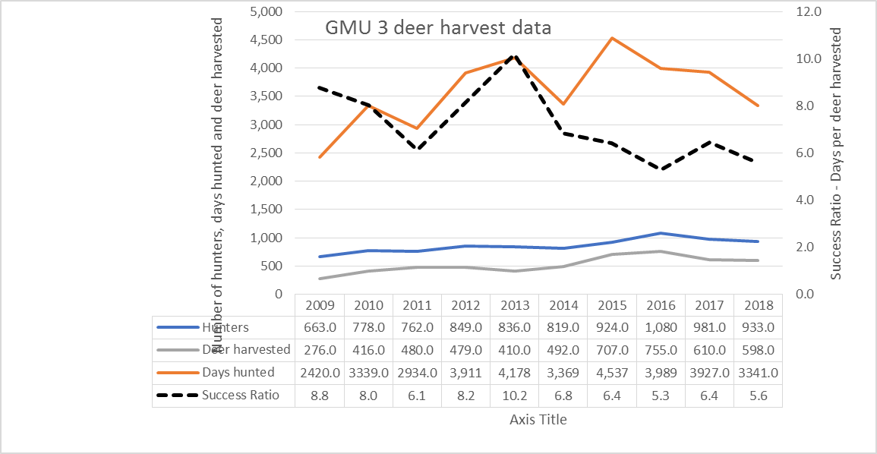
As you can see, the number of hunters has generally increased as has the deer harvest. In addition, the Success Ratio indicates that since 2013 is has taken fewer and fewer days for the average successful deer hunt. Looking at individual islands also provides some interesting information. For instance;
- Kuiu Island has had only 3 to 10 hunters per year for the last ten years and the success ratio has been improving in recent years. Potential impacts to subsistence hunting should not be a concern on Kuiu Island.
- On Mitkof Island the number of hunters has increased and the hunter success ratio has also improved over the last five years.
- Much of Zarembo Island has been heavily logged, but it has the best success ratio of any of the six major islands in the project area.
- On Etolin Island (much of which is designated as Wilderness) the number of hunters has declined in the last few years but their success ratio has been relatively stable.
- On Kupreanof and Wrangell Islands, the number of reported hunters and their success ratio has been increasing over the last three years.
All of these islands have extensive young growth stands that are well past the stem-exclusion stage, yet the deer populations are doing just fine. The deer model simply doesn’t reflect reality. Responsible logging practices do not harm fish or wildlife habitat. Please point this out in your final EIS for this project.

In closing, we urge you to make the survival of our existing industry the primary focus of your timber sale program. Please resist any decisions that would reduce the amount of volume available or add additional, costly constraints to your timber sale projects.

Sincerely,
Owen Graham
Executive Director
Alaska Forest Association
111 Stedman Suite 200
Ketchikan, AK 99901

Phone 907-225-6114
Email owengraham39@gmail.com

