The photos below show post-harvest conditions of
logged areas of national forests. Incredibly, the sale
names include the word “restoration.” Ask yourself
what resources are restored by the timber sale units
shown below. Do you really believe these timber
sales created healthier forests as the USFS claims?
Isn’t it time to come to grips with what you are doing?
Does it make you proud to assault the Americans who
enjoy recreating on their national forests?

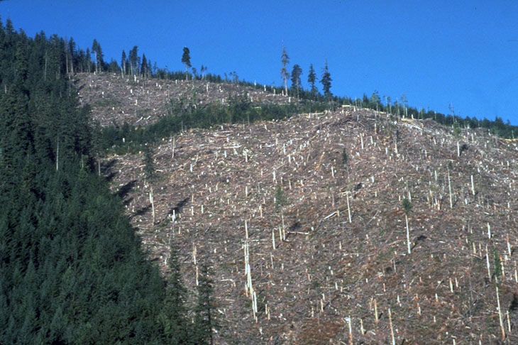
Photo #1…Bulldog Restoration Project

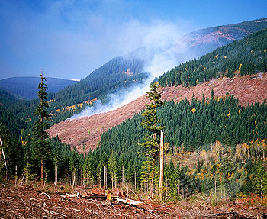
Photo #2…Clear Creek Restoration Project

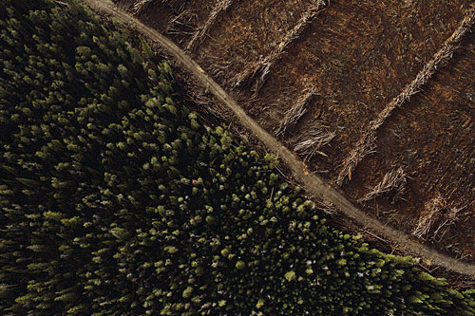
Photo #3…Crane Mountain Restoration Project

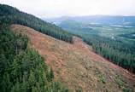
Photo #4…Sedgelaw Restoration Project

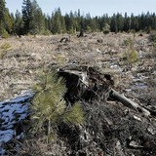
Photo #5…Bald Bear Restoration Project

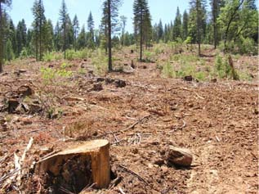
Photo #6…Heckler Restoration Project

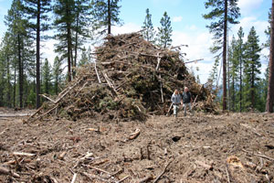
Photo #7...Lava Cast Restoration Project

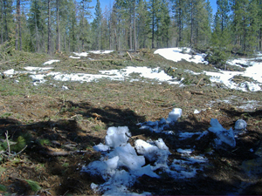

Photo #8...Upton Heights Restoration Project

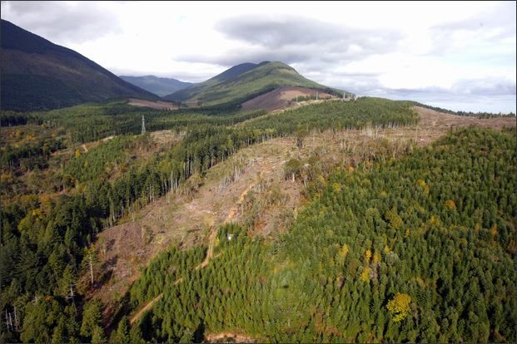
Photo #9...Elk River Restoration Project

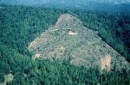

Photo #10…Crenshaw Restoration Project (note the landslide)

Below are photos of cutting units located in national
forests in R-1, R-5 and R-6. The sale names are
unknown. Please identify the natural resources that
have been “restored” and decide of the forest is
healthier now or before it was logged and roaded.

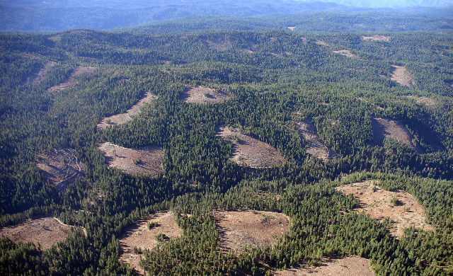

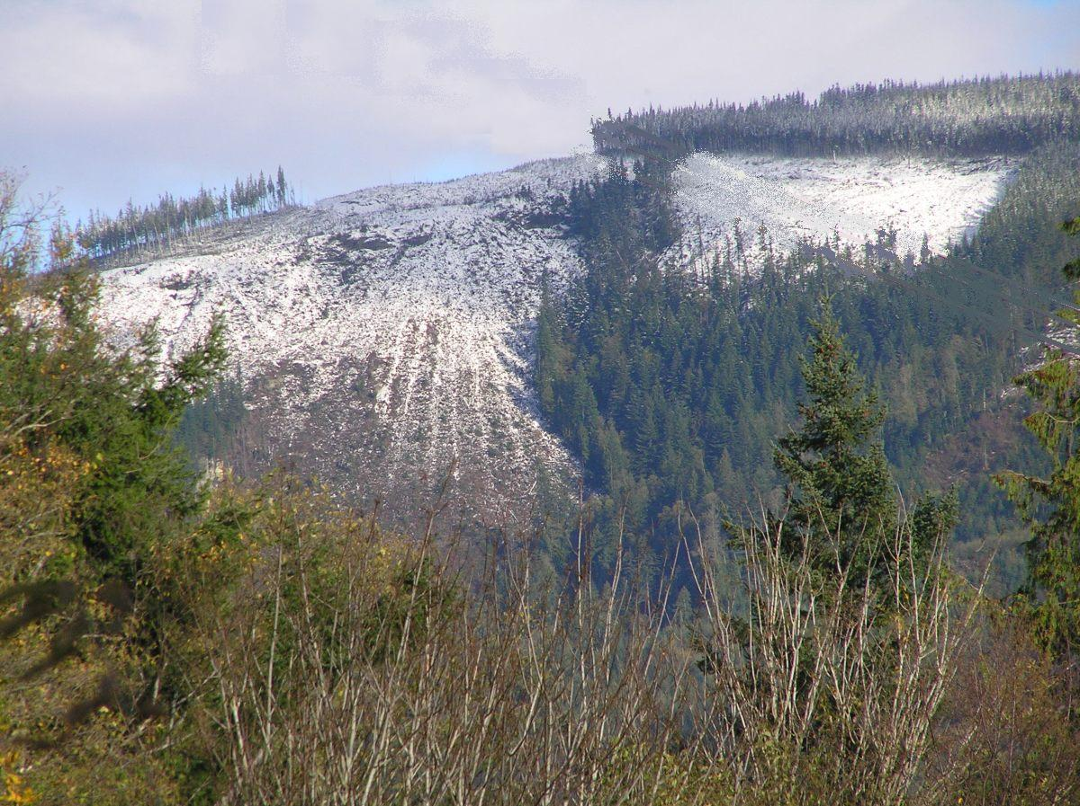

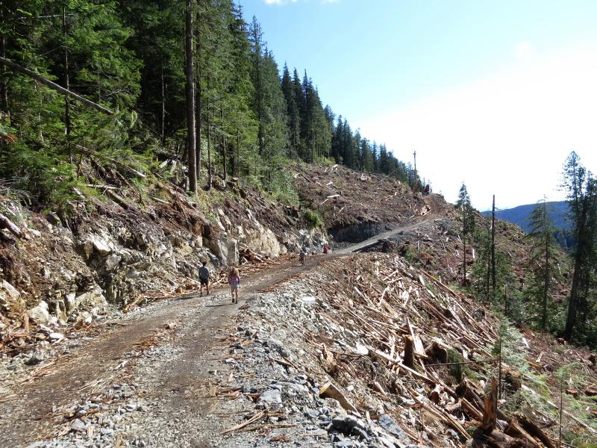

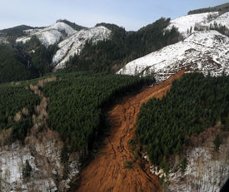
Note the landslide that blocked the stream caused by a “temporary” road at the bottom of the clearcut.

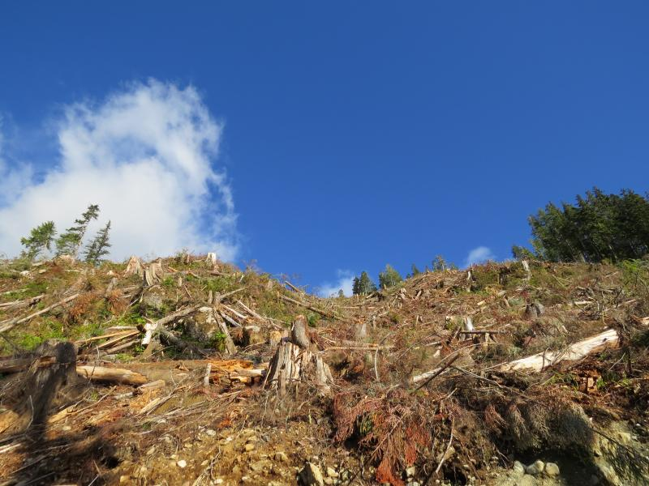

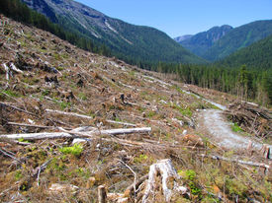
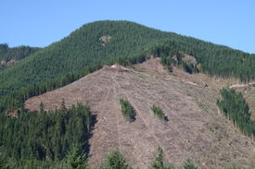

A USFS skyline “managed area”

