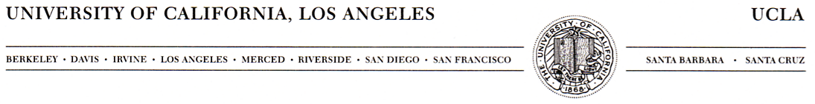
DEPARTMENT OF ECOLOGY AND EVOLUTIONARY BIOLOGY
621 CHARLES E. YOUNG DRIVE SOUTH
BOX 951606
LOS ANGELES, CALIFORNIA 90095-1606

FAX: (310) 206-3987

15 July 2019

Greetings,

Thank you for giving us the opportunity to comment on the GMUG revision plan. I write as a landowner in Gothic, CO, and as a Principle Investigator at the Rocky Mountain Biological Laboratory in Gothic, CO, where I run the long-term study of yellow-bellied marmots. Begun in 1962 by now emeritus University of Kansas professor Ken Armitage, I took over day-to-day management of the project in 2001/2002. The study is one of the longest-running studies of the fate of individually marked mammals in the world. From this study we have learned a lot about drivers of population size and response to climate change. We have learned about the importance of phenotypic plasticity (the ability for individuals to respond to environmental drivers) for population persistence. We have learned that not all animals benefit from being social, and we are starting to learn much more about aging and senescence in wild populations.

Most of the marmots we study live on USFS land; some live in adjacent private holdings. The marmots are negatively affected by human recreation in the Upper East River Valley. For instance, it is becoming more common for animals to crawl into vehicles and be dispersed out of our population (some have made it to DIA!), and it’s becoming more common for animals to be struck and killed by vehicles (including, a few years ago, a mountain bike!). Each human-caused mortality event threatens the long-term sustainability of the population; a population that we know exists as a meta-population—one that requires marmots to persist in individual patches and those patches to be connected by dispersal. Fatal road-crossing attempts isolate populations. Animals that get distracted by vehicles and end up at DIA reduce population viability. Thus, I’m quite concerned about human recreation in the area.

I have started to study the effects of human recreation. I’m an avid outdoor recreationist and I fully support the right of people to use our public lands for recreation. But I also have written extensively on the challenges that ecotourism creates for wildlife. Here in the Upper East River Valley I have started to study the impacts of humans on marmots and I’m now broadening my studies to other species. I’ve found that human activity modifies critical predation risk assessment in deer and white-crowned sparrows. I’ve found that marmots have transient response to human activities and that marmots living in areas with more disturbance behave differently than those in areas with less disturbance. For my studies focusing on other mammals I am starting to put up camera traps in areas of different human recretational uses.

I have described my interest in studying recreational impacts on wildlife because they would be greatly facilitated by creating a Special Management Area in and around the Upper East River Valley. A legion of my colleagues (present and past) have studied this area for the past 90-some years have generated an incredible amount of information about our ‘model ecosystem’. Some of this information has been influential in developing Federal legislation like the Clean Air and Clean Water Acts. Some has provided vital insights to life-sustaining ecosystem services like pollination. Some has helped us better understand the impacts of invasive species. And some has given us profound insights into the impacts of global climate disruption. Recognizing this area as a Special Management Area would give researchers based at the Rocky Mountain Biological Laboratory more flexibility in conducting studies that will continue to provide vital insights and information that help sustain life on Earth. We could better study the effects of human activities on the ecology of this place by capitalizing on the gradient of human disturbance that varies from the valley floor, along trails, slopes, and into the wilderness area around us.

For these reasons, I urge you to define the area as an SMA. Managing this area in a way that recognizes the long history of scientific discovery that has emerged from Rocky Mountain Biological Laboratory researchers will benefit society at large and also will have concrete benefits for future sustainable management of this precious region.

Sincerely Yours,



Daniel T. Blumstein, Professor

Department of Ecology and Evolutionary Biology

The Institute of the Environment and Sustainability
marmots@ucla.edu

