Mountain Livestock
Cooperative

Conserving the Working Ranch and Large
Carnivore Populations in the Mountain West

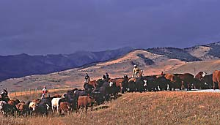
Vision

The Mountain Livestock Cooperative (MLC) is a regional conservation initiative that combines ranching tradition and economics with a scientific understanding of carnivore-livestock interactions to sustain the working ranch and large carnivore populations in the Mountain west. Drawing on the experience of
ranchers and using science to understand the nature of carnivore-livestock relationships, our vision is straightforward: develop a practical ‘working model’ to reduce large carnivore-livestock conflicts across foothill and mountain landscapes in western North America. We emphasize the tremendous conservation value of private ranchlands bordering public land, and the important role that ranchers can play in crafting workable solutions that benefit livestock producers and sustain grizzly bear and wolf populations.
Overview

Lessons of time and experience reveal that protected areas alone are too small to sustain such wide ranging large carnivores as gray wolves and grizzly bears. As a consequence, rural lands that surround protected areas hold enormous potential for both conservation, and conflict. Sustaining rare carnivores at the public- private land interface throughout western North America is an international challenge that involves cultural, economic, and ecological dimensions. Simply

put, large carnivores that play important natural roles in protected areas can cause economic harm to ranch communities that border protected area boundaries. Carnivore management programs have not provided a long-term solution to this problem.

When conflicts involving death of livestock and removal of bears or wolves occur, different values of urban and rural citizens often make the problem worse. Indiscriminate or excess killing of large carnivores near ranch communities by poisoning, snaring, and shooting angers urban residents, who perceive such actions as careless and unnecessary. Ranchers are frustrated when their efforts to ‘fix’ a problem--costing them time,
work, and money to mend fence, doctor wounded animals, or prevent harassment of their livestock--are misunderstood by those removed from earning a living from the land.
These debates generate resentment in ranching and rural families toward carnivore restoration, and weaken urban support for
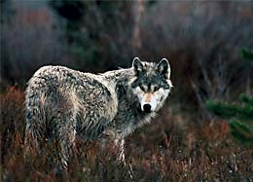
large and contiguous ranch operations that can benefit wildlife

by providing open space and diverse habitats. Past efforts to reconcile these conflicts have been
hindered by a perception in rural communities that conservation initiatives involving large carnivores too often “benefit some, but not others”. Our purpose is to remedy this deficiency.

Our Approach

We believe that an effective ‘working model’ to resolve conflicts depends on merging rancher’s knowledge about livestock, their land and surroundings with scientific knowledge about carnivore behavior and ecology. Our perspective stems from nearly two decades of work with large carnivores and support from ranchers across the mountains and foothills of
Idaho, Wyoming, Montana and Alberta. Our approach is designed to improve understanding of livestock management practices and large carnivore-livestock interactions. We apply a solution-oriented focus on problems and their causes.

Not all large carnivores prey on livestock. Once carnivores learn to kill livestock, however, a pattern of depredations often continues. We hypothesize that carnivores first learn to prey on livestock when they encounter naive and vulnerable calves and yearlings on spring and summer range. This predatory behavior appears selective, and continues into other times of year. In winter, such carnivores as wolves follow migrating natural prey to low elevations where again, they encounter livestock. Here, at the edge of big
game winter range, seasonal overlap of natural prey

coupled with traditional range and husbandry practices can influence carnivore predation behavior and contribute to repeat livestock losses and harassment throughout the year. Consequently, work by MLC to reduce large carnivore-livestock conflicts encourages the help of local ranchers and uses scientific information focused on why carnivores prey on livestock, to inform a prevention-oriented and proactive program carefully fit to specific livestock operations.

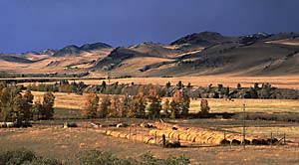

Our year-long efforts are comprehensive, incorporating landscape size and features with seasonal habitats, distribution and behavior of carnivore family groups and their prey. From winter feeding to spring calving and summer grazing to weaning, ranchers and
carnivore biologists work ‘side by side’ sharing knowledge and experience about the habits of livestock and large carnivores.


Mountain Livestock Cooperative is a registered

non-profit initiative with:

For more
information contact: Timmothy Kaminski, Box 742, Bozeman, MT 59771 406.579.8773 Email: timmothyj@earthlink.net

Photos and text © S.LeGault and MLC, 2000-
2004. All Rights Reserved.
We emphasize working and learning together in a “prototype” approach to systematically integrate, evaluate, and adapt livestock management practices with depredation avoidance techniques.

Program Goals and Objectives

Our initiative seeks to forge a cooperative and positive working relationship among ranchers, scientists, private enterprise and governments. Our goal is to reduce the number of carnivore-livestock conflicts by providing ranchers with long-term, practical, and effective tools they can easily and independently apply to benefit their operations. We believe it makes better sense, economically and ecologically, to invest in proactive efforts to prevent large carnivore depredations than to investigate recurring depredation
incidents and supply untimely and partial payments for losses that are unacceptable to livestock producers.

We envision a management approach that carefully incorporates the evolutionary traits of social and long- lived carnivores, natural prey and domestic livestock at a regional scale as a prospect to sustain ranching, reduce conflicts and improve large carnivore and big game conservation.

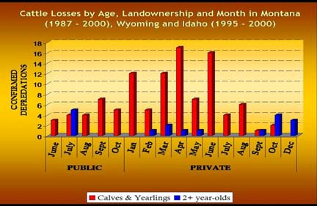

The following objectives form the core of our
Program:
Assess the circumstances associated with past livestock depredations;
Determine what factors contribute to current large carnivore conflicts and depredations;
Identify practical techniques to avoid depredations and integrate with new practices for managing

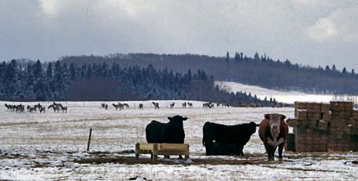
large carnivores and livestock; Evaluate the

practicality, ease and cost- effectiveness of livestock depredation avoidance techniques;
Conduct extension programs in rural and urban communities that inform people about the value of an integrated, proactive and “learning-based” approach to sustain and conserve ranching, livestock and large carnivores;
Develop an incentive-based indemnity program that provides timely and full compensation for livestock losses with emphasis to ranchers who integrate depredation avoidance methods into their livestock management practices;

Advocate a North American Carnivore Trust that leverages appropriated dollars with public and private contributions to provide long-term public funding for research, information and

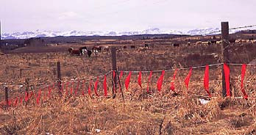

management of carnivores and their prey at province and state levels.

Top photo: Example of winter ‘mixing’ of natural prey and cattle that contributes to wolf-livestock conflicts at the edge of public and private lands. Bottom photo: Application of fladry, a depredation avoidance method to reduce livestock losses during spring calving when cattle are confined to relatively small pastures.

