June 6, 2019

Custer Gallatin Forest Planners,

My passion

I grew up in nature. I had a childhood that included watching the Lone Ranger and Sky King, but I grew up in nature. Our subdivision near Seattle was surrounded by woods, filled with all sorts of creatures. We moved to California and I explored creekbeds, reservoirs, ocean beaches, redwoods and grassy hills covered with scattered oaks. I rode my bike all over the city, exploring my limits. I joined the Boy Scouts. Then we moved to the Eastern Sierra, and I was in heaven. Skiing, hiking and swimming in ice-cold alpine lakes became my life.

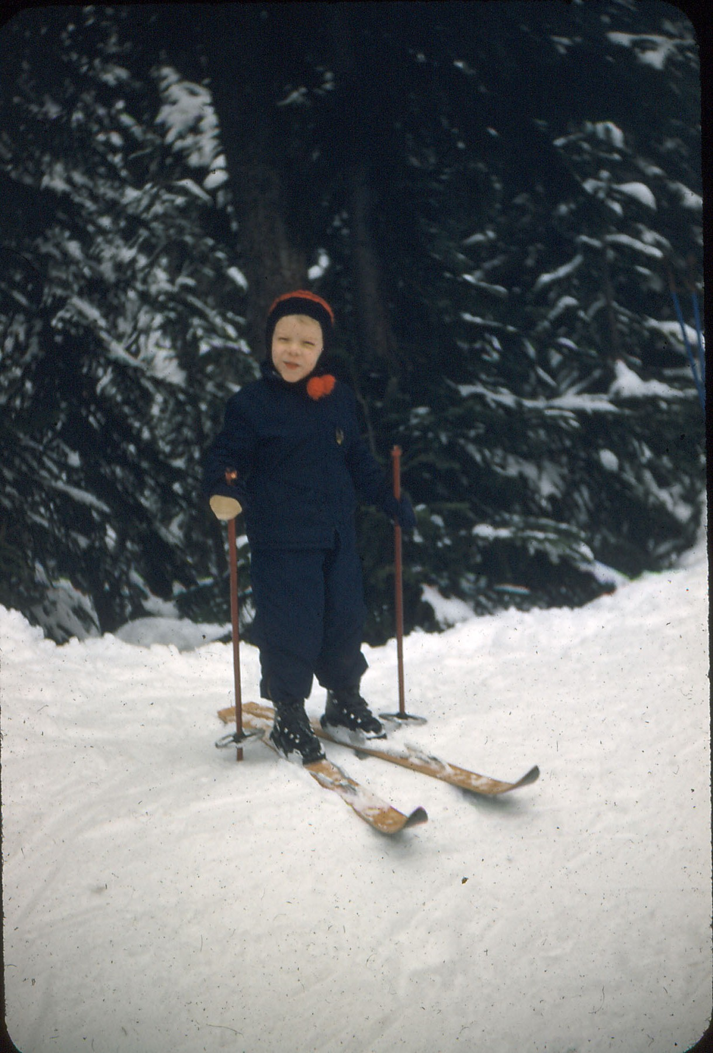

I later married and moved to Bozeman with my wife, to have a home and raise a family. After 25 years of hard work my body was stressed, damaged. A co-worker needled me for a year to try mountain biking. The sport had been therapeutic for him, recovering from a brain injury. Eventually I gave in and we explored Hyalite, the Bridgers, Porcupine and Buffalo Horn. Over several years we traveled close to 50 different trails. While I was still physically compromised I found I was also becoming quite fit. Mountain biking was saving me. The alpine landscapes were bringing back the sights and smells of my time growing up in the Sierras.

But I heard of a small group of intrepid bike explorers who always traveled a little higher and farther than we did. I searched them out and was invited to join them. I discovered they were homebodies, they didn’t care to travel far for adventure. When not working, they lived on our landscape right here in Gallatin and Park counties. This was home and it was good.

Self sufficient, they traveled the mountains in the worst weather, carrying all supplies, and compressing grand adventures into single day experiences, preferring to not camp out. They love the land and its creatures. Riding with them on another 50 new trails, I acquired those same values. They were old practiced hands at navigating the challenges of the Gallatin Crest Trail. I joined them for quite a number of journeys along the top of the range.

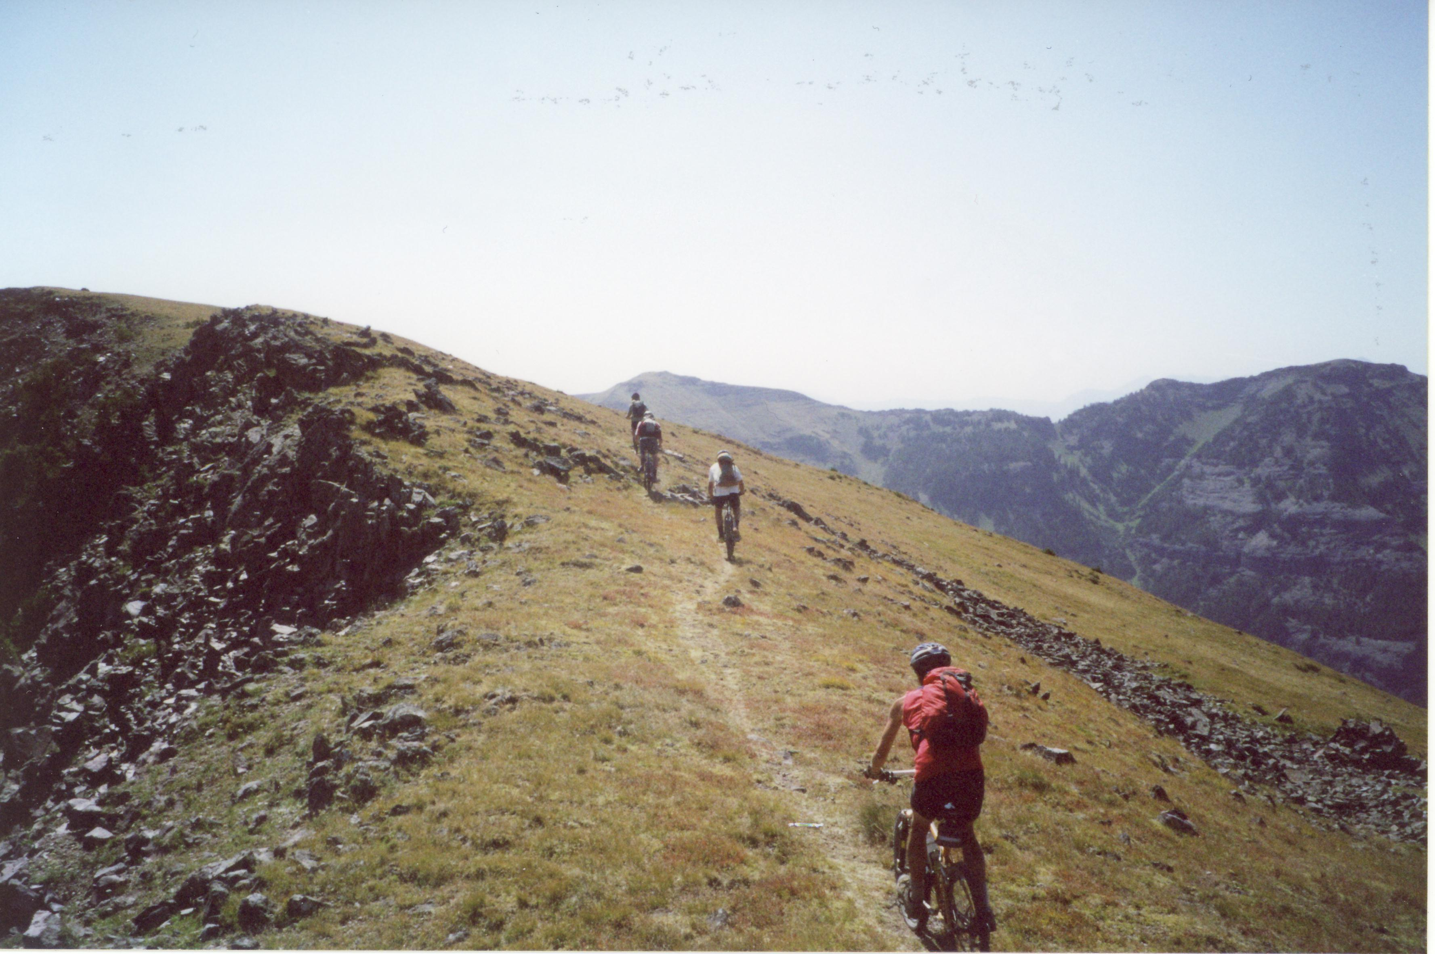

This group is still out there, but they have now been banned from the trails and experiences they loved the most. I hurt, but they hurt worse. I submit the statement, believing it to be true, that they understood the Crest area better than anyone in Montana. How could they not? At least 4 of them have traveled the Crest more than 30 times. One person has traveled the Crest more than 80 times over a 25-year period. These outings were just the through trips, not the shorter ones, such as going over Eaglehead to Ramshorn Lake, looping through Rock Creek, or navigating Lewis Creek. This devotion carries a lot of opportunity to make observations, but the most profound observation is that they have not been removed from the Crest for ecological reasons, but for political ones. I have to agree. I think its wrong.
For the past 10 years I’ve waited for the Forest Service to justify the trail closures to bicycles. Justification hasn’t happened. It appears that mountain biking has been lumped in with the large groups of motorcycle riders that used to travel the Crest, and maybe the Forest Service thinks that is just fine, just what we deserve. We apparently deserve to be banned without justification, by people who don’t get it, don’t understand. This makes me both mad and sad. I don’t know how to retrieve what’s been taken away.

An Iconic Experience

“Of all the trails in the Hyalite Porcupine Buffalo Horn wilderness Study Area, the Gallatin Crest Trail #96 stands apart. Traversing the trail takes commitment, planning, self-sufficiency, and a lot of grit. Its rewards are infinite vistas and reliable solitude. A world apart, no other trail in the HPBHWSA is equal. There is no substitute. Across Montana there is no substitute”.

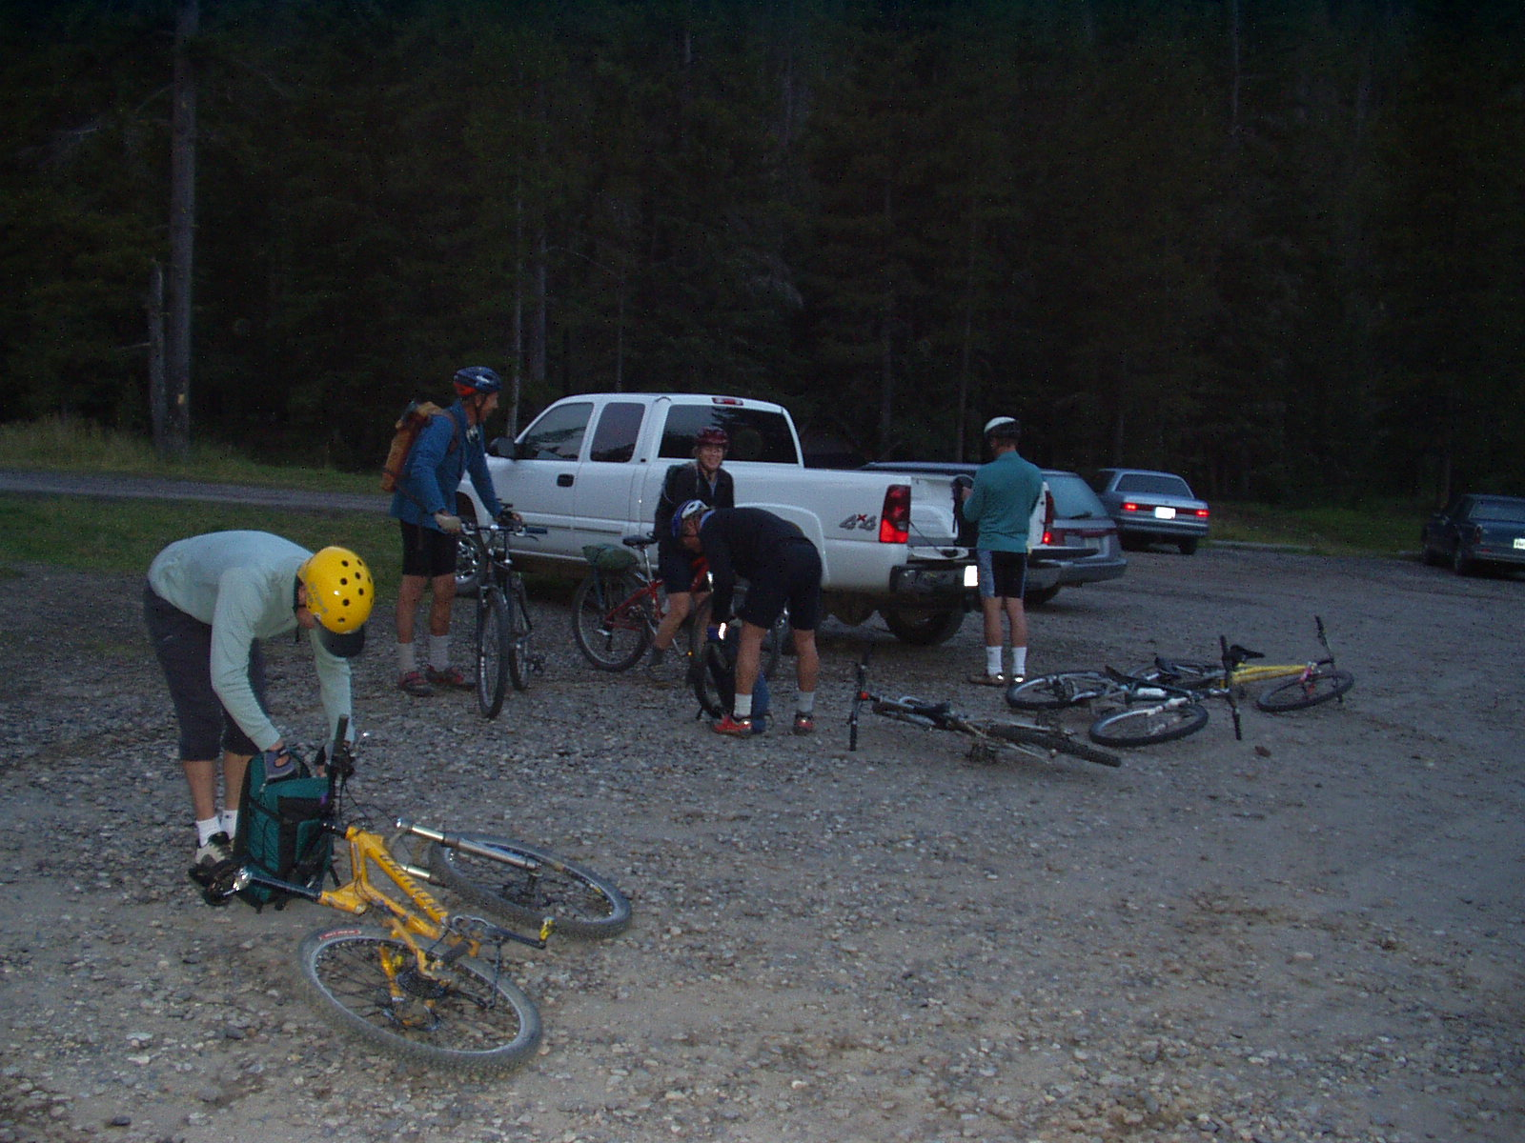

“Bicyclists used to revere the Crest Trail. Since the early 1980s it gained legendary status among adventurous cyclists. We would ride many miles of increasingly difficult trails during the early summer, building strength and endurance to ready ourselves for a ride along the Crest (aka Devils Backbone). This through route, from Hyalite to Windy Pass, was a big deal. Setting up a return shuttle at Portal Creek was required. Each rider had to check and double check every scrap of food, spare parts, tubes and tools. Bring two lunches. Bring foul weather clothing. Be prepared for the worst. Our normal riding packs would strain to contain their expanded loads. Sleep the night before, usually the first weekend of August, was hit or miss. Rise at 3:30 and jamb down a breakfast. Then head to the gathering spot, usually someone’s front yard, where gear and bikes were checked once again by flashlight, and the last gulps of coffee were downed. Usually we crammed into one vehicle, because one vehicle was all we had parked for a return shuttle. (Most Crest rides had less than 6 riders) We would slowly drive to Grotto Falls Trailhead for an “Alpine Start.”
Riding the Crest wasn’t a hasty endeavor but more of a practiced pace, an enjoyable progression. Sure we often wound up huddled under sparse tree branches while ducking from a hailstorm, we would bonk and we would also eat all of our food. But traveling along that trail was a visual delight, we felt so lucky and privileged to be doing it. The trail is an elevated path, literally above the distinctly different and separate ecosystems to the east and west below it. We strove for a pace slow enough to take in the surroundings. We would often stop to stroll over to the edge of an escarpment. Sometimes herds of elk could be spotted in the basins below. For 17 miles one travels the heights of the Gallatin Range between 9 and 10 thousand feet in elevation. Wildlife at those higher elevations is almost exclusively ravens, marmots, bighorn sheep, and mountain goats. For Montana’s bicyclists, this trail has been a unique gift. It’s incredibly special. Usually we would reach Windy Pass by 6 or 7 p.m., lingering as long as possible, then head down the trail to our shuttle vehicle. For most people this outing would represent the zenith of their summer. We were satisfied for another year, and smug in the knowledge that we were very low impact, that the trail was bicycle friendly and was/is the lowest impact route through the Range. We had pictures and memories to share until the next year; life in Montana was grand. Sadly without any attempt to manage or understand, this experience has been removed in order to quell special interest conservation groups quest for wilderness through litigation.” (Montana Mountain Bike Alliance comment)

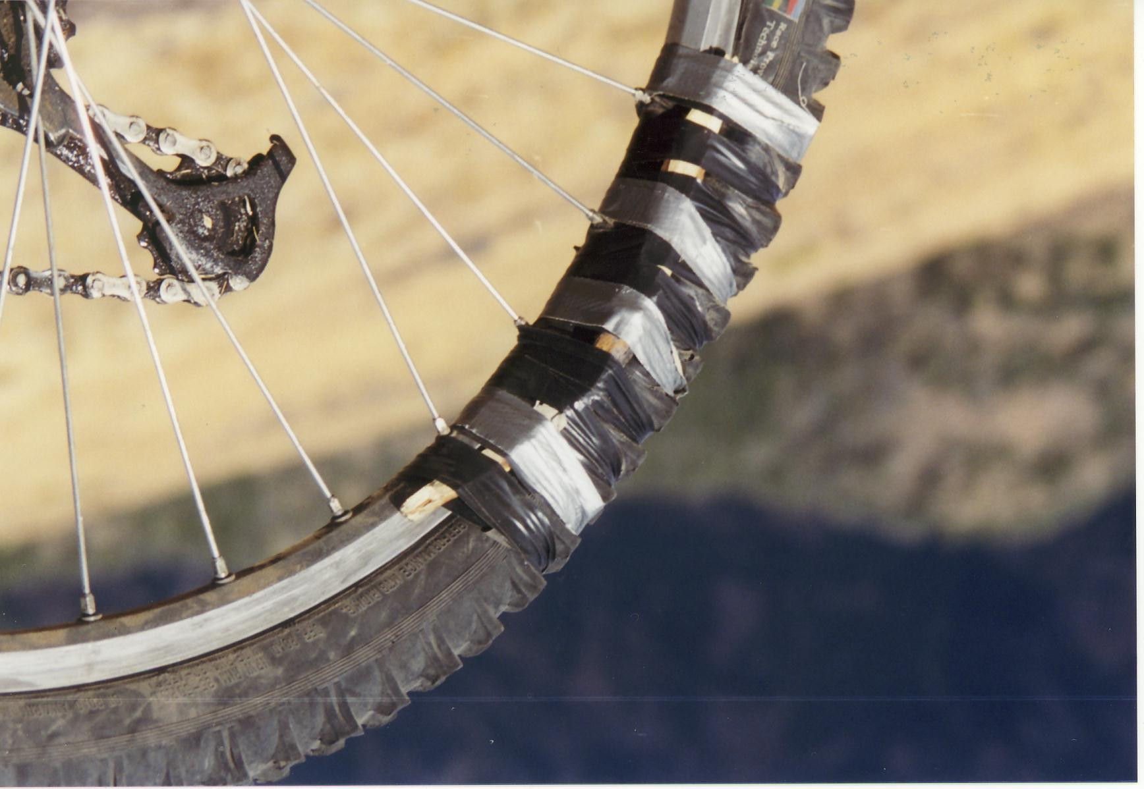
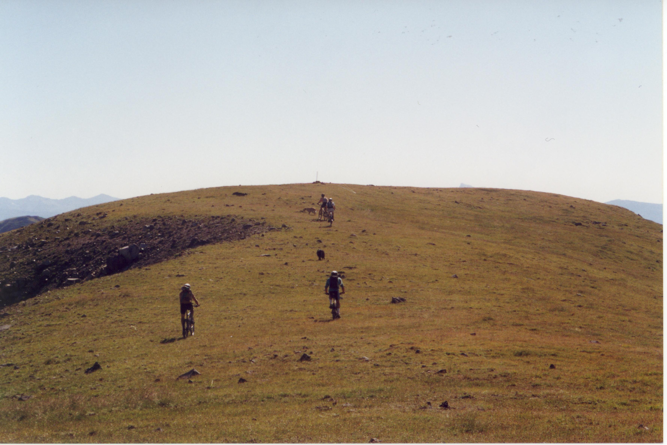

My Impression

I’ve continued to ride around the Gallatin/Park county area since the Crest closure in 2010. I’ve searched, and I feel secure in saying that there is nothing like the Gallatin Crest within 200 miles of Bozeman. There might be nothing like it anywhere in the Northern Rockies. Lionhead, as awesome as it is, is a distant second place, having only a brief couple of miles of trail above timberline. Being 100 miles from Bozeman is a disadvantage, as most Lionhead trips require overnight camping. In comparison, the Gallatin Crest is truly a backyard wonder, and as long as it stays wild, it should be shared.

The closure occurred, spoiling my ambitions to share the experience with my children. For this I harbor some bitterness, for they won’t be able to experience the same feelings I did. Why must we wait for 10 years to find out why we were banned? While Forest Service employees continue to receive paychecks, the most invested, passionate public is denied due process. This is disturbing. I think it’s just plain wrong to not manage recreation in this Wilderness Study Area, because if it were managed then Forest Service managers would gain knowledge of the law, of the landscape, and how people can respectfully and quietly enjoy the landscape during the brief summer months. I think Custer-Gallatin National Forest should renew its responsibilities to manage recreation on the Gallatin Crest Trail, a resource component subject to what Congress intended in 1977, and manage people, not ban them, according to the Forest’s lawful obligations to the Wilderness Study Act.

Sincerely,
Greg Beardslee

