June 5, 2019

Custer Gallatin National Forest
Attn: Forest Plan Revision Team
P.O. Box 130
10 E Babcock
Bozeman, MT. 59771

Forest Plan Revision Team:

I am writing to comment on the Custer Gallatin Forest Plan Revision. Sun Mountain Lumber supports alternative E. We strongly support managing lands suitable for timber production to meet forest goals for growth and yield of saw timber. This alternative provides the greatest volume of wood products and the most acres in the suitable classification.

This alternative projects the lowest amount of wildland fire as a result of active management. Reducing fuels and costs of fire suppression are important goals for national forests. This will also increase fire fighter safety and help protect infrastructure.

The plan should remain as flexible as possible regarding slope steepness for harvesting. Tractor logging should be allowed on slopes greater than 35% where soils types will not be excessively impacted. Using feller bunchers on steeper slopes needs to be considered as a means to address sawyer safety in dead lodgepole and timber sale economics.

Sun Mountain depends on the Custer Gallatin to supply our mill and keep people employed. We want the forest to continue with an active timber sales program. Thank you for the opportunity to provide comments on the Custer Gallatin Draft Revised Forest Plan.

Respectfully,
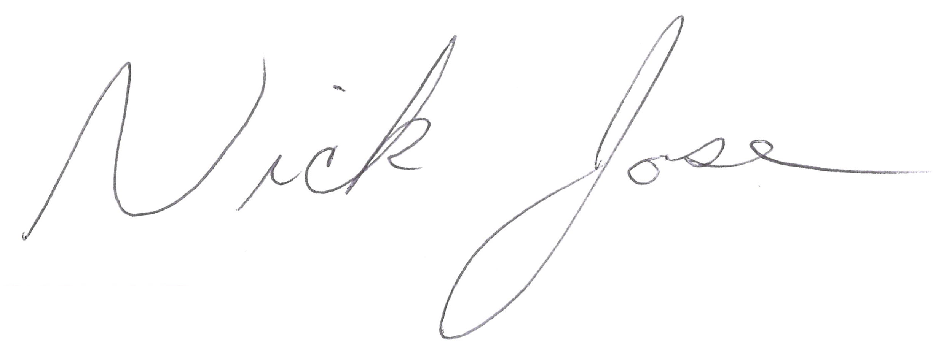

Nick Jose
Resource Manager
Cell 406-560-0374
Off 406-846-1600
Nick.jose@sunmtnlumber.com

