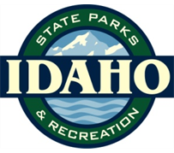

Brad Little

Governor

David R. Langhorst

Director

…………..……………

IDAHO PARK AND RECREATION BOARD

…………..……………

Doug Eastwood

District One

Randy Doman
District Two

Brian Beckley

District Three

Gordon Hansen

District Four

Pete J. Black
Board Chair

District Five

Louis Fatkin

District Six

…………..……………
director’s office

…………..……………

5657 Warm Springs Avenue
P.O. Box 83720
Boise, Idaho 83720-0065

Phone (208) 334-4199

www.parksandrecreation.idaho.gov

May 10, 2019

Keith Lannom, Forest Supervisor
Payette National Forest
500 N. Mission Street
McCall, ID 83638-3805

RE: South Fork Salmon River Restoration and Access Management Plan EA

Dear Mr. Lannom:

The Idaho Department of Parks and Recreation (IDPR) staff reviewed the South Fork Salmon River Restoration and Access Management Plan Environmental Assessment (EA). This EA evaluates proposals developed by the Big Creek-Yellow Pine Collaborative Group.

The IDPR staff participated in this collaborative group for the South Fork Proposal. We helped the collaborative refine recommendations and helped with GIS Work for a map of the Davis Ranch Road.

Table 1 and Table 2 on Pages 15-20 shows all proposed management activities that this EA is considering. The planning team considered all the items that the Big-Creek Yellow Pine Collaborative covered during its meets on the South Fork of the Salmon River. Unfortunately, the collaborative was unable to come to conclusion on two route proposals (Cougar Creek and the Davis Ranch Road. Our comments will focus on these two route proposals.
The EA analyzes is redesignating the Cougar Creek Trail #098 as two-wheeled motorized (motorcycle) in Alternative B and D. This trail was open to motorcycle use until the 2008 Payette Travel Plan Decision. The original Payette Forest Plan recommended this area for wilderness and this decision was carried forward in the current forest plan.

The Cougar Creek Trail #098 is an historic single-track trail opportunity that was open and maintained by Trail rangers and the motorized public until the 2008 Payette Travel Plan Decision. This trail provides an essential looping opportunity that allows motorcyclists to connect to Buckhorn Trail #096. Designating the trail single-track motorized would ensure continued maintenance on the trail that allows our Trail Rangers to maintain the trail. It would keep it from disappearing like what happened to Martin Ridge Trail #301 and many other trails in Idaho that have been converted to non-motorized use.

Motorcycle use in recommended wilderness has never prevented Congress from designating them as Wilderness. The Hells Canyon, Gospel Hump, Frank Church River of No Return, and the Jedediah Smith Wilderness Areas all had motorcycle use in them before they were designated by Congress. Below is a picture that our retired staff took while visiting the Gospel Hump by motorcycle before it was designated Wilderness.

Figure 1
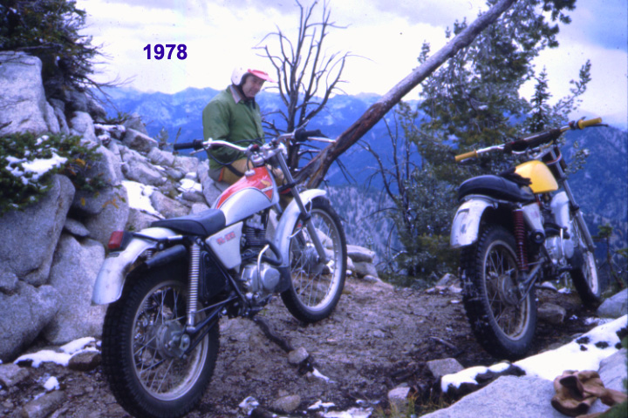

The Cougar Creek Trail designated as two-wheeled motorized would add 9 miles to single-track motorized trails on the Krassel Ranger District, accounting for a less one percent change in non-motorized trail opportunities in recommended wilderness in Idaho. Given that the Cougar Creek Trail is located near the South Fork of the Salmon River and it is remote, it most likely will not receive a lot of use from either motorized or non-motorized visitors.

On Page 46, the EA indicates that a Forest Plan Amendment would be needed to due to the reclassification on Cougar Creek from non-motorized to single-track motorized. The trail was designated as single-track motorized in the 2004 Payette National Forest Backroads Map. It was changed to non-motorized in the 2008 Travel Plan Decision which was found invalid by the court. The Recreation Opportunity Spectrum has not been changed either. Reclassifying the Cougar Creek Trail #098 does not violate the standard.

The Recreation Conclusions on Page 95 address the need for a revised Recreation Opportunity Spectrum (ROS). It asserts that the ROS can’t change from semi-primitive non-motorized to semi-primitive motorized in recommended wilderness. The ROS layer most likely has not been updated since the Forest Plan revision which would have had SPM corridors along Cougar Creek, Martin Ridge, and the South Fork Salmon River. This EA will officially close the Martin Ridge Trail with this decision. This closure increases the SPNM acreage in the Needles RWA.

On Page 96, the EA asserts that only Alternative C maintains or improves wilderness character. Both Alternative B and D would close the Martin Ridge Trail. This increases SPNM acreage in the Needles RWA. Given the lack of funding for 16 bridges, it is unlikely that the Davis Ranch Road can be rebuilt to accommodate either private ATV use (Alternative B) or public single-track motorized use in Alternative D.

Table 7 on Page 97 has an incorrect statement about ROS. The ROS will increase in Alternative B and D, since the Martin Ridge Trail will be designated non-motorized. The Davis Ranch Road will also likely not be built any time soon, so the ROS could be changed in that area as well. So, there will be a change in ROS in Alternative B and Alternative D.

The table indicated that the RWA would be degraded by designating the Cougar Creek Trail as single-track motorized. In Alternative B, the Martin Ridge Trail would be closed which will offset the designation of the Cougar Creek Trail.

On Page 100, the EA states that the Cougar Creek Trail was not designed for motorcycle use. Motorcycles have lesser clearing limits, a rough trail tread, and tighter switchbacks than trails designed for stock. The Cougar Creek Trail meets the standards for a motorcycle trail in Class 2. Table 1 on the next page shows the USFS Trail Design Perimeters for both stock and motorcycles.

Table 1
 |  | Designed Use  PACK AND SADDLE Trail Class 2 | Designed Use  MOTORCYCLE  Trail Class 2
Design Tread Width | Non-Wilderness  (Single Lane) | 12” – 24”  May be up to 48” along steep side slopes  48” – 60” or greater along precipices | 8” – 24”
Design Tread Width | Non-Wilderness  (Double Lane) | 60” | 48”
Design Tread Width | Structures  (Minimum Width) | Other than bridges: 36”  Bridges without handrails: 60”  Bridges with handrails: 84” clear width | 36”
Design Surface² | Type | Native, with limited grading  May be frequently rough | Native, with limited grading  May be continuously rough  Sections of soft or unstable tread on grades < 5% may be common and continuous
Design Surface² | Protrusions | ≤ 6”  May be common and continuous | ≤ 6”  May be common and continuous
Design Surface² | Obstacles  (Maximum Height) | 12” | 18”  May be common or placed for increased challenge
Design  Grade ² | Target Grade | 5% – 20% | 10% – 25%
Design  Grade ² | Short Pitch Maximum | 30% | 40%
Design  Grade ² | Maximum Pitch Density | 15% – 20% of trail | 20% – 40% of trail
Design Cross Slope | Target Cross Slope | 5% – 10% | 5% – 10%
Design Cross Slope | Maximum Cross Slope | 10% | 15%
Design Clearing | Height | 8’ – 10’ | 6’ – 7’
Design Clearing | Width  (On steep side hills, increase clearing on uphill side by 6” – 12”) | 72”  Some light vegetation may encroach into clearing area | 36” – 48”  Some light vegetation may encroach into clearing area
Design Clearing | Shoulder Clearance | 6” – 12”  Pack clearance: 36” x 36” | 6” – 12”
Design Turn | Radius | 4’ – 5’ | 3’ – 4’

This table shows that pack and saddle trails require great clearing limits, wider switchbacks and a smoother surface than motorcycle trails in Trail Class 2.

The above documentation shows that Cougar Creek Trail can be designated as a single-track motorized trail as identified in Alternative B and Alternative D. The Cougar Creek Trail #098 is a historic motorized single-track trail opportunity that provides an essential looping opportunity that allows motorcyclists to connect to Buckhorn Trail #096.

On Page 101, the EA asserts that the Martin Ridge Trail is accessible by foot. In some sections, our staff has found that the trail has completely disappeared from the landscape. In our view, the Martin Ridge Trail isn’t truly accessible by foot either.

On Page 101, the EA asserts that the Teapot/Jackie Trail #382 is the only ATV Trail on the Krassel Ranger District. This is not true. The Krassel Ranger District also has the Quartz Creek Trail #067 (1.1 miles) and Smith Creek Trail #194 (4.9 miles). It would be more appropriate to state that the Teapot/Jackie Trail #382 is the only ATV Trail in Management Area 12.

On Page 107, The EA references Landres et all 2015. Our staff downloaded this report. This is a report about managing wilderness characteristics in Wilderness, not recommended wilderness. The report makes no mention of motorized use.

One Page 110, the EA covers the impacts of the Cougar Creek Trail being designated as single-track motorized. The EA asserts that this would degrade the wilderness characteristics. Our comments show that this is not the case. Motorcycle trail opportunities have been lost because of Wilderness Designation. The Forest Service is required to maintain wilderness characteristics, but, it is Congress that creates Wilderness through the legislative process.

On Page 115, the EA worries about population growth in the Treasure Valley and its impact on the recommended Wilderness for the Needles. Treasure Valley citizens desiring Wilderness already have Wilderness areas closer to Boise than the Needles. The Queens River Trailhead that accesses the Sawtooth Wilderness is only 75 miles away. The Little Jacks Creek Wilderness is 73 miles away. The Needles area is over 150 miles away.

The EA also states the increasing role of mechanization and the lack of ability to get a non-motorized recreation experience. There are far more non-motorized trails in Idaho than motorized. In fact, over the past 50 years, non-motorized trails opportunities on Idaho’s National Forests have increased. In 1978, there were 5,160 miles of non-motorized trails. In 2017, Idaho’s National Forests had 10,626 miles of non-motorized trails. We have a great story map showing these changes at https://arcg.is/1r5XXv. View #9 shows the east half of the Payette National Forest. On the next page is a chart that shows the changes on the Krassel Ranger District.

Figure 2

This chart shows that non-motorized trail opportunities have increased from 574 miles in 1978 to 711 miles in 2019. During this same time frame, motorized trail opportunities have decreased from 284 miles to 150 miles. The 2008 Payette Travel Plan decision also abandoned Trails #304, #305, and #309 from the Payette National Forest Trail System. This was a loss for non-motorized trail visitors. The decision also abandoned the Camp Creek Trail #290 that was a loss for motorcyclists and non-motorized visitors.

The EA also states, “Expanded motorized use in the RWAs would result in an increase in use by existing user groups.” Our staff is not aware of any studies that show the motorized use increases in RWAs because of the RWA designation in a Forest Plan. This statement should be removed from the final EA.

The Davis Ranch Road would be designated non-motorized in Alternative C. Alternative B designates the road as non-motorized; but, allows ATV use for the private landowners. Alternative D designates the road as single-track motorized for the public and the landowners.

None of the action alternatives address the landowners desire for access. Both the of the private landowners would ultimately desire for the road to be reconstructed for full size vehicles. This is not economically feasible. With the other action alternatives, the landowners would still want to use the Hamilton Bar Road for access. Alternative C would still provide permitted full-size vehicle access, but with a narrower road prism.

The action alternatives require building up to 16 bridges to bring the washed-up road up to trail standards. The cost of building and installing these bridges (millions of dollars) for a 11.4-mile dead end trail (motorized) makes the action alternatives uneconomical. The location of the trail is also undesirable from a motorized recreation standpoint. The trail is located on the mid-point of the mountain and dead ends at private property.

The EA also presents options for narrowing the Hamilton Bar Road from a full-sized vehicle down to a single-track motorized trail. This road is used to access the Fritzer Ranch under a special use permit for the landowner. The landowner would still want to use this road until the Davis Ranch Road is fixed. The landowners would also have to incur a cost of reinstalling a cable car across the South Fork of Salmon River for the Davis Ranch Road to be used as private land access.

Many of the items listed in Table 1 and Table 2 are the same across the range of action alternatives. These items were agreed to by the collaborative and should be implemented.

We appreciate the opportunity to review this draft EA. The final EA will need some updates that we have identified in our above comments, if you have any questions about our comments, please let me know.

Sincerely,
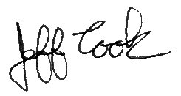
Jeff Cook, Outdoor Recreation Analyst
Recreation Bureau

