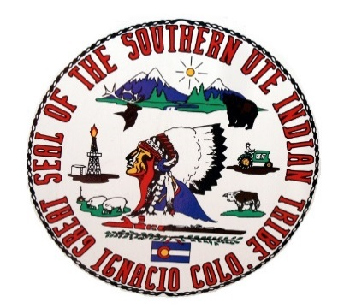
Southern Ute Indian Tribe
Southern Ute Cultural & Preservation Department
P.O. Box 737, Mail Stop #73, Ignacio CO 81137
Phone: 970-563-0100 Fax: 970-563-1098
December 7, 2018

Sam Massman
900 Grand Ave.,
Glenwood Springs, CO 81601-3602

Dear Mr. Massman,

I have reviewed your Consultation Request under section 106 of the National Historic Preservation Act regarding the EA Copper Mountain Resort, Winter Snowmaking and Summer Projects project and offer the following response as indicated by the box that is checked.

NO EFFECT: I have determined that there are no properties of religious and cultural significance to the Southern Ute Indian Tribe that are listed on the National Register within the area of potential effect or that the proposed project will have no effect on any such properties that may be present.
NO ADVERSE EFFECT: I have identified properties of cultural and religious significance within the area of effect that I believe are eligible for listing in the National Register, for which there would be no adverse effect as a result of the proposed project.
ADVERSE EFFECT: I have identified properties of cultural and religious significance within the area of potential effect (APE) that are eligible for listing in the National Register. I believe the proposed project would cause an adverse effect on these properties.
REQUEST FOR ADDITIONAL INFORMATION: The Southern Ute Indian Tribe requests additional information on the planned site for its impact on properties of religious and cultural importance to the Tribe as follows: We Wish to enter into Section 106 Consultation. There lands are culturally affiliated to the Southern Ute. We utilize areas within the White River National Forest. There is an non in existence with the Southern Ute and Ute Mtn Ute, White River National Forest, Grand Mesa -Uncompahgre- Gunnison National Forest, Routt National Forest and CCIA concuring the identification + preservation of cultural and historical resources, which should also be utilized and the forest to be aware of.
Please reply to Cassandra Atencio at catencio@southernute-nsn.gov and Garrett Briggs at gbriggs@southernute-nsn.gov and refer to in future ongoing correspondence with this office.

Sincerely,

Ms. Cassandra Atencio
NAGPRA Coordinator
Southern Ute Cultural Department
Southern Ute Indian Tribe

