Tom Boyd
Vail Valley Foundation
PO Box 6550
Avon, CO, 81620

Dear Mr. Fitzwilliams,

For more than 35 years, the Vail Valley Foundation has worked closely with both the U.S. Forest Service and Vail Resorts. During that time, we have seen continued evidence that Vail Resorts is committed to responsible, sustainable stewardship of the mountain areas in which they operate.

Vail Resorts is currently seeking to improve the snowmaking coverage on Vail Mountain. I am writing on behalf of the Vail Valley Foundation to voice our support of this project.

The plans are in line with the resort’s Master Development Plan, would create a significant improvement of the experience on Vail Mountain, would create an added benefit for the local economy by providing a better experience for guests and locals, and would utilize energy-efficient technology to ensure the long-term sustainability of the snowmaking on Vail Mountain.

Sincerely,

Tom Boyd

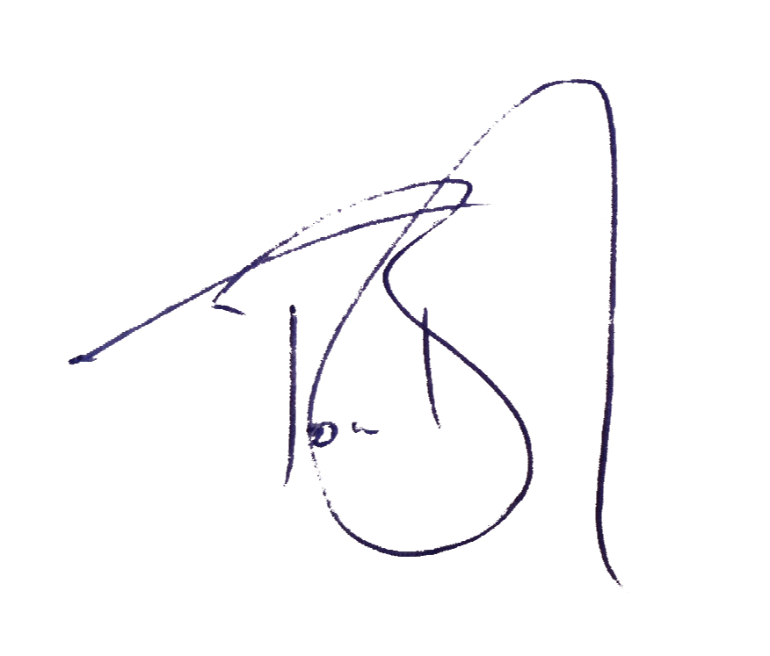

Director of Communications
Vail Valley Foundation

