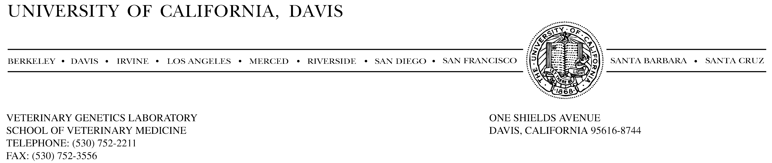

Cate B. Quinn, Ph. D.
Mammalian Ecology and Conservation Unit
(703) 489-5350
cbquinn@ucdavis.edu

Jason Kuiken
Stanislaus National Forest, Attn: OSV
19777 Greenly Road, Sonora, CA 95370
comments-pacificsouthwest-Stanislaus@fs.fed.us

October 10, 2018

RE: Comments on Stanislaus OSV Designation Project Draft Environmental Impact Statement

Dear Mr. Kuiken,

I am a wildlife biologist writing to comment on the Stanislaus Over-Snow Designation Project Draft Environmental Impact Statement (DEIS). I completed a doctoral dissertation on the Sierra Nevada red fox subspecies and have seven years of direct experience (2010–2018) monitoring the Distinct Population Segment (Sierra Nevada DPS) residing on the Stanislaus National Forest. Through this course of research I have become intimately familiar with the ecological habitats and Forest Service lands where Sierra Nevada red foxes have been frequently detected.

I acknowledge that the preferred alternative (Alternative 5) is an improvement on the proposed action (Alternative 1) in regards to potential impacts on Sierra Nevada red fox. However, I am concerned that this action fails to adequately mitigate potential impacts to the long-term viability of this Sierra Nevada DPS, a Candidate Species warranted but precluded by higher priorities from listing under the Endangered Species Act. I believe Alternative 3 is a more appropriate plan for compromising recreation and resource protection needs, and specifically for ensuring the persistence of this vulnerable Sierra Nevada red fox population. Additionally, I believe all of the proposed alternatives could be strengthened by stipulating specific measures and trigger points to address non-compliance issues.

My general concern stems from the fact that little data exists to support that there are minimal impacts of over-snow vehicle (OSV) on sensitive populations of high-elevation mesocarnivores such as Sierra Nevada red fox. Incursion from coyotes, disturbance to denning and breeding behavior, and the effect of snow compaction on rodent pretty communities are some of the possible impacts of increased OSV use. To date, >90% of detections of Sierra Nevada red fox have occurred in the high-elevation areas between Highway 4 and Highway 108, meaning that the project lands covered in this DEIS have high overlap with the core range of this population. Many of the lower elevation regions immediately to the west of the crest have yet to be surveyed for red fox and may contain additional territories. Furthermore, results from noninvasive, molecular identification of individuals indicate that Sierra Nevada red foxes have extremely large home ranges and occur at low densities, numbering fewer than 50 breeding individuals. With apparent limited range and abundance, the conclusion stated in the EIS that the Stanislaus National Forest Over-snowVehicle use Designation project “may affect individuals, but are not likely to lead to a loss of viability or a trend toward Federal listing” is unwarranted. In very small populations, failed reproduction of even a few individuals sustained over multiple years has the potential to cause or accelerate declines. Given the vulnerability of this population, I believe it unwise to increase motorized winter use in suitable habitat that was previously designated as non-motorized, until adequate data exist to demonstrate that OSV has minimal effect on the reproductive success of Sierra Nevada red fox.

Specifically, while Alterative 5 reduces the acreage of Near Natural Areas available for cross-country OSV use, the designated areas in the Eagle Peak and Pacific Valley Near Natural roadless areas pose a threat to the Sierra Nevada DPS. First, allowing OSV use in these areas has potential to directly disturb the high-elevation (>9,000’), open volcanic ridges favored by Sierra Nevada red fox. Sierra Nevada red fox has been previously detected using genetic and photographic approaches near Peep Sight Peak, close to the proposed Pacific Valley area. Keeping Near Natural Areas free of motorized use as suggested in Alterative 3 would protect suitable habitat from potential OSV impacts. Second, these two Near Natural Areas serve as important buffers to the bordering wilderness areas. Numerous Sierra Nevada red fox detections, including those associated with confirmed breeding territories, occur in neighboring portions of the Carson-Iceberg and Emigrant wildernesses. Given that non-compliance encroachment into wilderness areas on the Stanislaus Forest currently occurs, I the increased signage and patrol presence indicated in Alternative 5 are vague and unrealistic solutions, especially given the reality of fluctuating budgets and personnel. In particular, the ungroomed trail along Long Valley Creek (Eagle Peak Area) designated in Alterative 5 would allow riders easy access to the northern portion of the Emigrant Wilderness. By keeping all Near Natural areas motorized-free, Alternative 3 would insulate critical, occupied habitat from potential direct and indirect impacts of OSV use. Regardless of which Alternative is selected, even if, it should be modified to outline an adaptive management strategy for non-compliance and wilderness trespass. This adaptive management should specify from outset a monitoring schedule and trigger points for which further actions (i.e., closures) would go into effect.

Thank you for considering.

Sincerely,

