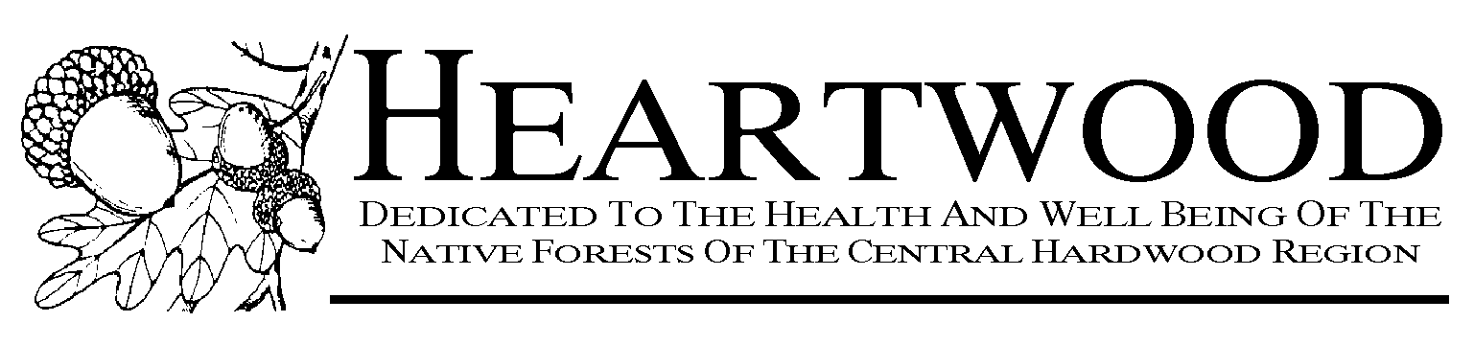

FOR IMMEDIATE RELEASE
JULY 15, 2008
Contacts below release.

FOREST SERVICE FAILS: AN ECONOMIC ANALYSIS OF THE WAYNE NATIONAL FOREST PLAN

––View full report, summary, and recommendations at heartwood.org–

––Video comments on the report at http://www.youtube.com/watch?v=CifauZYpxZ8––

At a telephone press conference today, authors of An Economic Analysis of the Wayne National Forest Plan, a new study by Greenfire, LLC, commissioned by the regional forest protection organization Heartwood, discussed their conclusions that the U.S. Forest Service’s (USFS) 15-year management plan for southern Ohio’s Wayne National Forest (WNF) ––Ohio’s only national forest––does not maximize net public benefits as required by law. Study co-author, economist Christine Glaser, PhD, stated that the Plan “does not create a net public benefit,” because both monetary and nonmonetary public costs are greater than public benefits. Andy Mahler, Heartwood Coordinator, summed up: “It’s really the worst of both worlds. Not only are we getting a degraded and cut-over public forest, but we are wasting tax money and preventing more desirable benefits from the forest in the process.”

The study evaluated costs of running USFS operations and found that “logging, mining, and off-highway vehicle (OHV) trails cost the Forest Service more than is coming back in revenues.” They also found that extensive pollution costs result from Forest Service plans to log more than 18,000 acres and to burn 68,000 acres (over a quarter of the Wayne) in the next ten years, as well as to expand OHV trails by over 100 miles. The authors challenged the rationale for logging, burning, and OHVs on economic and environmental grounds. The study points out that southeast Ohio has one of the highest air pollution levels in the nation, that four Wayne counties are in noncompliance with EPA particulate standards, and that OHVs are high emitters of particulates, volatile organic compounds (VOCs), and nitrous oxides (NOx).

The authors also found high costs in lost ecosystem services from FS activities. Glaser gave examples of forest ecosystem services that are diminished by logging, burning, and OHV use:
- Trees filter out pollution (“and there is lots of air pollution in the Wayne area”).
- Forests purify water and regulate flow, storing storm water, releasing it slowly, and
thereby reducing flooding.
- Forests store carbon and sequester carbon from the atmosphere.
Glaser also discussed recreation as an ecosystem service. The study documents the wider popularity and greater economic contribution in the Wayne of recreation activities that are largely incompatible with OHVs: nature viewing, hiking, sightseeing, and picnicking.

The study calculates that ecosystem services provided by the Wayne have an average value of $1800 per acre per year compared to timber’s value of $250 per acre per year or less. Based on the $1800 value, the study estimates that Wayne ecosystem services could be worth $381 million per year. Glaser asked, “Does it make economic sense to manage the forest for timber, when logging is a losing business for the Forest Service, when the ecosystem services that are lost because of logging are worth more than the timber, and when logging causes pollution and environmental degradation on top of it?”

Glaser critiqued USFS justifications for burning and logging, as well as its claim to protect biodiversity: “How can the Forest Service claim to protect biodiversity when logging and burning reduce rather than increase the availability of large tracts of interior forest, which are extremely rare and not available on private land at all?”

Co-author Karyn Moskowitz, MBA, pondered, “Why does the Forest Service pay millions of dollars in taxpayer money to subsidize private logging, mining, and OHVs on public land? Why does the Forest Service not just decide to do what makes most sense from an economic as well as ecological perspective, that is, to let the forest naturally grow into an old growth forest, which requires minimal ‘management,’ and get highly valued forest ecosystem services completely free of charge?” She answered her own questions: “The answer is fairly simple and straightforward––the Forest Service does what it gets paid for.” She explained, “Congress has established funds that the Forest Service can use without having to go to Congress,” funds that specifically support and therefore promote logging, burning, and OHV use.

Moskowitz challenged the Forest Service’s commitment to “ecosystem management” as a smokescreen to cover its real goal of promoting logging and burning, because these programs generate revenue for the Forest Service, although not enough to cover costs. She added, “The Forest Service also tries to justify the logging and mining by saying that we need to log in order to hold up the local economy, we need the oil for energy security, or we need to satisfy all interest groups and allow OHVs. However, we found that the counties surrounding the Wayne National Forest are not dependent on logging for their economic security. Other industries, like health care and government, are actually more important. We also found that the little oil left in the ground under the Wayne wouldn’t supply enough oil for even one day of driving. Finally, Indiana, West Virginia, and Illinois have all banned OHVs from National Forests because they are so destructive. Their OHV industry moved to private lands, and that industry did not die.”

Moskowitz pointed out that logging, burning, and OHVs discourage more environmentally benign and profitable recreation activities and also prevent attraction of new businesses, due to the degradation of the land and the air and water pollution generated by these destructive practices.

Andy Mahler commented, “The GreenFire study will go a long way toward raising awareness that the economy and the environment are not in conflict, that doing the right thing environmentally actually benefits the economy.” In closing, Buckeye Forest Council Executive Director David Maywhoor called on Ohioans “to become involved in preserving the Wayne National Forest and in preventing its continued exploitation as a sacrifice zone funded by public tax dollars. This is our national and natural heritage,” Maywhoor stated and then concluded, “The report’s recommendations provide a clear plan for safeguarding the Wayne. We urge Ohioans to make sure their federal legislators have read the report and are committed to work on implementing its recommendations.”

Commenting on the study, Athens City Council member Debbie Phillips said, "This study deserves consideration by officials and planners in our region. The Wayne National Forest is an important public resource, and policymakers need to understand the relative economic and environmental benefits for our region. When making decisions about public land management, it is important that those decisions be based on sound scientific data.”

Full report, summary and recommendations are available at
http://heartwood.org/Wayne_Economic_Analysis/
OHV video in the Wayne: http://www.youtube.com/watch?v=bRGEsbtV6GA&feature=related
Contacts: Heartwood:
Mark Donham, Program Director, Brookport IL (618) 564-3367 markkris@earthlink.net
Andy Mahler, Network Coordinator, Paoli IN (812) 723-2430 andy@blueriver.net

Report authors: Greenfire Consulting Group, LLC
Christine Glaser, Bloomington IN (812) 336-0360 christineglaser@sbcglobal.net
Karyn Moskowitz, Louisville KY (502) 475-8979 kmoskowitz@sbcglobal.net
Ohio contacts: David Maywhoor, Executive Director, Buckeye Forest Council, Columbus OH

(614) 487-9290 david@buckeyeforestcouncil.org
Heather Cantino, Board Chair, Buckeye Forest Council, Athens OH

(740) 594-3338 heather.cantino@gmail.com
Stefanie Spear, Executive Director, EarthWatch Ohio, Cleveland OH
(216) 387-1609 spear@earthwatchohio.org

Heartwood, a tax-exempt not-for-profit organization, is a cooperative regional network of more than sixty grassroots organizations in the eastern, midwestern, and southern United States. Heartwood has worked on public land issues across the eastern U.S. since 1990, with a special focus on the national forests of the Central Hardwood Region, which extends from Maryland to Missouri and from Michigan to Mississippi.
####

