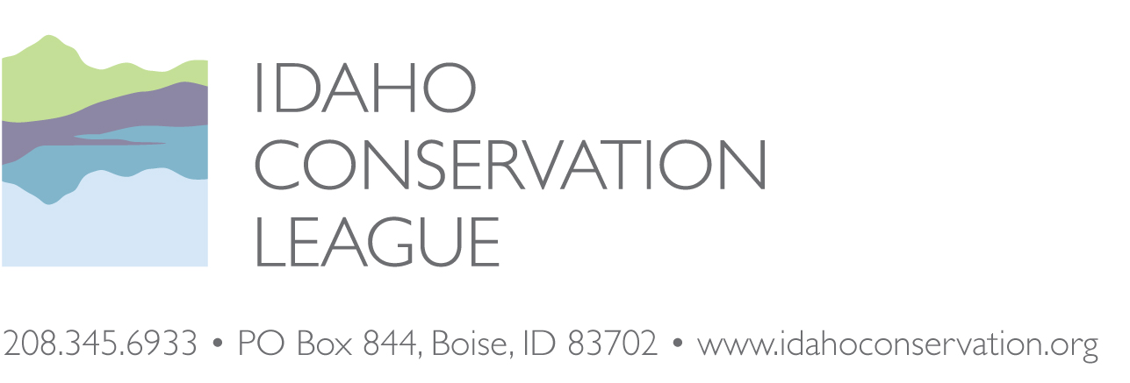
Anthony Botello, District Ranger
Krassel Ranger District
Payette National Forest
500 N. Mission St., Building 1
McCall, ID 83638

September 6, 2018

E-mail: comments-intermtn-payette-krassel@fs.fed.us and jpappani@fs.fed.us
RE: Idaho Conservation League Scoping Comments on the Big Creek Hazardous Fuels Reduction Project
Dear District Ranger Botello,
Thank you for considering our scoping comments on the Big Creek Hazardous Fuels Reduction proposal. As Idaho’s leading voice for conservation, we represent over 30,000 supporters from across the state who have a deep interest in the health and management of our forests. The Idaho Conservation League works to protect the air you breathe, the water you drink and the land you love. To learn more about the Idaho Conservation League, log onto: www.idahoconservation.org.
The Payette National Forest (PNF) is proposing a fuels reduction project in the vicinity of Big Creek on 10,600 acres, including commercial logging, non-commercial thinning, and prescribed burning. In addition, the PNF is proposing some of the above treatments in Riparian Conservation Areas. Finally, the PNF is proposing up to 1 mile of temporary road construction.
In general, the Idaho Conservation League supports the focus of fuels reduction in the immediate vicinity of homes and structures. We also support the intent to focus largely on small diameter materials through thinning and understory removal to modify fire behavior in the Wildland-Urban Interface. At the same time, we do have some questions on the issues of temporary road construction, treatments in Riparian Conservation Area, roadside treatments, and treatments around unmaintained and uninhabited private lands. We also want to stress the importance of private landowners coordinating with these efforts if the project is to be successful.
In addition to the issues associated with roads, NEPA, and riparian areas, ICL encourages you to thoroughly consider and disclose impacts associated with old growth and mature forest retention, snag retention, watershed function, sedimentation, erosion, wildlife habitat security, migratory songbird nesting habitat and other sensitive resources that could be impacted as a result of these proposals.
Finally, because the project is being proposed under the 2014 Farm Bill, the EA should include information on how the project is consistent with the direction of the Farm Bill. In particular, consistency with the large tree retention provisions should be discussed.
Again, we appreciate the opportunity to engage in this review and look forward to working with you and your staff on this and other projects in the future. Please don’t hesitate to contact me if we can answer any questions, or provide any clarification.
Sincerely,

Jonathan Oppenheimer
Government Relations Director

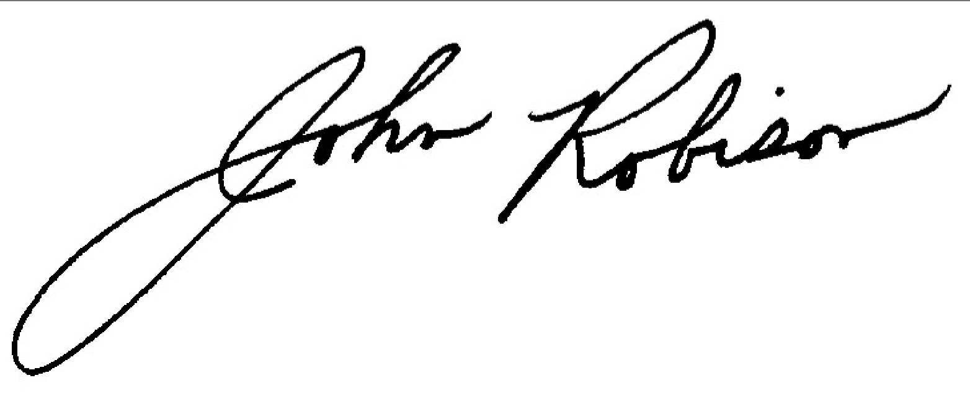

John Robison
Public Lands Director
jrobison@idahoconservation.org
(208) 345-6942 x 13

Idaho Conservation League comments on the Big Creek Hazardous Fuels Reduction Proposal
Focal Areas
We appreciate that the project appears to focus fuels reduction treatment in the immediate vicinity of private property. We are curious whether each of these private inholdings contain structures and whether homes or residences are present. If fuels reduction is being proposed around vacant private inholdings, or abandoned mines/structures, the Forest Service should consider dropping these acres if the overall benefits of the fuel reduction activity can still be maintained. The EA should discuss the intent of each of the treatments and how they may be integrated with fuels reduction efforts on private lands.

As mentioned above, if the Forest Service reduces fire risk on its side of the property line, and no action is taken on the adjacent private lands, little will be accomplished. The EA should also discuss where and how treatments have been implemented on private ground and whether the Valley County is applying for any grant funding to reduce fire risk on private lands within or adjacent to the project area.

Cumulative Effects Analysis
We recommend that the Forest Service conduct a robust cumulative effects analysis for the direct, indirect and cumulative impacts associated with the Big Creek project proposal. Other projects should include the Big Creek RAMP, Golden Hand Mine, Eiguren Ranch Fuels Reduction project, adjacent wildfires and other road, recreation, vegetation and fire management projects. We believe this analysis is warranted given the close proximity of each of these projects to one another or cumulative effects on shared transportation routes to the area.

Road Management and Roadside Cutting
The map provided in the scoping notice did not identify the location of the proposal temporary road. The EA should clearly identify the location for the new road and should include a discussion of the tradeoffs if the road is not built. Based on the direct and indirect impacts associated with roads, we recommend that the Forest Service consider an alternative that avoids new road construction. If the temporary road alternative is carried forward, special care should be taken to disclose whether the entire temporary road will be restored to slope, if existing unauthorized roads may be utilized in the project, whether any road decommissioning is being considered, and whether additional barriers (gates, berms or other impediments) will be installed following completion of the project.

In addition, the EA should disclose how existing roads will be managed in the project, whether widening or reconstruction of any roads is anticipated, what the impacts of that work might be and how road management and traffic may impact RCAs and water quality. We do appreciate that the scoping notice included information about the mileage of roads within RCAs and the number of stream crossings. We are curious how roadside RCA treatments may be different from non-RCA treatments and encourage the Forest Service to include detailed information in the EA about how the project complies with Forest Plan direction related to roads, RCA management, water quality and fisheries.

Use of Prescribed Burning
We support the proposed use of prescribed burning in order to reduce the fire risk associated with excessive ground fuels, and to promote and reestablish natural processes. We also recommend that the Forest Service consider the potential for prescribed fire during either spring or fall burn windows. At the same time, care should be taken to minimize impacts to nesting migratory birds or other sensitive species that may not be adapted to spring burning.

Wildlife Conservation
The EA should disclose and include specific design features specific to protection of Goshawk, Black Backed Woodpeckers, Flammulated Owl and elk habitat. We also recommend that the Forest Service analyze and disclose how the project applies relevant elements of the Wildlife Conservation Strategy and other Forest Plan and legal requirements relative to protection of threatened, endangered and sensitive species.

Riparian Conservation Areas
ICL is concerned about the potential impacts to Riparian Conservation Areas (RCAs). The EA should detail how RCAs are being assessed (i.e. Option 1, 2 or 3), and how that complies with Forest Plan director. We are particularly concerned about the impacts associated with roadside fuel reduction in association with roads located close to streams. As we noted above, the EA should clearly disclose the anticipated affects to RCAs as a result of roadside thinning and cutting. In particular, the EA should consider and discuss the impacts to riparian management objectives such as: stream shading, large woody debris recruitment, fine organic litter, bank stabilization, sediment control, nutrients and other dissolved materials, riparian microclimate and productivity, wildlife habitat and windthrow.

Roadless
The EA should assess and disclose impacts to Idaho Roadless Areas and should discuss consistency with the Idaho Roadless Rule. If activities are proposed within roadless areas, the project should be presented to the Idaho Roadless Commission, which has a meeting upcoming in October. Please contact Brian Riggers in the Northern Regional Office to coordinate, as needed.

Coordination with Private Land Owners
As noted above, we encourage the Forest Service to coordinate closely with the adjacent landowners in order to ensure the effectiveness of the project.

Large Tree and Snag Retention
We encourage the Forest Service to provide a discussion on how the project meets the direction of the 2014 Farm Bill relative to large tree retention. In addition, the project must follow the Forest Plan’s large tree and snag retention guidelines and provide an explanation in the decision document as to how project implementation will be consistent with these guidelines.

Weed Management
We recommend the Forest Service work with the local Cooperative Weed Management Area to ensure control of noxious and invasive weeds through the proper reestablishment of ground vegetation.

Restoration components
While the primary objective is to decrease the potential intensity and severity of a wildfire, we encourage the Forest Service to incorporate a watershed restoration component to further reduce sediment input into waterways. Although the Big Creek RAMP project addressed many road-related issues, there may be some additional opportunities for improvement. GRAIP studies can help pinpoint sediment sources and help prioritized road sections needing treatment. Restoration actions could include replacing culverts, better enforcement of road closures, removing conifers around aspen stands, providing coarse woody debris for aquatic restoration work, hardening dispersed recreation sites as needed, and limiting vehicle use for all contractors to designated routes. Activity areas and harvest intensity should be consistent with forest restoration and hazardous fuel reduction needs. Hazardous fuel removal areas should be located where needed to break up fuel continuity, particularly near any structures.

Future treatments
The Forest Service should also describe the timeline and intensity of future fuel reduction treatments in this area. Depending on the success of this project, some areas may be suitable for treatment with prescribed fire and only limited hand-thinning in the future.

Fuelwood
We recommend that operators deck any wood material that is not commercially viable and that is not needed for nutrient cycling and leave it in an accessible area for area residents or campers to utilize as fuelwood. Leftover woody debris from the project could potentially be utilized for aquatic restoration projects in the area.

Fire risk
Given the remote location of this project and distance from fire-fighting services, prevention of human-caused ignition will be a key component to the success of this project. The Forest Service should incorporate a public awareness component to this project to educate recreationists and private property owners about fire prevention tips. These outreach materials could be combined with information on recreational opportunities and trails in the area.

