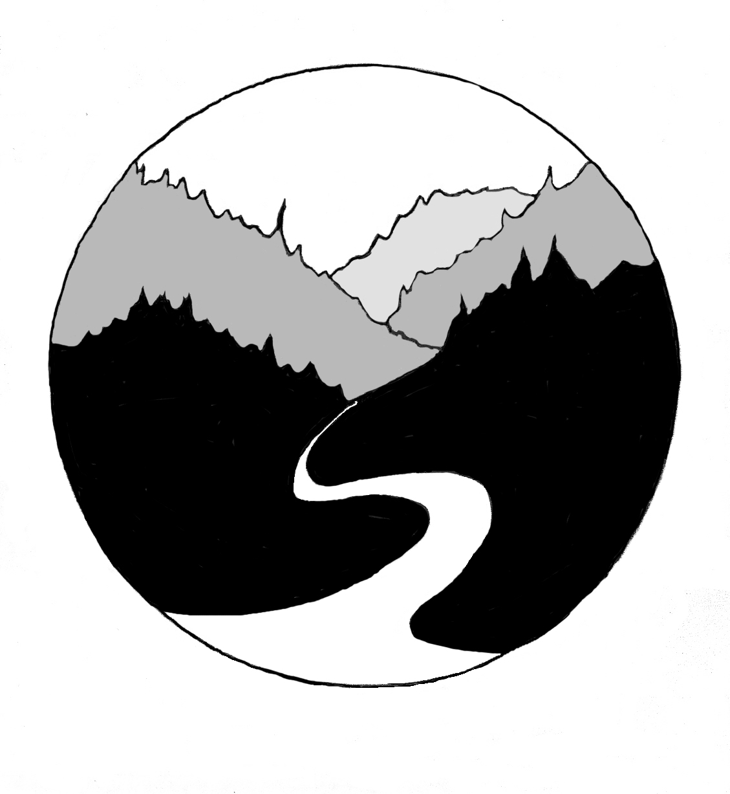
Mid Klamath Watershed Council

P.O. Box 409, Orleans, CA 95556 (primary)
P.O. Box 50, Happy Camp, CA 96039

Tel: (530) 627-3202
www.mkwc.org
mail@mkwc.org

July 26, 2018

Ted McArthur, Scott Salmon District Ranger
ATTN: Danika Carlson
Salmon/Scott River Ranger District
11263 N.Highway 3
Fort Jones, CA 96032

RE: Comments on Kelly Bar Habitat Enhancement Project #52447

The Mid Klamath Watershed Council strongly supports the Kelly Bar Project for the substantive reasons specified in the following comments. We have offered some support to bring long-time residents in the community along with us on this journey to restore our salmon runs. While we understand there are reasons why some residents disagree with this project, we believe from our interactions that these are tractable issues relating to communication, past failed efforts at restoration based on incomplete science, impacts of past unrelated projects to tribal aboriginal lands, and conflicts with other human uses of this site. Hopefully, these issues have been addressed through efforts of SRRC staff and others, and we can use this project as a demonstration of fisheries restoration techniques that have a proven record of restoring salmonid habitat.
Based on my review the selected alternative meets the purpose and need statements for the proposed project. The analysis shows that the project will enhance complex habitat in a floodplain degraded by historic mining practices. This restoration project is essential for improving habitat conditions for multiple anadromous fisheries, which are in decline and in dire need of more spawning and rearing habitat on the Salmon River. This project meets the restoration objectives identified in NMFS’s Final Recovery Plan for the Southern Oregon/Northern California Coast Evolutionarily Significant Unit of Coho Salmon (Oncorhynchus kisutch) by meeting Task item SalR.2.1.7 (2014). The project also works toward meeting the goals of the NCRWQCB’s Total Maximum Daily Load for Temperature and Implementation Plan (2005). Additionally, this project meets the USFS’ Forest Plan Aquatic Conservation Strategy Objectives by aiding the recovery of fish habitat, riparian habitat, and water quality (6-46). The Recovery Strategy for California Coho Salmon (CDFG, 2004) also identifies projects like this as a high priority action in the Salmon River watershed (SA-HA-09).
I strongly support implementing this project because it clearly meets the recommended actions in the Klamath Project Biological Opinion for coho salmon, Appendix C Restoration Project Type 5, Creation of Off-Channel Ponds/Side Channel Habitat, as it will re-connect side-channels and improve off-channel alcoves and ponds (NMFS and USFWS 2013); creating much needed habitat complexity and refugia for coho and spring Chinook populations at high risk of extinction on the Salmon River.
This project is essential to restoration efforts for anadromous fisheries on the Salmon River and has been identified through the collaborative planning effort to restore the Salmon River. Thank you for participating in this planning effort and following through by actually implementing a high priority project. The Salmon River Floodplain Habitat Enhancement and Mine Tailing Remediation Project Phase 1: Technical Analysis of Opportunities and Constraints identifies projects like this as essential to the long-term viability of fluvial processes and fisheries on the Salmon River (Stillwater 2018). “Restoration and enhancement of degraded floodplains, mine tailings, and aquatic habitats within lower gradient, predominantly alluvial reaches of the mainstem, North Fork, and South Fork remains the highest priority watershed work... If these impairments are promptly addressed, the Salmon River will have exceptional value as a long-term refuge for salmon, steelhead, and other cold-water dependent aquatic species.” This project is identified as a high priority for restoration in Appendix B, Opportunities and Constraints in Potential Floodplain Habitat Enhancement Segments, segment NF23b sta 64,850 (1).
This project will meet the goals and objectives of multiple watershed recovery plans for the state of California, including the State Coastal Conservancy’s Strategic Plan (meeting objectives 6D and 6E); the California Water Action Plan by restoring important species habitat in the Klamath Basin (page 12); state planning priority AB 857 in the California @ 50 Million by increasing ecosystem services and biodiversity, as well as increasing resilient natural systems to recover from disruption; the California Climate Adaptation Strategy/Safeguarding California: Reducing Climate Risk Plan by developing management practices to help safeguard species and ecosystems from climate risks by improving and protecting climate refugia; and the State Wildlife Action Plan, enhancing the degraded floodplain will meet conservation strategy goals (page 5.1-81).
The Final SONCC Coho Salmon Recovery Plan states that summertime temperatures and lack of winter rearing habitat are the primary stressors for juvenile coho in the Salmon River (NMFS 2014). The Plan also identifies Kelly Bar as having high Intrinsic Potential for coho fisheries. Kelly Bar offers low gradient habitat that is known to host rearing juvenile coho and Chinook salmon, as do other nearby tributaries and refugial areas within the project vicinity. However, the river bar has been altered by historic mining and no longer provides much needed off-channel habitat for coho salmon and other anadromous fish. Implementing this project would address the NMFS recommendation of developing more year-round habitat for juvenile coho, and would additionally provide habitat for all anadromous fisheries in the Salmon River watershed.
Restoring hydraulic conditions and riparian forest to the project’s off-channel habitat, will not only benefit high risk anadromous fisheries (coho, spring Chinook, and summer steelhead), it will also benefit multiple at-risk/sensitive riparian and aquatic associate species including neotropical migratory birds (including willow flycatcher), Cascades frog, foothill yellow-legged frogs, tailed frogs, western pond turtles, American dipper, northern water shrews, long-tailed voles, resident rainbow trout, and Pacific lamprey.
The Salmon River hosts the last remaining viable run of wild spring-run Chinook in the Klamath Basin, a species with particular cultural significance to the Karuk Tribe and other tribes throughout the Klamath Basin. The SRRC has been working collaboratively with the Karuk Tribe, community members, and other interested parties for many years to actively protect and restore spring-run Chinook in the Salmon River. The persistence and restoration of this last remaining viable run of wild spring-run Chinook in the Klamath Basin is essential in the fight to maintain this important species within the basin and will likely play an important role in the restoration of a viable spring-run Chinook population in the upper Klamath Basin post dam removal. This project would advance those efforts.
Wild runs of coho salmon, spring-run Chinook, and summer steelhead still persist in the relatively unimpaired waters of the Salmon, yet they face a high risk of extinction. Coho salmon are listed as Threatened under the Federal Endangered Species Act (ESA), spring-run Chinook are currently being reviewed for listing under the ESA, and summer steelhead are listed by the state of California as a sensitive species that is of concern and at-risk of extinction. Increasing the available rearing habitat for juveniles of these species is of great importance for the future of salmonids in the Salmon River Watershed. Because these fish require winter slow water refugia and summer cold water temperatures for rearing habitat, increasing side channel habitat as well as riparian forest canopy are especially beneficial to the future health of this important species. Implementing this project will provide much needed off-channel habitat for these imperiled species and I strongly support this project.
Survey data shows that juvenile coho and spring-run Chinook use Kelly Bar and nearly all of the tributaries and their associated refugia on this reach of the North Fork Salmon River. Implementing this project will enhance side-channels; creating much needed habitat complexity and refugia for coho and spring-run Chinook populations at high risk of extinction. Since coho and spring-run Chinook salmon require slow water refugia and summer cold water temperatures for rearing habitat, increasing side channel habitat augmented with large woody debris and riparian vegetation for cover and food will be especially beneficial to juveniles. Additionally, suitable spawning habitat can be limited in the main river channel and therefore improving off-channel habitat will benefit adults, which spawn when flows are high. The Kelly Gulch river bars currently have very poor quality off-channel and side channel habitat, with limited connection to the river during high flows, enhancing those areas will provide much needed habitat on a river reach essential to coho and spring-run Chinook.
This project will occur in a Severely Disadvantaged Community Block Group as defined in CWC Section 79505.5(a). Communities on the Salmon River are very small, economically impoverished, lack opportunities for economic development, and are considered severely economically disadvantaged. The Salmon River is home to four tiny, extremely remote communities and numerous outlying neighborhoods, which once relied on mining and logging industries but were devastated when these economies went belly up. Currently, the SRRC is the largest employer in the watershed, employing residents in ecological restoration. The SRRC will provide work through this project to local community members. In the long-term, projects like this will support local entrepreneurs as well as improve fisheries, resulting in economic benefit to the community from fish-based recreation related activities. To date, the SRRC has successfully implemented several instream restoration projects and hired local operators/contractors for at least a portion of the work required to complete those projects, in some cases all work was completed by local community members. Additionally, the SRRC has been supported through long-term voluntary support by local community members which actively participate in a variety of restoration efforts on the Salmon River. Many local community members are aware of the instream restoration efforts of the SRRC and are very supportive of projects like this as well as this type of work on the Salmon River.
This project was developed and designed using the most current and best practices and standards for instream restoration by a design firm with a wealth of experience and success in this field. This project was developed following years of fisheries monitoring and a riparian assessment completed in 2008. The site was identified as a high priority for restoration of riparian conditions and salmonid habitat through a planning process completed by Pacific Watershed Associates in 2012. The project was then reviewed and fully supported by the Salmon River Technical Advisory Committee, a diverse group of community, tribal, and agency stakeholders. Following resounding support of the project, the SRRC initiated fully engineered designed plans, based on a year of water monitoring and in-depth site characterization, which were completed in June 2017. The plans were developed to meet Chapter VII of the California Department of Fish and Wildlife Habitat Restoration Manual (Flosi et al., 2010) and the current standards and practices of the industry. A diverse team of specialists and agency stakeholders participated in the design review process, including CDFW, Karuk Tribe, MKWC, NMFS, NOAA, SRRC, and USFS. Therefore, this project has been well analyzed, designed, and vetted and should move forward as planned. I strongly support this project, the process that developed this project, and look forward to more planning efforts developed in this way on the Salmon River.
This collaboratively designed and vetted instream fisheries restoration project includes extensive post project implementation monitoring and SRRC has committed to long term monitoring of the project. Long-term effects from this project will be monitored by the SRRC, who has a track record of committed, quality, reliable monitoring efforts within the Salmon River Watershed. Extensive restoration effectiveness monitoring will be conducted for this project, which will provide valuable insight into how specific features of the project perform and provide refugia for fisheries. Evaluations of the project will also inform future restoration projects on the Salmon River. Additionally, if items of concern arise, consultation with the project team members, and/or other agencies, would occur in order to determine if a maintenance action is warranted. I am confident that the project will be well studied, any issues resulting from the project will be addressed adequately, and the effects of the project will be essential in guiding the long-term efforts to restore at risk fisheries throughout the Salmon River.
The project has undergone archaeological review to ensure no cultural resources are impacted by project implementation. The project area is historically and culturally significant to the Karuk, Shasta, and Konomihu people. No traditional cultural properties, traditional or contemporary use areas, or specific areas of spiritual significance have been identified within the Area of Potential Effect of this project. Additionally, the entire project occurs within the 100-hundred year floodplain, which was completely disturbed during the 1964 flood event. There will be no effects to Native American Heritage Resources from implementing this project, other than positive effects to culturally significant species such as spring-run Chinook salmon.
In conclusion, we hope that the Klamath NF chooses to implement this project in its entirety and take a significant step towards restoring salmon runs in the Salmon River watershed. If you have any questions, please feel free to contact me.

Regards,
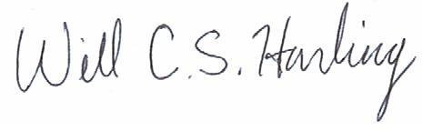
Will Harling, Director
Mid Klamath Watershed Council

