
PO Box 11648 | Eugene OR 97440 | 541-344-0675 | fax 541-343-0996
dh@oregonwild.org | http://www.oregonwild.org/

10 August 2016

TO: comments-pacificnorthwest-umatilla@fs.fed.us

Subject: Programmatic Aquatic Restoration on the Umatilla National Forest EA — scoping comments

Dear Forest Service:

Please accept the following scoping comments from Oregon Wild concerning the proposed Programmatic EA for Aquatic Restoration on the Umatilla National Forest. Oregon Wild represents over 15,000 members and supporters who share our mission to protect and restore Oregon’s wildlands, wildlife, and water as an enduring legacy. Our goal is to protect areas that remain intact while striving to restore areas that have been degraded. This can be accomplished by moving over-represented ecosystem elements (such as logged and roaded areas) toward characteristics that are currently under-represented (such as roadless areas and complex old forest).

The proposed action alternative involves programmatic EA covering 18 categories of aquatic restoration projects that would receive no further NEPA analysis as long as they are consistent with Project Design Criteria in the 2013 NMFS/FWS Aquatic Restoration Biological Opinion (ARBO II). The seventeen (17) project categories covered by this analysis include:
• Fish Passage Restoration (Stream Simulation Culvert and Bridge Projects; Headcut and Grade Stabilization; Fish Ladders; Irrigation Diversion Replacement/Relocation and Screen Installation/Replacement)
• Large Wood, Boulder, and Gravel Placement (Large Wood and Boulder Projects; Engineered Logjams; Porous Boulder Weirs and Vanes, Gravel Augmentation; Tree Removal for Large Wood Projects)
• Dam, Tide Gate, and Legacy Structure Removal
• Channel Reconstruction/Relocation
• Off- and Side-Channel Habitat Restoration
• Streambank Restoration
• Set-back or Removal of Existing Berms, Dikes, and Levees
• Reduction/Relocation of Recreation Impacts
• Livestock Fencing, Stream Crossings and Off-Channel Livestock Watering
• Piling and other Structure Removal
• In-channel nutrient enhancement
• Road and Trail Erosion Control
• Juniper Removal
• Riparian Vegetation Treatment (controlled burning)
• Riparian Vegetative Planting
• Bull Trout Protection
• Beaver Habitat Restoration
• Fisheries, Hydrology, Geomorphology Wildlife, Botany, and Cultural Surveys in Support of Aquatic Restoration

Our concerns are mostly with the programmatic process, but we have some specific suggestions on the substance of the PDCs (in bold below). We raise some serious concerns about the use of programmatic NEPA to provide site-specific project analysis. These concerns can be partially mitigated if the Umatilla Forest will provide a robust system of timely public notice and comment on proposed restoration projects.

Oregon Wild strongly supports ecological restoration. Many of the project types listed above closely align with our priorities for management of the National Forests. We also support efficient use of agency time and resources to plan, fund, and implement good restoration projects. However, we feel that restoration science is still developing and that site-specific review and public involvement are critical to making sound decisions that are in the public interest and have the support of the public. To the extent that this EA will embody a programmatic-only approach to NEPA, we are concerned that this proposal runs afoul of the letter and spirit of the landmark conservation law that is NEPA, as well as the tiered decision-making approach recognized in the Umatilla LRMP.

We do not want to be a road-block to much needed restoration, but we encourage the Forest Service to come up with an efficient method of public notice and comment on restoration projects.

We are most concerned about “juniper removal” and “riparian vegetation management.” These actions might not be ecologically necessary and they pose a “slippery slope” problem. For instance, some young encroaching juniper might need to be killed, but they do not need to be “removed.” It Is probably better to retain the nutrients on site. We support the PDC encouraging use of juniper for on-site restoration of instream wood (it should also be considered valuable for terrestrial large wood.) If juniper is removed, inappropriate incentives arise that could easily allow economics to over-ride ecological restoration objectives.

In-channel nutrient enhancement appears to be a new category that we are not familiar with. Most aquatic systems are degraded by excess nutrients so we are not sure there is a compelling need for more nutrients.

The PDC for juniper allow feller-bunchers and slash busters. We do not think heavy equipment should be used in riparian areas without site-specific NEPA analysis. The PDF for juniper also reference restoration of “natural stocking levels” but juniper is a native species and it’s recent proliferation may have a lot to do with climate change and atmospheric carbon enrichment. The extra CO₂ in the atmosphere allows plants to get all the carbon they need more quickly while losing less water through their stomata. This increases plants’ water use efficiency and drought tolerance. From this perspective, the current increase in stocking may be “natural stocking.” Trying to fight juniper expansion (without addressing the underlying problem of atmospheric carbon enrichment) is probably a losing battle.

We recommend that the PDC for juniper removal be modified to:
- Change the name to “juniper management” instead of juniper removal;
- exclude heavy equipment; allow hand work only (like the PDC for riparian vegetation management),
- retain killed juniper on-site or use it for nearby large wood restoration efforts; and
- retain ~15% of treatment units as untreated patches of juniper.

The category heading “Riparian vegetation treatment” is just too vague. It sounds like it could include logging, but the PDC just references fire reintroduction. If that is the real purpose, the title of this category should be “reintroducing fire,” not “riparian vegetation treatment.”

The variance process is also a concern. A variance process is not needed because if a project does not meet the PDC then it just goes through NEPA. That’s a good thing.

Some of the PDCs are too vague, e.g., “Temporary access roads will not be built on slopes where grade, soil, or other features suggest a likelihood of excessive erosion or failure. When necessary, temporary access roads will be obliterated or revegetated.” First, road construction of any kind should be prohibited under this blanket NEPA process. Second, the language here (“excessive,” “when necessary”) is too permissive and subjective. The criteria for all categories of restoration actions should be very clear, without ambiguities about what is allowed under this decision and what kinds of action require site-specific NEPA analysis. Road construction should be specifically prohibited. Commercial removal of logs should be explicitly prohibited. Heavy equipment should be prohibited with inventoried roadless areas.

All the categories of restoration actions need more sideboards that specify an appropriate scale of action covered by this EA, e.g., scale should be described as acres of treatment, square footage of soil disturbance, cubic yards of soil movement, etc. It is easier to see how small projects might be covered by this process, but larger projects should get their own EAs. Also, a temporal scale needs to be clearly specified. The EA should expire and be reanalyzed.

“Fish passage” PDCs should be expanded to account for the needs of wildlife other than fish. Restoration should focus on the ecosystem, not just a few focal species. Insects, mollusks, and amphibians also need to move. “Passage” should also include large wood and sediment that need to move from uplands to the stream and then through the stream system.

The PDC urge consideration of climate change, but it should go further to require that restoration projects adopt increased capacity to accommodate increased storm flows.

The site rehab PDC should require use of native species, not just “prefer” it.

Decompacting soils is a good idea, but it comes with trade-offs, such as damage to the roots of existing vegetation, and spreading weeds. The PDC make no effort to balance these trade-offs.

The PDC for “wood removal for LW projects” raises concerns. Adding wood in one place obviously requires taking it from another place. The ARBO essentially allows almost unlimited ground-based logging as long as its for stream restoration. There is just too few sideboards on where trees can be removed. The PDC appears to allow removal of mature trees from protected land allocations “when conifers and trees are fully stocked.” This is not appropriate. Full stocking is an agro-forestry term, not a valid ecological criteria for tree removal. Taking trees from a fully stocked stand will “capture mortality” and reduce future snag habitat. The adverse effects of this are not accounted for. This is the kind of trade-off that requires site-specific NEPA. We are comfortable with the removal of hazard trees along well-travelled roads for use in aquatic restoration, but we urge the FS to close the wide open loophole allowing removal of mature trees from native forests using this programmatic EA.

The PDC for gravel augmentation says “Gravel can be mined from the floodplain at elevations above bankfull … ” We do not support this. The floodplain provides many ecological values. This PDC places the value of fish instream above other values. This is not appropriate. This is the kind of trade-off that requires site-specific NEPA.

Providing off-channel water for livestock and fencing livestock out of riparian areas comes with many trade-offs. Fences cause direct and indirect wildlife mortality. Also, fences and watering facilities may not be maintained over time while livestock use continues and stream damage occurs in spite of mitigation efforts. It may be better to just remove the livestock than to install ineffective mitigation half-measures that perpetuate the harmful activity. There are alternatives to fences and off-channel water that need to be considered in a NEPA process, e.g. livestock removal.

The FS should add to the restoration categories of actions: “reduction or removal of livestock grazing.” This restoration action would provide fairly predictable environmental effects.

Part of our concern is that this proposal is akin to adopting a huge new list of Categorical Exclusions for the Umatilla NF. It’s really worse than a CE in some ways because the public gets more notice and comment on CEs than seems to be contemplated for these restoration projects. Note: The FS has already adopted an agency-wide set of excluded categories at 36 CFR 220. The Umatilla Forest is not allowed to use this alternative process to adopt its own expansive set of additional CEs.

We are concerned that the programmatic restoration effort contemplated here will not meaningfully involved the public. Forgoing project level NEPA misses many opportunities to share success stories with the public. This is a big public relation faux pas. Project-level notice and comment helps inform the public and avoid surprises and awkward post-hoc explanations.

For very good reasons, public involvement has become a fundamental tenet of public land management. Does it seem strange that the process here requires notice to NFMA and FWS but not the public who’s lands these are? “Streamlining Level 1 teams will review and discuss aquatic restoration projects planned for implementation during an upcoming work season …”

The FS is preparing this programmatic EA to adopt the ARBO II which was developed by NMFS and FWS outside of the NEPA process. How much influence will public comment during this NEPA process have on the terms of the ARBO II? This programmatic EA then skips over the crucial step of project level planning where the public might be notified and have substantive comments to improve restoration plans and decisions. The FS has proposed an agency-wide restoration policy which calls for a more collaborative approach. https://www.federalregister.gov/articles/2013/09/12/2013-22149/ecological-restoration-policy

We are also concerned that public involvement is not being provided consistent with current requirements. The FS must comply with both NEPA, and also with the notice-comment-objection rules at 36 CFR 218 which requires public involvement in all actions implementing forest plans. This includes future projects implementing this programmatic EA.

Site-specific NEPA is not optional. NEPA is the embodiment of the democratic process for decisions affecting our shared environment. NEPA does take time but it serves a purpose. It informs the decision-maker and leads to better decisions that are more likely to find public support. The FS should search for other ways to be more efficient in the way it implements NEPA's requirements. Simply side-stepping NEPA and notice & comment procedures for a whole suite of different actions is not an appropriate approach.

We have some concerns about the programmatic nature of this NEPA process. To be clear we are not concerned about programmatic NEPA per se, but we are concerned when the Forest Service tries to cover all of its NEPA obligations with just a programmatic document, and fails to follow up with site-specific NEPA analysis and public involvement at the project level. This proposal seems to contemplate that approval of this one EA will adequately cover a wide variety of future site-specific actions that will not receive future site-specific NEPA analysis. NEPA requires that the FS conduct site-specific NEPA to consider the site-specific effects of actions. Programmatic NEPA is not the end of the NEPA process but a step toward later site-specific NEPA. Proper NEPA analysis is not generic, but rather site-specific. This staged decision-making framework is described in the CEQ regs section on "tiering" -

40 CFR 1502.20 Tiering.
Agencies are encouraged to tier their environmental impact statements to eliminate repetitive discussions of the same issues and to focus on the actual issues ripe for decision at each level of environmental review (Sec. 1508.28). Whenever a broad environmental impact statement has been prepared (such as a program or policy statement) and a subsequent statement or environmental assessment is then prepared on an action included within the entire program or policy (such as a site specific action) the subsequent statement or environmental assessment need only summarize the issues discussed in the broader statement and incorporate discussions from the broader statement by reference and shall concentrate on the issues specific to the subsequent action. The subsequent document shall state where the earlier document is available. Tiering may also be appropriate for different stages of actions. (Section 1508.28).

If it was appropriate to do a programmatic EA for a range of site-specific management actions this procedure would have been used during forest planning, but that was not done because it is not considered appropriate. The Umatilla LRMP (pp 1-2, 1-3) recognizes the tiered approach, saying –
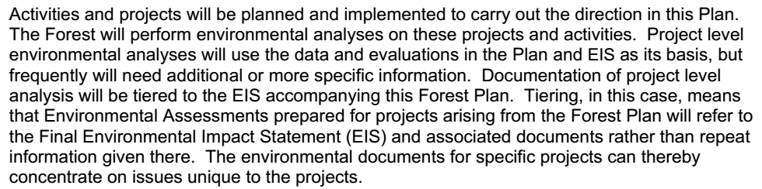
…
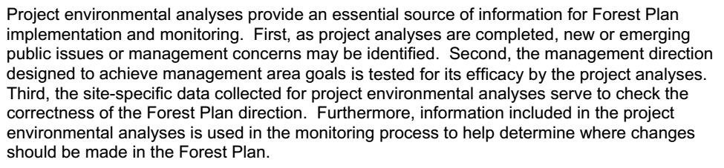
There is a clear expectation of "tiered decision-making" with programmatic plans followed by site-specific environmental analyses. The Programmatic Restoration EA exists outside the proper NEPA/NFMA frame.

In order to comply with NEPA requirements and cover both the programmatic and site-specific impacts of restoration, the NEPA analysis must carefully document all the contingencies under which covered restoration actions might occur —
- all the different soil types and topographies;
- all the different plant communities; impacts to habitat for all the different special status species;
- proximity to special resources;
- possible conflicts with site-specific recreation uses;
- compliance with LRMP requirements for all the different land allocations;
- consideration of new information that renders the programmatic EA obsolete;
- compatibility with the cumulative effects setting that exists in all the different watersheds. etc. etc.
It's hard to imagine this being done well and thoroughly in a programmatic EA.

The EA needs to provide an adequate description of the existing condition, and site-specific environmental consequences. The description of environmental effects need to be site-specific. The EA needs to clearly describe all the likely effects of restoration actions in all the places that could be impacted under this process.

Sincerely,
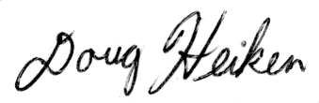
Doug Heiken

