22 June 2018

TO: USFS
ATTN: Dean Schlichting, McKenzie District Planner and Project Lead
VIA: https://cara.ecosystem-management.org/Public//CommentInput?Project=53966

Subject: Flat Country project — scoping comments

Dear Forest Service:

Please accept the following scoping comments from Oregon Wild concerning the Flat Country project, https://www.fs.usda.gov/project/?project=53966. Oregon Wild represents 20,000 members and supporters who share our mission to protect and restore Oregon’s wildlands, wildlife, and water as an enduring legacy. Our goal is to protect areas that remain intact while striving to restore areas that have been degraded. This can be accomplished by moving over-represented ecosystem elements (such as logged and roaded areas) toward characteristics that are currently under-represented (such as roadless areas and complex old forest).

The proposed action alternative involves:
- ~5000 acres of forest management treatments including
  - commercial thinning,
  - variable forest thinning,
  - shelterwood
  - fuels reduction treatments and
  - early seral creation through gaps and aggregate retention harvest;
  - Located in matrix and riparian reserves
  - Create fuels breaks along 57 miles of roads (2597 acres)
  - 368 acres of meadow enhancement
- Road work would be part of the actions associated with the proposed activities and would include
  - road maintenance/reconstruction on approximately 46 miles of forest roads,
  - 2 (or 16) miles of temporary road construction (the scoping notice gives conflicting info),
  - no new permanent road construction and
  - 8 miles of road decommissioning.

Thinning in the matrix should have an ecological focus. The matrix includes ecological objectives. Variable thinning is preferable to uniform thinning and will still produce timber volume.

Logging older stands and regen harvest are not warranted. New information since the NWFP was adopted strongly indicate a need to modify matrix objectives to:
- retain suitable owl habitat to reduce adverse competitive interactions between spotted owls and barred owls,
- retain and restore carbon in forest ecosystems,
- retain mature forest canopy trees to help maintain a natural fire regime and reduce fire severity associated with regen harvest,
- retain enough green trees to ensure adequate snag recruitment over the life of the stand, etc.
The FS should not rely on the matrix land allocation because the analysis supporting the 24 year old NWFP FSEIS under-estimates the benefits of conserving forests, and over-estimates the benefits of logging. See Heiken, Doug. 2009. The Case for Protecting Both Old Growth and Mature Forests, Version 1.8. Oregon Wild. https://www.dropbox.com/s/4s0825a7t6fq7zu/Mature%20Forests%2C%20Heiken%2C%20v%201.8.pdf?dl=0. Given the climate crisis that we are collectively facing, it is simply inexcusable transfer large amounts of carbon from the forest to the atmosphere via logging mature & old-growth forest, or conducting regen harvest, especially on public land. The FS has no NEPA documentation to support logging in the matrix for timber production, in light of new information about the contribution of logging to the cumulative problem of GHG emissions, and urgent need to reduce GHG emissions.

The purpose and need for this project need to be adjusted to account for new information and the compelling need to manage for carbon storage.

The current purpose and need is too vague and unfocussed, e.g., “improve stand conditions.” The purpose and need also pre-ordains that “active management” is the best way to meet objectives, when science says that natural processes often do a better job. See Lutz. J.A. 2005. The Contribution of Mortality to Early Coniferous Forest Development. MS Thesis. University of Washington. http://faculty.washington.edu/chalpern/Lutz_2005.pdf. And see, the Mature Forest White Paper cited above.

Logging riparian reserves for “habitat complexity and hardwood composition” is not warranted. The reduction in dead wood recruitment caused by logging riparian reserves is significant and long-lasting and does not outweigh the modest and short-lived benefits attributed to logging. Except in the case of the youngest plantation stands, science shows that natural processes will develop higher quality riparian habitat, so logging riparian reserves is not “needed” as per the standards & guidelines of the Aquatic Conservation Strategy.

This project area includes prime bull trout habitat which must be very carefully conserved. Given the great extent and intensity of past timber harvest, the FS should go lighter on the land to avoid pushing this landscape past a tipping point of watershed integrity that bull trout (and other organisms) can no longer tolerate.

Creating early seral habitat via regen harvest is not warranted. Early seral habitat created by logging is not as high quality as early seral created by natural disturbance events that retain woody biomass and complex structure. Early seral is still vastly over-abundant (and late seral is vastly under-represented), across the landscape including non-federal lands. The Sisters District is not far away that they have experienced a lot of fires. There is not a shortage of early seral at the large scales that matter for the mobile/opportunistic species that prefer early seral forests.

Logging in riparian reserves should be limited to small trees less than 12” dbh and streams should be generous buffered (>50 feet for stands <50 years old, and >100 feet for stands >50 years old). Mature forests in riparian reserves should not be logged because such stands are meeting ACS objectives and there is no need for logging.

“Gaps” should mimic natural disturbance events and retain live and dead trees structure. Gaps should be small patches of very heavy thinning, not mini-clearcuts.

Meadow enhancement should be done non-commercially by cutting and retaining small-young trees onsite as down wood habitat. The smallest trees might need to be piled and burned, but not within the meadow. All old trees should be retained in the meadow enhancement. Heavy equipment should be excluded from the meadows.

Fuel reduction is not a compelling reason to log these forests because:
- the fire return interval is relatively infrequent, so there is a low probability that fuel treatments will interact with fire during the brief period before fuel regrow;
- MTBS data shows that wildfires are still burning with a characteristic mix of low, moderate, and severe fire effects, so is there really a need to modify normal fire behavior when there are big trade-offs in terms of spotted owls, carbon, etc.
- Even if fuel treatments do interact with fire, they have only a modest effect on fire extent and behavior;
- Many of the treatments proposed will make fire hazard worse, not better, e.g., regen harvest, mature forest logging, and heavy thinning of plantations,

Fuels breaks should only remove trees <9” dbh. Hardwoods and yew trees should be retained, because hardwoods are heat sinks, and yew trees are special and under-represented. Retain all canopy trees helps moderate fire behavior because it maintains a cool-moist-less-windy microclimate, reduce slash production, and suppresses growth of surface and ladder fuels.

There appear to be several units located between the wilderness boundary and the last road. See Oregon Wild unroaded map attached. These units should be dropped because they impact ecologically important and under-represented unroaded/unmanaged forest.

The NEPA analysis should carefully consider trade-offs associated with logging of mature and old forests, regen harvest, and road construction, e.g., habitat degradation, snag habitat loss, carbon emissions, erosion, and hydrologic impacts, etc.

The NEPA analysis should consider alternatives that avoid logging mature forests and avoid regen harvest and avoids all road construction.

We are concerned about cumulative impacts with other large logging projects in this area, such as the Robinson Scott timber sales. See map attached. The NEPA analysis should describe the stand history for each harvest unit. We are particularly interested in which units have been previously regen harvested, which may have been thinned but still have significant mature trees, and which have never been previously managed.

Sincerely,

Doug Heiken
dh@oregonwild.org

Enclosed: 2 maps
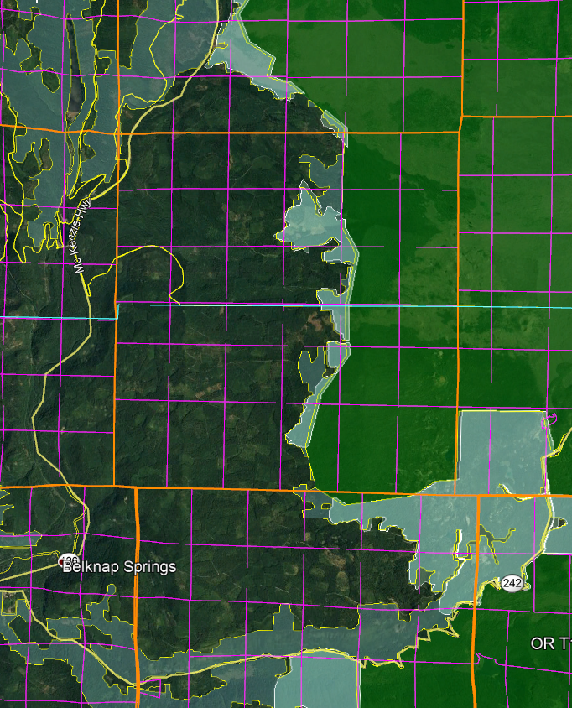
Oregon Wild map of unroaded areas in two shades of green adjacent to the wilderness.

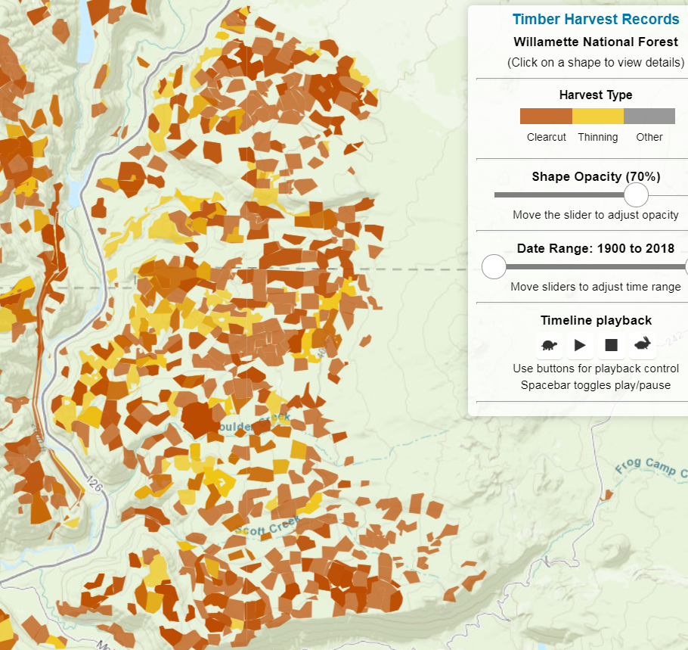
Map of past timber harvest in this planning area. Significant cumulative impacts expected.
https://timber-harvest.oregonhowl.org/?f=willamette

